**K - NN**

**CSE 303: Machine Learning**

Submitted by

Name: Guntur Ridhi

Roll No: AP22110011467

Section: CSE M

Lab Date: 16/09/2024

Submission Date: 24/09/2024

**Department Computer Science and Engineering**

**School of Engineering and Sciences**

**SRM University–AP**

**Amaravati, Andhra Pradesh – 522 240, India**

1. **Question**

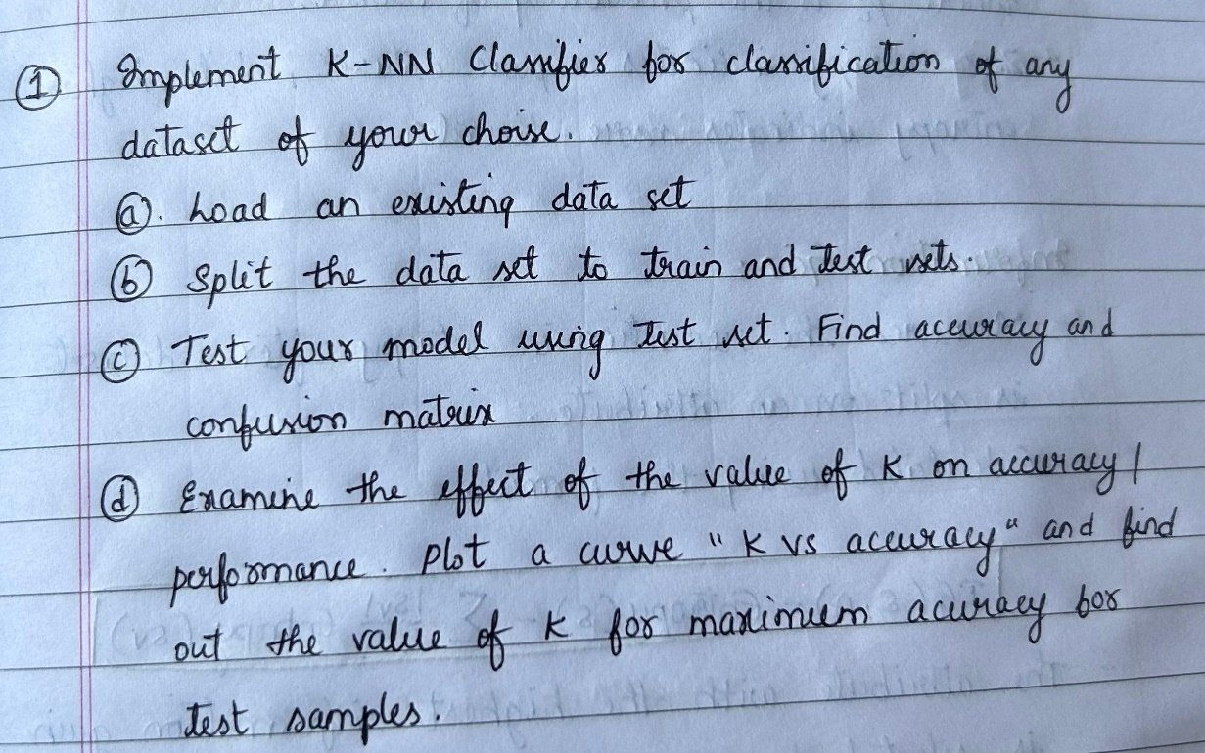

1. **Algorithm Description**

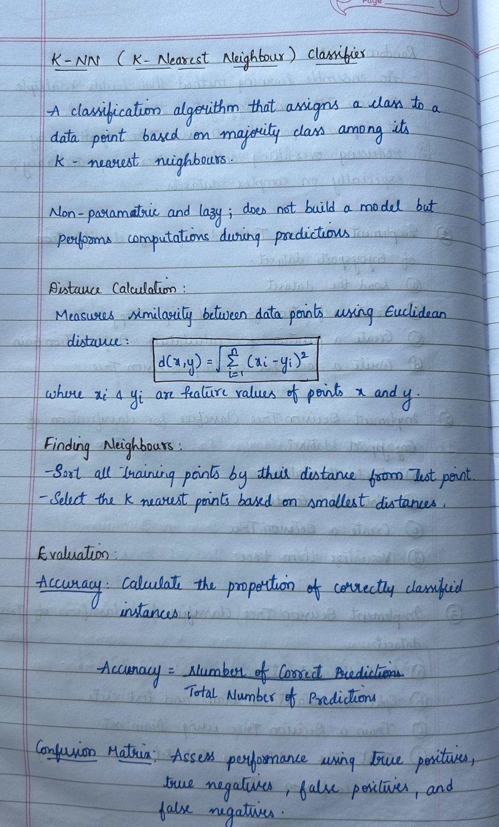

1. **Solution**

**K-NN Classifier Implementation**

|  |
| --- |
| **1. Loading and Preprocessing the Dataset** |
| import numpy as np  import pandas as pd |
| # Load the dataset  car_data = pd.read_csv(r"C:\Users\guntu\Downloads\car_data.csv") |
| **Drop 'User ID' and encode 'Gender' column as 0 (Female) and 1 (Male)** |
| # Split data into features (X) and target (y)  X = car_data[['Gender', 'Age', 'AnnualSalary']].values  y = car_data['Purchased'].values |
| **2. Splitting the Data into Train and Test Sets** |
| # Function to split data into train and test sets  def train_test_split(X, y, test_size=0.2):  indices = np.arange(X.shape[0])  np.random.shuffle(indices)  split_idx = int(X.shape[0] * (1 - test_size))  train_idx, test_idx = indices[:split_idx], indices[split_idx:]  return X[train_idx], X[test_idx], y[train_idx], y[test_idx]  # Split the dataset into training and testing sets  X_train, X_test, y_train, y_test = train_test_split(X, y) |
| **3. Implementing the K-NN Classifier** |
| # Euclidean distance calculation  def euclidean_distance(x1, x2):  return np.sqrt(np.sum((x1 - x2) ** 2)) |
| # K-NN algorithm without using external libraries like Counter  def knn_classifier(X_train, y_train, X_test, k):  y_pred = []  for test_point in X_test:  # Compute distances from the test point to all training points  distances = [euclidean_distance(test_point, x_train) for x_train in X_train]    # Get the indices of the k-nearest neighbors  k_indices = np.argsort(distances)[:k]    # Get the corresponding labels of the nearest neighbors  k_nearest_labels = [y_train[i] for i in k_indices]    # Manual majority voting  label_count = {}  for label in k_nearest_labels:  if label in label_count:  label_count[label] += 1  else:  label_count[label] = 1    # Determine the class with the highest count (majority voting)  majority_class = max(label_count, key=label_count.get)  y_pred.append(majority_class)    return np.array(y_pred) |
| **4. Evaluating the Model (Accuracy and Confusion Matrix)** |
| # Function to compute accuracy  def compute_accuracy(y_true, y_pred):  return np.sum(y_true == y_pred) / len(y_true)  # Function to compute confusion matrix  def confusion_matrix(y_true, y_pred):  tp = np.sum((y_true == 1) & (y_pred == 1))  tn = np.sum((y_true == 0) & (y_pred == 0))  fp = np.sum((y_true == 0) & (y_pred == 1))  fn = np.sum((y_true == 1) & (y_pred == 0))  return np.array([[tn, fp], [fn, tp]]) |
| # Test the K-NN Classifier with k=5  k = 5  y_pred = knn_classifier(X_train, y_train, X_test, k)  # Compute accuracy  accuracy = compute_accuracy(y_test, y_pred)  print(f"Accuracy: {accuracy}") |
| Accuracy: 0.835 |
| # Compute confusion matrix  conf_matrix = confusion_matrix(y_test, y_pred)  print(f"Confusion Matrix:\n{conf_matrix}") |
| Confusion Matrix:  [[107 14]  [ 19 60]] |
| **5. Examining the Effect of K on Accuracy** |
| import matplotlib.pyplot as plt  # Test the K-NN Classifier for different values of k and store the accuracies  k_values = range(1, 20)  accuracies = []  for k in k_values:  y_pred = knn_classifier(X_train, y_train, X_test, k)  accuracy = compute_accuracy(y_test, y_pred)  accuracies.append(accuracy)  # Plot k vs accuracy  plt.plot(k_values, accuracies, marker='o')  plt.xlabel('k (Number of Neighbors)')  plt.ylabel('Accuracy')  plt.title('K vs Accuracy')  plt.show() |
|  |
| # Find the best k for maximum accuracy  best_k = k_values[np.argmax(accuracies)]  print(f"Best value of k: {best_k}") |

1. **Code Repository:**

GitHub Link: <https://github.com/Ridhi-215/K-NN>