**LINEAR DISCRIMINANT ANALYSIS**

**CSE 303: Machine Learning**

Submitted by

Name: Guntur Ridhi

Roll No: AP22110011467

Section: CSE M

Lab Date: 22/10/2024

Submission Date: 28/10/2024

**Department Computer Science and Engineering**

**School of Engineering and Sciences**

**SRM University–AP**

**Amaravati, Andhra Pradesh – 522 240, India**

1. **Algorithm Description**

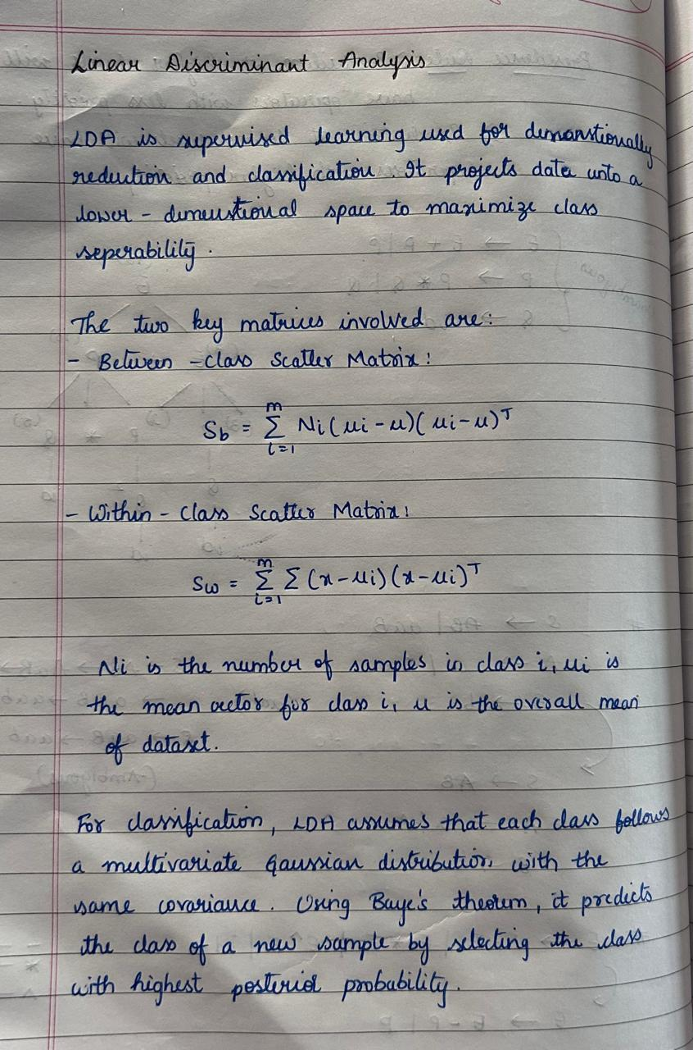

1. **Solution**

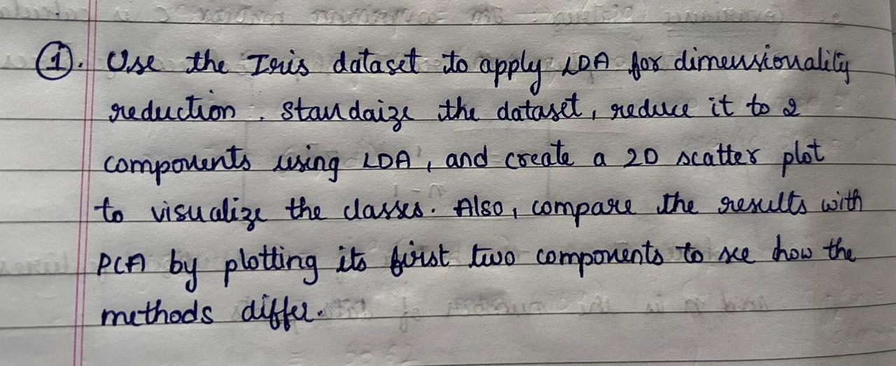

|  |
| --- |
| import numpy as np  import pandas as pd  import matplotlib.pyplot as plt  import seaborn as sns  from sklearn.datasets import load_iris  data = load_iris()  X = data.data # Feature matrix (4 features)  y = data.target # Target labels (3 classes)  target_names = data.target_names  from sklearn.preprocessing import StandardScaler  scaler = StandardScaler()  X_standardized = scaler.fit_transform(X)  print("Standardized data:")  print(X_standardized[:5])  from sklearn.discriminant_analysis import LinearDiscriminantAnalysis  lda = LinearDiscriminantAnalysis(n_components=2)  X_lda = lda.fit_transform(X_standardized, y)  print(f"Transformed shape with LDA: {X_lda.shape}")  plt.figure(figsize=(8, 6))  for i, target in enumerate(np.unique(y)):  plt.scatter(X_lda[y == target, 0], X_lda[y == target, 1],  label=target_names[target], alpha=0.7)  plt.title("2D LDA Projection of Iris Dataset")  plt.xlabel("LD1")  plt.ylabel("LD2")  plt.legend()  plt.show()  from sklearn.decomposition import PCA  pca = PCA(n_components=2)  X_pca = pca.fit_transform(X_standardized)  plt.figure(figsize=(8, 6))  for i, target in enumerate(np.unique(y)):  plt.scatter(X_pca[y == target, 0], X_pca[y == target, 1],  label=target_names[target], alpha=0.7)  plt.title("2D PCA Projection of Iris Dataset")  plt.xlabel("PC1")  plt.ylabel("PC2")  plt.legend()  plt.show() |

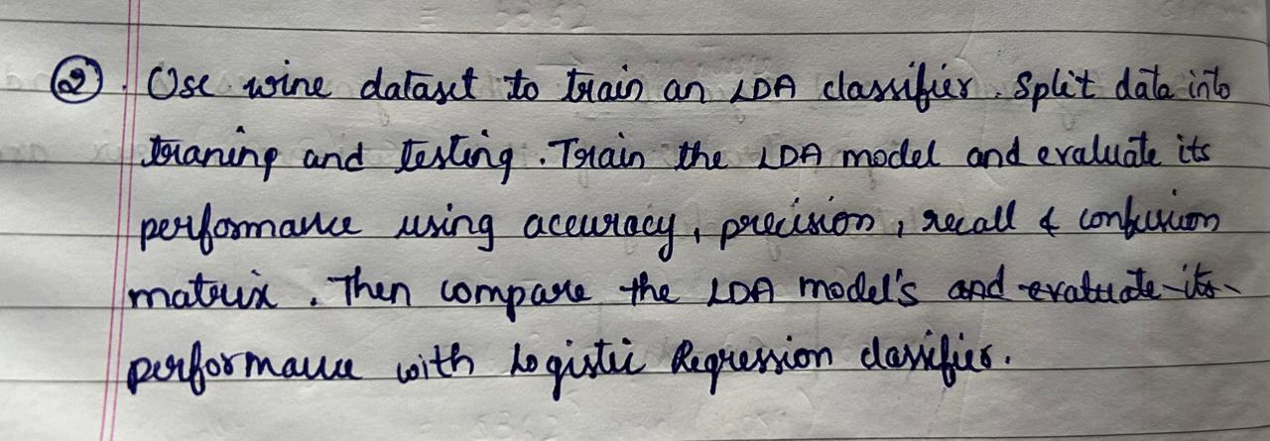

|  |
| --- |
| from sklearn.datasets import load_wine  data = load_wine()  X = data.data  y = data.target  print(f"Feature matrix shape: {X.shape}")  print(f"Target vector shape: {y.shape}")  print(f"Classes: {data.target_names}")  from sklearn.model_selection import train_test_split  X_train, X_test, y_train, y_test = train_test_split(  X, y, test_size=0.3, random_state=42, stratify=y  )  print(f"Training set shape: {X_train.shape}")  print(f"Testing set shape: {X_test.shape}")  from sklearn.preprocessing import StandardScaler  from sklearn.discriminant_analysis import LinearDiscriminantAnalysis as LDA  scaler = StandardScaler()  X_train_scaled = scaler.fit_transform(X_train)  X_test_scaled = scaler.transform(X_test)  lda = LDA()  lda.fit(X_train_scaled, y_train)  y_pred_lda = lda.predict(X_test_scaled)  from sklearn.metrics import accuracy_score, precision_score, recall_score, confusion_matrix, classification_report  accuracy = accuracy_score(y_test, y_pred_lda)  precision = precision_score(y_test, y_pred_lda, average='weighted')  recall = recall_score(y_test, y_pred_lda, average='weighted')  print(f"LDA Accuracy: {accuracy:.2f}")  print(f"LDA Precision: {precision:.2f}")  print(f"LDA Recall: {recall:.2f}")  conf_matrix = confusion_matrix(y_test, y_pred_lda)  print("\nConfusion Matrix:\n", conf_matrix)  print("\nClassification Report:\n", classification_report(y_test, y_pred_lda))  from sklearn.linear_model import LogisticRegression  log_reg = LogisticRegression(max_iter=10000)  log_reg.fit(X_train_scaled, y_train)  y_pred_log_reg = log_reg.predict(X_test_scaled)  accuracy_log = accuracy_score(y_test, y_pred_log_reg)  precision_log = precision_score(y_test, y_pred_log_reg, average='weighted')  recall_log = recall_score(y_test, y_pred_log_reg, average='weighted')  print(f"\nLogistic Regression Accuracy: {accuracy_log:.2f}")  print(f"Logistic Regression Precision: {precision_log:.2f}")  print(f"Logistic Regression Recall: {recall_log:.2f}")  conf_matrix_log = confusion_matrix(y_test, y_pred_log_reg)  print("\nLogistic Regression Confusion Matrix:\n", conf_matrix_log) |

1. **Code Repository:**

GitHub Link: <https://github.com/Ridhi-215/LDA>