**Assignment No: 01**

MULTIPLE LINEAR REGRESSION

**CSE 303: Machine Learning**

Submitted by

Name: Guntur Ridhi Roll No: AP22110011467

Section: CSE M Lab Date: 27/08/2024

Submission Date: 02/09/2024



**Department Computer Science and Engineering School of Engineering and Sciences**

**SRM University–AP**

**Amaravati, Andhra Pradesh – 522 240, India**

1. **Questions**

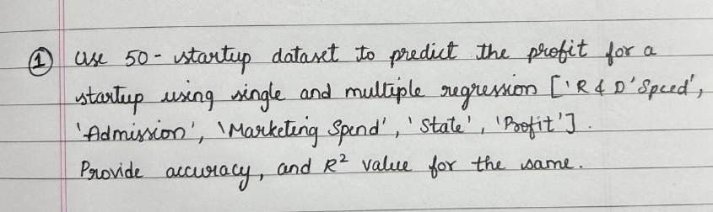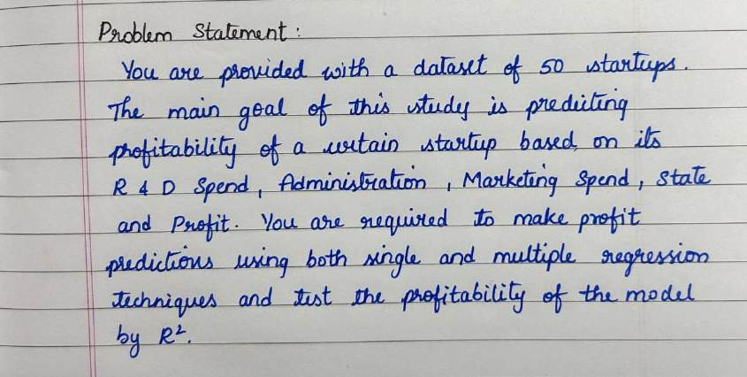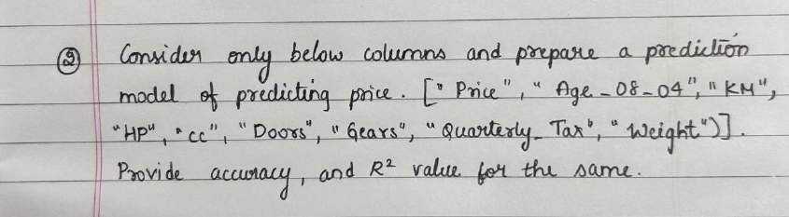

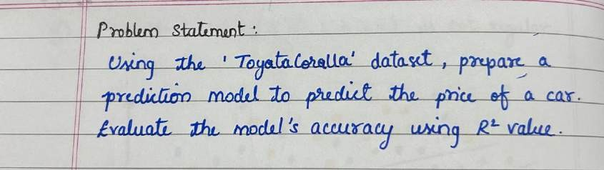

1. **Algorithm Description**

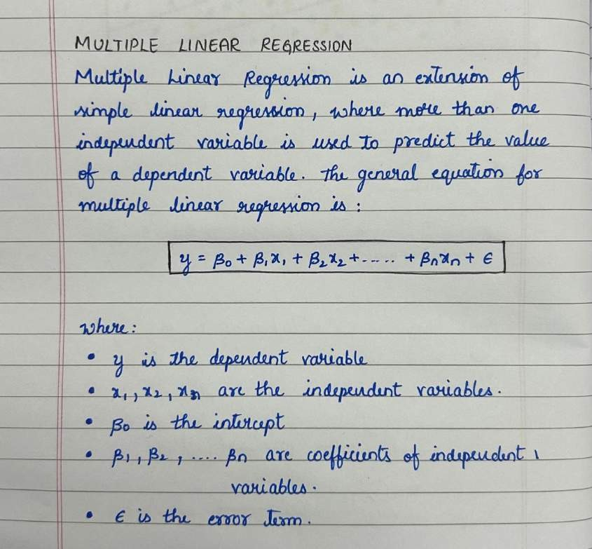

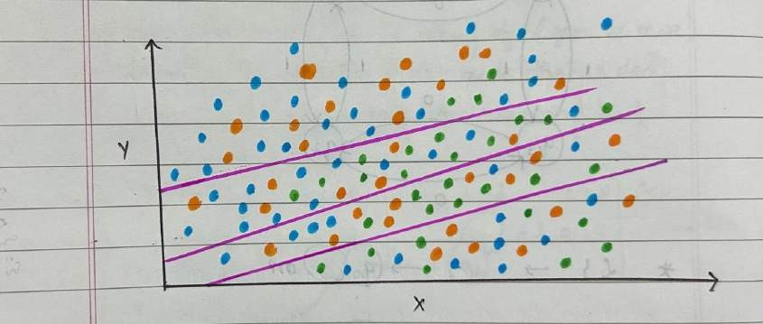

1. **Solution**

Data Set Link: [https://www.kaggle.com/code/cundratjuninhokuth/multiple-linear-regression-](https://www.kaggle.com/code/cundratjuninhokuth/multiple-linear-regression-predict-profit) [predict-profit](https://www.kaggle.com/code/cundratjuninhokuth/multiple-linear-regression-predict-profit)

**Question 1: a) Using Linear Regression**

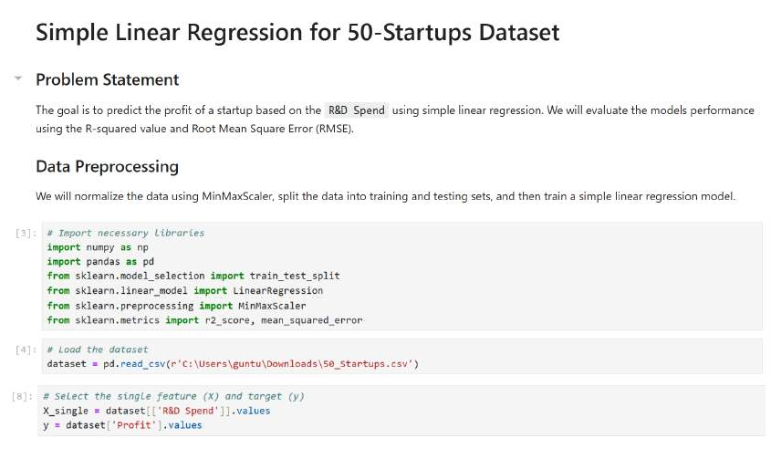

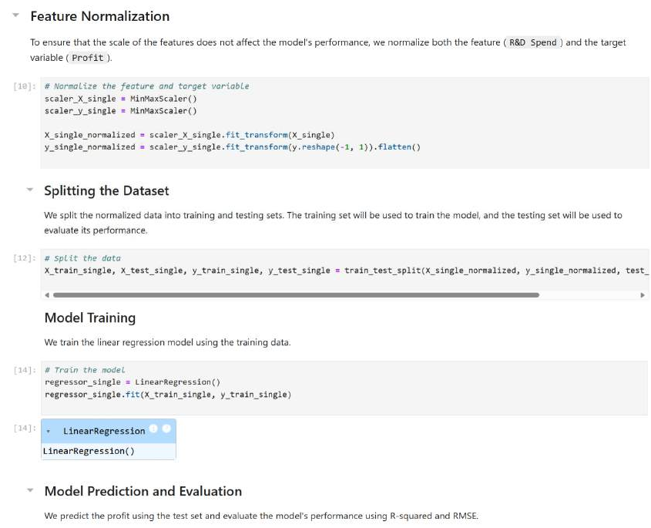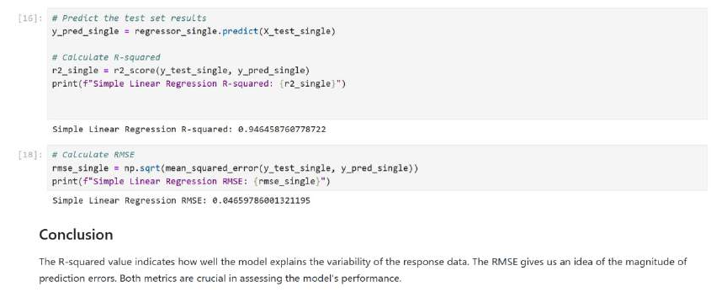

**b) Using Multiple Regression**

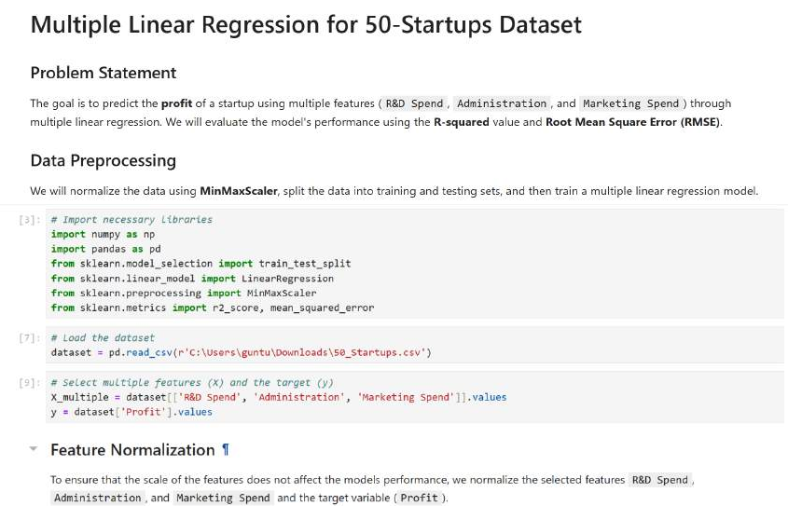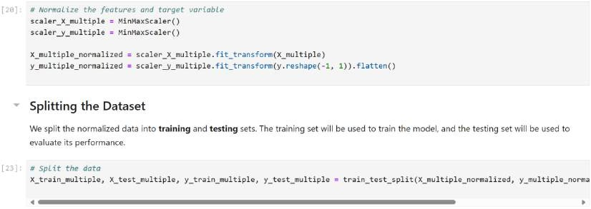

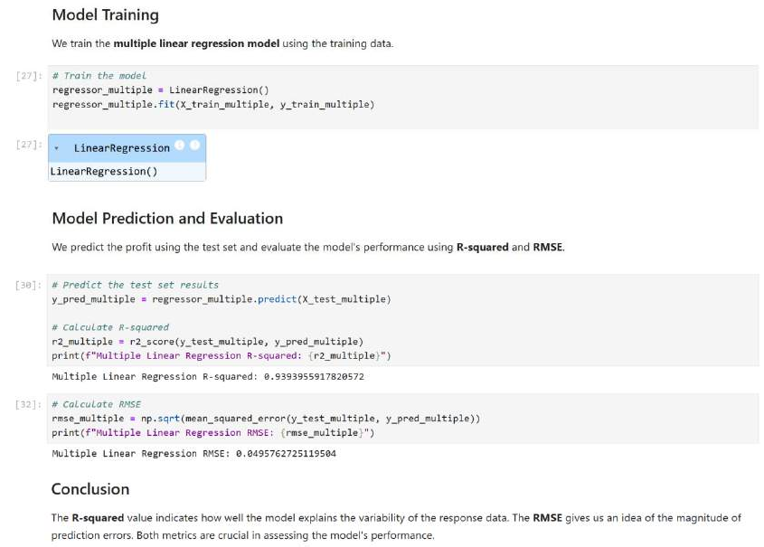

**QUESTION-2:**

