**PRINCIPAL COMPONENT ANALYSIS (PCA)**

**CSE 303: Machine Learning**

Submitted by

Name: Ridhi Guntur

Roll No: AP22110011467

Section: CSE M

Lab Date: 15/10/2024

Submission Date: 21/10/2024

**Department Computer Science and Engineering**

**School of Engineering and Sciences**

**SRM University–AP**

**Amaravati, Andhra Pradesh – 522 240, India**

1. **Algorithm Description**

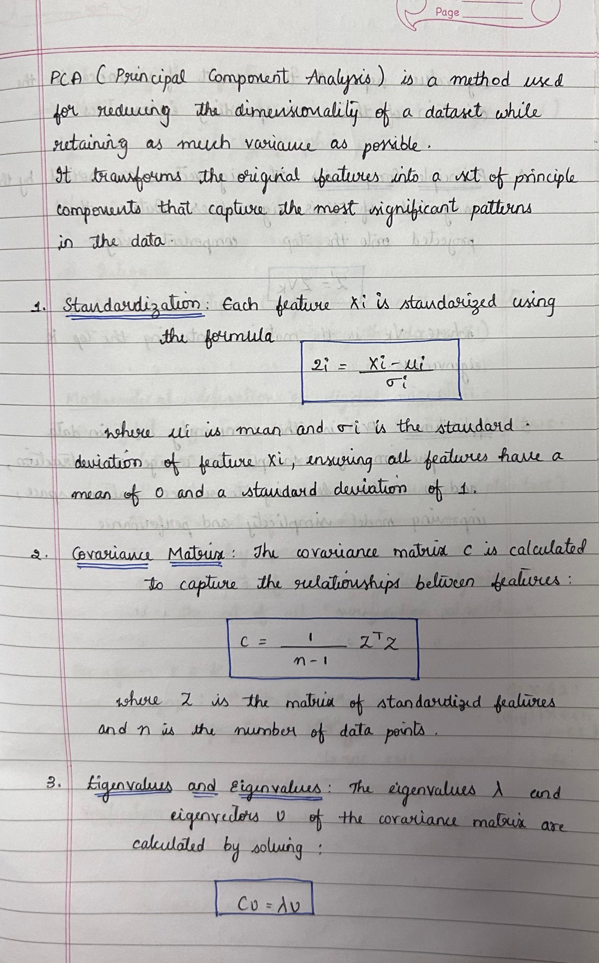

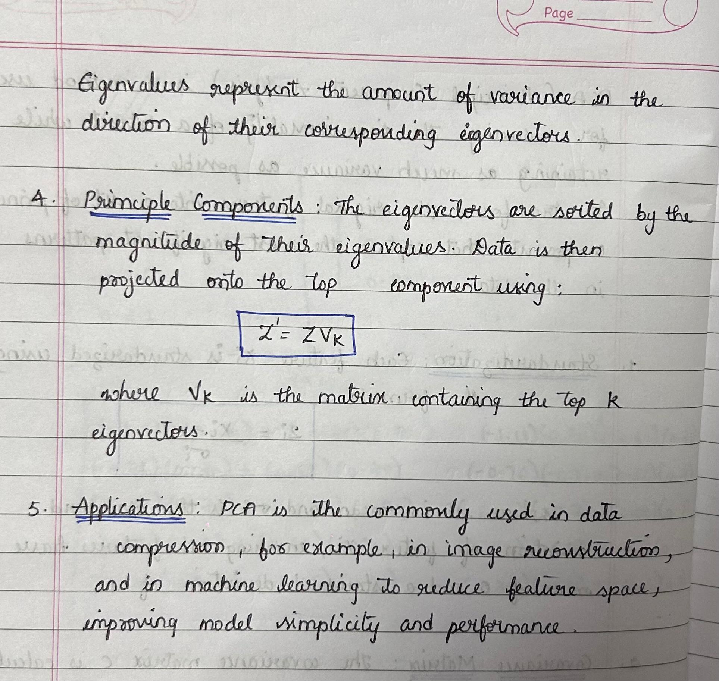

1. **Solution**

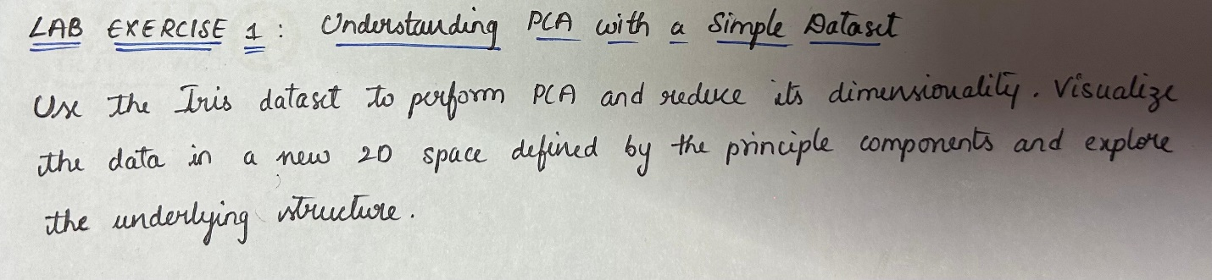

|  |
| --- |
| import pandas as pd  import seaborn as sns  # Load the Iris dataset from seaborn  data = sns.load_dataset('iris')  print(data.head())  # Create boxplots to see the distribution of features by species  import matplotlib.pyplot as plt  fig, axes = plt.subplots(2, 2, figsize=(12, 8))  for ax, feature in zip(axes.flatten(), data.columns[:-1]):  sns.boxplot(x='species', y=feature, data=data, ax=ax)  ax.set_title(f'{feature} by Species')  plt.tight_layout()  plt.show()  from sklearn.preprocessing import StandardScaler  X = data[['sepal_length', 'sepal_width', 'petal_length', 'petal_width']]  scaler = StandardScaler()  X_standardized = scaler.fit_transform(X)  X_standardized_df = pd.DataFrame(X_standardized, columns=X.columns)  print(X_standardized_df.head())  import numpy as np  cov_matrix = np.cov(X_standardized.T)  print(cov_matrix)  eigenvalues, eigenvectors = np.linalg.eig(cov_matrix)  print("Eigenvalues:")  print(eigenvalues)  print("\nEigenvectors:")  print(eigenvectors)  sorted_indices = np.argsort(eigenvalues)[::-1]  sorted_eigenvalues = eigenvalues[sorted_indices]  sorted_eigenvectors = eigenvectors[:, sorted_indices]  print("Sorted Eigenvalues:")  print(sorted_eigenvalues)  print("\nSorted Eigenvectors:")  print(sorted_eigenvectors)  top_2_eigenvectors = sorted_eigenvectors[:, :2]  X_pca = np.dot(X_standardized, top_2_eigenvectors)  X_pca_df = pd.DataFrame(X_pca, columns=['PC1', 'PC2'])  print(X_pca_df.head())  import matplotlib.pyplot as plt  X_pca_df['species'] = data['species']  plt.figure(figsize=(8, 6))  sns.scatterplot(x='PC1', y='PC2', hue='species', data=X_pca_df, palette='Set1', s=100)  plt.title("Iris Dataset Projected onto the First Two Principal Components", fontsize=14)  plt.xlabel("Principal Component 1", fontsize=12)  plt.ylabel("Principal Component 2", fontsize=12)  plt.show() |

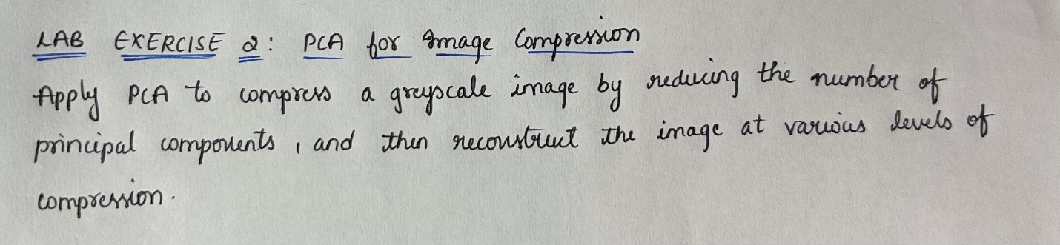

|  |
| --- |
| import numpy as np  import matplotlib.pyplot as plt  from skimage import color, io  image = io.imread(r"C:\Users\guntu\Downloads\image-1.jpeg", as_gray=True) # Provide the correct path to your image  image_resized = np.array(image)  plt.figure(figsize=(6, 6))  plt.imshow(image_resized, cmap='gray')  plt.title('Original Image')  plt.axis('off')  plt.show()  print(f"Original image shape: {image.shape}")  X = image_resized.reshape(-1, image_resized.shape[1])  print("Shape of reshaped image: ", X.shape)  from sklearn.decomposition import PCA  def apply_pca_and_reconstruct(X, num_components):  pca = PCA(n_components=num_components)  X_pca = pca.fit_transform(X) # Applying PCA  X_reconstructed = pca.inverse_transform(X_pca) # Reconstructing the image from the PCA components  return X_reconstructed  X_reconstructed_50 = apply_pca_and_reconstruct(X, 50)  image_reconstructed_50 = X_reconstructed_50.reshape(image_resized.shape)  components_list = [5, 20, 50, 100]  reconstructed_images = []  for n in components_list:  X_reconstructed = apply_pca_and_reconstruct(X, n)  reconstructed_images.append(X_reconstructed.reshape(image_resized.shape))  plt.figure(figsize=(10, 10))  plt.subplot(3, 2, 1)  plt.imshow(image_resized, cmap='gray')  plt.title('Original Image')  plt.axis('off')  for i, n in enumerate(components_list):  plt.subplot(3, 2, i+2)  plt.imshow(reconstructed_images[i], cmap='gray')  plt.title(f'Reconstructed with {n} components')  plt.axis('off')  plt.tight_layout()  plt.show() |

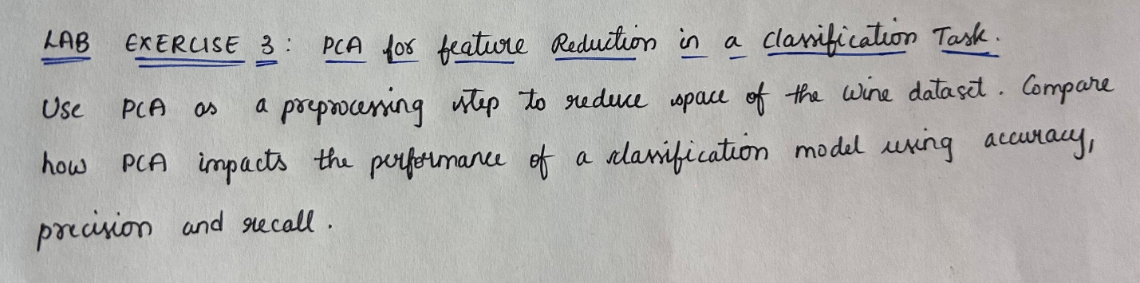

|  |
| --- |
| # Import necessary libraries  import numpy as np  import matplotlib.pyplot as plt  from sklearn.datasets import load_wine  from sklearn.model_selection import train_test_split  from sklearn.preprocessing import StandardScaler  from sklearn.linear_model import LogisticRegression  from sklearn.svm import SVC  from sklearn.metrics import accuracy_score, precision_score, recall_score  from sklearn.decomposition import PCA  wine = load_wine()  X = wine.data # Features  y = wine.target # Labels  print("Feature shape:", X.shape)  X_train, X_test, y_train, y_test = train_test_split(X, y, test_size=0.3, random_state=42, stratify=y)  scaler = StandardScaler()  X_train = scaler.fit_transform(X_train)  X_test = scaler.transform(X_test)  log_reg = LogisticRegression(max_iter=10000)  log_reg.fit(X_train, y_train)  y_pred = log_reg.predict(X_test)  accuracy = accuracy_score(y_test, y_pred)  precision = precision_score(y_test, y_pred, average='macro')  recall = recall_score(y_test, y_pred, average='macro')  print("Baseline Model (No PCA) - Logistic Regression")  print(f"Accuracy: {accuracy:.4f}")  print(f"Precision: {precision:.4f}")  print(f"Recall: {recall:.4f}")  components_list = [2, 5, 10]  X_train_pca_list = [] # Reduced training data for each PCA run  pca_models = []  for n in components_list:  pca = PCA(n_components=n)  X_train_pca = pca.fit_transform(X_train) # Fit PCA and transform the training data  X_train_pca_list.append(X_train_pca) # Store the reduced training data  pca_models.append(pca) # Store the PCA model for later use on test data  print(f"Training data transformed with {n} components. Shape: {X_train_pca.shape}")  X_test_pca_list = []  for i, pca in enumerate(pca_models):  X_test_pca = pca.transform(X_test) # Transform the test data using the same PCA model  X_test_pca_list.append(X_test_pca) # Store the reduced test data  print(f"Test data transformed with {components_list[i]} components. Shape: {X_test_pca.shape}")  results = []  for i, n in enumerate(components_list):  log_reg_pca = LogisticRegression(max_iter=10000)  log_reg_pca.fit(X_train_pca_list[i], y_train)  # Evaluate performance  y_pred_pca = log_reg_pca.predict(X_test_pca_list[i])  accuracy_pca = accuracy_score(y_test, y_pred_pca)  precision_pca = precision_score(y_test, y_pred_pca, average='macro')  recall_pca = recall_score(y_test, y_pred_pca, average='macro')    results.append({  'components': n,  'accuracy': accuracy_pca,  'precision': precision_pca,  'recall': recall_pca  })  print(f"\nModel with {n} PCA components:")  print(f"Accuracy: {accuracy_pca:.4f}")  print(f"Precision: {precision_pca:.4f}")  print(f"Recall: {recall_pca:.4f}")  components = [result['components'] for result in results]  accuracies = [result['accuracy'] for result in results]  plt.figure(figsize=(8, 6))  plt.plot(components, accuracies, marker='o', linestyle='-', color='b')  plt.title('Accuracy vs Number of PCA Components')  plt.xlabel('Number of PCA Components')  plt.ylabel('Accuracy')  plt.grid(True)  plt.show() |

1. **Code Repository:**

GitHub Link: