### What is ServiceNow?

ServiceNow Platform is a cloud-based platform providing digital workflow automation to manage the organization's various business processes and IT operations.

ServiceNow actual business primarily deals with managing "incident, problem, and change" IT operational events.

ServiceNow provides a wide range of applications that cover.IT service management (ITSM), IT operations management (ITOM), IT business management (ITBM), and many other business functions such as HR, security, and customer service.

Services provided by ServiceNow

IT Service Management (ITSM):

● Incident Management-Tracks, manages and resolves IT incidents

● Problem Management-Finds the cause of incidents and prevents repeat incidents

● Change Management-Manages changes in the IT environment

● Request Fulfilment-Manages services requests coming from employees or customers

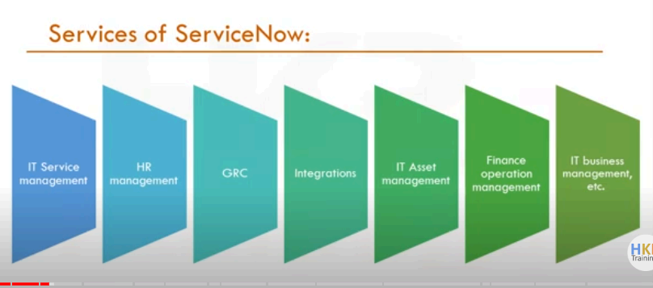

IT Operations Management (ITOM)

● Event Management-Infrastructure and services monitoring related to health and availability

● Discovery-Asset discovery automatically, mapped the IT infrastructure.

● Orchestration: Automate repetitive tasks like password resets or restarts on servers.

IT Asset Management (ITAM):

Hardware Asset Management: Track the lifecycle of hardware assets.

Software Asset Management: Manage software license and compliance.

IT Business Management (ITBM):

Project Portfolio Management (PPM): IT project portfolios, resources, and cost management.

Financial Management: Align IT costs with business priorities.

Security Operations (SecOps):

Security Incident Response: Manage and respond to security incidents.

Vulnerability Management: Identify and prioritize vulnerabilities.

Customer Service Management (CSM):

Manage customer requests, automate case management, and improve the customer experience.

Human Resources Service Delivery (HRSD):

Streamline worker services like onboarding and benefits requests with employee-self-service portals.

Governance, Risk, and Compliance (GRC):

Automate workflows for risk and compliance, and governance should be visible across all parts of the organization.

ServiceNow Instance

PDI in ServiceNow is known as Personal Developer Instance. It is a free personal instance of the servicenow platform that is given to developers for practice, experimenting, and developing

applications.

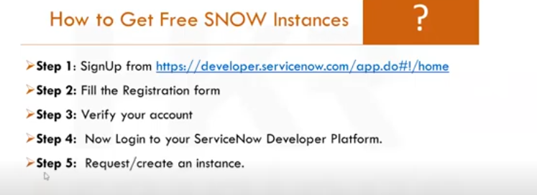

We can choose which version of servicenow we want, from among the available

● If the instance is idle for 10 days, then the instance is released

● If the instance is idle for more than 24 hours, then instance might go into hibernation state

Career and growth in Servicenow

A career in ServiceNow is extremely challenging with a broad scope since the platform is increasingly being implemented by organizations in IT service management, business automation, and enterprise workflow optimization.

The following are essentials of career development and growth in the ServiceNow environment-

1. Job Roles in ServiceNow

ServiceNow Developer-

● Develop applications customized and configure and implement solutions on the ServiceNow platform

● Requires expertise in JavaScript, UI design, workflows, integrations, and scripting.

ServiceNow Administrator-

● Manage ServiceNow instance setup and ongoing maintenance from configurations, user, to security.

● Manage Upgrades, patches, and troubleshoots

ServiceNow Architect

● Design large-scale implementations of ServiceNow, which includes the system architecture and integration strategy.

● Leads teams for best-practices and optimized systems.

ServiceNow Consultant

● Advisory services on implementing ServiceNow solutions, optimizing workflows, and integrating with other systems.

ServiceNow Business Analyst

● Collects requirements, defines business process, and aligns with ServiceNow features and functionalities.

ServiceNow Project Manager:

Lead ServiceNow implementation projects and manage timelines and resources to ensure project goals are met.

2. Certifications:

Growth in ServiceNow is mainly through certifications. Such valuable ones that really add up are:

Certified System Administrator (CSA): The entry-level certification for administering the platform.

Certified Application Developer (CAD): For any custom application

Certified Implementation Specialist (CIS): Specialized in ITSM, ITOM, HR, and SecOps

Certified Technical Architect (CTA): Advanced Level certification for designing complex implementations.

Job Market Demand

ServiceNow professionals are highly in demand and on the rise. The organizations of the sector-IT, finance, healthcare, and government sectors adopt ServiceNow as it is adaptable to manage all their IT services and operations. This enhances the job prospect for a skilled professional to work with the implementation, customization, and maintenance of the platform.

A career in ServiceNow has rich growth opportunities riding on the tide of increased adoption of the platform across sectors. Professionals possessing technical skills, business process knowledge, and ServiceNow certifications can opt for a career path that features both vertical growth wherein individuals are offered opportunities to transition into senior and leadership positions and horizontal growth.

ServiceNow User Interface Overview

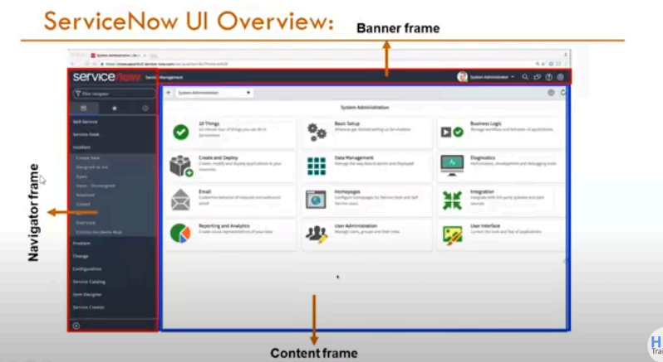

Banner Frame Contains:

Company Logo, Navigation Menu, Global Search Bar, Discussions sidebar(chat tool) ,

Show Help, Notifications and User Menu

Things to Keep in Mind when using User Menu

1. Profile - Show the profile of the logged-in user

2. Impersonate User - To log in and act like another user

3. Elevate Roles - Only available for base admin to elevate his role to security_admin

Global Search : Search the entire instance for records matching keywords.

Assistance: Context-sensitive help available; a badge on the icon will indicate a help text is provided, providing access to User Guide and documentation Search tool

Content Frame:

The Content Frame is the central body of the ServiceNow user interface that visually represents what is inside the application or module being selected. Here the user works with forms, lists, dashboards,reports, and other information.

ServiceNow Modules

Modules are the building blocks that comprise the Servicenow application navigator. Module:

Is an abstraction of a particular application menu function or action such as to view a list of, create new, or report on

All- system definition-application menus-module

Application Menu-

Application Menu is a navigational object that collates and catalogues groups of related modules.

(font functionalities) under the canopy of the platform, enabling the user to discover and access tools and features more quickly and easily that is necessary to do certain things

Application Menu: Group modules in a meaningful way with common headings thereby creating structured intuitive user interface

Module: A specific function or task within an application menu. For example, viewing a list of records, making a new record, or displaying a report.

Visualizing the Relationship-

Application Menu: Think of it like a folder on your computer

Modules: What's inside the folder? Each file inside represents a specific function

List: If you open a file/module that just shows information, for example an Excel spreadsheet, what you're looking at (the rows and columns) is like a list in ServiceNow

Example Exercise-

Application Menu: "Incident"

Module: "Open"

○ When you click on this module, you get a listing of all open incidents .

Module: "Assigned to Me "

○ When you click here, you will get a list of incidents assigned to you.

Incident Module

The Incident module in ServiceNow is applied in the management of unplanned interruptions to restore as quickly as possible normal service operations. It manages incidents from logging and

categorization through prioritization and assignment to the right support teams.

The aim is to minimize business operations disruptions through the tracking of incidents until resolution and closure to ensure SLAs are met.

Incident management focuses on quick resolution so that organizations can continue smooth operations even with any disruption.

Application Navigator > Incidents > All Incidents or My Incidents.

Incident Lifecycle:

Logging: Information regarding the incident are logged.

Categorization: Incident are categorized (Hardware or Software).

Prioritization: Depending on Urgency and Impact.

Task: Escalated to the relevant support team.

Solution and Resolution: Incident is resolved, and the incident is closed.

Problem Management

The Problem module solves the causes of the repeated incidents. By performing root cause analysis (RCA), it aims to identify and eliminate the root causes of issues, which should not make the incidents occur again.

In this section, problems can be discovered either reactively by incident patterns or proactively by

Trend Analysis. Once known workarounds may be applied as remedial measure of a long-term resolution.

The module ensures that recurring problems are managed in a structured way to improve the overall IT environment

Application Navigator > Problems > All Problems or Open Problems .

Change Lifecycle:

1. Request : A change is requested

2. Assessment and Approval: The change is assessed and approved

3. Implementation: Change is implemented according to the plan.

4. Review and Closure: After the change, review and close the request.

Change Management

The Change module assists in the automation of controlled changes towards IT infrastructure, services, or processes. In this module, the change is planned and assessed, then in turn, implemented to ensure it affects business operations minimally.

This approval workflow handles different kinds of changes as standard, normal, and emergency, which identifies the kind of risk and impact of the said change within this module. Standard changes are pre-approved and low-risk, whereas standard changes are scheduled and authorized.

Emergency changes are accelerated to resolve serious issues. Once implemented, changes

are assessed after implementation to ensure they are successful and not introducing new issues.

Application Navigator > Changes > My Changes or All Changes

Change Life Cycle:

1. Request: A change is requested.

2. Evaluation and Approval: The change is assessed and approved.

3. Implementation: The change is implemented based on the change request.

4. Review and Closure: After changes, review and close request.

Lists and Filters in ServiceNow

Lists in serviceNow are another kind of interface. In Lists records from a table can be viewed in a grid or tabular format. The lists allow multiple records to be viewed, filtered, sorted, and interacted with.

Table_name.list: Displays the list view of a table. Table_name.LIST: opens list in new tab

List Header Contains Many Useful Things:

1. List Controls

2. List Filters

3. Search bar on top of the table

4. Customize Icon

List Controls

In ServiceNow, lists have several context menus that allow users to easily perform action that can be done on list items (records) or the list as a whole.

On lists three types can be found-

1. List Control menu - Contain Views, Filters, GroupBy, Refresh List, Create Favorite

2. Column option men - Has Configure, import, Reporting, Sorting

3. List field menu - used to copy sys_id

Views

Views Users can easily display the same list or form differently. System Administrators are allowed to create views for lists as well as for forms. You can create a view by choosing Control options menu - configure - List Layout - select the fields by using the list Collector - Scroll Down to select view - new - Enter the name of the view then save You can see the view you have created from List Control Menu - views Filters in List

A filter is a set of conditions applied to a list of records in a table.

Three elements make up a filter condition:

1. Field: A picklist based on the table and user authorizations. The picklist includes fields on related tables by dot-walking.

2. Operator: A picklist based on the field type.

3. Value: A text entry field or a choice list, depending on the field type.

Wildcard conditions Used in column search row-

*value contains

!*value does not contain

=value equals

!value does not equal

Value % starts with

% value ends with

Add filters to your Favorites by clicking the List Controls icon and selecting Create Favorite

In the classic list, select Run to see the results of your filter displayed in the list.

To save a filter, click Save. A new field will appear where you can name your filter. Once

you have named the filter, select who it will be visible to, then click the Save button to the right of the

name and visible to options.

The new filter will then be available by selecting Filters from the list context menu.

Breadcrumbs

Conditions that apply filters to the list are summarized in the breadcrumbs, displayed with blue letters

across the top of the list. In addition to an "at-a-glance" view of the conditions affecting the filter, you can change conditions as needed.

For instance, you can click on the greater than sign preceding a condition to delete that condition,

or click on a breadcrumb to delete all of the conditions that follow.

List Personalization

● List Personalize Changes the appearance of a list for one user. The platform default is not affected.

● Personalization should be used for one-time events. Global changes will not be included in a personalized list

ServiceNow Workflows

A workflow is the set of activities or tasks that automate a business process. Workflows help streamline processes, enforce business rules, and reduce manual intervention.

4 Primary Workflows of ServiceNow

IT Workflow

Aims at the automation of IT service management processes. Includes Incident, Change, and Request Management.

Example: In this context, resolving an IT incident or processing a change request .

Employee Workflow

Streamlines internal processes to enhance employee experience. It includes HR Service Delivery, Employee Center, and Employee Onboarding.

Example: Automate onboarding of new employees or processing HR requests.

Customer Workflow

Enhances customer service and support functions. The module includes Case Management, Field Service Management, and Customer Service Management.

Example: Managing a customer inquiry or scheduling a field service appointment.

Creator Workflow

Used to customize building of apps to meet specific needs of a business. The module includes App Engine and Integration Hub.

Example: Building a custom app to automate an activity involved in the business process.

Workflow and Process Automation according to the principles of ITIL:

● ITIL Compliance: ServiceNow adheres to the best practices of IT service management according to ITIL.

● Automation Benefits: Automates several IT, security, HR, and customer services workflows

● Efficiency: It ensures efficiency in a process, reduces the levels of hand effort, enhances service delivery, and ensures all processes are standardized.

Areas of Service Delivery

IT: It manages incidents, changes, problems, and requests that concern the IT services

Security: It manages security incidents and handles vulnerability management

HR Service Delivery: It automates onboarding, case management, and employees' questions.

Customer Service: Manage customer incidents and engage with other departments for a

seamless customer experience.

Business Applications: Develop custom applications on the ServiceNow platform for

automation of business workflows and processes.

Industries: IT, Healthcare, Finance, Government, and Retail.

Global Customers: Fortune 500 companies across the globe adopt ServiceNow to manage and

automate IT and business processes.

Notable Customers: Coca-Cola, Deloitte, Accenture, and Unilever.

ServiceNow Architecture

The ServiceNow Platform is an Application Platform as-a-Service. This means the platform

lives in the cloud. Businesses are no longer required to purchase and maintain the hardware that would be required to support these applications.

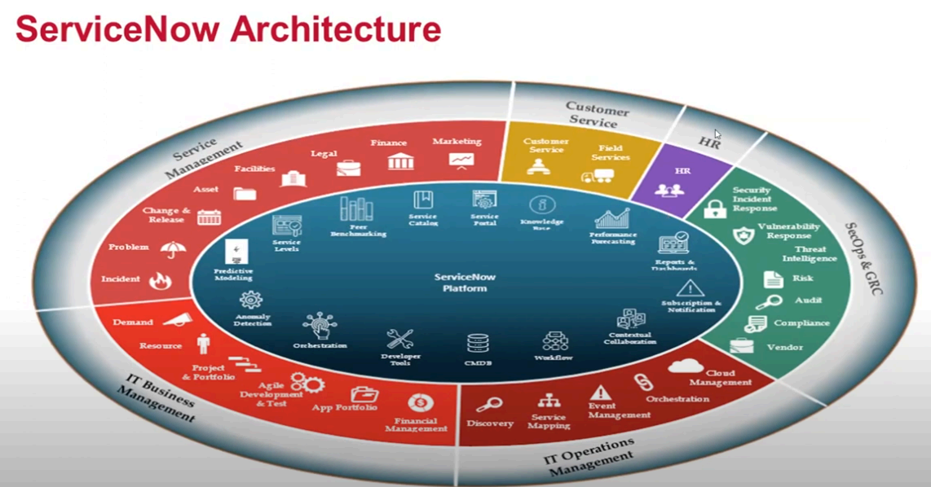

● ServiceNow uses a sophisticated, multi-instance, single-tenant architecture as its

base product for customers, thereby meaning an instance has a uniquely isolated

database that holds data, applications, and customizations.

● ServiceNow delivers services to its end-users from a flexibly configurable web-based

user interface, constructed atop a flexible database schema.

● The Platform and applications that operate on it utilize a system of record to

integrate the business functions of an organization.

● The Platform interfaced with other enterprise systems, and supports plug-and-play for a large

variety of applications.

DashBoards in Servicenow

A dashboard is a customized arrangement of widgets and enables you to display multiple

performance analytics and also reporting on a single screen.

Go to the Self Service > Dashboards to see all of your available dashboards in the instance.

Dashboards allow us to put multiple Performance Analytics, reporting, and more widgets

all on one page. Use dashboards for telling a data-based story that you can share. Dashboards

can be either responsive or non-responsive. Responsive dashboard functionality is on by default.

Non-responsive dashboards have some restrictions on who can create, view, and edit them.

Benefits-

● Show Performance Analytics and Reporting visualizations directly within both Workspaces and classic dashboards

● Create and edit Performance Analytics reports and other widgets directly from the dashboard

● Use the Add Widgets pane to quickly discover and preview the widgets, adding them to the dashboard

● Share dashboards easily through the integrated sharing pane

● Use quick layouts to snap widgets into a known layout, and then send to what you want

● Make dashboards your home page so you can easily access information that you use

Frequently.

To see dashboards in the ServiceNow Platform, navigate to All > Self-Service > Dashboards.

Service Catalog in ServiceNow

The Service Catalog application of the Platform enables users to view, request and shop around

for services and products.

● Surf around the interface of Service Catalog

● Capturing and restocking carts of catalog items

● Lists for Requests, Requested Items, and Tasks

The Service Catalog in your instance allows us to request IT Services, report issues, order office

supplies, request accessories for hardware, request hardware and software for your work area,

and request mobile devices to help you get work done.

As we step through below, the categories organize catalog items into logical groups:.

Once we have ordered a catalog item (requests, requested items, and/or tasks), we can find the status of the item by opening All > Service Catalog > Open Records select Requests, Items, or Tasks.