#### Scripting in Servicenow

ServiceNow essentially involves scripting as code writing and utilization to modify and automate the automation of procedures, tasks, and business logic found within the service. It extends ServiceNow applications functionality and behavior beyond what is delivered with out-of-the-box capabilities.

The two main types of scripts ServiceNow mainly uses:

•Client-side scripting: It will run on the user's browser. It is used to control how forms, fields, and user interfaces behave. Common client-side scripts are:

•Server-side scripting: The code is executed at the server and is utilized to govern data operations and business rules.Popular server-side scripts include :These scripts rely on JavaScript as the programming language and make it possible for developers to alter data, automate a variety of processes, validate data, build integrations, and more.

###### Client-side vs. Server-side

Scripts in ServiceNow run either on the client (user's browser) or within the ServiceNow back end. It is

Important to know where a script will execute because the APIs differ in client and server-side scripts.

Client-side-

-Manage forms and form fields

-UI Policies

-Client Scripts

Server-side-

-Manage database and back-end:

-Business Rules

-Scheduled Jobs

-Script Actions

-Script include

The script types listed above are examples. This is not an exhaustive list of script types in ServiceNow.

Client Scripts-

-Onload()

-Onsubmit()

-Onload()

-Onchange()

GlideForm

• g_form.showFieldMsg() - prints a message on a blue background below the field

passed in the method call.

• g_form.addInfoMessage() - prints a message on a blue background to the top of the current form.

g_form.addErrorMessage() - prints a message on a red background to the top of the

current form.

•alert is a JavaScript method that opens a dialog with an OK button.

•confirm is a JavaScript method that opens a dialog with OK and Cancel buttons.

• g_form.setMandatory()

• g_form.SetReadOnly()

• g_form.setdisplay()

• g_form.set_value( ' feild_name\", 'value') - sets the value of the field

• g_form.get_value( 'feild_name) - returns the value in the field

GlideUser

•g_user.lastname

•g_user.firstname

• g_user.userId

• g_user.username

• g_user.getfullname

• g_user.hasrole('role_name')

• g_user.hasroleexactly('role_name')

• g_user.hasroleFromList('role_name')

• g_user.hasroles()

Scripting assistance-Press ctrl-spacebar

UI policy

Client-side logic governing form and field behavior. UI Policies dynamically change the Behaviour of information on a form and controlling custom process flows for tasks. You can use UI policies to make a number field on a form.

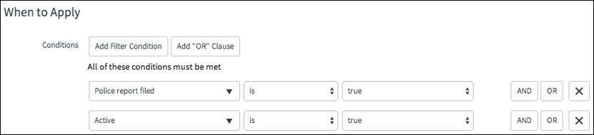

•read-only

•field mandatory

•hide other fields.

UI Policy Scripts -

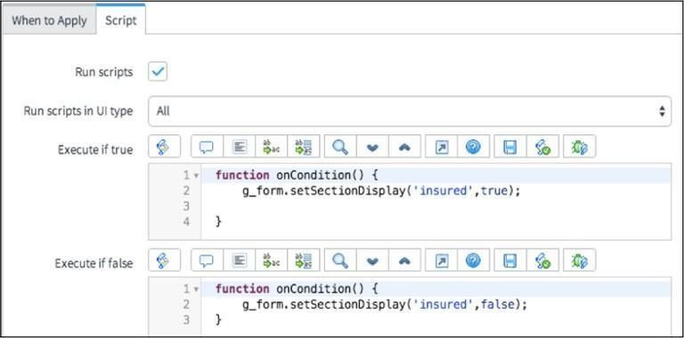

Server-side scripts

•GlideForm and GlideUser, GlideAjax classes are part of the client-side API.

•GlideRecord and GlideSystem are part of server side API.

Data Policy

A Data Policy is a rule that makes fields mandatory and/or read-only for enforcing data consistency.

Data Policy controls are similar to UI Policies except that UI Policies will only be enforced at time of entry on data entered into a form (passed through the UI).

Data Policies apply to all data entered into the system: form (UI), Import Sets, or Web Services.

Business Rule

A Business Rule in ServiceNow is a server-side script that runs when a record is inserted, updated, deleted, displayed, or queried from a database table. Script Include A Script Include in ServiceNow is a reusable server-side JavaScript class or function that can be called from other server-side scripts like

Business Rules, Workflow scripts, or even from the client-side via GlideAjax.

Types of Script Include:

•Classless Script Include (Function-Based Script Include)

•Class-Based Script Include (Object-Oriented Script Include):

•Extend existing class

UI Actions

User Interface (UI) Actions adds buttons, links, and context menu items to forms and lists which makes the UI more interactive, customizable, and event-orientated toward specific user activities.

The New button on the existing list of All Incidents is one type of UI Action.

Script Actions

Script Actions in ServiceNow are server-side scripts, which execute based on specific system events. They are commonly used with event-driven architecture where the script executes some action based on specific events that occur within the system.

Key Properties of Script Actions:

•Event-driven

•Server-side

•Attached to Events

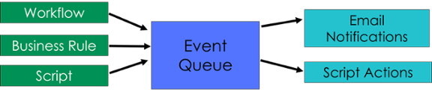

Methods for Script Actions:

•gs.eventQueue()

•gs.addErrorMessage()

•Current

•event