### ServiceNow Platform Overview

The ServiceNow Platform is an Application Platform-as-a-Service. That is, the platform

lives in the cloud. Companies are no longer required to purchase and maintain the hardware needed to host these applications.

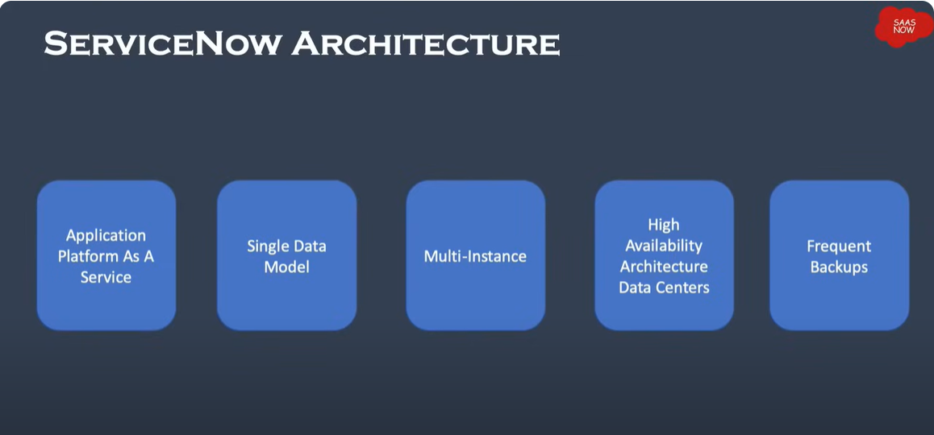

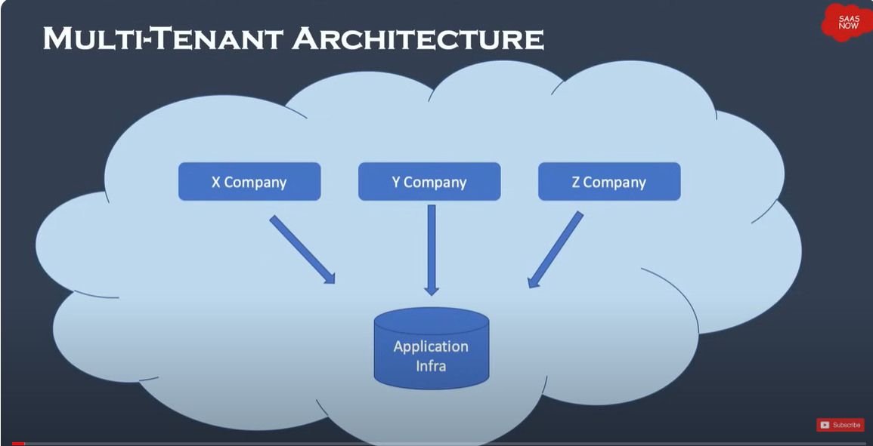

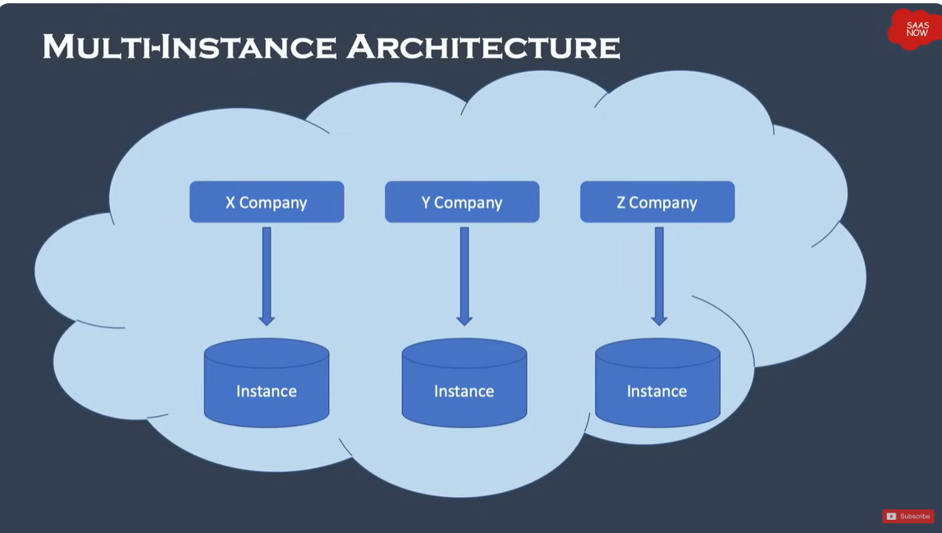

● ServiceNow employs an innovative, multi-instance, single tenant architecture as the

standard delivery for customers, that is, an instance hosts a personally isolated

database housing data, applications, and customizations.

● ServiceNow delivers its services from a customizable web based user interface,

built on top of a flexible database schema.

● The Platform and the applications that run on it use a single system of record to

consolidate an organization's business processes.

● The Platform integrates with other enterprise systems and supports a wide variety of

plug-and-play applications.

● ServiceNow Provides a platform upon which you can build custom applications.

● All ServiceNow Data Centers are paired with another datacenter to provide redundancy.

Redundancy is engineered into each Layer including devices and network resources.

● Backups & Security - Servicenow offers 4 weekly full data backups and 6 days of

daily differential backups. The whole platform is secured by third party security

Organization.

###### Authentication in ServiceNow

When a user logs in to an instance, Servicenow verifies his identity and allows access to

applications and modules according to his roles and

groups.

It uses-

1. local database authentication

2. External single sign-on(SS0)

3. Multi factor authentication

4. Digest Token

5. OAuth 2.0

Types of Instances

There are mainly two types of instances-

Production

NoN Production - it has development, testing, quality assurance

In ServiceNow, a PDI stands for Personal Developer Instance. It is a free, individual instance

of the ServiceNow platform provided to developers for learning, experimentation, and building

applications.

A load-balanced instance is located (hosted) in one of the ServiceNow Data Centers

across the globe, or for an extremely, extremely few of our customers, a deployment can

be done on location at the customer site.

Each ServiceNow instance has a unique URL that follows the pattern of

https://<instance name>.service-now.com

User, Group, Role in ServiceNow

User in servicenow-

In ServiceNow, "User" applies to a person accessing the application. Users can

be staff members, customers, partners, or any other stakeholder that needs access to ServiceNow

functionalities.

They are stored in sys_user table

Role in servicenow-

A "Role" in ServiceNow defines a set of permissions and access rights that determine what a

user can do within the platform. Roles are assigned to users based on their responsibilities and

job functions. They are stores in sys_user_role table.

ServiceNow provides several built-in roles (e.g., ITIL user, ITIL admin, etc.), and administrators

can also create their own custom roles tailored to their organizations, if that is what they desire. Roles control access to applications, modules, records, and other system features.

Groups in Servicenow-

" Groups" in ServiceNow are a collection of users having similar attributes or coming from the same business unit. Groups simplify user management by giving the administrators the convenience of applying roles, permissions, and other configurations to a group of users all at once. Groups can be used for role assignments, access controls, notifications, and collaboration activities. They are

stored in sys_user_group table.

ServiceNow User Interface Overview

There are three sections:

1. Banner Frame

2. Application Navigator

3. Content Frame

Content Frame:

The Content Frame is the principal area in the ServiceNow interface where the content associated with the chosen application or module is shown. This is where users interact using forms, lists,

dashboards, reports, and other data.

Banner Frame Includes:

Company Logo, Navigation Menu, Global Search Bar, Discussions sidebar(chat tool) ,

Show Help, Notifications and User Menu Important Things in User Menu-

1. Profile - shows the profile of currently logged-in user

2. Impersonate User - used during login to assume another identity

3. Elevate Roles - Only the base admin is permitted to elevate his role to security_admin

System Settings- you can reach and customize some settings for your experience as a user in ServiceNow such as themes, Display options, Time zone.

Global Search : Search the entire instance for records matching keywords.

Help : Displays contextual help as available; a badge on the icon indicates embedded

help is available, provides access to User Guide and documentation Search tool

Discussions Sidebar (Connect Chat) - Chat tool for real-time messaging.

Application Navigator:The Application Navigator in ServiceNow is a component placed at the left side of the interface which provides users with the ability to access various modules and functionalities of the tool.

Applications are groups of files and data, these are the service offering blocks like IT HR resource management Service Desk etc .

Modules are functionalities or operations of an application in modules.We can Pin applications and modules to favorites, making their easy for us to access.

We can use the Favorites to mark the application we frequently use and have quick access to it. Moreover, we have an option of History in which we can check our recent actions. Default is last 30 items we have accessed.

###### ServiceNow Branding

Customization like changing logo, company name can be done using the system properties

ALL - System Properties - System Configuration - Set timezone,date, color

ALL - System Properties - My Company - UI Banner - logo - Banner Text

All the properties are a table in servicenow so these properties come under sys_properties

Table

To locate all the system properties

All -> sys_properties.list

glide.polaris.next experience - it is used for enabling or disabling next experience unified navigation

in platform.

###### Tables and columns in ServiceNow

Sys_db_object - table used for the purpose of storing all the information pertaining to all the tables in servicenow

Sys_dictionary - table used for storing all the information related to fields of all the tables in servicenow

Sys_documentation - tables used for storing all the field labels of servicenow.

The System Dictionary is one of the core components ServiceNow uses to define and manage database table structure and their fields. The System Dictionary is a central information repository related to the database schema, including definitions for tables, fields, data types, and table relationships.

The System Dictionary contains one definition for each field across all tables within the ServiceNow instance.

All > System Definition > Dictionary to access the system dictionary to modify table and field

attributes.

All > System Definitions > Tables or All > System Definitions > Tables & Columns to review or

create new tables.

###### Lists In serviceNow

Lists in serviceNow are a type of interface that displays a set of records from a table in a grid or

Tabular format.Lists Provides interface to view, filter, sort and work with multiple records.

Table_name.list This generates a list view of the table. Table_name.LIST Open list in new table.

The List Header contain many useful things to perform action on list:

1. List Controls

2. Filter Lists

3. Table Search bar

4. Personalize Icon

###### List Views

Views allow users to display the same list or form in different ways quickly. System Administrators can create views on lists or forms.

You can create view by choosing-

Control options menu - configure - List Layout - select the fields using list Collector - Scroll Down to select view - new -enter the view name - save

You may view the newly created view from

List Control Menu - views

###### Creating a classic list view

All - System definition - tables - incident

To add new column to table -click on incident table-columns-new to add column

To add new view -column header-column options-configure-list layout-using list collector add, remove order the column you want in your view-list view-change from default to new-give name-save-a new list is created

To view the new list view created-list controls-views-name of the view

###### List Collector

All items that appear green and contain a plus (+)sign next to them point to related tables

To view fields on related tables, use dot-walking

If this column you want to add was in another table and not in the current one:

dot- walking method - select the table with the record from the drop down list

collector - click on dot walking (expand table reference fields) and you will see the

column you wish to include, include it.

###### Filters in Lists

A filter is an applied conditions set on a table list so that one can isolate a subset of the data.

The three components of a filter condition are :

1. Field : Choice list based on table and User access privileges Choice list contains fields in related tables using dot-walking.
2. Operator: Choice list based on field type. In the incident table, for example, the greater than operator does not apply to the Active field, whereas it does apply to the Priority field.
3. Value: Text input field or a choice list based on the field type.

Add filters to your Favorites by clicking the List Controls icon and selecting Create Favorite.

In the classic list, select Run to see the result of your filter in the list. To save a filter,

select Save. A new field will appear where you can name your filter. Once a filter is named,

select who it will be visible to, then select the Save button to the right of the name and visible to

options. The new filter will be available by selecting Filters from the list context menu.

###### Breadcrumbs

Filter conditions applied to the list are summarized in the breadcrumbs, shown in blue letters

across the top of the list. Not only do the breadcrumbs provide an "at-a-glance" view of the

filter's conditions, but they let you edit conditions if needed.

For example you can click on the greater than sign to the left of a condition and delete that condition,

or click on a breadcrumb to delete all of the conditions that follow.

###### Context Menu in Lists

In ServiceNow, context menus in lists give users easy access to actions that

can be taken against list items (records) or the list itself.

For lists there are three types-

1. List Control menu

2. Column option men

3. List field menu

Menus, (which may also appear as Additional Actions when in a form) can be accessed

from lists, columns, or on records using the right-click menus which provide various levels

of controls:

· List Controls menu: Select the list control icon near the name of the list (Knowledge in this

example) to expand options related to list-wide article viewing and filtering.

· Column Options menu: Over the column name. On the right side of the column, you will see an icon consisting of three dots. Over the column header where you want the column options icon appears, click on it to reveal actions for that column like opening the quick report, list configuration, and export.

· List Fields (Right-click) Context Menu: To access the following, right-click on any cell of a row:

actions on the values in that cell, like filter options, assign tags, etc .

In the Column Options menu we have list layout thru which the system administrator configures the list that too gets reflected to all the users. We also get list control which is used to configure the UI of the list.

Forms In ServiceNow

A form provides fields from one record, and users can see and update the data of the record. The content varies according to the record type that is rendered.

They have three Context menus-

1. Form control menu / Additional Actions

2. Field context menu

3. Related list menu

###### Configuration of the forms

Open a list - select a record - on top left corner - additional actions - configure - list layout

Adding new fields( columns) into the form Can be done in three ways:

1. Using Dictionary fields

2. Using form layout

3. Using form Design

1. Using Dictionary fields

All - System definition - tables - open table - scroll down to columns - new - fill the

dictionary form - save

2. Using form layout

All - table_name.list (opening list of the table) - select any record - on the top left

Corner select extra actions ( form control menu) - customize - form layout - Scroll down to

Create new field - add

3. Using form Design

Dot - walking does not come into play here Only existing columns of the table, no new columns can be added.

Fields can be dragged and dropped to different locations on the form and new fields can

dragged and dropped from the Fields tab or the Field Types tab to be added to the form.

Navigate to Configure > Form Design. This opens the Form Designer in a new tab. If

you get pink instead of being allowed to change the form, you are not in the correct application scope.

###### Notifications

A notification is a tool for alerting users when events of concern to them have occurred.

They can be event-based and require no scripting knowledge. Use

notifications to notify the users of events in ServiceNow; for example, update to incidents or change

requests.

The following are the methods used for sending notifications in ServiceNow

● Email

● SMS

● Meeting Invitation

Email Notifications

The use of email notifications is when one selects to notify users by email or SMS about certain activities in the system, for instance update to an incident or change request.

To open a new notification record

All > System Notification > Email > Notifications.

To see your instance notifications Click

All >System Mailboxes > Outbound > Outbox.

Right click on Created Date then select Preview Email

To Creating Email Notifications

ALL - System Notifications - Email - Notifications - all

We have three fields to fill:

1. When to send the notification

2. Whom to send the notification

3. What it will contain

When to send dropdown options are:

● Record inserted or updated

● Event is triggered

● Triggers

Default recipient of the message is 100, if you want to send it to 1000 then it will send the msg 10 time.

If u want to change the recipient limit then set the system property glide.email.smtp.max_recipients.

###### Email layouts

The application creates emails to define the HTML to be rendered in the body of one or more email templates. The system by default includes several sample layouts that can be used by administrators to create their own layouts. Administrators can use an inline HTML editor or inputting HTML code directly to create email layouts.

All > System Policy > Email > Layouts

The sys_email_layout table is used by the system to store email layout records.

Creating Email templates :

1. Log in to System Notification > Email > Templates.

2. The system displays all currently used email templates.

3. On the Email template you would wish to add an email layout

4. In Email layout click on the email layout you want in using in the formatting of email message body.

5. Click Update

The email template uses the selected email layout in formatting the body of email messages.

###### Knowledge Management

KM holds information, sharing, or viewing knowledge articles that are applied to help

Information to self users and process users for their day to day works.

Knowledge Base contain Categories, Categories Contain Knowledge Articles

 To view knowledge articles-

 ALL -self-service- knowledge

ALL -Knowledge -Homepage-opens workspace containing all the Knowledge bases

ALL -Knowledge-All-opens table containing all the Knowledge Articles

 We have to have a role of Knowledge, Knowledge_admin, Knowledge_manager to access KA

New Knowledge articles the cycle is-

1. Draft a article

2. Sent for approval Manager

3. Publish the article

4. Get feedback and rating

5. Retire the article

6. Sent for Approval

7. Article is retired

The Knowledge homepage shows knowledge articles grouped by Knowledge Base and

Category. An article can be associated with only one knowledge base.

From the homepage, users who have the proper permissions can import a Word document to a

Knowledge Base using the Import Articles button and creating a new article by clicking Create

an Article.

Administrators can create multiple Knowledge Bases and assigning them to individual managers

responsible for controlling the behavior and organizational schema of each Knowledge Base

Knowledge management Guided setup is used to develop Knowledge Base for the

Organization.

###### Creating an article

All - Knowledge - all - new - fill the form - Click on publish - Approve request is sent

###### Approval of the Article Publish

Impersonate Approver - all - servicedesk - my approvals - open record - approve

Or

As system administrator you can open Knowledge article records - scroll to related lists

Approvals - Approve .

###### User Criteria

User Criteria defines conditions that are evaluated against users to determine which users can

Knowledge Articles creation, reading, writing and retirement .

Multiple knowledge content can be applied to a User Criteria records.

User Criterion is applied at Knowledge Base level.

Knowledge Base with no user criteria selected - all articles in this Knowledge Base are available to everyone.

Use the glide.knowman.block_access_with_no_user_criteria property to deny access to everyone but logged-in users.

This is what the outcome of User Criterion are:

canRead:users who can read all articles in a Knowledge Base

cantRead : Those users who cannot read or/and create and/or revise an article in the Knowledge Base

canContribute : Those users who can read, create, as well as change articles in the Knowledge Base

cantContribute : Those users who cant make any new articles or change existing ones in the Knowledge Base.

###### Create a User criteria

All- knowledge-User criteria-New

All > Knowledge > Knowledge Bases and select a knowledge base - User Criteria records are

accessed from the Can read or Can contribute related lists.

###### Service Catalog

One-stop shopping for ordering, requesting required products, Services. The Service Catalog application in the Platform allows users to view, request, and shop around for services and products.

To add a new item or edit an existing item, go to

All > Service Catalog > Catalog Definitions > Maintain Items

Variables and Variable Sets

The variables in the Service Catalog are designed to outline some of the definition for the form used in catalog item presentation to the customer. For example, you can define variables as Hardware Type, Color or Price, etc.

Functionally, a Variable Set is just a container, therefore it has only two fields: Name and Description.

How to add a new variable set.

Go to All > Service Catalog > Catalog Variables > Variable Sets

Variable Types-

Multiple Choice: Produces radio buttons for predefined choices on a user-defined question

Select Box: Produces a list of choice created on a user-defined question

Single Line Text: Creates a single line text input field

Reference: Identifies a record in another table, such as a reference field

Check box: Produces a check box that can be checked or cleared

Record Producer

A Record Producer is most concentrated on a single business process or activity and can be employed anywhere throughout the ServiceNow interface.

A record producer is a kind of catalog item that allows an end user to create a task-based record, such as an incident record, directly from the service catalog.

Record Producers appear as simplified forms, allowing users to input data that gets translated into task-based records being added or modified in the database.

Order Guide

Order Guides you can submit many related items in one order remember that variables are rendered by the Order field number. Use an Order Guide to help users determine which items they need.

Service Catalog Item Request Output

For Catalog items, a request is created. A request may have one or more items associated with

it. An item can have one or more tasks associated with it. Each output is stored in the appropriate corresponding table.

REQ# Request [sc_request] table: A request number generated to keep track of an order.

Records on this table begin with REQ and behave like containers. REQ record is the shopping cart. It can contain one or many items.

RITM# Requested Item [sc_req_item] table: Records on this table begin with RITM and manage the shipment of every individual object in the order. Of an order created from a catalog

order, each distinct object ordered is assigned a unique "Ordered Item Number" called an RITM (number).

SCTASK# Catalog Task [sc_task] table: Records on this table start with SCTASK and are the

job tasks assigned that have to be completed to deliver every item on a Request from start to

completion. Some of the most important fields are the Assignment group, the Due date, Work start, and Work end dates.

Catalog Builder - It is applied in the process of creating Custom Catalog Items.

Process Stages

Flow stages associated with an object indicating the progress or status of an object in the delivery process with one of the following stages:

● Pending for approval (In Progress)

● Approved

● In progress (has not begun)

● Fulfillment (In Progress)

● Deployment/Delivery

● Completed

All > Self-Service > My Requests

Users are easily able to track their request after submitting a request by accessing the following resource and clicking on the record that's associated with their request.

Table administration

All within servicenow is on a relational database serviced by servicenow platform.

All records have an unique, 32-character, globally unique ID, known as sys_id.

Administrators have used these for viewing and altering the structure of the database:

Tables module: shows list of tables contained in the database.

Tables & Columns module: it shows a list of the available tables in the system, along with columns, column attributes and indexes.

Schema map: It is a graphical view of the table and its relationships .

Data dictionary tables: Contains further information that defines the database elements.

Types of tables

1. Core Tables:

● Description: Core tables are the basic tables that ServiceNow provides out of the box. These tables form the very basis of functionality of the system A core table is something that is provided within the Service now base system.

● Examples :

○ Task (task): Master table that acts as a parent for so many tables such as Incident, Problem, Change Request, etc.

○ User (sys_user): Stores the user records,CMDB (cmdb_ci): It is the master table for Configuration Items (CIs).

2. Custom Tables:

● Description: These are user-defined tables. When one creates a new custom table, the table name is defaulted based on the table label and prefix. If the

When table is created in scoped application the name is prefixed with namespace

identifier: "x_", that it is an app part. For custom tables otherwise in global application "u_" appears before the table name.

● Examples:

○ Table for internal project tracking (u_project), Table to hold the customer feedback (u_feedback).

3. Extended Tables:

● Description: Tables are extended to automatically inherit fields and behavior from a parent table. This is part of the ServiceNow table inheritance model.

● Examples:

○ Incident (incident): Table extended from the Task table,

○ Problem (problem): Also a table extended from the Task table.

4. Base Tables:

● Description: A base table is a table that is not extended from any other table. It is at the

top of its table hierarchy. Lots of core tables in ServiceNow are base tables.

● Examples:

○ Task (task): a base table to view tasks

○ CMDB (cmdb_ci): the base table for Configuration Items

5. System Tables:

● Description: System tables store data that ServiceNow uses itself to manage its

operations, such as user records, roles, settings, and more. Those tables are many times

hidden from the standard user interface.

● Examples:

○ sys_user: Stores user records.sys_db_object: Stores metadata about tables in the instance. sys_dictionary: Stores the definitions for fields in tables.

The two properties of tables

Extends table - determines from which table the current tables is extended.

Extensible - is true / false field that determine if any other table are extended from it.

Schema Map:

Schema Map: The Schema Map is an image inside of ServiceNow that outlines the relationships of tables, which ones are the parents and which are children and how they interlink.

All-System Definition-Tables & columns-Schema Map-will open in new window.

It indicates the entire view of a table and its reference. It will highlight what are the referencing tables, referencing tables, extended tables, and extending tables.

Extending tables- those which are extended from the given table, tables with blue bars. (child of current table)

Extended tables- table from which current table is extended from. green color. it shows parent tables

Referenced tables - tables that current table refers to for its records

Referencing Tables - tables that contain fields referring to records in the current table

Schema Map of Incident Table

Extension table is task since it is an extension of the same table.

Referencing tables is incident task since it has a field that references incident records.

Table Relationship-

●One to many

●Many to Many

●Extensions

●Database views

One-to-Many - A single record in the parent table is related to multiple records in the child table

for example Users and Incidents).

There are three types of one-to-many relationship fields

1. Reference Fields -Lets a user select a record on a table defined by the reference field

Example: Caller field on the Incident table lets a user select any record on User table

2. Glide List -Lets a user select multiple records on a table defined by the glide list.

Example: The Watchlist field on the Incident table allows the user to select any record or

records on the User table.

3. Document ID Fields - Allows a user to select a record on any table in the instance.

Example: Document field on the Translated Text table.

Many-to-Many - Bi Directional Relationship - Multiple records in one table relate to multiple

records in another table, managed by a joining table (e.g., Users and Groups).

Information about m2m tables Sys_m2m and sys_collections tables.

Database views - They are used to join two tables for reporting an analysis based on a

common field. Having a common field is required for creating database views in

ServiceNow. It's a similar concept to joins in SQL. The data in the virtual table that a database

view produces is read-only.

Create Database Views by going to System Definition > Database Views.

Extensions: A child table inherits fields from a parent table (example Task and Incident). A table that

extends (is an extension of) another table is a child class. The table from which it extends is the parent class.

Access Control List -

it determines how the servicenow user is going to interact with the Data .It is stores in tables

sys_security_acl

There are three security modules typically used by the System Administrator:

● All > System Properties > Security

● All > System Security > Access Control (ACL)

● All > System Security > High Security Setting

Access Control

It is a security placed on tables to avoid users from interacting or modifying with the data of the

table, it restricts the use of CRUD operations. applied to two levels

●Row level

●column level

Other than CRUD it also limits service now specific operations to be performed-

1. Personalize choice

2. Edit_ci_relations - user cannot define relationship between configuration tables

3. Report on - user cannot create reports

4. Execute - run scripts or UI

5. Save_ templates - controls data when template is saved

ACL - Access Control List - It contains all the Access Controls of that particular Instance

To see ACL-

ALL - System Security - ACL

ALL - Table_Name.CONFIG - Access Controls of table

Each Access Rules Specifies three components-

1. Operation - valis servicenow function

2. Object - table, record, field

3. Permissions

Access Control : Rule Types

1. table.–None–

2. table.field

3.table.*

Create an ACCESS CONTROL

All - System Security - Access Control List - New - Select the table and field - Save -

Scroll down Add Role - submit

The Acl will be reflected in the table related lists section

ALL THE TIME, ADD ROLES TO ACL - ROLES TO GROUPS - USERS TO GROUPS

Thus the users under the group can now access the particular ACL

Elevate Role

The base system admin can get elevated to a role to obtain the High security features

Settings.

How to elevate roles:

1. Open the user menu

2. Click on elevates role

3. Choose an elevated role and click update

Evaluation of ACL

ACL table rules: These scan first and determine whether the user should be allowed to see

the record of the entire table. The system examines these rules in order from most specific to most

general.

ACL field rules: These execute after checking the table ACL's rules and determine whether the

user can see specific fields in the record. In this case too, the system works based on rules from most-

specific to most general.

● A user fails a table access control rule and is prevented from accessing any of the fields in the table even if that same user would have passed a field ACL rule.

● A user passes a table ACL rule, but fails a field ACL rule, then the user cannot access the field defined by the field ACL rule.

Import Sets In Servicenow

They are used to load data into tables in servicenow from different sources.Import Sets provide a mechanism to pull data into ServiceNow.

Import Sets store data in Import Set tables. Any user logged in with the admin or import_admin role can manage all aspects of Import Sets.

In service now we can not directly load data into tables, Thus we use the Import sets

There are 6 items to import the data into the table say incident in servicenow

The Import Set Table is a staging area for records imported from a data source.

Transform Maps tell you how to move data from Import Set (staging) tables to "Target" tables. Field mapping provides direct field-to-field data moves.

A transform map is an accumulation of field maps that define the relationships between fields in an

import set and fields in an existing ServiceNow table, such as Incidents [incident] or Users

[sys_user].

Coalesce Fields

When coalescing a field (or more than one), the field(s) will serve as a unique key during imports.

When the coalesce field(s) result in a match, the system will update the existing record from the information being imported

When the coalesce field(s) do not create a match, then a new record will be inserted in the database

There are three types of coalesce-

1. Single

2. Multiple

3. Conditional - script is written to return sys_id

There are two kinds of mapping done in Transform Map-

Automatic Mapping Utility: field names of the Import Set match the name of the fields on the Target table where the data will be transformed. In this case, click Auto Map Matching Fields in the related links in the Table Transform Maps form and confirm proper matching.

Mapping Assist Utility: The Mapping Assist utility provides a richly intuitive environment for

specifying mapping between Import Set fields and Target table fields. Using the Mapping Assist

utility, one can map a single source field (field on an Import Set table) to multiple

destination fields (fields on a Target table).

If there are some discrepancies concerning what fields were automatically matched, these can easily be corrected with the help of Mapping Assist utility.

When all fields are matched correctly, click Transform in the related links to start transforming data onto the destination table.

Process to import data into servicenow table from excel

All - System import sets - load data - creating import set table - choosing the file - loading data into import set table - open the import set table - go to related links - transform map - Assist mapping select the Servicenow table - map the fields - save - Transform

The above process can be executed by any user with the role import_admin or

import_set_loader and import_transformer.

CMDB (Configuration Management Database)

The Configuration Management Database, in ServiceNow, is a centralized repository that holds information about all Configuration Items (CIs) in an organization's IT environment.

A Configuration Item (CI) is any component within an IT environment that needs to be was successfully delivered IT service. Each CI in the CMDB has several attributes and relationships

that determine its character, status, and relationship with other CIs

Configuration Management Database is the set of tables and fields that hold all the Configuration Items, their attributes and relationships. The rights to access the CMDB tables and data behind them are given once you have one or a set of certain permissions, one of which includes:

Three core CMDB tables are-

1. Base Configuration Item [cmdb] - that is the mother table of both IT and Non IT CI's

2. Configuration Item [cmdb_ci] - which holds data related to the CIs of IT as well it's

a sub table of cmdb

3.CI Relationship [cmdb_rel_ci] which holds CI relationship related data.

CMDB is put to effective use to handle the root cause of problems caused by the infrastructure failure of the organization.

An up-to-date, correct CMDB will allow the IT teams to:

●Identify failed changes and related Incidents

●Support impact analysis of proposed changes

●Analyze trends of problems for specific CI

●Handle incidents about CIs and service delivery efficiently

Dependency View

Dependency Views provide an interactive graphical environment to present relationship between

configuration items.

ALL - Configuration - Open a CI - Form View scroll to Related Items

In Dependency view the root CI or root node is depicted as a dark pulsating icon at the center Dependency view depicts both upstream and downstream relationships by default the Dependency view depicts 3 levels.

CI Class Manager

CI Class Manager is the feature in ServiceNow which allows the administrator to manage the Configuration Item (CI) classes of the CMDB.

The CI Class Manager displays the full hierarchy of CMDB classes in the tree-view form.

A CI Class is kind of Configuration Item that is the tab that aggregates certain information

A CI Class is a class or collection of Configuration Item (CI) in ServiceNow which falls into a common set of characteristics and properties in CMDB, or Configuration Management Database. Each CI class represents a type of asset, component, or entity that an organization wishes to trace and manage within its IT system.

For each class you can obtain direct access to CMDB

Health settings, identification and reconciliation rules, CI list, Relationship rules.

Basic Info: Specifies information about a selected class, including display name and table name,

description, and class icon.

Role required: itil for read, and itil_admin and personalize_dictionary for write.

Attributes: Displays the table attributes (columns). You may edit such attributes and add new ones.

It is available as All, Derived and Added types

Role needed: itil for viewing and itil_admin and personaloze_dictionary for creating

Recommended Links

Use the CI Relationship Editor to define CI relationships.

CI Relationship Editor can be accessed from the Related Items toolbar on a configuration item form.

The CI record where the editor was launched is designated as the base CI. According to the Selected Relationship Type The base CI can become the parent CI or child CI in a new

All > Configuration > Relationships > Suggested Relationships.

Update Sets

An Update Set is a group of configuration changes which may be imported from one instance to another. Updates Sets enable administrators to put a number of changes in a named set and then move them in that unit.

Every implementation of ServiceNow comes with a default update set, but admins have to use named update sets for the transfer of customization between instances .

An update set is an XML file that embodies:

● A set of record details uniquely defining the update set.

● A list of configuration changes.

● A state that decides whether another instance will receive and apply configuration changes.

Update sets monitor changes in applications and platform features for the system.

In other words, an Update Set record is a "point in time" snapshot of process records as XML. An Update Set processes by writing changes made from tables tracked to the Customer Update [sys_update_xml] table.

Batch update sets give you the ability to group update sets such that you may preview and commit them in batches. you will either make a new Update Set or make an existing one current.

All > System Update Sets > Local Update Sets - new - fill out form submit

After you have filled out the configurations and done a comparison of local update sets to resolve

conflicts, check the update set as Complete.

Click Related Links/export to XML.

The XML file downloads onto your local computer.

Save the exported .xml update set file to your local computer. The name of the file should

begin with: sys_remote_update_set_

Get

a. Go to All > System Update Sets > Retrieved Update Sets

b. Click Import Update Set from XML

c. Choose a file to upload

d. Upload the file

Preview

Commit

Business Rule

A Business Rule is applied that will fire when a record is accessed, added, updated, deleted, or

whenever a table is searched.

● Pre-save of the record to the database

● Post-save of the record in the database

● Async (queued); client and server work independently so the client is not waiting for the

server

● Display before the record is displayed

Business Rules execute on the server side the table they are stored in is sys_script