**Task 2:**

**Task Description:**

Task 2(Level 2) (1.5 hours) Write an automated test script for our login page my.bonify.de that tests all functions and features on this one page and performs login. Expected result is the self-runnable test and step by step explanation on how to run it, including the needed tools installations to be made.

**Implementation:**

Implemented above automation using selenium webdriver with java. Used TestNG framework and page object model design patterns. In order to support Page Object model, Page Factory is implemented using @Findby annotation. Page Factory is used to initialize web elements that are defined in web page classes.PageFactory.initElemets eliminates the StaleElementReference Exception. initElements() method loads the elements but initialize it during run time (Lazy Initiatization) thus eliminates the StaleElementReferenceException.

**Environment:**

IDE – Eclipse

Build Tool: Maven

Framework : TestNG

Test Report:

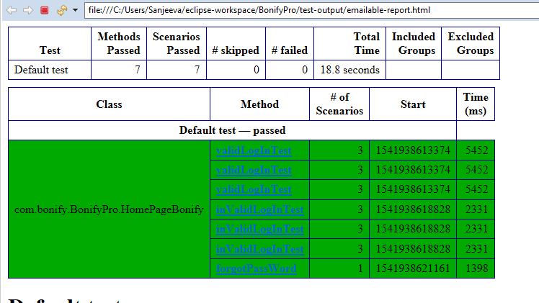

Steps to run the project:

This mavan project can be run either using pom.xml file using eclipse or using Jenkins by configuring mavan environment and pom.xml path in Jenkins . Commonly during development eclipse would be used but during regression testing Jenkins would be configured to run the test suite.

**1.Using Eclipse**

1. This Mavan project can be executed by running pom.xml file using eclipse:

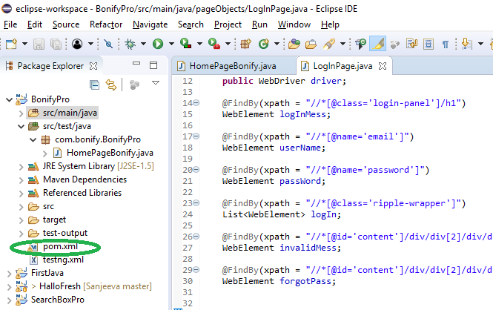

Steps:

1.Right click on pom.xml

2. Click on ‘Run As’ and then ‘Run Configurations’

3.Click on ‘Run’ in Maven run configuration window.

1. **Using Jenkins**.
2. Navigate to the Jenkins dashboard (<http://localhost:8080>) in the browser window.

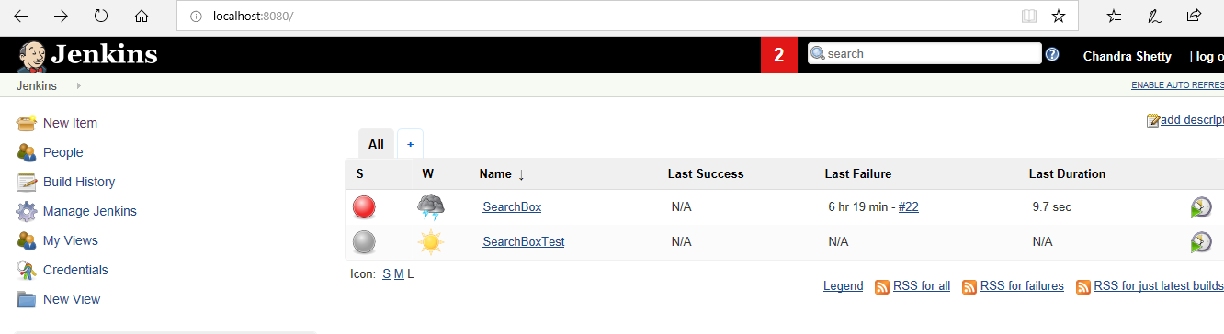

1. Click on the **New Item** link to create a Jenkins job. the FreeStyle project radio button as shown in the following screenshot:

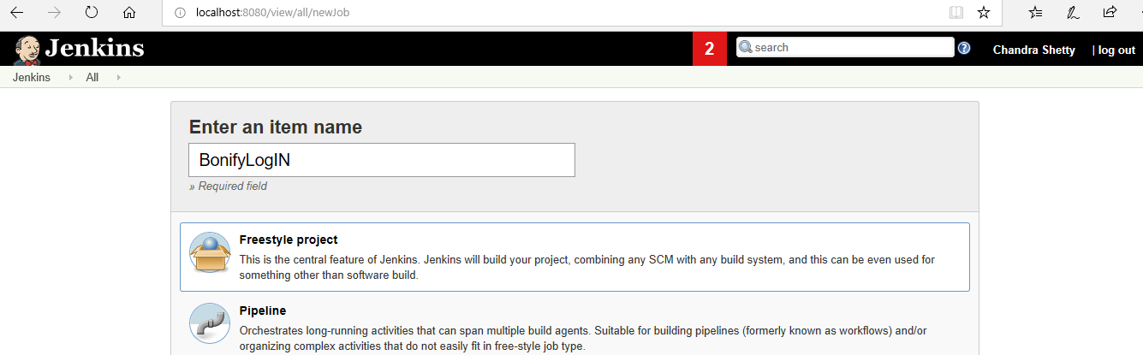

3. Click on OK button. A new job with name "BonifyLogIN" is created in Jenkins Dashboard.

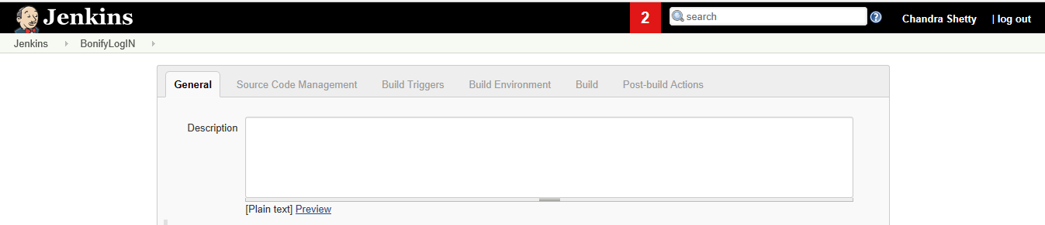

4. Configure JDK as shown in the screen shot below:

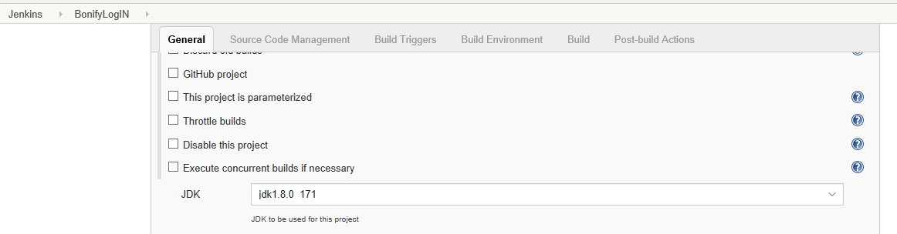

5. Set the Maven project path in ‘use custom workspace’

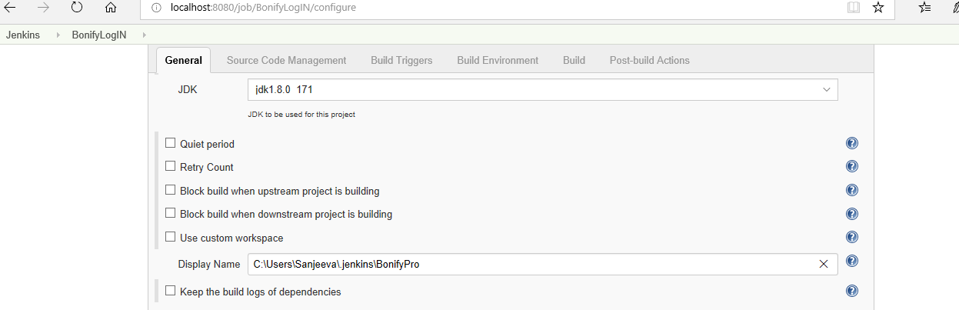

6. Set the goals as ‘test’ in Invoke top-level Maven targets as shown in screenshot below:

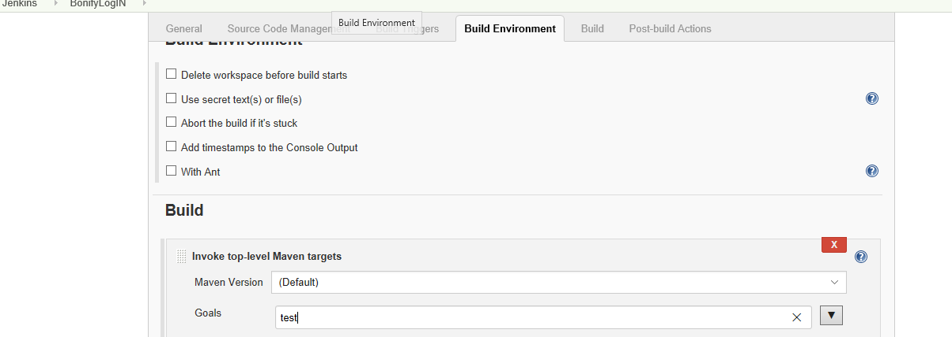

7. Click on ‘Build Now’ to build and test the application.

