Student Name: Ridhima Gulati UID: 24BCY70132
Branch: AIT-CSE (Cyber Security) Section/Group: 24AIT_KRG-G2
Semester: 4 Date of Performance: 24/04/2026
Subject Name: Database Management System Subject Code: 24CSH-298

WORKSHEET 10
AIM: To design and implement a trigger in PostgreSQL that automatically generates primary key values, ensuring unique identification of records and demonstrating automated database programming.

S/W Requirement: Database Management System:
- Oracle Database Express Edition (Oracle XE)
- PostgreSQL Database
Database Administration Tool / Client Tool:
- Oracle SQL Developer (for Oracle XE)
- pgAdmin (for PostgreSQL)

OBJECTIVES:
- To implement automatic primary key generation using triggers
- To eliminate manual key insertion errors
- To maintain data integrity using database automation
- To understand trigger execution in PostgreSQL

PROBLEM STATEMENT:
In enterprise systems, manually assigning primary keys can lead to:
- Duplicate values
- Data inconsistency
- Human errors
To overcome this, design a trigger that:
- Automatically assigns a unique primary key before inserting records
- Uses sequence-based logic
- Ensures consistency and reliability
This approach is widely used in companies like Amazon, Flipkart, and Oracle Corporation.

TABLE STRUCTURE:
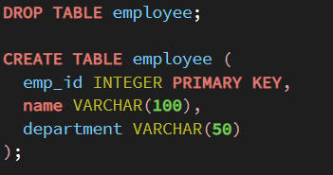


IMPLEMENTATION

PROGRAM:
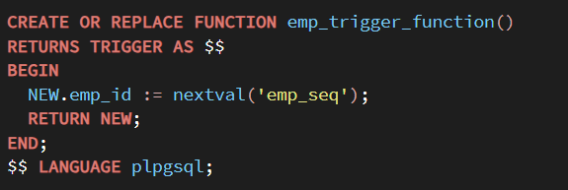
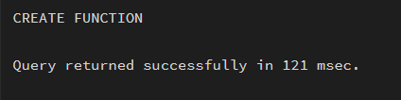
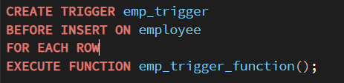
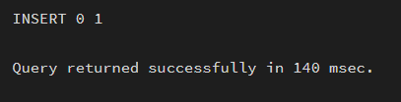


OUTPUT:
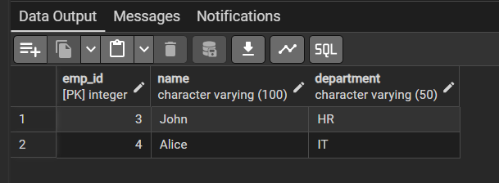
LEARNING OUTCOMES:
- Understand the concept of database triggers
- Implement automatic primary key generation
- Ensure data integrity without manual intervention
- Apply trigger-based automation in real-world systems
- Gain practical exposure to enterprise-level database techniques

CONCLUSION:
The experiment successfully demonstrated the use of triggers in PostgreSQL to automate primary key generation. By integrating sequences with triggers, the system ensures unique record identification without manual input. This method enhances data integrity, reduces errors, and aligns with industry practices followed by modern enterprise applications.

