Student Name: Ridhima Gulati UID: 24BCY70132
Branch: AIT-CSE (Cyber Security) Section/Group: 24AIT-KRG-G2
Semester: 4 Date of Performance:28/01/2026
Subject Name: Database Management System Subject Code: 24CSH-298

WORKSHEET-3
AIM: This experiment aims to understand the basic structure of a PL/SQL program by creating and executing a simple PL/SQL block that includes declaration and execution sections, and to display output using built-in procedures.

Software Requirements:
Database Management System:
- PostgreSQL
- Oracle Database (Oracle SQL / Oracle Express Edition)
Database Administration Tool:
- pgAdmin
- Oracle SQL Developer

OBJECTIVES:
- To understand the basic structure of a PL/SQL program.
- To learn how to use the DECLARE section to define and initialize variables.
- To understand the BEGIN…END execution section of a PL/SQL block.
- To perform operations using declared variables.
- To display output using the built-in procedure DBMS_OUTPUT.PUT_LINE.
- To gain practical experience in writing and executing a simple PL/SQL program.

Practical / Experiment Steps
- Start the PostgreSQL server.
- Open pgAdmin and connect to the PostgreSQL server.
- Open a new SQL worksheet.
- Write a PL/SQL block using DECLARE, BEGIN, and END sections.
- Declare variables for employee id, employee name, and employee salary.
- Initialize the declared variables with suitable values.
- Use DBMS_OUTPUT.PUT_LINE to display variable values.
- Execute the PL/SQL program.
- Verify the displayed output.
- Save the program and take screenshots of execution and results.

Procedure of the Experiment
- Log in to the system.
- Open pgAdmin and connect to the PostgreSQL database.
- Open the SQL editor.
- Declare variables in the DECLARE section.
- Write executable statements inside the BEGIN…END block.
- Use output statements to display values.
- Execute the PL/SQL block.
- Observe and verify the output generated.

Program
Query:

DECLARE
emp_id INTEGER := 101;
emp_name VARCHAR(50) := 'Rahul Sharma';
emp_salary NUMERIC(10,2) := 45000.50;
BEGIN
DBMS_OUTPUT.PUT_LINE('Employee Id : ' || emp_id);
DBMS_OUTPUT.PUT_LINE('Employee Name: ' || emp_name);
DBMS_OUTPUT.PUT_LINE('Employee Salary: ' || emp_salary);
END;

Input / Output Details:
Input
PL/SQL commands for declaring variables, executing statements, and displaying output using DBMS_OUTPUT.PUT_LINE.
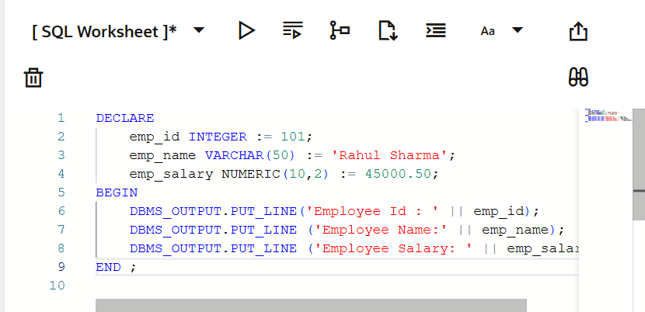

Output
Successful execution of the PL/SQL program displaying:
- Employee Id
- Employee Name
- Employee Salary
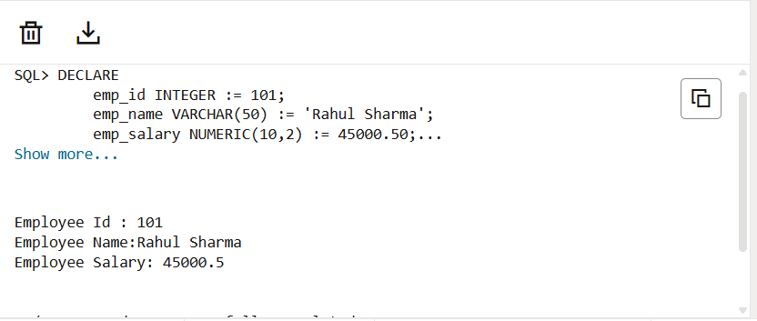
Result
Thus, the PL/SQL program was successfully executed. The declaration section and execution section were implemented correctly, and the output was displayed using built-in procedures.

Learning Outcomes:
- Understood the basic structure of a PL/SQL program.
- Learned how to declare and initialize variables using the DECLARE section.
- Gained understanding of the BEGIN…END execution block in PL/SQL.
- Learned how to perform operations using declared variables.
- Understood the use of the built-in procedure DBMS_OUTPUT.PUT_LINE for displaying output.
- Gained practical experience in writing, executing, and verifying a simple PL/SQL program using database tools.

