Student Name: Ridhima Gulati UID: 24BCY70132
Branch: AIT-CSE (Cyber Security) Section/Group: 24AIT-KRG2
Semester: 4 Date of Performance:16/01/2026
Subject Name: Database Management System Subject Code: 24CSH-298

WORKSHEET 2
AIM: To design and implement a sample database system using DDL, DML, and DCL commands, including database creation, data manipulation, schema modification, and role-based access control to ensure data integrity and secure, read-only access for authorized users.
S/W Requirement: Oracle Database Express Edition and pgAdmin
OBJECTIVES:
- To retrieve specific data using filtering conditions
- To sort query results using single and multiple attributes
- To perform aggregation using grouping techniques
- To apply conditions on aggregated data
- To understand real-world analytical queries commonly asked in placement interviews
Given:
Practical / Experiment Steps
Step 1: Database and Table Preparation
- Start the PostgreSQL server.
- Open the PostgreSQL client tool.
- Create a database for the experiment.
- Prepare a sample table representing customer orders containing details such as customer name, product, quantity, price, and order date.
- Insert sufficient sample records to allow meaningful analysis.
Query:
Table Creation:
CREATE TABLE Students1 (
id NUMERIC PRIMARY KEY,
name VARCHAR(50),
city VARCHAR(30),
marks NUMERIC(10,0)
);
Insertion Of Records
INSERT INTO Students1 VALUES (1, 'Aman', 'Mohali', 85);
INSERT INTO Students1 VALUES (2, 'Rohit', 'Mohali', 78);
INSERT INTO Students1 VALUES (3, 'Neha', 'Mohali', 92);
INSERT INTO Students1 VALUES (4, 'Simran', 'Amritsar', 88);
INSERT INTO Students1 VALUES (6, 'Karan', 'Amritsar', 75);
SELECT * FROM Students1;
Output:
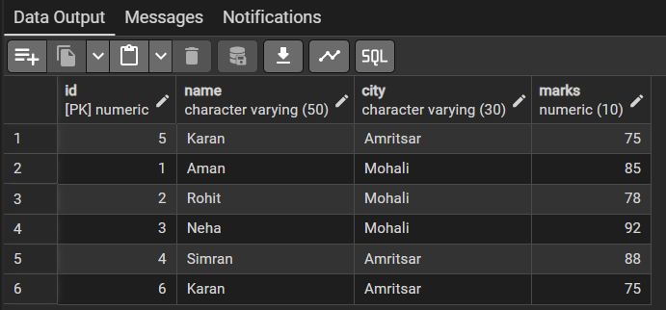

Step 2: Filtering Data Using Conditions
Query:
SELECT city,count(*) as count_of_students
from Students1
group by city;

SELECT city,count(id) as count_of_students
from Students1
group by city;

SELECT city,COUNT(ID) as count_of_students
FROM Students1
GROUP BY city
HAVING COUNT(ID)>=3;
Output:
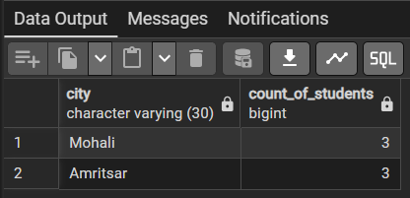
Step 3: Sorting Query Results
- Retrieve selected columns from the table and arrange the output based on numerical values such as price.
- Perform sorting using both ascending and descending order.
- Apply sorting on more than one attribute to understand priority-based ordering.
Query:
Sort orders by price in ascending order
SELECT city, COUNT(*) as count_of_students
FROM Students1
GROUP BY city
ORDER BY COUNT(*) ASC;
Output:
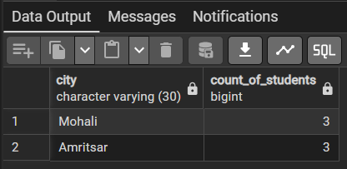
Step 4: Grouping Data for Aggregation
Query:
SELECT city,AVG(MARKS)::NUMERIC(10,2) as average_marks
FROM Students1
Group BY city;
Output:

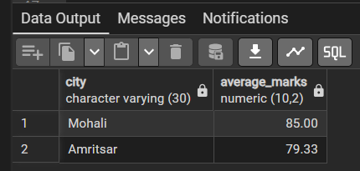
SELECT city, SUM(marks) FROM Students1 GROUP BY city;
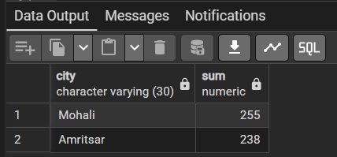
SELECT city, MAX(marks) FROM Students1 GROUP BY city;
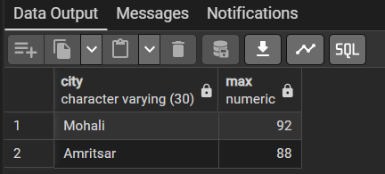
SELECT city, MIN(marks) FROM Students1 GROUP BY city;
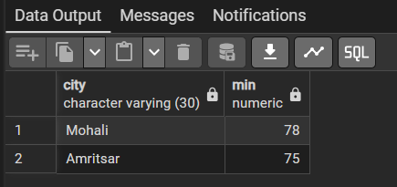
Learning Outcomes:
- Understand how to create relational database tables using appropriate data types and constraints
- Learn to retrieve required data from a table using row-level filtering with the WHERE clause.
- Gain the ability to apply column-level (group-level) filtering using the HAVING clause.
- Understand the use of aggregate functions such as SUM(), AVG(), and COUNT() for analytical reporting.
- Clearly differentiate between row-level filtering and group-level filtering, and apply them correctly in real-world SQL scenarios.

