Student Name: Ridhima Gulati UID: 24BCY70132
Branch: AIT-CSE (Cyber Security) Section/Group: 24AIT_KRG-G2
Semester: 4 Date of Performance: 27/02/2026
Subject Name: Database Management System Subject Code: 24CSH-298

WORKSHEET 5
AIM: To understand and apply conditional logic in SQL using the MOD (%) operator to classify employee salaries as odd or even.

S/W Requirement: • Database Management System: PostgreSQL / Oracle Database Express Edition
• Database Administration Tool: pgAdmin

OBJECTIVES:
To write and execute SQL queries that:
- Use the MOD (%) operator
- Identify whether salary values are odd or even
- Display employee details based on salary classification

PROBLEM STATEMENT:
Develop and execute SQL queries that utilize conditional logic to analyze employee salary data. The queries should determine whether salaries are odd or even using the MOD operator and display appropriate results.
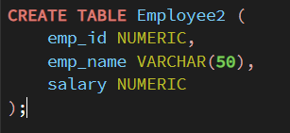

- PROBLEM STATEMENT – Display Salary Type (Odd/Even)

Write an SQL query to display employee details along with salary classification as odd or even.
PROGRAM:

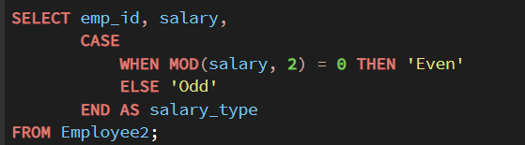
OUTPUT:
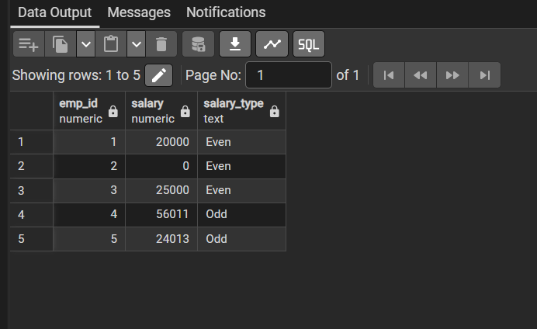

- PROBLEM STATEMENT – Display Employees with Even Salaries

Write an SQL query to display employees whose salaries are even.
PROGRAM:


OUTPUT:
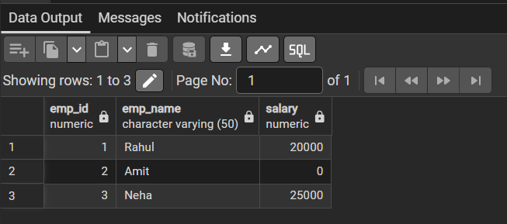

- PROBLEM STATEMENT – Display Employees with Odd Salaries
Write an SQL query to display employees whose salaries are odd.
PROGRAM:

OUTPUT:


- PROBLEM STATEMENT – Count Odd and Even Salaries

Write an SQL query to count employees based on salary type.
PROGRAM:
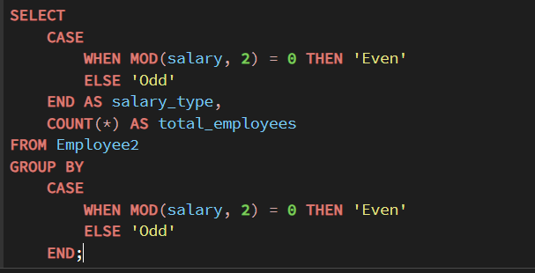
OUTPUT:
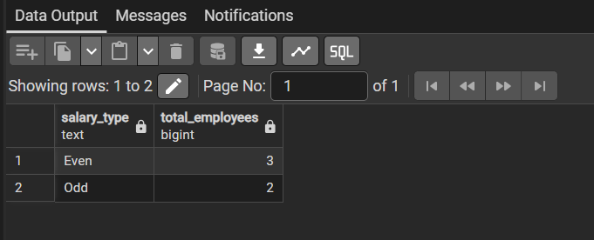

LEARNING OUTCOMES:
1. Learned how to use the MOD (%) operator in SQL
2. Understood classification of data into odd and even values
3. Gained knowledge of CASE statements in SQL
4. Improved data filtering and grouping techniques
5. Enhanced SQL query writing skills

CONCLUSION:
This experiment demonstrated how conditional logic can be implemented in SQL using the MOD operator. It helped in classifying and analyzing employee salary data effectively, improving decision-making and data handling skills.

