Student Name: Ridhima Gulati UID: 24BCY70132
Branch: AIT-CSE (Cyber Security) Section/Group: 24AIT_KRG2
Semester: 4 Date of Performance: 13/01/2026
Subject Name: Database Management System Subject Code: 24CSH-298

WORKSHEET 1
AIM: To design and implement a sample database system using DDL, DML, and DCL commands, including database creation, data manipulation, schema modification, and role-based access control to ensure data integrity and secure, read-only access for authorized users.
S/W Requirement: Oracle Database Express Edition and pgAdmin
OBJECTIVES:
To gain practical experience in implementing Data Definition Language (DDL), Data Manipulation Language (DML), and Data Control Language (DCL) operations in a real database environment. This will also include implementing role-based privileges to secure data.
Given:
A Library wants to develop a Library Management System database to manage information about books, members, and book issue records efficiently. The database should be designed using appropriate tables, primary keys, foreign keys, and constraints to ensure data integrity. The system must support basic database operations such as inserting records, updating existing data, and deleting obsolete entries. To ensure database security, a database role named Librarian must be created. This role should be password protected and granted SELECT, INSERT, AND DELETE permissions on the required tables. The system administrator (pgAdmin) should also have the ability to revoke these permissions when required using role-based access control.
- Database Design
Create multiple tables such as Books, Library_Visitor, Book_Issue
Define appropriate PRIMARY KEY and FOREIGN KEY constraints.
Enforce NOT NULL, UNIQUE, and CHECK constraints where necessary.

Query:
CREATE TABLE books (
id INT PRIMARY KEY,
name VARCHAR(20) NOT NULL,
author_name VARCHAR(30) NOT NULL
);

CREATE TABLE library_visitor(
USER_ID INT PRIMARY KEY,
USER_NAME VARCHAR(20),
AGE INT CHECK(AGE>=17) NOT NULL,
EMAIL_ID VARCHAR(20) UNIQUE NOT NULL
);

CREATE TABLE book_issue(
BOOK_ISSUE_ID INT PRIMARY KEY,
BOOK_ID INT REFERENCES books(ID),
USER_ID INT REFERENCES library_visitor(USER_ID) NOT NULL,
BOOK_ISSUE DATE NOT NULL
);

- Data Manipulation
Insert sample records into all tables.
Query:
INSERT INTO books (id, name, author_name)
VALUES (140, ‘The Tiger King’, ‘J.K. Rowling’);
VALUES(130,’mowgli’,’clearstone’);
VALUES(120,’panchtantra’,’J.K.Rowling’);
VALUES(110,’STEVE ROLLS’,’ROLL CLANS’);
SELECT * FROM books;
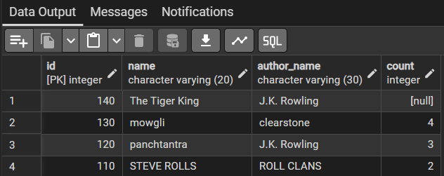
INSERT INTO library_visitor(USER_ID,USER_NAME,AGE,EMAIL_ID) VALUES(101,'aly',19,'abcd@gmail.com');
INSERT INTO library_visitor(USER_ID,USER_NAME,AGE,EMAIL_ID) VALUES(102,'aman',21,'efgh@gmail.com');
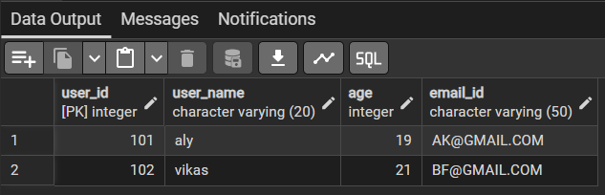
INSERT INTO book_issue VALUES(555,140,101,'05-01-2026');
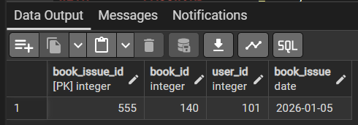
Perform UPDATE operations to modify existing records.
Query:
UPDATE books
SET COUNT=3 WHERE ID=120;

UPDATE library_visitor
SET USER_NAME='vikas'
WHERE USER_ID=102;

UPDATE library_visitor
SET EMAIL_ID='AK@GMAIL.COM'
WHERE USER_ID=101;

UPDATE library_visitor
SET EMAIL_ID='BF@GMAIL.COM'
WHERE USER_ID=102;

- Access Control & Security
Query:
Grant ONLY SELECT privilege on required tables to this role/user.
Querry:
CREATE ROLE librarian
WITH LOGIN PASSWORD 'Husan_123';
GRANT SELECT, INSERT, DELETE, UPDATE ON books TO librarian;
GRANT SELECT, INSERT, DELETE, UPDATE ON book_issue TO librarian;
GRANT SELECT, INSERT, DELETE, UPDATE ON library_visitor TO librarian;
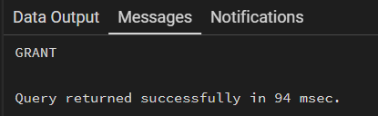
Explicitly REVOKE CREATE privilege so that the user cannot create any database objects.
Query:
REVOKE SELECT, INSERT, DELETE, UPDATE ON library_visitor FROM librarian;
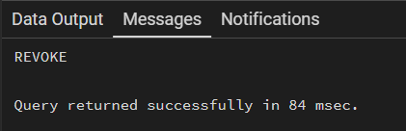

- Schema Modification
Use ALTER TABLE to add or modify a column.
Query:
ALTER TABLE books
ADD COUNT INT CHECK(COUNT>=1);

ALTER TABLE library_visitor
ALTER COLUMN EMAIL_ID TYPE VARCHAR(50);

ALTER TABLE library_visitor
DROP COLUMN EMAIL_ID;

ALTER TABLE library_visitor
ADD COLUMN EMAIL_ID VARCHAR(30) UNIQUE;
Learning Outcomes:
- Understood the basics of relational database design using tables, keys, and relationships.
- Learned to apply primary key and foreign key constraints to maintain data integrity.
- Gained hands-on experience with INSERT, UPDATE, and DELETE operations safely.
- Understood how roles and privileges control access to database objects.
- Learned to use GRANT and REVOKE for implementing read-only users.
- Practiced ALTER TABLE and DROP TABLE for managing database changes.

