Student Name: Ridhima Gulati UID: 24BCY70132
Branch: AIT-CSE (Cyber Security) Section/Group: 24AIT-KRG2
Semester: 4 Date of Performance:16/01/2026
Subject Name: Database Management System Subject Code: 24CSH-298

WORKSHEET 2
AIM: To design and implement a sample database system using DDL, DML, and DCL commands, including database creation, data manipulation, schema modification, and role-based access control to ensure data integrity and secure, read-only access for authorized users.
S/W Requirement: Oracle Database Express Edition and pgAdmin
OBJECTIVES:
- To retrieve specific data using filtering conditions
- To sort query results using single and multiple attributes
- To perform aggregation using grouping techniques
- To apply conditions on aggregated data
- To understand real-world analytical queries commonly asked in placement interviews
Given:
Practical / Experiment Steps
Step 1: Database and Table Preparation
- Start the PostgreSQL server.
- Open the PostgreSQL client tool.
- Create a database for the experiment.
- Prepare a sample table representing employee details containing id, name, department, salary, joining date
- Insert sufficient sample records to allow meaningful analysis.
Query:
Table Creation:
CREATE TABLE employee1(
emp_id NUMERIC PRIMARY KEY,
emp_name VARCHAR(50),
department VARCHAR(50),
salary NUMERIC(10,2),
joining_date DATE[ ]
);

Insertion Of Records:
INSERT INTO employee1 VALUES (101, 'Amit', 'IT', 19000, '2020-02-12');
INSERT INTO employee1 VALUES (102, 'Priya', 'HR', 22000, '2019-03-10');
INSERT INTO employee1 VALUES (103, 'Rahul', 'Sales', 35000, '2021-07-18');
INSERT INTO employee1 VALUES (104, 'Neha', 'IT', 55000, '2018-09-22');
INSERT INTO employee1 VALUES (105, 'Rohan', 'Finance', 32000, '2022-01-05');
INSERT INTO employee1 VALUES (106, 'Sara', 'Sales', 13000, '2020-12-03');
INSERT INTO employee1 VALUES (107, 'Vikram', 'HR', 12000, '2017-04-11');

SELECT * FROM employee1;
Output:
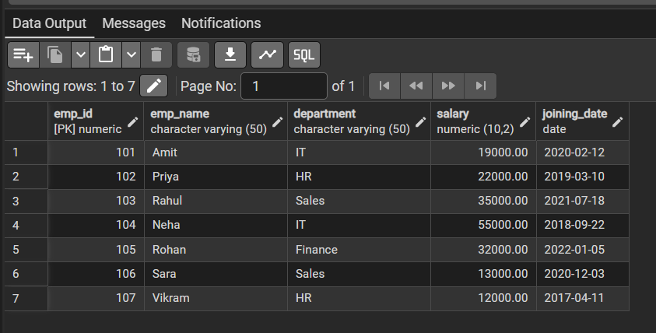

Step 2: Filtering Data Using Conditions
Query:
SELECT department, AVG(salary) AS avg_salary
FROM employee1
GROUP BY department;

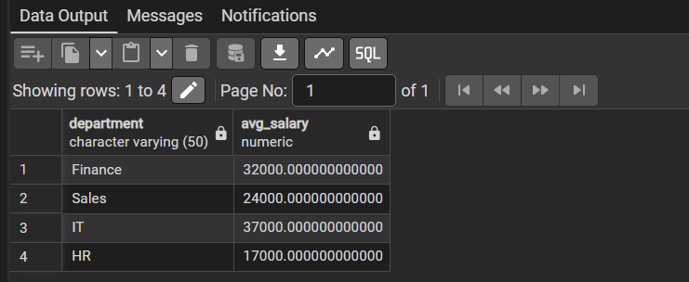

SELECT department, AVG(salary) AS avg_salary
FROM employee1
WHERE salary > 20000
GROUP BY department;
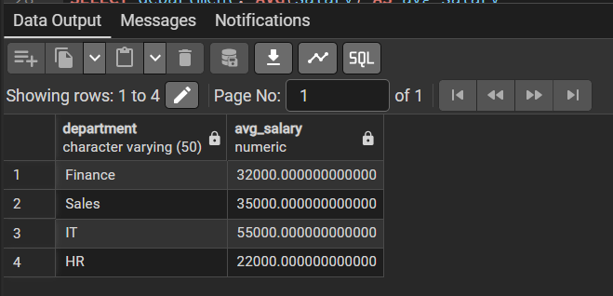

SELECT department, AVG(salary) AS avg_salary
FROM employee1
GROUP BY department
HAVING AVG(salary) > 30000;
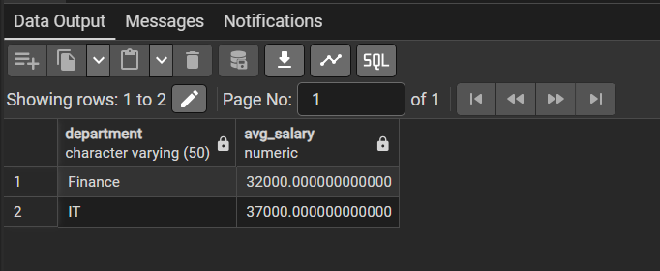
Step 3: Sorting Query Results

SELECT department, AVG(salary) AS avg_salary
FROM employee1
WHERE salary > 20000
GROUP BY department
HAVING AVG(salary) > 30000
ORDER BY avg_salary DESC;

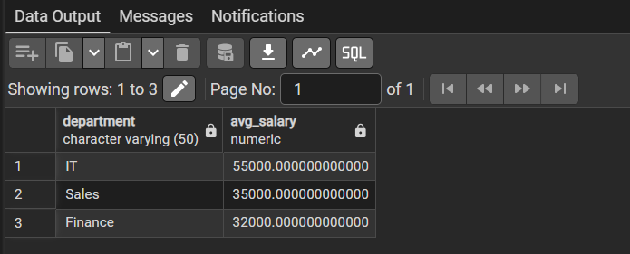
Learning Outcomes:
- Understand how to create relational database tables using appropriate data types and constraints
- Learn to retrieve required data from a table using row-level filtering with the WHERE clause.
- Gain the ability to apply column-level (group-level) filtering using the HAVING clause.
- Clearly differentiate between row-level filtering and group-level filtering, and apply them correctly in real-world SQL scenarios.
- Learnt to perform grouping on the sorted data.

