**B.Tech. IoT Programming**

**Project Report**

**On**

**ACCIDENT DETECTOR AND ALERT SYSTEM**

**by**

**Ridhima (123103134)** [**Email address**](mailto:123103134@nitkkr.ac.in) **Phone**

**Branch: IT B**

**Subject: IoT Programming (ITPC 209)**

***Abstract***

The 2023 Global Status Report on Road Safety highlights a 5% reduction in road traffic deaths from 2010 to 2021, with 1.19 million fatalities globally each year [1]. While some countries like Belarus and Norway cut fatalities by over 50%, India saw a 15% rise, with deaths increasing from 134,000 in 2010 to 154,000 in 2021 [2]. In early 2023, fatalities dropped by 2.8% compared to 2022 but were still 4.3% higher than pre-pandemic levels. [3]

With vehicles becoming more affordable from time to time, there has been an upsurge in the number of vehicles on the road. Moreover, with continuous development in technology, the vehicles are *seemingly* safer than before. Keeping this fact in mind, people often drive rashly. But because of this, even due to improved technology, the number of accidents is sky-rocketing. A lack of communication with the concerned medical authorities and delay in providing immediate medical services to the accident victim deteriorate the situation.

The present scenario definitely speaks of the need of an Accident Detector & Alert System which can serve as a ‘LifeSaver’ in many critical conditions. This **IoT** project is the development of such a system which detects accidents and alerts emergency services. The system uses sensors, alongwith real-time algorithms, to detect whether an accident has occurred. Incorporating **GPS** technology, **GSM** module, **accelerometer** and different algorithms in the system allows it to figure out any unusual behaviour in speed, and send alerts and notifications in case of an accident and the **buzzer** is activated. Moreover, integrating **Machine learning** model(**YOLO** & **SAHI**) in the project enhances the system’s ability to accurately detect accidents and minimise false alarms by analysing sensor data patterns.

**Important Keywords-** IoT, Accelerometer, GPS, GSM, Buzzer, Machine learning, YOLO, SAHI, etc.

# Introduction

The accident detection & alert system is aimed at minimizing the number of fatal outcomes of road accidents through early call for emergency. It can connect with collision sensors that analyse the severity of the accident and determine, with the help of GPS, the precise location to deliver the affected party to the nearest medical facility. It also informs the family of the victim. This system uses the current technologies as a foundation & aims at being a cost-efficient solution for decreasing the emergency response time on crowded highways. This means that medical aid can reach the people who need it much faster, and this can easily turn into saving lives.

The prominent details of the model include:

* The model is both sensor and ML based.
* Using ML, the image is processed and analysed properly to find whether an accident has occurred or not.
* Various sensors like accelerometer and gyroscope are used to determine/confirm occurrence of accident. Further, the accident is classified based on severity level.
* GSM module is used to contact emergency services and predefined contacts.
* GPS tracks the exact site of the accident and sends alerts.

This system easily identifies and responds to such situations in a timely manner, decreasing the time taken in delivery of medical help which may help save lives.

**Machine Learning Integration:**

**Image Analysis:** Object detection models like *YOLO*(You Only Look Once) are used to recognise vehicle accidents from camera feeds. The model trained on datasets of accident and non-accident images, is able to find out if accident has occurred or not. Combining these results with that of SAHI, better accuracy and precision are obtained.

**Sensor Data Analysis:** Integrating ML with sensor-based model, the accuracy of the model increases. In case of wrong prediction by any of the component, the other one is there to confirm/discard the prediction.

**Unique Functionality**

**Real-Time Object Detection Using YOLO & SAHI**: YOLO application in an accident scene is able to identify and locate the people like pedestrians, other vehicles, and road hazards nearby. Using the data obtained, what they got, will emergency responders receive complete reports about the surroundings. SAHI works alongwith YOLO, which divides the image into smaller pieces, which are then analysed. SAHI provides higher detection accuracy and speeds up response. Both models combined make the accident detection system more reliable.

**Driver Response Assessment**: Here, a voice assistant will be there to check how the driver has reacted after the accident, which aids in determining the severity of injuries.

**Camera Monitoring**: Camera sensor will be used here for instance to detect driver’s condition after the accident, which will be forwarded to responders to get best help as soon as possible

# Related Work in Project

The need to address road accident has been felt since population and technology boom (2010 -2015). Modifications are continuously being added, starting from simple alert generating system to the use of deep learning in developing a lower risk model.

The starting model were based on sensors only. The main sensors used in these models are – temperature sensor, vibration sensor, alcohol detectors, shock sensors, etc. If the sensor detects the abnormal value an alert system is set on. The signal transmission is made possible with the help of Global System for Mobile communication (GSM) network model. For getting the exact location of the accident or the concerned driver we use Global Positioning System (GPS). GPS system rely on satellite network for getting the ground location of an object. The information obtained through GPS and GSM are stored in microcontrollers. The GPS system provides the latitude and longitudinal coordinates of a target. These locations can be easily tracked by the relatives of the injured person too.

Further around 2018, the black-box system and cloud storage started being used in accident detection. The black-box included monitoring system to collect the continuous data of the vehicle so to use it in further investigation. The tracking system included GPS and GSM. The system is designed such that, after the alarm is set off the location is sent to the police and the nearest hospital. These are crucial functions required in the model to rescue the life of the vehicle user. But this system is very costly.

The models developed in 2019- 20 focus on the fast transmission of the alert signal and communication. For this the real time vehicle status is continuously recorded and updated. RF modules are employed for wireless communication. The voice assistant started showing up in these newly developed models.

The existing models are trying to reduce the dependency on the sensors. For this purpose, live video input systems and well-trained deep learning models are being developed, but still are not in mainstream accident detection system. These systems need huge amount of data for training and testing the system with better storage options. These models are more accurate and efficient than previous sensor based models.

|  |  |  |  |  |  |  |
| --- | --- | --- | --- | --- | --- | --- |
| **Author** | **Link of published work (research paper/patent)** | **Year** | **Features** | **Result** | **Model/ sensor used** | **Drawbacks** |
| Nikhlesh Pathik et al. [4] | <https://www.mdpi.com/2071-1050/14/13/7701> | 2022 | * Alarm reset possible in case of less critical or false detection * Nearest helpline is contacted * Deep learning gives high accuracy * Input video through the dashboard camera | The system detects the accident by force sensors and measures the impact of collision.  The data is fed on cloud and transmission to sources is done. | * Force Sensor FlexiForce A401 * ATMEGA328 microcontroller * Raspberry Pi 3B+ * Pi camera * GSM SIM900A * GPS Neo-6m Module * Deep learning algorithms | Huge amount of data required.  Well trained system needed. |
| Dr. C. K. Gomathy et al. [5] | <https://www.researchgate.net/profile/C-K-Gomathy/publication/360620242_ACCIDENT_DETECTION_AND_ALERT_SYSTEM/links/63ef2e6a19130a1a4a87111b/ACCIDENT-DETECTION-AND-ALERT-SYSTEM.pdf> | 2022 | * Detection of speed with the help of the Sensor Fusion Based Algorithm * Cancellation of alert message in non-critical accidents * Location detection * Hospital and police get accident alert message | The system assists the injured person to contact hospital in case he is unable. The system is cost effective | * ATmega328P microcontroller * Arduino UNO * GSM SIM900 module * GPS SIM28ML module * LCD module 16x2 | Not possible to know the driver’s current situation in accident.  On the spot medical help is not possible |
| Abdulkadir Shehu Bari et al. [6] | <https://www.academia.edu/download/90817440/GJRECS2401050.pdf> | 2022 | * Low power consumption * Location detection * Alert message is sent to the helpline numbers | The system detects the accident by sensors and sends the GPS location to the relatives and helpline | * Accelerometer (ADXL335) * Vibration Sensor * Thermistor * Arduino UNO | The system doesn’t work offline.  In no GSM network, the communication is difficult.  False accident detection possible. |
| Arnav Chaudhari et al. [7] | <https://ieeexplore.ieee.org/abstract/document/9582163/> | 2021 | * Checking of the presence of the driver inside the vehicle * Detection of vibrations caused by collision of a vehicle * Location detection * Alert message to the emergency contacts * False alert message prevention | The system detects the accident if a threshold frequency of vibrations is reached.  The system sends location coordinates via Google map link to the contacts concerned. | * seismic detector SW-420 * Ultrasonic sensor HC-SR04 * Arduino UNO R3 * GPS Module (NEO-6M) * GSM (SIM900A) | Complex system.  Not possible to know the driver’s current situation in accident |
| Aayush Doshi et al. [8] | <https://www.researchgate.net/profile/Aayush-Doshi/publication/355985808_Accilert_-Accident_Detection_And_Alert_System/links/6189227a61f09877207064fb/Accilert-Accident-Detection-And-Alert-System.pdf> | 2021 | * Location detection * Alert message system * Sensor based system | The system records speed and orientation and sends the alert to the helpline. | * Accelerometer ADXL335A * Arduino UNO * Shock sensor | Current situation of the passenger can’t be known. |
| R. Raffik et al. [9] | <https://kalaharijournals.com/resources/DEC_325%20(1).pdf> | 2021 | * The GPS unit can determine speed, journey distance, bearing, tack, dawn and sunset times, distance * A GPS receiver must receive data from at least four satellites to be accurate * both voice calls and text messages are used to send out alerts | The system records accident and sends an SMS with location and vehicle number to the concerned helplines | * Arduino UNO * ATmega328P microcontroller * 16 MHz ceramic resonator, * Gyroscope Sensor * GSM Module | The satellite data can be inaccurate in case of adverse weather conditions. |
| Nicky Kattukkaran et al. [10] | <https://ieeexplore.ieee.org/abstract/document/8389130/> | 2017 | * Vehicle fall detection * Heartbeat sensing * Message transmission via Bluetooth to the Android phone connected * Location detection * Alert message delivery to emergency contacts | The system can detect the severity of an accident and sends alert to the medical center and relatives of the driver via Bluetooth. | * Accelerometer ADXL335 IC * Regulator IC LM117 * Heartbeat sensor MSP430 microcontroller * Bluetooth module HC-06 | In case of false accident detection, the buzzer can’t be turned off |
| Ravi Kishore Kodali et al. [11] | <https://ieeexplore.ieee.org/abstract/document/8389130/> | 2017 | * Accident detection through shock sensers(eg. Airbags) * http request is sent through preinstalled mobile application * Location detection * Speed and pressure monitoring | The system detects the possibility of an accident and accordingly alerts the driver. | * NodeMCU * ADXL335 Accelerometer * Ultrasonic sensor * Piezo-electronic buzzer * SSD1306 OLED Display | No technology to contact the concerned authorities and relatives.  Current situation of the passenger can’t be known. |
| Jazim Baramy et al. [12] | <https://www.academia.edu/download/54843849/Anti_Accident.pdf> | 2016 | * Provides basic information on the accident site to the hospital or police station * A three-axis accelerometer and GPS tracking system work for accidental monitoring * Location detection * SMS delivery to the person | The system detects the accident on the basis of shock sensor and sends an alert SMS to the concerned relative | * Arduino Atmel348P * GPS EB-3531 with external antenna * GSM Module with SIM Card 300 * Shock sensor | The location of accident can’t be sent to the emergency contact if no network is present.  Current situation of the passenger can’t be known. |
| Fahim Bin Basheer et al. [13] | <https://ieeexplore.ieee.org/abstract/document/8389130/> | 2013 | * A tilt meter is used to find the inclination of the motorcycle * GSM module for communication | The accident information reached the emergency services within seconds after the incident which clearly is a real improvement from the current situation. | * NMEA0183 GPS technology * triple axis accelerometer MMA 7341 | Not precise as wholly sensor dependent |

**Drawbacks in these existing projects**

The above projects have following drawbacks-

* False accident detection
* Failed detection of accident
* No record of magnitude of accident collision (and of damage occurred) to modify the alert message
* High chances of error in wholly sensor-based system
* Damage to the sensors
* Internet availability required
* Physical condition of the passenger can’t be recorded
* Signal not delivered issue
* Difficulty in contacting nearest hospital
* On the spot medical help availability

# Project

The Accident detection and alert system consists of multiple sensors. Each serves a specific purpose in identifying and responding to accident situations. The microcontroller acts as a hub for receiving data from various sensors such as accelerometers, gyroscopes, and vibration sensors to track vehicle movement in real time. The accelerometer detects sudden changes in speed, which can signal a collision while the gyrometer measures angular velocity to determine if the vehicle is entering a dangerous or sudden curve. Vibration sensors detect the strong vibrations that often accompany shock which helps in confirming the accident.

When a potential accident is detected, the system uses additional sensors to assess the situation. To investigate the severity of the crash, the camera captures images of the scene which are tested upon by object-detection model(like YOLO).

In terms of notification and response, the GPS module determines the exact location of the accident, and the GSM module sends automatic notifications to emergency services (e.g. police, ambulance) and the victim's family members. The LCD screen shows the status of the accident. It provides real-time vehicle status information.

In machine learning part, the Accident Detection & Alert System utilizes camera images taken in real time structure from motion techniques to recognize objects such as cars, people, and threats in the picture. YOLO detection approach divides the image into a set of gridded boxes and predicts bounding boxes for each object present inside the box. It helps in quick assessment of number of vehicles, possible injuries. This assists the first responders in evaluating the level of potential damage caused by the accident enabling them to respond appropriately and within the shortest time possible. SAHI (Slicing Aided Hyper Inference) enhances accuracy and precision of accident detection system by allowing for the detection of smaller details within complex accident scenes.

**3.1 Conceptual Design Diagram**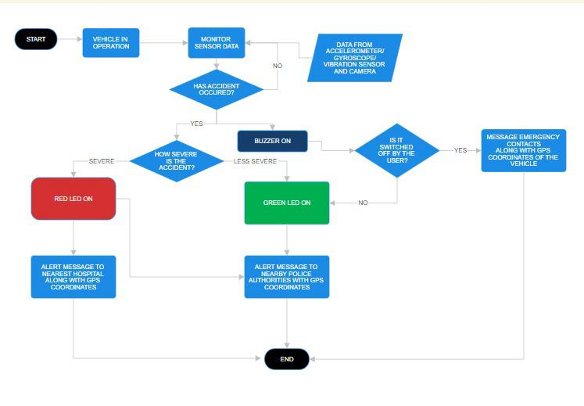

**Fig-1: Framework/ Architecture/ Flowchart**

1. **Start System**

Initialize system

Check if vehicle is in operation

If vehicle is in operation:

Set system status to "Active"

Else:

Set system status to "Inactive"

End

1. **Monitor sensor data**

While system status is "Active":

Continuously read data from:

- Accelerometer

- Gyroscope

- Vibration sensor

- Camera

1. **Accident detection check**

If any sensor data indicates potential accident:

Set accident_flag = True

Else:

accident_flag = False

1. **Accident severity assessment**

If accident_flag is True:

Check severity using accelerometer and gyroscope data

If severity is above threshold:

Set severity_status = "Severe"

Else:

Set severity_status = "Less Severe"

1. **Buzzer activation and user response check**

If accident_flag is True:

Activate buzzer to alert nearby people

Wait for user response (e.g., manually turning off buzzer)

If user turns off buzzer:

Set user_response_flag = True

Else:

user_response_flag = False

1. **Determine Action based on user response and severity**

If user_response_flag is False:

If severity_status == "Severe":

Turn on Red LED

Prepare alert message with GPS coordinates

Set destination to "Nearest Hospital"

Send alert message to hospital

Else If severity_status == "Less Severe":

Turn on Green LED

Prepare alert message with GPS coordinates

Set destination to "Nearest Police Station"

Send alert message to police

End If

Else:

Cancel alert message

End

1. **Emergency contact notification**

If user_response_flag is False:

Prepare message for emergency contacts with:

- Accident details

- GPS coordinates

Send message to emergency contacts

1. **End process**

Once alert is sent and/or user has responded:

End system process

**Fig-2: Framework/ Architecture/ Flowchart**

**3.2 Working Example**

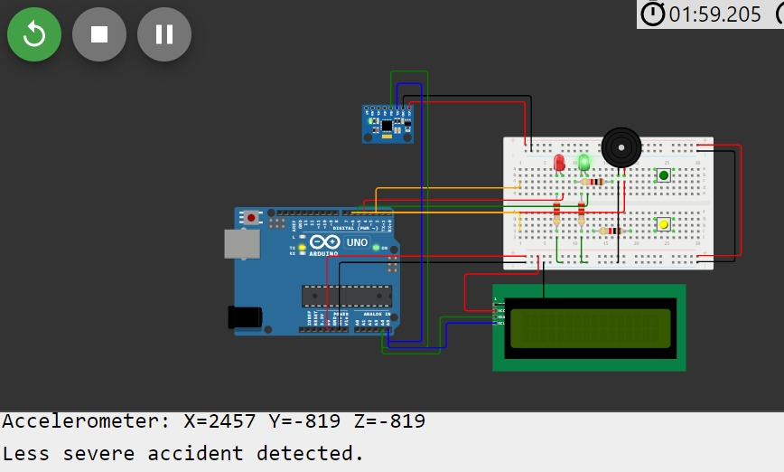

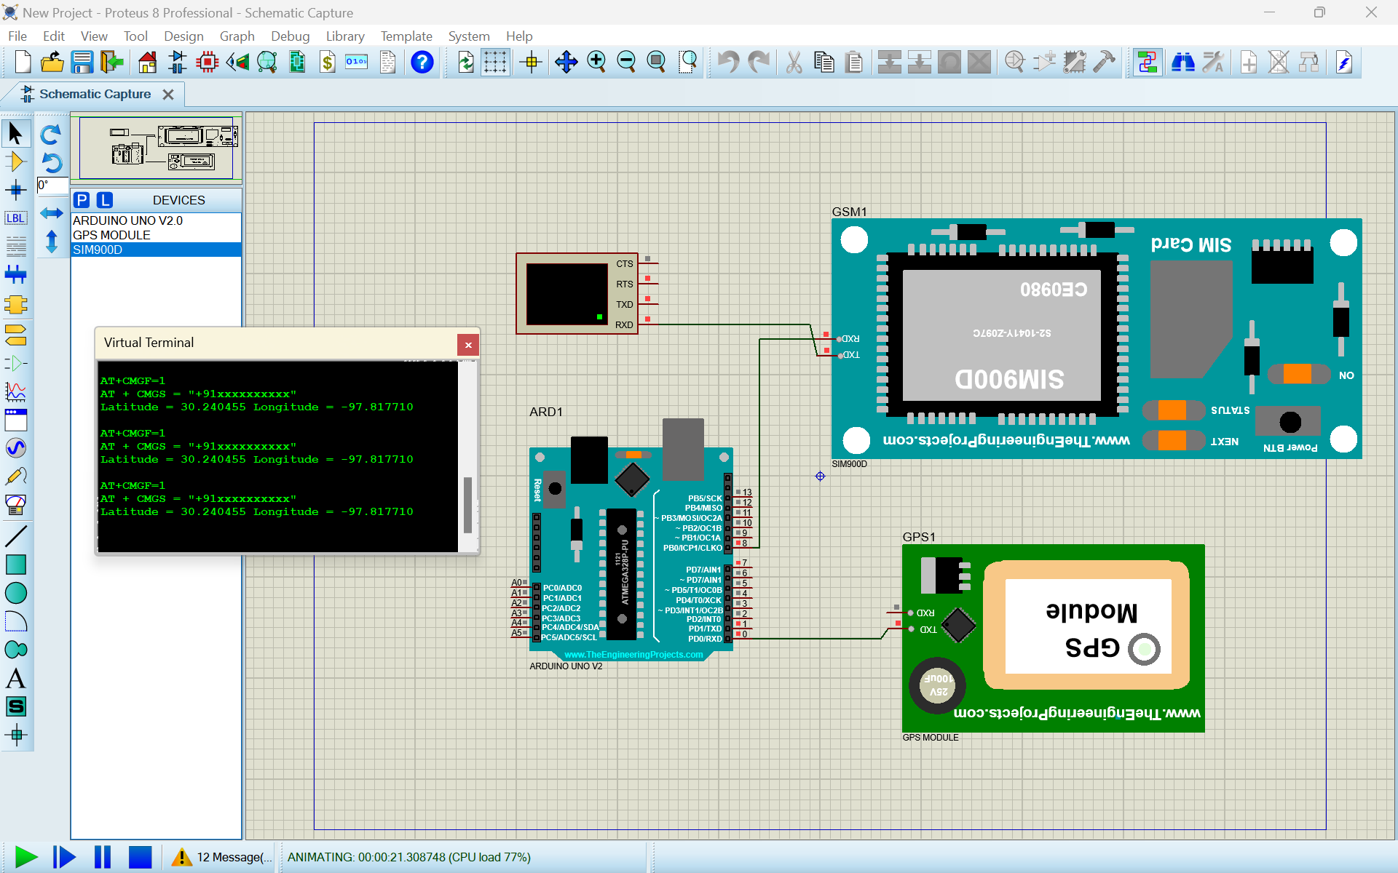

Communication system on proteus

# Experimental Setup

**4.1. Implementation Details**:

**Hardware and Sensors**:

* **Micro Controller**: It will take decisions on basis of given input and output as according to sensor outputs it will be performing certain tasks correspondingly.
* **Gyroscope and Accelerometer**: They are connected to sense sudden change in speed and angular direction of the car indicating some mishap.
* **Camera**: To get shots the vehicle that are to be fed to model to confirm if the mishap has occurred.
* **GSM module**: It will enable devices to communicate over a mobile network. When the accident is detected and confirmed it will help this to communicate to authorities.

**Models:**

**YOLOv8**: A pretrained model to detect if an accident has occurred or not. This model is trained with about 4000 pictures of car accidents, with half depicting actual accidents and the other half depicting non-accident scenarios. YOLOv8 processes the entire image and divides it into a grid, where each cell is responsible for detecting objects. It uses advanced architecture and computational techniques to enhance object detection accuracy and speed. After making predictions based on the training data it filters out its results.

**SAHI**: SAHI is an advanced technique for object detection. It can detect small objects which might be missed while working with models like YOLO. It enables selective processing of the parts in the image where probability of accident is more.

**Dataset**

Dataset link from Kaggle: <https://www.kaggle.com/datasets/amedeograndi/accidents-detection-dataset>

|  |  |  |  |  |
| --- | --- | --- | --- | --- |
| Train | Test | Validation | Total | Total |
| 649 | 649 | 1004 | 12.1 K | 10500 |

* Train --> 10469 images and labels (86%) used during the training process
* Valid --> 1004 images and labels (8%) used to validate the model during the training process
* Test --> 649 images and labels (5%) used after the neural network has been trained to understand if the training process has been conducted in the correct way or not

The data set for this accident detection project consists of images which are labelled and the data obtained from dashboard cameras, and data from accelerometers, gyroscopes, as well as GPS modules. The image data encompasses different drive cases while the sensor data logs instances like dynamic impacts and change of motion of the vehicle. Such annotations involve the level of accident observance, objects involved (vehicles and pedestrians), accurate GPS coordinates. This dataset assists in training algorithms so as to find accident occurrences, their seriousness and initiate the right alarms.

**Table 1: Implementation Details**

|  |  |  |  |  |
| --- | --- | --- | --- | --- |
| **Hardware** | Arduino UNO    The Arduino Uno is a microcontroller board based on the Atmel's ATmega328  The Arduino Uno original contains everything needed to support the microcontroller, simply connect it to a computer with a USB cable | Pi Camera    The Raspberry Pi Camera Board is a custom designed add-on module for Raspberry Pi hardware.   It attaches to Raspberry Pi hardware through a custom CSI interface. The sensor has 5 megapixel native resolution in still capture mode. | Microcontroller  A diagram of a microchip  Description automatically generated  The **microcontroller** acts as the central processing unit.  It continuously collects data from sensors like the accelerometer and gyroscope to detect sudden changes that indicate an accident. Upon confirming an incident, it activates alarms and communicates with the GPS module to obtain the vehicle's location. |  |
| **Sensors** | GPS  A circuit board with wires  Description automatically generated  GPS, or Global Positioning System.  It consists of a GPS receiver that communicates with satellites to determine the exact geographic location of a device on Earth. The receiver processes signals from multiple satellites to calculate its position, speed, and time. | GSM  A diagram of a circuit board  Description automatically generated  The GSM module is triggered to send an emergency alert.  The **GSM module** sends this information via **SMS or voice call** to emergency services (like the police or hospitals), as well as to the victim's predefined contacts. It ensures that alerts are transmitted in real-time, which is critical for reducing the response time of rescue teams. |  |  |
| **Sensors** | Vibration sensor    Vibration sensors are devices that detect vibration, shock, and sound.  They can be used to detect problems before they happen.  Vibration sensors work by detecting the motion of a material or object by sensing its frequency. The faster the movement, the higher the frequency detected on a vibration sensor. | Accelerometer  A circuit board with wires  Description automatically generated  It is a tool that measures the acceleration of any body or object in its instantaneous rest frame.  An accelerometer works by utilizing an electromechanical sensor that is designed to measure either static or dynamic acceleration. | Gyroscope     A gyroscope sensor measures angular velocity or tilt of an object by detecting rotation rate.  The sensor works by applying the rotational motion to a crystal element, which generates a Coriolis force that acts on the drive arms |  |
| **Models** | YoloV8n  It stands for “You Only Look Once,” meaning it can identify all objects in an image with just a single forward pass.  It can handle diverse tasks beyond object detection, like instance segmentation, pose estimation, and classification. | SAHI  Slicing Aided Hyper Inference is a technique developed to tackle the challenge of small object detection.  It offers a robust and efficient solution for small object detection. By integrating slicing in the fine-tuning and inference stages, thus enhance the network’s ability to effectively handle the challenges posed by small objects, leading to significant improvements in object detection performance. |  |  |

**4.2. Experimental Results**

|  |  |  |  |  |  |  |
| --- | --- | --- | --- | --- | --- | --- |
| s.no | Accelerometer reading in x-axis | Accelerometer reading in y-axis | Accelerometer reading in z-axis | Gyroscope reading | Meaning | result |
| 1. | 0 | 0 | 0 | 0 | No accident | No led on+ no buzzer |
| 2. | 819 | -819 | -819 | 200 | No accident | No led on+ no buzzer |
| 3. | 2473 | -487 | 2376 | 250 | Less severe accident | Green light |
| 4. | 4502 | -3467 | 234 | 450 | Less severe accident | Green light |
| 5. | 3023 | 200 | -782 | 500 | Less severe accident | Green light |
| 6. | 6373 | -768 | 300 | 545 | Severe accident | Red light+ buzzer active |
| 7. | 15564 | -8146 | 723 | 765 | Severe accident | Red light+ buzzer active |
| 8. | 12398 | 6543 | 2347 | 654 | Severe accident | Red light+ buzzer active |

**GRAPHS**

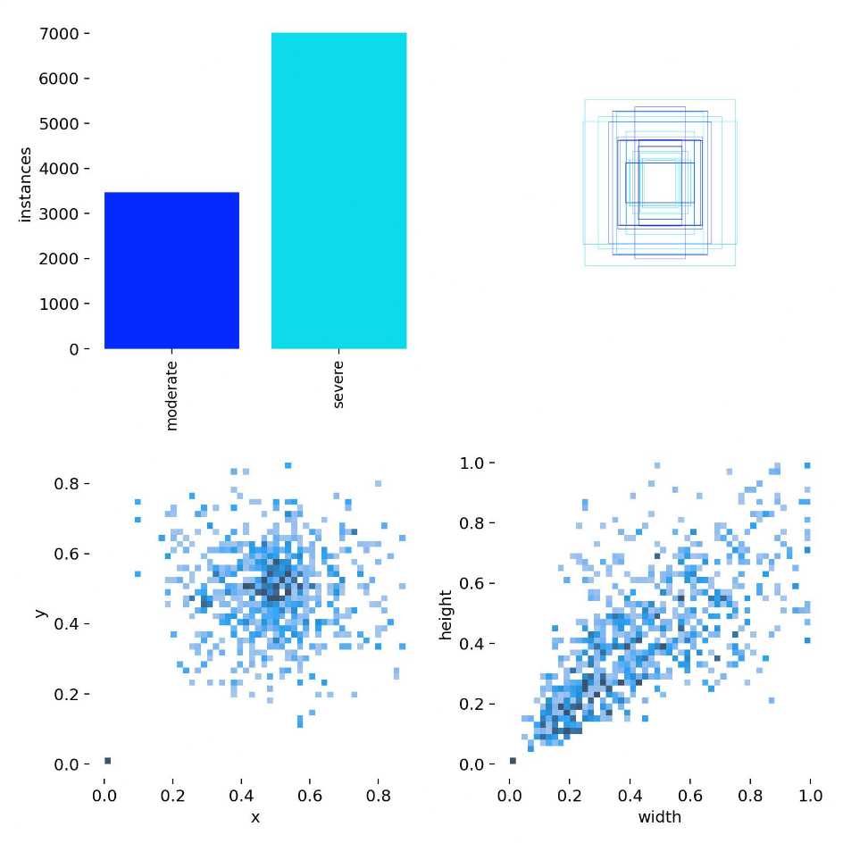

label

**Metrics:**

mAP 50% IoU is the mean Average Precision at 50% Intersection over Union, which is a measure of how accurate the model is at detecting objects, and the graph shows that, MAP starts out very low and increases dramatically at the beginning of the training as the model becomes more accurate, and after about 10 steps, it levels off to around 0.9. That means that the model is very accurate and consistent in recognizing objects, which is very important in the project when it comes to dependable crash detection.

**Train:**

As illustrated by the graph, DFL gradually decreases over the course of the training steps, which shows that prediction errors have been reduced by the system. The loss began at roughly 1.3, then drops steadily as the model learns. Around step 40, there is a substantial plunge toward rapid decrease- thus indicating the model is trickling steadily toward its optimum and exceptionally reducing errors in its predictions. This trend identifies training as being successful in exertion of accuracy to be achieved progressively.

This next graph represents the training progress of the classification loss which is commonly termed as cls_loss, and as we can clearly see this continues to decrease steadily across the training process. At the start, the lost is nearly 2.0, so there are high mistake rates in object identification, but it rapidly decreases as soon as the model is trained. At step 50, the loss for training lies below 0.2, which proves that the model is successfully classifying the objects with negligible mistakes which proves that training process has been conducted successfully.

The graph shows how the "box loss" goes down during the training process, indicating the improvement of the model in predicting outlying boxes Initially the loss is high, indicating incorrect prediction. As training proceeds over more steps, the loss gradually decreases, indicating that the model becomes smaller and more accurate in its predictions and that with later training steps, the box loss becomes minimal which implies awareness of the ubiquitous. Such measures indicate that the training was successful, which is the main source of observations in the project

**SAHI Inference**

 SAHI is a technique for running inference on a computer vision model which aids in detecting smaller objects in an image.

Its core functionality lies in partitioning images into manageable slices, running object detection on each slice, and then stitching the results back together. SAHI is compatible with a range of object detection models, including the YOLO series, thereby offering flexibility while ensuring optimized use of computational resources.

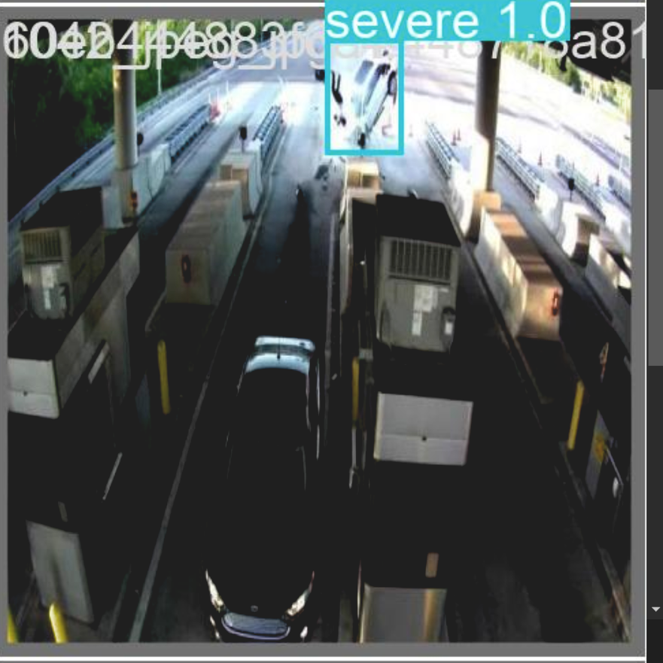 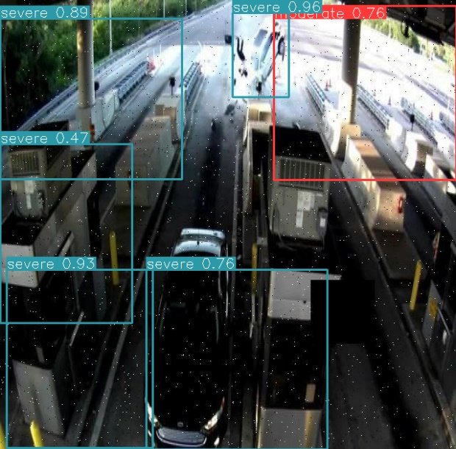

YOLO result image SAHI Inference result

* YOLO result text file



1. **Comparison with the Existing Work**

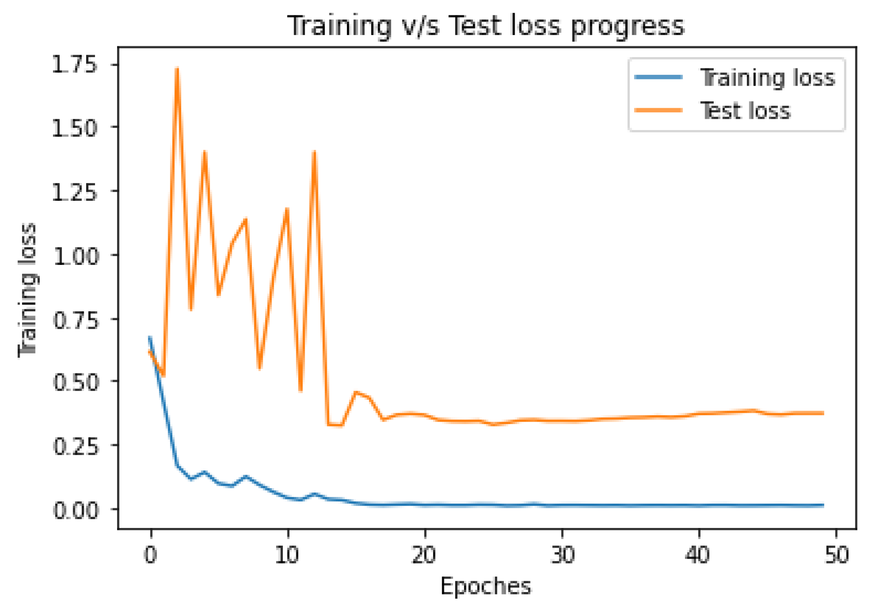Previous work

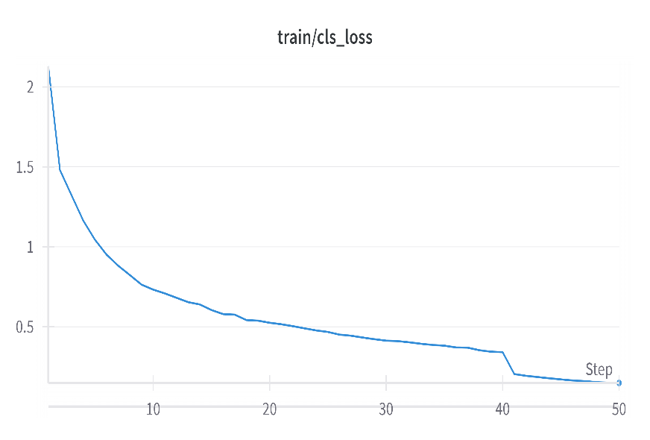 YOLO project

1. **Conclusion and Future Work** **Conclusion**: The Accident Detection & Alert System is an innovative introduction to road safety whose main aim is to save lives it can be the help of providing intelligent rapid and accurate emergency alerts. By using sensors such as GPS, GSM accelerometer and gyroscope our system determines if an accident has been occurred or not intelligent way that we perform by designing YOLO real-time object detection. This service automatically alerts emergency services and family to ensure prompt assistance reaches the victims. Since it is a system that combines high-tech sensors with advanced algorithms, this way of working can be very practical seems to be scalable and cost-effective which will translate into helping save lives on the road. The mAP of the model comes out to be 0.91, which speaks of the high precision in detecting & classifying different objects and confirming the occurrence or non-occurrence of an accident. **Future Work**: Built using AI-based predictive analytics can prevent the accidents in future, Cloud storage data that provides real-time analysis and vehicle-vehicle communication to get instant alerts. On the other hand, further supplementing it with biometric sensors for monitoring drivers' heartbeats if they were to spot a hazard, and autonomous emergency responses in self-driving cars and image recognition capabilities that can detect secondary hazards would make them even better suited at being proactive as well as reactive in ensuring road safety.

# References

|  |  |
| --- | --- |
| [1] | WHO, “World Health Organization (WHO) - Global status report on road safety 2023,” 13 12 2023. [Online]. Available: https://www.who.int/teams/social-determinants-of-health/safety-and-mobility/global-status-report-on-road-safety-2023. |
| [2] | ITF, “ITF - Preparation of the 2023 edition and update on the country chapters,” 8 01 2024. [Online]. Available: https://www.itf-oecd.org/sites/default/files/2-mignot-irtad-2023-annual-report_0.pdf. |
| [3] | D. IAS, “Drishti IAS - Global Status Report on Road Safety 2023: WHO,” 14 12 2023. [Online]. Available: https://www.drishtiias.com/daily-updates/daily-news-analysis/global-status-report-on-road-safety-2023-who. |

[4] Pathik, Nikhlesh, Rajeev Kumar Gupta, Yatendra Sahu, Ashutosh Sharma, Mehedi Masud, and Mohammed Baz. "Ai enabled accident detection and alert system using iot and deep learning for smart cities." *Sustainability* 14, no. 13 (2022): 7701.

[5] Gomathy, C. K., K. Rohan, Bandi Mani Kiran Reddy, and V. Geetha. "Accident detection and alert system." *Journal of Engineering, Computing & Architecture* 12, no. 3 (2022): 32-43.

[6] Bari, Abdulkadir Shehu, Muhammad Abubakar Falalu, Muhammad Auwal Umar, Yakubu Yunusa Sulaiman, A. M. Gamble, and M. A. Baballe. "Accident Detection and Alerting Systems: A Review." *Global Journal of Research in Engineering & Computer* (2022).

[7] Chaudhari, Arnav, Harsh Agrawal, Smiti Poddar, Kiran Talele, and Manisha Bansode. "Smart accident detection and alert system." In *2021 IEEE India Council International Subsections Conference (INDISCON)*, pp. 1-4. IEEE, 2021.

[8] Doshi, Aayush, A. B. Shah, and Jubin Kamdar. "Accilert-accident detection and alert system." *International Journal of All Research Education and Scientific Methods (IJARESM)* 9, no. 11 (2021): 114-119.

[9] Raffik, R., M. Michael Jones, T. Murugajothi, and B. Kannadasan. "Intelligent accident detection and smart alert system for vehicles." *International Journal of Mechanical Engineering* 6, no. 3 (2021): 2391-2396.

[10] Kattukkaran, Nicky, Arun George, and TP Mithun Haridas. "Intelligent accident detection and alert system for emergency medical assistance." In *2017 international conference on computer communication and informatics (ICCCI)*, pp. 1-6. IEEE, 2017.

[11] Kodali, Ravi K., and Shubhi Sahu. "MQTT based vehicle accident detection and alert system." In *2017 3rd International Conference on Applied and Theoretical Computing and Communication Technology (iCATccT)*, pp. 186-189. IEEE, 2017.

[12]

[13] Basheer, Fahim Bin, Jinu J. Alias, C. Mohammed Favas, V. Navas, Naveed K. Farhan, and C. V. Raghu. "Design of accident detection and alert system for motor cycles." In *2013 IEEE global humanitarian technology conference: South Asia satellite (GHTC-SAS)*, pp. 85-89. IEEE, 2013.