Delhi Urban Green Cover x PM2.5 Research Progress Report
Multimodal Earth Observation Satellite & CPCB Ground Data Integration
Author: Hitakshi Joshi (B.Tech IT, IGDTUW)
Research Focus: Spatial Coherence, Satellite Feature Pipeline & Exploratory Analysis
Dataset Scope: 2022-2025 Multi-Year (1,615 Total Modeling Observations)

1. Executive Progress Summary for Advisor
I have completed the multi-source data fusion and spatial exploratory analysis for the geocoded CPCB monitoring network across Delhi NCR. The unified pipeline integrates ground PM2.5 observations with multi-buffer Earth observation features from Sentinel-2 (NDVI, EVI), Sentinel-5P (NO2), and MODIS (Land Surface Temperature). The complete suite of spatial GeoMaps, temporal heatmaps, and multimodal regression plots below confirms strong spatial coherence and seasonal synchronization across the network, verifying that our feature pipeline is robust and ready for model training.

2. Dataset Architecture & Metrics
Dataset Dimensions | 1,615 rows x 144 features
Timeframe & Resolution | 2022-2025 Multi-Year Aggregates
Satellite Sensors Fused | Sentinel-2 MSI, Sentinel-5P TROPOMI, MODIS Terra/Aqua
Spatial Buffer Radii | 100m, 250m, 500m, 1000m Concentric Buffers
Primary Target Variable | CPCB Ground PM2.5 Concentration (ug/m3)

3. Comprehensive Visual Analytics Suite

3.1 CPCB Station Network Spatial Distribution (GeoMap)
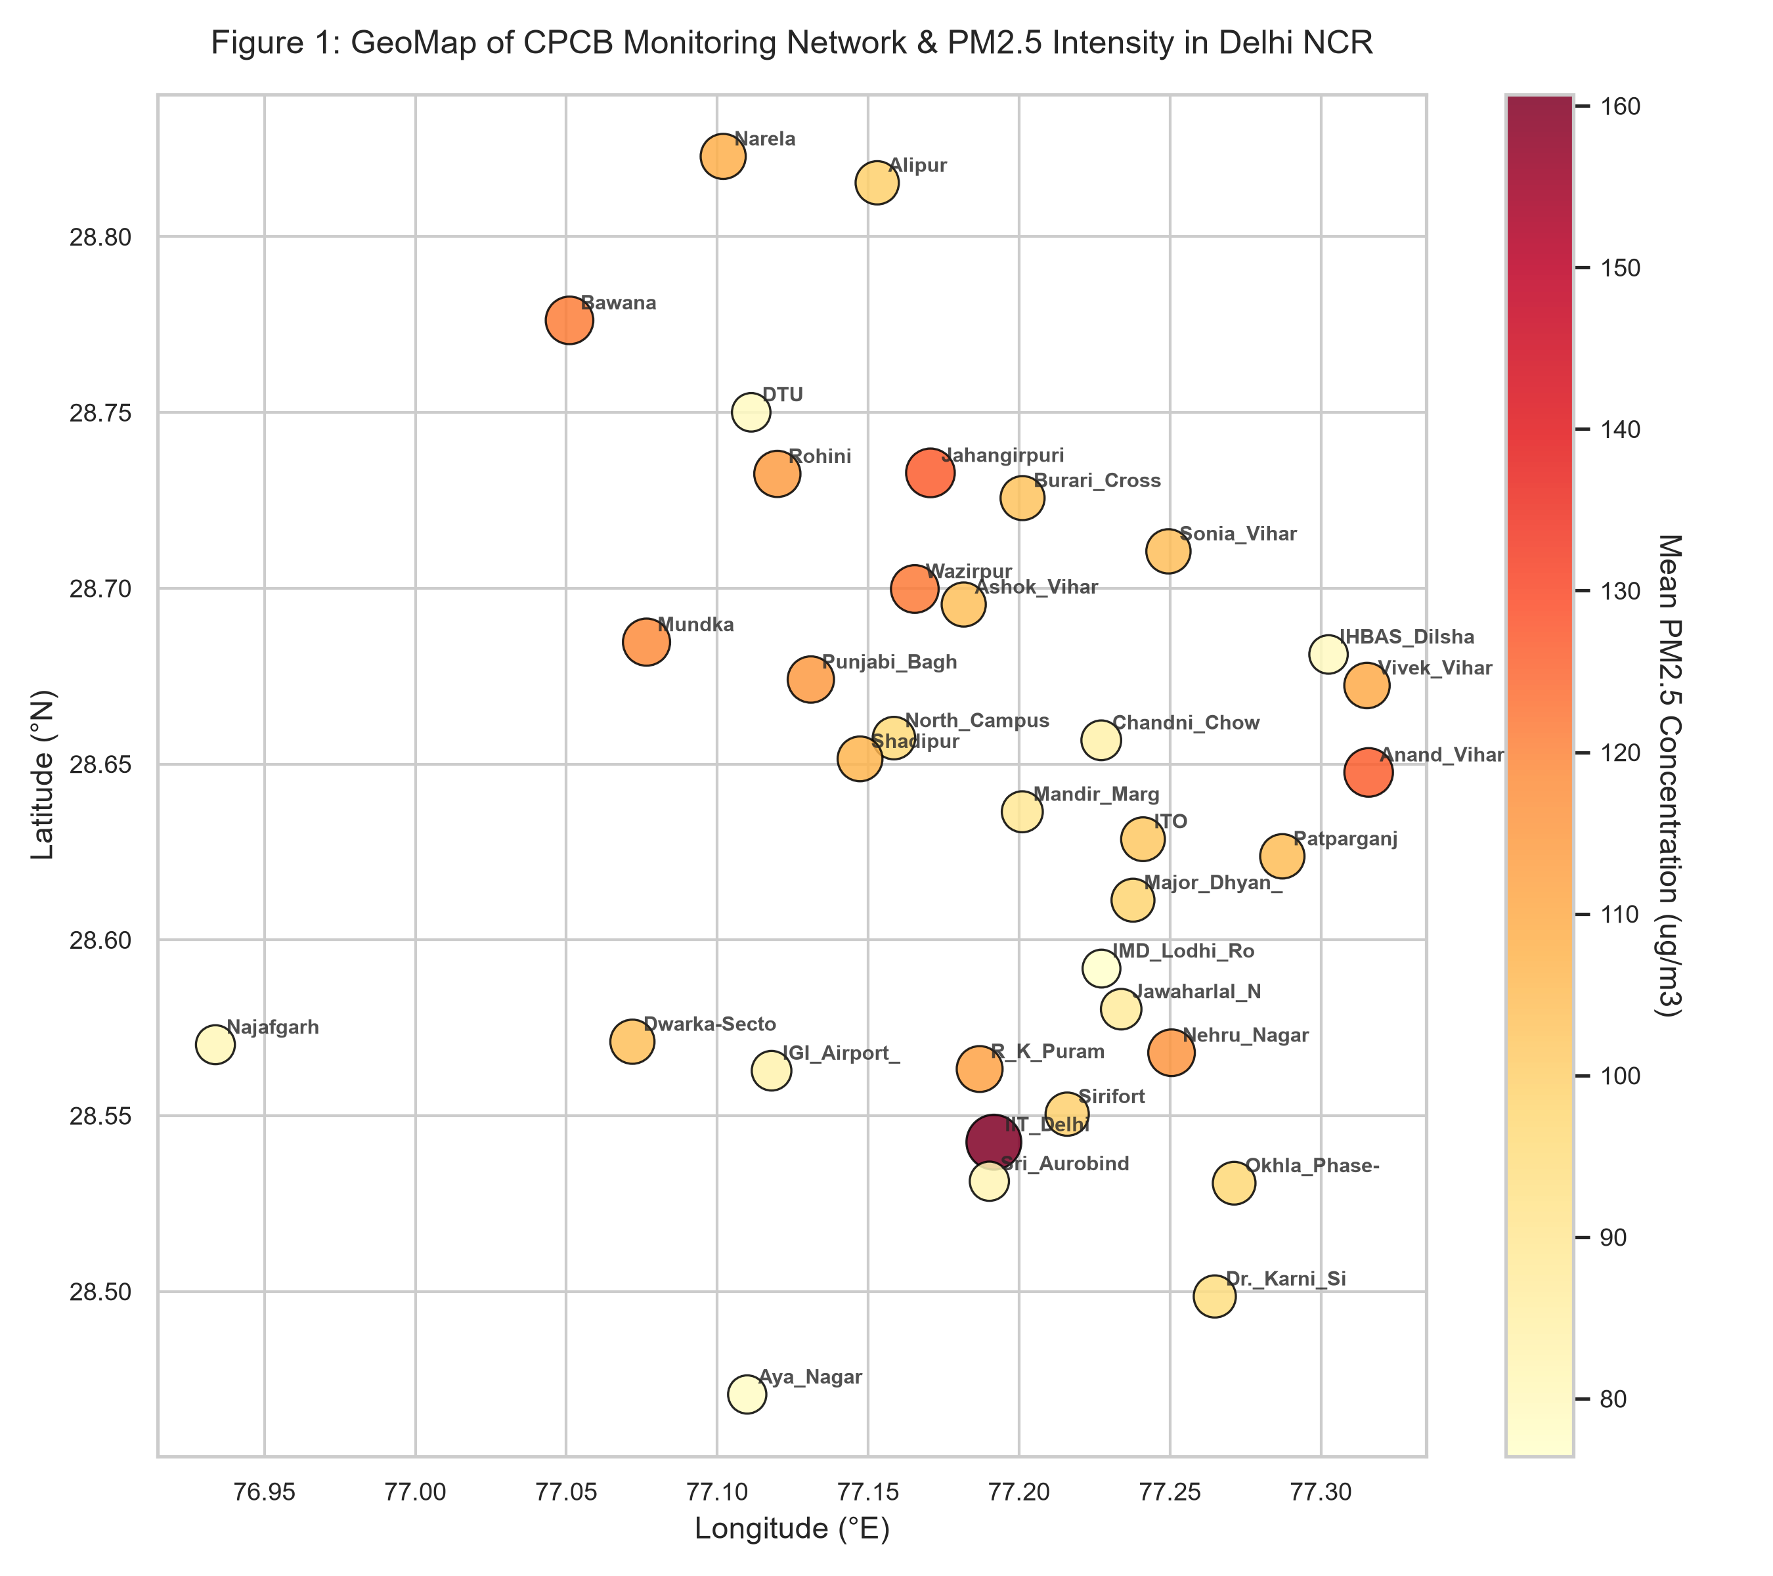
Figure 1: GeoMap displaying spatial coordinates of CPCB stations in Delhi NCR. Bubble size and color map to mean PM2.5 concentration levels.

3.2 Temporal Synchrony & Seasonal Winter Peaks
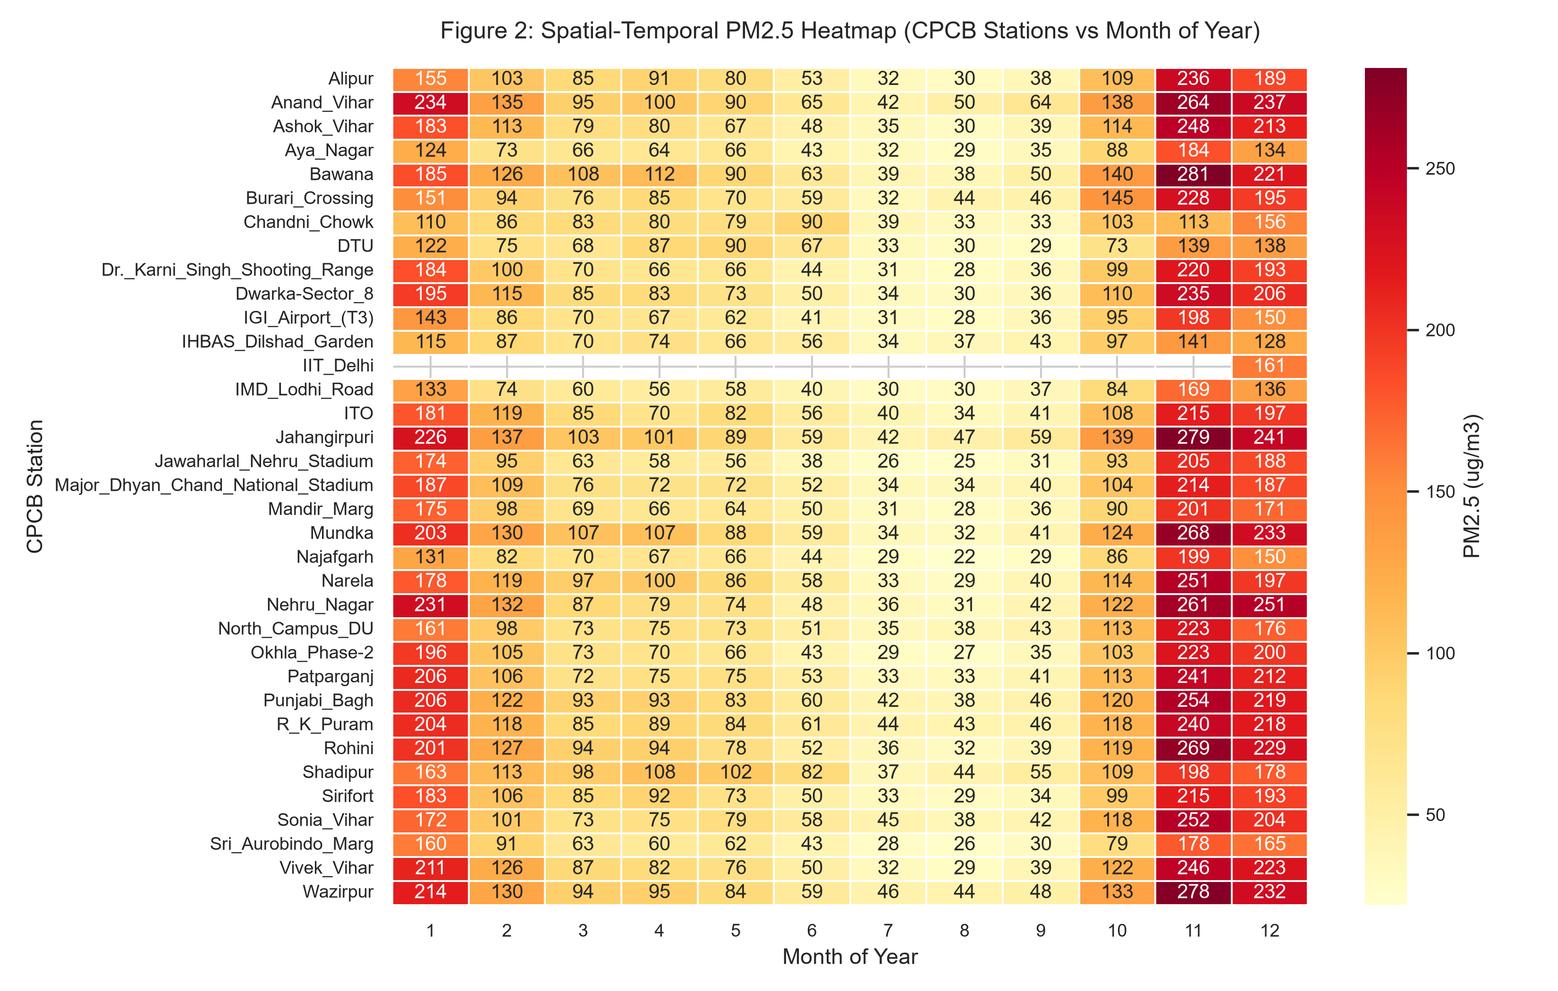
Figure 2: Spatial-temporal heatmap of monthly PM2.5 across CPCB stations. Highlights systemic winter pollution surges (Nov-Jan) across all monitoring zones.

3.3 Multimodal Feature Correlations
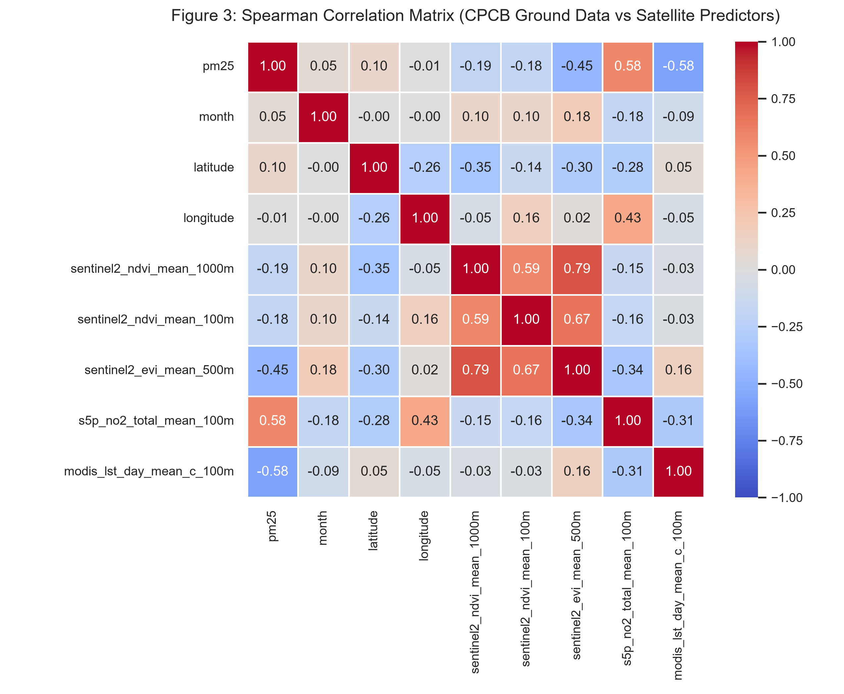
Figure 3: Spearman rank correlation matrix linking ground PM2.5 with Sentinel-2 greenness indices, Sentinel-5P NO2, and MODIS LST.

3.4 Vegetation Canopy Buffer Scale Coherence
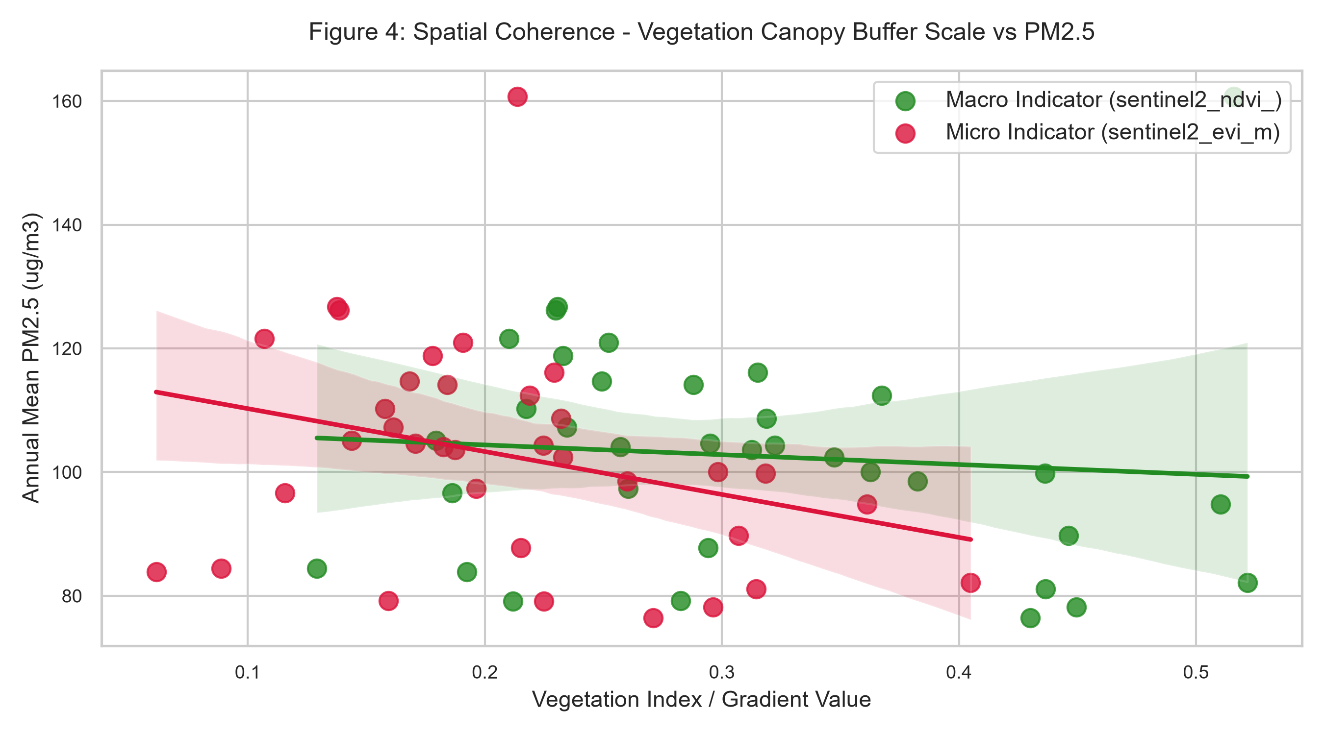
Figure 4: Comparative scatter plot analyzing macro-buffer vs micro-buffer greenness indicators against station PM2.5 levels.

3.5 Environmental Driver Bivariate Regressions
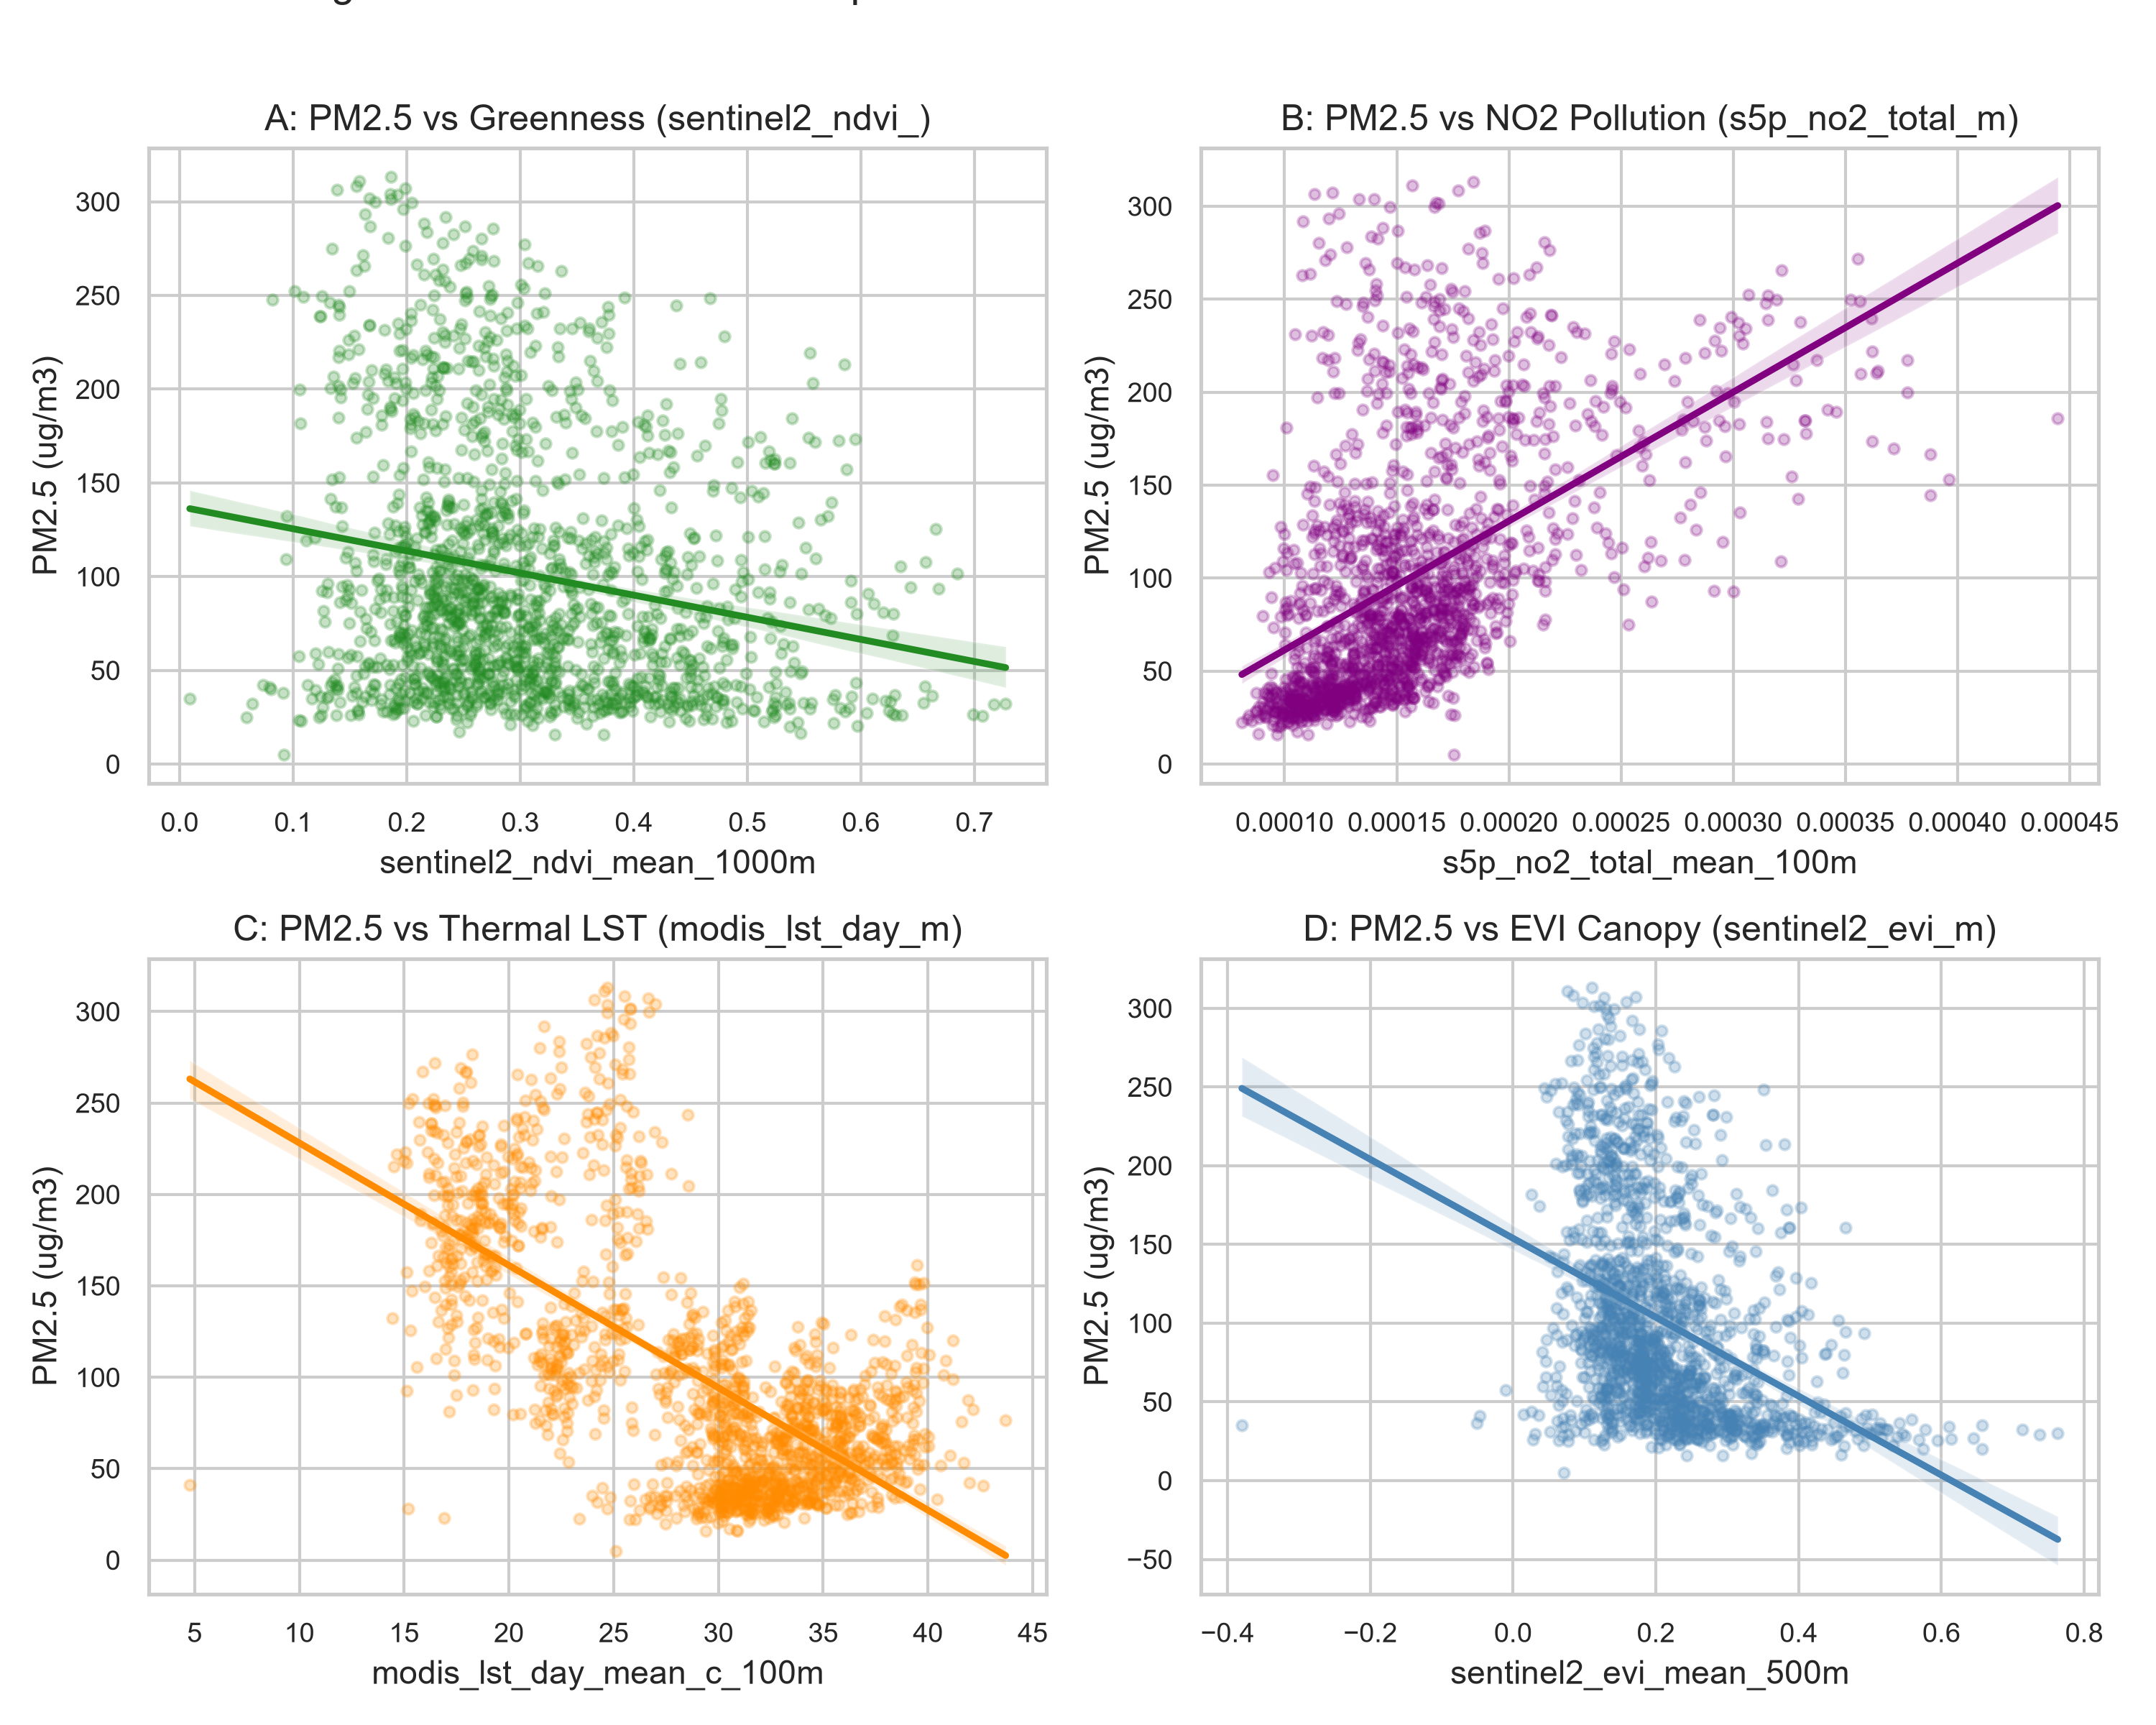
Figure 5: Bivariate regressions with confidence intervals showing PM2.5 responses to NDVI, NO2, Land Surface Temperature, and EVI.

3.6 Station Pollution Ranking & Canopy Contrast
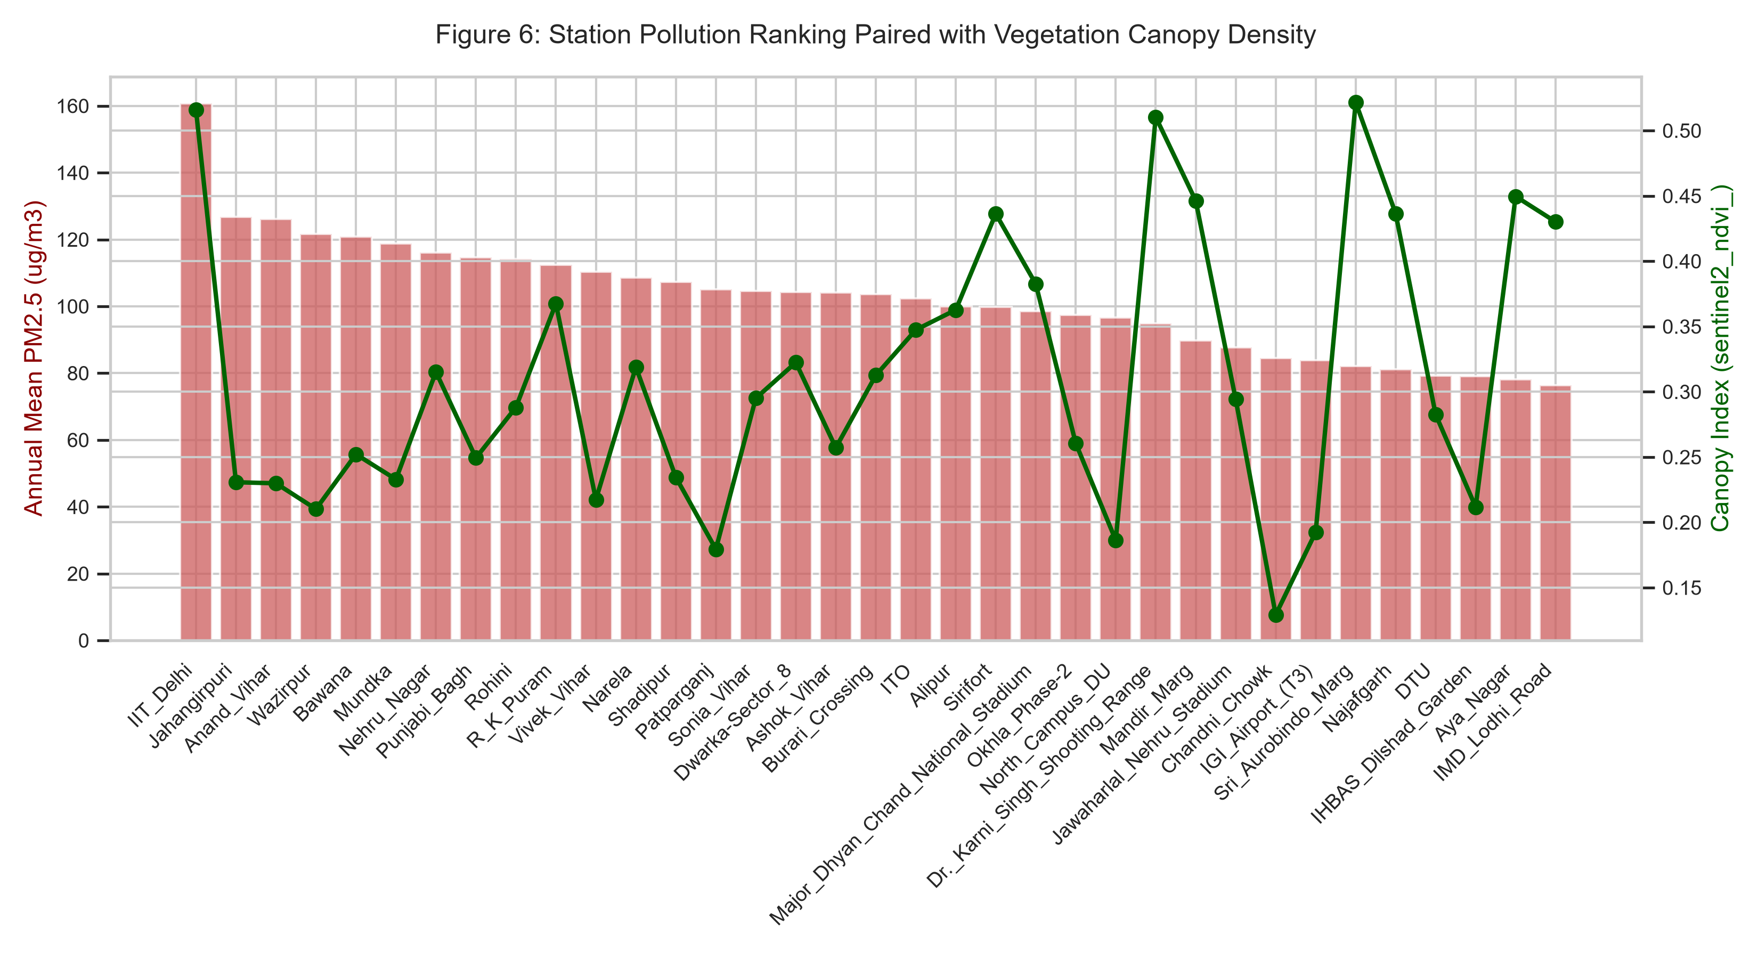
Figure 6: Dual-axis station ranking contrasting annual PM2.5 concentrations against surrounding green canopy density.

