**1)** #include <stdio.h>

1. int main() {
2. int num, binary[32], i = 0;
3. printf("Enter a number: ");
4. scanf("%d", &num);
5. if (num == 0) {
6. printf("Binary representation: 0\n");
7. return 0;
8. }
9. while (num > 0) {
10. binary[i] = num % 2;
11. num = num / 2;
12. i++;
13. }
14. printf("Binary representation: ");
15. for (int j = i - 1; j >= 0; j--) {
16. printf("%d", binary[j]);
17. }
18. printf("\n");
19. return 0;
20. }

**OUTPUT:**

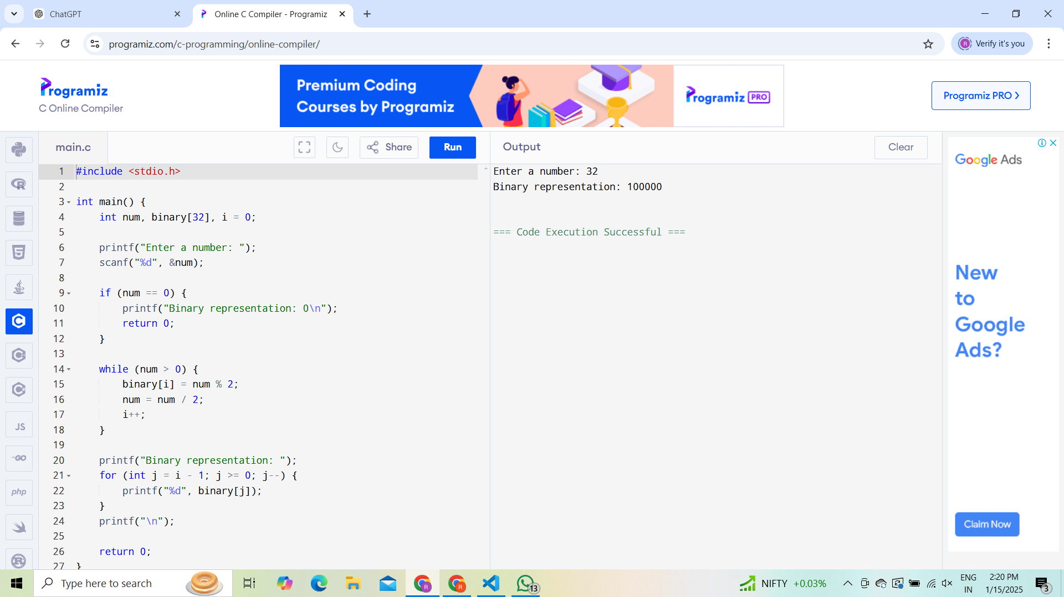

**2)**

1. #include <stdio.h>
2. #include <ctype.h>
3. int main() {
4. char str[100], *ptr;
5. int vowels = 0, consonants = 0;
6. printf("Enter a string: ");
7. fgets(str, 100, stdin);
8. ptr = str;
9. while (*ptr != '\0') {
10. char ch = tolower(*ptr);
11. if (ch >= 'a' && ch <= 'z') {
12. if (ch == 'a' || ch == 'e' || ch == 'i' || ch == 'o' || ch == 'u') {

vowels++;

1. } else {

consonants++;

1. }
2. }
3. ptr++;
4. }
5. printf("Vowels: %d, Consonants: %d\n", vowels, consonants);
6. return 0;
7. }

**OUTPUT:**

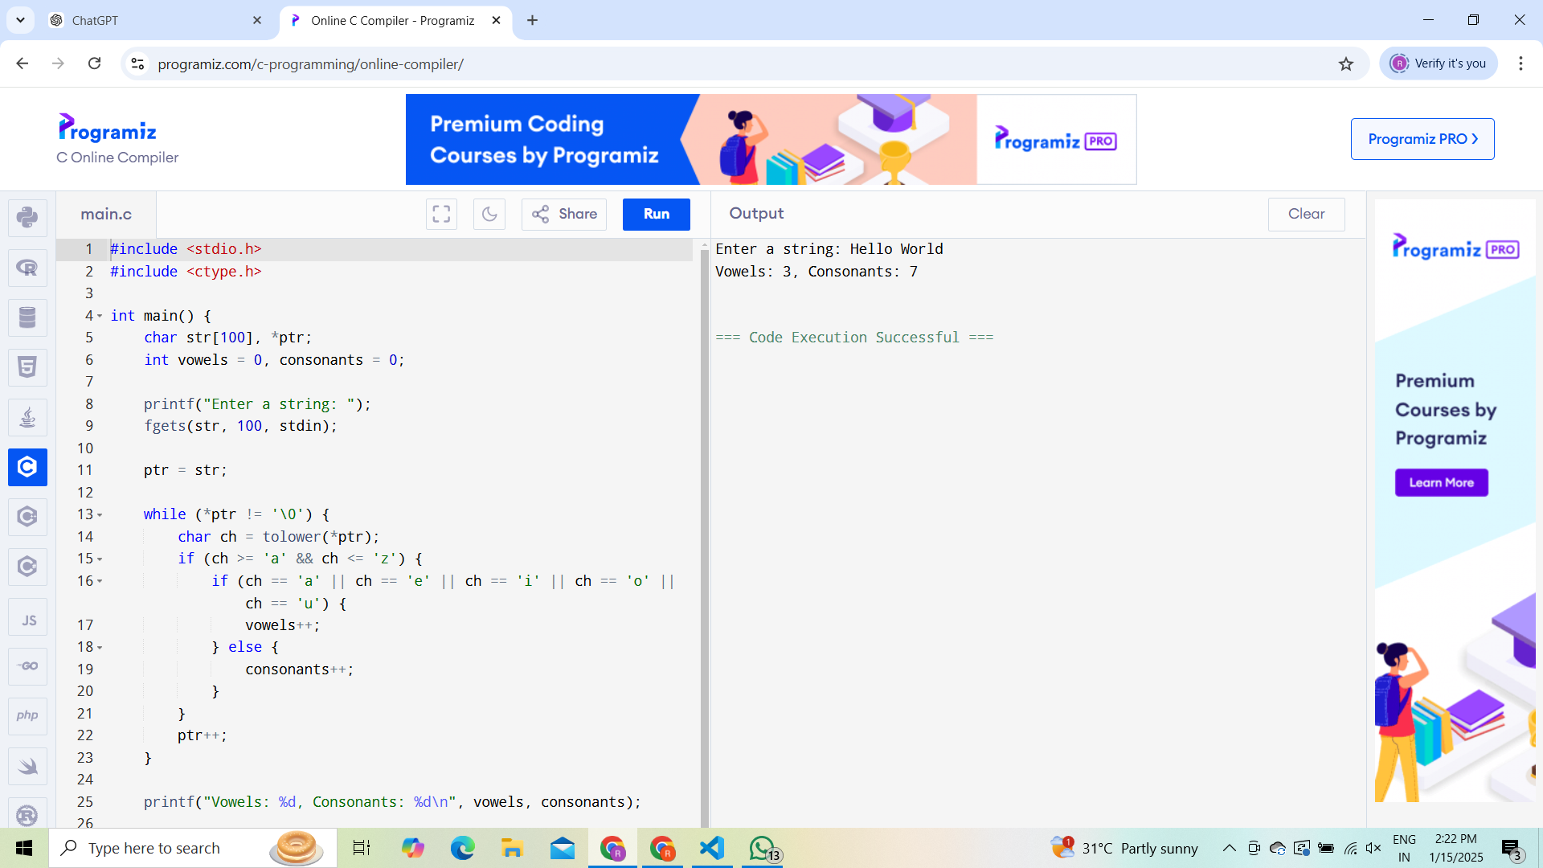

**3)**

1. #include <stdio.h>
2. void add(int a, int b) { printf("Sum: %d\n", a + b); }
3. void subtract(int a, int b) { printf("Difference: %d\n", a - b); }
4. void multiply(int a, int b) { printf("Product: %d\n", a * b); }
5. void divide(int a, int b) {
6. if (b != 0)
7. printf("Quotient: %d\n", a / b);
8. else
9. printf("Division by zero is not allowed.\n");
10. }
11. int main() {
12. int choice, a, b;
13. do {
14. printf("\nMenu:\n1. Add\n2. Subtract\n3. Multiply\n4. Divide\n5. Exit\n");
15. printf("Enter your choice: ");
16. scanf("%d", &choice);
17. if (choice >= 1 && choice <= 4) {
18. printf("Enter two numbers: ");
19. scanf("%d %d", &a, &b);
20. }
21. switch (choice) {
22. case 1: add(a, b); break;
23. case 2: subtract(a, b); break;
24. case 3: multiply(a, b); break;
25. case 4: divide(a, b); break;
26. case 5: printf("Exiting...\n"); break;
27. default: printf("Invalid choice!\n");
28. }
29. } while (choice != 5);
30. return 0;
31. }

**OUTPUT**

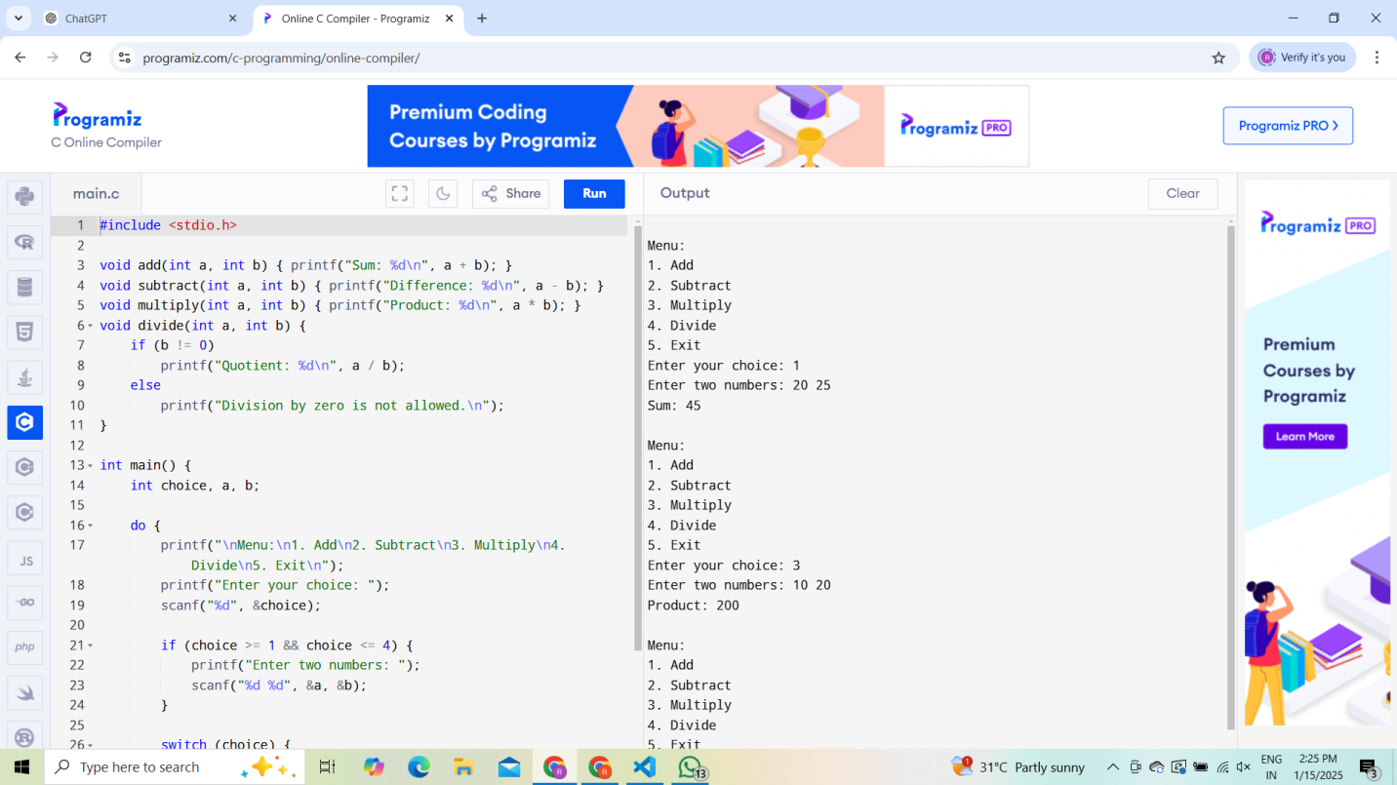

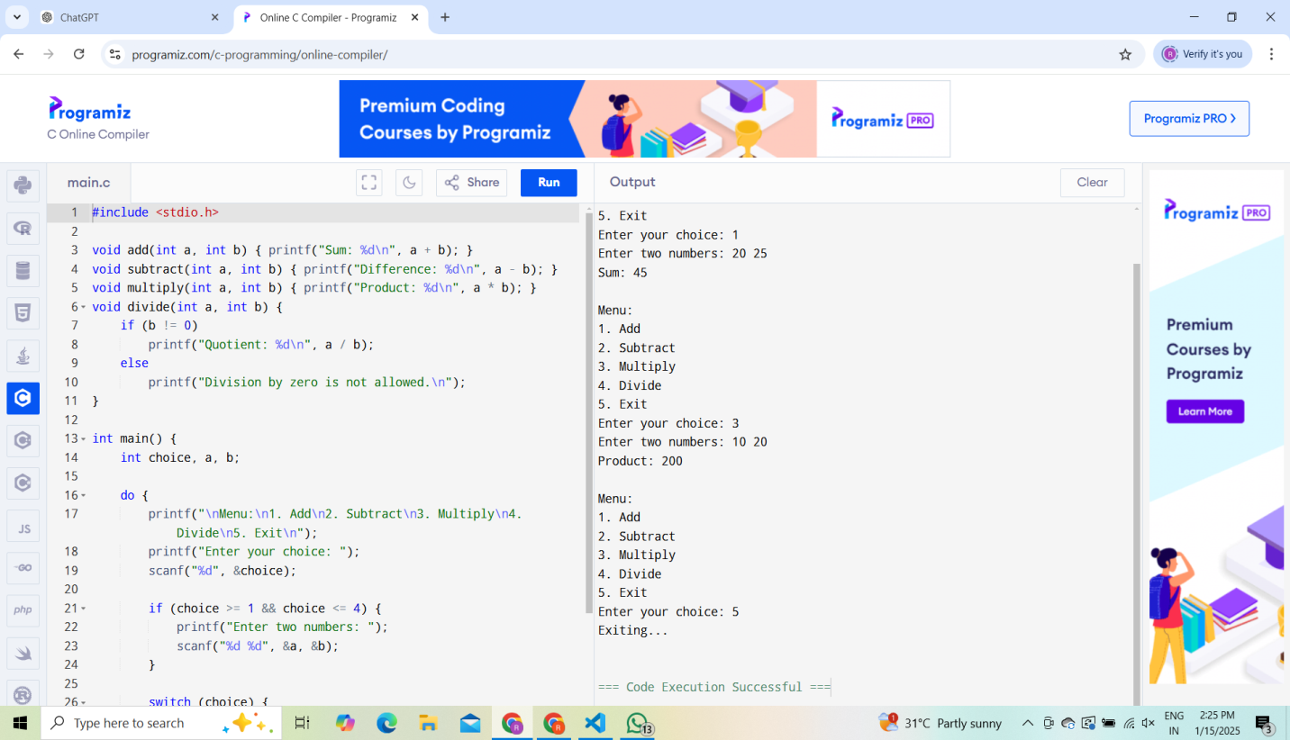

**4)**

1. #include <stdio.h>
2. int main() {
3. int n;
4. printf("Enter the number of rows for the diamond pattern: ");
5. scanf("%d", &n);
6. for (int i = 1; i <= n; i++) {
7. for (int j = i; j < n; j++) {
8. printf(" ");
9. }
10. for (int j = 1; j <= (2 * i - 1); j++) {
11. printf("*");
12. }
13. printf("\n");
14. }
15. for (int i = n - 1; i >= 1; i--) {
16. for (int j = n; j > i; j--) {
17. printf(" ");
18. }
19. for (int j = 1; j <= (2 * i - 1); j++) {
20. printf("*");
21. }
22. printf("\n");
23. }
24. return 0;
25. }

**OUTPUT:**

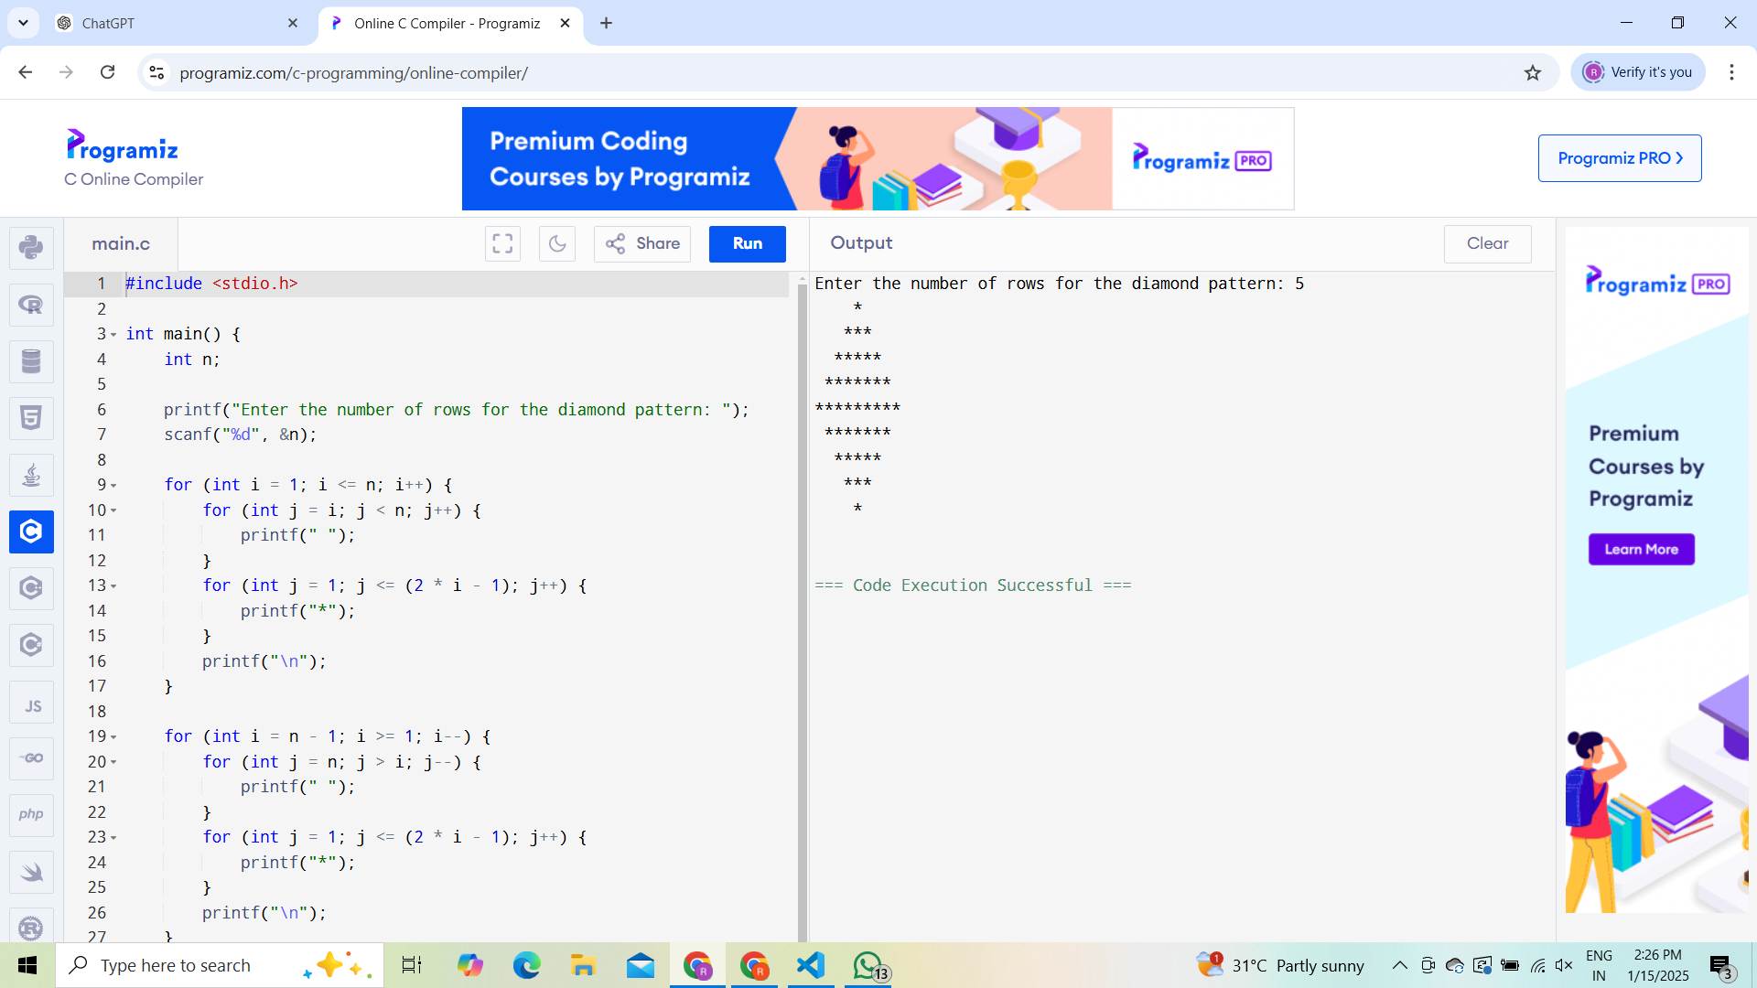

**5)**

1. #include <stdio.h>
2. int main() {
3. char str[100], *ptr;
4. int length = 0;
5. printf("Enter a string: ");
6. fgets(str, 100, stdin);
7. ptr = str;
8. while (*ptr != '\0') {
9. length++;
10. ptr++;
11. }
12. // Exclude the newline character
13. Length--;
14. printf("Length of the string: %d\n", length);
15. return 0;
16. }

**OUTPUT:**

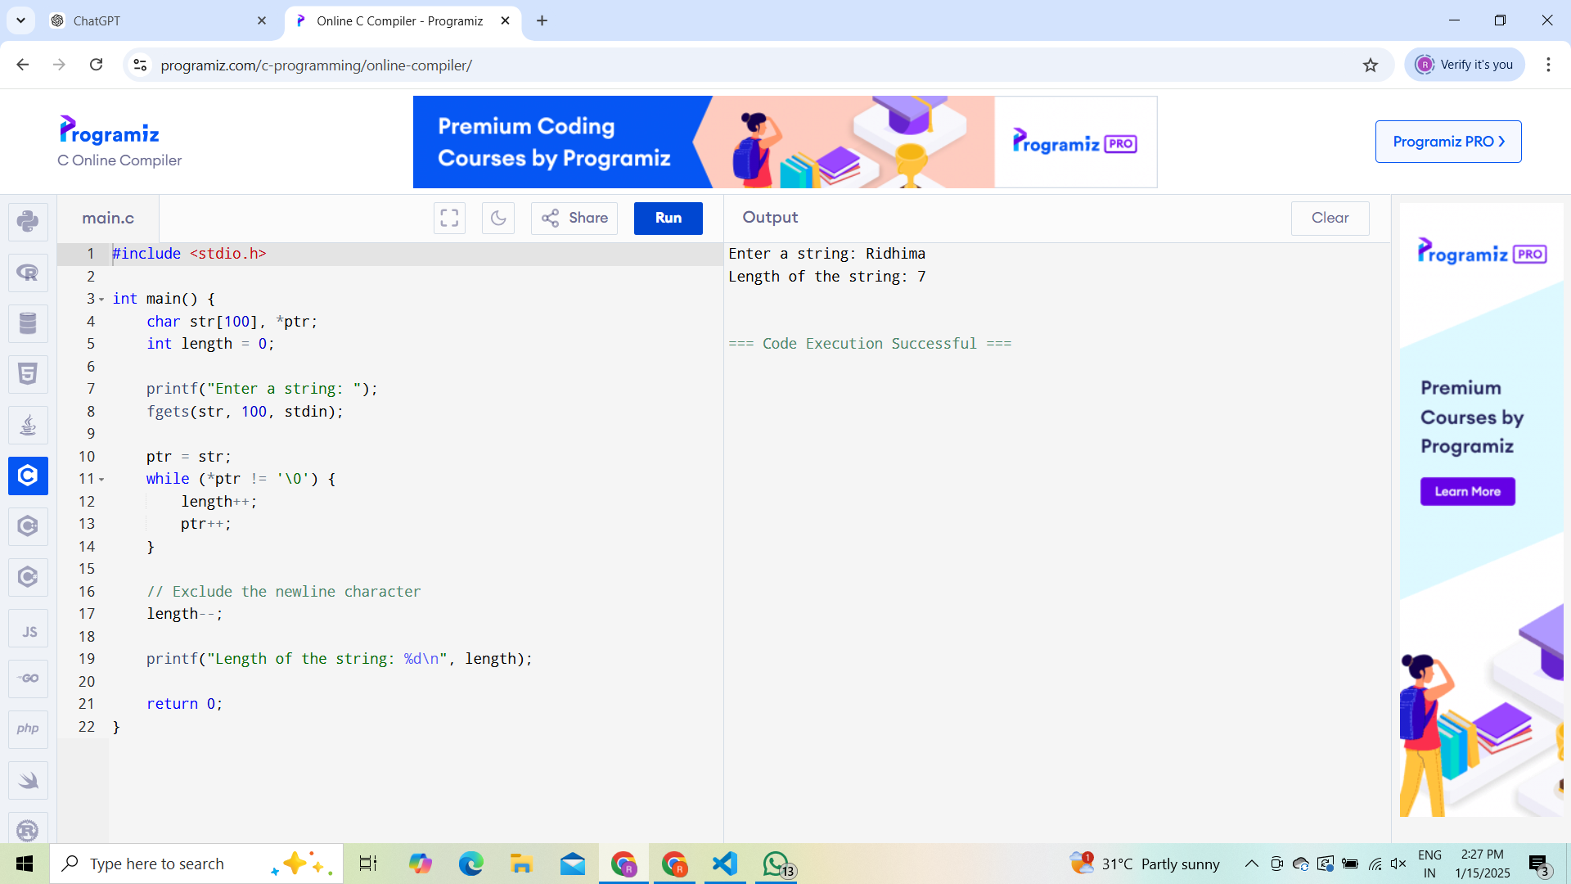

**6)**

1. #include <stdio.h>
2. int gcd(int a, int b) {
3. if (b == 0)
4. return a;
5. return gcd(b, a % b);
6. }
7. int main() {
8. int a, b;
9. printf("Enter two numbers: ");
10. scanf("%d %d", &a, &b);
11. printf("GCD is: %d\n", gcd(a, b));
12. return 0;
13. }

**OUTPUT:**

