Advanced web Technology
Lab Report
SESSION: 2024-27



SUBMITTED By : SUBMITTED To :
Name - RIDHI KUMARI Prof. Prateek Raj Guatam
Sap Id- 590018683
BCA 06

awt01

🧪 Experiment Summary
Experiment | Files Included | Description
Experiment 1 | D1.js, index.html, s.css | Basic HTML, CSS, and JavaScript integration
Experiment 2 | D2.js, index.html, s.css | DOM manipulation and jQuery-style scripting
Experiment 3 | app.js, index.html | JavaScript web app with dynamic functionality
Experiment 4 | bill.html, form.html | HTML form handling and billing layout
Experiment 5 | index.html, nodetest.js, server.js | Node.js basics — running a local server and file testing
Experiment 6 | package.json, server.js | Node.js app setup with npm and Express concepts
Experiment 7 | cokkie-example.js, session-example.js | Understanding cookies and session handling in Node.js

📘 Detailed Learnings

🔹 Experiment 1 – Basic Web Structure
What I learned: - How to structure a webpage using HTML. - Applying CSS for styling and layout. - Linking external JS and CSS files.
code

index.html
<!DOCTYPE html>
<html lang="en">
<head>
<meta charset="UTF-8">
<meta name="viewport" content="width=device-width, initial-scale=1.0">
<title>LAB EXP 1</title>
<script src="https://ajax.googleapis.com/ajax/libs/jquery/3.7.1/jquery.min.js"></script>
<link rel="stylesheet" href="s.css">
</head>
<body>
<div class="container">
<h1>1. Right-Click Disabled</h1>
<p>Try right-clicking anywhere on this page. The context menu will not appear.</p>
</div>
<hr>
<div class="container">
<h1>2. Show/Hide Message</h1>
<button id="showBtn">Show Message</button>
<button id="hideBtn">Hide Message</button>
<div id="messageDiv">
<p>Hello! This message can be hidden and shown using the buttons above.</p>
</div>
</div>
<hr>
<div class="container">
<h1>3. Paragraph Color Change on Hover</h1>
<p class="hover-para">This paragraph changes color.</p>
</div>
<hr>
<div class="container" style="height: 1200px;">
<h1>4. Scroll to Top</h1>
<p>Scroll down this page to see the image in the bottom-right corner. Clicking it will bring you back to the top of the page.</p>
</div>
<img src="C:\Users\hp\Pictures\Screenshots\Screenshot 2025-08-25 231221.png" alt="Scroll to Top" id="scrollToTopBtn">
<script src="d1.js"></script>
</body>
</html>

D1.js
$(document).on("selectstart", function(e) { e.preventDefault(); });
$(document).on("keydown", function(e) {
if (e.ctrlKey && e.keyCode === 67) e.preventDefault();
});
$(document).ready(function() {
// 1. Disable the right-click menu
$(document).on("contextmenu", function(e) {
e.preventDefault();
});
// 2. Display and hide a message
$("#showBtn").click(function() {
$("#messageDiv").show('slow');
});
$("#hideBtn").click(function() {
$("#messageDiv").hide('slow');
});
// 3. Change paragraph color on mouseover
$(".hover-para").mouseover(function() {
$(this).css("color", "red");
});
$(".hover-para").mouseout(function() {
$(this).css("color", "#333");
});
// 4. Click an image to scroll to the top
$("#scrollToTopBtn").click(function() {
$("html, body").animate({ scrollTop: 0 }, 'slow');
})
});

s.css
body {
font-family: Arial, sans-serif;
margin: 20px;
padding-bottom: 1500px;
}
.container {
margin-bottom: 40px;
}
h1 {
color: orchid;
}
p {
font-size: 1.1em;
cursor: pointer;
transition: color 0.3s ease;
}
#messageDiv {
padding: 20px;
border: 1px solid yellowgreen;
background-color:white;
margin-top: 10px;
border-radius: 8px;
display: none;
}
button {
padding: 10px 15px;
margin-right: 10px;
cursor: pointer;
border: none;
border-radius: 5px;
background-color: pink ;
color: white;
}
button:hover {
background-color: red;
}
#scrollToTopBtn {
position: fixed;
bottom: 20px;
right: 20px;
width: 50px;
height: 50px;
cursor: pointer;
border: 2px solid beige;
}body {
font-family: Arial, sans-serif;
margin: 20px;
padding-bottom: 1500px;
}
.container {
margin-bottom: 40px;
}
h1 {
color: orchid;
}
p {
font-size: 1.1em;
cursor: pointer;
transition: color 0.3s ease;
}
#messageDiv {
padding: 20px;
border: 1px solid yellowgreen;
background-color:white;
margin-top: 10px;
border-radius: 8px;
display: none;
}
button {
padding: 10px 15px;
margin-right: 10px;
cursor: pointer;
border: none;
border-radius: 5px;
background-color: pink ;
color: white;
}
button:hover {
background-color: red;
}
#scrollToTopBtn {
position: fixed;
bottom: 20px;
right: 20px;
width: 50px;
height: 50px;
cursor: pointer;
border: 2px solid beige;
border-radius: 50%;
background-color: powderblue;
box-shadow: 0 4px 6px black;
}

output
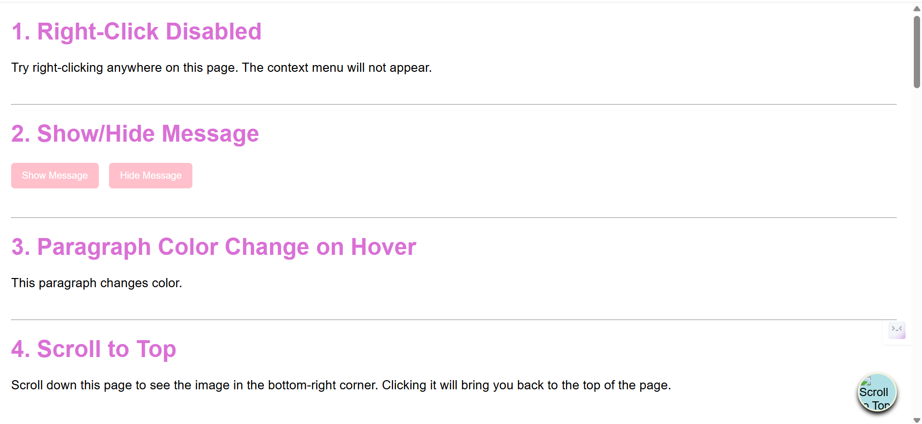 Challenges faced: - Managing proper linking of files. - Debugging minor syntax issues in CSS and JS.

🔹 Experiment 2 – DOM Manipulation
What I learned: - Accessing and modifying HTML elements using JavaScript. - Using event listeners to make pages interactive. - Understanding traversal methods like parent(), children(), and find().
code ## index.html
<!DOCTYPE html>
<html lang="en">
<head>
<meta charset="UTF-8">
<meta name="viewport" content="width=device-width, initial-scale=1.0">
<title>Lab exp 2</title>
<link rel="stylesheet" href="s.css">
<script src="https://code.jquery.com/jquery-3.6.0.min.js"></script>
</head>
<body>
<div class="container">
<h1>Add a class to an element</h1>
<button id="addbtn">Add border</button>
<p id="adclass">Click the button to add a border to me</p>
</div>
<hr>
<div class="container">
<h1>Access element's position</h1>
<button id="getposition">Get position</button>
<div id="result"></div>
<div id="pele">This is the positioned element</div>
</div>
<hr>
<div class="container">
<h1>Animate multiple CSS properties</h1>
<button id="animatebtn">Animate box</button>
<div id="animatedBox"></div>
</div>
<script src="d2.js"></script>
</body>
</html>

D2.js
$(document).ready(function(){
$("#addbtn").click(function(){
$("#adclass").addClass("highlighted");
});
$("#getposition").click(function(){
var position = $("#pele").position();
var res = "Top: " + position.top + "px, Left: " + position.left + "px";
$("#result").text(res);
});
$("#animatebtn").click(function(){
$("#animatedBox").animate({
width: '200px',
height: '200px',
opacity: 0.5,
marginLeft: '50px'
}, 1000, function() {
$(this).animate({
width: '100px',
height: '100px',
opacity: 1,
marginLeft: '0px'
}, 1000);
});
});
});

s.css
body {
font-family: Arial, sans-serif;
margin: 20px;
padding-bottom: 1500px;
}
.container {
margin-bottom: 40px;
}
h1 {
color: #333;
}
.highlighted {
border: 5px solid #ff0000;
box-shadow: 0 0 10px rgba(255, 0, 0, 0.5);
}
#animatedBox {
width: 100px;
height: 100px;
background-color: #ff9800;
position: relative;
}
button {
padding: 10px 15px;
margin-right: 10px;
cursor: pointer;
border: none;
border-radius: 5px;
background-color: blue;
color: white;
}

output
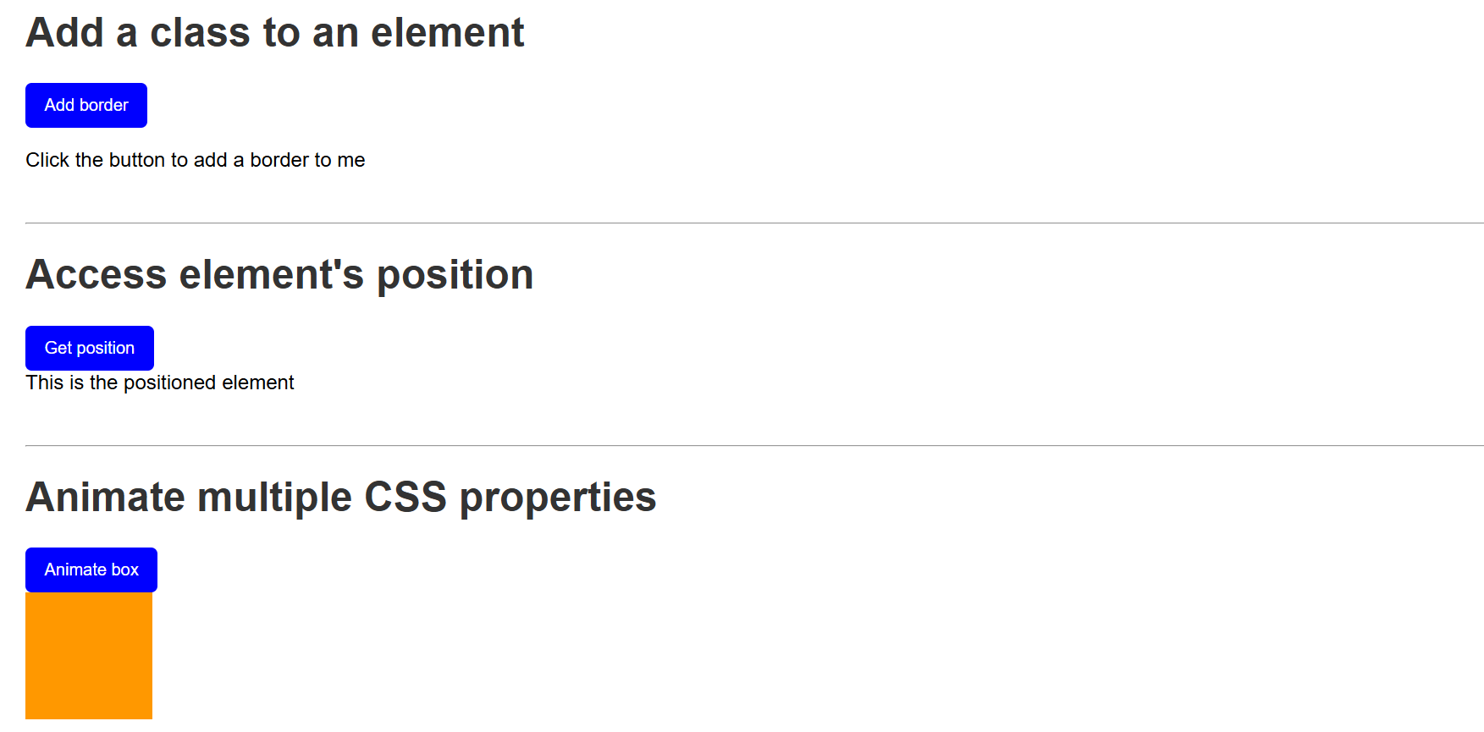
output screenshot
Challenges faced: - Understanding how DOM updates reflect dynamically. - Handling multiple nested elements efficiently.

🔹 Experiment 3 – JavaScript Application
What I learned: - Building a small interactive app using JS. - Handling user input and updating the UI. - Understanding basic app logic and modular code.
code

index.html
<!doctype html>
<html ng-app="tableApp">
<head>
<meta charset="utf-8">
<title>Experiment 3 - AngularJS Tables</title>
<script src="https://ajax.googleapis.com/ajax/libs/angularjs/1.8.3/angular.min.js"></script>
<script src="app.js"></script>
<style>
table { border-collapse: collapse; width: 100%; }
th, td { border: 1px solid #ccc; padding: 8px; }
tr.even { background: #f8f8f8; }
tr.odd { background: #ffffff; }
th { background: #eee; }
</style>
</head>
<body ng-controller="TableController as ctrl">
<div class="container">
<h1>AngularJS Table Examples</h1>
<section>
<h2>1. Display a Table</h2>
<table>
<thead>
<tr>
<th>#</th>
<th>Name</th>
<th>Age</th>
<th>Department</th>
</tr>
</thead>
<tbody>
<tr ng-repeat="student in ctrl.students track by $index" ng-class-odd="'odd'" ng-class-even="'even'">
<td>{{$index + 1}}</td>
<td>{{student.name}}</td>
<td>{{student.age}}</td>
<td>{{student.dept}}</td>
</tr>
</tbody>
</table>
</section>
<section>
<h2>2. Display contents with orderBy filter</h2>
<label>Sort by:
<select ng-model="ctrl.sortKey">
<option value="name">Name</option>
<option value="age">Age</option>
<option value="dept">Department</option>
</select>
<label><input type="checkbox" ng-model="ctrl.reverse"> Reverse</label>
</label>
<table>
<thead>
<tr>
<th>#</th>
<th>Name</th>
<th>Age</th>
<th>Department</th>
</tr>
</thead>
<tbody>
<tr ng-repeat="student in ctrl.students | orderBy:ctrl.sortKey:ctrl.reverse track by $index" ng-class-even="'even'" ng-class-odd="'odd'">
<td>{{$index + 1}}</td>
<td>{{student.name}}</td>
<td>{{student.age}}</td>
<td>{{student.dept}}</td>
</tr>
</tbody>
</table>
</section>
<section>
<h2>3. Display Table with even and odd rows (styling already shown)</h2>
<p>Notice rows have alternating backgrounds using <code>ng-class-even</code> and <code>ng-class-odd</code>.</p>
</section>
</div>
</body>
</html>

app.js
angular.module('tableApp', [])
.controller('TableController', function() {
const vm = this;
vm.students = [
{ name: 'Asha', age: 22, dept: 'CSE' },
{ name: 'Bikram', age: 24, dept: 'ECE' },
{ name: 'Charu', age: 21, dept: 'ME' },
{ name: 'Deep', age: 23, dept: 'CSE' },
{ name: 'Esha', age: 20, dept: 'EE' }
];
vm.sortKey = 'name';
vm.reverse = false;
});

output
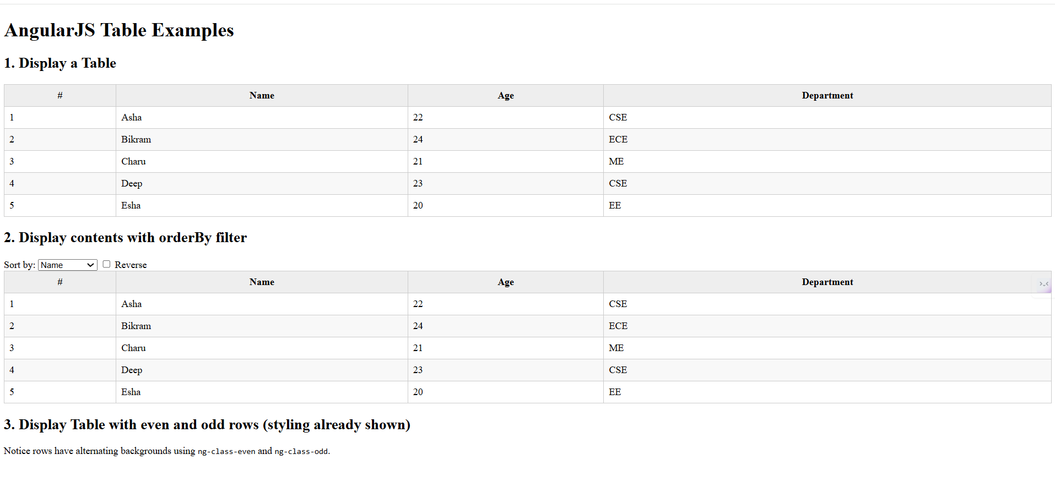
output screenshot
Challenges faced: - Debugging logic errors and managing functions. - Keeping the code reusable and readable.

🔹 Experiment 4 – Form and Billing System
What I learned: - Creating and validating HTML forms. - Structuring a billing page layout. - Collecting and displaying user data effectively.
code

bill.html
<!DOCTYPE html>
<html lang="en" ng-app="billApp">
<head>
<meta charset="UTF-8">
<title>Bill Payment Record</title>
<script src="https://ajax.googleapis.com/ajax/libs/angularjs/1.8.3/angular.min.js"></script>
<style>
body { font-family: Arial, sans-serif; margin: 20px; }
table { border-collapse: collapse; width: 100%; margin-top: 20px; }
th, td { border: 1px solid #ccc; padding: 8px; text-align: left; }
th { background: #eee; }
input, button { margin: 5px; padding: 6px; }
</style>
</head>
<body ng-controller="BillController">
<h2>Bill Payment Record</h2>
<!-- Form to add new records -->
<form name="billForm" ng-submit="addRecord(billForm)" novalidate>
<label>
Name:
<input type="text" name="name" ng-model="newRecord.name" required>
</label>
<label>
Amount:
<input type="number" name="amount" ng-model="newRecord.amount" required min="0">
</label>
<label>
Date:
<input type="date" name="date" ng-model="newRecord.date" required>
</label>
<button type="submit" ng-disabled="billForm.$invalid">Add</button>
</form>
<!-- Records table -->
<table ng-if="records.length > 0">
<thead>
<tr>
<th>#</th>
<th>Name</th>
<th>Amount</th>
<th>Date</th>
</tr>
</thead>
<tbody>
<tr ng-repeat="record in records track by record.id">
<td>{{$index + 1}}</td>
<td>{{record.name}}</td>
<td>{{record.amount | currency}}</td>
<td>{{record.date | date:'mediumDate'}}</td>
</tr>
</tbody>
</table>
<script>
angular.module('billApp', [])
.controller('BillController', function($scope) {
// Initial records
$scope.records = [
{ id: 1, name: 'Electricity', amount: 1200, date: '2025-07-01' },
{ id: 2, name: 'Internet', amount: 799, date: '2025-07-05' }
];
$scope.newRecord = {};
// Add new record
$scope.addRecord = function(form) {
if (form.$valid) {
let newId = $scope.records.length + 1;
$scope.records.push({
id: newId,
name: $scope.newRecord.name,
amount: $scope.newRecord.amount,
date: $scope.newRecord.date
});
$scope.newRecord = {};
form.$setPristine();
form.$setUntouched();
}
};
});
</script>
</body>
</html>

form.html
<!DOCTYPE html>
<html lang="en" ng-app="formApp">
<head>
<meta charset="UTF-8">
<title>AngularJS Registration Form</title>
<script src="https://ajax.googleapis.com/ajax/libs/angularjs/1.8.3/angular.min.js"></script>
<style>
.error { color: red; font-size: 14px; }
input.ng-invalid.ng-touched { border: 2px solid red; }
input.ng-valid.ng-touched { border: 2px solid green; }
.success { color: green; margin-top: 10px; }
</style>
</head>
<body ng-controller="FormController">
<h2>User Registration</h2>
<form name="regForm" novalidate ng-submit="register(regForm)">
<label>Name:
<input type="text" name="name" ng-model="user.name" required ng-minlength="3">
</label>
<div class="error"
ng-show="(regForm.name.$touched || submitted) && regForm.name.$invalid">
Name must be at least 3 characters.
</div>
<br><br>
<label>Email:
<input type="email" name="email" ng-model="user.email" required>
</label>
<div class="error"
ng-show="(regForm.email.$touched || submitted) && regForm.email.$invalid">
Enter a valid email.
</div>
<br><br>
<label>Password:
<input type="password" name="password" ng-model="user.password" required ng-minlength="6">
</label>
<div class="error"
ng-show="(regForm.password.$touched || submitted) && regForm.password.$invalid">
Password must be at least 6 characters.
</div>
<br><br>
<button type="submit">Register</button>
</form>
<p class="success" ng-if="success">{{success}}</p>
<script>
angular.module('formApp', [])
.controller('FormController', function($scope) {
$scope.user = {};
$scope.submitted = false;
$scope.success = '';
$scope.register = function(form) {
if (form.$valid) {
// In real app, send data to server
$scope.success = 'Registration successful for ' + $scope.user.name;
$scope.user = {};
form.$setPristine(); // Reset form state
form.$setUntouched(); // Reset touched state
$scope.submitted = false;
} else {
$scope.success = '';
$scope.submitted = true; // Show validation messages
}
};
});
</script>
</body>
</html>

output
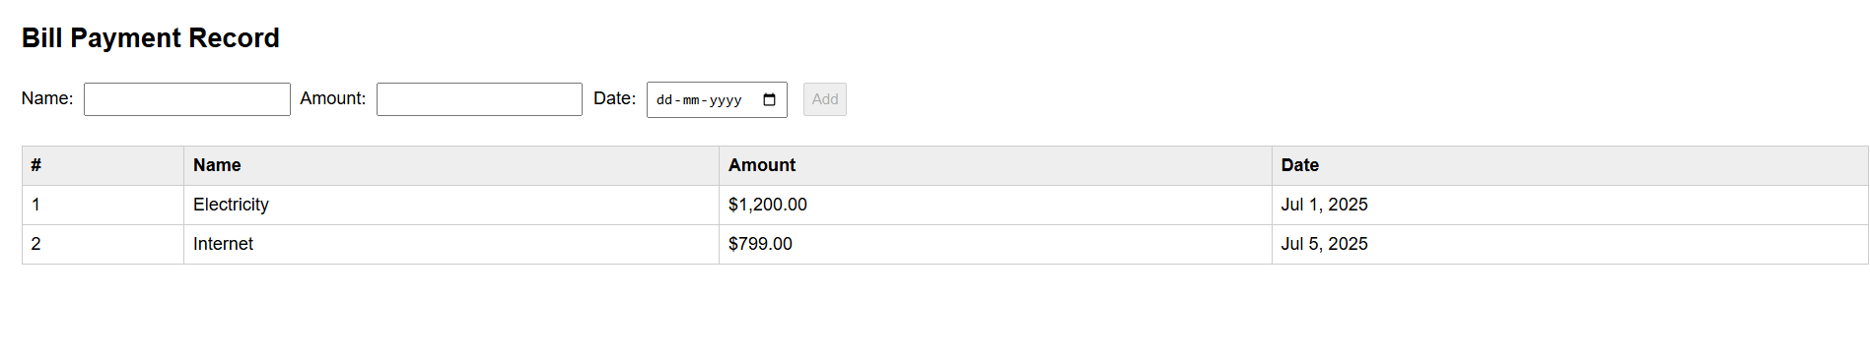 ## output 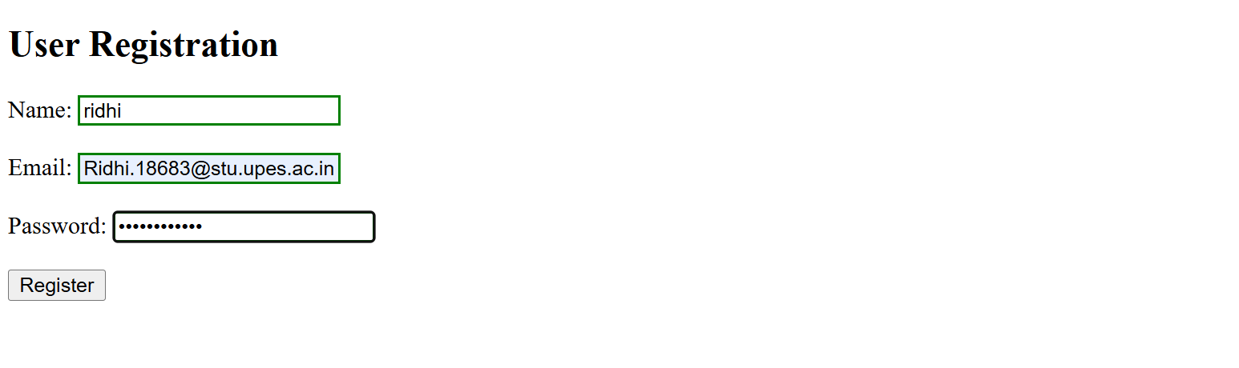
Challenges faced: - Handling form validation without libraries. - Designing responsive form layouts.

🔹 Experiment 5 – Node.js Basics
What I learned: - Running JavaScript code on the server side. - Using built-in modules like http and fs. - Creating a simple server and reading files.
Challenges faced: - Understanding how asynchronous operations work. - Managing errors when reading or serving files.

🔹 Experiment 6 – Node.js with npm
What I learned: - Initializing a Node.js project using npm init. - Installing and using packages like Express. - Handling HTTP requests and responses efficiently.
code ## pacage.json
{
"name": "express",
"version": "1.0.0",
"description": "testing nodejs",
"main": "server.js",
"scripts": {
"test": "node server.js",
"start": "node server.js"
},
"repository": {
"type": "git",
"url": "awt01"
},
"keywords": [
"[\"nodejs\"",
"\"express\"",
"\"lab\""
],
"author": "ridhi",
"license": "ISC"
}

server.js
const express = require('express');
const app = express();
const port = 3000;
// Hello World endpoint
app.get('/', (req, res) => {
res.send('Hello, World!');
});
// String replacement endpoint
app.get('/replace', (req, res) => {
const { text } = req.query;
if (!text) {
return res.status(400).json({ error: 'Text parameter is required' });
}
const regex = /a{2,}/g;
const result = text.replace(regex, 'b');
res.json({ original: text, replaced: result });
});
// Calculator endpoint
app.get('/calculate', (req, res) => {
const { operation, num1, num2 } = req.query;
const n1 = parseFloat(num1);
const n2 = parseFloat(num2);
if (isNaN(n1) || isNaN(n2)) {
return res.status(400).json({ error: 'Invalid numbers provided' });
}
let result;
switch (operation) {
case 'add':
result = n1 + n2;
break;
case 'subtract':
result = n1 - n2;
break;
case 'multiply':
result = n1 * n2;
break;
case 'divide':
result = n2 !== 0 ? n1 / n2 : 'Error: Division by zero';
break;
default:
return res.status(400).json({ error: 'Invalid operation. Use add, subtract, multiply, or divide' });
}
res.json({ operation, num1: n1, num2: n2, result });
});
// Array iteration endpoint
app.get('/iterate', (req, res) => {
const array = [10, 20, 30, 40, 50];
const iterations = [];
// Using for loop
iterations.push("Using for loop:");
for (let i = 0; i < array.length; i++) {
iterations.push(`Index ${i}: ${array[i]}`);
}
// Using forEach
iterations.push("Using forEach:");
array.forEach((item, index) => {
iterations.push(`Index ${index}: ${item}`);
});
// Using for...of
iterations.push("Using for...of:");
for (const item of array) {
iterations.push(`Item: ${item}`);
}
res.json({ array, iterations });
});
app.listen(port, () => {
console.log(`Server running at http://localhost:${port}`);
console.log('Available endpoints:');
console.log(' GET / - Hello World');
console.log(' GET /replace?text=your_text - Replace multiple a\'s with b');
console.log(' GET /calculate?operation=add&num1=5&num2=3 - Calculator');
console.log(' GET /iterate - Array iteration examples');
});
Challenges faced: - Understanding middleware and routing concepts. - Setting up dependencies correctly in package.json.

output
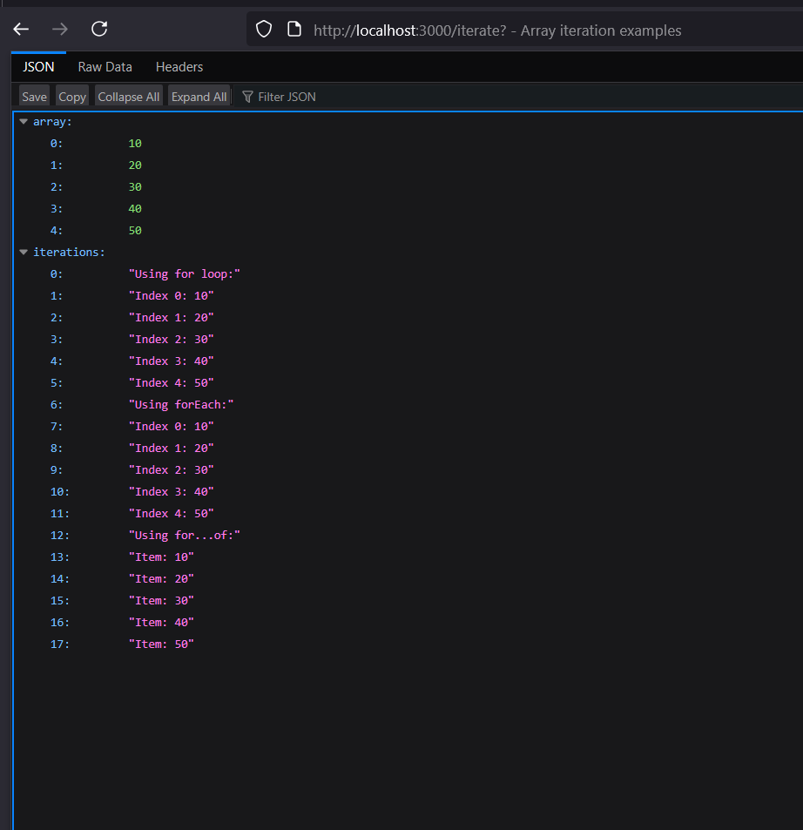 ## output 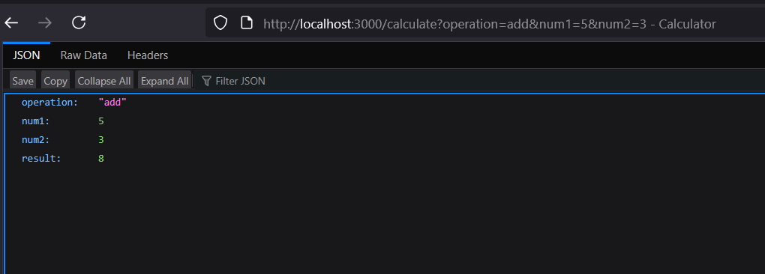 ## output 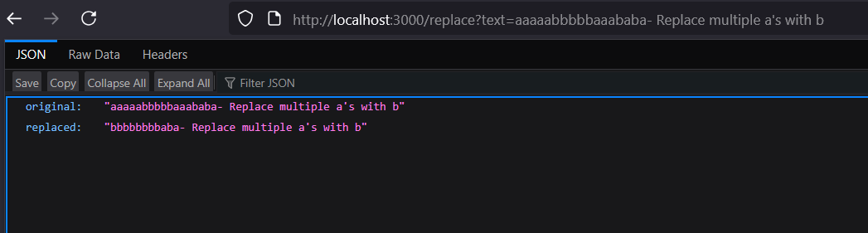 ## output

🔹 Experiment 7 – Cookies and Sessions
What I learned: - Storing and managing cookies in Node.js. - Using sessions for authentication or tracking. - Understanding client-server state management.
code

cookie-example.js
const express = require('express');
const cookieParser = require('cookie-parser');
const app = express();
app.use(cookieParser());
// Set cookie
app.get('/set-cookie', (req, res) => {
res.cookie('username', 'JohnDoe', { maxAge: 900000 });
res.send('Cookie has been set');
});
// Get cookie
app.get('/get-cookie', (req, res) => {
const user = req.cookies['username'];
res.send(`Cookie Retrieved: ${user}`);
});
// Delete cookie
app.get('/delete-cookie', (req, res) => {
res.clearCookie('username');
res.send('Cookie deleted');
});
const PORT = process.env.PORT || 3000;
app.listen(PORT, () => {
console.log(`Server started on http://localhost:${PORT}`);
});

session-example.js
const express = require('express');
const session = require('express-session');
const app = express();
// Configure session middleware
app.use(session({
secret: 'mysecretkey',
resave: false,
saveUninitialized: true
}));
// Root route
app.get('/', (req, res) => {
if (req.session.views) {
req.session.views++;
res.send(`Welcome back! You visited ${req.session.views} times.`);
} else {
req.session.views = 1;
res.send('Welcome to the session demo. Refresh to count visits.');
}
});
// Destroy session
app.get('/destroy', (req, res) => {
req.session.destroy(err => {
if (err) {
return res.send('Error destroying session');
}
res.send('Session destroyed');
});
});
const PORT = process.env.PORT || 3000;
app.listen(PORT, () => {
console.log(`Server started on http://localhost:${PORT}`);
});

output
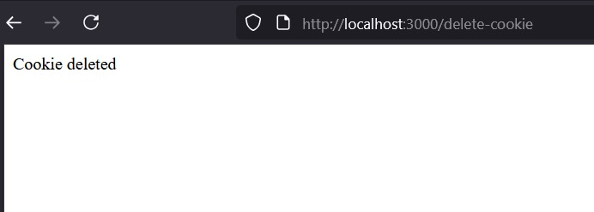 ## output 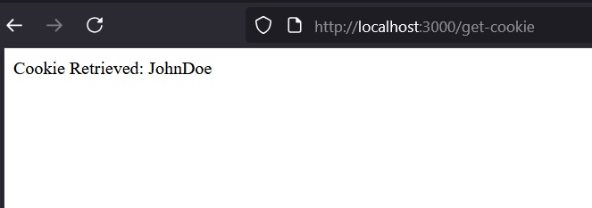 ## output 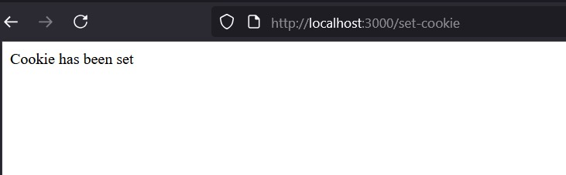 ## output 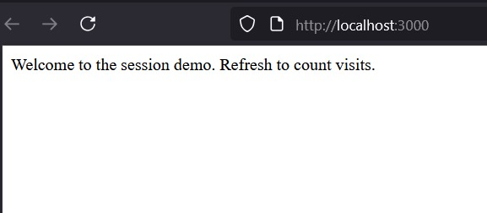 ## output 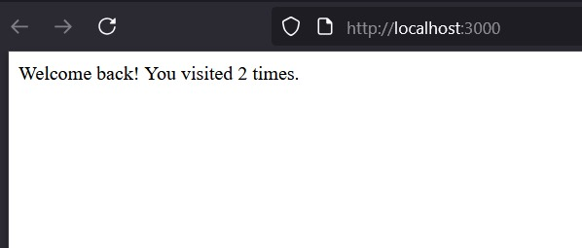
Challenges faced: - Handling cookie expiration and security flags. - Managing session persistence across routes.

✅ This README provides a full overview of all lab experiments, what was learned, and challenges faced during implementation.

