**LSP**

Nama: Muhammad Ridho Ramadhan

Kelas: 12 RPL 1

1. Migrations
2. Struktur Folder

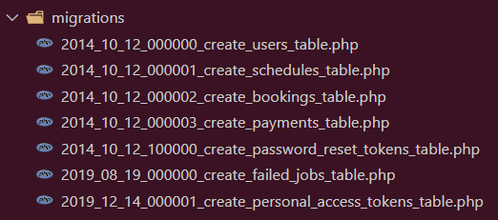

1. Table users:

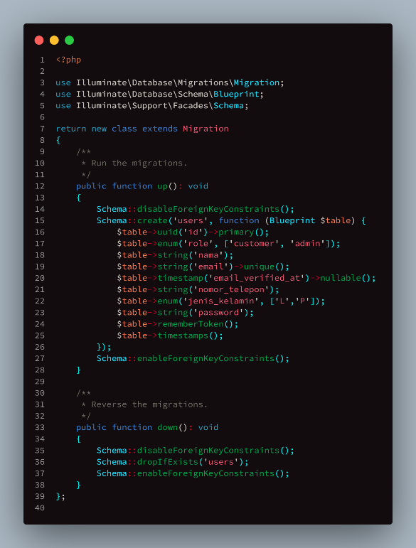

1. Table schedules

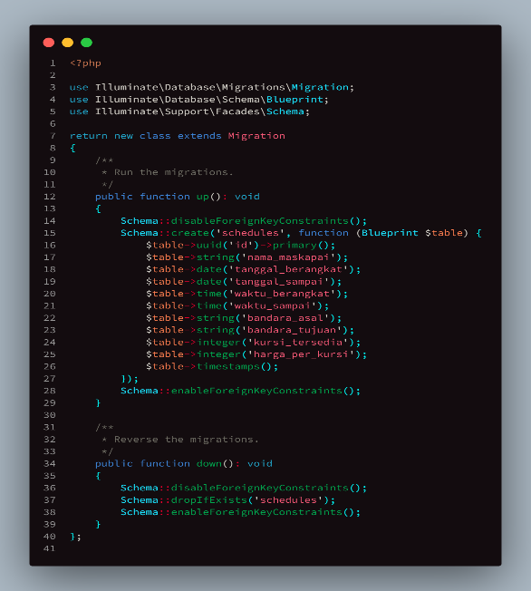

1. Tabel bookings

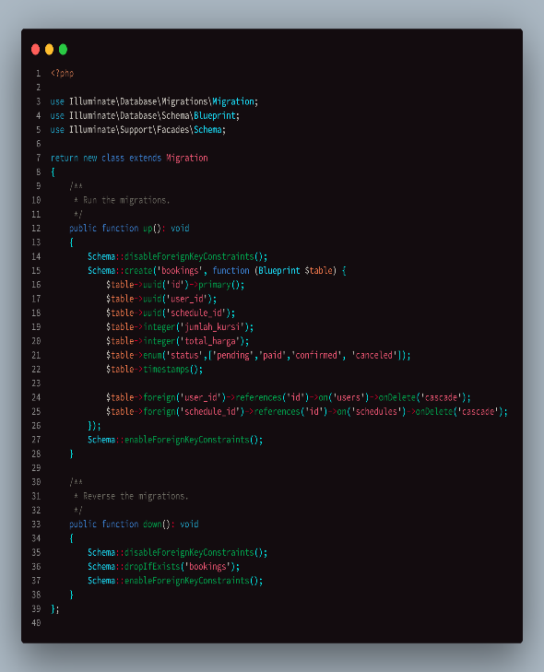

1. Tabel payments

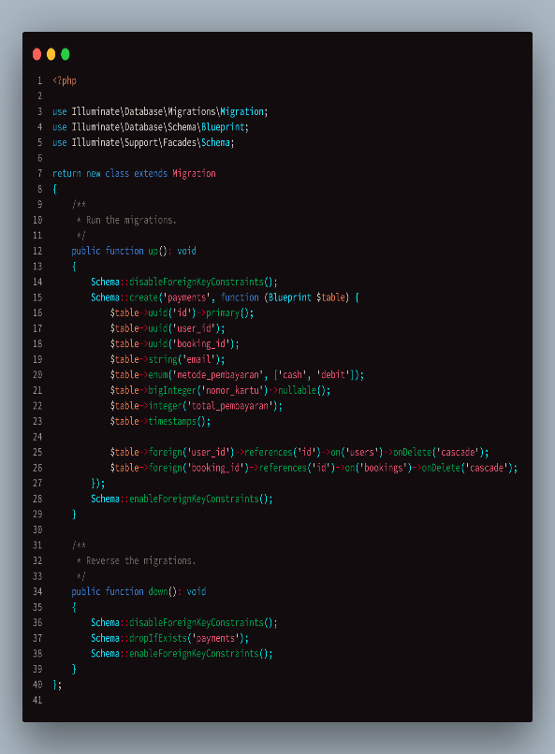

1. Model
2. 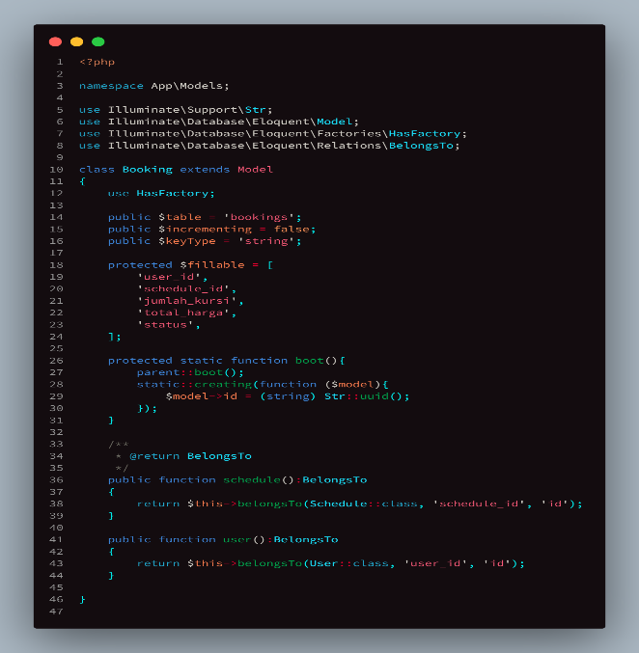Booking
3. Payment

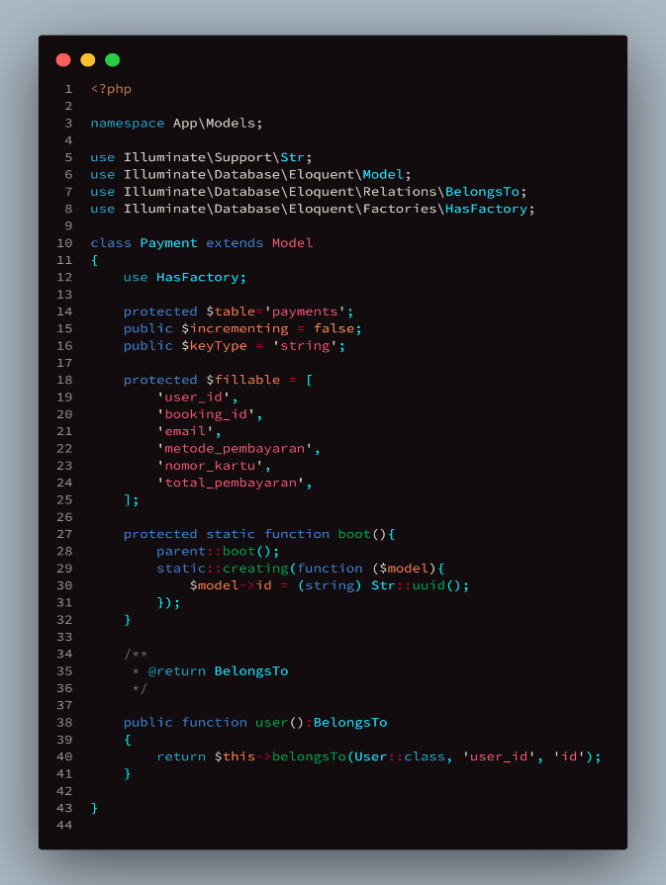

1. Schedule

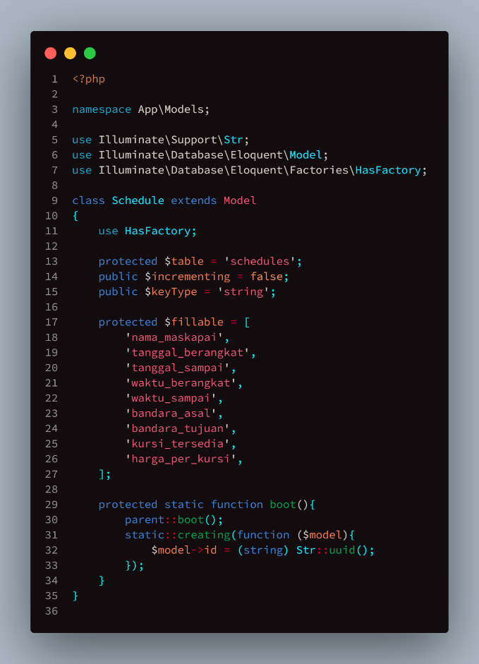

1. User

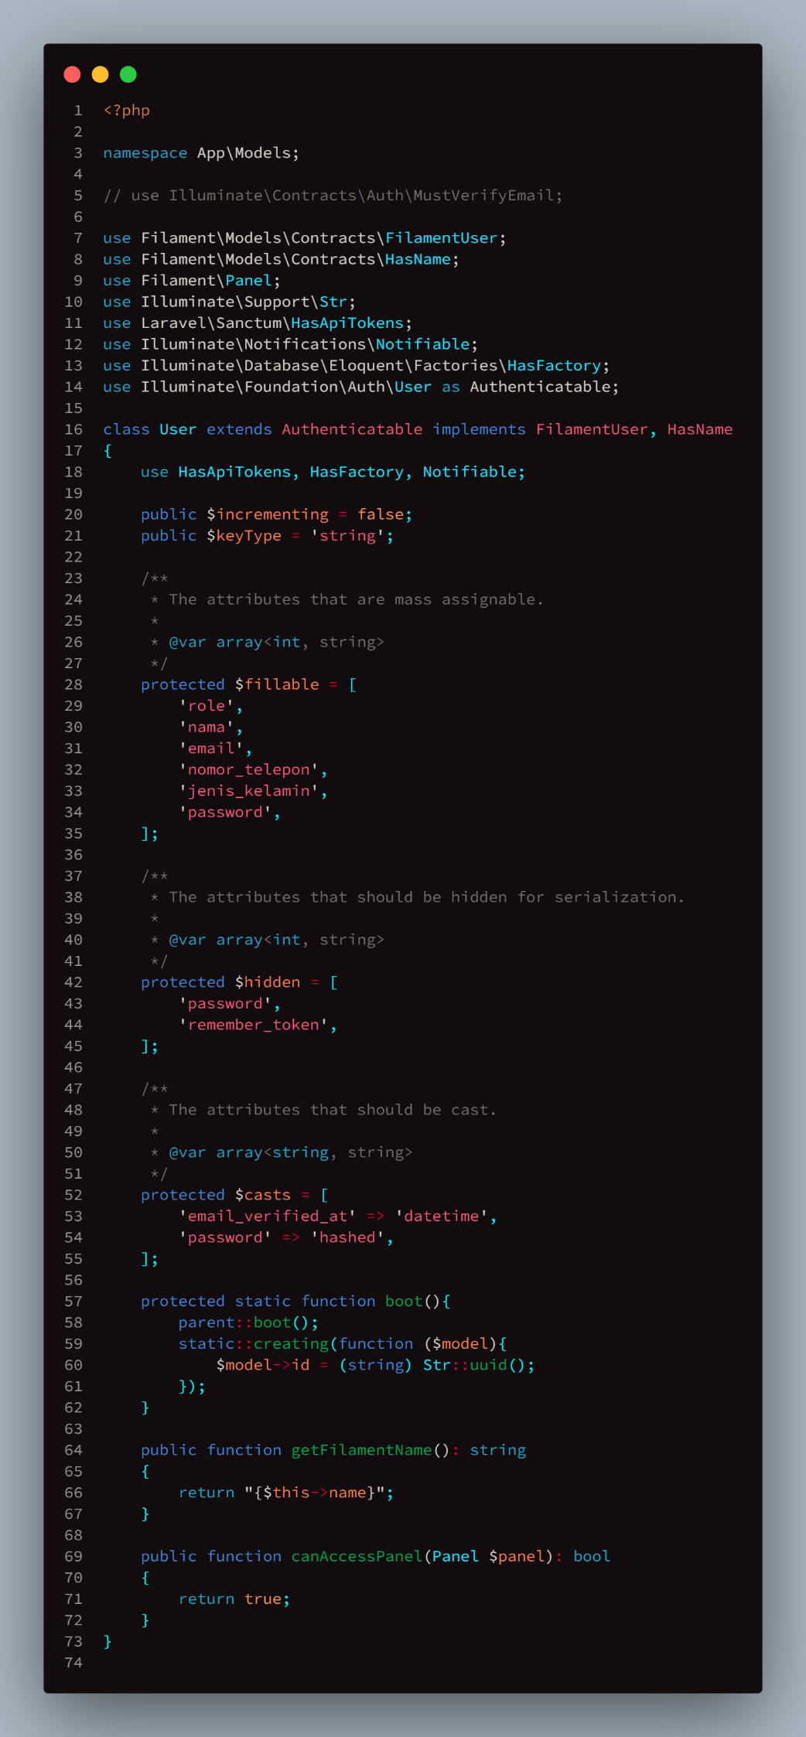

1. Controller
   1. Struktur Folder

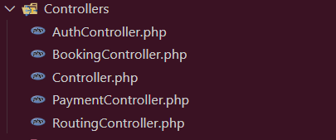

* 1. AuthController

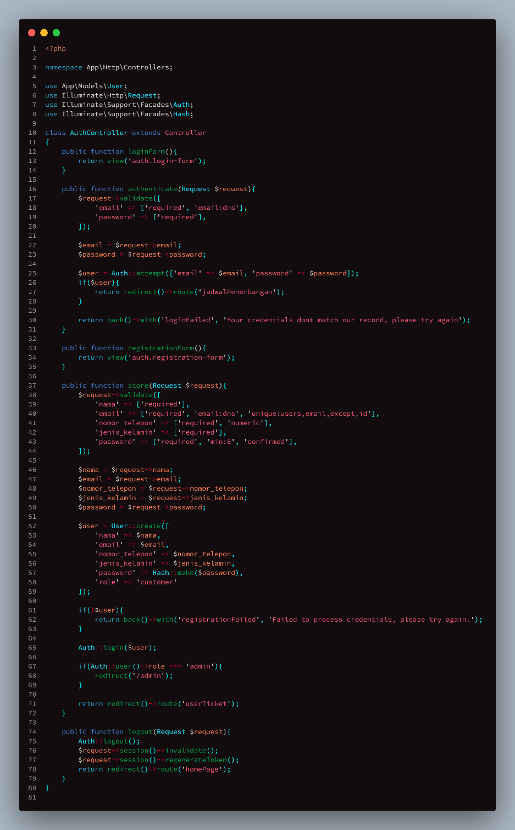

* 1. BookingController

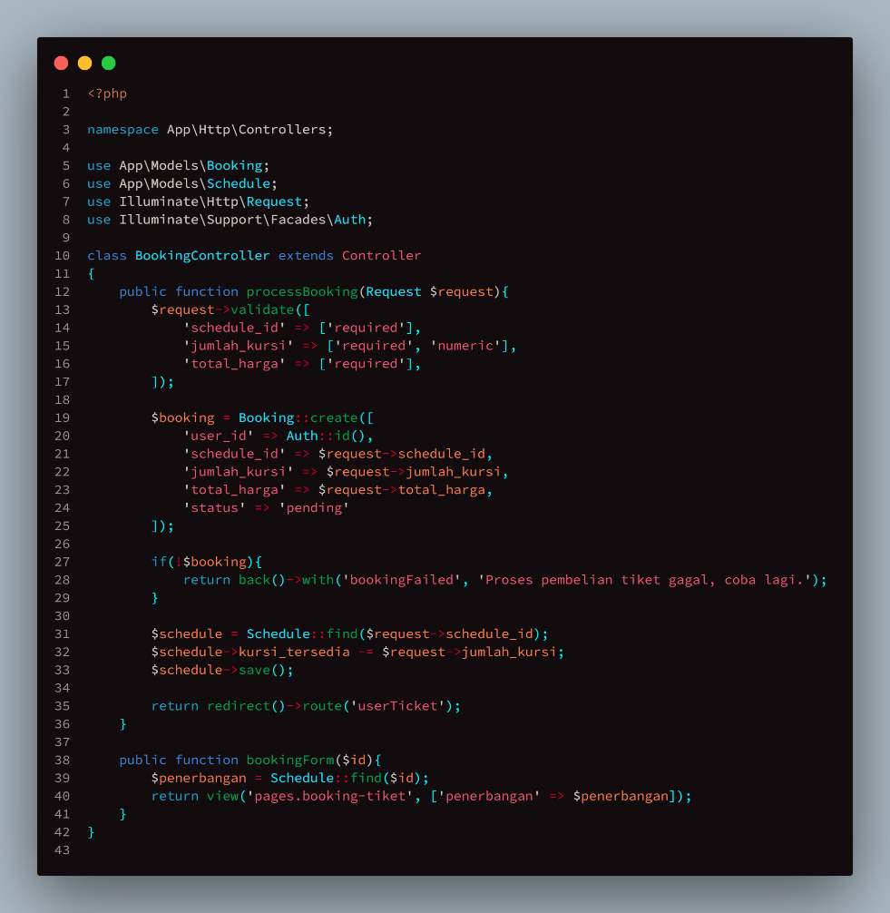

d. PaymentController

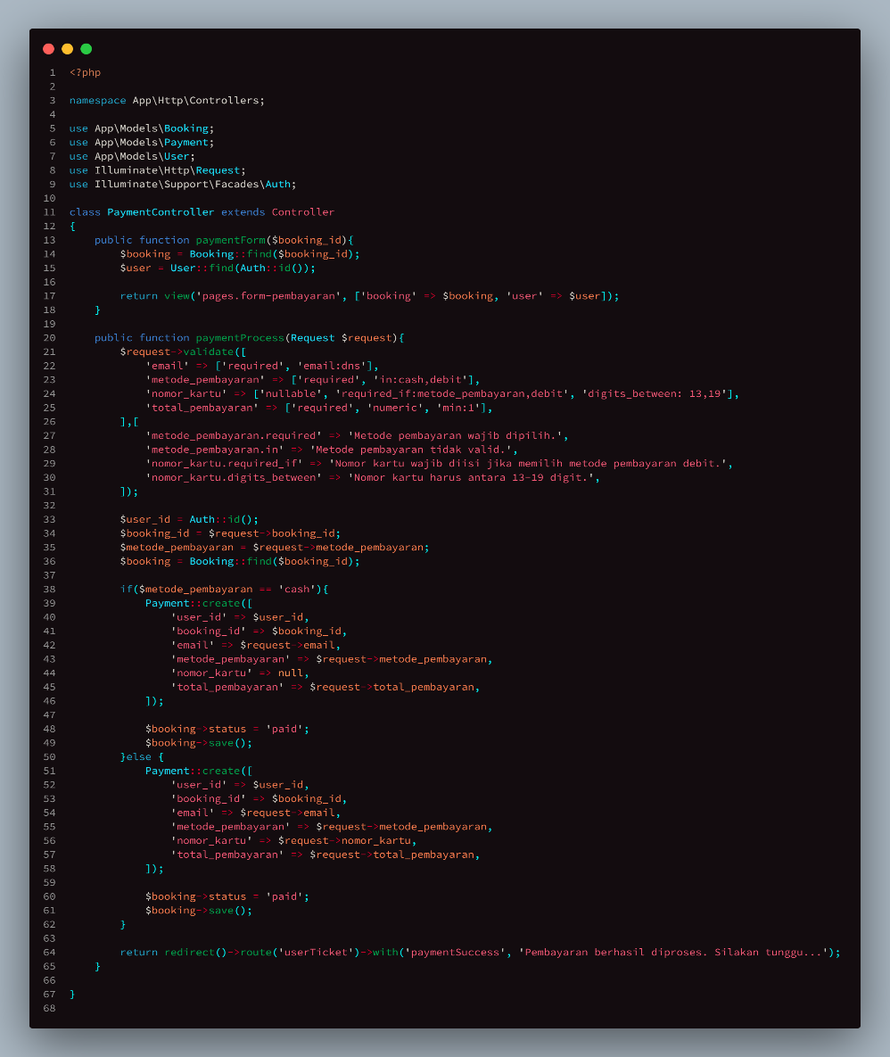

1. RoutingController

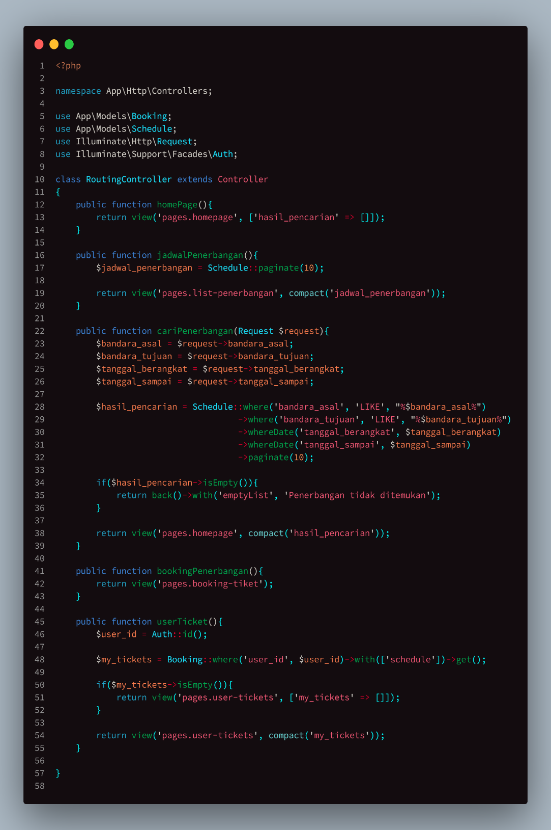

1. Views
   1. Struktur folder

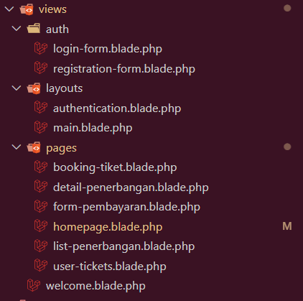

1. Route

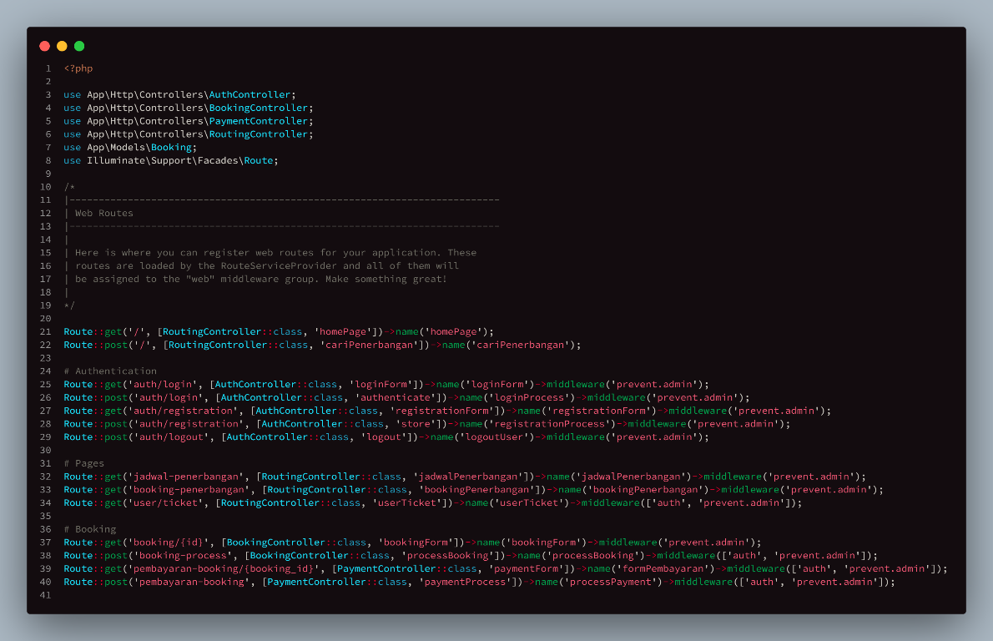

1. Filament
2. Installasi

Command: composer require filament/filament

1. Bikin command untuk create user admin filament

Command: php artisan make:command CreateFilamentAdmin

1. Buat resource

Command: php artisan make:filament-resource Customer

1. CreateFilamentAdmin

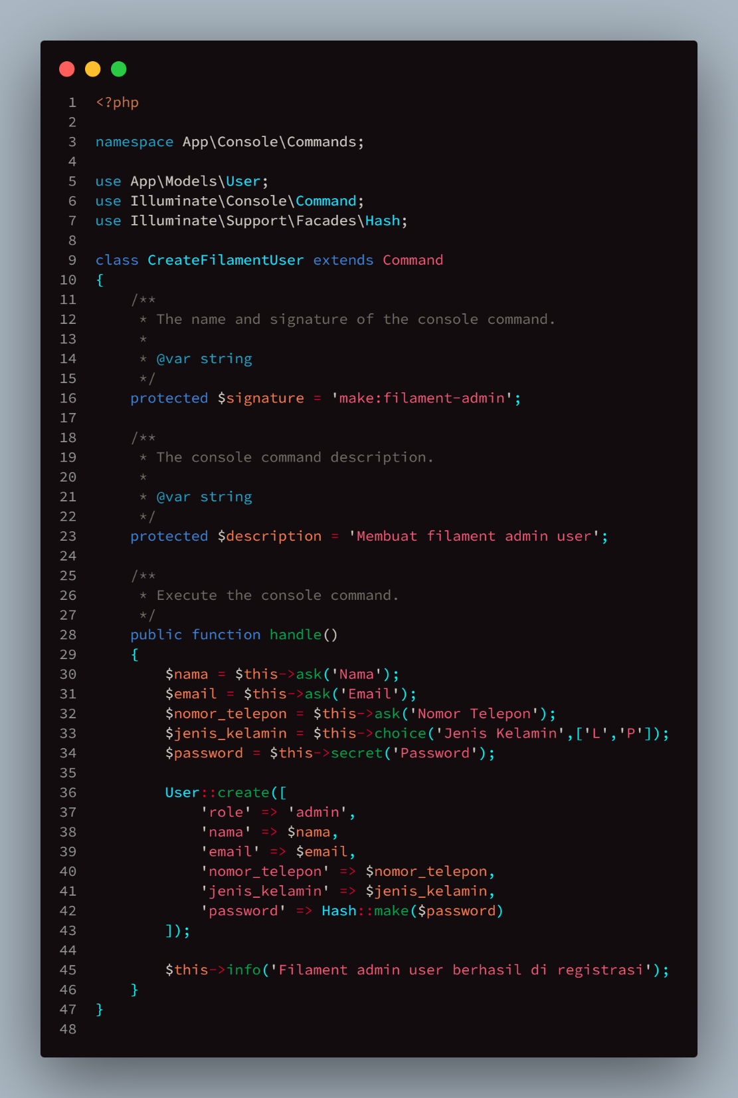

1. Struktur folder filament

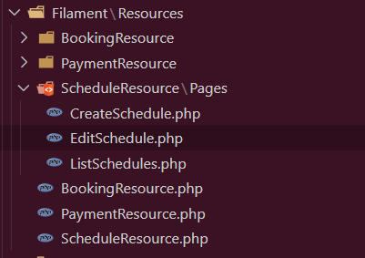

1. Resource Filament
   * 1. BookingResource

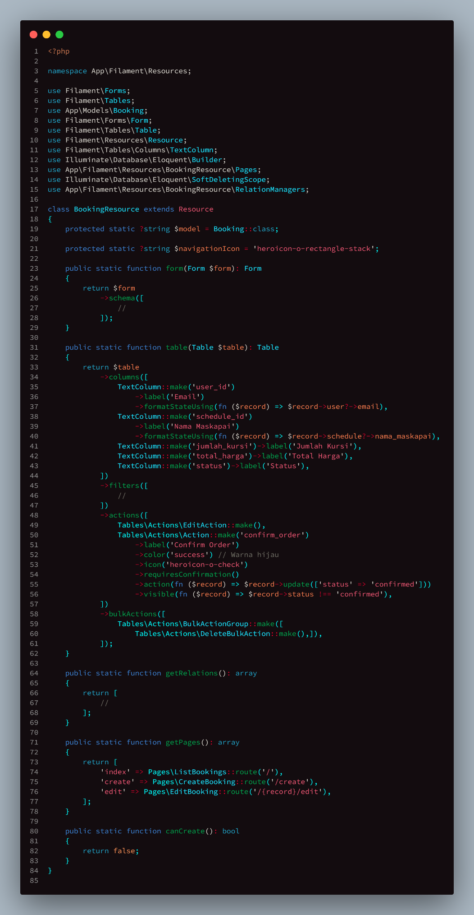

* + 1. PaymentResource

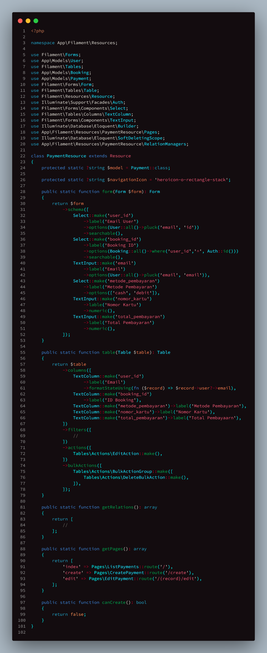

* + 1. ScheduleResource

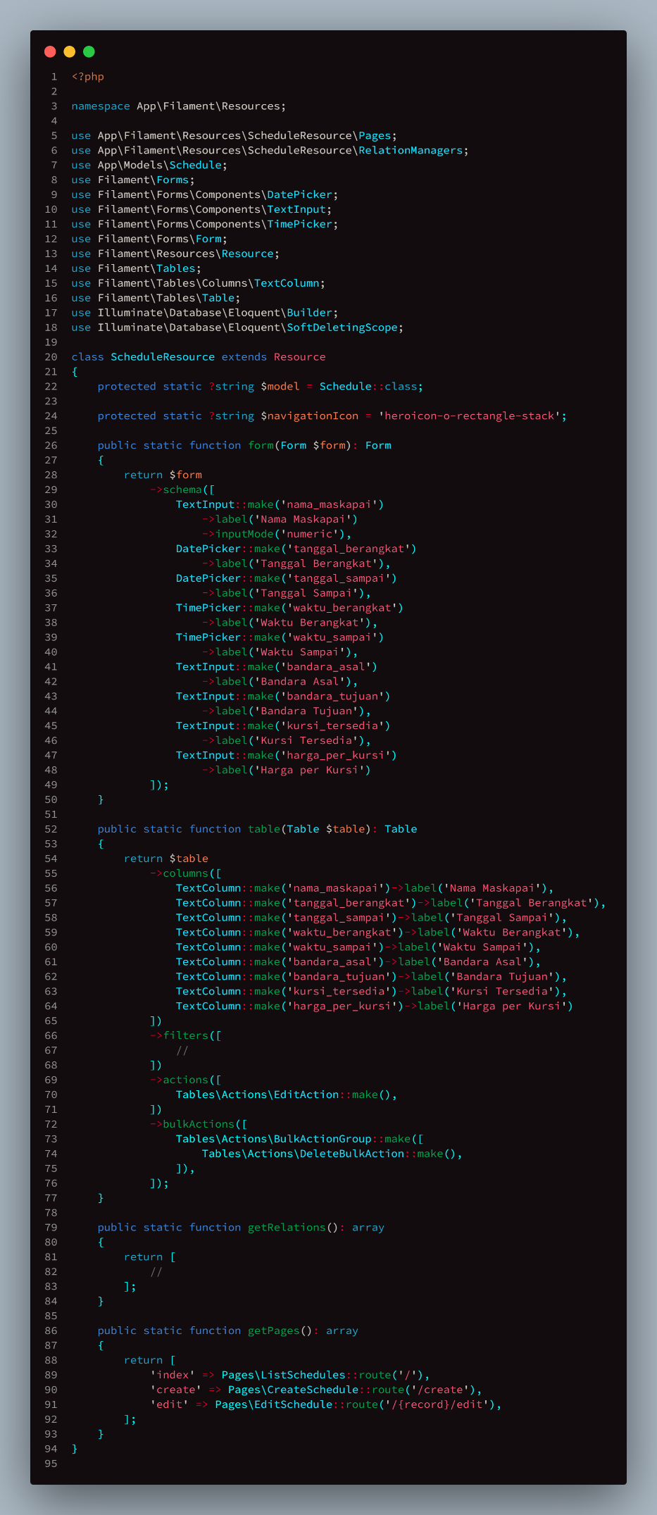

1. Middleware
2. PreventAdminAccess

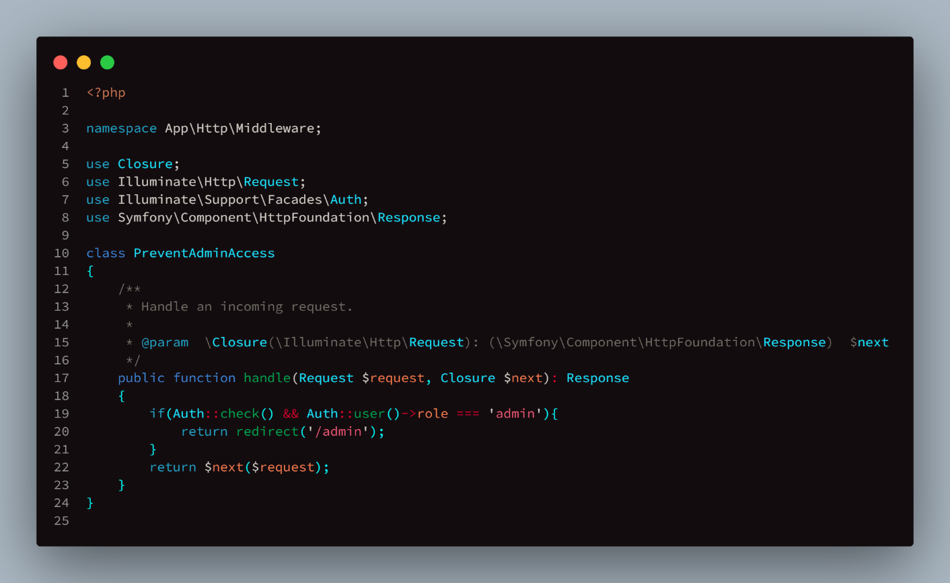

1. PreventUserAccess

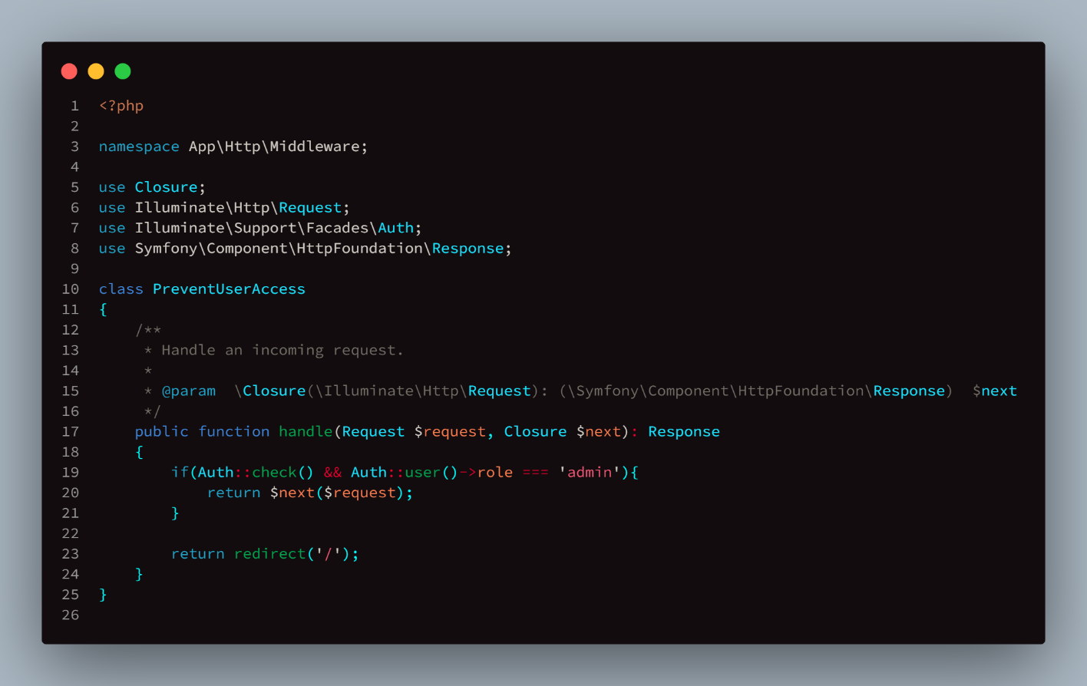

1. Kernel

