**PRACTICUM REPORT**

Job sheet 3

Variables, Data Types, and Operators



RIDHO ANFA’AL

2341720222

CLASS 1I (INTERNATIONAL)

INFORMATICS ENGINEERING­­

INFORMATION TECHNOLOGY

STATE POLYTECHNIC OF MALANG

**Contents**

Experiment 1 3

Experiment 2 4

Experiment 3 5

Experiment 4 6

Experiment 5 7

**Experiment 1**

Questions!

1. Change the variable name so that the variable naming model is good and correct!

Answer :

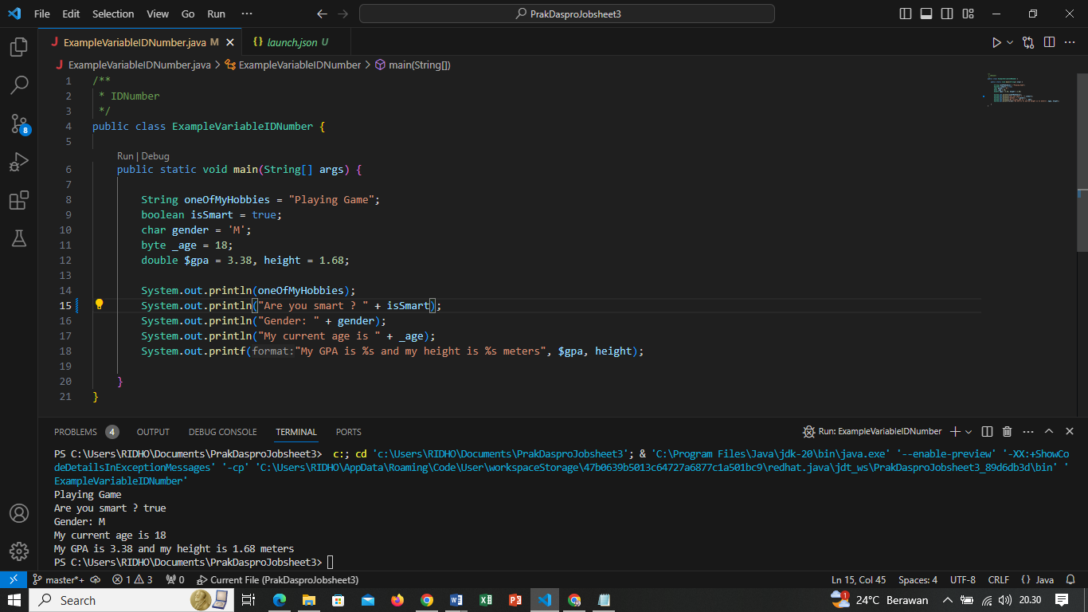

2. What is the function of %s in the statement below? Is there anything you can use instead of %s? Name and explain it!

Answer : %s as a placeholder for strings, and there are other format specifiers like %d for integers, %f for floating-point numbers, etc., for different data types. These format specifiers can be used to format strings in a more controlled and specific manner.

**Experiment 2**

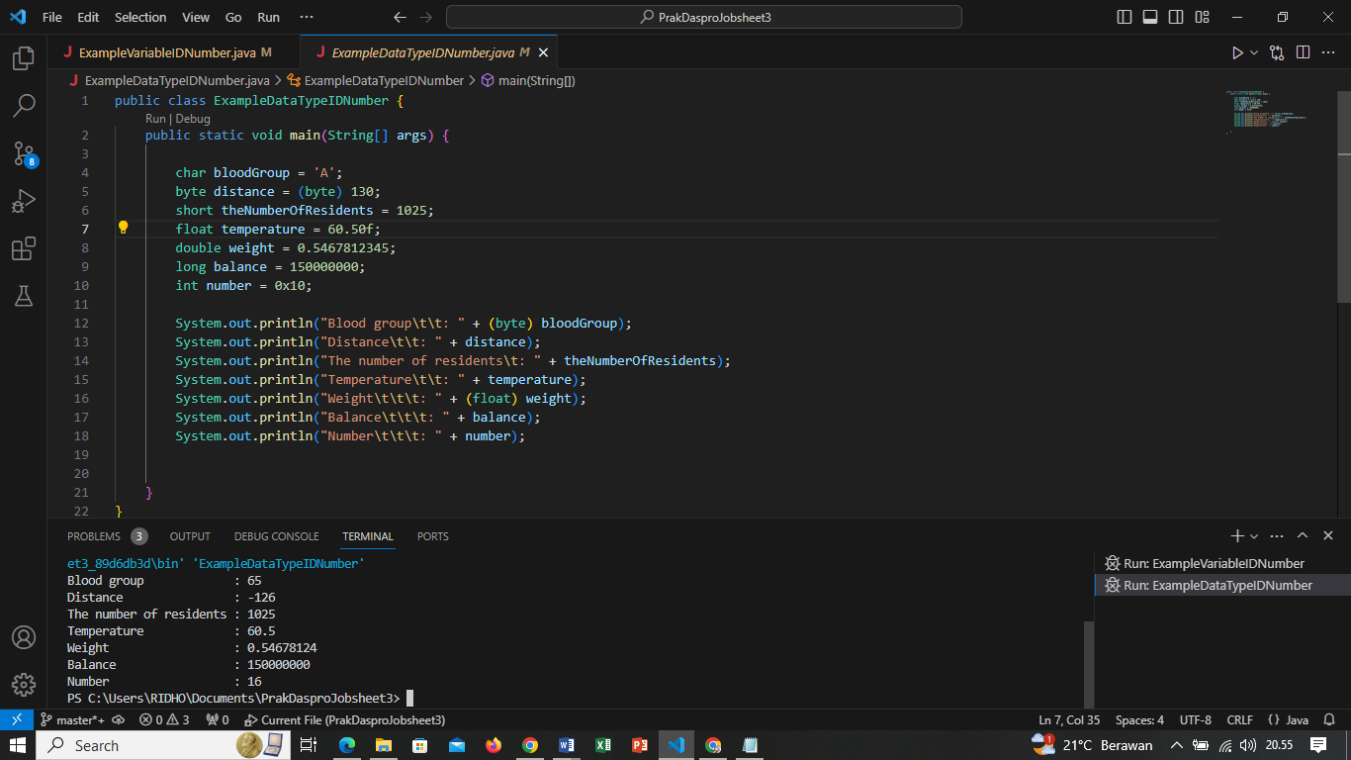

Questions!

1. Explain why the bloodGroup does not display an "A"!

Answer : Because the blood group whose data type is integer is changed or cast to bytes to produce the value 65, which is the value of A according to ASCII

2. Explain the meaning of byte distance = (byte) 130! Then, explain why the results

change when displayed!

Answer : when you cast the integer 130 to a byte in Java using (byte) 130, it results in an overflow because bytes can only hold values in the range of -128 to 127. The binary representation of 130 in two's complement wraps around to -126, and that value is stored in the byte variable.

3. In the syntax float temperature = 60.50F; remove the letter F, then run again. What

happened?

Answer : when you declare a float variable, you typically add the letter F or f at the end of the value to explicitly indicate that it's a float literal. If you remove the F from the float literal, the value is treated as a double by default.

4. Why does the result change when displaying weight values?

Answer : Because in the print command the weight variable whose data type is double is changed to the float data type, where the float data type stores fewer values ​​than the double data type which can store more values

5. Explain the meaning of initializing 0x10 on number variables! What does it do?

Answer : 0x10 is a hexadecimal number, 0x10 (hexadecimal) = 16 (decimal) Because 0x prefix represents a HexaDecimal base.

**Experiment 3**

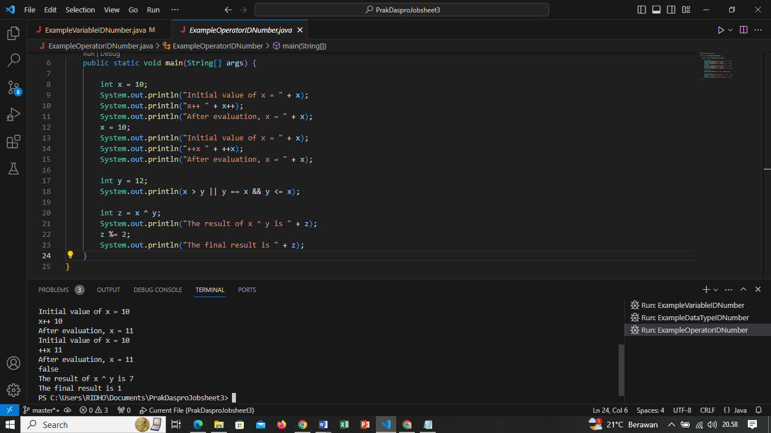

Questions!

1. Explain in your opinion what is the difference between x++ and ++x!

Answer : In x++ the value of variable is printed first then it is incremented whereas in ++x the value is incremented first and then it is displayed.

2. What is the result of int z = x ^ y; do the calculations manually (you can use a

calculator)!

Answer : z = x ^ y

z = 11 XOR 12

z = 1011 XOR 1100

z = 0111 = 7

**Experiment 4**

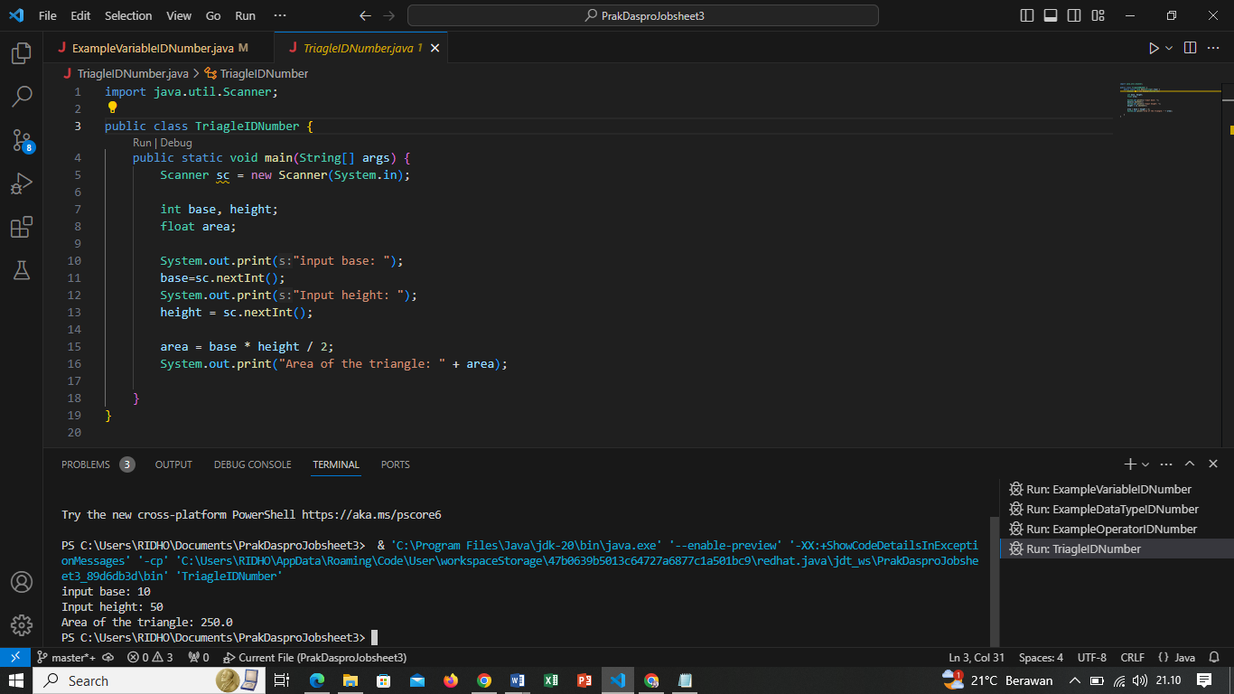

Questions!

1. Explain why you have to declare Scanner in Experiment 4?

Answer : In Java, you need to declare and initialize a Scanner object before you can use it to read input from the user or from some input source, such as a file or a stream.

2. Explain the use of the program snippets below!

Answer : The program gives commands for the base and height variables so that the values ​​ can be entered manually by the user

**Experiment 5**

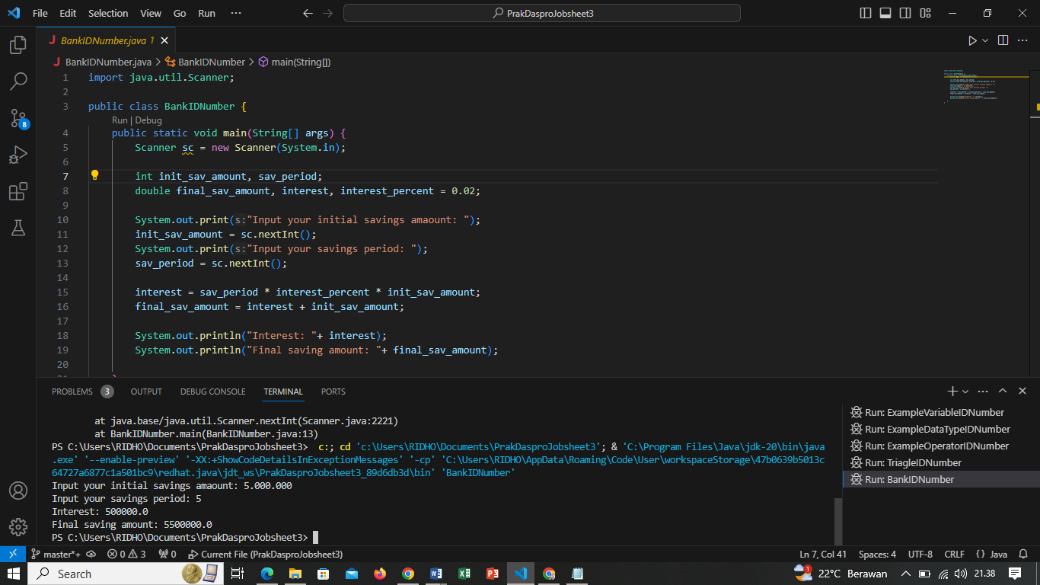

Assignment

1. Do assignments according to your group's final project topic!

a. Identify input, output, processes based on the scope of each group's final project topic. The processes identified are limited to processes that use arithmetic operators.

Answer :

1. Input :

1. Applicant's Personal Data

2. Loan Purpose

3. Requested Loan Amount

4. Loan Term

b. Output :

1. Loan Decision

2. Credit Report

3. Transaction Records

c. Process :

1. Loan Application

2. Identity Verification

3. Approval or Rejection

4. Loan Disbursement

5. Loan Repayment

6. Credit Reporting

b. Identify variables and data types based on input, output, and process according to project topic based on 1a.

Answer :

Int = Applicant's Personal Data, Loan Purpose, Loan Decision, Approval or Rejection, Identity Verification,

Double = Requested Loan Amount, Loan Term, Transaction Records, Loan Repayment