**Assignment-Day 01**

**01: Instances Dashboard**

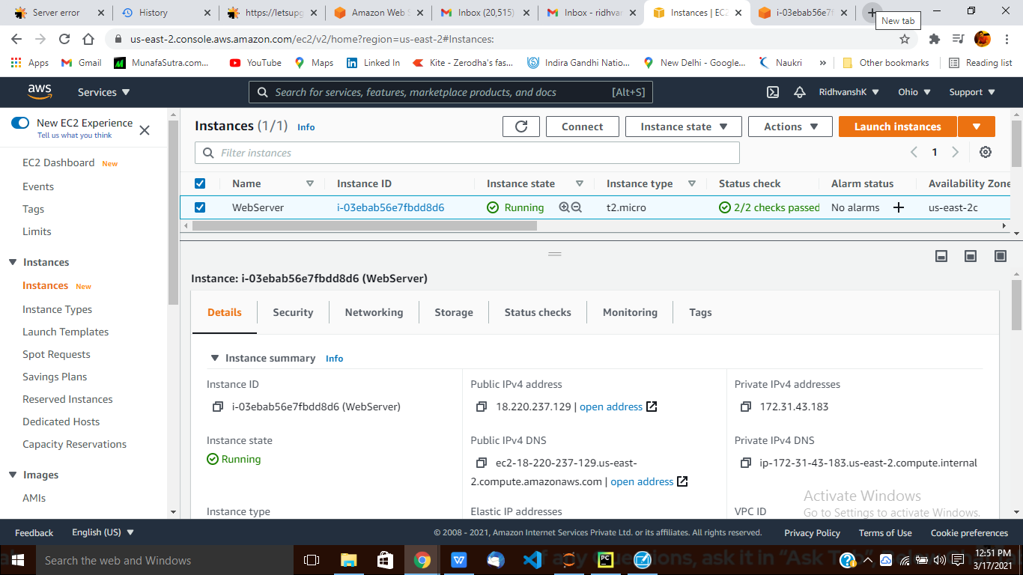

**02: Instances Dashboard(Public IP)**

**03: Ubuntu Commands(Update)**

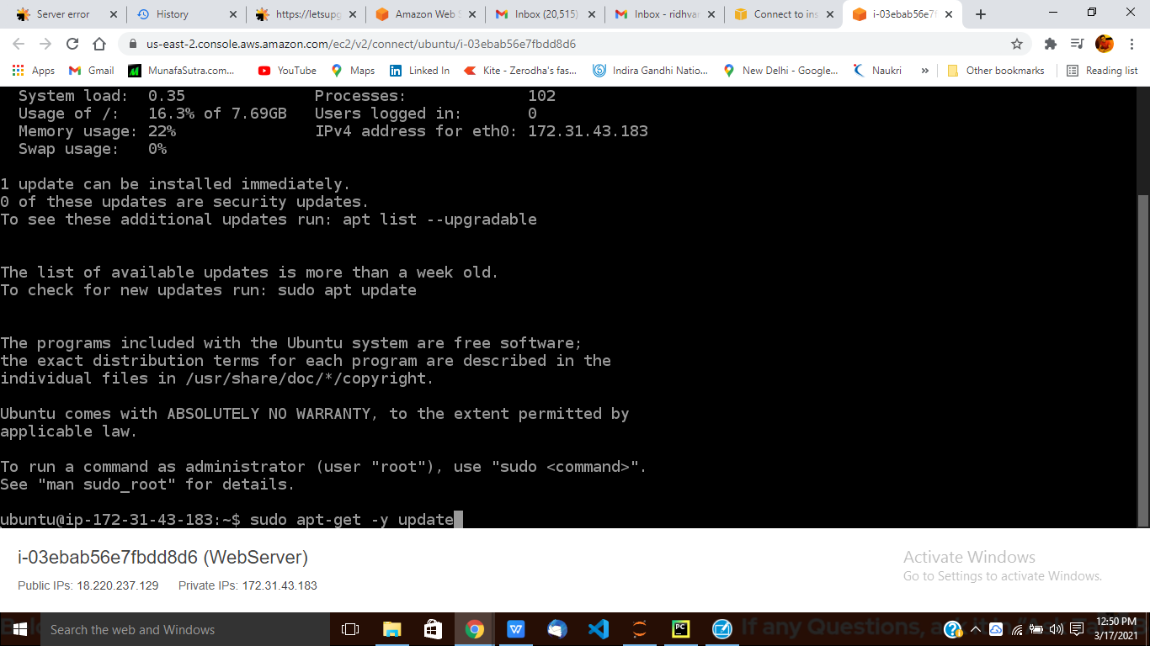

**04: Ubuntu Commands(Nginx)**

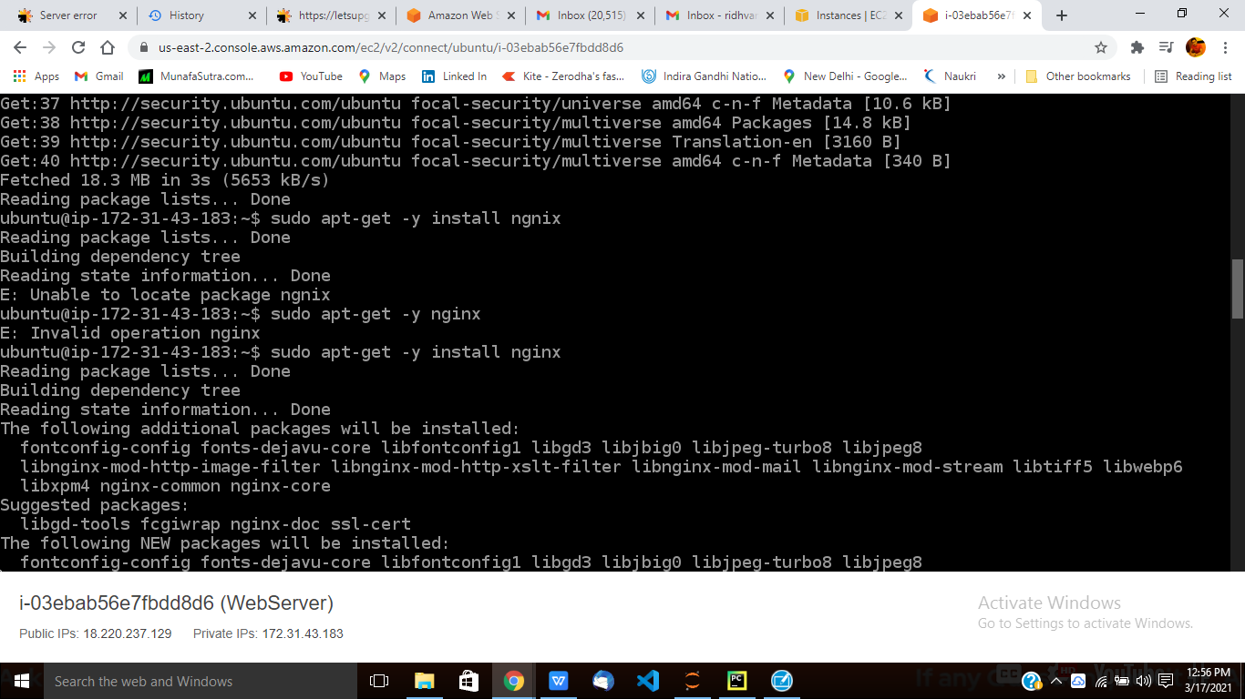

**05: Nginx Page**

