**Assignment 02-Day 02**

**01: EC2 Instance Creation (02 Nos)**

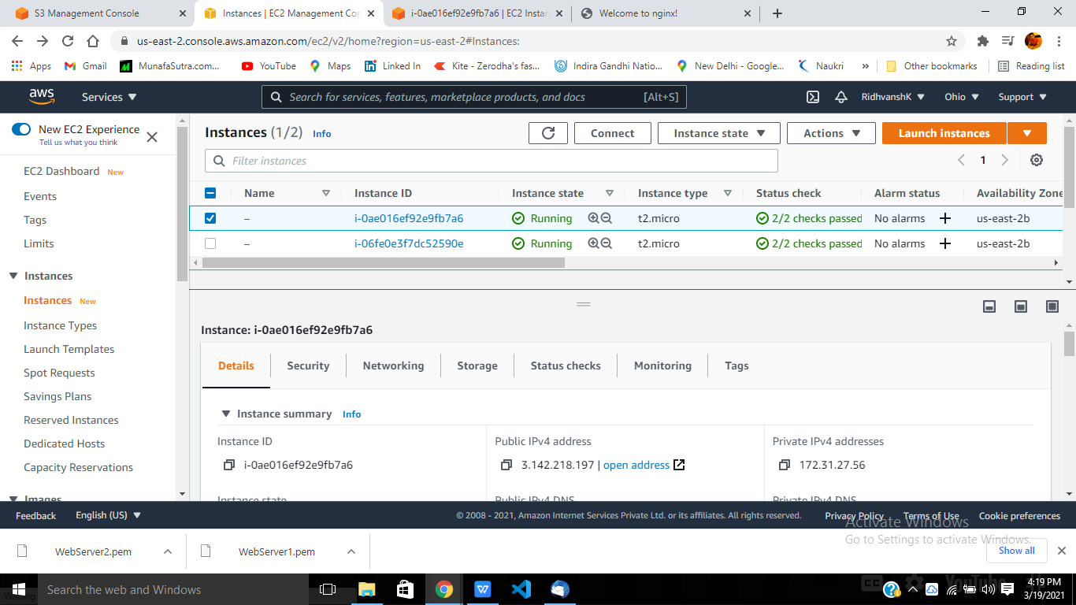

**02: Nginx installed on Instance 01**

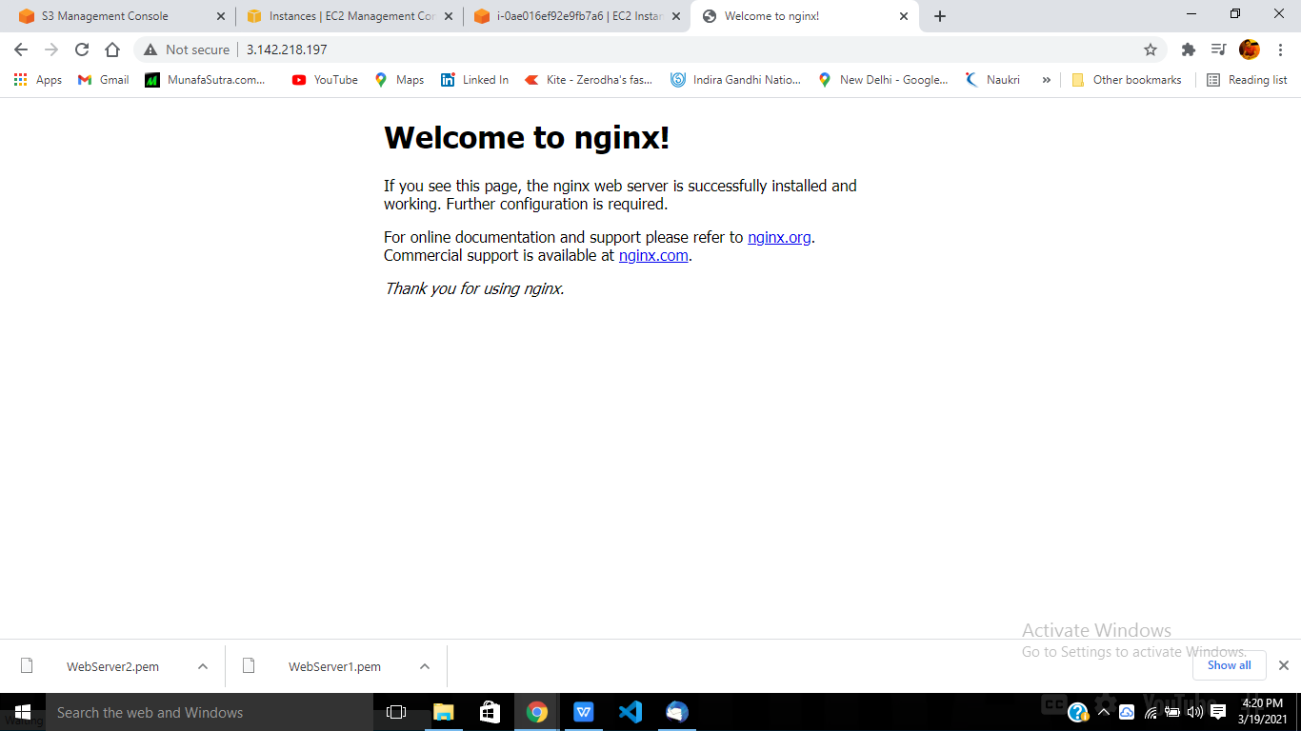

**03: Nginx installed on Instance2**

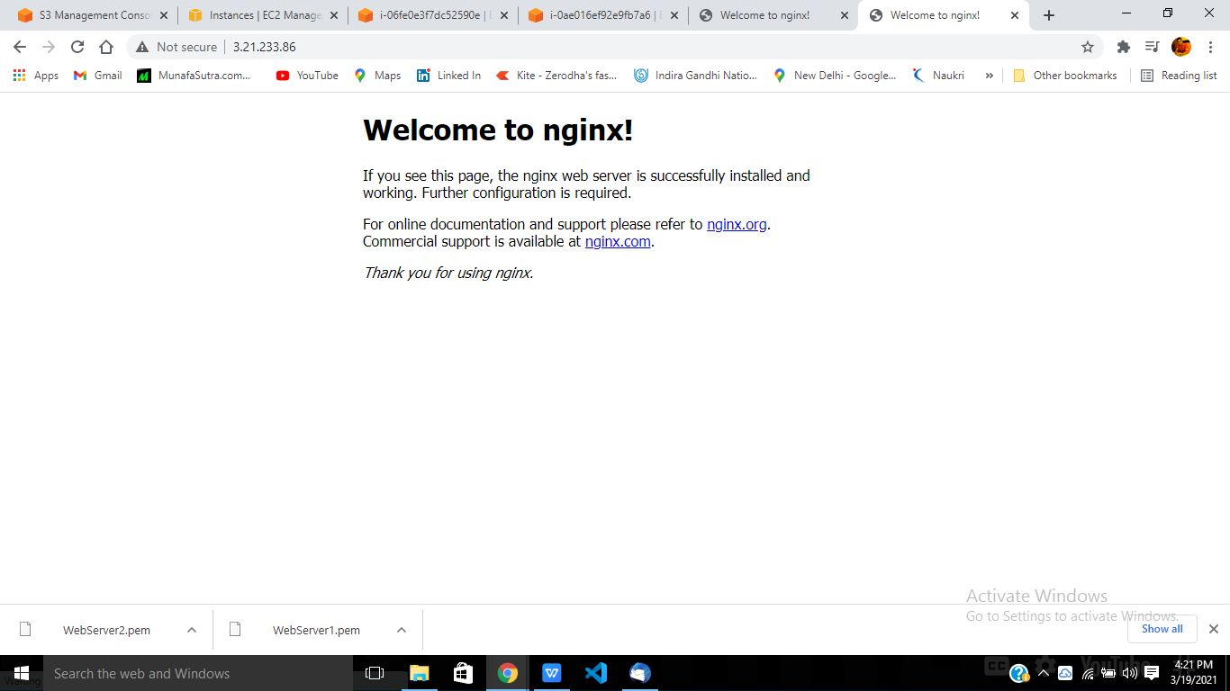

**04: Adding Instances to Tragetted Group-ELB**

