1b)Review of Linux commands

AIM:
To study the linux commands and execute it using the virtualization tools (oracle virtual box)
Commands:
1. ls -> Lists files and directories in the current directory.
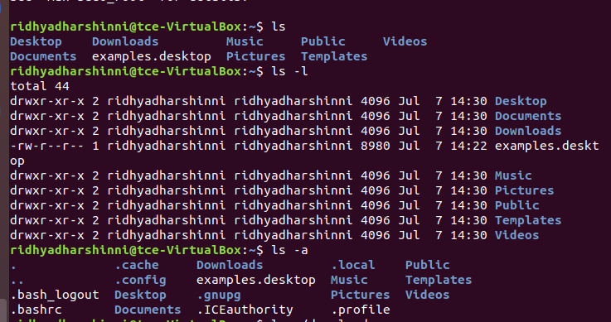

2. cd-> Changes the current working directory.
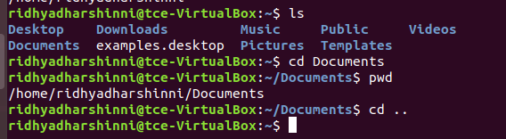

3. pwd-> Prints the current working directory path.
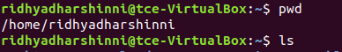
4.mkdir-> Creates a new directory (folder)

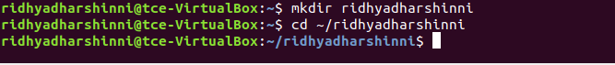

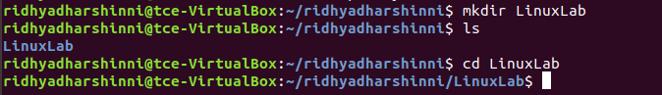

5. rm->Deletes files or directories. rm file.txt, rm -r myfolder (for directory)
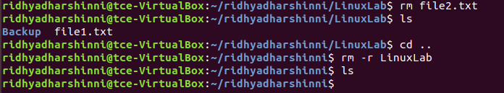

6.Cp-> Copies files or directories. Example: cp file1.txt file2.txt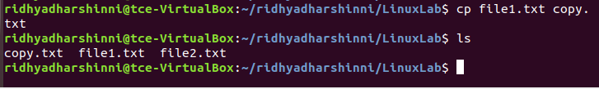
7. mv-> Moves or renames files or directories. Example: mv file.txt /tmp/ or mv old.txt new.txt
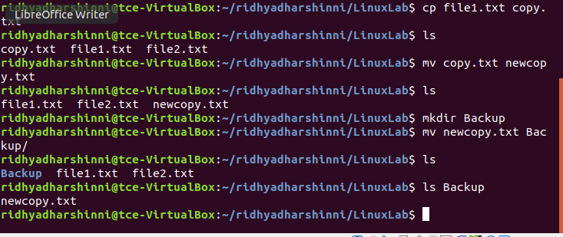

8. touch->Creates a new empty file. Example: touch test.txt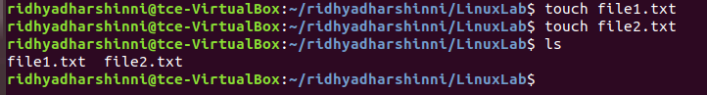

9.cat ->Definition: Displays content of a file. Example: cat file.txt
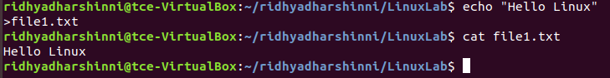

10.nano:->Definition: Terminal-based text editors. Example: nano file.txt
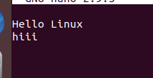
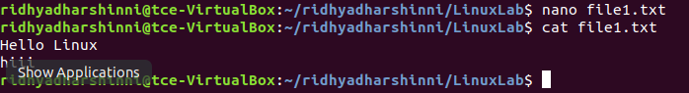

11.grep->Searches for patterns or keywords in files.Example: grep "error" logfile.txt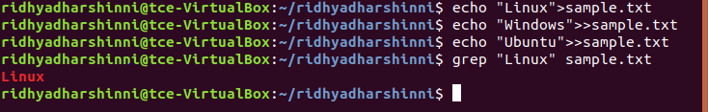

12)ps->Definition: Displays running processes. Example: ps aux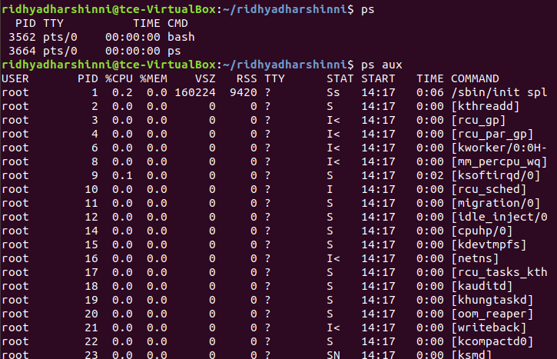

13) top-> Displays system tasks and resource usage in real-time.Example: top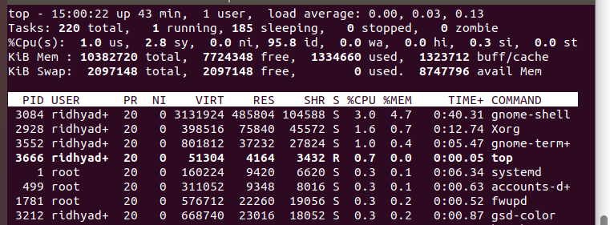
14) kill-> Terminates a process using its PID. Example: kill 1234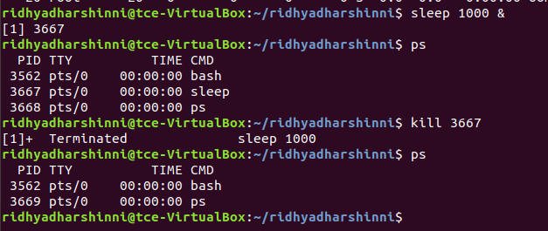

15)df->: Shows disk usage and free space of file systems. Example: df -h (human-readable)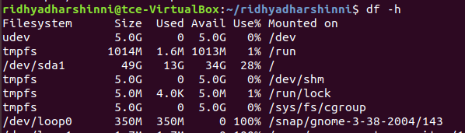

16. du -> Shows disk usage of files and directories. Example: du -sh folder_name/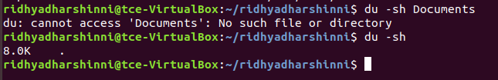
RESULT:

Thus the study of linux commands has been studied and executed successfully and output has been verified successfully.

