3)Cold Migration of VM from one host to another

Aim:
To perform cold migration of a virtual machine (VM) from one host to
another using the export/import appliance method (OVA format) in order to transfer VM configurations and disk data seamlessly while the VM is powered off.

STEPS:
Prerequisite
- VM must be shut down (powered off).
- Both systems (source and destination) must have VirtualBox
- Ensure enough storage on destination host.
- Created a java file to check whether the same file exist in vm after imported(cold migrated ) in another system
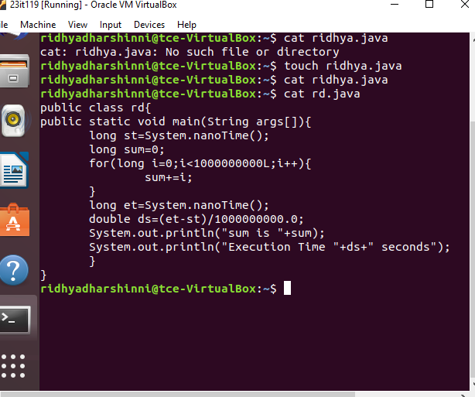

- Shut down the VM completely.Open VirtualBox and select the VM → Click File > Export Appliance (or File > Export OVF).
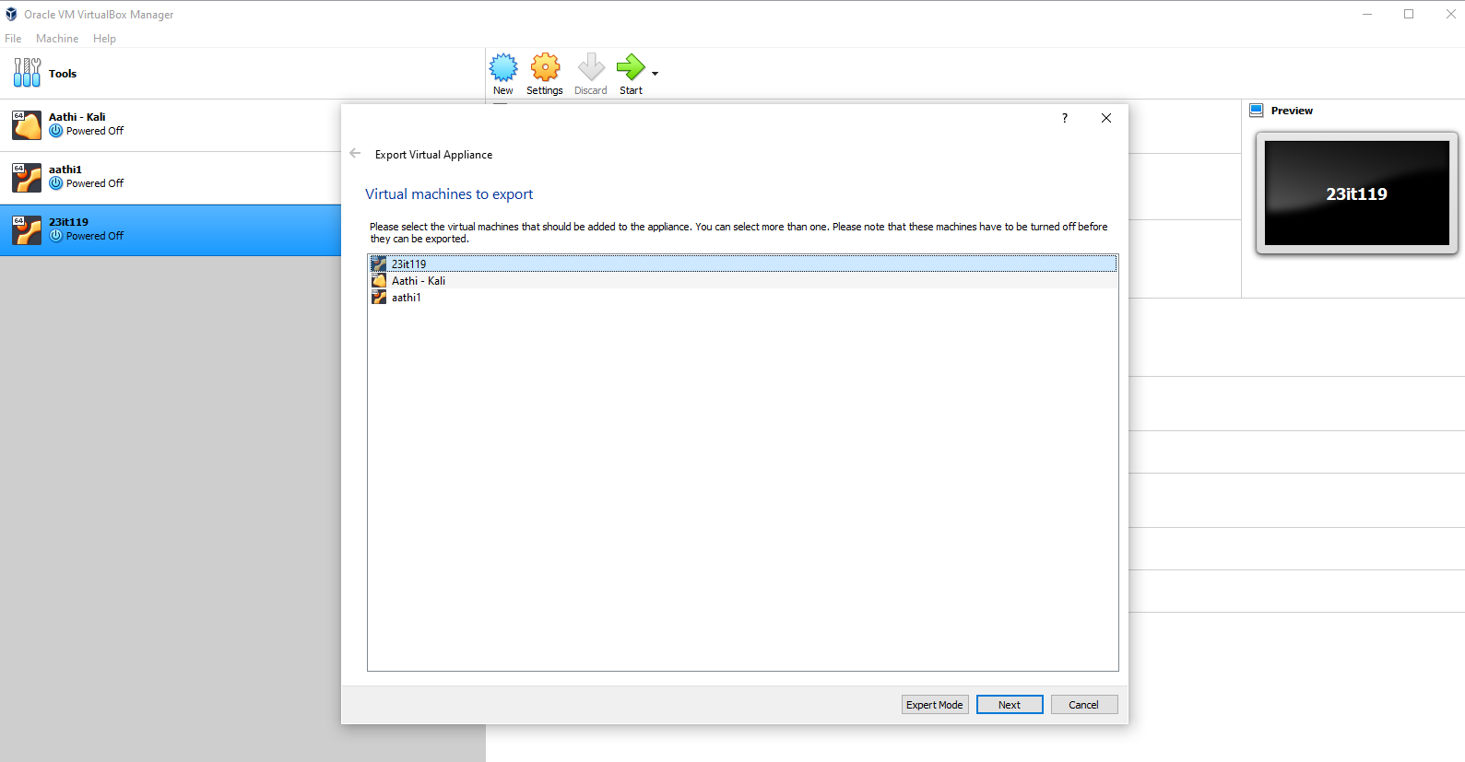
- Select the vm which you want to export
- Select the format which you want to export ova or ovf file format and select the path where you want to export in the file system
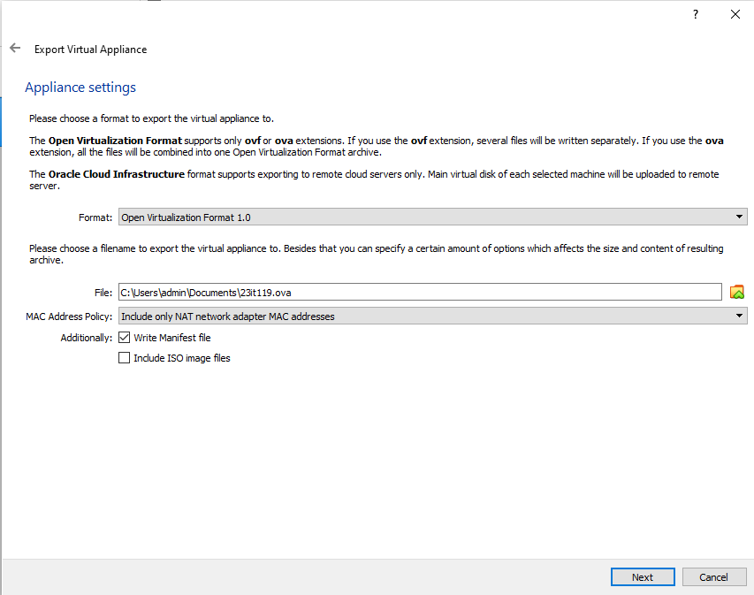

- Click export to (export appliance to the file system where you selected the location)
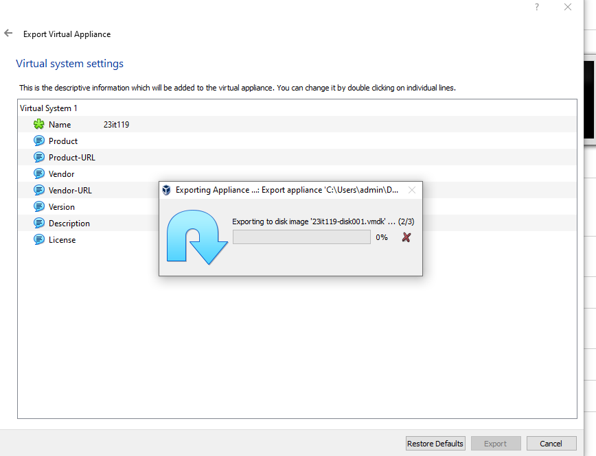
- Check the folder whether the ova image has been present in the folder
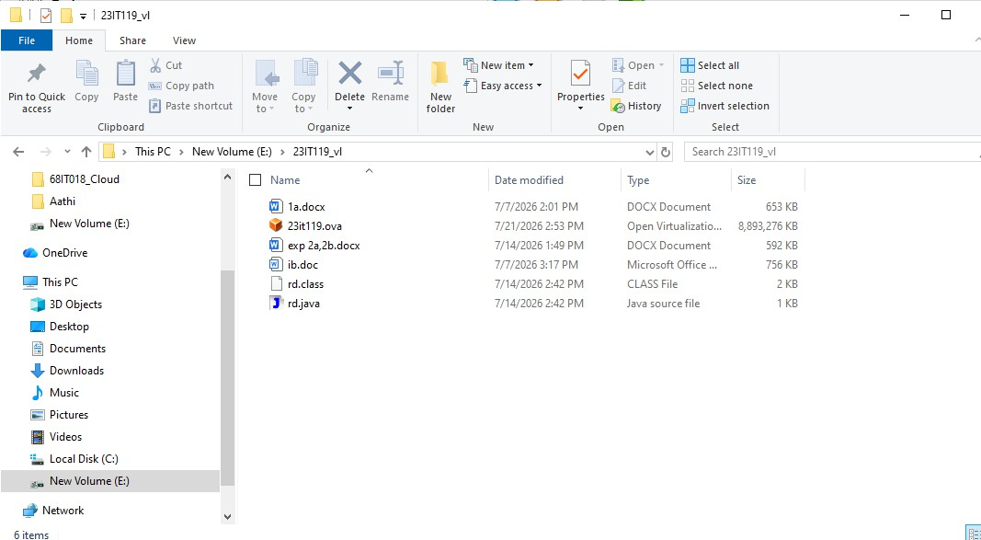

- Copy the image to the external device via internet , USB etc I am using the usb and stored in my smartphone .
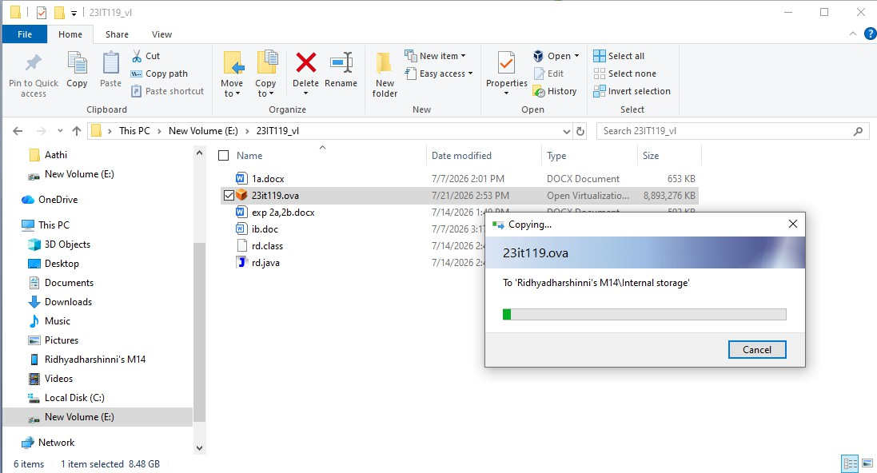
- Copy the image from your external device to the destination machine via usb
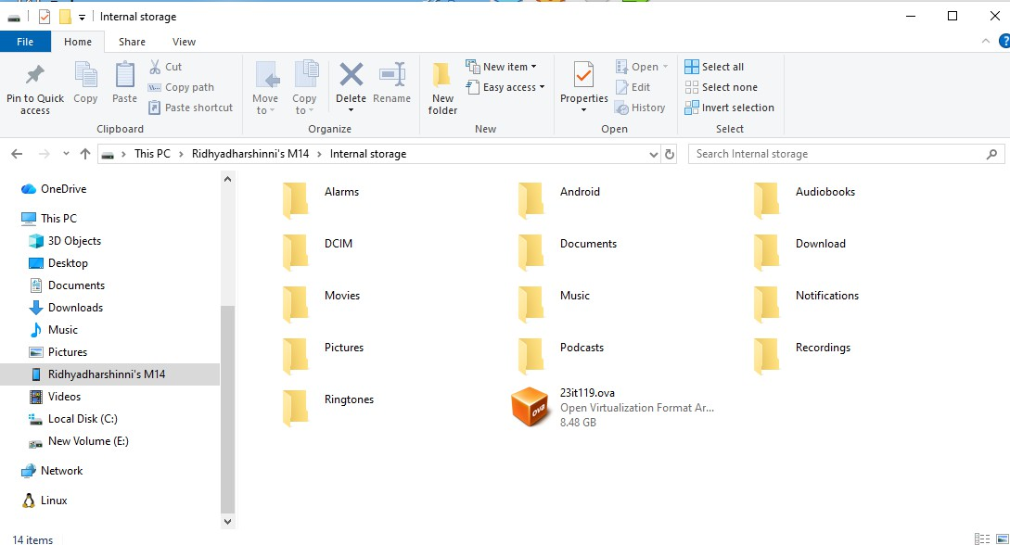

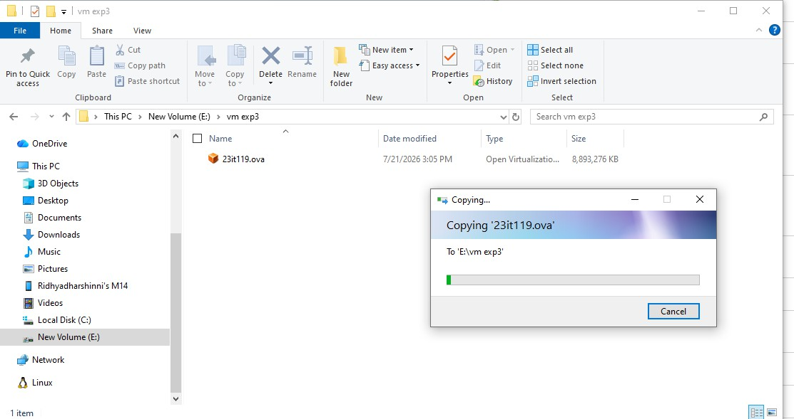
- On the Destination Host: Import the OVAOpen VirtualBox Go to File > Import Appliance (or File > Open). Browse and select the .ova file you transferred.
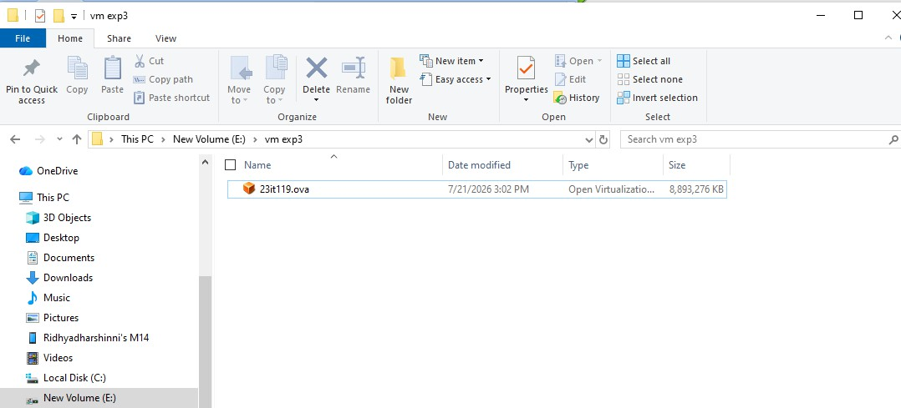

- Import the image by import appliance in the file ->import appliance
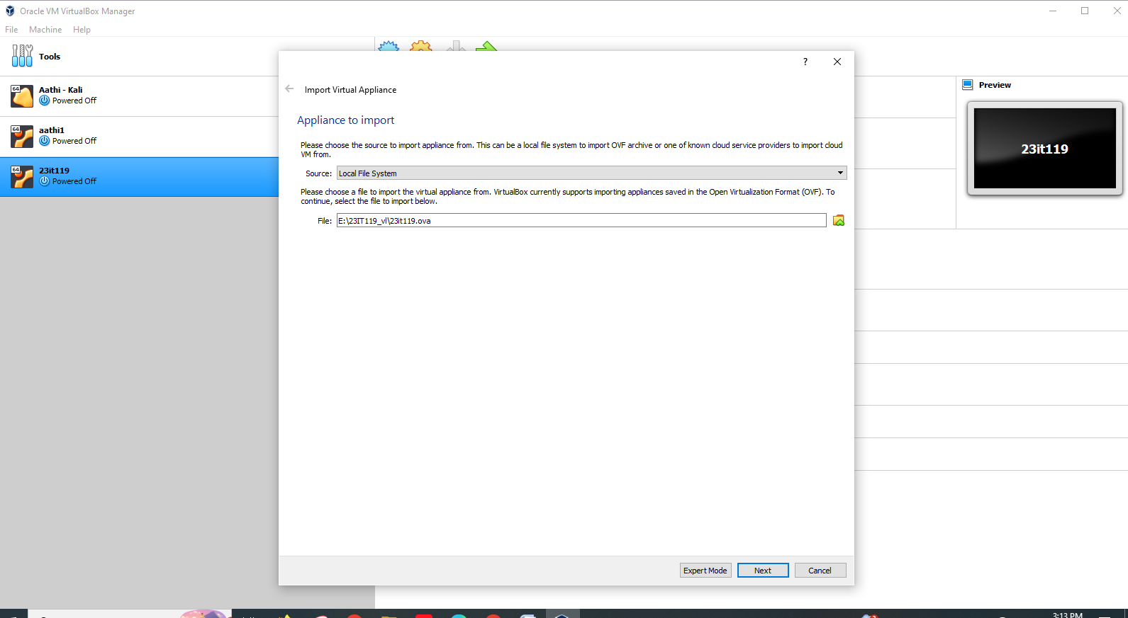
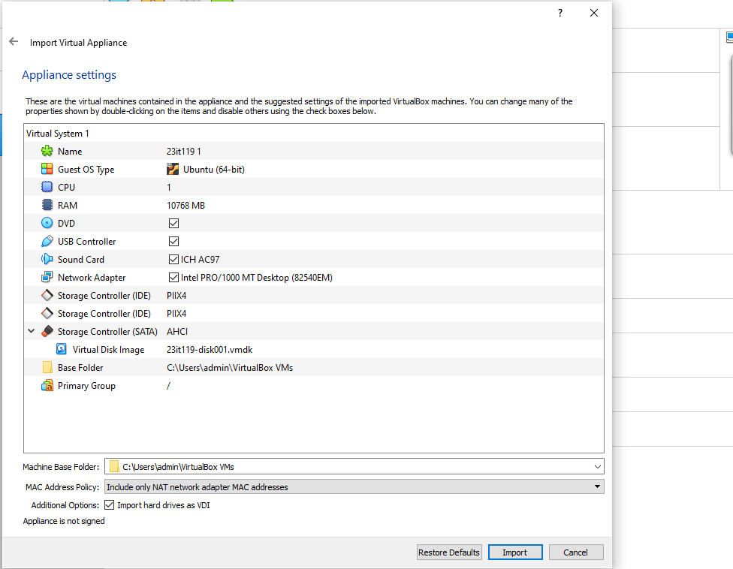

- Now the image has been importing
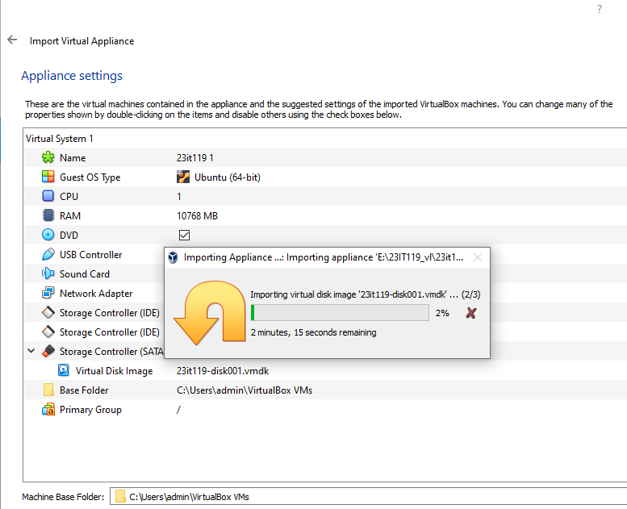
- Check whether the vm is shown in the oracle virtual box and open it
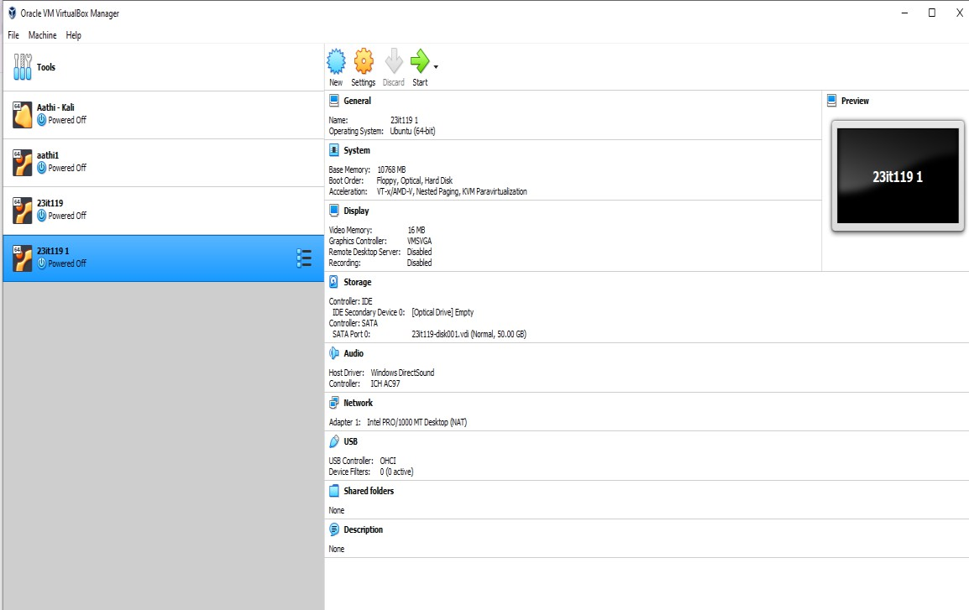

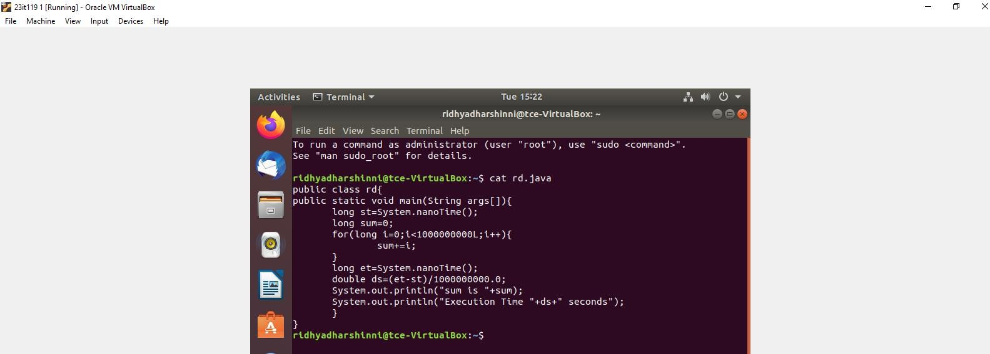
- Open the java file which you saved first using the linux commands cat kesho.java And its verified that the file are located and cold migration has done

RESULT:
The virtual machine was successfully migrated to the destination host in a powered-off state(cold migration) using the OVA export/import method. All configurations and data were retained, and the VM booted up and functioned correctly on the new host.

