4 a) Installation of Citrix XenServer 1 b) Live Migration of Virtual Machines using Xen Center

Aim:
To install and configure Citrix XenServer for virtualization of multiple
operating systems , use Xen Center for graphical management of virtual machines and perform live migration of VMs between physical hosts without downtime.

Xen
Xen is a Type 1 (bare-metal) hypervisor that enables the execution of multiple virtual machines (VMs) on a single physical machine by abstracting the hardware. It supports both paravirtualization and hardware-assisted full virtualization (via Intel VT or AMD-V).

Virtualization Type: Para or Full?
Feature Xen
Supports Both Paravirtualization (PV) and Hardware-assisted Full Virtualization (HVM)
Default Mode Originally designed for Paravirtualization (efficient, faster)

With Hardware Assist
Uses HVM mode for OSes like Windows (needs CPU virtualization support)

Xen Type 1 vs Type 2 Hypervisors
Feature Type 1 (Xen) Type 2
Runs on Bare metal (hardware directly) Runs on host OS

Examples Xen, VMware ESXi, Microsoft
Hyper-V
VirtualBox, VMware Workstation

Performance High performance, low overhead Slightly lower performance Security More secure (minimal layers) Depends on host OS security

Equivalent Hypervisors to Xen Hypervisor Type Notes

KVM Type 1 (in Linux kernel)
Integrated with Linux, uses hardware virtualization

VMware ESXi Type 1 Enterprise-grade, GUI support
Microsoft Hyper- Type 1 Windows-based hypervisor

V
VirtualBox Type 2 Desktop virtualization

Requirements for Live Migration in Xen
- Shared Storage (e.g., NFS, iSCSI, SAN): Both hosts must access the same virtual disk.
- Same CPU family: Compatible CPU features between source and destination.
- Network Connectivity: Low-latency, high-speed network between hosts.
- Xen-compatible tools: xm, xl, or XenAPI-based management like XenCenter.
- Proper Configuration: Dom0 should have migration tools enabled, with firewall ports open.

XenServer vs XenCenter

Feature XenServer XenCenter

Definition Commercial distribution of Xen
hypervisor
GUI-based management tool for XenServer

Runs on Physical Server (bare-metal) Windows desktop (client-side
software)
Function Creates and runs VMs Manages, monitors, and controls
XenServer

Open Source?
XenServer is partly open-source (Citrix)
XenCenter is free but not open-source

1a)
Citrix XenServer is a virtualization platform based on the open-source Xen
Hypervisor. It enables efficient creation, management, and execution of multiple virtual machines (VMs) on a single physical host.

Installation Steps:
- Download ISO:
  - Get the official XenServer ISO from Citrix website.

Create Bootable Media:
  - Use tools like Rufus or Ventoy to create a bootable USB with XenServer ISO.

BIOS Settings:
  - Enable VT-x / AMD-V (hardware virtualization) and set USB as first boot device.

Boot and Install:
  - Insert the USB and boot the server.
  - Follow the on-screen instructions:
    - Select installation drive (e.g., local disk).

    - Configure network settings (static IP recommended).
    - Set root password.
    - Choose to install XenServer tools

Complete Installation:
  - Reboot system after installation.
  - XenServer boots with a console UI showing IP address and system info.

Live Migration of Virtual Machines using XenCenter
Live Migration refers to moving a running virtual machine from one physical host to another without shutting it down, using XenCenter’s GUI.

Steps 1:
Add the new server by clicking the server in the xencenter and server->
Add

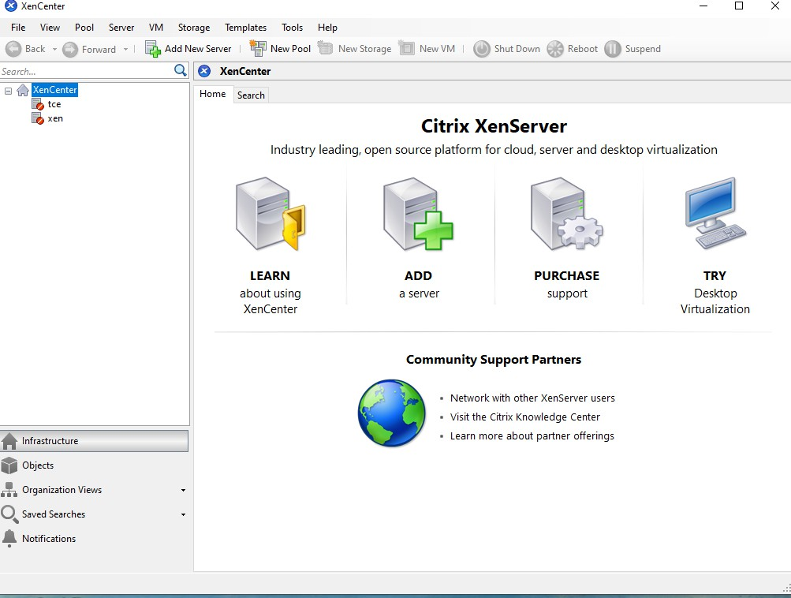

Steps 2:
Add the xenserver 1 by entering the Server , Username and password and click add.
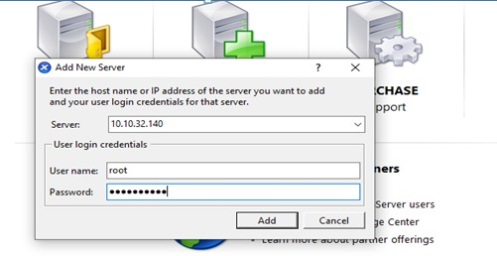

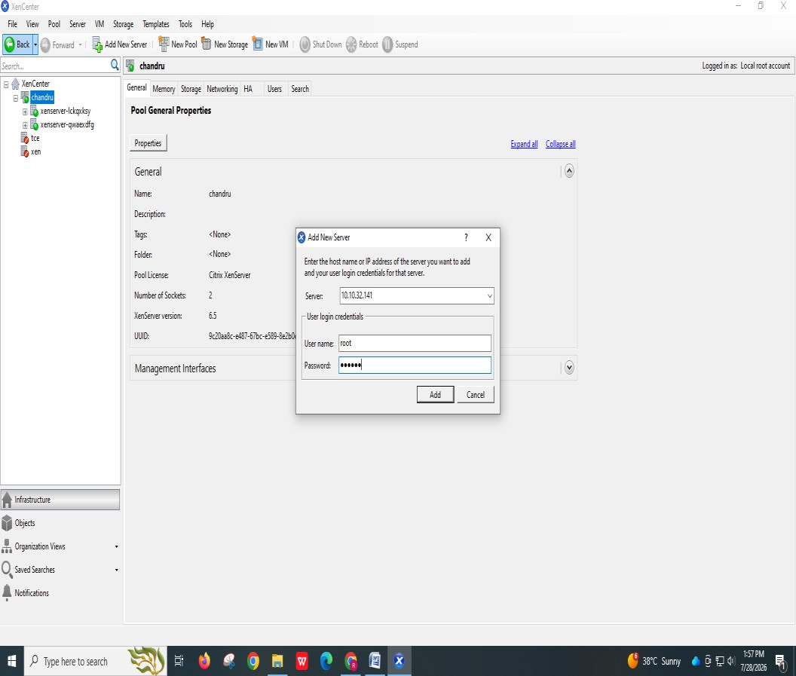

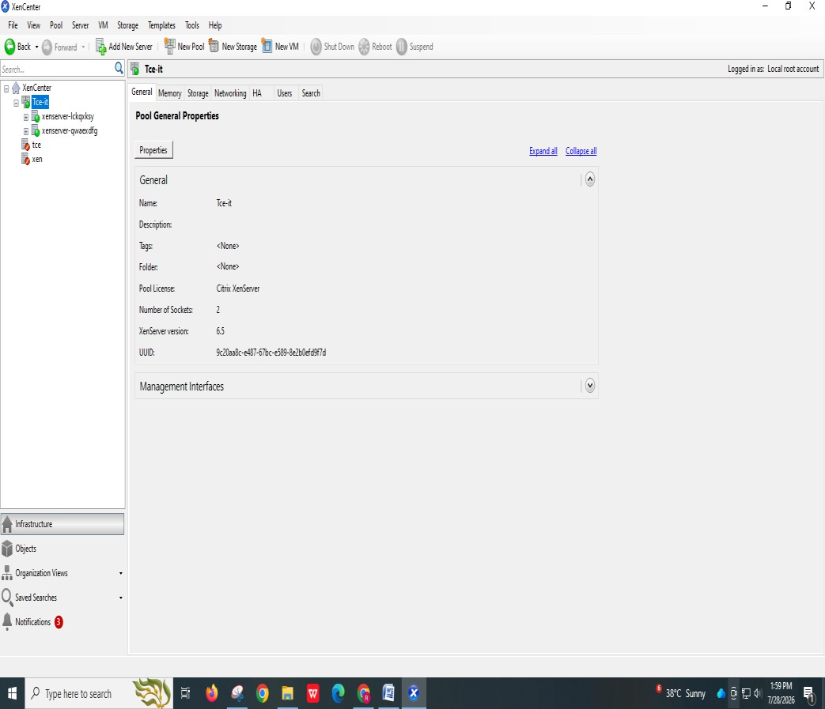

Steps 3:
Next add the vm of yours by clicking the xenserver 1 (right click) and add click new vm
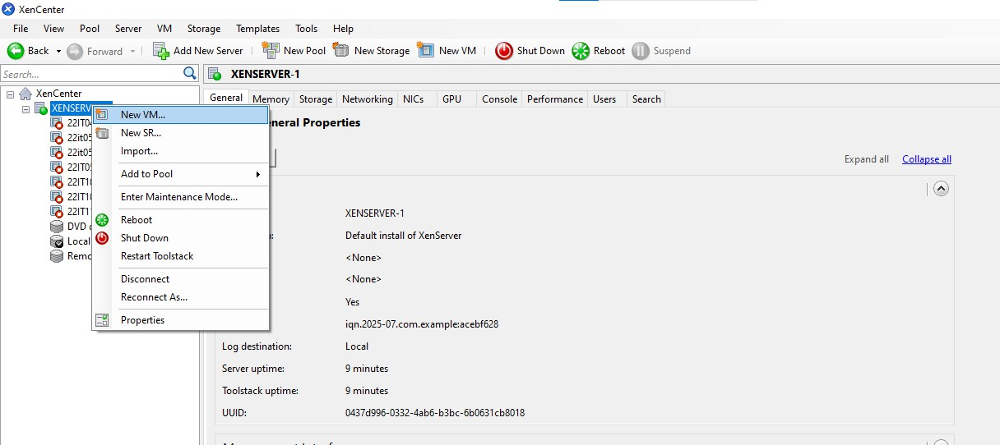

Steps 4:
Click the template example citric or ubunttu os or cent os(os which you
have).

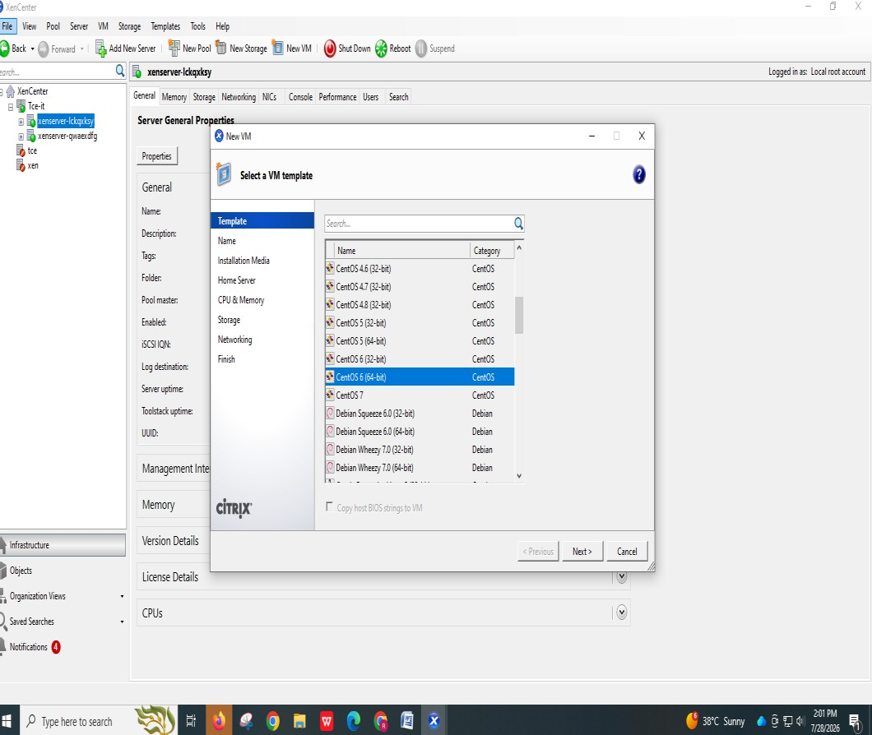
Steps 5: Give the name for your Vm and click next.
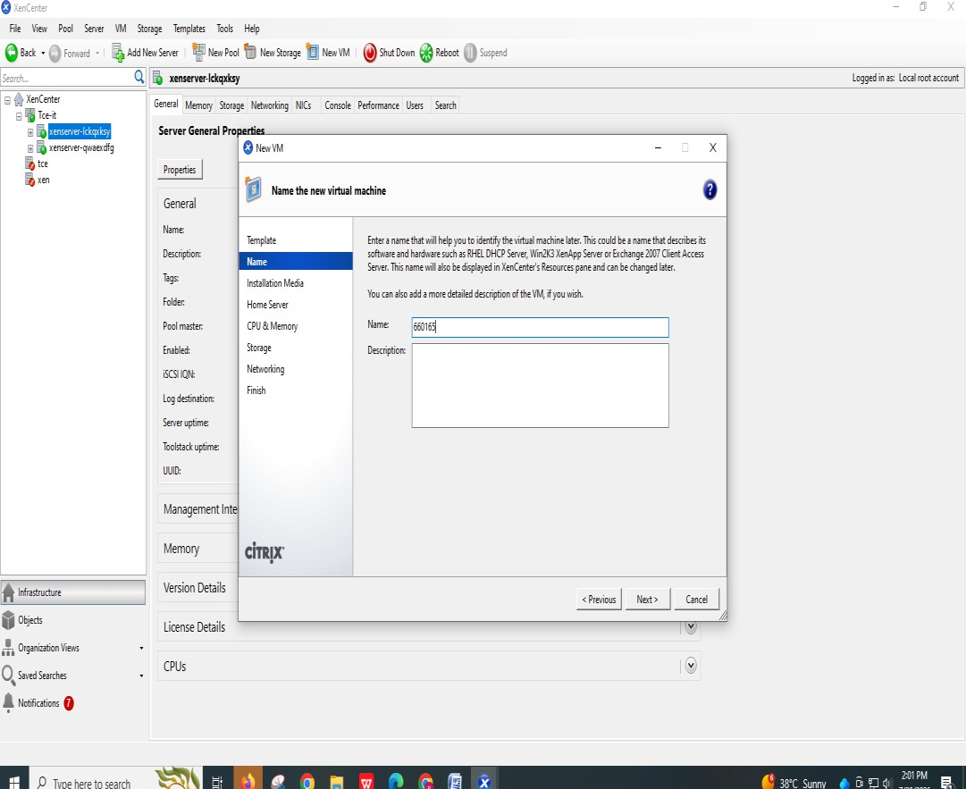
Steps 6: Select the iso file inside and click the next

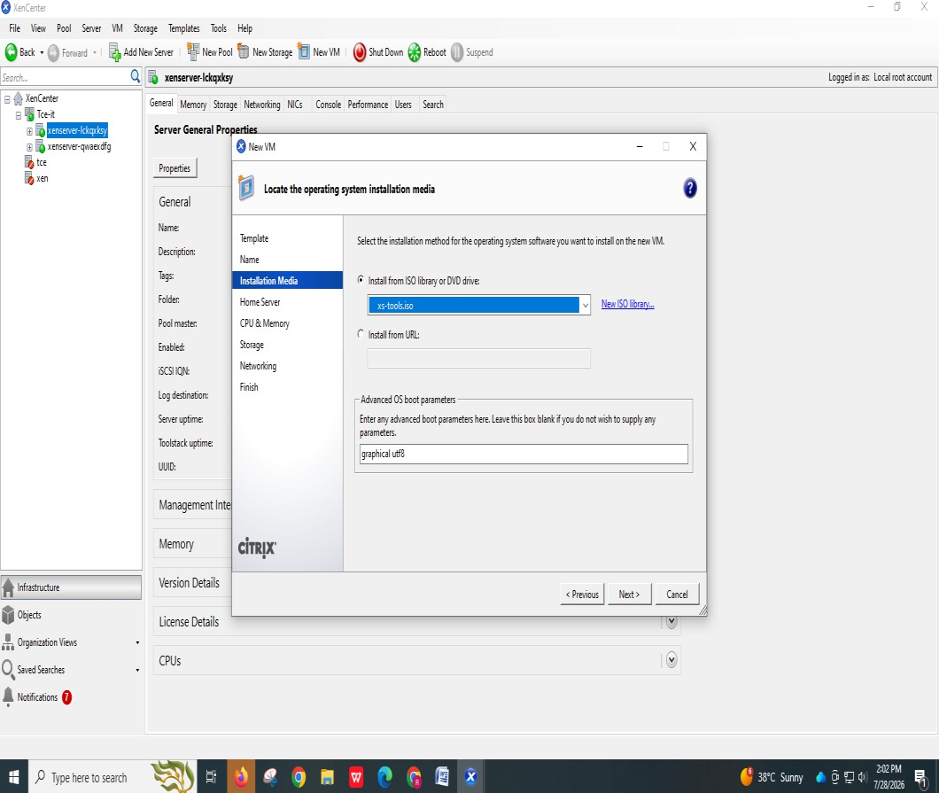
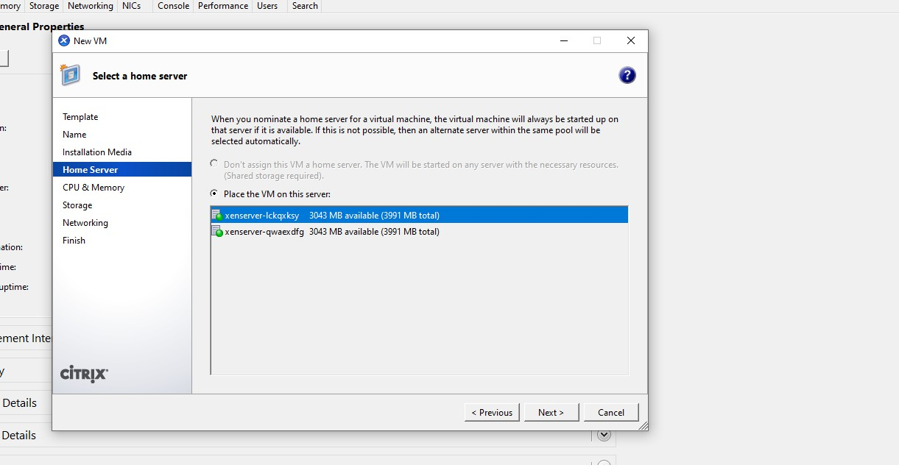

Steps 7:
Finally click the create now option then your vm has been created successfully.

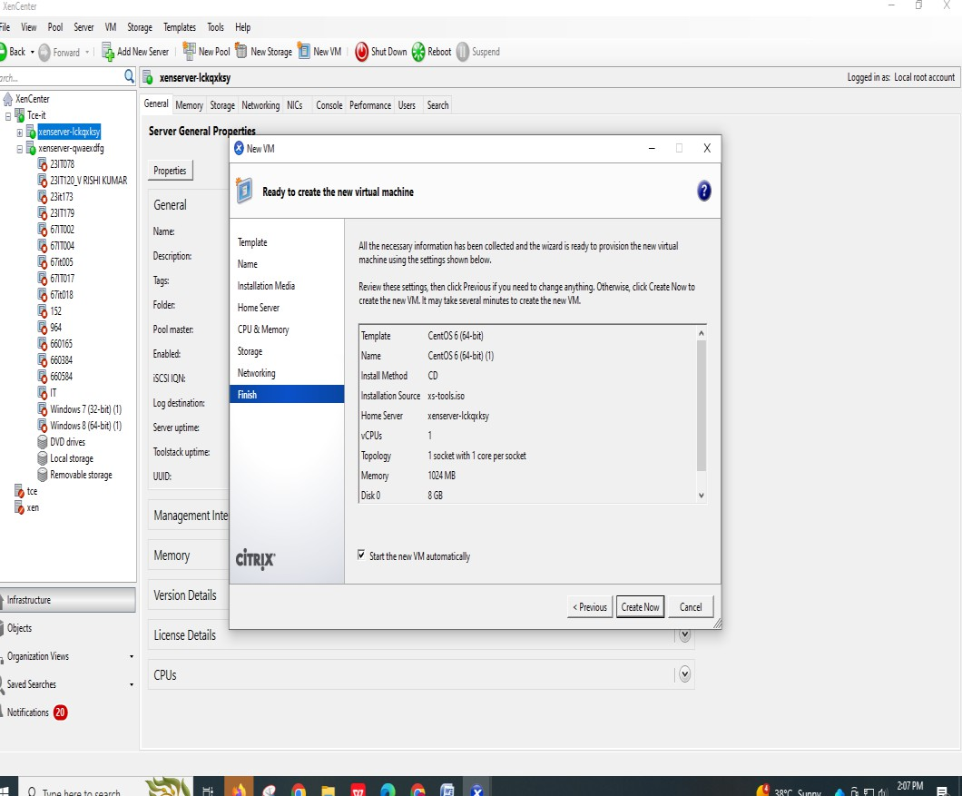
Steps 8: Create a xenserver 2 same procedure followed in first xenserver1 and click the xenserver 1.
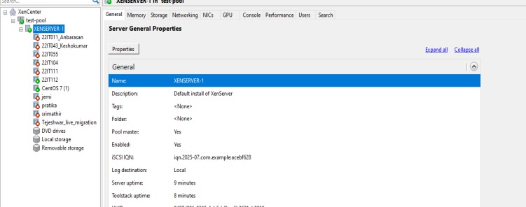

Steps 9:
Right click the vm and select the move vm option from the following
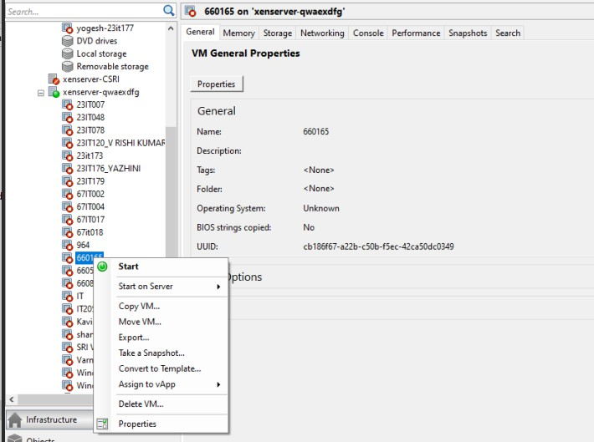

Steps 10: Select the xenserver 2 from the following list
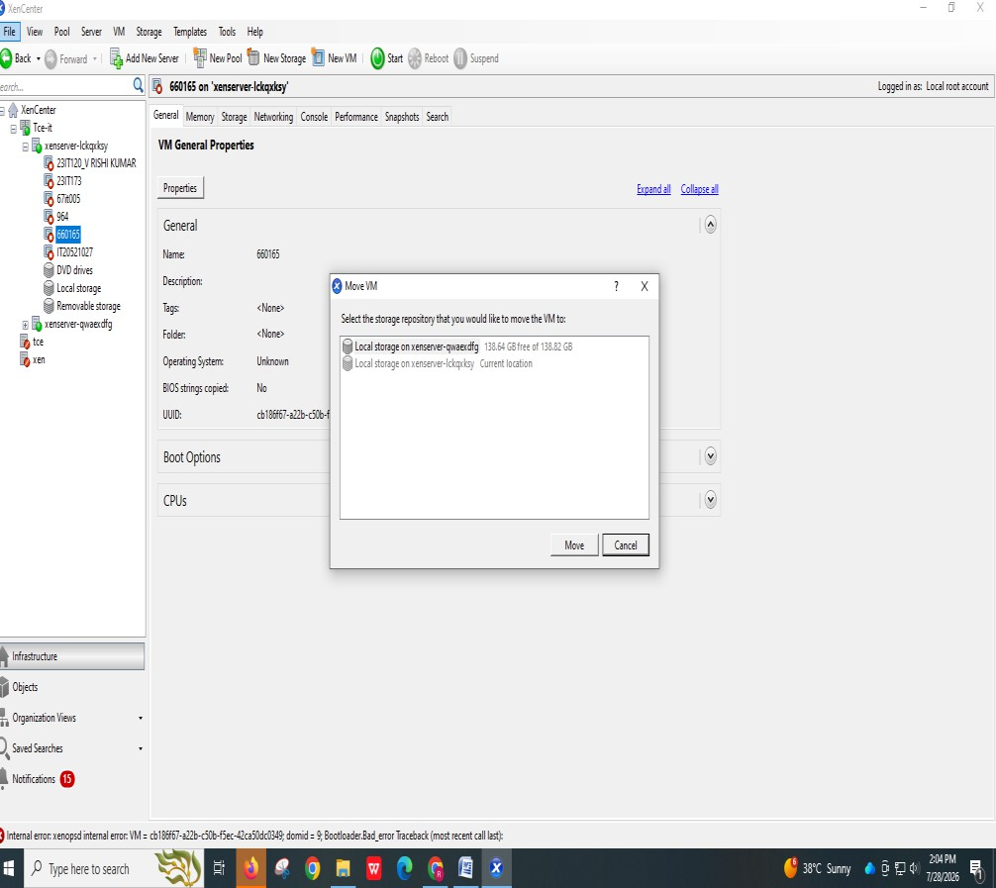

Steps 11:
Now see the Vm in the second server tce and the live migration has been executed successfully.
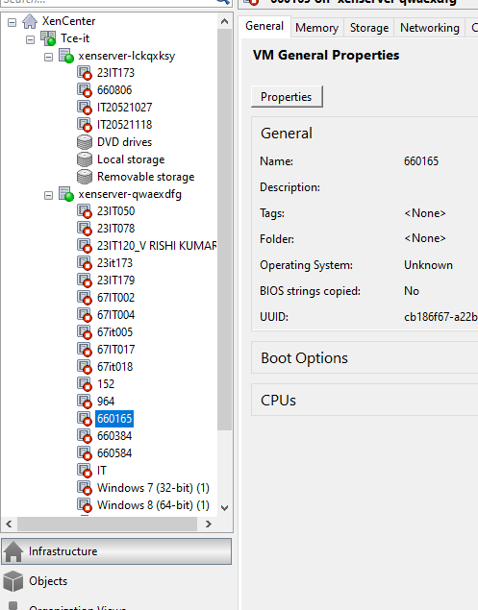

RESULT:
Successfully executed the setup of XenServer and XenCenter; live migration was performed and output verified with zero downtime during VM transfer.

