5a) Installation of KVM and creation of Virtual instances

Aim:
To install a KVM and creation of virtual instance for setting up a virtualized
environment on linux system.
What is KVM?
KVM (Kernel-based Virtual Machine) is an open-source virtualization technology built into the Linux kernel. It turns Linux into a type-1 hypervisor that allows you to run multiple virtual machines (VMs) on a physical host.
Each VM has its own virtual hardware (CPU, RAM, disk, etc.), and runs its own full-fledged operating system.
Benefits of KVM Feature Benefit
Open Source Free and supported by the Linux community.
Performance Near-native performance using hardware virtualization (Intel VT or AMD-V).
Security Isolation between VMs using SELinux and AppArmor. Scalability Can handle many VMs on a single host (scales well vertically). Flexibility Supports many OSes (Linux, Windows, BSD, etc.).
Integration Works with tools like libvirt, virt-manager, OpenStack, etc.

Live Migration
Procedure:
Supports live VM migration between hosts.

Virtualization Technology
- Check Hardware Virtualization Support.
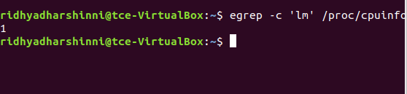

Output ≥ 1 indicates support. If 0, CPU doesn't support hardware virtualization.
- Run uname -a , which shows kernel name, hostname, kernel version, build date, architecture, and OS type in one line.
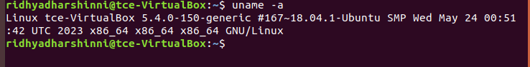
- To list the KVM kernel module files present in your kernel, run:
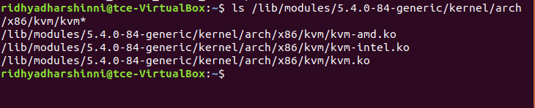

KVM Installation
- Install required packages : qemu-kvm, libvirt-bin, bridge-utils, virt-manager and qemu-system.

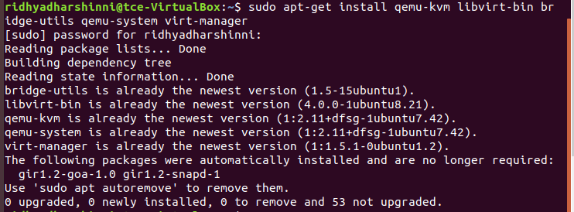
- Configure the libvirt daemon configuration file for remote access & socket permissions in KVM/libvirt

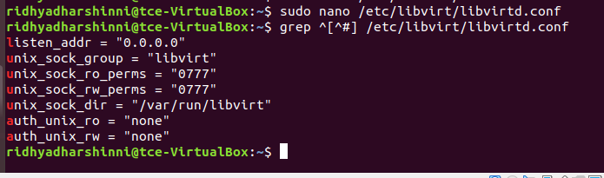
After configuring it, restart libvirtd dervice.
- Run virsh list - Displays no of Virtual machine running.
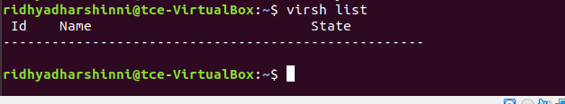
- Connecting to Virtualization interactive terminal.
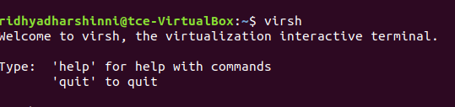
- Getting Version of libvirt & QEMU.
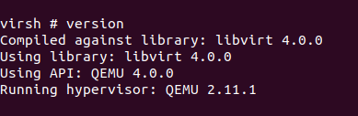
- Getting Node information

- 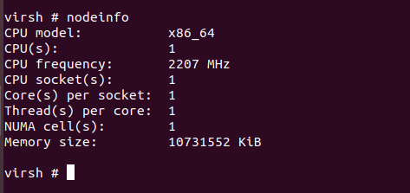

Importing existing VM
- Go to virtual machine manager (virt-manager) in your linux system. Then, right click QEMU/KVM and select New to create new VM.
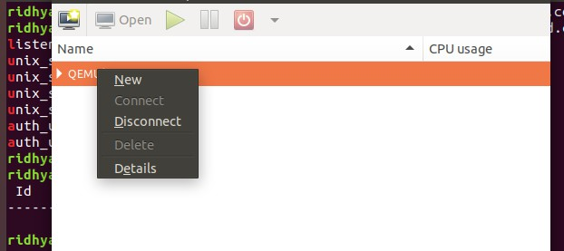

- Select import existing disk image and click forward.
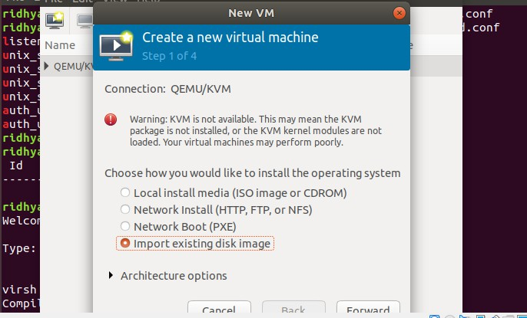

- Download cirros disk image from the link: https://download.cirros-cloud.net/0.5.1/
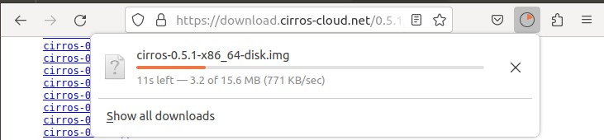

- Give the path of downloaded cirros disk image and click forward.

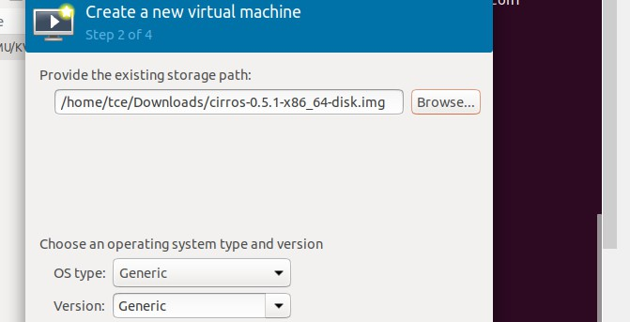
- Choose memory and CPU settings and click forward.
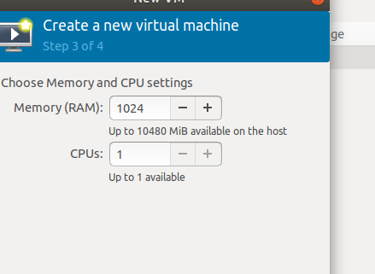

- Name your VM and click Finish.
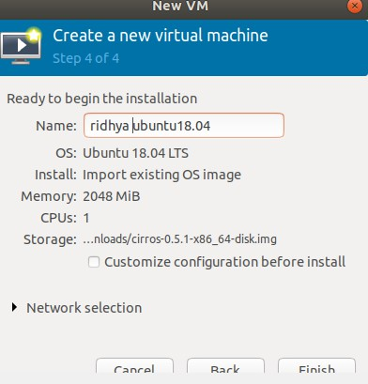

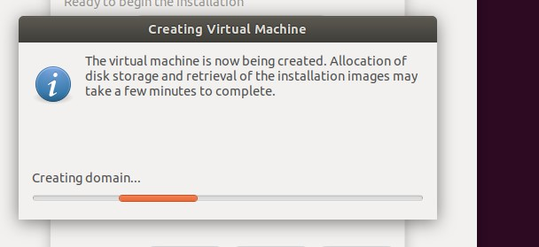

- The VM is booted successfully and the login was also successful.
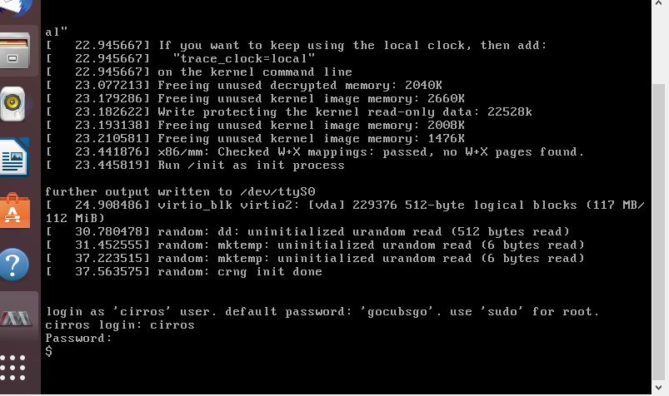

Result:
Thus, the KVM was successfully installed on the Linux system, and virtual instances were created and configured using Virt-Manager, demonstrating the setup of a virtualized environment.

