6.Transfer of files from one Virtual Machine to another
Aim:
To transfer files from Ubuntu VM to Kali VM using NFS share, enabling read and write access on both ends.
Steps:

SHARED FOLDER

Step 1: Create a Shared Folder on Your Host

- On your host machine (Windows/Linux):

  - Create a folder, e.g., C:\VMShared

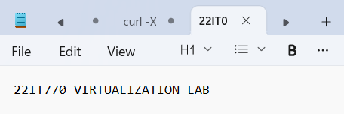
  - Add a test file (22IT043.txt) to confirm later.

Step 2: Enable Shared Folder in VirtualBox (for Both VMs) Repeat this for both Ubuntu VMs.
- Shut down the VM if it’s running.

- In VirtualBox Manager, select your VM.

- Click Settings → Go to Shared Folders tab.
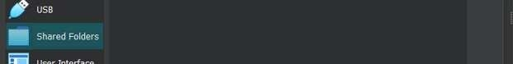

- Click “+” (Add new shared folder).

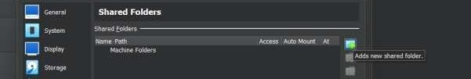
- Set:

  - Folder Path: Select C:\VMShared (or wherever you created it).

  - Folder Name: VMShared (updates once path is entered)

  - Check(Tick) Auto-mount
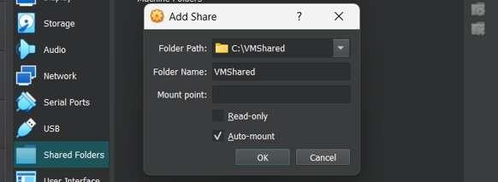

Click OK.

- Then, again Click OK (at bottom) to save.

Do this for both VMs VM2:
- In VirtualBox menu (inside VM window), go to: Devices → Insert Guest Additions CD image

VM1:

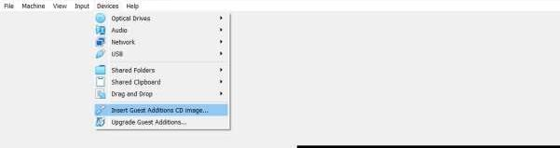

Now use the command: ls /media
  - It lists all the directories (i.e., mounted devices or drives) under the
/media directory.
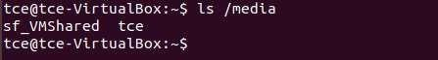

Therefore, in VM1 sf_VMShared folder is there in /media directory.

VM2: SAME PROCEDURE FOR virtualbox 2 Run the command: ls /media

Therefore, in VM2 also sf_VMShared folder is there in /media directory.

Step 4: Access the Shared Folder

After rebooting each VM, the shared folder should be mounted automatically at:
/media/sf_VMShared

To check, run the command : ls /media VM1 :
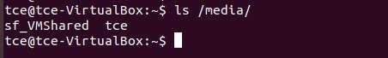

VM2 :

Run the command : ls /media/sf_VMShared VM1 :

VM2 :

You should see the 22IT043.txt file from your host.

But in VM1 and VM2 , it asks for permission to list the files of sf_VMShared folder.

Step 5: Fix Permissions (if Permission Denied) You need to add your user to the vboxsf group: sudo usermod -aG vboxsf $USER

Then reboot again:

sudo reboot

Now try again:

ls /media/sf_VMShared``
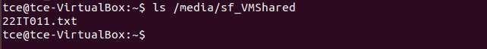


You should now have full access. Step 6: Transfer Files Between VMs
- Now in VM1, copy a file to /media/sf_VMShared folder,

cp VM1.txt /media/sf_VMShared/

- Switch to VM2, and check the shared folder:

ls /media/sf_VMShared

The VM1.txt file will appear — you can copy it out to any other location and also you can edit files in shared folder location itself. Any changes done in shared folder using one VM will also be reflected to the other VM.

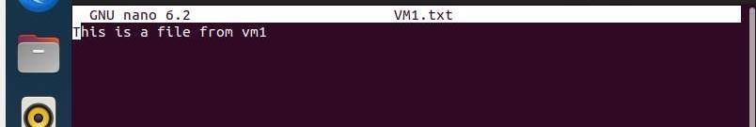

Also 22IT043.txt file is accessible in VM2,


METHOD 3(SSH Secure Shell)

Step 1: Install SSH

On both VMs (VM1 & VM2):

sudo apt update

sudo apt install openssh-server -y
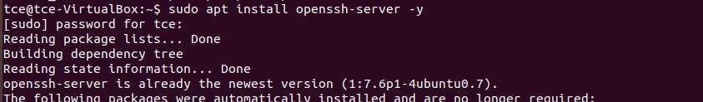
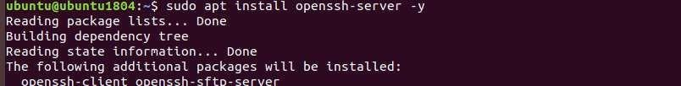

Check SSH status:

sudo systemctl status ssh
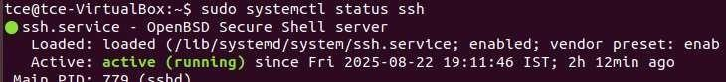

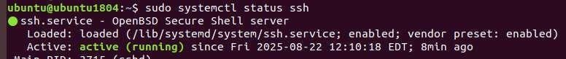

Step 2: Get Server’s IP

On VM1 (Server, username = tce):ip a

Allow firewall settings for SSH to avoid Connection timed out error.

sudo ufw allow 22/tcp sudo ufw reload
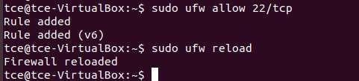

Step 3: Connect from VM2 to VM1 On VM2 (Client, username = ubuntu): ssh tce@192.168.56.103
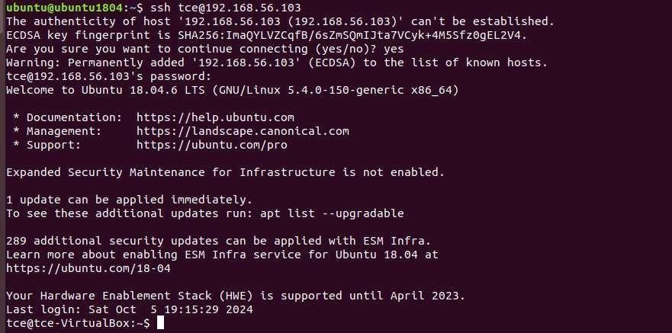
Enter tce’s password → now you are logged into VM1.

Step 4: Transfer Files with SCP (From VM2)

- Copy file from VM2 → VM1

scp 𝑓ile.txt tce@192.168.56.103:/home/tce/

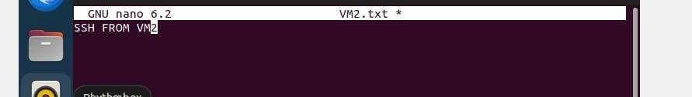

- Copy file from VM1 → VM2

scp tce@192.168.56.103:/home/tce/serverfile.txt /home/ubuntu/

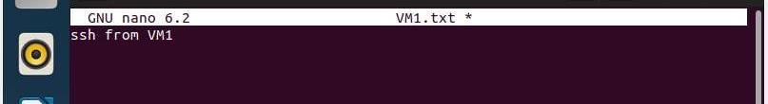

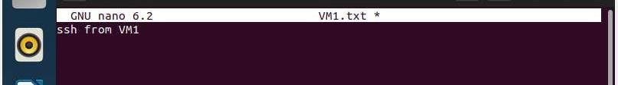

METHOD 4(FTP (File Transfer Protocol)

Step 1: Install FTP Server on VM1 (VM1 = server, VM2 = client)
On VM1:
sudo apt update

sudo apt install vsftpd -y
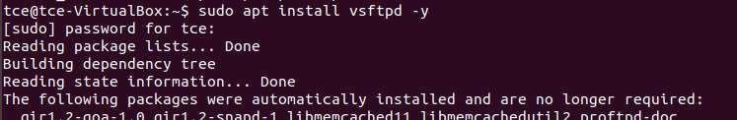
Enable and start the service: sudo systemctl enable vsftpd sudo systemctl start vsftpd
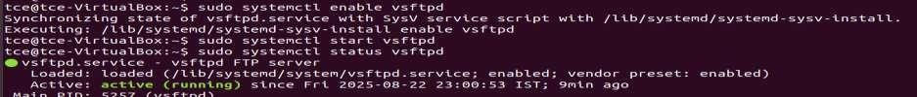

Step 2: Configure vsftpd

Edit the config file:

sudo nano /etc/vsftpd.conf

Make sure these lines are set (uncomment or add if missing):

local_enable=YES write_enable=YES chroot_local_user=YES allow_writeable_chroot=YES Save (CTRL+S, CTRL+X)
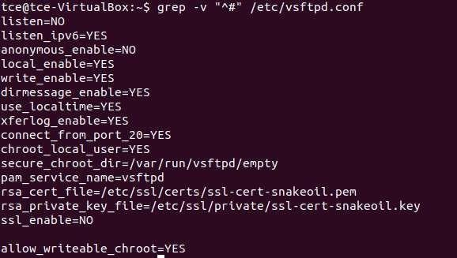

Restart the ftp server:

sudo systemctl restart vsftpd

Step 3: Check VM1 IP Address On VM1, run:
ip a

Allow firewall settings for FTP to avoid Connection timed out error.
sudo ufw allow 21/tcp
sudo ufw allow 20/tcp # (for data transfer) sudo ufw status

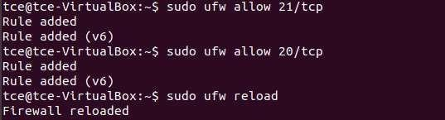

Step 4: Connect from VM2 (FTP client) On VM2, install ftp client:

sudo apt install ftp -y

Now connect:

ftp 192.168.56.103
Enter VM1’s username (tce) and password when prompted.
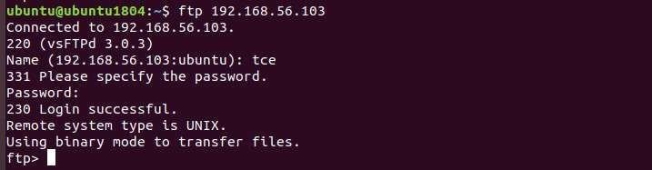

Step 5: FTP Commands
Once connected, you can use:
- ls → list files on VM1

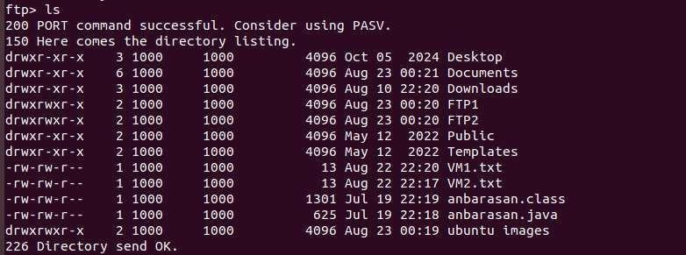

- cd folder → change directory on VM1
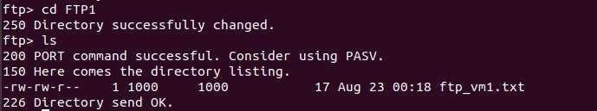

- get filename → download file from VM1 → VM2
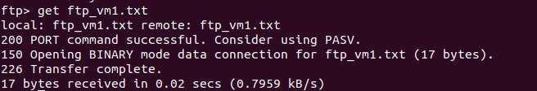

- put filename → upload file from VM2 → VM1
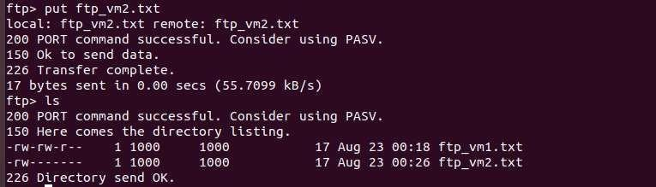

- bye → exit
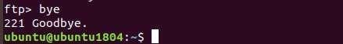

Step 6: Verify

- ftp_vm1.txt should now be in VM2’s current directory.

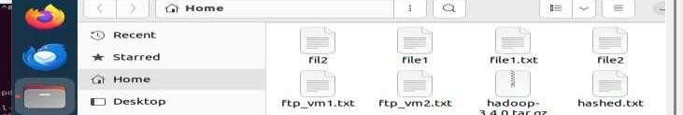

- ftp_vm2.txt should now be uploaded to VM1’s /home/FTP1/ directory.

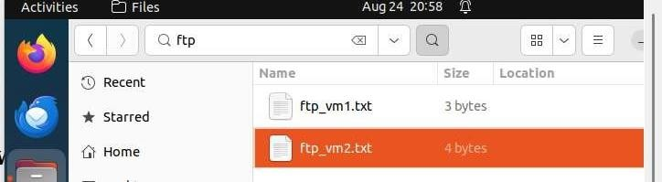

RESULT:

Thus the file transfer between Ubuntu and Kali VMs is executed successfully and both VMs can read and write files in the shared folder seamlessly.

