7a) Configuration of HyperV on Windows of VMs
Aim:
To configure Hyper-V on Windows for creating and managing virtual machines (VMs), enabling efficient virtualization and resource utilization.
Steps:
1)Open the windows server and open the server manager Click add roles and features . Read before you begin and click next.
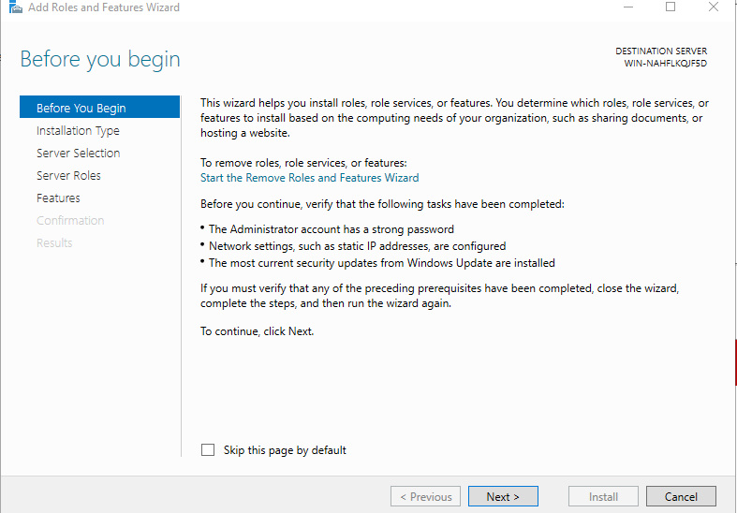
2) Select role based installation type and click next.
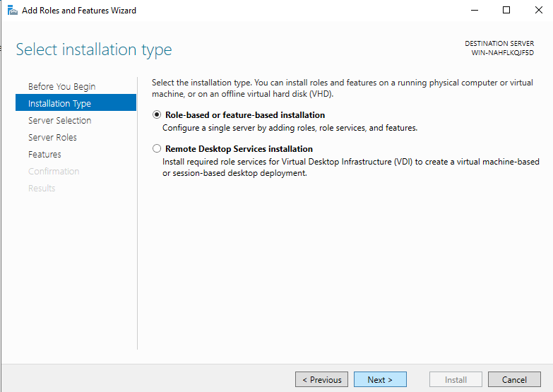

3)Select the server and click next
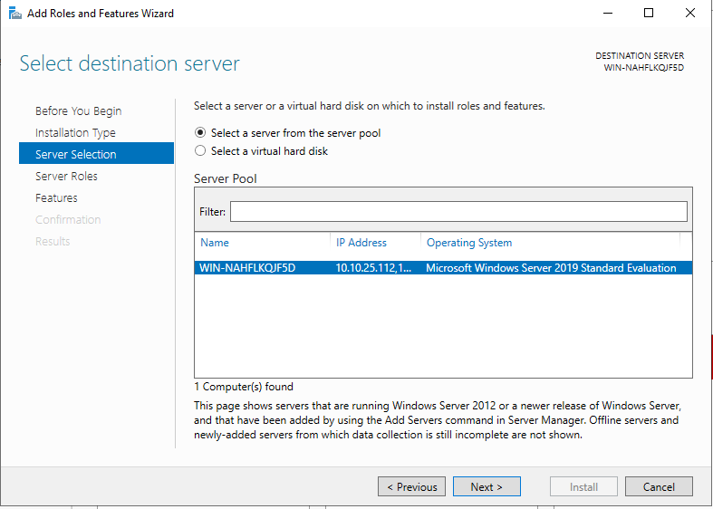
4) In server roles .check on hyper v and click the add features .
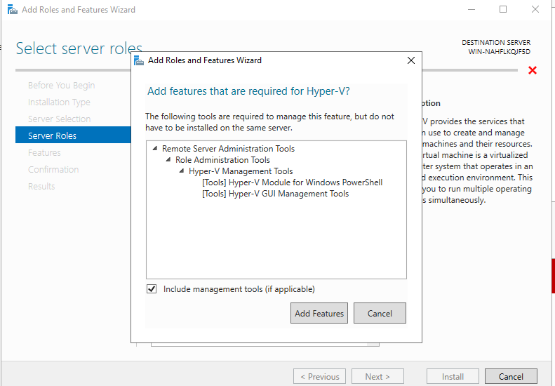

5) Enable virtual switches both ethernet and virtual box host only adapter
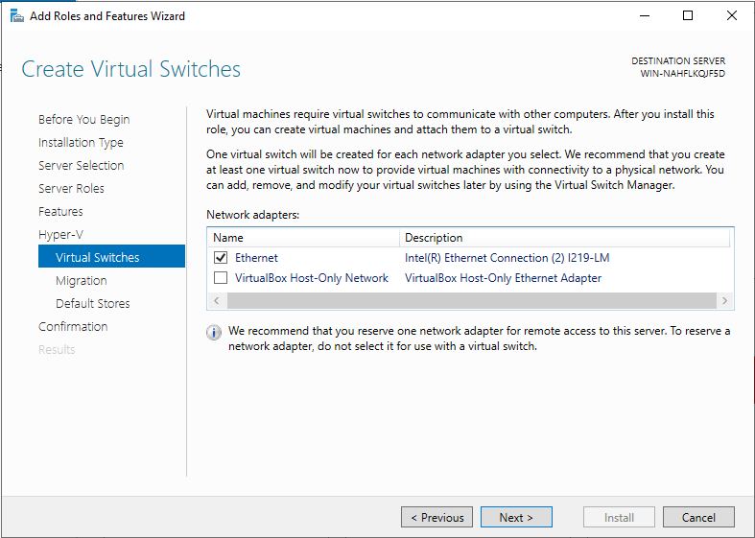

6) For migration use credential security support provider
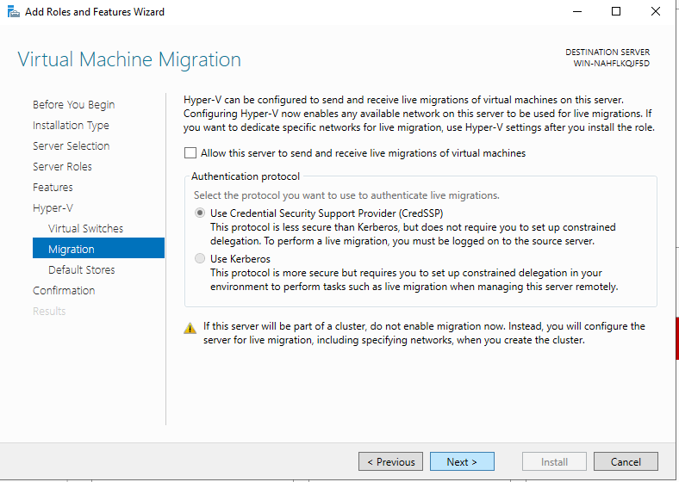

7) Click install and hyperv has been installed and enabled on the windows server
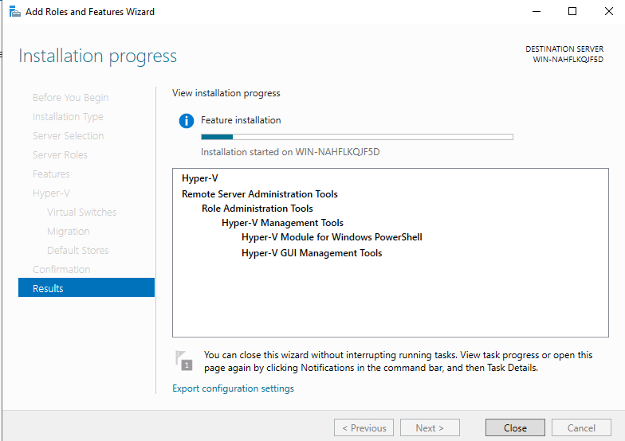
8)Open hyperv manager in tools
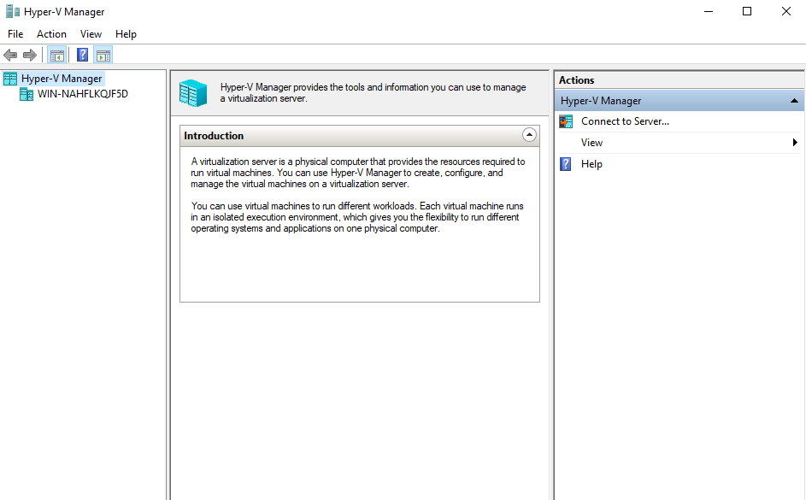

RESULT:
Thus the configuration Hyper-V on Windows for creating and managing virtual machines (VMs), enabling efficient virtualization and resource utilization has been executed successfully.
7b) Creation of VM, Powershell commands, Management
Aim:
To create and manage Virtual Machines (VMs) using Hyper-V, including PowerShell commands for automation and efficient administration.
Procedure:
(Vm installation without powershell)
1)open Tools-> hyper v manager-> right click on server and click create new vm
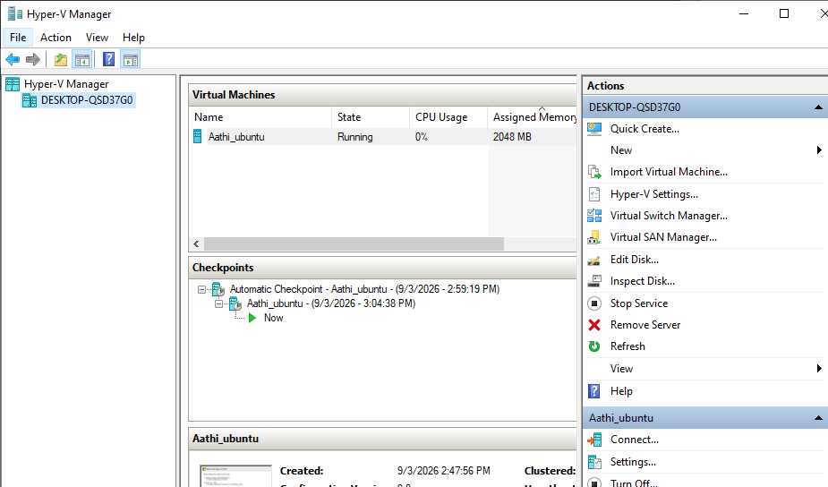

2)Specify name and location click next.
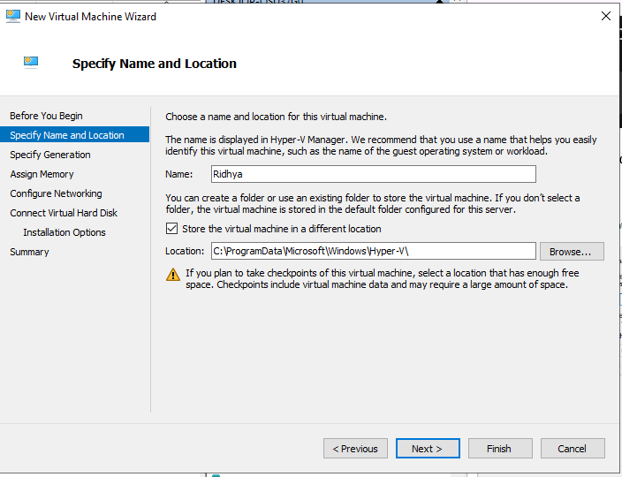

3)Assign the memory for the vm(for safety give as 2gb )
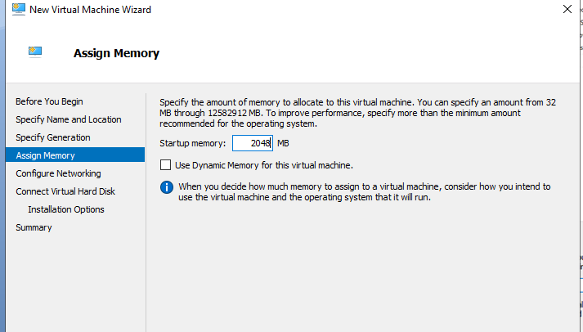
4)Conigure the network click on interR Ethernet connection virtual switch
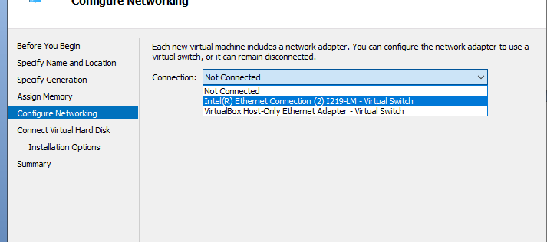
5)Connect virtual harddisk (name,location,maximum gb) click next
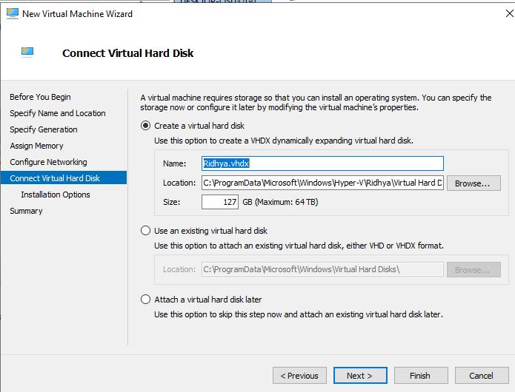

6)Import the iso file which os need to install on the vm(here ubunttu)
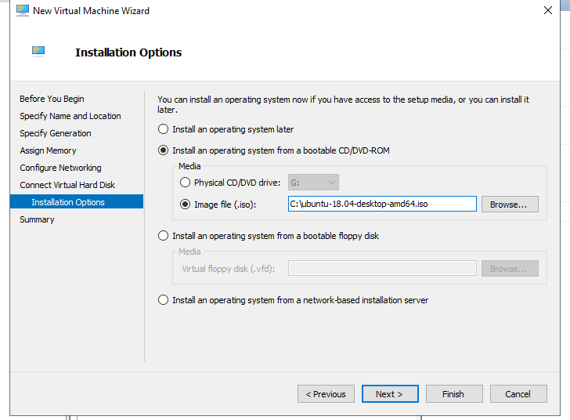
7)Click finish
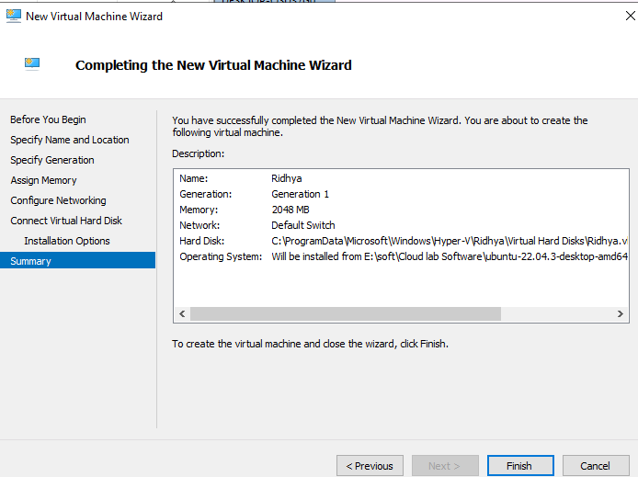

Vm installation using Powershell Procedure :
- Create vm with name and space in gb with virtual hard disk creation
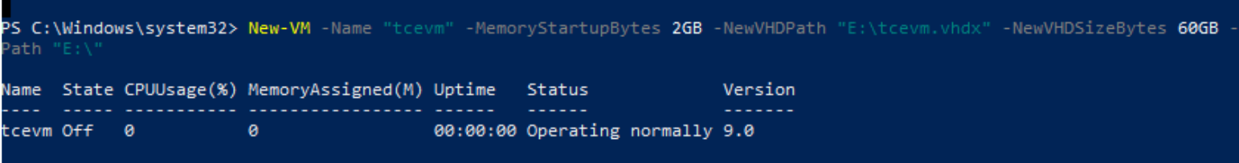
2)Asssign virtual switch to the vm
3)import the iso file which os need to install on vm
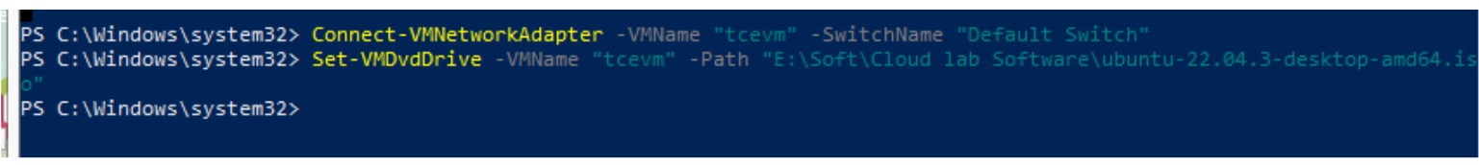
4)Start the vm
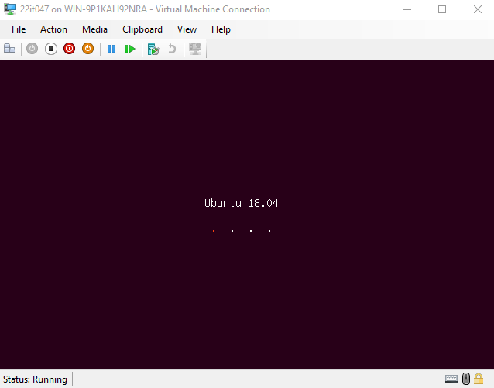
Powershell commands
1)Get vm and start vm
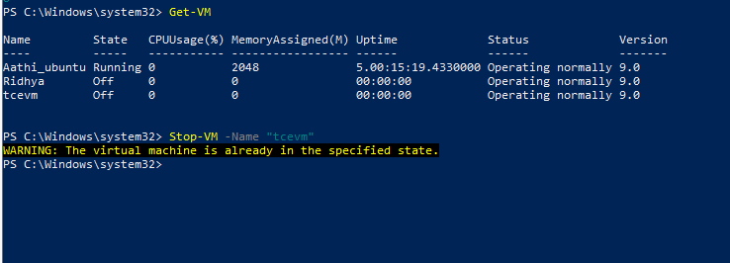
2)Stop vm
Migration(Right click the vm and click move) and give finish .
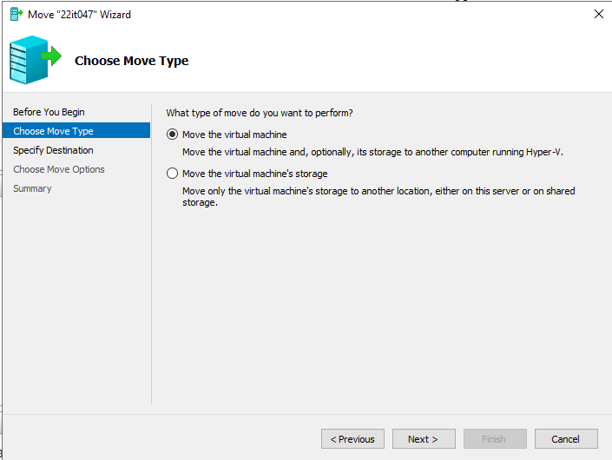
Result:
Thus the creation and manage Virtual Machines (VMs) using Hyper-V, including PowerShell commands for automation and efficient administration has been executed successfully.

