* This document only implies used material of actual running program.

1. **Overall structure**

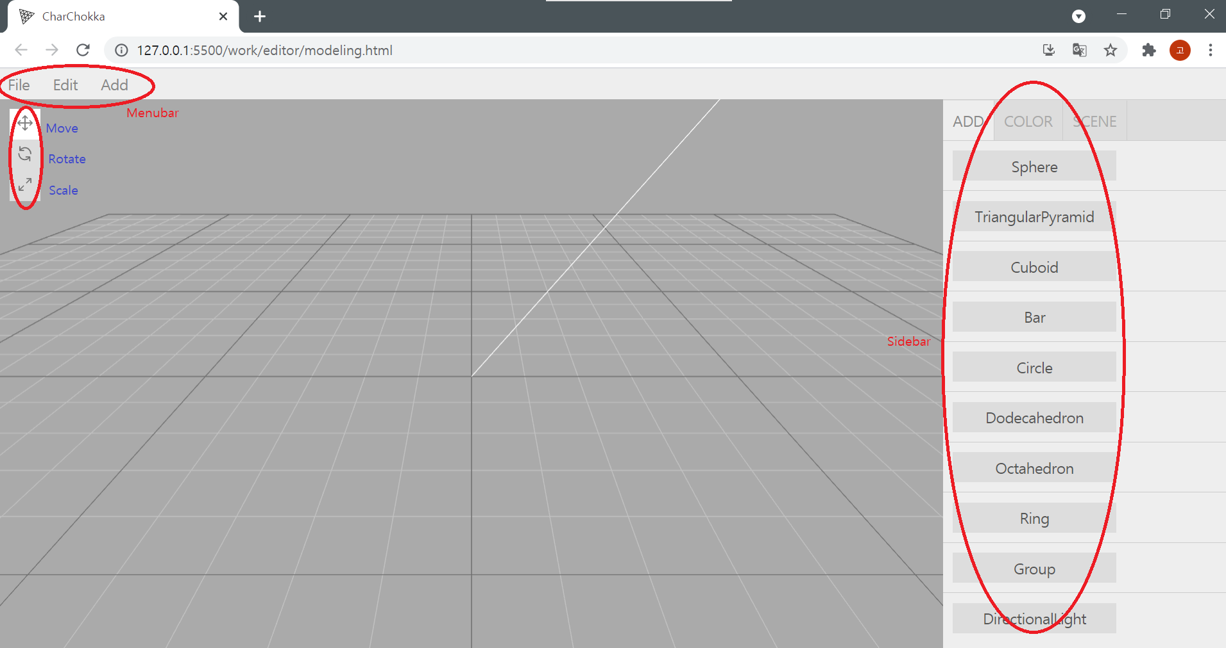

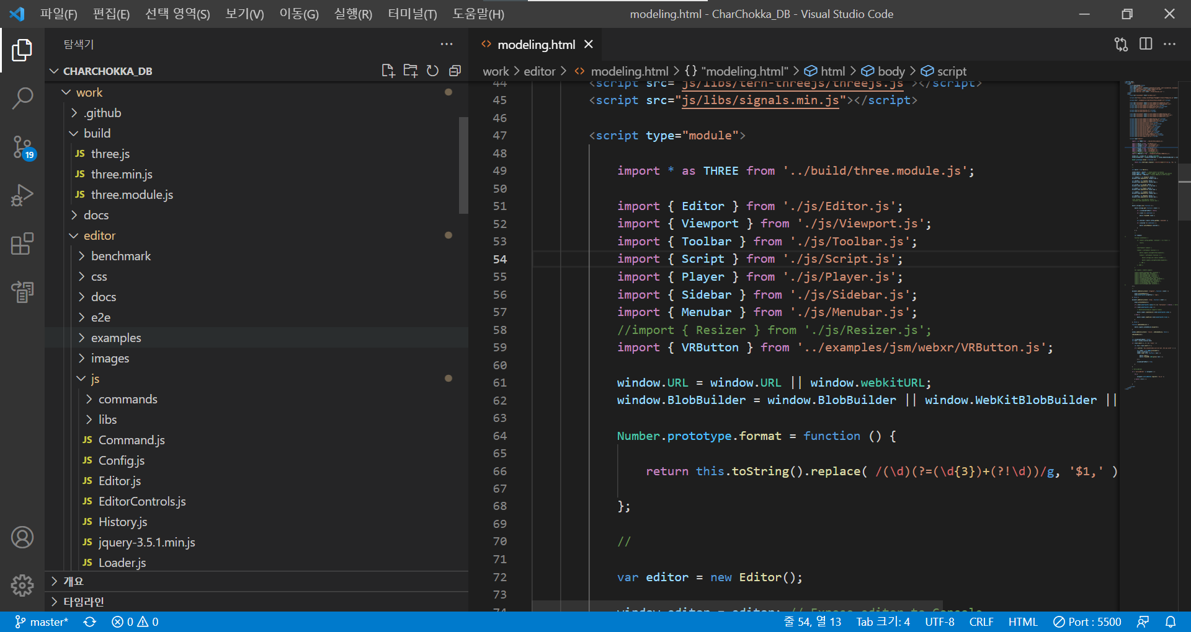

1. Main: ‘work(modeling root directory)/editor/modeling.html’
2. ‘modeling.html’ import /js/three.js, Menubar.js, Sidebar.js, String.js and many js, css materials
3. Menubar.js again import Menubar.File.js, Menubar.Edit.js, Menubar.Add.js ….
4. Sidebar.js again import Sidebar.Add.js, Sidebar.color.js, Sidebar.Scene.js …

* three.js does not need to be modified.

1. **how to add/delete figure in Menubar(left-up side buttons) (Menubar.Add.js)**

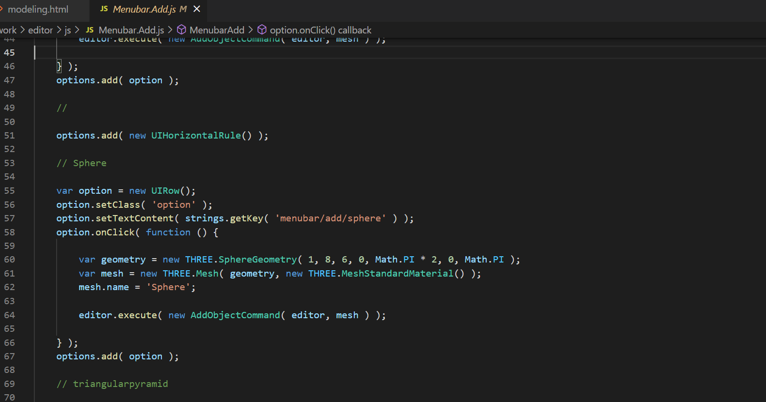

In Menubar.Add.js, make a variable option and UIRow() to make a object and a space.

and Set class and string. Then make a onClick event with function. Actual code of making figure is in function. Finally, you shoul add object(in this case, option) in top object(in this case, options)

1. **how to add/delete figure in Sidebar(right side buttons) (Sidebar.Add.Button.js)**

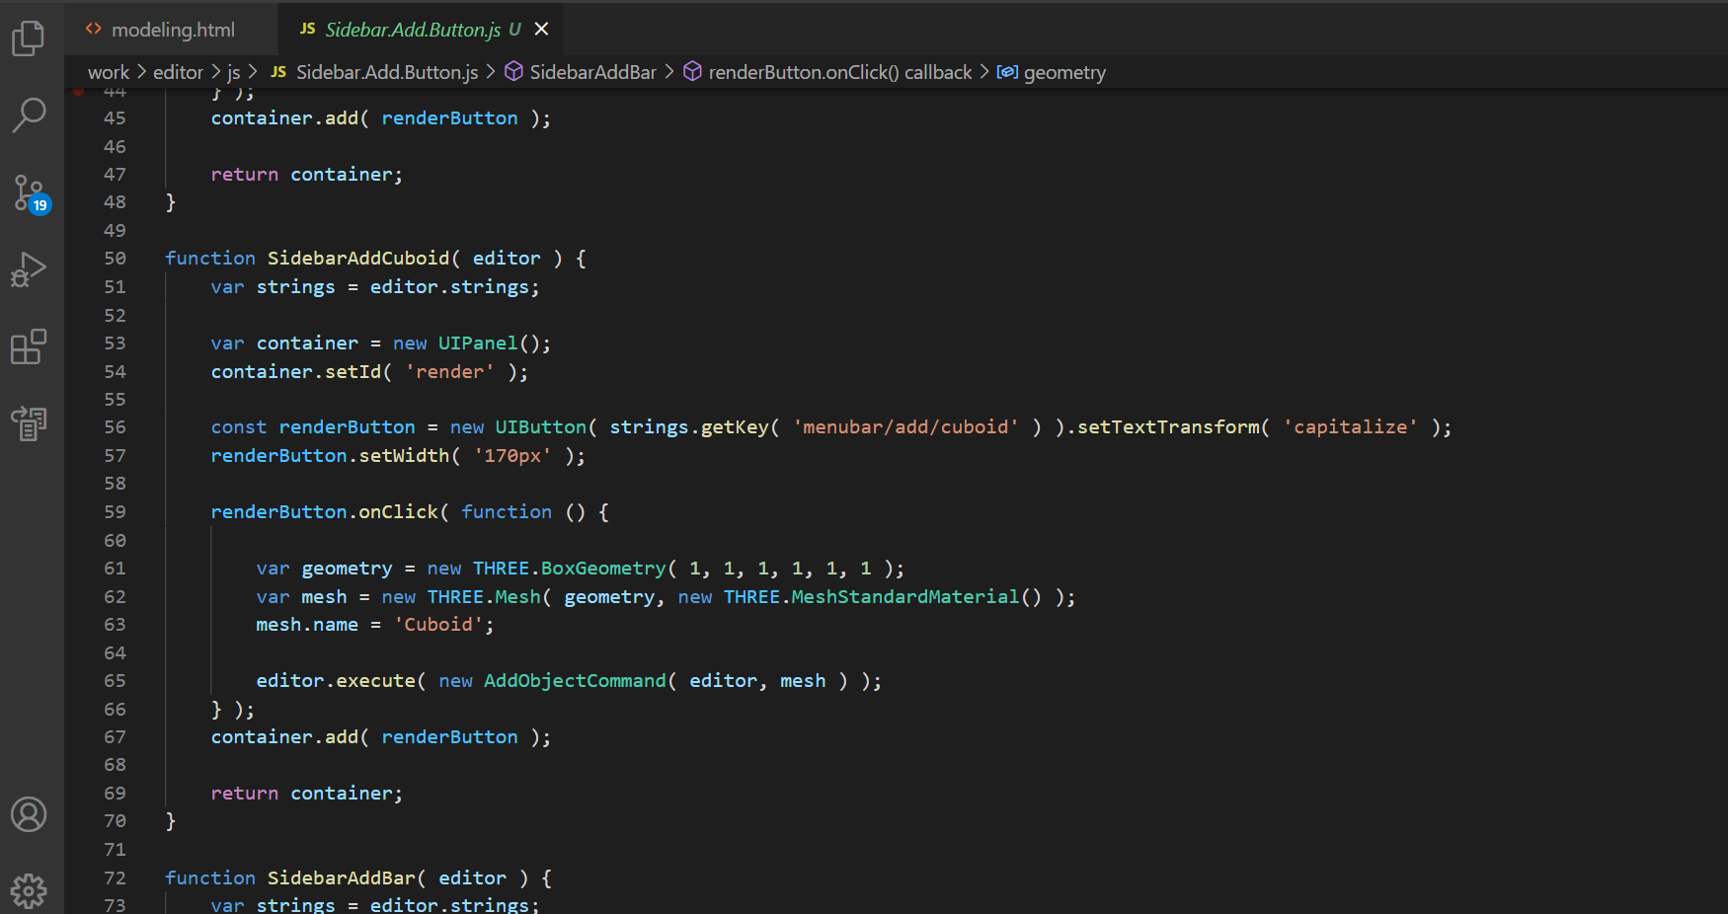

It almost same with 2.how to ~ in Menubar. Copy one of exist function. And change things below(###).

1. function name (SidebarAdd###)
2. UIButton(string.getKey( ###)
3. onClick event(same with 2.)
4. At the end of Sidebar.Add.Button.js, add function name in export { }.
5. At Sidbar.Add.js, Add the function name in import { }, and below, add container.add in function SidebarAdd.

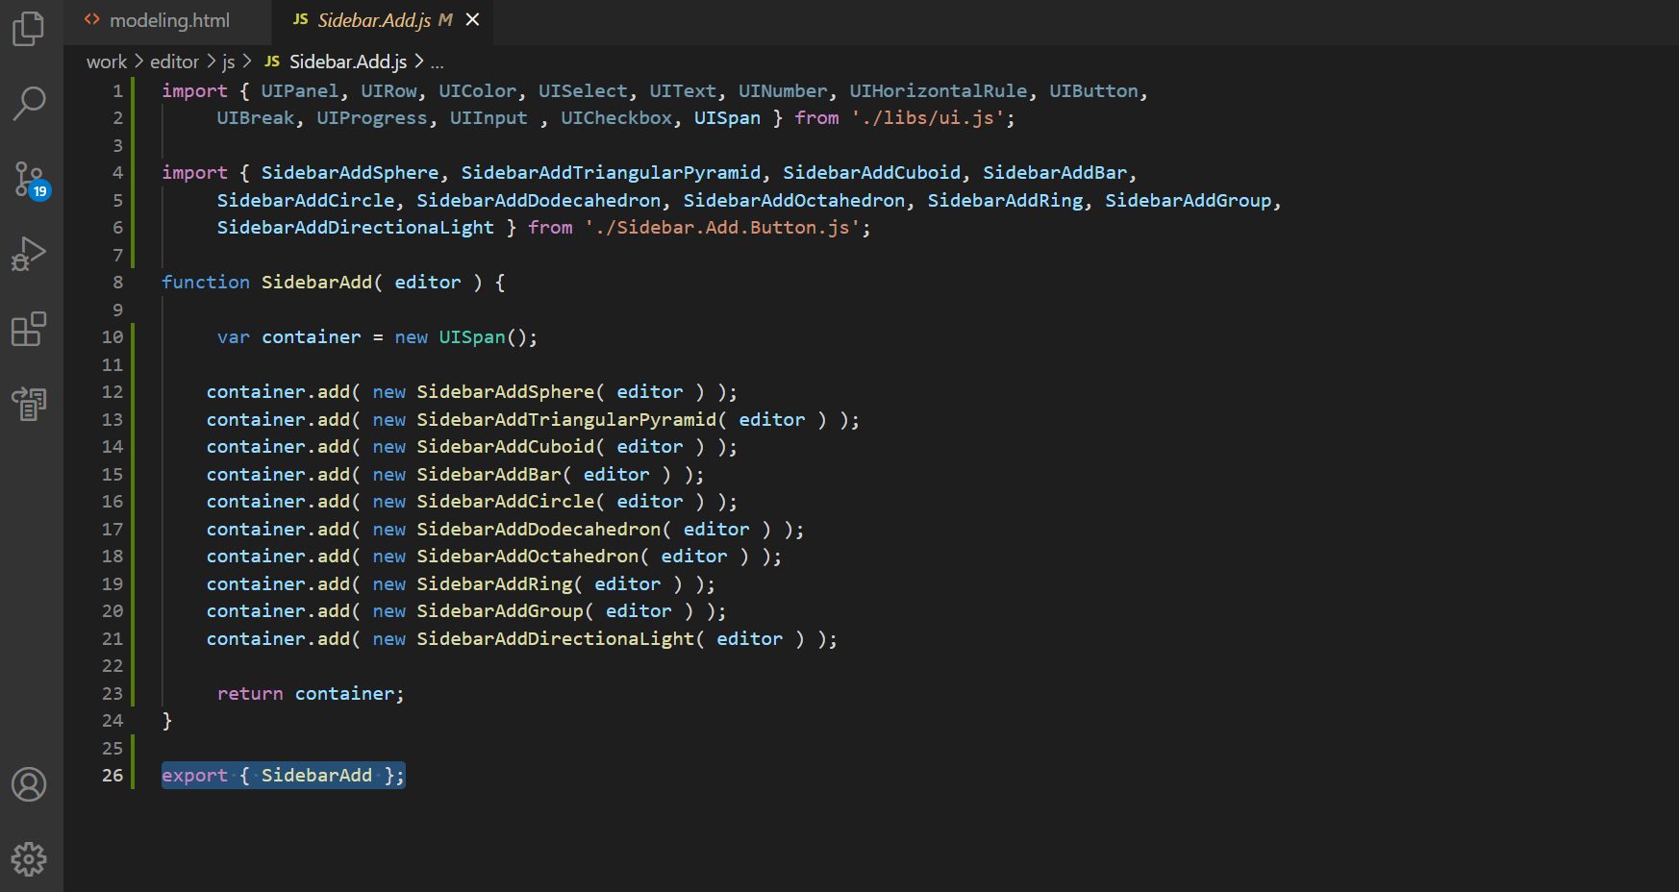

1. **how to change string of buttons**

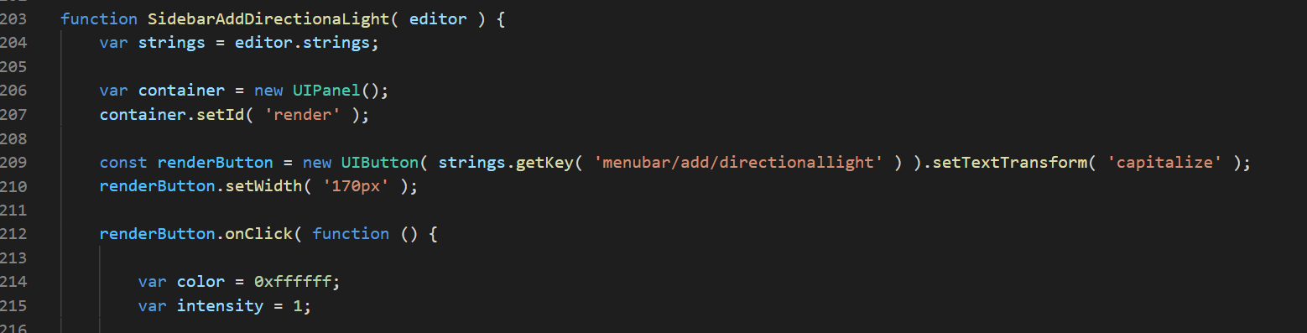

Most of functions which appears to button when running has strings.getKey.

In String.js, those are stored and getKey just load them. So to change string of buttons, you should change both strings.getKey( ###) and original of that in String.js

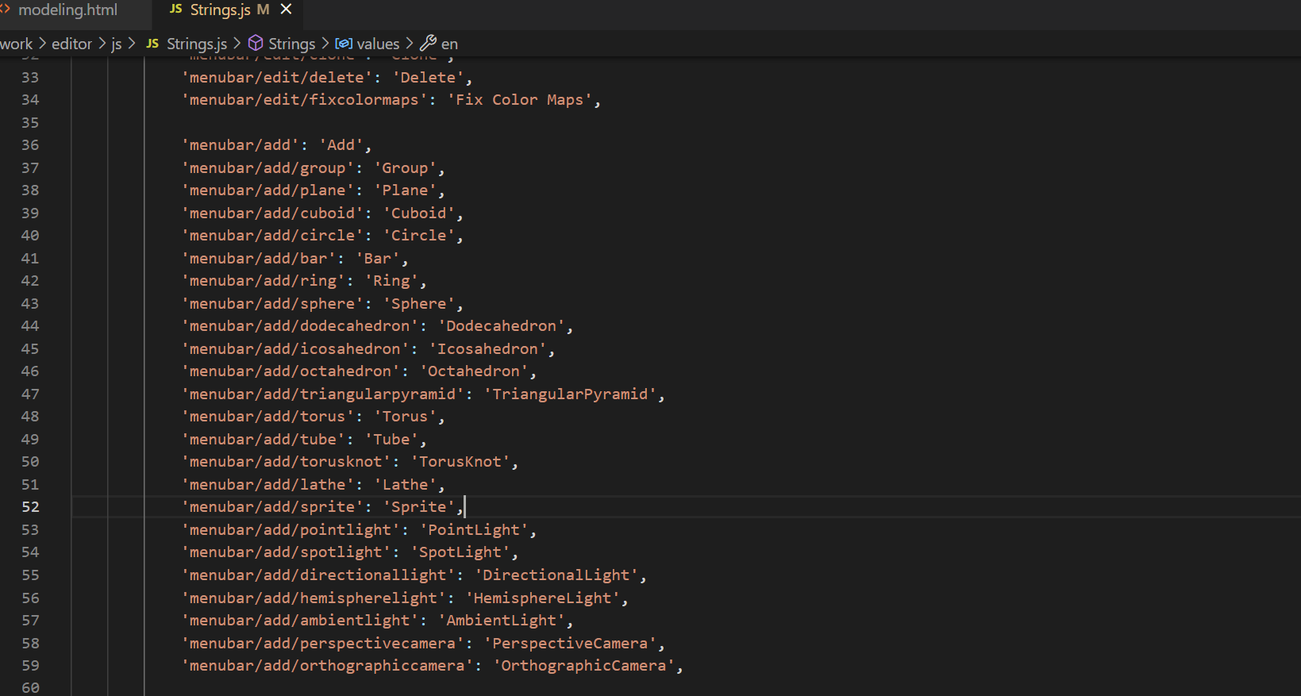

1. **how to change color of figures**

To change color of figure, first, Add a figure in scene. Next, go to color tap in sidebar, and click the palette button.

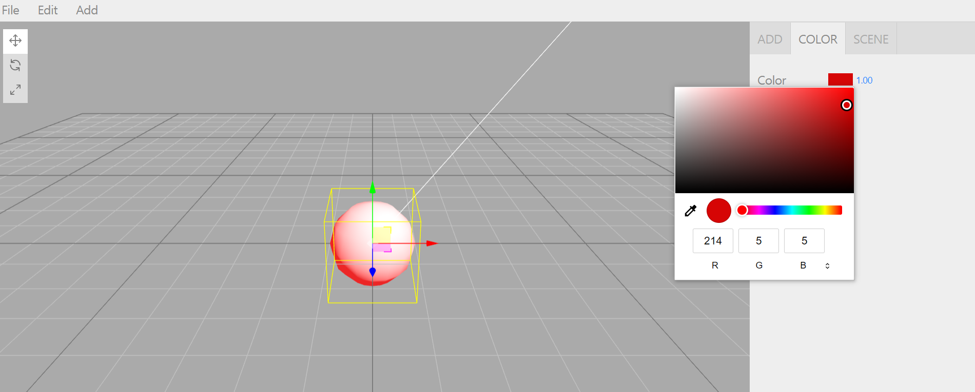

1. **how to use ‘group’ button**

group button exist for two reason.

* To manipulate many figures at the same time.
* To save(export) all figures in one obj file

To make a group, add group (before making figures or whenever). go to scene tap in sidebar.

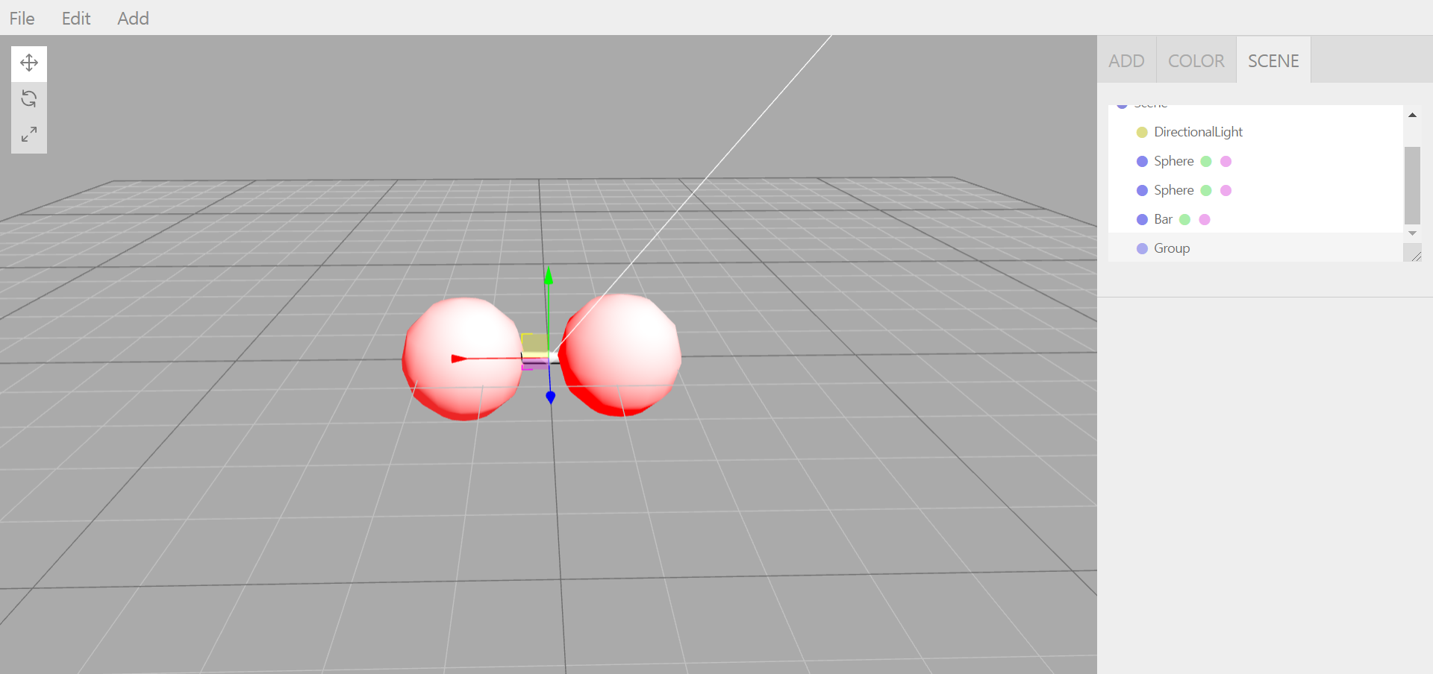

There are group and figures. Then drag figures on group and drop.

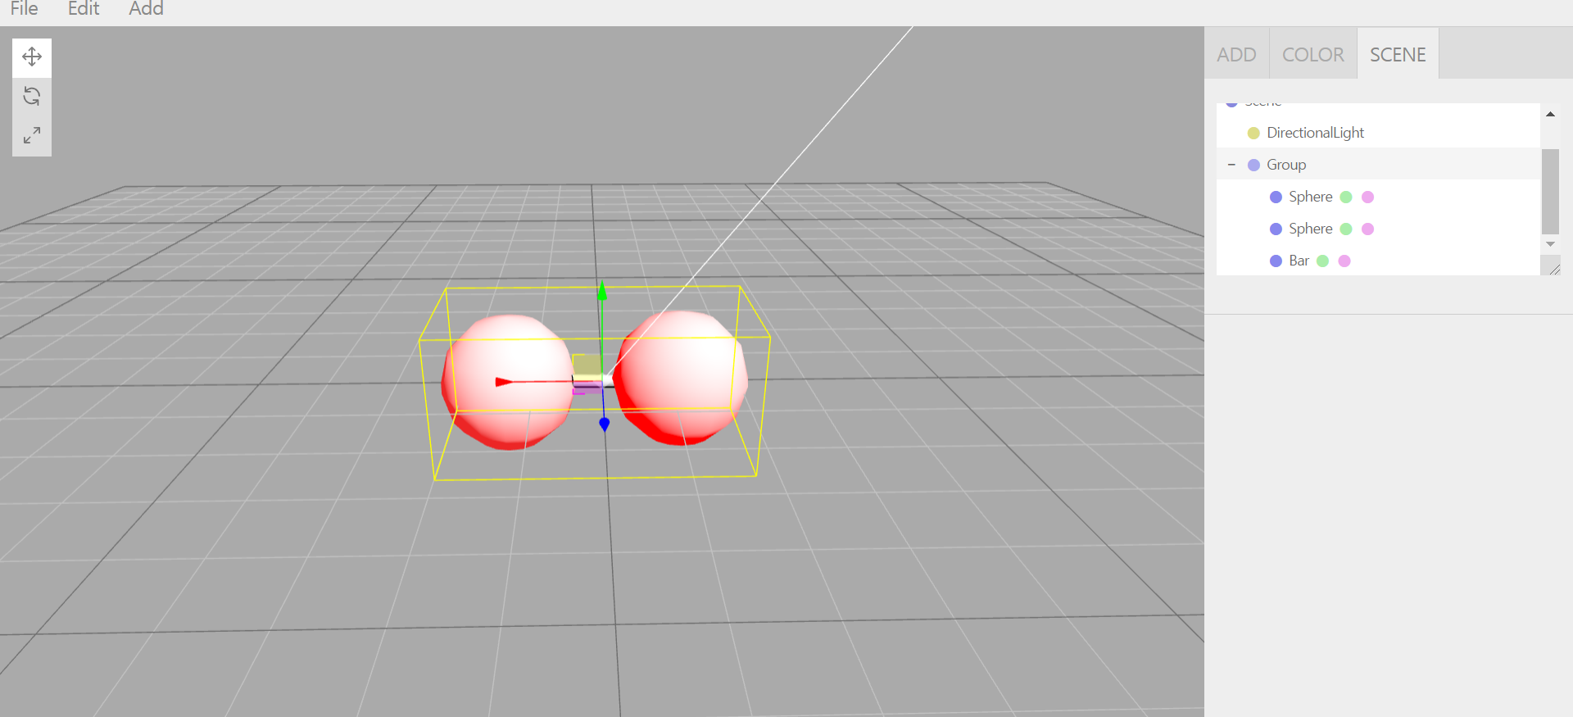

Then figures are in group. And when select that group, you can move, rotate, scale all in same time. In addition, you can export that group to obj file in menubar-File-export OBJ.

1. **Menubar-File**

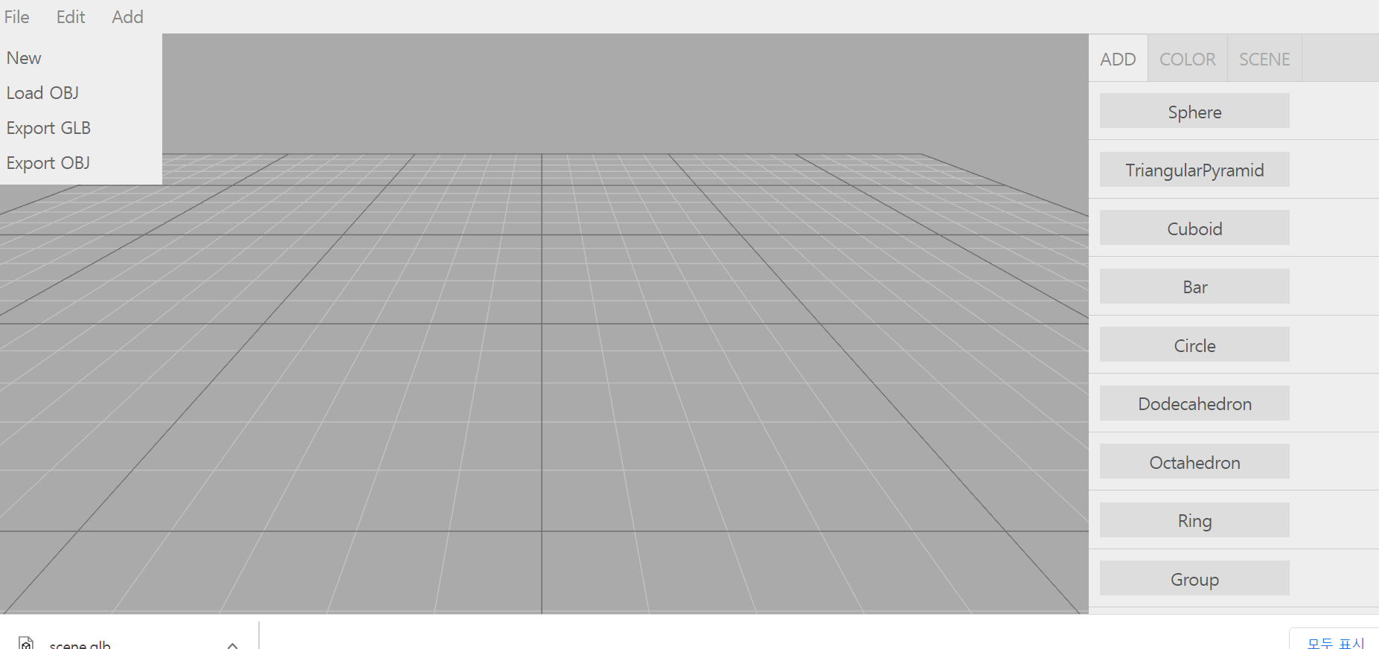

Menubar-File has 4 options.

- New: make a new scene. All thing is deleted.

- Load OBJ, Export GLB, Export OBJ: load and store on local

If add other load/export option used to be open-source(three.js editor), modify Menubar.File.js under the line 132

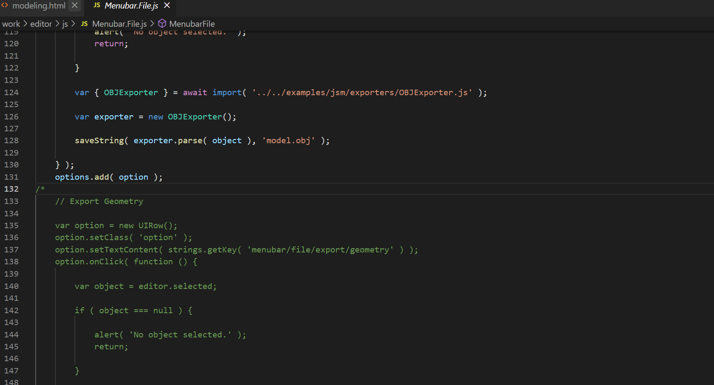

1. **Etc.**

* Even if it is the same shape in the upper left menubar-Add and right sidebar-Add, the codes exist separately. So if you manipulate some or new figure, you should modify both codes. Remove menubar-Add in case of hassle.

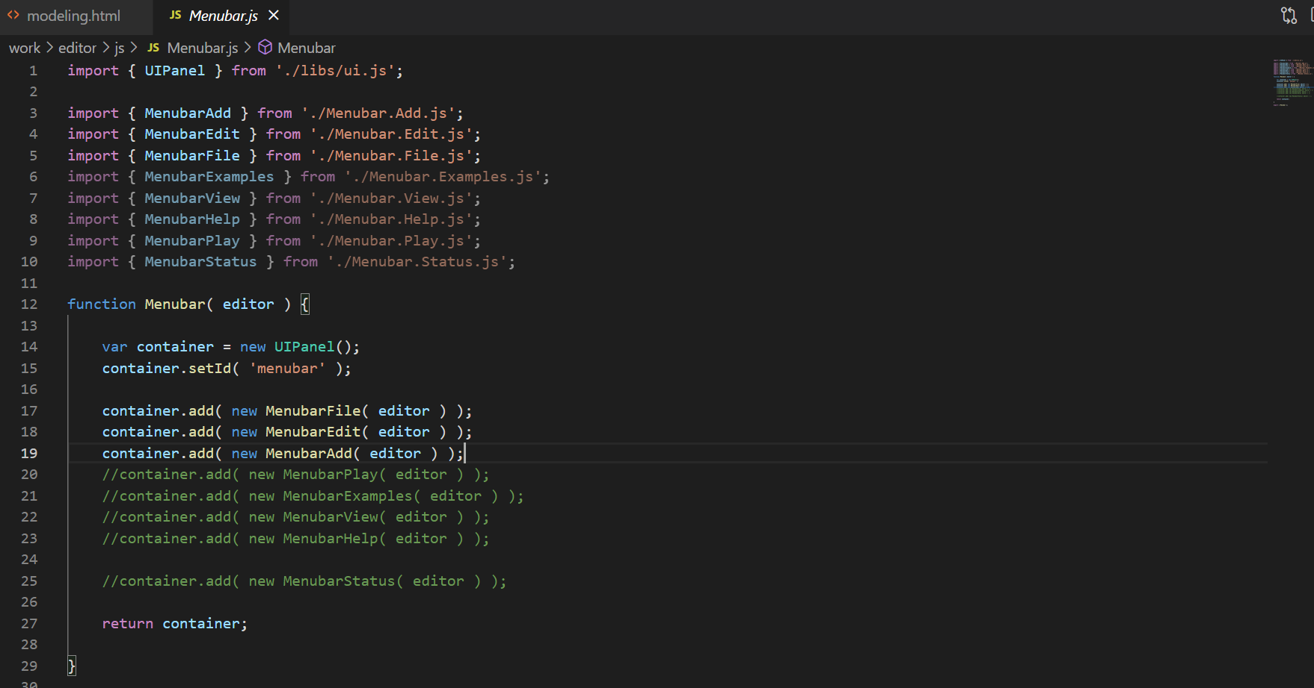

In Menubar.js, make line 19 “container.add( new MenubarAdd( editor));” being comment

* Directional light is for 3D figures. First you run program, DirectionalLight is exist. If you want 2D figures select directionallight in sidebar-scene and delete in menubar-Edit. Also you can add additional directionallight many as you want.

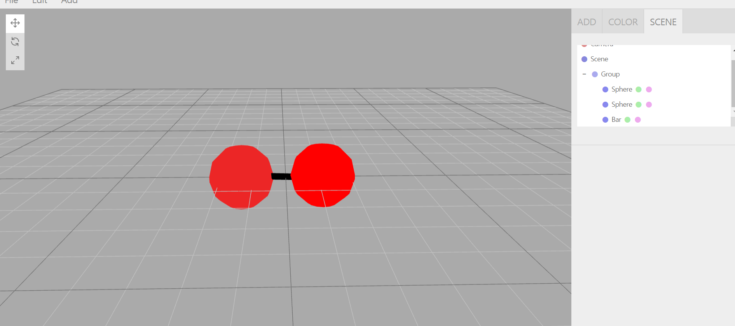

(After delete directionallight)