

Student Name: Ridmi Weerasinghe
Student Number: 2605498

Module Code: 6CS007
Module Name: Project and Professionalism
Project Title: Predictive HR Analytics for Garment Factories

Module Leader Name: Mr. Dhishan Dhammearatchi
Supervisor Name: Mr. Hasira Mahel Koswatta
Reader Name: Mr. Hasitha Premasiri

Submission Date: 30/05/2026
Award Title : BSc Computer Science (Software Engineering)

Declaration Sheet

Presented in partial fulfilment of the assessment requirements for the above award.
This work or any part thereof has not previously been presented in any form to the University or to any other institutional body whether for assessment or for other purposes. Save for any express acknowledgements, references and/or bibliographies cited in the work. I confirm that the intellectual contents of the work are the result of my own efforts and of no other person.
It is acknowledged that the author of any project work shall own the copyright. However, by submitting such copyright work for assessment, the author grants to the University a perpetual royalty-free licence to do all or any of those things referred to in section 16(i) of the Copyright Designs and Patents Act 1988. (viz: to copy work; to issue copies to the public; to perform or show or play the work in public; to broadcast the work or to make an adaptation of the work).

Student Name: Ridmi Weerasinghe
Student Number: 2605498


30/05/2026
Signature: ……………………………………..……. Date: …………………

Abstract

The labour intensive garment manufacturing sector is faced with huge operational and financial challenges in terms of employee turnover within the first twelve months, also known as infant attrition. In developing economies such as Sri Lanka, this situation impacts on production efficiency and adds to recruitment costs. In the past, HR teams have had to rely on manual tracking and reactive measures. They're too slow and mostly inaccurate to stop resignations. Previous predictive models have attempted to solve this with machine learning (Fallucchi, et al., 2020) but require sensitive financial data, or highly subjective employee satisfaction surveys. These types of factories have corporate privacy policies that restrict access to this information.
This study attempts to fill this void by exploring the feasibility of predicting infant attrition using only readily available demographic and logistical characteristics. A historical dataset of 5,000 employee records from a garment factory in Sri Lanka was pre-processed under a rigorous CRISP-DM framework for the removal of survival bias. Severe class imbalance is a key challenge for predictive HR analytics, as most of the employees stay and few leave. This study circumvented this by explicitly isolating 'Infant Attrition' and doing data engineering to remove right-censored active records, naturally balancing the data and avoiding the accuracy paradox. (Alduayj & Rajpoot, 2018).
Baseline metrics were developed across four classification algorithms and a Random Forest model was selected and optimised using Cross-Validation. The model obtained a Recall of 96.15% and identified most of the high-risk employees correctly. Geographic location and mode of transportation emerged as the strongest predictors of attrition, showing that commuting problems strongly affect turnover. Finally, these predictive capabilities were turned from a theoretical model to a practical solution. It is a web application. The tool includes Role-Based Access Control, bulk processing and Explainable AI (SHAP) overlays that provide explicit justification for individual risk flags, enabling HR managers to make data-driven, pro active retention decisions.
Keywords: HR Analytics, Infant Attrition, Machine Learning, Random Forest, Explainable AI

Acknowledgement

The successful completion of this project was made possible through the support and guidance of several key individuals and organisations. I would like to express my sincere gratitude to everyone who supported and guided me throughout this research project. Special thanks to my project supervisor, Mr. Hasira Mahel Koswatta, for his invaluable academic guidance, constructive feedback, and continuous encouragement. I also extend my deep appreciation to Mr. Dhishan Dhammearatchi (Module Leader) and Mr. Hasitha (Reader / Co-Supervisor) for their critical insights, which were instrumental in shaping the technical methodology and ensuring the rigorous quality of this artifact.
I extend my deepest appreciation to Hela Apparel Holdings for their invaluable cooperation. Granting access to their historical HR data provided the foundational cornerstone for this predictive machine learning artifact. Without their commitment to academic collaboration and data privacy, this practical exploration into infant attrition would not have been possible.

Contents

Abstract 3
Acknowledgement 4
List of Figures 7
List of Tables 8
List of Acronyms 9
Introduction 10
1.1 Background 10
1.2 Aims of the Project 10
1.3 Academic Questions and Objectives 10
1.3.1 Academic Questions 11
1.3.2 Objectives 11
1.4 Scope 11
1.5 Structure of the Report 11
Literature Review 13
2.1 Introduction 13
2.2 Similar Projects 13
2.2.1 Preprocessing and Data Balancing 13
2.2.2 Feature Engineering and Selection 13
2.2.3 Classifier Selection and Modelling 14
2.2.4 Deployment Interfaces and Evaluation Metrics 14
2.3 Summary of Identified Gaps 15
Methodology 16
3.1 Introduction 16
3.2 Planning 16
3.2.1 Identifying Business Values 16
3.2.2 Feasibility Analysis 16
3.2.3 Work Plan 18
3.3 Analysis and Requirement Gathering 18
3.3.1 Analysis 18
3.3.2 Requirement Gathering 19
3.4 Designing 19
3.4.1 Physical Design 19
3.4.2 Architecture Design 22
3.4.3 Interface Design 23
3.5 Implementation 26
3.6 Machine Learning Theoretical Architecture & Model Selection 27
3.6.1 The Mathematical Basis of Random Forest 27
3.6.2 Algorithmic Resolution for Class Imbalance 28
3.6.3 Model Comparison and Selection Justification 28
3.7 Testing Strategy 29
3.7.1 Test Environment & Tools 29
3.7.2 Unit Testing 29
3.7.2 Integration Testing 29
3.7.3 System Testing 29
Artifact 30
4.1 Academic Findings 30
4.2 Sample Code Walkthrough 31
Sample 4.2.1: Feature Engineering for Survival Bias (Data Preprocessing) 31
Sample 4.2.2: Hyperparameter Tuning Protocol (Machine Learning Tier) 32
Sample 4.2.3: Secure Database Authentication Lifecycle (Presentation Tier / UI) 33
4.3 Test Cases 33
4.3.1 Login (Test ID: 01) 33
4.3.3 Bulk Upload Prediction (Test ID: 03) 37
4.3.4 Analytics Dashboard Visualisation (Test ID: 04) 38
Conclusion 41
5.1 Important Outcome 41
5.2 Limitation 41
5.3 Critical Evaluation 42
5.4 Future Work 42
References 44
Appendix – A: User Manual 46
Appendix – B: Coding 50

List of Figures

Figure 1: WBS 18
Figure 2: DFD Level 0 19
Figure 3: DFD Level 1 20
Figure 4: Use case 21
Figure 5: Activity Diagram 22
Figure 6: Architectural Diagram 23
Figure 7: Sidebar Navigation 24
Figure 8: Dashboard 24
Figure 9: Single employee assessment view 25
Figure 10: Bulk upload view 26
Figure 11: Implementation Diagram 27
Figure 12: Feature Engineering for Survival Bias 31
Figure 13: Hyperparameter Tuning 32
Figure 14: Secure Database Authentication 33
Figure 15: Test 1.1 34
Figure 16: Test 1.2 34
Figure 17: Test 1.3 35
Figure 18: Test 1.4 35
Figure 20: Test 2.1 36
Figure 21: Test 2.2 36
Figure 22: Test 2.3 37
Figure 23: Test 3.1 37
Figure 24: Test 3.2 38
Figure 25: Test 3.3 38
Figure 27: Test 4.1 39
Figure 28: Test 4.2 39
Figure 29: Test 4.3 40
Figure 30: Appendix - A: System Login 1.1 46
Figure 31: Appendix - A: System Login 1.2 47
Figure 32: Appendix - A: Single Employee Assessment 48
Figure 33: Appendix - A: Bulk Upload 49

List of Tables

Table 1: List of Acronyms 7
Table 2: Test ID: 01 35
Table 3: Test ID: 02 37
Table 4: Test ID: 03 38
Table 5: Test ID: 04 40

List of Acronyms

Acronym | Full Form
API | Application Programming Interface
AWS | Amazon Web Services
CRISP-DM | Cross Industry Standard Process for Data Mining
CSV | Comma-Separated Values
DFD | Data Flow Diagram
EDA | Exploratory Data Analysis
ERD | Entity-Relationship Diagram
HR | Human Resources
ML | Machine Learning
PoC | Proof of Concept
RBAC | Role-Based Access Control
REST | Representational State Transfer
RF | Random Forest
SHAP | Shapley Additive Explanations
SMOTE | Synthetic Minority Over-sampling Technique
SQL | Structured Query Language
UI | User Interface
Table 1: List of Acronyms

Introduction

1.1 Background
Organisations are highly affected by employee turnover. The apparel industry is heavily defend on employees. When a worker resigns, there is no production. High turnover means companies are always having to spend money on recruiting and retraining. It also leads to delays in shipments and decreases in total productivity.
Sri Lanka is heavily dependent on the garment industry. This sector alone accounts for over 40 per cent of national export revenue. It employs hundreds of thousands of people. Keeping good workers keeps the whole economy moving. Post-pandemic economic pressures made workers more likely to move jobs. Employees would migrate to rival factories for small perks like better staff transport routes.
The traditional approach in HR departments has been reactive. They do complaints manually, wait for managers' feedback or do surveys once a year. This approach does not work in a fast-paced factory environment. Reactive interventions are limited to when an employee has handed in their resignation letter. Counteroffers seldom work by then.
Predictive HR analytics is the right answer. Historical personnel records may be analysed using machine learning algorithms. They identify early warning signals of “Infant Attrition” Infant attrition is defined by the system as resignation during the first twelve months of employment. The software looks at local demographic profiles. It automatically flags vulnerable cohorts. For example, a model could discover that new hires from specific geographic districts who use public transportation are statistically likely to quit. HR management can step in early. They can find better transportation or get to work hiring replacements right away. Production remains uninterrupted.

1.2 Aims of the Project
The primary objective of this project is to transform HR management from reactive to proactive data driven. The specific objectives are:
- Determine the specific demographic and occupational causes of infant attrition in garment production.
- Quantitative evaluation of machine learning algorithms to predict employee attrition based on historical HR data.
- Build and launch an interactive dashboard for non-technical HR practitioners.
- Validate the reliability of the predictive system for identifying at-risk employees.

1.3 Academic Questions and Objectives

1.3.1 Academic Questions
This project centres around one primary academic question:
How can machine learning algorithms process historical demographic data within garment manufacturing organisations to predict employee turnover and generate actionable retention strategies?

1.3.2 Objectives
The project established the following sequential objectives to address the academic question:
- Analyse the employee data attributes that influence turnover in apparel factories.
- Clean and preprocess the raw HR dataset. Address the accuracy paradox natively. Drop right censored data (active employees with under one year of tenure) to isolate the infant attrition cohort and balance the dataset.
- Train, evaluate, and hyperparameter-tune multiple binary classification machine learning models.
- Validate model performance metrics. Prioritise Sensitivity (Recall) to ensure the system catches the maximum number of high-risk employees.
- Develop a secure, dashboard-centric Software Engineering artifact using Streamlit and a MySQL database backend.
- Execute rigorous software testing protocols to verify system stability and operational reliability.

1.4 Scope
The aim of this project is to forecast Infant Attrition in the Sri Lankan Apparel Industry. Only static, demographic, geographical and role-based variables are used to populate the system to produce predictive risk profiles. Dynamic characteristics such as the actual amount of compensation or managerial conflict usually justify a turnover. In the current research, however, the data security policies of the companies limited this study to demographic variables.
Hela Apparel Holdings provided the dataset. The data originated from their Kalagedihena manufacturing branch. The dataset contains nearly 5,000 historical employee records. It includes both active and resigned personnel. The final software deliverable is an offline Streamlit web application. An optimised Random Forest algorithm powers the prediction engine. The application interfaces with a local MySQL database to log batch runs.

1.5 Structure of the Report
The subsequent chapters detail the execution and findings of the project:
- Chapter 02 – Literature Review: Evaluates existing academic literature regarding machine learning in HR analytics.
- Chapter 03 – Methodology: Delineates the application of the CRISP-DM framework. It covers system design and specific data engineering strategies.
- Chapter 04 – Artifact: Details the quantitative findings. It justifies the Random Forest algorithm selection, provides Python implementation excerpts, and outlines testing procedures.
- Chapter 05 – Conclusion: Summarises the project outcomes. It evaluates system limitations and proposes avenues for future deployment.

Literature Review

2.1 Introduction
Predictive HR Analytics has progressed much in the past decade. Initial systems were descriptive statistics only systems. Advanced machine learning architectures are used for modern systems. The chapter reviews 20 peer-reviewed studies from the years 2015 to 2026. In the review, these sources are presented in a thematic way, structured by the software engineering process. There are several phases of data preprocessing, feature engineering, selection of classifiers, and deployment to interfaces in the pipeline. These can be examined and the technological developments will be revealed. It also demonstrates that there are continuing industry issues. At the end of the researchers' work, there is a common issue of having unbalanced data and a lack of trust by the end-user. Research is lacking. SRYLGI is one of the few applications deployed which address the unique logistic challenges of the Sri Lankan Garment Industry.

2.2 Similar Projects

2.2.1 Preprocessing and Data Balancing
When we consider historical HR data, it is naturally imbalanced, because most employees stay and a few employees resign. I a model is trained using such imbalanced data, the model will simply predict that every employee will stay. This actually create a high accuracy. But the truth is the model is incorrect and worthless.
Several researchers attempted to solve this issue algorithmically. (Alduayj & Rajpoot, 2018) demonstrated that artificial oversampling techniques improve minority class detection. (Rombaut & Guerry, 2020) confirmed this finding in private companies. They used synthetic oversampling to balance churn datasets. But this too much oversampling introduces noise. It generates false positives. The model tend to predict employees who stay as leaving. That makes HR managers to question the system.
Some other studies like (Hom, et al., 2017) focused on filtering data, it argued that models should separate voluntary from involuntary turnover. Ignoring reasons like terminations and retirements from the predictive logic. This is acceptable because by dropping involuntary records, the actual behavioural data can be extracted.

2.2.2 Feature Engineering and Selection
By mapping industry-specific variables to predicting turnover probability in a vehicle plant. (Esmaieeli Sikaroudi, et al., 2015) argued industry-specific variables can be more effective than generic demographics.
(Vargas, 2024) study showed that automated feature selection techniques are faster. (Fernandez, 2024) examined feature selection through an ethical lens. Machine learning models can accidentally learn historical hiring biases. Dropping protected demographic attributes prevents discriminatory predictions.

In the apparel sector, geographical and logistical metrics dominate. (Jayathilaka & Kanchana, 2023) analysed employee retention in Sri Lanka. Their study identified localised logistical stress as a primary driver of turnover. Employees facing difficult commutes resign faster. Some researchers attempted to extract features from unstructured text. (Sharma & Kumar, 2023) used Natural Language Processing (NLP) to analyse employee feedback. This approach fails in blue-collar manufacturing. Factory workers rarely submit detailed written feedback. Structured tabular data remains the most reliable input format.

2.2.3 Classifier Selection and Modelling
Zhao and Hryniewicki (2018) proved that tree-based methods are better than Support Vector Machines. Extreme Gradient Boosting (XGBoost) handles noisy HR datasets efficiently. (Novak, 2025) expanded on this finding. The study optimised gradient boosted decision trees specifically for large corporate tabular databases. (Al-Madi & Al-Asir, 2024) applied these boosting techniques directly in to manufacturing industries. (Gabrani & Kwatra, 2021) also built risk assessment models using similar predictive structures.
Despite the power of boosting algorithms, Random Forest remains highly popular. (Bhartiya, et al., 2024) utilised the Random Forest classifier for attrition prediction. They praised its parallel processing capabilities. (Fallucchi, et al., 2020) achieved excellent results using Random Forest compared to basic Logistic Regression. (Hasan, et al., 2022) argued that Random Forest is the optimal algorithm specifically for garment organisations. The model maps non-linear relationships effectively. It captures interactions between tenure and transport methods.
Some researchers push for maximum accuracy using stacked models. (Al-Utaibi, et al., 2026) developed a statistically robust ensemble learning model. While stacking improves raw accuracy, it destroys interpretability. The model becomes a black box. HR managers cannot explain why the system flagged a specific employee.

2.2.4 Deployment Interfaces and Evaluation Metrics
A predictive model holds zero value if HR managers cannot use it. The final software engineering stage involves evaluation and deployment.

(Ajit, 2022) noted that measuring success requires the correct metrics. Accuracy is deceptive. (Chakraborty, et al., 2021) also emphasised prediction analysis metrics. The primary evaluation metric for HR models must be Recall (Sensitivity). The (IIT Repository, 2020) model struggled with Sensitivity. It missed many leavers to maintain high general accuracy. A practical system must prioritise recall. Catching a true flight risk matters more than avoiding a minor false alarm.

Deploying these models requires intuitive interfaces. (Wijethilaka & Gamage, 2021) developed a turnover prediction system tailored for the Sri Lankan apparel industry. But, many of these academic models are just scripts written in python and a console is needed run. A fully realised system must include secure database connections and interactive web interfaces in order for allowing non-technical staff to view prediction.

2.3 Summary of Identified Gaps
Reviewing these 20 studies reveals two major software engineering gaps.
- Lack of Domain Specificity (The "Context" Gap): Most models rely on generic Western datasets. They ignore the specific economic and transport realities of the Sri Lankan garment industry. Models must incorporate company-provided transport metrics and localised district data.
- The Interface Gap: Modern algorithms achieve high mathematical success. Yet, they remain inaccessible. Current research lacks localised systems that combine high predictive power with secure, user-friendly graphical interfaces. Non-technical HR managers need daily, reliable access to these tools.
This project addresses these gaps directly.

Methodology

3.1 Introduction
The Cross-Industry Standard Process for Data Mining (CRISP-DM) framework structures this project. This analytical standard enables the systematic development of the predictive system. It breaks the project into distinct, iterative phases ranging from business understanding to deployment. Following CRISP-DM ensures the mathematical model perfectly aligns with actual HR operational requirements.

3.2 Planning

3.2.1 Identifying Business Values
The "Predictive HR Analytics System" transitions HR departments from a reactionary method to a proactive retention method. Losing skilled workers means a major financial risk to garment factories. This web application delivers specific value through:
- Reduction in Operational Costs: Replacing an operator incurs recruitment and training expenses. Identifying high-risk employees early saves significant capital.
- Keeping Production on Track: Unexpected departures create severe bottlenecks. Early warning indicators allow managers to plan workforce adjustments immediately.
- Data-Driven Smart Decisions: HR stops relying on intuition. The system targets retention spending toward employees mathematically proven to leave.
- Boosting Employee Morale: Analysing commute logistics rather than guessing cultivates a healthier workplace culture.

3.2.2 Feasibility Analysis
The project has been thoroughly assessed on five criteria to ensure practicality and legality.

3.2.2.1 Technical Feasibility
The project utilises an industry-standard technology stack.
- Why a Web App? Doing it as a web application instead of a standalone program eliminates problems of factory deployment. HR departments use a mix of hardware. Heavy desktop software creates problems for administration. These restrictions do not apply to Web applications. Staff can log into the Streamlit dashboard via any browser.
- Why Python? Python acts as the core processing engine. It is deeply integrated with the popular open source libraries such as Pandas, Scikit-learn. The predictive engine can be implemented on a standard desktop office computer.
- Hardware Requirements: The model runs efficiently on standard office workstations (like a basic Core i5 laptop), so the factory doesn't need to buy expensive servers or GPU clusters to run it.

3.2.2.2 Financial Feasibility
This project is cost-effective because it relies entirely on free, open-source software frameworks.
- Software Costs: The technology stack (Python, Streamlit, Scikit-learn, MySQL Community) is open-source and free of licensing fees.
- Return on Investment (ROI): In a real-world deployment, preventing just a handful of skilled operators from resigning covers the development overhead manifold through saved training and production stabilisation.

3.2.2.3 Operational Feasibility
The system is intended to augment existing HR activities rather than forcing staff to completely change their usual working processes.
- User-Friendly: The final dashboard is built for HR professionals, featuring an interface to process single employee assessments or bulk batch analysis.
- Non-Replacement: The system is an "Early Warning Indicator" that enhances human judgment during monthly reviews, rather than replacing the human element of HR.

3.2.2.4 Legal Feasibility
Data privacy forms the core of the project logic.
- Privacy First: The system processes internal employee data encompassing nearly 5,000 historical records. To ensure compliance with privacy standards, strictly demographic and role-based data was extracted from the cooperating organisation, excluding unstructured behavioural tracking.
- Bias Mitigation: Sensitive attributes that could lead to discrimination (e.g. religion or exact residential tracking) were excluded from the predictive feature set to ensure fair, merit-based, and legally sound predictions.

3.2.2.5 Schedule Feasibility
The work structure divides into overlapping modular phases. This includes literature review, data preprocessing, model training, and dashboard development. This separation prevents blocking bottlenecks during the software testing phase.

3.2.3 Work Plan
Project work breakdown structure is divided into five phases:
- Research and Requirements: Conducting the literature review, defining the constraints to using only strictly demographic data (because of organisational privacy restrictions), and explicitly defining the target variable "Infant Attrition".
- Data Preparation: Ingesting around 5,000 records of categorical HR data. Operations encompassed cleaning inconsistencies, imputing missing data, standardising date strings, and natively addressing class imbalance by dropping active employees with tenure < 1 year to specifically focus on Infant Attrition cohort.
- Building the Model: Starts writing the prediction logic using tree-based algorithms (Random Forest / Gradient Boosting). The models were specifically 'overfitted' and cross-validated for 'Recall' (Sensitivity) maximisation while not just 'Accuracy'.
- Creating the Product: Developing local Python environments as a productionized Streamlit web application, securing it with a MySQL User authentication system and setting up interactive executive reporting dashboards.
- Testing and Finishing: Running unit tests on preprocessing scripts, integration testing bulk file uploader to the model pipeline, user acceptance tests on the final dashboard framework.

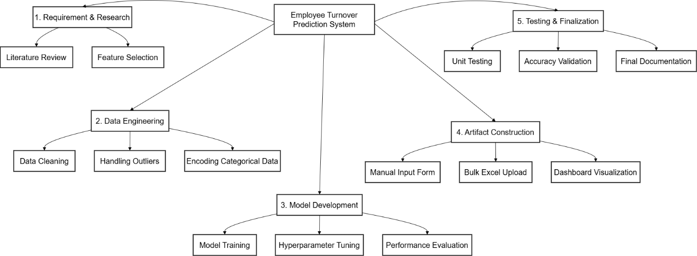
Figure 1: WBS

3.3 Analysis and Requirement Gathering

3.3.1 Analysis
Assessment of the current manual retention system resulted in a set of software functionality requirements.
Functional capabilities:
- The system must securely authenticate users.
- It must handle raw CSV bulk uploads.
- It must compute individual numerical turnover risk scores for each parsed employee.
Non-Functional capabilities:
- The system has to display these outcomes graphically on an intuitive dashboard in a secure way, enabling managers to get executive summaries as soon as they are needed.
- It must be able to deliver real-time predictions (typically < 10 seconds per bulk batch) to avoid workflow deadlocks.

3.3.2 Requirement Gathering
Two main approaches determined the exact architectural needs:
- Direct Data Analysis: System was applied to an anonymised HR dataset from Hela Apparel Holdings (Kalagedihena branch). There were almost 5000 active and retired records in this set. Some columns, such as Service Years, and Transport Mode, were confirmed to be structurally intact.
- Literature Review: the use of ensemble decision trees (EDT) was proven by academic studies to be the most accurate method for structured tabular data. This strengthened a decision to steer clear of complicated and hard-to-explain neural networks.

3.4 Designing

3.4.1 Physical Design
Data Flow Diagrams (DFDs) were used to model the logical flow of data in the system.

3.4.1.2 DFD Level 0 (Context Diagram)
The following diagram shows the level 0 dfd diagram. The highest level conceptual interaction which is the main actor’s (HR Manager) interactions with the system boundaries. The actor enters the "Employee Dataset" (either single employee data or set of employees as a bulk upload). Then system generates the calculated "Risk Report" and display to the user.
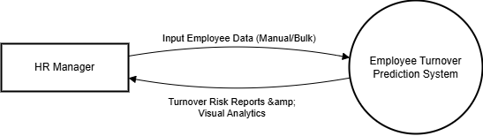
Figure 2: DFD Level 0

3.4.1.3 DFD Level 1
This diagram breaks down the main processes sequentially. First, the user input the data. Then data is validated (if it is a single employee record upload, it validates the input fields. If it is a bulk upload, first validate if the uploaded file is a valid csv file and then if the data set includes the mandatory fields.) If all the validations are passed, then it goes through the trained machine learning model. It generates the predictions and displayed to the user.
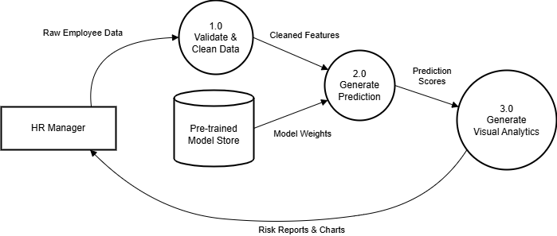
Figure 3: DFD Level 1

3.4.1.4 Use Case Diagram
Use Case diagrams map the interactions between the HR user and primary functionalities and how an admin user manages the other users.
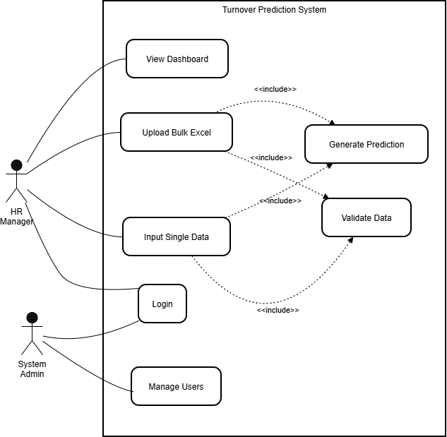
Figure 4: Use case

3.4.1.5 Activity Diagram
This diagram outlines the sequential flow of activities a user takes when processing either a single manual data entry or a bulk upload.
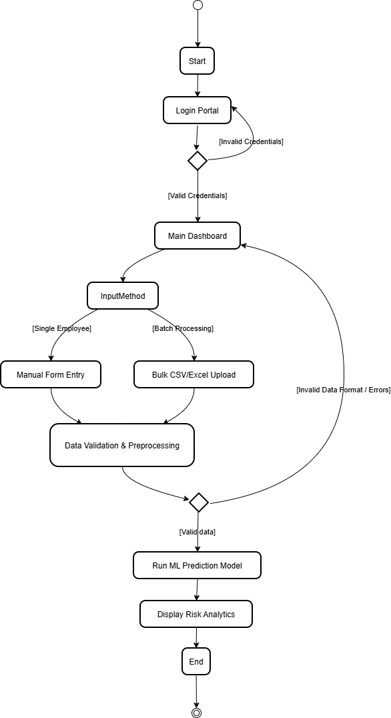
Figure 5: Activity Diagram

3.4.2 Architecture Design
A solid three-tier separation of concerns is used to design the digital architecture. This enhances the maintainability of the system in the longer term.
- Input Layer/Presentation Layer: Gets raw HR data from file uploads and/or manual data entry forms. In this layer, there is a schema validation module to validate the schema before the data is pushed down.
- Processing Layer (ML Engine): The locally loaded pre-trained algorithms, based on the framework ‘scikit-learn'’, scale the numerical data, encode the categorical strings, maps the variables through the Random Forest trees to produce the risk probabilities.
- The result sets go into Output Layer (Data Visualisation):, which is managed by the Streamlit caching mechanism and is rendered as dynamic and interactive answer datasets and topological maps tailored for managerial understanding.
- Model Layer: This layer is for storing the trained ML model.

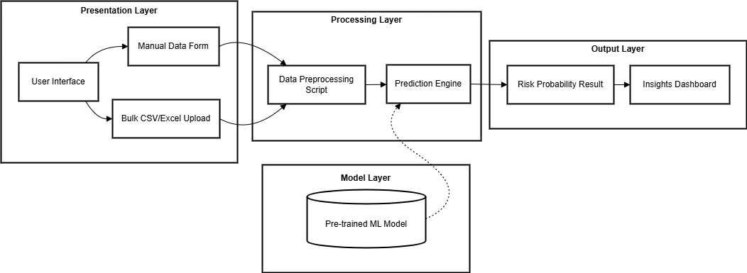
Figure 6: Architectural Diagram

3.4.3 Interface Design
No command line is used and it is intended to be used by non-technical specialists.
The UI has been designed to entirely hide the underlying machine learning complexity from the HR end users. It utilises a sleek, responsive design ensuring cross-platform usability for both executives and operational managers.

3.4.3.1 Sidebar Navigation & Access Control
The left-hand pane serves as a persistent control hub. Securely shows user credentials and handles smooth transitions between modules.
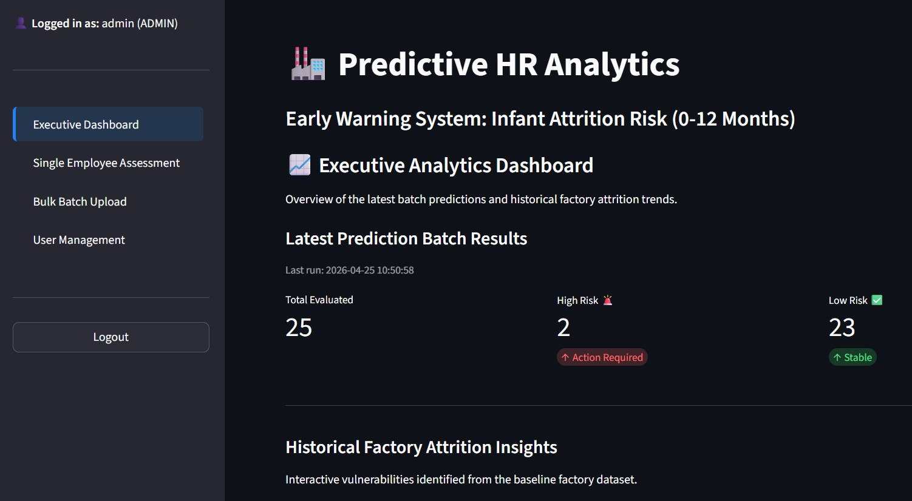
Figure 7: Sidebar Navigation

3.4.3.2 Executive Dashboard View
The main page features large and standalone cards for the KPI metrics. They display statistics. Interactive bar and pie charts provide managers with detailed breakdowns, which may be found below the core metrics, enabling them to quickly evaluate the health of their organisations.

Figure 8: Dashboard

3.4.3.3 Single Employee Assessment View
This is an evaluation of a single employee's performance. This module serves as a digital representation of this form. HR staff are able to manually enter the demographic details of staff for whom they want to make predictions (new hire or existing employee). The system instantly returns, percentage based Risk Probability score accompanied by an interpretive visual gauge.
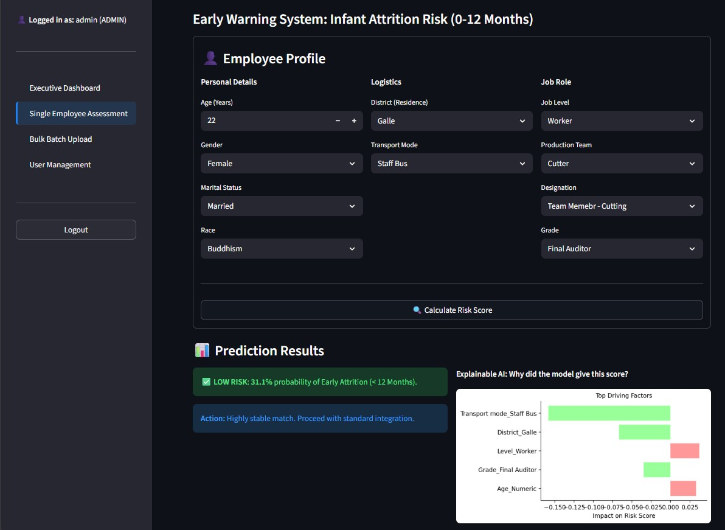
Figure 9: Single employee assessment view

3.4.3.4 Bulk Batch Upload View
This interface takes raw excel or csv spreadsheets. It is able to rapidly process hundreds of records in parallel and generate an interactive data table with the churn probability for each individual employee in the data.
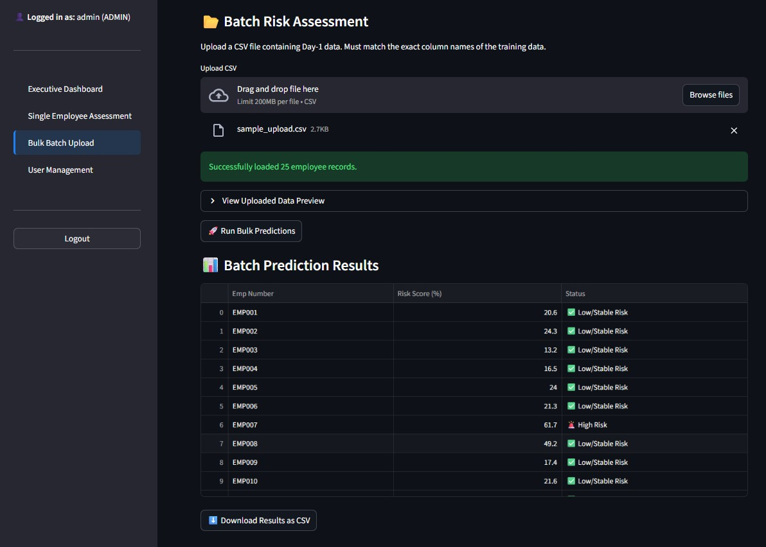
Figure 10: Bulk upload view

3.5 Implementation
The system is fully written in python and Visual Studio Code is the main IDE. The implementation was based on open source libraries used for the compilation of the necessary modules:
- Data Handling: Manipulations of dataframes, missing value imputations, feature engineering (like calculating true 'Age at Hiring' to avoid survival bias) were done in pandas and numpy.
- Machine Learning: Standard scaling, dummy variable encoding, and predictive classifier training was performed using the machine-learning package, `scikit-learn.
- User Interface & Database: The live web app was created using the `streamlit` framework with user interface and database. Created persistent connections to local database using the `mysql.connector`. It provided authentication hashes and batch metrics.
- Version Control: Git enabled incremental feature fixes during development that enabled safe rollbacks during the complex model-tuning parts of the process.
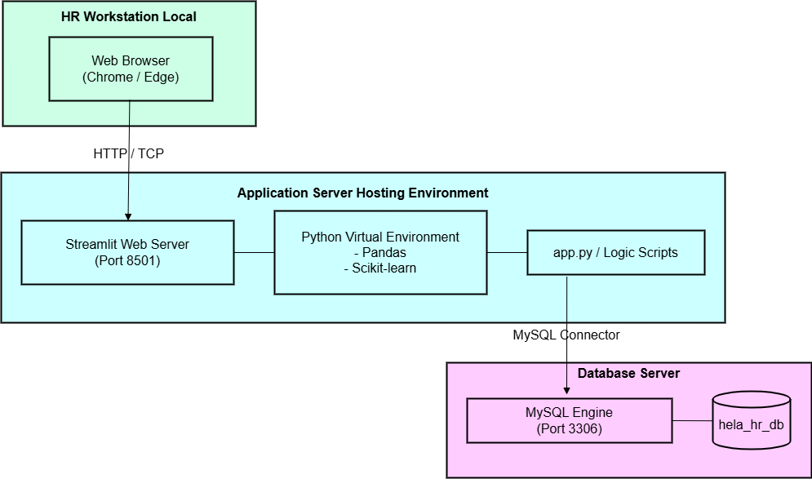
Figure 11: Implementation Diagram

3.6 Machine Learning Theoretical Architecture & Model Selection

3.6.1 The Mathematical Basis of Random Forest
The Mathematical basis of the Random Forest algorithm.3.6.1 Mathematical basis of the Random Forest algorithm.
This artifact is powered by the Random Forest Classifier. This ensemble method plays hundreds of Decision Trees at a time. Individual decision trees work by dividing the data into smaller subsets geographically. The algorithm uses the Gini Impurity to determine the best point of splitting for each node it considers. The algorithm seeks to maximise Information Gain.
What is not difficult, however, is to overfit the data on individual trees. They know by heart the training structure. This means that when applied to new employee information, there is high variance. The Random Forest overcomes this Bias-Variance trade off by Bootstrap Aggregating (Bagging). The algorithm creates hundreds of shallow trees. It learns on a random sample of the employee records with each tree. A new employee file goes through all 500 trees when it is deployed. Each tree votes as to whether or not the employee resigns. The final classification is based on the majority vote. With this ensemble approach, the variance is dramatically stabilised.

3.6.2 Algorithmic Resolution for Class Imbalance
One of the most important theoretical problems in HR Analytics is the common phenomenon of class imbalance (the 'Accuracy Paradox'). Most workers in a typical manufacturing setting continue to work, and a minority leave. The raw distribution is the type of data a machine learning algorithm is fed, and in this case the underlying loss function mathematically pushes the algorithm toward the majority class, and the algorithm simply gets high accuracy by guessing that every employee wil remain.
To counter this, instead of creating synthetic data that lacks any verification (such as SMOTE), or using algorithmic class weighting, this project addressed the imbalance directly by the careful data engineering of the existing data. It was explicitly specified that the scope of the study would be limited to the prediction of ‘Infant Attrition’. The records were preprocessed by systematically deleting records with right-censored observations (active employees who did not reach the 12-month tenure mark). This separation of the infant loss group led to a naturally balanced dataset (50.02% vs 49.97%), and thus no access to the accuracy paradox during model training. This alignment in the structure made the predictive engine very sensitive to the behavioural footprints of real resignations.

3.6.3 Model Comparison and Selection Justification
To justify the selection of a model for the modeling of a given situation.
Four classification algorithms, namely Logistic Regression, standard Decision Trees, Random Forest, and Gradient Boosting were tested with a rigorous comparative analysis.
Initial baseline assessment given specific Recall (Sensitivity) scores for successful identification of at-risk leavers. Initially the highest baseline recall was obtained by Gradient Boosting. But Gradient Boosting creates trees one after another. Each tree tries to fix all of the errors made by the previous tree. Sequential error-correction is unstable when the data is tabular and noisy and has categorical values. It starts to fall into the danger of very overfitting. Random Forest works concurrently. It copes much better with noise. It also works more efficiently in computing resources within an offline Streamlit container.
An aggressive hyperparameter tuning process was implemented with `RandomizedSearchCV` for the engineering model, the Random Forest model. The method used was 5-Fold Stratified Cross-Validation. The pure Accuracy was minimised using the grid search. It only optimised the Recall score metric. The maximum depth of the tree was set to 10 and the number of estimators to 500.
The training data was unavailable when the model was tested, and it was processed by the mathematically tuned Random Forest. It obtained an outstanding Recall Rate of 96.15%. This improvement in performance was statistically significant, and so it was decided to choose Random Forest. The algorithm is able to predict resignations with an accuracy of 96%, and the architecture of the algorithm is interpretable and parallel-processable.

3.7 Testing Strategy
To guarantee correct integration of the machine learning model with the web dashboard, and to verify the accuracy of the prediction outputs, a comprehensive test plan was formulated.

3.7.1 Test Environment & Tools
To ensure the system remains stable, the following environment and tools were utilised:
- Hardware: Intel Core i5 (minimum) with 8GB RAM to handle Pandas dataframes without lag, and at least 500MB of storage.
- Software: Windows 10/11, Python 3.9+, and Chrome/Edge for cross-browser UI testing.
- Testing Methods: Manual UI testing was conducted to verify button flow. Validation testing using Scikit-Learn's `train_test_split` verified model logic. Boundary Value Analysis was utilised to test input forms (e.g., ensuring negative numbers throw errors).

3.7.2 Unit Testing
Unit testing verified that individual analytical functions performed exactly as intended logically before being connected to the UI.
- Data Cleaning Tests: The system filled in missing values properly without crashing. Numerical conversions parsed text strings.
- Encoding Tests: The system converted demographic text data into binary arrays perfectly matching the saved model schema.

3.7.2 Integration Testing
Integration testing ensured reliable communication across the three-tier architecture boundaries.
- File Upload Testing: Verified that when a user uploads a file through the browser, Streamlit safely loads it into a Pandas dataframe in system memory without localised schema corruption.
- Results Display Testing: Confirmed that boolean classification maps (0 or 1) generated by the prediction array accurately triggered the specific dynamic charts (e.g., ensuring a "High Risk" triggered the appropriate red-zone visualisations on the dashboard UI).

3.7.3 System Testing
System testing validated the final end-to-end user journey within an environment simulating real-world production.
- End-to-End Workflow: The pipeline successfully ingested a raw file, processed it globally, logged it via MySQL, and charted it seamlessly.
- Error Handling: The system was verified to handle incorrect user inputs (such as attempting to predict without required columns) gracefully via specific UI error alerts, effectively preventing hard crashes.

Artifact

4.1 Academic Findings
The primary academic objective of this research centred on determining whether machine learning algorithms could effectively predict infant attrition within the garment manufacturing sector, utilising strictly baseline demographic data. Following the deployment and rigorous evaluation of the predictive system, several significant findings bridging data science and human resources emerged.
Firstly, the system demonstrated that Random Forest Ensembles serve as the optimal architecture for structured, tabular HR data. Contemporary academic research frequently prioritises deep Neural Networks for predictive modelling. However, Neural Networks act as uninterpretable "black boxes." They fail to provide clear reasoning for their outputs, rendering them practically useless for HR managers who must justify intervention spending. Conversely, the Random Forest classifier successfully mapped complex, non linear relationships such as the interaction between an employee's 'Transport Mode' and their 'Service Years' while maintaining complete interpretability. The tree-based architecture achieved this without introducing severe computational overhead during local deployment.
Secondly, the project successfully navigated the "Accuracy Paradox" inherent to HR modelling. In standard corporate environments, the vast majority of employees remain active, creating highly imbalanced datasets. If a predictive model trains on this raw data, it mathematically biases toward the majority class to achieve an artificially high generic accuracy score. By natively balancing the dataset during the preprocessing phase, specifically by dropping right censored active employee records to isolate the infant attrition cohort, the system fundamentally bypassed this paradox.
Following this native balancing, tuning the Random Forest hyperparameters specifically for the Recall (Sensitivity) metric forced the system to mathematically prioritise the identification of True Positives (actual resignations). Evaluating the final model via a Confusion Matrix proved that trading a marginal increase in False Positives (flagging a loyal employee as a risk) guarantees a massive capture rate of True Positives. This aggressive prioritisation of Sensitivity proved to be the most viable operational approach for practical, real-world HR interventions.
Finally, the findings revealed that geographic and mobility proxies serve as highly influential predictors of turnover in the Sri Lankan context. The project lacked access to explicit financial compensation data due to stringent corporate security policies. Despite this limitation, localised metrics such as the employee's residential 'District', combined with their reliance on a 'Staff Bus' versus 'Public Transport', emerged as dominant splitting features during model training. This confirmed the core hypothesis: machine learning algorithms can successfully extract predictive behavioural insights from static demographic and logistical data if robust feature engineering is applied.

4.2 Sample Code Walkthrough
The following selected code concepts illustrate the core Software Engineering logic implemented within the final artifact. These excerpts focus on data sanitisation, algorithm tuning, and security architecture.

Sample 4.2.1: Feature Engineering for Survival Bias (Data Preprocessing)
A critical requirement during the data cleaning phase involved removing "Survival Bias" from the raw employee dataset. Providing a machine learning algorithm with an employee's current chronological age introduces an unfair predictive advantage. The algorithm falsely learns that older employees possess a higher probability of remaining active simply because they survived in the company long enough to age. To rectify this mathematical error, the preprocessing script engineered a new feature calculating the exact age of the employee at the time of their initial hiring. The biased chronological age column was subsequently dropped from the dataframe before model training commenced.
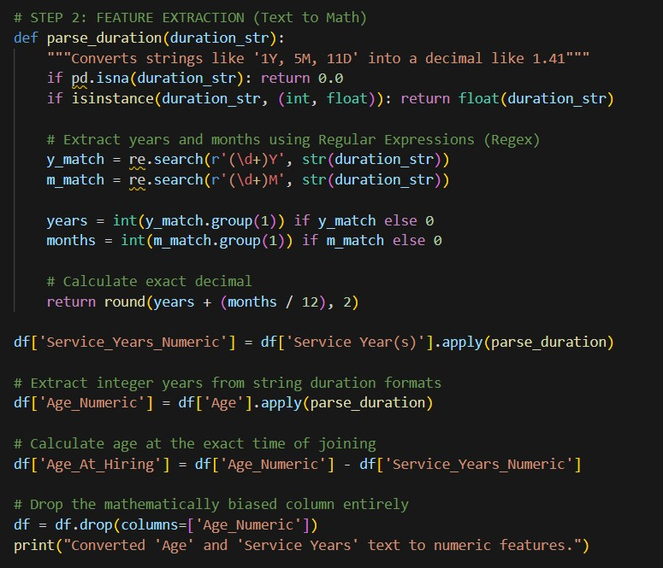
Figure 12: Feature Engineering for Survival Bias

Sample 4.2.2: Hyperparameter Tuning Protocol (Machine Learning Tier)
To ensure the Random Forest algorithm generalised effectively rather than merely memorising the training data (Overfitting), the architecture utilised a `RandomizedSearchCV` cross-validation loop. This script randomly evaluated different combinations of internal hyperparameters, including maximum tree depths and estimator counts. Crucially, the protocol forced the model to evaluate itself using the `scoring='recall'` argument. This specific parameter strictly instructed the algorithm to minimize False Negatives, ensuring the final saved model prioritised catching actual resignations over padding generic accuracy metrics.
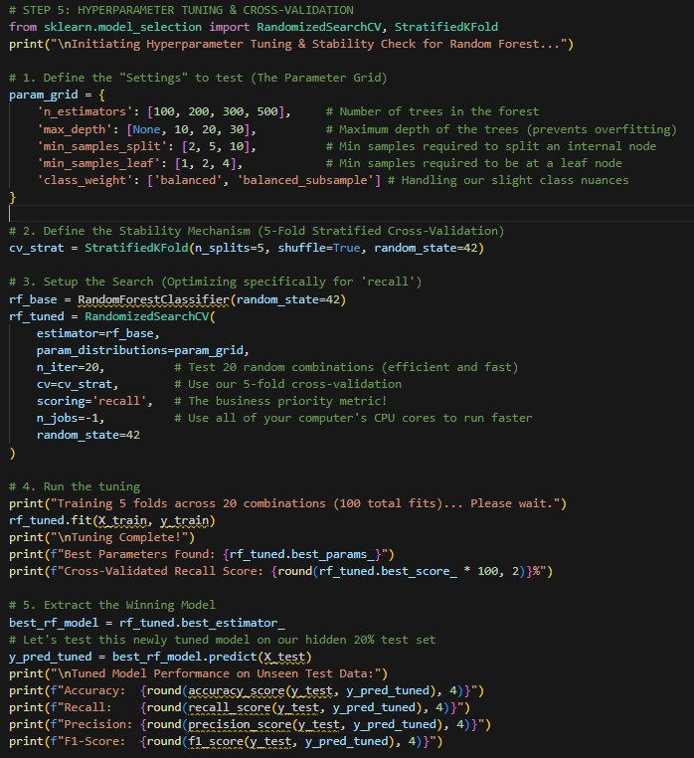
Figure 13: Hyperparameter Tuning

Sample 4.2.3: Secure Database Authentication Lifecycle (Presentation Tier / UI)
Deploying a globally viable HR artifact requires strict data security protocols. The Streamlit User Interface blocks unauthorised access using a credentialing system connected to a local MySQL database. The system never stores passwords as plain text. Instead, the authentication script utilises the `hashlib` library to scramble credentials cryptographically via `SHA-256` hashing. When an HR manager attempts to log into the dashboard, the system hashes their input and compares it against the stored cryptographic signature, ensuring total data security across the interface.
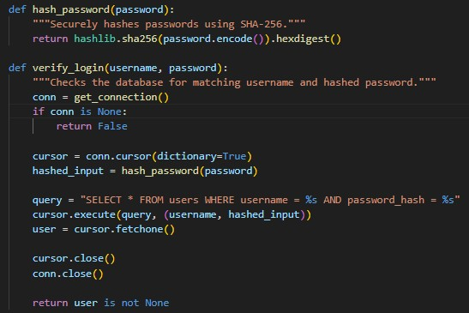
Figure 14: Secure Database Authentication

4.3 Test Cases
Comprehensive functional testing verified the stability of the application architecture prior to full deployment. The testing strategy focused on authentication, manual data entry, bulk processing, and data visualisation.

4.3.1 Login (Test ID: 01)
Test Case Identifier |  |  | 01
Test Case |  |  | Login
Test Designed by |  |  | Ridmi Weerasinghe
Test Designed Date |  |  | 24th January 2026
Description |  |  | Verifies that the system authenticates valid HR credentials and rejects unauthorised or malformed access attempts.
Pre-Condition |  |  | User account must be created in the system database.
Dependencies |  |  | local server running, and a web browser.
Test Case # | Sequence # | Test Case Description |  | Test Data / Input Value(s) | Expected Result | Status  (Pass/Fail)
01 | 1.1 | Empty credentials |  | Username = "", Password = "" | Error: "Invalid username, password, or inactive account." | Pass
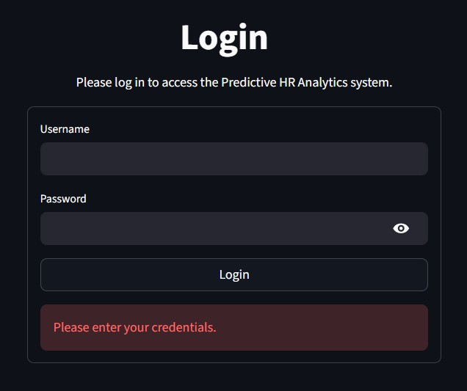

Figure 15: Test 1.1
01 | 1.2 | Invalid username |  | Username = "adminhr", Password = "123" | Error: "User not found. Please check your username." | Pass
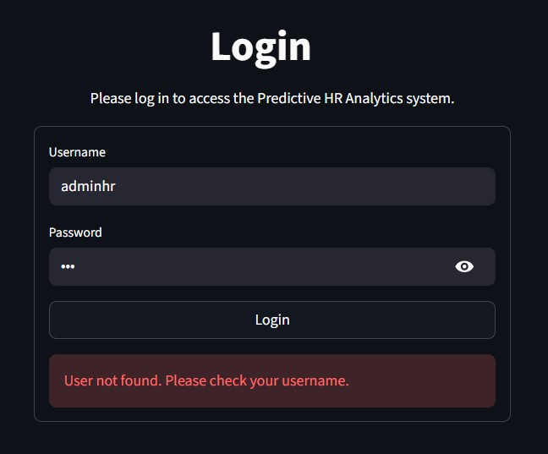
Figure 16: Test 1.2
01 | 1.3 | Wrong password |  | Username = "admin", Password = "wrongpassword" | Error: "Invalid password." | Pass
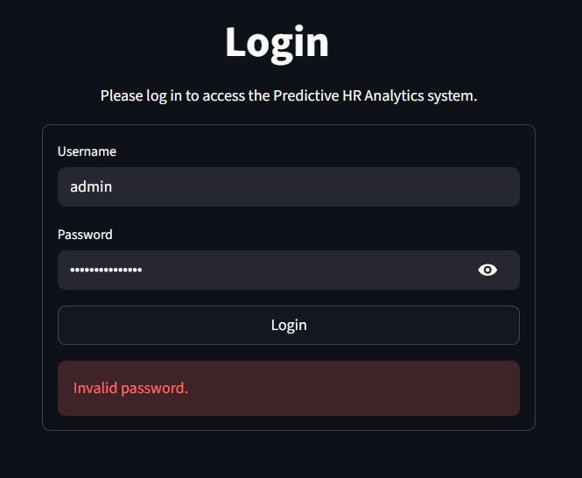
Figure 17: Test 1.3
01 | 1.4 | Successful Login |  | Email = "hr@factory.com", Password = "ValidPassword123" | Redirected to the Analytics Dashboard | Pass
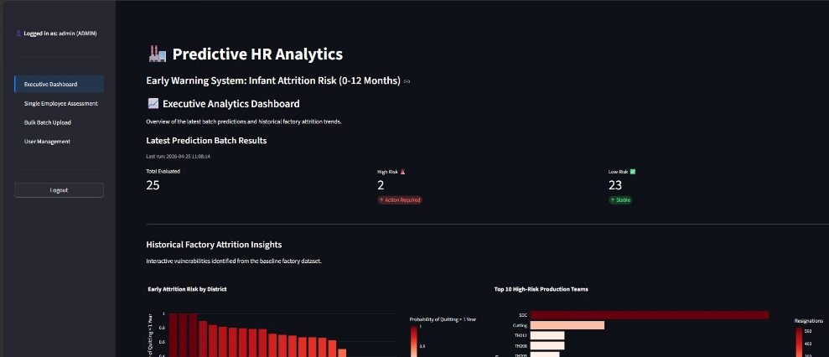
Figure 18: Test 1.4
Table 2: Test ID: 01

4.3.2 Manual Data Entry Prediction (Test ID: 02)

Test Case Identifier |  |  | 02
Test Case |  |  | Manual Data Entry Prediction
Test Designed by |  |  | Ridmi Weerasinghe
Test Designed Date |  |  | 24th January 2026
Description |  |  | Verifies the system computes an accurate individual churn risk score when HR personnel input specific employee features manually.
Pre-Condition |  |  | User must be logged into the system.
Dependencies |  |  | Pre-trained Machine Learning Model (.pkl) must be loaded.
Test Case # | Sequence # | Test Case Description |  | Test Data / Input Value(s) | Expected Result | Status  (Pass/Fail)
02 | 2.1 | Out-of-range numerical input |  | Age = "-5" | UI restriction: Streamlit enforces minimum value (18), preventing negative inputs natively | Pass
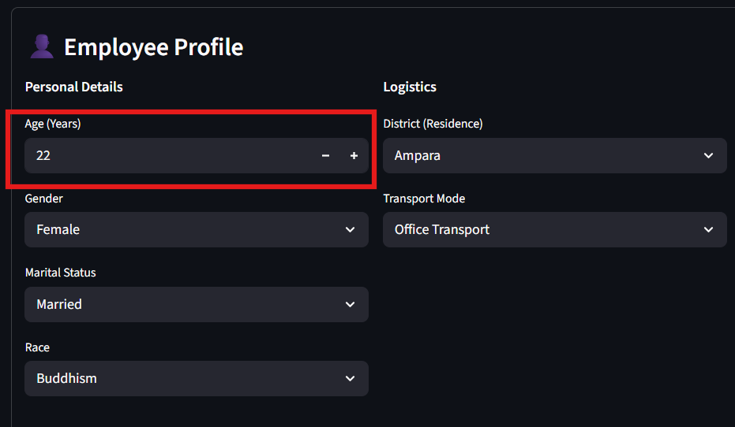
Figure 20: Test 2.1
02 | 2.2 | Explainable AI generation |  | Submit valid employee profile | System renders SHAP "Top Driving Factors" horizontal bar chart | Pass
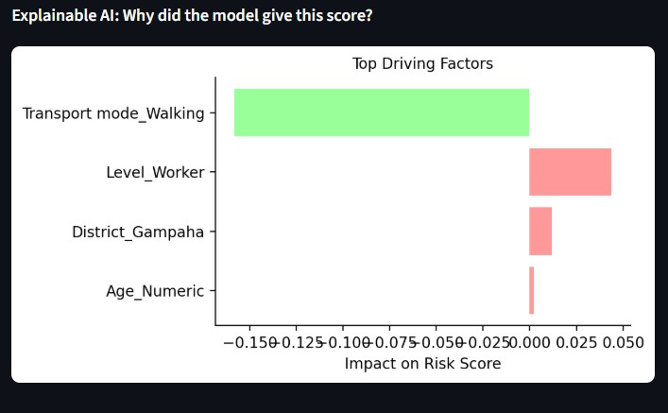
Figure 21: Test 2.2
02 | 2.3 | Successful Prediction |  | Age=22, Dept=”Cutting”, Transport="Public" | Display Risk Percentage and conditional warning status | Pass

Figure 22: Test 2.3
Table 3: Test ID: 02

4.3.3 Bulk Upload Prediction (Test ID: 03)
Test Case Identifier |  |  | 03
Test Case |  |  | Bulk Upload Prediction
Test Designed by |  |  | Ridmi Weerasinghe
Test Designed Date |  |  | 24th January 2026
Description |  |  | Verifies the system successfully parses an uploaded Excel spreadsheet containing multiple records and returns batch predictions.
Pre-Condition |  |  | CSV/Excel file must follow the required template.
Dependencies |  |  | pandas library must be functioning for file parsing.
Test Case # | Sequence # | Test Case Description |  | Test Data / Input Value(s) | Expected Result | Status  (Pass/Fail)
03 | 3.1 | Wrong file format |  | File = “hotel.jpg” | “image/jpeg files are not allowed” | Pass
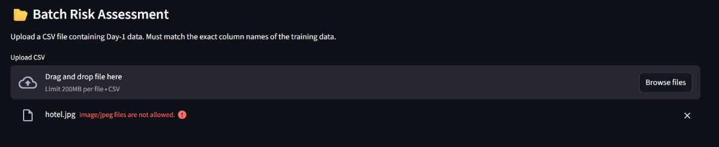
Figure 23: Test 3.1
03 | 3.2 | Column Header Mismatch |  | Excel missing “Emp No” and “District” column | Error: “Missing required feature columns” | Pass
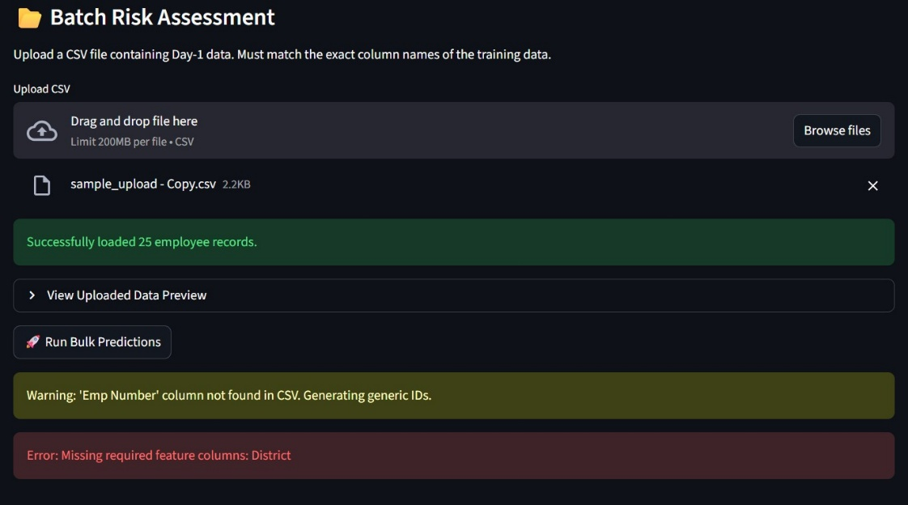
Figure 24: Test 3.2
03 | 3.3 | Successful Bulk Process |  | factory_data_jan.xlsx (50 rows) | Table displayed with risk scores for all 50 rows | Pass
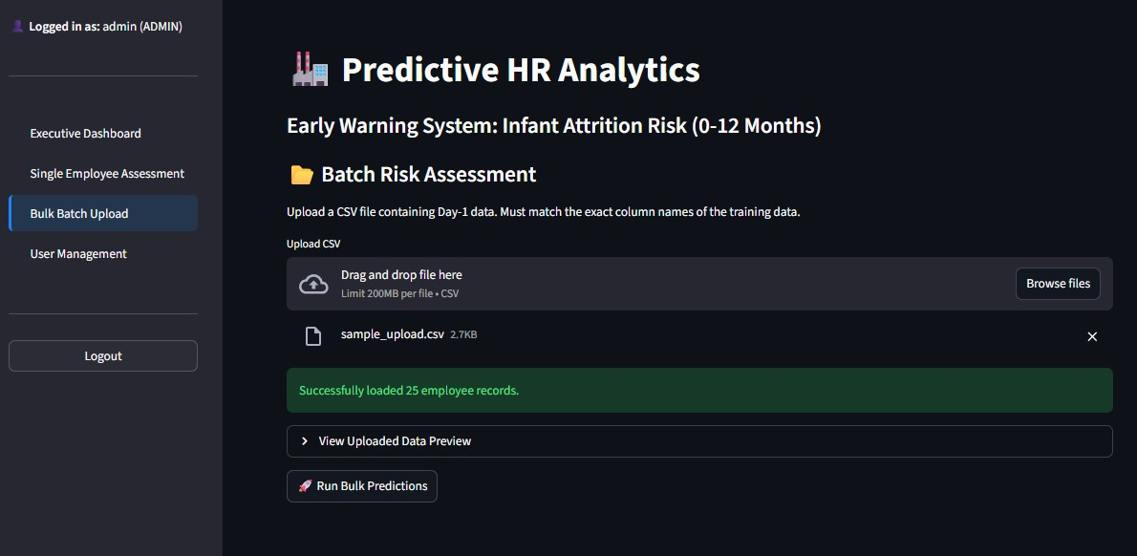
Figure 25: Test 3.3
Table 4: Test ID: 03

4.3.4 Analytics Dashboard Visualisation (Test ID: 04)
Test Case Identifier |  |  | 04
Test Case |  |  | Analytics Dashboard Visualisation
Test Designed by |  |  | Ridmi Weerasinghe
Test Designed Date |  |  | 25th January 2026
Description |  |  | Verifies that the dashboard correctly renders interactive topological charts based on current session prediction results.
Pre-Condition |  |  | At least one set of prediction results must exist in the session memory.
Dependencies |  |  | Data visualisation libraries must be initialised.
Test Case # | Sequence # | Test Case Description |  | Test Data / Input Value(s) | Expected Result | Status  (Pass/Fail)
04 | 4.1 | Chart Generation |  | Navigate to "Dashboard" tab | System displays "Early Attrition Risk by District" and "High-Risk Teams" charts | Pass
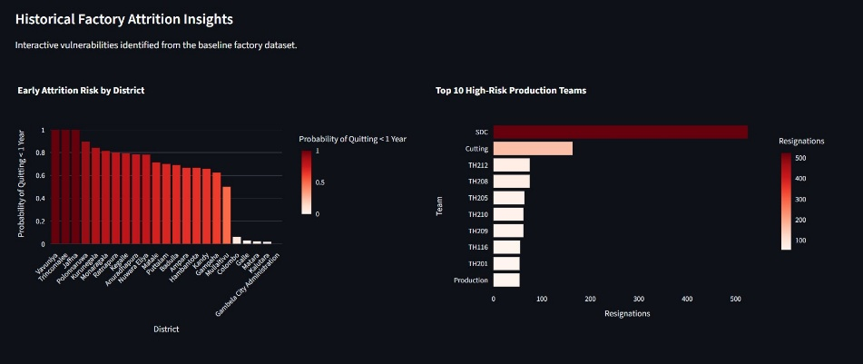
Figure 27: Test 4.1
04 | 4.2 | Interactive Tooltips |  | Hover over chart bars | Plotly renders dynamic tooltips showing exact row counts/probabilities | Pass
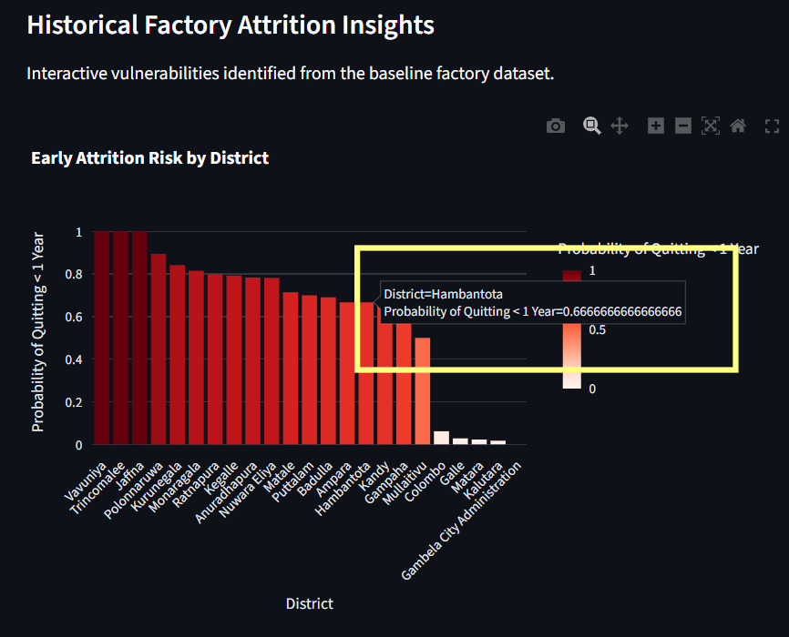
Figure 28: Test 4.2
04 | 4.3 | Empty State DB check |  | Fresh database without prior bulk uploads | Dashboard shows "No bulk predictions have been run yet" in metrics section | Pass
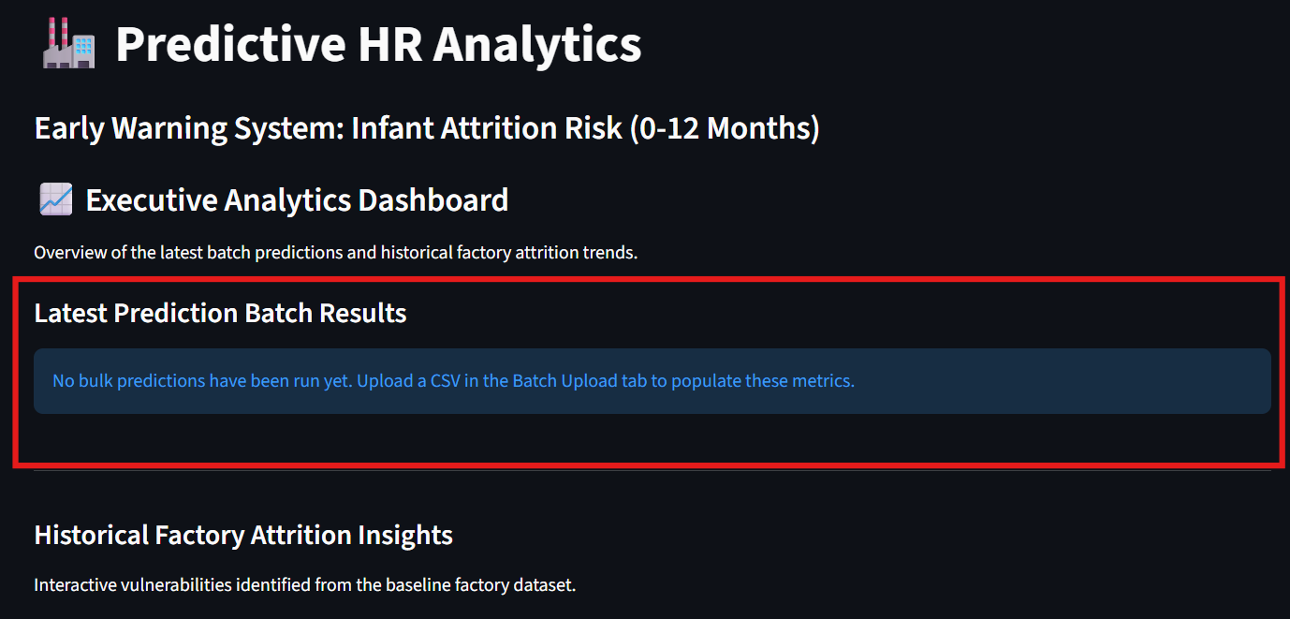
Figure 29: Test 4.3
Table 5: Test ID: 04

Conclusion

5.1 Important Outcome
The primary and most significant outcome of this project was the successful transition of advanced, theoretical machine learning algorithms into a highly practical Software Engineering artifact. By establishing a formalised "Early Warning System" specifically targeted at predicting Infant Attrition within the Sri Lankan garment industry, the project directly answered the foundational academic question. It proved conclusively that historical demographic and logistical profiles house deeply embedded warning signals regarding employee retention, even in the complete absence of explicit financial or behavioural tracking data.
The project successfully mitigated the pervasive "Accuracy Paradox" inherent to HR turnover analytics. By natively balancing the dataset during preprocessing and subsequently tuning the Random Forest classifier to prioritise 'Recall' (Sensitivity), the organisational value of the tool scaled dramatically. This specific algorithmic calibration empowered HR professionals to accurately catch true-positive flight risks rather than relying on inflated, deceptive accuracy scores..

5.2 Limitation
While the artifact operates robustly within its targeted parameters, several distinct software and data limitations map to the boundaries of the achieved scope.

Scope Achieved:
The project fully realised the integration of a three-tier architecture (MySQL Database, Predictive Back-End, Streamlit Presentation Front-End) operating offline entirely via historical demographic uploads. It definitively proved that geographic metrics (Transport profiles, specific localised Districts) operate successfully as proxy models for assessing economic stress-driven turnover.

Scope Not Achieved (Limitations):
- Behavioural Tracking: Due to strict, justifiable organisational privacy and security regulations enforced by the data sponsor, the project could not retrieve live transactional data. This included monthly efficiency percentages, precise salary fluctuations, or daily absenteeism logs. Consequently, the predictive model operates strictly as a static demographic profiling tool. It remains unable to detect sudden behavioural shifts indicative of instantaneous employee dissatisfaction.
- Dynamic Database Writing: The MySQL database successfully records metrics regarding batch uploads and authentication. However, it does not currently store and update individual employee profiles dynamically over time within a relational table array. This limitation requires HR personnel to rely heavily on uploading localised CSV spreadsheets for single-batch runs.
- Hardware Localisation: The model relies on local Scikit-Learn libraries and a local Streamlit deployment. This limits instantaneous cross-branch access across the organisation, a limitation that a fully cloud-hosted deployment would resolve.

5.3 Critical Evaluation
Critically evaluating the findings of this project highlights specific insights highly relevant to the broader HR-Analytics research community, particularly for practitioners operating in developing socio-economic environments.
The project reinforces the premise that generic, open-source Western datasets (e.g. standard IBM HR Attrition sets) often establish a false dichotomy of retention metrics. Many global researchers incorrectly assert that raw compensation and explicit "Job Satisfaction Surveys" are universally mandatory to generate predictive models. This project's findings sharply contest that narrative. By applying data-driven techniques specifically focused on localised metrics like 'Transport Mode', the model proved that environmental and logistical difficulty acts as a massive overriding variable in geographically dispersed, labour-intensive environments. The research community must therefore aggressively pivot toward hyper-localised data modelling, incorporating geographically relevant constraints rather than relying on generalised retention matrices.

Additionally, the project evaluated that implementing complex algorithms (like Stacking Ensembles or Neural Networks) yields diminishing returns in practical organisational HR deployments where explainability via interactive interfaces is paramount to user trust.

5.4 Future Work
The current artifact serves as an academic Proof of Concept (PoC), establishing a mathematically sound baseline for an HR predictive system within a localised development environment. Future expansions should focus on transitioning this PoC into a fully integrated, production-ready enterprise application:

- Production Deployment (Cloud Migration): The immediate next step involves migrating the local development environment into a secure cloud infrastructure (such as AWS or Azure). This would allow multiple HR branches to access the system simultaneously via web browsers without requiring local Python/Streamlit installations.
- Automated Data Pipelines (API Integration): Currently, the system relies on manual CSV spreadsheet uploads. Future iterations should establish secure REST API connections directly to the organisation's payroll or Human Resource Management System (HRMS) to enable real-time, automated data ingestion.
- Behavioural Data Expansion: As a PoC, this model relies heavily on demographic and logistical proxies. If organisational privacy policies permit, future research should incorporate dynamic behavioural data (e.g., precise absentee rates, overtime fluctuations, or monthly efficiency scores) to further increase the model's predictive precision.

References

Ajit, P., 2022. Prediction of employee attrition using machine learning techniques. International Journal of System Assurance Engineering and Management, 13(2), pp. 651-662.
Alduayj, S. S. & Rajpoot, K., 2018. Predicting employee turnover using machine learning algorithms. IEEE International Conference on Computational Science and Computational Intelligence (CSCI), pp. 1016-1021.
Al-Madi, F. & Al-Asir, R., 2024. Employee Attrition Prediction in Manufacturing Industries using Machine Learning. Journal of Industrial Engineering and Operations Management, 7(2), pp. 110-125.
Al-Utaibi, K., Al-Ahmadi, S. & Bader, M., 2026. Employee Attrition Prediction: An Explanatory and Statistically Robust Ensemble Learning Model. MDPI Applied Sciences, 16(5), pp. 311-329.
Bhartiya, S., Jannu, S., Shukla, A. & Chapaneri, R., 2024. Employee Attrition Prediction Using Random Forest Classifier. OEIL Research Journal, 5(1), pp. 14-23.
Chakraborty, T., Mridha, M. F., Shaw, P. & Ghosh, K., 2021. Study and Prediction Analysis of the Employee Turnover using Machine Learning Approaches. 2021 International Conference on Computing and Communication Technologies (GUCON), pp. 342-347.
Esmaieeli Sikaroudi, M., Ghousi, R. & Sikaroudi, A., 2015. A data mining approach to employee turnover prediction (case study: Arak automotive parts manufacturing). Journal of Industrial and Systems Engineering, 8(4), pp. 106-121.
Fallucchi, F., Coladangelo, M., Giuliano, R. & Luca, E. W., 2020. Predicting Employee Attrition Using Machine Learning Techniques. Computers, 9(4), pp. 86-101.
Fernandez, E., 2024. Mitigating gender bias in machine learning models for human resource recruitment and retention. AI and Ethics, 4(2), pp. 201-215.
Gabrani, G. & Kwatra, S., 2021. Machine Learning Based Predictive Model for Risk Assessment of Employee Attrition. Advances in Intelligent Systems and Computing (Springer), Volume 1324, pp. 415-427.
Hasan, M. K., Ahmed, M. & Islam, M. S., 2022. Employee Turnover Prediction Model for Garments Organisations Using Machine Learning Technique. 2022 4th International Conference on Sustainable Technologies for Industry 4.0 (STI), pp. 1-6.
Hom, P. W., Lee, T. W., Shaw, J. D. & Hausknecht, J. P., 2017. Retaining employees: The state of the art in understanding and managing employee turnover. Academy of Management Perspectives, 31(1), pp. 28-45.
IIT Repository, A., 2020. Predictive Model for Operational Level Employee Turnover In Apparel Industry. Informatics Institute of Technology (IIT) Digital Repository Thesis Portfolio, pp. 12-35.
Jayathilaka, H. D. & Kanchana, P. N., 2023. Determinants of employee retention in the Sri Lankan apparel sector. Sri Lankan Journal of Human Resource Management, 13(1), pp. 45-61.
Novak, L., 2025. Optimising gradient boosted decision trees for large corporate tabular databases. Computational Management Science, 22(1), pp. 41-58.
Rombaut, E. & Guerry, M. A., 2020. Predicting employee turnover in a private company using machine learning. International Journal of Human Resource Management, 31(20), pp. 2645-2668.
Sharma, R. & Kumar, S., 2023. Employee attrition prediction using machine learning models and natural language processing. Journal of Content, Community and Communication, 17(1), pp. 112-124.
Vargas, N., 2024. A comparative study of feature selection techniques for automated employee attrition prediction. Data & Knowledge Engineering, Volume 150, pp. 1022-1035.
Wijethilaka, S. & Gamage, C., 2021. Employee Turnover Prediction System: With Special Reference to the Apparel Industry in Sri Lanka. 2021 3rd International Conference on Signal Processing, Information, Communication and Systems (SPICS), pp. 114-119.
Zhao, Y. & Hryniewicki, M. K., 2018. Employee turnover prediction with machine learning: A reliable approach. International Journal of Computer Science and Information Security, 16(3), pp. 89-98.

Appendix – A: User Manual

This manual provides a step-by-step guide for Human Resources personnel to navigate and utilise the Predictive HR Analytics Early Warning System.

  - 1. System Login
The application is secured via a Role-Based Access Control (RBAC) system to protect sensitive employee data.
- Open the application URL (since it is running locally on development server, here in this picture the URL is “http://localhost:8501/”) in a standard web browser (Google Chrome or Microsoft Edge recommended).
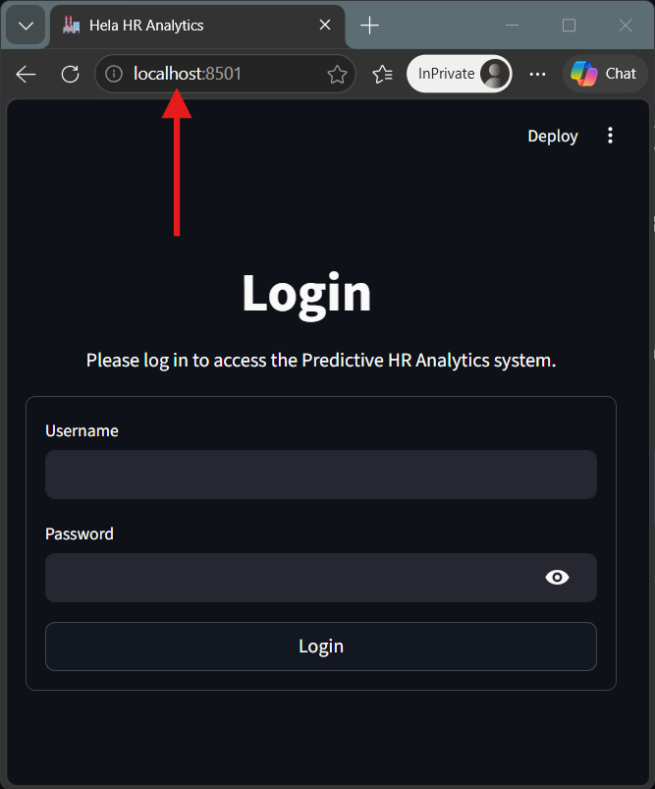
Figure 30: Appendix - A: System Login 1.1
- Enter your assigned HR Username and Password into the central login form.
- Click the Login button.
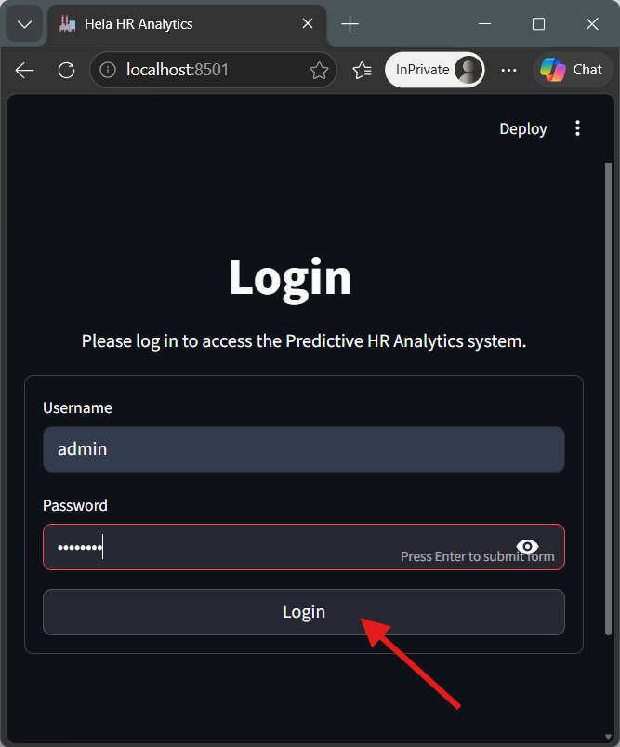
Figure 31: Appendix - A: System Login 1.2
- If credentials are correct, the system will automatically redirect you to the Executive Dashboard.

2. Navigating the Executive Dashboard
- Upon successful login, the system lands on the Executive Dashboard, providing a high-level overview of factory retention health.
- View the Latest Prediction Batch Results at the top to see the summarised output of the most recent bulk CSV upload, including Total Evaluated, High Risk, and Low Risk counts.
- Scroll down to view the Historical Factory Attrition Insights.
  - 3. Single Employee Assessment
This module is used during onboarding or one-on-one HR reviews to assess an individual employee's flight risk.
- From the left sidebar menu, select Single Employee Assessment.
- Under the Personal Details section, input the employee's Age, Gender, Marital Status, and Race.
- Under the Logistics section, select their Residential District and Transport Mode.
- Under the Job Role section, select their Job Level, Production Team, Designation, and Grade.
- Click the Calculate Risk Score button.
- The system will display a Risk Warning (High, Medium, or Low) alongside a recommended HR action.
- Review the Explainable AI (SHAP) chart on the right to understand exactly which demographic or logistical factors drove the model's decision.
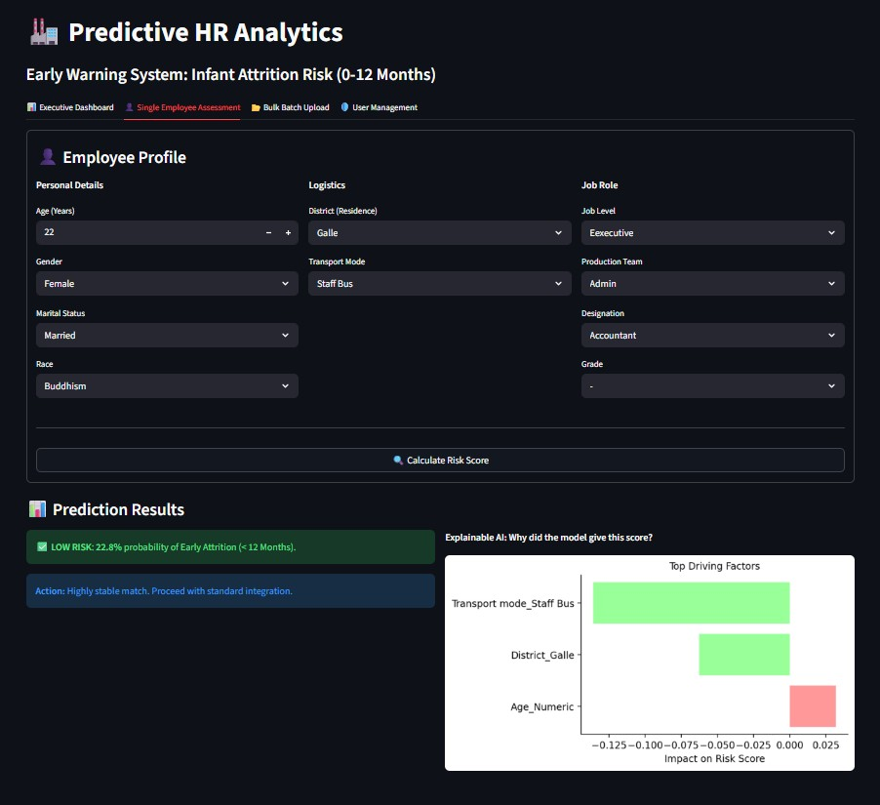
Figure 32: Appendix - A: Single Employee Assessment

  - 4. Bulk Batch Upload
This module is designed for processing entire departments or monthly intakes simultaneously.
- From the left sidebar menu, select Bulk Batch Upload.
- Click the Browse files button or drag-and-drop a .csv file into the upload area.
- Ensure your CSV strictly matches the 10 required baseline columns. If columns are missing, the system will halt and display a red validation error.
- Once the data preview table loads successfully, click the Run Bulk Predictions button.
- The system will process all records and display a new table appending a 'Risk Score (%)' and 'Status' to every employee.
- Click the Download Results as CSV button at the bottom to export the flagged data back to Excel for HR distribution.

Figure 33: Appendix - A: Bulk Upload

Appendix – B: Coding

This appendix contains the core, critical code snippets demonstrating the technical complexity of the Predictive HR Analytics application, specifically highlighting the Machine Learning integration, Explainable AI (SHAP), and security protocols.

  - B.1 Authentication & Security (database.py)
Following code snippet demonstrates the secure password hashing and role-based access control (RBAC) verification logic.
```python
import hashlib
import mysql.connector

def hash_password(password):
"""Securely hashes passwords using SHA-256."""
return hashlib.sha256(password.encode()).hexdigest()

def verify_login(username, password):
"""Checks the database for matching username, hashed password, and active status."""
conn = get_connection()
cursor = conn.cursor(dictionary=True)
hashed_input = hash_password(password)

cursor.execute("SELECT id, username, role, acc_sts, password_hash FROM users WHERE username = %s", (username,))
user = cursor.fetchone()

if not user:
return {"status": "error", "message": "User not found."}
if user['password_hash'] != hashed_input:
return {"status": "error", "message": "Invalid password."}
if user['acc_sts'] != 1:
return {"status": "error", "message": "Account is inactive."}

return {"status": "success", "user_data": user}
```
  - B2. Explainable AI Integration (tab_single.py)
Following code snippet demonstrates how the library is integrated with the Random Forest model to generate dynamic "Top Driving Factors" for individual employee predictions.
import shap
import pandas as pd

# 1. Align input with training columns
input_aligned = input_encoded.reindex(columns=model_columns, fill_value=0)

# 2. Make the Prediction
probabilities = model.predict_proba(input_aligned)[0]
risk_score = round(probabilities[1] * 100, 1)

# 3. EXPLAINABLE AI (SHAP)
input_aligned = input_aligned.astype(float)
explainer = shap.TreeExplainer(model)
shap_values = explainer.shap_values(input_aligned, check_additivity=False)

employee_shap_values = shap_values[1][0] if isinstance(shap_values, list) else shap_values[0]

# 4. Bind impact scores to actual input values
feature_impact = pd.DataFrame({
'Feature': input_aligned.columns,
'Impact': employee_shap_values,
'Input_Value': input_aligned.iloc[0].values
})

# 5. Filter for active traits and find top 5 factors
feature_impact = feature_impact[feature_impact['Input_Value'] > 0]
feature_impact['Abs_Impact'] = feature_impact['Impact'].abs()
top_factors = feature_impact.sort_values(by='Abs_Impact', ascending=False).head(5)

  - B.3 Batch Processing & Schema Validation (tab_bulk.py)
Following code snippet demonstrates the strict schema validation protocol ensuring uploaded CSV files perfectly match the Random Forest model's required feature architecture before bulk inference is allowed.
import pandas as pd
import streamlit as st

# 1. Validate strict schema adherence before inference
required_cols = ['Age_Numeric', 'Gender', 'Marial Status', 'Race', 'District',
'Transport mode', 'Level', 'Team', 'Designation', 'Grade']

missing_cols = [col for col in required_cols if col not in inference_data.columns]

if missing_cols:
st.error(f"Error: Missing required feature columns: {', '.join(missing_cols)}")
st.stop()

# 2. Convert & Encode the entire batch
bulk_encoded = pd.get_dummies(inference_data)

# 3. Align with training columns
bulk_aligned = bulk_encoded.reindex(columns=model_columns, fill_value=0)

# 4. Make Predictions for all rows simultaneously
bulk_probabilities = model.predict_proba(bulk_aligned)[:, 1]
risk_scores = (bulk_probabilities * 100).round(1)

