214007X - ML Assignment

1. Problem Definition & Dataset Collection
Sri Lanka gets millions of tourists every year, but arrivals change a lot depending on the month, season, and events like COVID-19. Tourists and planners had no easy way to know whether a chosen month and place is actually a good or bad time to visit Sri Lanka.
To solve this, I built a machine learning model that learns from historical Sri Lankan tourism data. A tourist enters their travel details like year, month, country, purpose, place, and accommodation and the model predicts how many tourists will visit that month and tells them if it is a good or bad time to visit, with clear reasons and recommendations.
Data Source: The data was collected from the Sri Lanka Tourism Development Authority Annual Reports.
Features & Target Variable:
- Input features: Year, Month, Country of Origin, Purpose of Visit, District, Accommodation Type, Duration, Group Size, Age, Prior Visits, Season, Crisis Period.
- Target variable: Monthly_Arrivals (the number of tourists visiting Sri Lanka that month).
Size of the Dataset:
- 1,530 rows
- 13 columns
Preprocessing Done:
- Fixed typos — Country names with spelling mistakes were corrected.
- Removed duplicates — About 30 duplicate rows were identified and deleted from the dataset
- Filled missing values — Empty values in Duration ,Days and Age columns were filled using the median value of each column
- Label Encoding — Categorical (text) columns such as Country, Purpose, District, Accommodation, and Season were converted into numbers so the model can process them.
Ethical Data Use:
- No real personal data was used.
- No names, passport numbers, or sensitive information included
2. Selection of a New Machine Learning Algorithm
Algorithm Selected: LightGBM (Light Gradient Boosting Machine)
LightGBM was selected because it is highly effective for structured, tabular datasets like this tourism data. It can handle a mix of numeric and categorical features, works well with missing patterns in data, and produces highly accurate predictions without requiring heavy data preparation. It also trains very fast compared to other boosting methods.
How it differs:LightGBM builds an ensemble of hundreds of decision trees, where each new tree learns from the mistakes of the previous one. This is called gradient boosting. Standard models do not do this:
- Decision Tree — builds only one tree, overfits easily, weak on complex patterns
- Logistic Regression — works only for classification, assumes a linear relationship between features and output, cannot model seasonal spikes or crisis drops
- k-NN — makes predictions based on similar rows in the dataset, very slow with large data, and performs poorly with many features
- LightGBM — combines hundreds of trees, handles non-linear relationships, resistant to overfitting due to built-in regularisation, and achieved R² = 0.9757 on this dataset — far better than any single standard model could achieve
3. Model Training and Evaluation
The cleaned dataset divided into three parts:
Split | Percentage | Rows | Purpose
Training set | 70% | 1,050 | Model learns patterns from this
Validation set | 15% | 225 | Used during training to stop early and avoid overfitting
Test set | 15% | 225 | Final evaluation — model has never seen this data

Hyperparameter Choices
Hyperparameter | Values Tested | Best Value
num_leaves | 31, 63 | 31
learning_rate | 0.05, 0.10 | 0.05
n_estimators | 200, 400 | 200
subsample | 0.8 | 0.8
colsample_bytree | 0.8 | 0.8

Performance Metrics
Metric | Value
R² Score | 0.9757
RMSE | 9,155
MAE | 7,231

The model achieved an R² of 0.9757, meaning it is highly accurate at predicting monthly tourist arrivals. The RMSE of ~9,155 on a scale of 0 to 250,000 arrivals represents an error of only around 4%, which is acceptable for tourism planning purposes.
The Actual vs Predicted plot 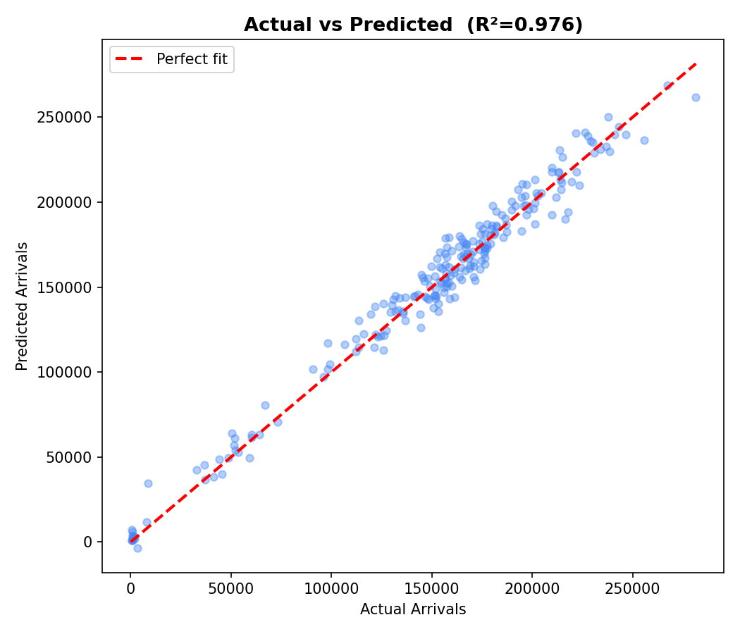
4. Explainability & Interpretation.
Explainability Method Used: SHAP
SHAP was applied to explain how the LightGBM model makes its predictions. It calculates how much each feature contributed to a specific prediction — either increasing or decreasing the predicted arrivals.
What the model has learned:
The model learned that tourist arrivals in Sri Lanka follow strong seasonal patterns
- December to March consistently attract the highest number of visitors
- May to June sees the lowest arrivals due to the monsoon season.
- crisis events such as the Easter 2019 attacks and the COVID-19 pandemic (2020–2021) caused dramatic drops in arrivals.

Which features are most influential:
Crisis_Period -Largest impact — crisis months have near-zero arrivals
Whether the model’s behavior aligns with domain knowledge:
The model's behaviour closely matches real-world tourism knowledge:
- December–March predicted as peak season
- COVID-19 years correctly identified as near-zero arrivals
- Yala and Wilpattu peaking in dry months — matches wildlife park seasonal openings

5. Critical Discussion.
Limitations of the Model:
Although the model achieved a high R² of 0.9757, it has several limitations. The model was not accurately predict arrivals during new, unseen events such as future economic crises, natural disasters, or global pandemics. Important external factors like flight ticket prices, currency exchange rates, competitor destinations, and real-time weather conditions were not included in the dataset, as they were difficult to obtain at the individual tourist level. The model also predicts at the monthly aggregate level, so it cannot forecast arrival patterns for a single week or specific date.
Data Quality Issues:
The dataset collected from SLTDA records contained several real-world quality issues. Some duration values and age values were missing, likely due to incomplete survey responses from tourists at entry points. And also country names contained spelling errors from manual data entry at border checkpoints. Approximately some rows were full duplicates, possibly caused by double-entry during data transfer.
Risks of Bias or Unfairness
The dataset is heavily skewed towards Indian tourists, who represent over 20% of all records. This means the model is more accurate for Indian visitors and may produce less reliable predictions for tourists from smaller markets such as Japan, Australia, or the Middle East. Crisis periods are also under-represented relative to normal years, which could cause the model to slightly underestimate the scale of future disruptions.

Real-World Impact & Ethical Considerations
This model helps hotels, airlines, and the SLTDA plan better by predicting tourist demand. Tourists can also use the web app to find the best time to visit. However, predictions are based on past data, so unexpected events like crises will not be reflected. Since the data comes from real immigration records, it must be kept secure and never used to discriminate against tourists.

