UNIVERSITY OF CALIFORNIA, DAVIS



BERKELEY • DAVIS • IRVINE • LOS ANGELES • MERCED • RIVERSIDE • SAN DIEGO • SAN FRANCISCO SANTA BARBARA • SANTA CRUZ

June 25, 2020

Dear Editors,

The accompanying manuscript, "The effects of population synchrony, life history, and access constraints on benefits from fishing portfolios," is being submitted for publication in Ecological Applications. In this manuscript, we developed a novel bioeconomic simulation model to explore the interactive effects of population synchrony and resource access on the revenue patterns experienced by people who rely on the resources for income. The model is parameterized to loosely represent three key fisheries in the California Current, but many of the conclusions are widely applicable. First, portfolios of populations with asynchronous early life survival stabilized revenue variability, but only when populations were short-lived. Available biomass of long-lived populations integrated recruitment, growth, and mortality over many years, so did not correlate with available biomass of short-lived populations. Second, increased access to fishing permits allowed more people to diversify their fishing portfolios and reduce revenue variability, though this came at a cost: the average revenue earned from a given fishing portfolio went down. This was especially problematic in the case of a downward sloping demand curve, where total revenue in the fishery decreased with increasing permit access, despite catching more biomass. This work will be of wide interest to the Ecological Applications readership. It illustrates that to understand the impacts of different management regimes, it is crucial to consider species interactions, both in terms of ecological interactions and those induced by participation decisions. We are not aware of any multispecies bioeconomic models that jointly consider ecological dynamics and management of access rights.

No part of this work has been published nor is it being considered for publication elsewhere. It is posted in its current version at X.

Sincerely,

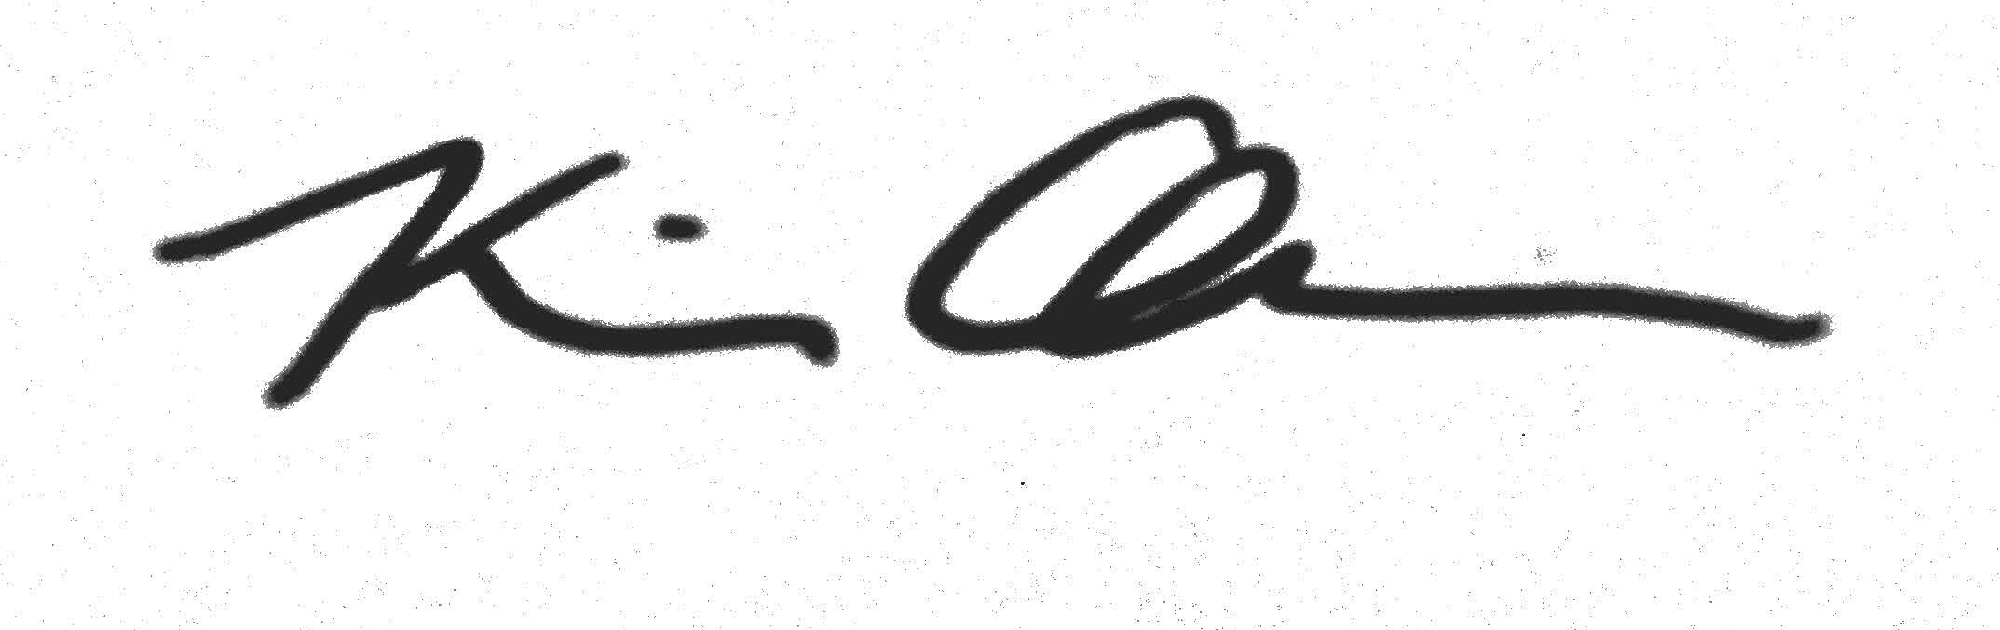

Kiva Oken, PhD

Department of Wildlife, Fish, & Conservation Biology

University of California, Davis

kloken@ucdavis.edu