Running head: Synchrony and permit access in fisheries

The effects of population synchrony, life history, and access constraints on benefits from fishing portfolios

Kiva L. Oken1,2,[1], Daniel S. Holland3, André E. Punt1

1 School of Aquatic & Fishery Sciences, University of Washington, Seattle, WA, USA

2 Corresponding author

3 Conservation Biology Division, Northwest Fisheries Science Center, Seattle, WA, USA

Abstract

Natural resources often exhibit large interannual fluctuations in productivity driven by shifting environmental conditions, and this translates to high variability in the revenue resource users earn. However, users can dampen this variability by harvesting a portfolio of resources. In the context of fisheries, this means targeting multiple populations, though the ability to actually build diverse fishing portfolios is often constrained by the costs and availability of fishing permits. These constraints are generally intended to prevent overcapitalization of the fleet and ensure populations are fished sustainably. As linked human-natural systems, both ecological and fishing dynamics influence the specific advantages and disadvantages of increasing the diversity of fishing portfolios. Specifically, a portfolio of synchronous populations with similar responses to environmental drivers should reduce revenue variability less than a portfolio of asynchronous populations with opposite responses. We built a bioeconomic model based on the Dungeness crab (*Metacarcinus magister*), Chinook salmon (*Oncorhynchus tshawytscha*), and groundfish fisheries in the California Current, and used it to explore the influence of population synchrony and permit access on income patterns. As expected, synchronous populations reduced revenue variability less than asynchronous populations, but only for portfolios including crab and salmon. Synchrony with the longer-lived groundfish population was not important because environmentally-driven changes in groundfish recruitment were mediated by growth and natural mortality over the full population age structure, and overall biomass was relatively stable across years. Thus, building a portfolio of diverse life histories can buffer against the impacts of poor environmental conditions over short time scales. Increasing access to all permits generally led to increased revenue stability and decreased inequality of the fleet, but also resulted in less revenue earned by an individual from a given portfolio because more vessels shared the available biomass. This means managers are faced with a tradeoff between the average revenue individuals earn and the risk those individuals accept. These results illustrate the importance of considering connections between social and ecological dynamics when evaluating management options that constrain or facilitate fishers’ ability to diversify their fishing.

Key words

Portfolio effects, economics, synchrony, bioeconomic model, fisheries, California Current

Introduction

Diverse resource portfolios can reduce revenue variability and financial risk caused by large fluctuations in productivity and profitability of exploited natural populations (Kasperski and Holland 2013). Variability in fishing revenue declines for individuals, vessels, and communities when groups diversify their portfolio of fishing activities by targeting multiple species or geographic areas (Kasperski and Holland 2013, Sethi et al. 2014, Himes-Cornell and Hoelting 2015, Anderson et al. 2017, Cline et al. 2017). However, the ability to build diverse fishing portfolios has declined as limited access programs that restrict the number of fishers permitted to harvest particular species have increasingly constrained access to fisheries. This is particularly the case for younger fishers who were not gifted fishing permits when limited access programs were first enacted (Kasperski and Holland 2013, Himes-Cornell and Hoelting 2015, Stoll et al. 2016, Holland and Kasperski 2016, Holland et al. 2017).

The ecological dynamics and life histories of the populations that comprise resource portfolios mediate the extent to which diverse portfolios stabilize income and reduce risk. First, population synchrony can play a role. Synchronous populations tend to respond in the same direction to shared drivers, have a bottom-up dominated predator-prey relationship, or have similar exploitation histories (Beaugrand et al. 2003, Baum and Worm 2009, Hansen et al. 2013). Asynchronous populations tend to be competitors, have a top-down dominated predator-prey relationship, or respond in opposite directions to a shared driver (Hare et al. 1999, Worm and Myers 2003, Gonzalez and Loreau 2009, Loreau and Mazancourt 2013). Populations that vary asynchronously or independently of one another yield a more temporally stable aggregate biomass than populations that vary synchronously, and this stability in biomass can lead to greater stability in the revenue that the portfolio of populations generates (Doak et al. 1998, Hilborn et al. 2003, Schindler et al. 2010). Second, variability itself can be driven by life history. Long-lived species with “slow” life histories tend to exhibit less interannual variation in biomass than “fast” short-lived species (Warner and Chesson 1985, Winemiller and Rose 1992, Bjørkvoll et al. 2012). Finally, phenology often determines timing of the fishing seasons. Vessels tend to target migratory species when they are closest to home fishing ports, and regulations often protect populations during periods that are particularly important for reproduction and growth (e.g., molting, carrying of egg sacs). If vessels carry a portfolio of complementary permits for fisheries that occur at different times of year, they can make fuller use of fishing capital. Portfolios that includes permits for fisheries that that overlap temporally can enable fishers to divert effort into another fishery in the event of a downturn or closure, but this may require investments in permits or gear that the fisher cannot fully utilize (Richerson and Holland 2017).

An extensive social-ecological modeling literature has demonstrated that accounting for the interactions between ecological and human dynamics in fisheries management can improve biological sustainability and increase the benefits fishers and society derive from the ecosystem (see Nielsen et al. 2018 for review). For example, vessels in multispecies fisheries can achieve more optimal harvest patterns by intentionally altering their fishing behavior to avoid species with lower natural productivities (Kirkley and Strand 1988, Squires and Kirkley 1991). Furthermore, accounting for ecological interactions such as predation can lead to different estimates of management targets and even lead to new fishing opportunities (Collie and Gislason 2001, Overholtz et al. 2008, Oken and Essington 2016, Holsman et al. 2016). However, there has been relatively little focus in this literature on the interaction between ecological dynamics, the benefits of revenue diversification gained, and the management of access rights. Sanchirico et al. (2008) acknowledged the costs of diversification in terms of efficiency and the benefits in terms of stability, and explored how catch allocations could be made to both minimize variability andmaximize returns. However, the correlation pattern assumed among the stocks in that analysis was based solely on correlations in historical gross revenue. It did not account for feedback between fishing intensity and population productivity or prices.

The California Current Large Marine Ecosystem (CCLME) provides an ideal model system to explore how ecological dynamics and management decisions combine to impact the profitability and risk fishers experience. Many fisheries in the CCLME are highly interdependent, sharing linkages through both exposure to common environmental drivers and cross-participation of fishers. Climate variability is a strong component of the CCLME, especially due to ENSO events and the Pacific Decadal Oscillation (Mantua et al. 1997, Hare and Mantua 2000, Schwing et al. 2010, Jacox et al. 2016). Climate cycles and oceanic conditions influence the productivity of many commercially valuable species across various spatial and temporal scales through impacts to recruitment, growth and spatial distribution, indirectly linking their dynamics (Black et al. 2010, Schwing et al. 2010, Hazen et al. 2013, Shanks 2013, Stachura et al. 2014, Stawitz et al. 2015). Participation of fishers in multiple fisheries within the CCLME provides additional connectivity of dynamics among populations, as shifts in productivity and profitability of fisheries can lead to shifts in effort among fisheries. Although the strength of this cross-participation varies among fishing ports, it represents an important linkage at the coastwide scale (Richerson and Holland 2017, Fuller et al. 2017).

We developed a simulation stylized model based on the fisheries for three key species in the CCLME and used it to evaluate the consequences of management strategies in conjunction with the ecological dynamics of the fish populations and the participation decisions of fishers. We used this model to explore how synchrony of productivity, combined with ease of access and movement among fisheries combine to affect profitability and variability in income for fishers. We simulated annual recruitment and population dynamics as well as weekly fishery participation decisions for three U.S. West Coast fisheries: Dungeness crab (*Metacarcinus magister*); Chinook salmon (*Oncorhynchus tshawytscha*); and groundfish (characterized by Sablefish: *Anoplopoma fimbria*, which contributes the largest share of revenue to the non-whiting groundfish fishery). We used the model to investigate how different access rules that restrict which fishers can participate in which fisheries, impact average revenue and revenue variability for 1) individual fishers, 2) species, and 3) the fleet at large, under positive and negative correlation in recruitment of the populations.

Methods

We built a simulation model of three species groups (crab, salmon, and groundfish) which are linked by cross-participation of fishing vessels and shared productivity dynamics. The model is intended to capture key ecological, economic, and management characteristics of these fisheries that are important to understanding their dynamics and interactions, but it is a stylized depiction. Results should be considered for their qualitative insights rather than as quantitative predictions. The actual fisheries are highly complex with substantial heterogeneities among fleets and regions that we are unable to parameterize accurately, in part due to lack of data, but also because the model would become too complex to yield clear insights. We explored different scenarios in the model across two main axes. First, we altered the productivity dynamics by adjusting the synchrony in recruitment among the three populations. Second, we altered the cross-participation dynamics by adjusting the fraction of vessels holding permits for more than one fishery. We simulated fisheries for 50 years and ran 10,000 50-year simulations for each scenario. Population dynamics (recruitment, growth, natural mortality) occurred on an annual time scale whereas fishing occurred on a weekly time scale. The model was written in R version 3.6.3 (R Core Team 2020) and code is available online (<https://github.com/okenk/CC_bioecon>).

*Focal fisheries*

Despite limits on the number of participants, vessels participating in Dungeness crab fisheries race to catch available crabs as quickly as possible. Nearly all legal-size males are caught in a matter of weeks after the start of the season, and catch rates decline rapidly as fishers deplete the population (Richerson et al. 2020). Most fishers exit before the fishery legally closes and participate in other fisheries or outside work. The timing of this exit varies substantially among years and vessels due to variability in opening dates, abundance of crab, and individual cost incentives. Recruitment of Dungeness crab is largely driven by environmental conditions during the larval phase, and there is little evidence for a stock-recruit relationship (Shanks and Roegner 2007, Shanks 2013). Fishery opening dates vary somewhat between states and years with start dates ranging from mid-November into January. Fisheries formally close in late summer or fall when crab molt. To simplify the analysis, we assumed crab fisheries open on December 1 (start of the model year) and close on August 14.

Ocean troll fisheries for salmon on the U.S. West Coast are mainly based on hatchery fish, but less abundant wild stocks mix with the hatchery fish and also appear in catches. Similar to crab, salmon display high interannual variability in abundance and hence catch, partly due to their short two- to five-year generation time. Biomass available to the fishery depends mainly on hatchery production and survival rates, not the number of fish that returned to spawn in the brood year, because the majority of the ocean salmon harvest is of hatchery origin (Shelton et al. 2019). Nevertheless, returns and catches vary substantially among years due to high variation in average survival rates associated with both freshwater and ocean conditions, predation, and other factors. Salmon fisheries experience much less depletion through the season than crab fisheries. Actual season dates vary by state and area, but for simplicity we assumed salmon fisheries open on May 1 and close on October 31, roughly in line with actual seasons.

The groundfish fishery operates year-round. It exhibits more inter-annual stability in fishable biomass, allowable catch, and landed catch than crab or salmon, largely because it targets longer-lived species and exerts much lower annual fishing mortality rates (e.g., Johnson et al. 2015).

*Salmon and crab population models*

We modeled recruitment for salmon and crab as a random lognormal variable with temporal autocorrelation to emulate observed regime-like patterns because these populations generally do not demonstrate a stock-recruit relationship, and individuals are generally only susceptible to the fishery for one year. Although salmon populations tend to display more complex age structure farther north in the CCLME, this is a realistic assumption for troll fisheries heavily dominated by the Central Valley populations, such as fisheries in California. The biomass available to the fishery is simply the biomass corresponding to the year’s recruitment. Thus, recruitment for species *s* in year *y* (*Rs,y*)was equal to abundance at the start of the year (*Ns,y,1*) which was:

$R_{s,y}=N_{s,y,1}={\overline{R}}_{s} exp\left(ε_{y,s}-\frac{{σ_{R,s}}^{2}}{2}\right)$ (1)

where ${\overline{R}}_{s}$  is average recruitment for species *s*, *εy,s* is an autocorrelated normal random variable, the second term in the exponent is a bias correction factor that ensures the expectation of the entire exponentiated term is 1, and *σR,s* is the unconditional standard deviation of *εs*. When recruitment is independent among populations,

$ε_{s,y}|ε_{s,y-1} \sim N\left(ϕ_{s}ε_{s,y-1}, {{ σ}_{R,s}}^{2}(1-{ϕ_{s}}^{2})\right) ,$ (2)

where *ϕs* is the strength of temporal autocorrelation (between negative one and one) for species *s*.

After the first week of the year, weekly catches from the fishery must be subtracted. Catch (in numbers) during week *w* is:

$C_{s,y,w}=\sum_{v}{I_{v,s,y,w}q_{s}N_{s,y,w}}$ (3)

where the sum is over all vessels *v*, *qs* is the catchability of species *s* (proportion of the population harvested by one vessel during one week), and *Iv,s,y,w* is an indicator variable equal to one when vessel *v* participates in the fishery for species *s* in week *w* of year *y*, and equal to zero otherwise (see fishery participation model below). Catch from the previous week is subtracted to obtain abundance in a given week, *Ns,y,w*. Biomass in week *w* is

$B_{s,y,w}=ω_{s}N_{s,y,w}$ (4)

where *ωs* is the weight of individuals of species *s.*

*Groundfish population model*

We modeled the groundfish populations using a Deriso-Schnute delay-difference model (Schnute 1985) with a Beverton-Holt stock-recruit relationship. This more complex model was necessary because the biomass of available groundfish in a given year depends on both new recruitment to the population and whatever biomass survived and grew from the previous year. The delay-difference model allows for changes in age structure, an advance from simpler surplus production models, but restrictively assumes selectivity and maturity are knife-edged functions of age and occur at the same age (Hilborn and Walters 1992, Quinn and Deriso 1999). Although biomass dynamics in this model can be simulated using a single equation, for ease we equivalently modeled both abundance (*Ng*, subscript *g* for groundfish) and biomass (*Bg*) (Hilborn and Walters 1992). For comparability with the crab and salmon population dynamics, we assumed these dynamics occurred at an annual time scale:

$B_{g,y+1,1}=S_{y}\left(αN_{y}+βB_{g,y,1}\right)+ω_{k,g}R_{g,y+1}$ (5)

$N_{g,y+1,1}=S_{y}N_{g,y}+R_{y+1,g}$ (6)

where *Sy* is total per capita survival in year *y*; *α* and *β* are the intercept and slope, respectively, of a Ford-Walford plot (i.e., a plot of weight at age *a* vs. weight at age *a* - 1); *ωk,g* is the weight at age *k*; *k* is the age at both recruitment to the fishery and at maturation; and *Ry,g* is the recruitment to the population during year *y*. The survival rate accounts for both natural mortality (*M*) and fishing mortality:

$S_{y}=exp⁡(-M)\left(1-\frac{\sum_{w=1}^{52}{C_{g,y,w}}}{N_{y}}\right)$ (7)

Groundfish catch is defined as in equation (3) and weekly catches are subtracted as described for crab and salmon. Biomass within a year for groundfish is:

$B_{g,y,w+1}={\left(1-q_{g}\sum_{v}{I_{v,g,y,w}}\right)B}_{g,y,w}$ (8)

We assumed a Beverton-Holt stock-recruit relationship using the steepness parameterization, so that:

$R_{g,y}=\dot{\dot{\frac{4hR_{0}\frac{B_{g,y-k,53}}{B_{0}}}{1-h+\left(5h-1\right)\frac{B_{g,y-k,53}}{B_{0}}}}⋅exp⁡\left(ε_{g,y}-\frac{{σ_{R,g}}^{2}}{2}\right)}$ (9)

where *h*, *R0*, and *B0* are steepness (expected proportion of unfished recruitment occurring at 20% of unfished biomass, i.e., “resilience”), unfished recruitment, and unfished biomass, respectively, and *εy,g* is a random recruitment deviation during year *y* for groundfish, modeled as described above. This model formulation presumes that reproduction occurs after fishing and before natural mortality, as is standard (Hilborn and Walters 1992). We used the biomass in a hypothetical week 53, even though there are only 52 weeks in a year, to include all weeks of fishing mortality but exclude the next year’s recruitment. Unfished biomass is calculated based on equilibrium conditions as:

$B_{0}=R_{0}/κ$ (10)

where *κ* is the growth-survival constant:

$κ=\frac{1-\left(1+β\right)\exp\left(-M\right)+β{\left[\exp\left(-M\right)\right]}^{2}}{ω_{k,g}-βω_{k-1,g}\exp\left(-M\right)}$ (11)

and *ωk-1,g* is the groundfish weight at age *k*-1, calculated as (*ωk,g* - *α*)/*β.*

*Weekly fishery participation model*

Each week of the year, each vessel considers its weekly costs and anticipated revenue and decides whether it would be profitable to fish. If it is profitable to fish in more than one fishery, vessels select the most profitable fishery open to them given their permit portfolio. Each vessel can fish in only one fishery each week because each fishery requires vessels to be outfitted differently.

Costs of fishing were divided into annual fixed costs for each species *s* (${\tilde{c}}_{s}$) that were automatically incurred every year (e.g., permits, boat and gear maintenance) and weekly variable costs for each species *s* and vessel *v* (*cs,v*) that were only incurred if a vessel chose to fish for a particular species in a given week (e.g., fuel, bait, labor). Variable costs varied among vessels according to a lognormal distribution to mimic heterogeneity in fishing efficiency and introduce differences in participation decisions among vessels during the season. The magnitude of a vessel’s variable costs did not change during a simulation (i.e., *cs,v*washeld constant), but they were only incurred during weeks that the vessel fished.

Fishers were assumed to have perfect knowledge of the available biomass each week, but were not forward-looking. Catchability was held constant with no interference among vessels. Expected revenue if fishing for any vesselduring the legal season for species *s* in week *w* of year *y,* *rs,y,w* was then:

$r_{s,y,w}={q_{s}B}_{s,y,w}P_{s,y,w}$ (12)

where *Ps,y,w* is the price per unit biomass of species *s* during week *w* of year *y*. Revenue is zero if it is not legal to fish for species *s* in week *w*. Prices were held constant for groundfish and salmon, so fishers also had perfect knowledge of the revenue and profit they would earn in a week for those populations. A linear demand function was built for crab to better mimic actual dynamics of the Dungeness crab fishery. Crab prices typically rise as the season progresses and landings fall (Pacific States Marine Fisheries Commission 2020). Compared with a constant price scenario, accounting for a demand function led to much higher population depletion by the end of the season and increased the temporal overlap between the actualized crab and salmon fisheries, and hence better mimicked reality. Prices for Dungeness crab (*Pd,y,w*, subscript *d* for Dungeness)increased linearly as catches fell once total weekly catches (*Cd,y,w*) were below 10% of average recruitment. The price when weekly catches were near zero was double the price for high early-season catches above the threshold:

$P_{d,y,w}=\left\{\begin{matrix}P_{d}, & C_{d,y,w-1}>0.1{\overline{R}}_{d} \\ 2P_{d}-\frac{P_{d}}{0.1{\overline{R}}_{d}} C_{d,y,w-1}, & \text{otherwise}\end{matrix}\right.$ (13)

This functional form ensures continuity at the threshold (0.1 ${\overline{R}}_{d}$) . Fishers used the crab prices from the previous week to calculate expected revenue and profit for the upcoming week. In the first week of the year, we assumed fishers already had perfect knowledge of recruitment, and they calculated expected prices based on the demand function, assuming that every vessel holding a crab permit would fish for crab in the first week (which usually occurs in both reality and the model).

Each week every fisher calculated their expected marginal profits (*rs,y,w* – *cs,v*) for each fishery that was open and for which they held a permit, and either fished in the most profitable fishery or did not fish that week if no fishery was profitable (*rs,y,w* – *cs,v* < 0 for all species *s*). For vessels holding multiple permits, variable costs across fisheries were correlated (i.e., efficiency across fisheries is correlated for each vessel at a correlation of *ρc*):

(14)

where *σc2*, the diagonal of Σ*c*, is the variance of the log of the weekly variable cost (shared for all three fisheries) and all off-diagonal entries in Σ*c* are equal to *ρcσc2*. Bold symbols are vectors comprised of the value of that variable for each species. The mean parameter, ***c***, is further described in the parameterization section. The indicator variable defining whether vessel *v* fishes for species *s* in week *w* of year *y*, *Iv,s,y,w*, is calculated as:

$I_{v,s,y,w}=\left\{\begin{matrix}1, & \underset{\text{species }i}{argmax}{r_{i,y,w}-c_{i,v}}=s, r_{s,y,w}-c_{s,v}>0 \\ 0, & \text{otherwise}\end{matrix}\right.$ (15)

That is, vessel *v* participates in the fishery for species *s* in week *w* of year *y* when species *s* provides the greatest expected marginal profits, and those profits are positive.

*Parameterization*

Many scaling parameters were set to unit values (Table 2) because we were interested in comparing revenue and profit patterns across scenarios, and not attempting to accurately represent the actual values of the revenue and profit earned. Examples of such parameters are average recruitment, price per unit weight, and weight at recruitment. These parameters all influence the revenue earned. We then tuned cost and catchability parameters to achieve appropriate participation dynamics.

We considered six permit portfolios: three “specialist” portfolios where vessels specialized in a single fishery (crab, salmon, or groundfish) and three “generalist” portfolios where vessels held permits for more than one fishery (crab-salmon, crab-groundfish, or crab-salmon-groundfish). We only modeled multi-fishery portfolios that included crab because crab is the highest grossing fishery on the West Coast, and we wished to keep the total number of portfolios manageable.

To maintain equilibrium in fishery participation (i.e., on average no entry or exit) and permit costs, we set total costs (fixed plus variable) in a year with average recruitment equal to total revenue for a marginal fisher who might be considering entry into the fishery[2] (see supplemental material for definition). For crab and salmon, we ensured this condition by projecting a single fishery in an average year and solving for the mean variable cost given the profitability constraint, fixed costs, and catchability. For simplicity, this variable cost calculation was done independently for each fishery (i.e., all vessels were assumed to be specialists during the calculations), but the projection is otherwise the same as described in the *Weekly fishery participation model*. Tuning the fishery parameters for groundfish was more complex than for crab and salmon because the groundfish population dynamics respond to the fishery dynamics, but we followed the same principle of assuming no profitability in an average year for a marginal fisher. See supplemental materials for a detailed description of the tuning process for all three fisheries.

The groundfish population was characterized by Sablefish, which accounted for over 40% of non-whiting groundfish revenue on the U.S. West Coast in 2018 (Pacific States Marine Fisheries Commission 2020). We assumed the groundfish population began each simulation at 40% of its unfished biomass under equilibrium age structure. Initial conditions were calculated analytically using the unfished biomass from equation 10. The groundfish growth parameters *α* and *β* were calculated by taking the weight-at-age based on the Sablefish age-length and length-weight relationships (Johnson et al. 2015) and estimating a linear regression through the resulting points (which are almost, but not exactly, linear). The regression was applied from the age at recruitment (4) to age 50. Age at recruitment was chosen by examining the maturity and selectivity curves in Johnson et al. (2015) and choosing an age cutoff. Steepness was taken from Johnson et al. (2015). Unfished recruitment was set at 0.5 so that sustainable catches at 40% of unfished biomass roughly matched those of crab and salmon.

*Scenarios*

We used the model to test how revenue and profit patterns changed under various ecological conditions (synchrony of productivity) and management strategies (access of individuals to diverse fishing portfolios).

The first set of scenarios varied the correlation in recruitment deviations among the three species. When recruitment was correlated among species, recruitment deviations became autocorrelated *multivariate* normal random variables:

$ε_{y} \sim MVN\left({ϕ⊙ε}_{y-1}, Σ\right)$ (16)

where $⊙$ indicates elementwise multiplication, bold symbols are vectors comprised of the value of that variable for each species, and Σ is the covariance matrix. The diagonal of Σ was defined by the variance term of the normal distribution in equation 2. The off-diagonals were defined as:

$Σ_{i,j}=ρ_{R,i,j}\left(1-ϕ_{i}ϕ_{j}\right)σ_{i}σ_{j}^{}$ (17)

where *ρR,i,j* is the correlation in log recruitment deviations between species *i* and *j*. Note when recruitment among all populations is independent, as it is in the baseline parameterization, *ρR,i,j* = Σ*i,j* = 0 for all *i* ≠ *j*, and equations 2 and 16 become equivalent. We tested scenarios with *ρR,i,j* = -0.5, 0, and 0.5, using the same value for all three pairwise correlations (i.e., *ρR,i,j = ρR*). We chose a magnitude of 0.5 because it was mathematically impossible to simulate correlated random variables for *ρR,i,j* << -0.5 For these scenarios, we held the number of vessels holding each permit portfolio constant according to the baseline scenario.

The second set of scenarios varied the number of vessels holding permits for a single fishery versus multiple fisheries while keeping the total number of vessels constant. We considered three scenarios: easy, medium, and hard access, with the number of specialist vessels increasing as access grows more difficult, and the medium access scenario having an equal number of specialists and generalists (Table 3). For these scenarios we held synchrony of recruitment constant at zero. The groundfish fishery had the potential to become overfished in the easy access scenario and underfished in the hard access scenario, particularly as our model had no explicit fishery management for groundfish other than permit restrictions. We checked population trends across 50 simulations for each scenario and determined that the increases under hard access and declines under easy access were limited and did not warrant additional complexity of a total allowable catch in the model (Appendix S1: Fig. S1). Under hard access, either the capacity of the fleet to deplete the stock was not significant, or vessels self-regulated and exited the fishery when the population, and thus profits, began declining.

Finally, we explored a set of scenarios that varied both synchrony and access. For these scenarios, we considered all combinations of endpoint values for the synchrony and access scenarios (i.e., no medium access or independent recruitment).

*Summarizing simulation results*

For each 50-year simulation, we calculated the total revenue (${\dot{r}}_{v,s,y}$) and total profit (*πv,s,y*) for each vessel *v* targeting each species *s* in each year *y*:

${\dot{r}}_{v,s,y}=\sum_{w}{r_{s,y,w}I_{v,s,y,w}}$ (18)

$π_{v,s,y}=-{\tilde{c}}_{s}+\sum_{w}{I_{v,s,y,w}\left(r_{s,y,w}-c_{s,v}\right)}$ (19)

We calculated the mean and standard deviation of profit and revenue and the coefficient of variation (CV, standard deviation divided by the mean) of revenue. Means and standard deviations were calculated across years within a simulation (i.e., *n=*50). The broadest level of aggregation of the results was total revenue summed across all vessels and species: $\sum_{v,s}{{\dot{r}}_{v,s,y}}$. This level of aggregation yielded one value for each summary statistic for each simulation. The second level of aggregation summed revenue for each species across vessels: $\sum_{v}{{\dot{r}}_{v,s,y}}$. This level of aggregation yielded three values for each summary statistic for each simulation: one for each species. For the third level of aggregation, we summed revenue for each vessel across species, calculated summary statistics, and then averaged summary statistics across vessels within each permit portfolio strategy. This yielded six values for each summary statistics for each simulation: one for each permit portfolio. Finally, for the access scenarios only we report revenue CV summed over species and calculated across years, but *not* averaged across vessels within a portfolio type. This yielded 402 summary statistics for each simulation, one for each vessel.

We measured inequality within the fleet using the Gini index. A Gini index of zero indicates perfect equality where each vessel earns the same revenue. A Gini index of one represents maximum inequality where all revenue is concentrated in one vessel, and many (theoretically infinite) vessels earn no revenue. We calculated the Gini index based on mean revenue over time for each vessel ($\sum_{s,y}{{\dot{r}}_{v,s,y}}/50$) in a simulation using the “Gini” function in the DescTools R package (Signorell et al. 2020). This yielded one value of the Gini index for each simulation.

We developed a “portfolio benefit” metric that quantified the increase in revenue stability of diversifying beyond a specialist crab-only permit portfolio to a generalist crab-salmon, crab-groundfish, or crab-salmon-groundfish portfolio. The portfolio benefit uses the CVs from the portfolio-specific aggregation across species (sum ${\dot{r}}_{v,s,y}$ over species, calculate CV across years, and average CVs across vessels within portfolio type). The CV for each permit portfolio had a probability distribution over the 10,000 simulations. The portfolio benefit is defined as the ratio of the revenue CV of the specialist portfolio at a given quantile to the revenue CV of a generalist portfolio at the same quantile. The portfolio benefit ranges from zero to infinity, with values in excess of one indicating increasing revenue stabilization from the diversified fishing portfolio.

Results

We report results here for mean revenue and revenue CV. Mean profit showed similar trends to mean revenue unless noted. The standard deviations of profit and revenue were similar, but both were heavily influenced by scale making interpretation challenging. We include results for revenue instead of profit because profit can be negative so does not have a meaningful CV. The supplementary materials contains figures and tables showing results for profit and the standard deviation of revenue (Appendix S1: Table S1, Figs. S4-6).

*Synchrony*

Synchrony alone had no influence on mean revenue. Average revenue remained constant across the synchrony scenarios when summed across all vessels (Table 4). This pattern also held for average revenue for each species (Figure 1, top row) and average revenue for individual vessels in each permit portfolio (Figure 2, top row). The stability in income across ecological conditions also meant that inequality in the fishery, as measured by the Gini index of average revenue, remained constant across the synchrony scenarios.

Synchrony increased variability of total revenue (Table 4), but had no impact on variability of revenue of each species. Synchronous populations tend to rise and fall together, so total revenue experienced large peaks and troughs. Conversely, when populations varied asynchronously, a bad year for one species was likely a good year for another, reducing variability in total revenue. Variability of revenue for each species did not change (Figure 1, bottom row). We held the CV of productivity of each individual population constant (diagonal of the variance-covariance matrix did not change). This assumption translated into minimal changes in revenue variability at the species level.

At the individual level, only vessels holding both crab and salmon permits saw increases in variability of their revenue with increasing synchrony (Fig. 2, bottom row). Specialist individuals holding only one permit saw no change in variability because variability for individual species was intentionally held constant. Synchrony also did not influence variability for vessels holding a crab-groundfish portfolio because variability in groundfish biomass was mediated by growth and natural mortality over the full population age structure, and overall groundfish biomass was relatively stable across years. Thus, the revenue the crab and groundfish fisheries generated did not strongly covary even when recruitment did. Although vessels with diversified permit portfolios including crab all experienced less variability than crab specialists, synchrony only mediated the extent of the portfolio benefit for vessels that fished for both crab and salmon (Fig. 3).

*Access*

Increasing access of vessels to diversified permit portfolios had mixed impacts on average revenue aggregated at the fleet and species level. Increasing access led to less total revenue in the fishery on average (Table 4). The drop in revenue from hard to medium access was much greater than that from medium to easy access. Profit was actually maximized under medium access (Appendix S1: Table S1). Both results for revenue and profit were surprising because the easy access scenario had the most permits available so should yield the most landings, and thus revenue. While salmon and groundfish revenue increased with increasing permit access, as initially expected, there was an unanticipated decline in crab revenue (Fig. 4, top row). The patterns for total revenue (and total profit) mirror those of crab because crab generate more revenue than salmon or groundfish. While the catch of crab was higher when more crab permits were available, the large number of vessels participating in the fishery flooded the market early in the season and caused more crab to be caught at the lower prices that occur when weekly catches are high. Unlike revenue, total profits declined from medium to hard access. The higher crab prices collected under hard access were offset by high variable costs due to a protracted tail to the crab season when marginal profits were barely positive (Fig. 5 top row).

Increasing permit access decreased the average revenue an individual could expect to earn from a given permit portfolio (Fig. 6, top row), but also decreased revenue inequality within the fleet. Although vessels caught more total biomass with increased access to permits, they were forced to compete more with each other and less biomass was caught per vessel. The capacity for a fishery to expand while maintaining profitable catch rates determines the extent of this decrease (e.g., large decrease for portfolios including crab, negligible for salmon specialists). However, while access decreased average revenue, it also decreased inequality in the fleet, as measured by the Gini index (Table 4). Under easy access 88% of vessels held permits for the highly grossing crab fishery, whereas under hard access only 46% did. When nearly everyone had access to the crab fishery, which generated the most revenue by a large margin, inequality was lowest.

Increasing access led to slightly greater variability of revenue from each species (Fig. 4, bottom row). There are two mechanisms for this increased variability. For crab and salmon, as individuals gained access to more fishing options, more vessels were able to capitalize on high abundances, leading to more revenue in good years. Conversely, they were also more likely to exit a poorly performing fishery early or elect not to participate at all, leading to less revenue from a given species in bad years. These two processes magnify variability of revenue from each species as permit access increases (Fig. 5, first and third rows). Variability in groundfish revenue is driven less by interannual variability in groundfish biomass and more by cross-participation decisions of vessels with multiple permits (Fig. 5). When most of the vessels with groundfish permits were specialists (i.e., hard access), they spent all year participating in the fishery and earned a relatively stable income each year. However, if most of the vessels also held other permits, when other species were doing well, vessels skipped groundfish that year or entered later. When other species were doing poorly, vessels focused more of their fishing effort on groundfish.

Access to permits had no impact on variability of revenue of the fleet in total when recruitment was independent as in the access-only scenarios, but non-independent recruitment led to a slight impact of access on this variability (Table 4). When species varied synchronously, overall revenue variability was higher, but increasing access slightly increased the variability further. The ability of more vessels under easy access to capitalize on synchronously good years across populations exacerbated the difference between revenue in strong and weak years. When species were asynchronous, overall variability was lower, but increasing access slightly decreased the variability further. Although the ability for more vessels to substitute groundfish in weak salmon or crab years increased revenue variability for groundfish, the same mechanism acted to decrease variability of revenue for the fleet at large. Under asynchronous recruitment, this substitution mechanism outweighed the mechanism whereby the fleet more fully capitalized on strong years, because strong years no longer tended to be shared across species. Synchrony was an order of magnitude more important than access in driving variability of revenue of the fleet at large over the range of synchrony and access scenarios that we tested.

Vessels holding a given permit portfolio experienced minimal changes in variability across levels of permit access (Fig. 6, bottom row). However, this masks changes in revenue variability as individuals gained access to more diverse permit portfolios. Individual-level variability across all possible permit portfolios generally declined as access to diverse permit portfolios increased and more vessels took advantage of risk reduction benefits that portfolios offer (Fig. 7). However, because groundfish revenue was extremely stable over time due to the low inter-annual variability of biomass, groundfish specialists experienced the least revenue variability of any possible permit portfolio and formed a separate low-variability mode in the distribution. Increasing access decreased the number of groundfish specialists, so the magnitude of the low-variability groundfish specialist mode declined with increasing permit access.

*Synchrony and access*

Results from simultaneously adjusting permit access and population synchrony generally led to results that could be predicted from adjusting each process separately. That is, the effect of synchrony is largely similar at easy and hard permit access, and the effect of permit access is similar for synchronous and asynchronous populations (Table 4, Appendix S1: Fig. S2, S3). The one exception is where increasing access slightly magnified the difference in revenue variability of the fleet at large between synchronous and asynchronous conditions, as noted above (Table 4).

Discussion

Managers can choose a more or less restrictive permitting structure, but they face these decisions given preexisting ecological dynamics. Managers presented with asynchronous populations can increase fishers’ revenue stability by choosing permitting policies that enable fishers to build diverse permit portfolios across all fisheries. Managers presented with more synchronous populations can still help fishers to increase revenue stability by enabling portfolios that include stable longer-lived populations in addition to highly variable ones. However, the decisions to increase or restrict permit access impact other socioeconomic indicators of fishery success in addition to variability. Increasing access to fishing permits generally decreased inequality in the fleet, particularly as access to high value fisheries increased, but access also decreased the total revenue individuals could expect to earn from a given portfolio. Increasing access can also exacerbate a race to fish that undermines economic value. Revenues in our simulations declined somewhat as participation in the crab fishery increased due to the increased concentration of catch early in the season leading to lower prices. Conversely, extremely restrictive access led to a protracted tail to the fishing season when fishers earned low profits due to catch rates that scarcely covered variable costs.

While synchrony increased variability of total revenue, as expected, its impact on revenue variability of a given permit portfolio depended on the life history of the species targeted. Specifically, we only modeled synchrony in recruitment, and groundfish have a protracted age-structure where annual recruitment represents only a fraction of fishable biomass, and growth and mortality serve as major contributors to productivity. Thus, synchrony between crab and groundfish recruitment did not influence revenue stability or the benefits of diversifying a permit portfolio. A rich literature describes how a population’s age structure influences how environmental variability is filtered through the population to ultimately influence variability of aggregate measures like biomass and productivity (Bjørnstad et al. 2004, Anderson et al. 2008, Bjørkvoll et al. 2012, Botsford et al. 2014). A similarly rich literature details how diverse portfolios of species (or populations within a species) can dampen variability of both ecological (abundance, biomass) and economic (revenue, profit) indicators (Hilborn et al. 2003, Schindler et al. 2010, Loreau and Mazancourt 2013, Anderson et al. 2017). We show here that the different ways that individual populations filter the environment can have impacts beyond single species dynamics, and can influence how populations relate to one another in the community and the type of portfolio benefits that the assemblage provides.

Fisheries within a permit portfolio can be substitutes or complements of one another, and this impacts revenue patterns at different levels of aggregation. Crab and salmon are complements of one another. In a poor crab year, fishers may benefit from the salmon season later in the year, and vice versa. The extent of this benefit depends on the synchrony between the populations. Still, the only alternative to participating in an unprofitable fishery is not to fish. Because the groundfish fishery operates year-round, it can act as both a complement and a substitute. More access to groundfish increases variability of groundfish revenue because it is more heavily utilized in poor salmon and crab years, but the same mechanism stabilizes revenue across the fleet. Whether fisheries can actually act as substitutes in poor years depends on factors beyond just season timing, such as catch limits, and vessels may also prioritize complementary fishing portfolios because permits and gear are expensive investments that they seek to fully utilize (Richerson and Holland 2017).

Managers are faced with a tradeoff between maximizing profitability and minimizing interannual variability because increasing access tends to lead to both less variability and less revenue for individuals (Silver and Stoll 2019). Empirical work has demonstrated that less diverse fishing portfolios are associated with both increased revenue and decreased revenue stability (Anderson et al. 2017, Ward et al. 2018). Limiting access through programs such as catch shares, which give individuals an exclusive right to a share of the total catch quota, concentrates revenue to fewer fishers and generally reduces diversification. However, catch shares can end the race to fish, in turn reducing year-to-year variability of individual fishers’ revenue within a fishery and promoting safer working conditions, both possible management goals (Pfeiffer and Gratz 2016, Birkenbach et al. 2017, Holland et al. 2017). Situations with competing goals where “win-wins” are not possible are common across fields of natural resource management (Halpern et al. 2013, Karp et al. 2015). The resilience and stability of ecosystem services and the total utility derived from those services are often at odds (Janssen and Anderies 2007). Multi-objective optimization can provide a useful framework that allows managers to embrace the tradeoff between profitability and stability rather than focus on a single aim (Mendoza and Martins 2006, Sanchirico et al. 2008, Halpern et al. 2013). Managers together with stakeholders could track quantitative metrics for multiple objectives (e.g., revenue stability, average revenue per vessel per year, and inequality of the fleet), explicitly weigh how important each of those objectives is (possibly uniquely across user groups), and ultimately select a strategy that balances desired outcomes across the different objectives and groups (Dowling et al. 2020).

Our stylized model of three key fisheries in the California Current makes many assumptions that could potentially influence our results. As such, the model should not be used for tactical management. First, we assume that participation in the fishery is stable and that the lowest efficiency vessels are making no net economic profits on average. If instead vessels are exiting the fishery (i.e., no longer paying fixed costs) during poor periods and entering during strong periods, this could magnify variability in aggregated revenue, though it could improve overall efficiency if exiting individuals have alternative productive employment outside the fishery. Second, we assume specialist and generalist vessels have the same average variable costs, whereas theoretically one may expect specialists to fish more efficiently than generalists as they invest in more specialized capital. This would dampen the differences in mean revenue aggregated over the fleet and the species that were observed across access scenarios. Third, we assumed a demand function only for crab. Prices for groundfish and salmon may also depend on landings, though they generally show a weaker relationship than crab, where prices tend to rise substantially as the season progresses and catches decline (Pacific States Marine Fisheries Commission 2020). In general, we would expect downward sloping demand to mitigate the impacts of recruitment fluctuations on revenues since catch declines are offset by higher prices. Finally, our set of simulated fisheries may also not be representative of other fishery systems in important ways. For example, groundfish in our model were sensitive to overexploitation, but did not remain profitable to target at low biomass so the fishery operated sustainably without direct controls on fishing mortality. However, many fisheries remain profitable even as stocks are depleted. In such cases management with a total allowable catch might stabilize revenue if managers successfully prevent stock declines.

Results from our bioeconomic model highlight potential avenues for future empirical and theoretical research. A relatively recent body of work has empirically documented changes in access to fishing rights, fishing portfolio diversity, and revenue stability (e.g., Kasperski and Holland 2013, Holland and Kasperski 2016, Anderson et al. 2017, Cline et al. 2017, Holland et al. 2017, Ward et al. 2018), but theoretical modeling studies such as this one that ground the work in mechanisms and generate more nuanced hypotheses are lagging. There are several areas of empirical and theoretical research that would complement the work presented here. More empirical studies simultaneously quantifying how average profitability and efficiency as well as revenue stability have changed for individuals as fishing portfolios have grown less diversified will help managers more explicitly grapple with potential tradeoffs they face between conflicting objectives of sustainability, profitability, stability, and equity. Comparative studies across systems or time periods that vary with respect to synchrony among populations, differences in life history, and the relative dominance of any fishery in total revenue can empirically test the patterns we demonstrated because all three influenced the type of stabilizing benefits a given portfolio provided. This study also opens up new theoretical directions. A similar approach could be used to study the impact of shifting timing of fishing seasons as climate change disrupts traditional phenology, plankton dynamics, and distributions, and previously complementary seasons begin overlapping (Moore et al. 2020, Santora et al. 2020). Modeling a wider range of life histories could also better illustrate how the environmental filtering patterns across life histories influences the stabilizing benefits of various fishing portfolios. Finally, expanding this model to include other key fisheries in the California Current and more realistically grounding the recruitment dynamics and synchrony can allow us to learn how best to manage fishing access under current and changing environmental conditions, and provide useful advice for decision-makers.

Acknowledgements

This work was funded by the National Science Foundation grant no. 1616821. The authors thank A.O. Shelton and two anonymous reviewers for comments on earlier versions of the manuscript. Many groups including the NatuRE Policy Lab at UC Davis (<http://naturepolicy.ucdavis.edu>) and attendees of a “Half Baked” seminar in Seattle also offered insightful comments on the ideas presented here.

Literature Cited

Anderson, C. N. K., C.-H. Hsieh, S. A. Sandin, R. Hewitt, A. Hollowed, J. Beddington, R. M. May, and G. Sugihara. 2008. Why fishing magnifies fluctuations in fish abundance. Nature 452:835–839.

Anderson, S. C., E. J. Ward, A. O. Shelton, M. D. Adkison, A. H. Beaudreau, R. E. Brenner, A. C. Haynie, J. C. Shriver, J. T. Watson, and B. C. Williams. 2017. Benefits and risks of diversification for individual fishers. Proceedings of the National Academy of Sciences 114:10797–10802.

Baum, J. K., and B. Worm. 2009. Cascading top-down effects of changing oceanic predator abundances. Journal of Animal Ecology 78:699–714.

Beaugrand, G., K. M. Brander, J. Alistair Lindley, S. Souissi, and P. C. Reid. 2003. Plankton effect on cod recruitment in the North Sea. Nature 426:661–664.

Birkenbach, A. M., D. J. Kaczan, and M. D. Smith. 2017. Catch shares slow the race to fish. Nature 544:223–226.

Bjørkvoll, E., V. Grøtan, S. Aanes, B.-E. Sæther, Engen Steinar, and R. Aanes. 2012. Stochastic Population Dynamics and Life-History Variation in Marine Fish Species. The American Naturalist 180:372–387.

Bjørnstad, O. N., R. M. Nisbet, and J.-M. Fromentin. 2004. Trends and cohort resonant effects in age-structured populations. Journal of Animal Ecology 73:1157–1167.

Black, B. A., I. D. Schroeder, W. J. Sydeman, S. J. Bograd, and P. W. Lawson. 2010. Wintertime ocean conditions synchronize rockfish growth and seabird reproduction in the central California Current ecosystem. Canadian Journal of Fisheries and Aquatic Sciences 67:1149–1158.

Botsford, L. W., M. D. Holland, J. C. Field, and A. Hastings. 2014. Cohort resonance: a significant component of fluctuations in recruitment, egg production, and catch of fished populations. ICES Journal of Marine Science: Journal du Conseil:fsu063.

Cline, T. J., D. E. Schindler, and R. Hilborn. 2017. Fisheries portfolio diversification and turnover buffer Alaskan fishing communities from abrupt resource and market changes. Nature Communications 8:14042.

Collie, J. S., and H. Gislason. 2001. Biological reference points for fish stocks in a multispecies context. Canadian Journal of Fisheries and Aquatic Sciences 58:2167–2176.

Doak, D. F., D. Bigger, E. K. Harding, M. A. Marvier, R. E. O’Malley, and D. Thomson. 1998. The Statistical Inevitability of Stability‐Diversity Relationships in Community Ecology. The American Naturalist 151:264–276.

Dowling, N. A., C. M. Dichmont, G. M. Leigh, S. Pascoe, R. J. Pears, T. Roberts, S. Breen, T. Cannard, A. Mamula, and M. Mangel. 2020. Optimising harvest strategies over multiple objectives and stakeholder preferences. Ecological Modelling 435:109243.

Fuller, E. C., J. F. Samhouri, J. S. Stoll, S. A. Levin, and J. R. Watson. 2017. Characterizing fisheries connectivity in marine social–ecological systems. ICES Journal of Marine Science 74:2087–2096.

Gonzalez, A., and M. Loreau. 2009. The Causes and Consequences of Compensatory Dynamics in Ecological Communities. Annual Review of Ecology, Evolution, and Systematics 40:393–414.

Halpern, B. S., C. J. Klein, C. J. Brown, M. Beger, H. S. Grantham, S. Mangubhai, M. Ruckelshaus, V. J. Tulloch, M. Watts, C. White, and H. P. Possingham. 2013. Achieving the triple bottom line in the face of inherent trade-offs among social equity, economic return, and conservation. Proceedings of the National Academy of Sciences 110:6229–6234.

Hansen, B. B., V. Grøtan, R. Aanes, B.-E. Sæther, A. Stien, E. Fuglei, R. A. Ims, N. G. Yoccoz, and Å. Ø. Pedersen. 2013. Climate Events Synchronize the Dynamics of a Resident Vertebrate Community in the High Arctic. Science 339:313–315.

Hare, S. R., and N. J. Mantua. 2000. Empirical evidence for North Pacific regime shifts in 1977 and 1989. Progress in Oceanography 47:103–145.

Hare, S. R., N. J. Mantua, and R. C. Francis. 1999. Inverse Production Regimes: Alaska and West Coast Pacific Salmon. Fisheries 24:6–14.

Hazen, E. L., S. Jorgensen, R. R. Rykaczewski, S. J. Bograd, D. G. Foley, I. D. Jonsen, S. A. Shaffer, J. P. Dunne, D. P. Costa, L. B. Crowder, and B. A. Block. 2013. Predicted habitat shifts of Pacific top predators in a changing climate. Nature Climate Change 3:234–238.

Hilborn, R., T. P. Quinn, D. E. Schindler, and D. E. Rogers. 2003. Biocomplexity and fisheries sustainability. Proceedings of the National Academy of Sciences 100:6564–6568.

Hilborn, R., and C. J. Walters. 1992. Quantitative fisheries stock assessment: choice, dynamics, and uncertainty. Chapman and Hall, New York.

Himes-Cornell, A., and K. Hoelting. 2015. Resilience strategies in the face of short- and long-term change: out-migration and fisheries regulation in Alaskan fishing communities. Ecology and Society 20.

Holland, D. S., and S. Kasperski. 2016. The Impact of Access Restrictions on Fishery Income Diversification of US West Coast Fishermen. Coastal Management 44:452–463.

Holland, D. S., C. Speir, J. Agar, S. Crosson, G. DePiper, S. Kasperski, A. W. Kitts, and L. Perruso. 2017. Impact of catch shares on diversification of fishers’ income and risk. Proceedings of the National Academy of Sciences 114:9302–9307.

Holsman, K. K., J. Ianelli, K. Aydin, A. E. Punt, and E. A. Moffitt. 2016. A comparison of fisheries biological reference points estimated from temperature-specific multi-species and single-species climate-enhanced stock assessment models. Deep Sea Research Part II: Topical Studies in Oceanography 134:360–378.

Jacox, M. G., E. L. Hazen, K. D. Zaba, D. L. Rudnick, C. A. Edwards, A. M. Moore, and S. J. Bograd. 2016. Impacts of the 2015–2016 El Niño on the California Current System: Early assessment and comparison to past events. Geophysical Research Letters 43:7072–7080.

Janssen, M. A., and J. M. Anderies. 2007. Robustness trade-offs in social-ecological systems. International journal of the commons 1:43–65.

Johnson, K. F., M. B. Rudd, M. Pons, C. A. Akselrud, Q. Lee, M. A. Haltuch, and O. S. Hamel. 2015. Status of the U.S. sablefish resource in 2015:377.

Karp, D. S., C. D. Mendenhall, E. Callaway, L. O. Frishkoff, P. M. Kareiva, P. R. Ehrlich, and G. C. Daily. 2015. Confronting and resolving competing values behind conservation objectives. Proceedings of the National Academy of Sciences 112:11132–11137.

Kasperski, S., and D. S. Holland. 2013. Income diversification and risk for fishermen. Proceedings of the National Academy of Sciences 110:2076–2081.

Kirkley, J. E., and I. E. Strand. 1988. The technology and management of multi-species fisheries. Applied Economics 20:1279–1292.

Loreau, M., and C. de Mazancourt. 2013. Biodiversity and ecosystem stability: a synthesis of underlying mechanisms. Ecology Letters 16:106–115.

Mantua, N. J., S. R. Hare, Y. Zhang, J. M. Wallace, and R. C. Francis. 1997. A Pacific interdecadal climate oscillation with impacts on salmon production. Bulletin of the American Meteorological Society 78:1069–1079.

Mendoza, G. A., and H. Martins. 2006. Multi-criteria decision analysis in natural resource management: A critical review of methods and new modelling paradigms. Forest Ecology and Management 230:1–22.

Moore, K. M., E. H. Allison, S. J. Dreyer, J. A. Ekstrom, S. L. Jardine, T. Klinger, S. K. Moore, and K. C. Norman. 2020. Harmful algal blooms: identifying effective adaptive actions used in fishery-dependent communities in response to a protracted event. Frontiers in Marine Science.

Nielsen, J. R., E. Thunberg, D. S. Holland, J. O. Schmidt, E. A. Fulton, F. Bastardie, A. E. Punt, I. Allen, H. Bartelings, M. Bertignac, E. Bethke, S. Bossier, R. Buckworth, G. Carpenter, A. Christensen, V. Christensen, J. M. Da‐Rocha, R. Deng, C. Dichmont, R. Doering, A. Esteban, J. A. Fernandes, H. Frost, D. Garcia, L. Gasche, D. Gascuel, S. Gourguet, R. A. Groeneveld, J. Guillén, O. Guyader, K. G. Hamon, A. Hoff, J. Horbowy, T. Hutton, S. Lehuta, L. R. Little, J. Lleonart, C. Macher, S. Mackinson, S. Mahevas, P. Marchal, R. Mato‐Amboage, B. Mapstone, F. Maynou, M. Merzéréaud, A. Palacz, S. Pascoe, A. Paulrud, E. Plaganyi, R. Prellezo, E. I. van Putten, M. Quaas, L. Ravn‐Jonsen, S. Sanchez, S. Simons, O. Thébaud, M. T. Tomczak, C. Ulrich, D. van Dijk, Y. Vermard, R. Voss, and S. Waldo. 2018. Integrated ecological–economic fisheries models—Evaluation, review and challenges for implementation. Fish and Fisheries 19:1–29.

Oken, K. L., and T. E. Essington. 2016. Evaluating the effect of a selective piscivore fishery on rockfish recovery within marine protected areas. ICES Journal of Marine Science: Journal du Conseil 73:2267–2277.

Overholtz, W. J., L. D. Jacobson, and J. S. Link. 2008. An Ecosystem Approach for Assessment Advice and Biological Reference Points for the Gulf of Maine-Georges Bank Atlantic Herring Complex. North American Journal of Fisheries Management 28:247–257.

Pacific States Marine Fisheries Commission. 2020. Pacific Fisheries Information Network (PacFIN) retrieval dated May 22, 2020. www.psmfc.org.

Pfeiffer, L., and T. Gratz. 2016. The effect of rights-based fisheries management on risk taking and fishing safety. Proceedings of the National Academy of Sciences 113:2615–2620.

Quinn, T. J., and R. B. Deriso. 1999. Quantitative fish dynamics. Oxford University Press, New York.

R Core Team. 2020. R: A language and environment for statistical computing. R Foundation for Statistical Computing, Vienna, Austria.

Richerson, K., and D. S. Holland. 2017. Quantifying and predicting responses to a US West Coast salmon fishery closure. ICES Journal of Marine Science 74:2364–2378.

Richerson, K., A. E. Punt, and D. S. Holland. 2020. Nearly a half century of high but sustainable exploitation in the Dungeness crab (Cancer magister) fishery. Fisheries Research 226:105528.

Sanchirico, J. N., M. D. Smith, and D. W. Lipton. 2008. An empirical approach to ecosystem-based fishery management. Ecological Economics 64:586–596.

Santora, J. A., N. J. Mantua, I. D. Schroeder, J. C. Field, E. L. Hazen, S. J. Bograd, W. J. Sydeman, B. K. Wells, J. Calambokidis, L. Saez, D. Lawson, and K. A. Forney. 2020. Habitat compression and ecosystem shifts as potential links between marine heatwave and record whale entanglements. Nature Communications 11:1–12.

Schindler, D. E., R. Hilborn, B. Chasco, C. P. Boatright, T. P. Quinn, L. A. Rogers, and M. S. Webster. 2010. Population diversity and the portfolio effect in an exploited species. Nature 465:609–612.

Schnute, J. 1985. A General Theory for Analysis of Catch and Effort Data. Canadian Journal of Fisheries and Aquatic Sciences 42:414–429.

Schwing, F. B., R. Mendelssohn, S. J. Bograd, J. E. Overland, M. Wang, and S. Ito. 2010. Climate change, teleconnection patterns, and regional processes forcing marine populations in the Pacific. Journal of Marine Systems 79:245–257.

Sethi, S. A., M. Reimer, and G. Knapp. 2014. Alaskan fishing community revenues and the stabilizing role of fishing portfolios. Marine Policy 48:134–141.

Shanks, A. L. 2013. Atmospheric forcing drives recruitment variation in the Dungeness crab (Cancer magister), revisited. Fisheries Oceanography 22:263–272.

Shanks, A. L., and G. C. Roegner. 2007. Recruitment Limitation in Dungeness Crab Populations Is Driven by Variation in Atmospheric Forcing. Ecology 88:1726–1737.

Shelton, A. O., W. H. Satterthwaite, E. J. Ward, B. E. Feist, and B. Burke. 2019. Using hierarchical models to estimate stock-specific and seasonal variation in ocean distribution, survivorship, and aggregate abundance of fall run Chinook salmon. Canadian Journal of Fisheries and Aquatic Sciences 76:95–108.

Signorell, A., K. Aho, A. Alfons, N. Anderegg, T. Aragon, A. Arppe, A. Baddeley, K. Barton, B. Bolker, H. W. Borchers, F. Caeiro, S. Champely, D. Chessel, L. Chhay, C. Cummins, M. Dewey, H. C. Doran, S. Dray, C. Dupont, D. Eddelbuettel, J. Enos, C. Ekstrom, M. Elff, R. W. Farebrother, J. Fox, R. Francois, M. Friendly, T. Galili, M. Gamer, J. L. Gastwirth, Y. R. Gel, V. Gegzna, J. Gross, G. Grothendieck, F. E. H. Jr, R. Heiberger, M. Hoehle, C. W. Hoffmann, S. Hojsgaard, T. Hothorn, M. Huerzeler, W. W. Hui, P. Hurd, R. J. Hyndman, P. J. V. Iglesias, C. Jackson, M. Kohl, M. Korpela, M. Kuhn, D. Labes, D. T. Lang, F. Leisch, J. Lemon, D. Li, M. Maechler, A. Magnusson, B. Mainwaring, D. Malter, G. Marsaglia, J. Marsaglia, A. Matei, D. Meyer, W. Miao, G. Millo, Y. Min, D. Mitchell, F. Mueller, M. Naepflin, D. Navarro, H. Nilsson, K. Nordhausen, D. Ogle, H. Ooi, N. Parsons, S. Pavoine, T. Plate, R. Rapold, W. Revelle, T. Rinker, B. D. Ripley, C. Rodriguez, N. Russell, N. Sabbe, V. E. Seshan, G. Snow, M. Smithson, K. Soetaert, W. A. Stahel, A. Stephenson, M. Stevenson, R. Stubner, M. Templ, T. Therneau, Y. Tille, L. Torgo, A. Trapletti, J. Ulrich, K. Ushey, J. VanDerWal, B. Venables, J. Verzani, G. R. Warnes, S. Wellek, H. Wickham, R. R. Wilcox, P. Wolf, D. Wollschlaeger, J. Wood, Y. Wu, T. Yee, and A. Zeileis. 2020. DescTools: Tools for Descriptive Statistics.

Silver, J. J., and J. S. Stoll. 2019. How do commercial fishing licences relate to access? Fish and Fisheries 20:993–1004.

Squires, D., and J. Kirkley. 1991. Production quota in multiproduct Pacific fisheries. Journal of Environmental Economics and Management 21:109–126.

Stachura, M. M., T. E. Essington, N. J. Mantua, A. B. Hollowed, M. A. Haltuch, P. D. Spencer, T. A. Branch, and M. J. Doyle. 2014. Linking Northeast Pacific recruitment synchrony to environmental variability. Fisheries Oceanography 23:389–408.

Stawitz, C. C., T. E. Essington, T. A. Branch, M. A. Haltuch, A. B. Hollowed, and P. D. Spencer. 2015. A state-space approach for detecting growth variation and application to North Pacific groundfish. Canadian Journal of Fisheries and Aquatic Sciences 72:1316–1328.

Stoll, J. S., C. M. Beitl, and J. A. Wilson. 2016. How access to Maine’s fisheries has changed over a quarter century: The cumulative effects of licensing on resilience. Global Environmental Change 37:79–91.

Ward, E. J., S. C. Anderson, A. O. Shelton, R. E. Brenner, M. D. Adkison, A. H. Beaudreau, J. T. Watson, J. C. Shriver, A. C. Haynie, and B. C. Williams. 2018. Effects of increased specialization on revenue of Alaskan salmon fishers over four decades. Journal of Applied Ecology 55:1082–1091.

Warner, R., and P. Chesson. 1985. Coexistence Mediated by Recruitment Fluctuations - a Field Guide to the Storage Effect. American Naturalist 125:769–787.

Winemiller, K. O., and K. A. Rose. 1992. Patterns of Life-History Diversification in North American Fishes: implications for Population Regulation. Canadian Journal of Fisheries and Aquatic Sciences 49:2196–2218.

Worm, B., and R. A. Myers. 2003. Meta-analysis of cod-shrimp interactions reveals top-down control in oceanic food webs. Ecology 84:162–173.

Table 1 Indices and simulated variables

|  |  |  |
| --- | --- | --- |
| **Symbol** | **Description** | **Equation Numbers** |
| *Indexes* |  |  |
| *y* | Year index |  |
| *w* | Week index |  |
| *s* | Species index |  |
| *v* | Vessel index |  |
| *Variables* |  |  |
| *Rs,y* | Recruitment | 1, 9 |
| *εs,y* | Log of recruitment deviation | 2, 16 |
| *Ns,y,w* | Abundance | 1, 6 |
| *Bs,y,w* | Biomass | 4, 5, 8 |
| *Sy* | Total survival (groundfish only) | 7 |
| *Cs,y,w* | Catch | 3 |
| *cs,v* | Variable cost to fish for one week | 14 |
| *rs,y,w* | Expected weekly revenue if fishing | 12 |
| *Iv,s,y,w* | Indicator variable for whether vessel *v* fishes for species *s* | 15 |
| $${\dot{r}}_{v,s,y}$$ | Annual revenue earned | 18 |
| *πv,s,y* | Annual profit | 19 |

Table 2 Parameters.

|  |  |  |
| --- | --- | --- |
| **Symbol** | **Description** | **Value** |
| $${\tilde{c}}_{s}$$ | Annual fixed costs | Crab: 0.0025, salmon: 0.0001, groundfish: tuned internally (see supplement) |
| *cs* | Average variable cost to fish for one week | Crab: tuned internally, salmon: tuned internally, groundfish: 0.00002 (see supplement) |
| *σc* | Standard deviation of log(*c*) | 0.149, CV = 0.15 |
| *ρc* | Correlation of variable costs for a vessel | 0.7 |
| *qs* | Catchability | Crab: 0.0005, salmon: 0.00005, groundfish: tuned internally (see supplement) |
| *Ps,y,w* | Price per unit biomass | Salmon: 1, groundfish: 1, crab: see text |
| *σR,s* | Standard deviation of log(*R*) | 0.555 (all 3 species), CV = 0.6 |
| *ρR,i,j* | Correlation of *εy,i* and *εy,j* (log-recruitment deviations) | -0.5, 0, 0.5 (baseline = 0) |
| Σ | Variance covariance matrix of log-recruitment deviations | Equations 2, 17 |
| *ϕs* | Recruitment autocorrelation parameter | 0.3 (all 3 species) |
| *k* | Age at recruitment (groundfish only) | 4 |
| *ωk,s* | Weight at recruitment (*k* subscript for weight at age *k*, applies to groundfish only) | 1 (all 3 species) |
| $${\overline{R}}_{s}$$ | Average recruitment (crab and salmon) | 1 (both species) |
| *R0­* | Unfished recruitment (groundfish only) | 0.5 |
| *B0* | Unfished biomass (groundfish only) | Equation 7 |
| *h* | Stock-recruit steepness (“resilience”) (groundfish only) | 0.6 * |
| *M* | Natural mortality rate (groundfish only) | 0.07 yr-1 * |
| *α, β* | Intercept, slope, respectively, of Ford-Walford plot (i.e., weight at agevs. age – 1) (groundfish only) | 0.459, 0.736 * |
| *κ* | Growth-survival constant | Equation 8 |

*Johnson et *al.* (2015)

Table 3 Access scenarios

|  |  |  |  |
| --- | --- | --- | --- |
| **Permit portfolio** | **Easy access**  **vessel count** | **Medium access**  **vessel count**  **(baseline)** | **Hard access**  **vessel count** |
| Crab only | 25 | 67 | 109 |
| Salmon only | 25 | 67 | 109 |
| Groundfish only | 25 | 67 | 109 |
| Crab-salmon | 109 | 67 | 25 |
| Crab-groundfish | 109 | 67 | 25 |
| Crab-salmon-groundfish | 109 | 67 | 25 |
| Total number of vessels | 402 | 402 | 402 |

Table 4 Summary of fishery-wide revenue patterns. First two columns are mean and coefficient of variation over time of revenue summed across all vessels and species, yielding one value per simulation. Entries in the column itself are averages across simulations. The Gini index entries are also averaged across simulations.

|  |  |  |  |
| --- | --- | --- | --- |
|  | Mean revenue | Revenue CV | Gini index |
| Access |  |  |  |
| Easy Access | 1.56 | 0.38 | 0.15 |
| Medium Access | 1.59 | 0.37 | 0.27 |
| Hard Access | 1.66 | 0.38 | 0.39 |
| Synchrony | |  |  |
| Asynchronous | 1.59 | 0.33 | 0.27 |
| Independent | 1.59 | 0.37 | 0.27 |
| Synchronous | 1.59 | 0.42 | 0.27 |
| Synchrony & Access | |  |  |
| Asynchronous Easy Access | 1.56 | 0.33 | 0.15 |
| Synchronous Easy Access | 1.56 | 0.43 | 0.15 |
| Asynchronous Hard Access | 1.66 | 0.34 | 0.39 |
| Synchronous Hard Access | 1.66 | 0.41 | 0.39 |

Fig. 1 Distribution of mean and coefficient of variation (both calculated over time) of revenue for each species for the synchrony scenarios. Note common x-axis scales for CV but variable scales for mean.

Fig. 2 Distribution of mean and coefficient of variation for individual vessels holding six possible permit portfolios for synchrony scenarios. Mean and CV are calculated over time for each vessel in each simulation, and then averaged across vessels within a simulation. Distributions show variability across simulations. Note common x-axis scales for CV but variable scales for mean.

Fig. 3 Benefit to revenue stability of a diversified fishing portfolio over being a crab specialist by synchrony scenario. Portfolio benefit is the revenue CV of the crab specialists at a given quantile divided by the revenue CV of the diversified portfolio at the same quantile. Quantiles are calculated across all vessels in all simulations. Points are at the 2.5th, 25th, 50th, 75th, and 97.5th percentiles.

Fig. 4 Distribution of mean (averaged over time) and coefficient of variation of revenue for each species for the access scenarios. Note common x-axis scales for CV but variable scales for mean.

Fig. 5 Catch dynamics through the year of the three species under the three different access scenarios in one simulation. Each line represents a different year of a single 50-year simulation. Recruitment is the same across access scenarios. Colored lined emphasize dynamics for five different representative years from the simulation.

Fig. 6 Distribution of mean and coefficient of variation for individual vessels holding six possible permit portfolios for access scenarios. Mean and CV are calculated over time for each vessel in each simulation, and then averaged across vessels within a simulation. Distributions show variability across simulations. Note common x-axis scales for CV but variable scales for mean.

Fig. 7 Distribution of revenue CV of all vessels in all simulations across access scenarios.

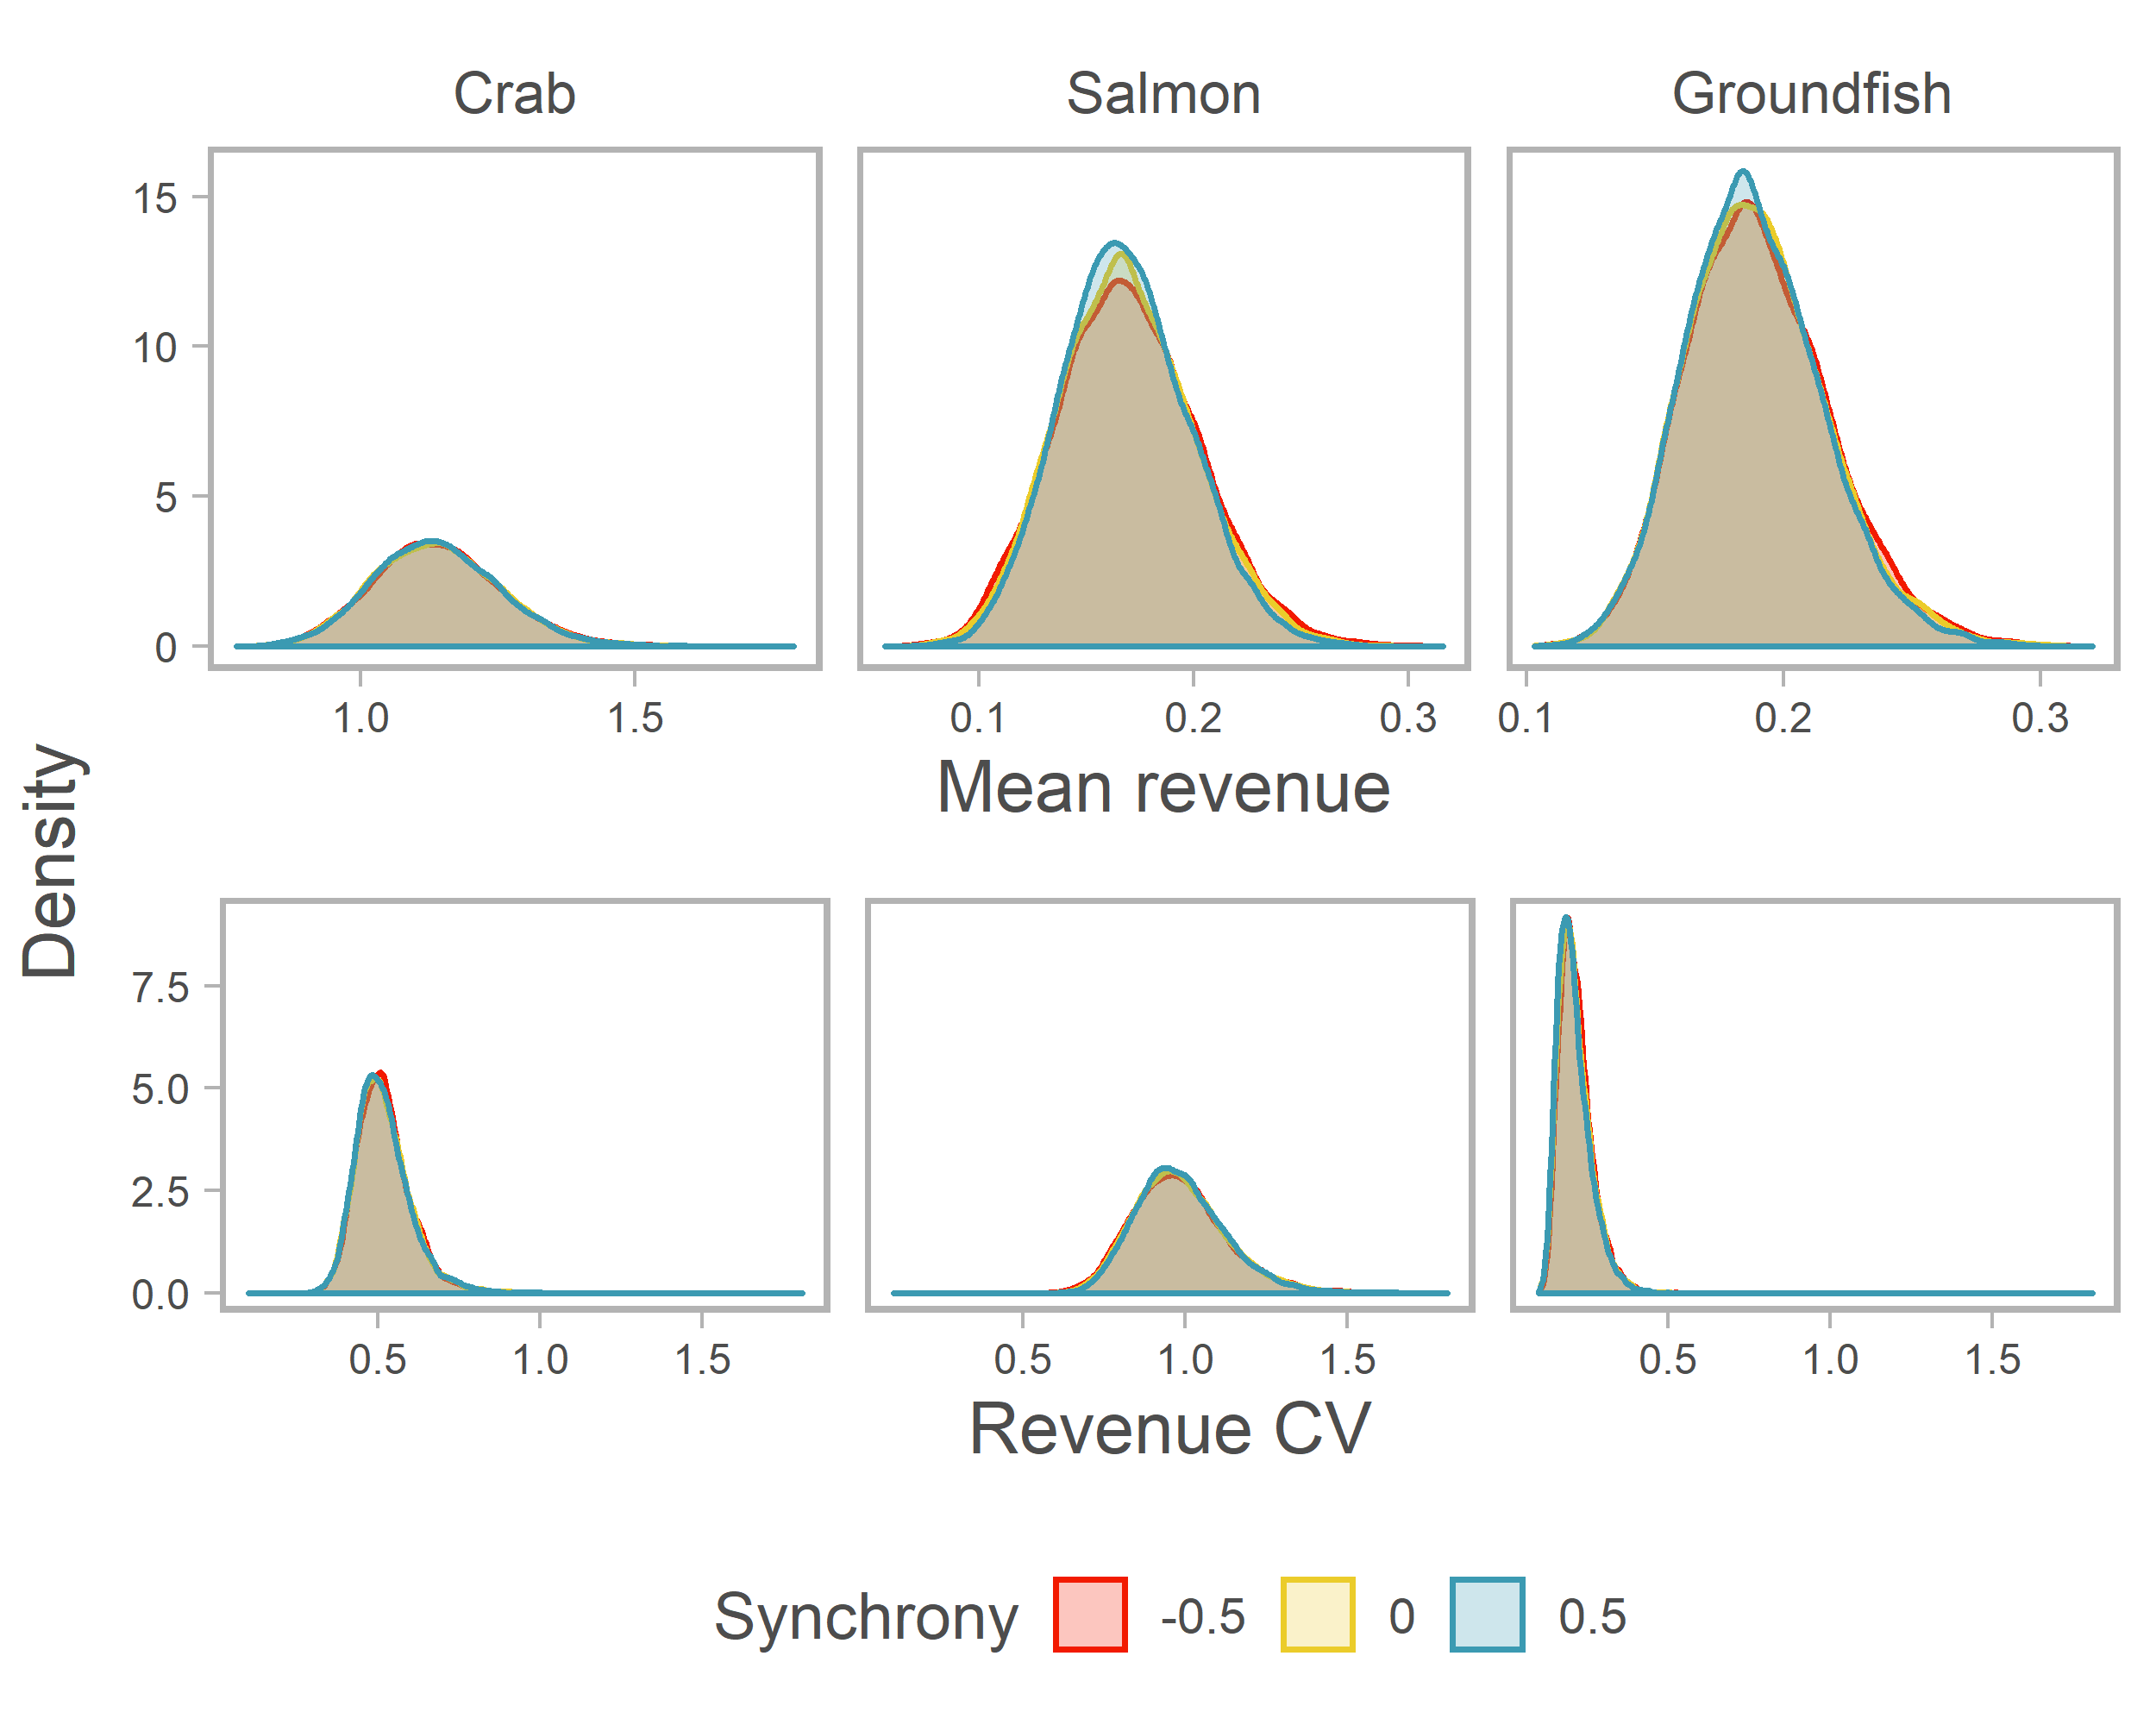

Fig. 1

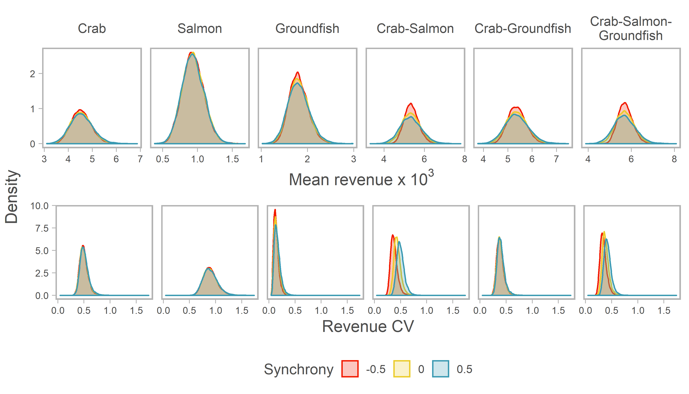Fig. 2

Fig. 3

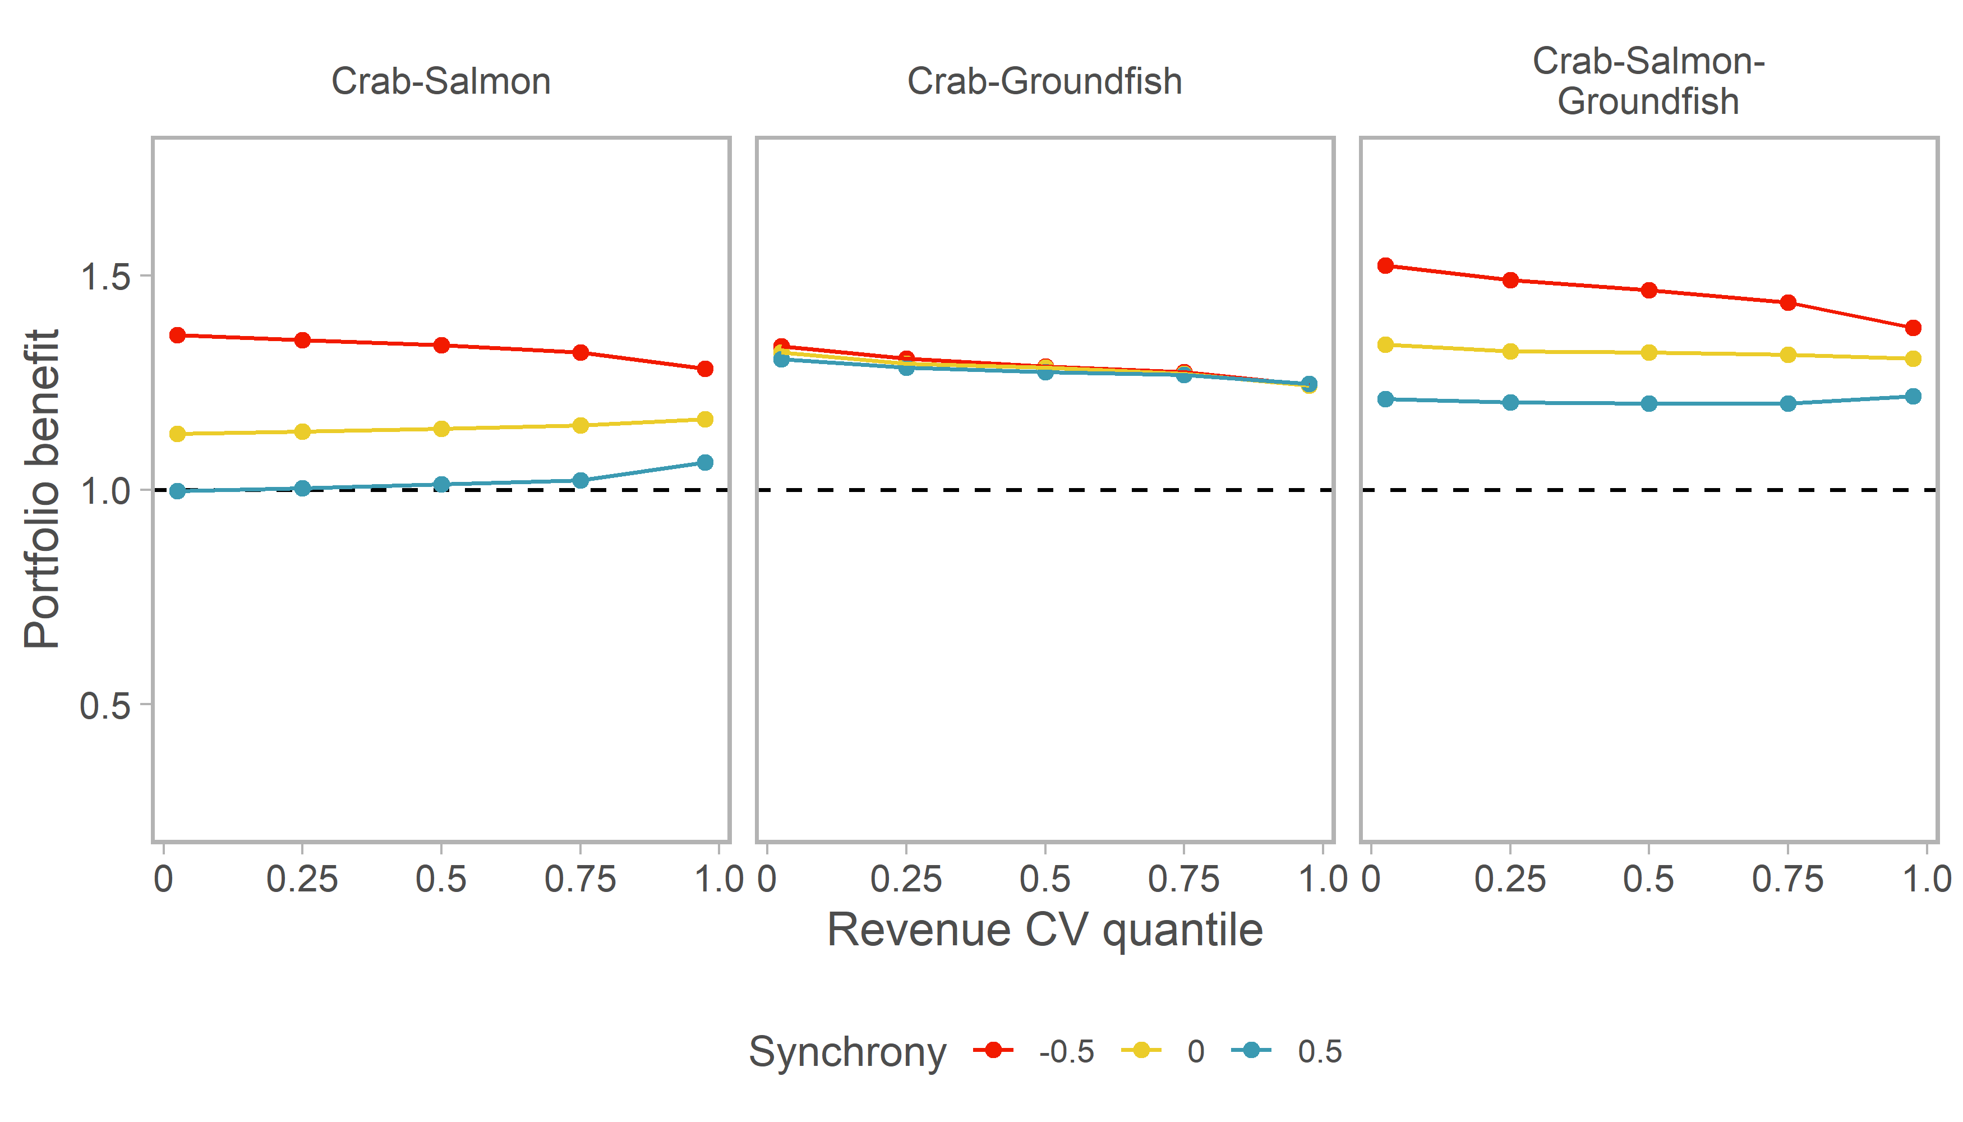

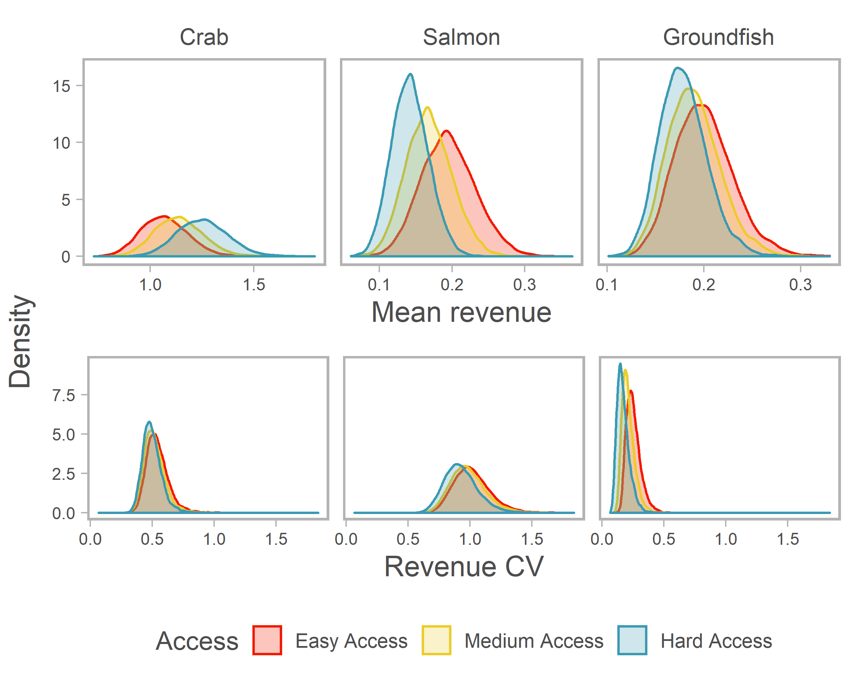

Fig. 4

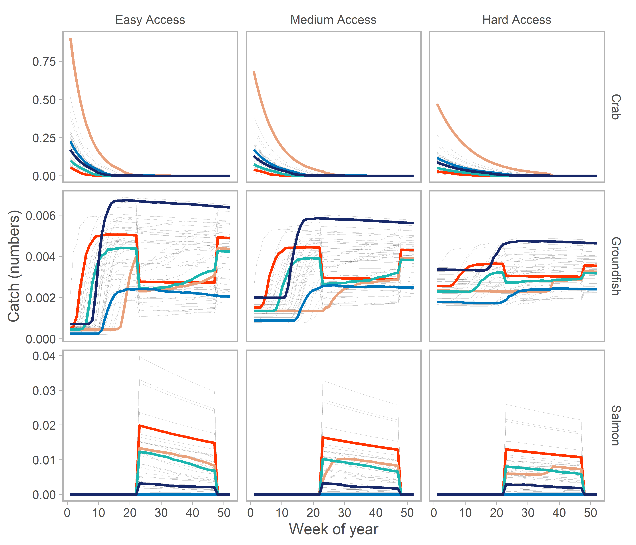

Fig. 5

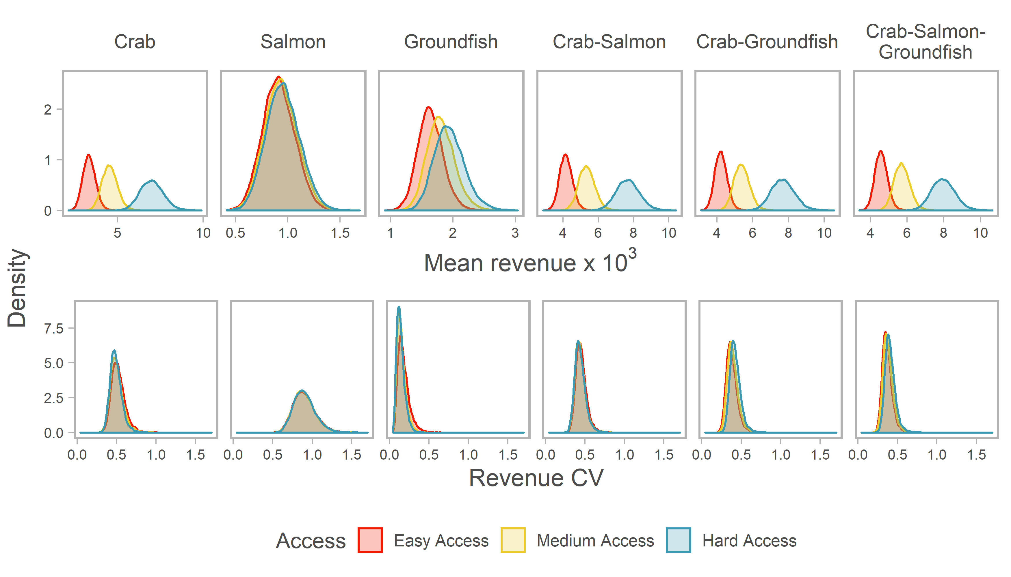Fig. 6

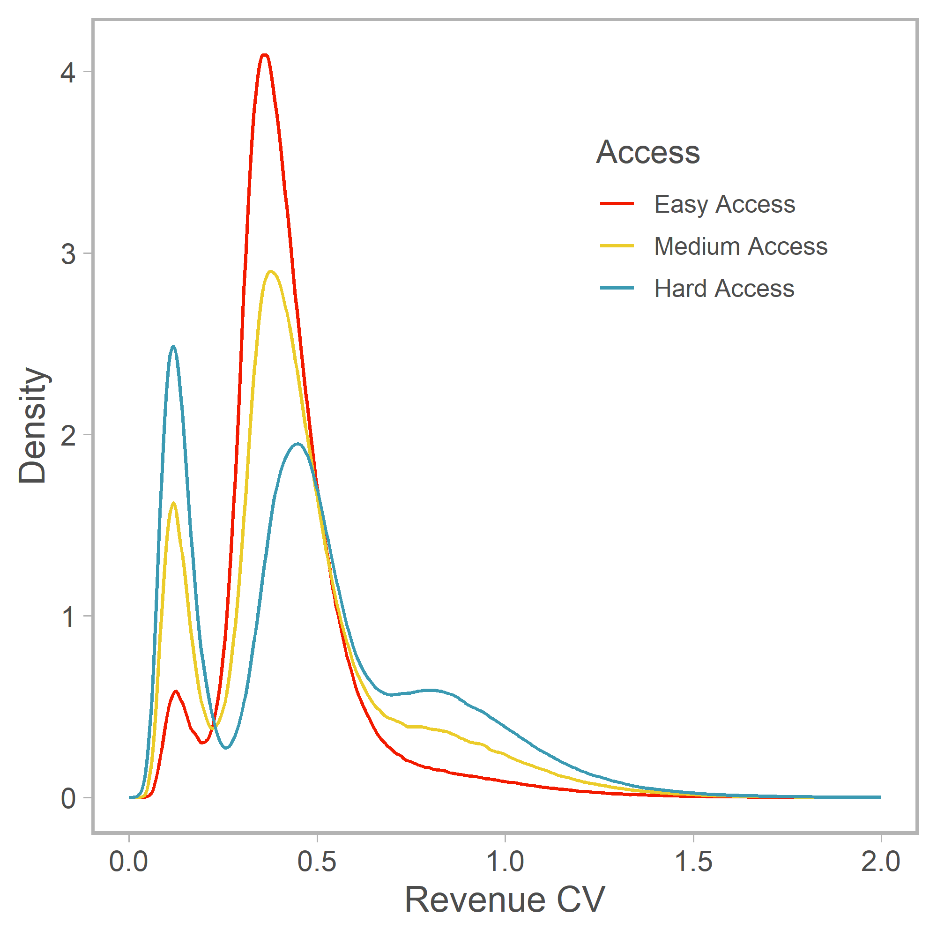

Fig. 7

1. Present address: Department of Wildlife, Fish, and Conservation Biology, University of California, Davis, Davis, CA, USA
2. If average profits exceeded (were below) cost of permits, we would expect permit prices, and thus fixed costs, to rise (fall).