Table 1 Simulated variables

|  |  |
| --- | --- |
| **Symbol** | **Description** |
| *y* | Year index |
| *w* | Week index |
| *s* | Species (population) index |
| *v* | Vessel index |
| *Ry,s* | Recruitment |
| *εy,s* | Log of recruitment deviation |
| *rs,y,w* | Revenue |
| *Bs,y,w* | Biomass |
| *Cs,y,w* | Catch |
| *cs,v* | Variable cost to fish for one week |
| *Sy* | Total survival (groundfish only) |
| *Ny* | Abundance (groundfish only) |
| *Hy* | Harvest rate (groundfish only) |

Table 2 Parameters

|  |  |  |
| --- | --- | --- |
| **Symbol** | **Description** | **Value** |
| *y* | Year index |  |
| *w* | Week index |  |
| *s* | Species (population) index |  |
|  | Annual fixed costs | Crab: 0.0025, salmon: 0.0001, groundfish: tuned internally |
| *cs* | Average variable cost to fish for one week | Crab: tuned internally, salmon: tuned internally, groundfish: 0.00002 |
| *σc* | Standard deviation of log(*c*) | 0.149, CV = 0.15 |
| *ρc* | Correlation of variable costs for a vessel | 0.7 |
| *qs* | Catchability | Crab: 0.0005, salmon: 0.00005, groundfish: tuned internally |
| *Ps,y,w* | Price per unit biomass | Salmon: 1, groundfish: 1, crab: see text |
| *σR,s* | Standard deviation of log(*R*) | 0.555 (all 3 species), CV = 0.6 |
| *ρR,i,j* | Correlation of *εy,i* and *εy,j* (log-recruitment deviations) | -0.5, 0, 0.5 (baseline = 0) |
| *ϕs* | Recruitment autocorrelation parameter | 0.3 (all 3 species) |
| *k* | Age at recruitment (groundfish only) | 4 |
| *ωk,s* | Weight at age *k* (i.e., recruitment) | 1 (all 3 species) |
|  | Average recruitment (crab and salmon) | 1 (both species) |
| *R0­* | Unfished recruitment (groundfish only) | 0.5 |
| *B0* | Unfished biomass (groundfish only) | Calculated internally |
| *h* | Stock-recruit steepness (“resilience”) (groundfish only) | 0.6 |
| *M* | Natural mortality rate (groundfish only) | 0.07 yr-1 |
| *α, β* | Intercept, slope, respectively, of Ford-Walford plot (i.e., weight at agevs. age – 1) (groundfish only) | 0.459, 0.736 |

Table 3 Access scenarios

|  |  |  |  |
| --- | --- | --- | --- |
| **Permit portfolio** | **Easy access vessel count** | **Medium access vessel count (baseline)** | **Hard access vessel count** |
| Crab only | 25 | 67 | 109 |
| Salmon only | 25 | 67 | 109 |
| Groundfish only | 25 | 67 | 109 |
| Crab-salmon | 109 | 67 | 25 |
| Crab-groundfish | 109 | 67 | 25 |
| Crab-salmon-groundfish | 109 | 67 | 25 |
| Total number of vessels | 402 | 402 | 402 |

Table 4 Summary of fishery-wide revenue patterns. First two columns are mean and coefficient of variation over time of revenue summed across all vessels, averaged across simulations. Gini index is also averaged across simulations.

|  |  |  |  |
| --- | --- | --- | --- |
|  | **Mean revenue** | **Revenue CV** | **Gini index** |
| Access |  |  |  |
| Easy Access | 1.54 | 0.38 | 0.16 |
| Even Access | 1.56 | 0.38 | 0.27 |
| Hard Access | 1.63 | 0.38 | 0.39 |
| Synchrony | |  |  |
| Asynchronous | 1.56 | 0.33 | 0.27 |
| Independent | 1.56 | 0.38 | 0.27 |
| Synchronous | 1.56 | 0.42 | 0.27 |

Fig. 1 Example weekly catch patterns from one simulation. Each line represents a different year of the 50-year simulation. Colors highlight five representative years ranging from good to poor crab conditions.

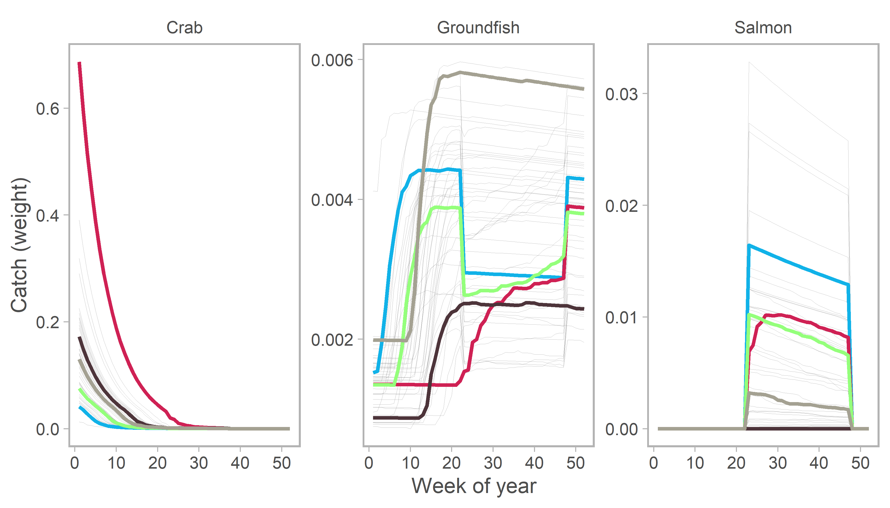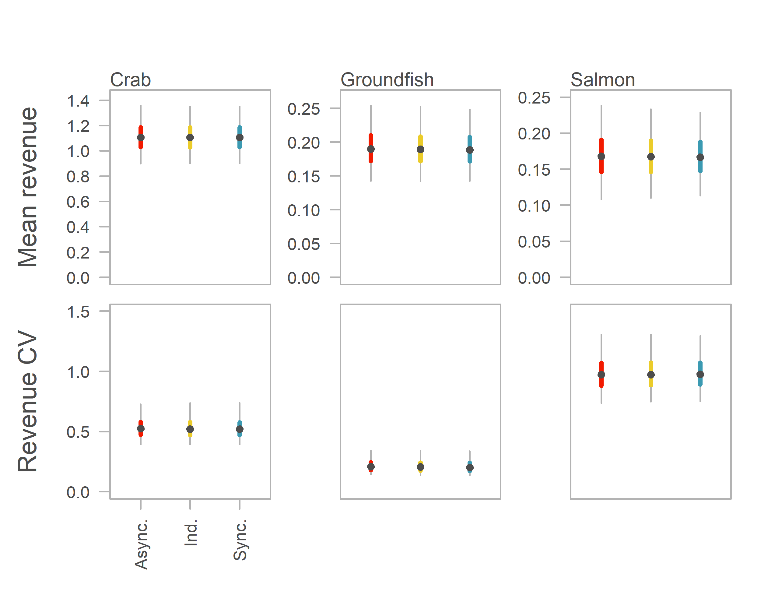

Fig. 2 Distribution of mean and coefficient of variation of revenue for each species under different synchrony scenarios. Center point is median, thick colored line is middle 50% of simulations, thin line is middle 95%. Note mean revenue has different y-axis ranges but revenue CV is consistent. Both mean revenue and revenue CV by species remain constant across synchrony scenarios.

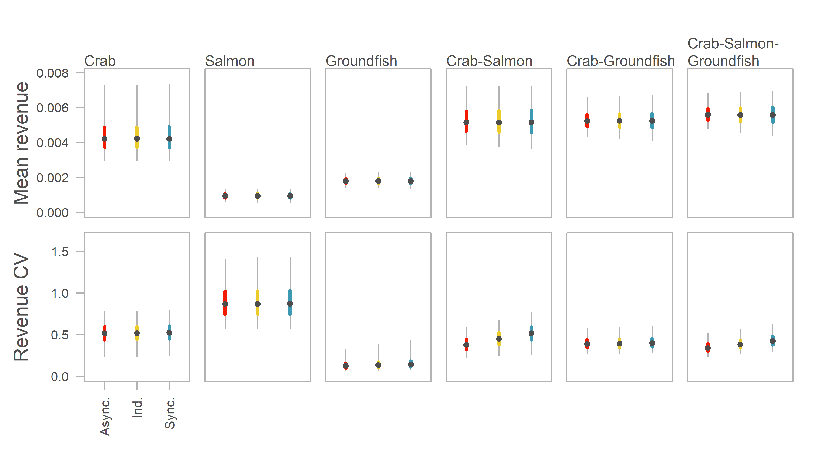

Fig. 3 Distribution of mean and coefficient of variation for individual vessels holding six possible permit portfolios under different synchrony scenarios. Distributions include all vessels in all simulations. Center point is median, thick colored line is middle 50% of simulations, thin line is middle 95%. Mean revenue remains constant across synchrony scenarios for all possible permit portfolios. Revenue CV decreases as populations become more asynchronous for diversified portfolios that include both crab and salmon.

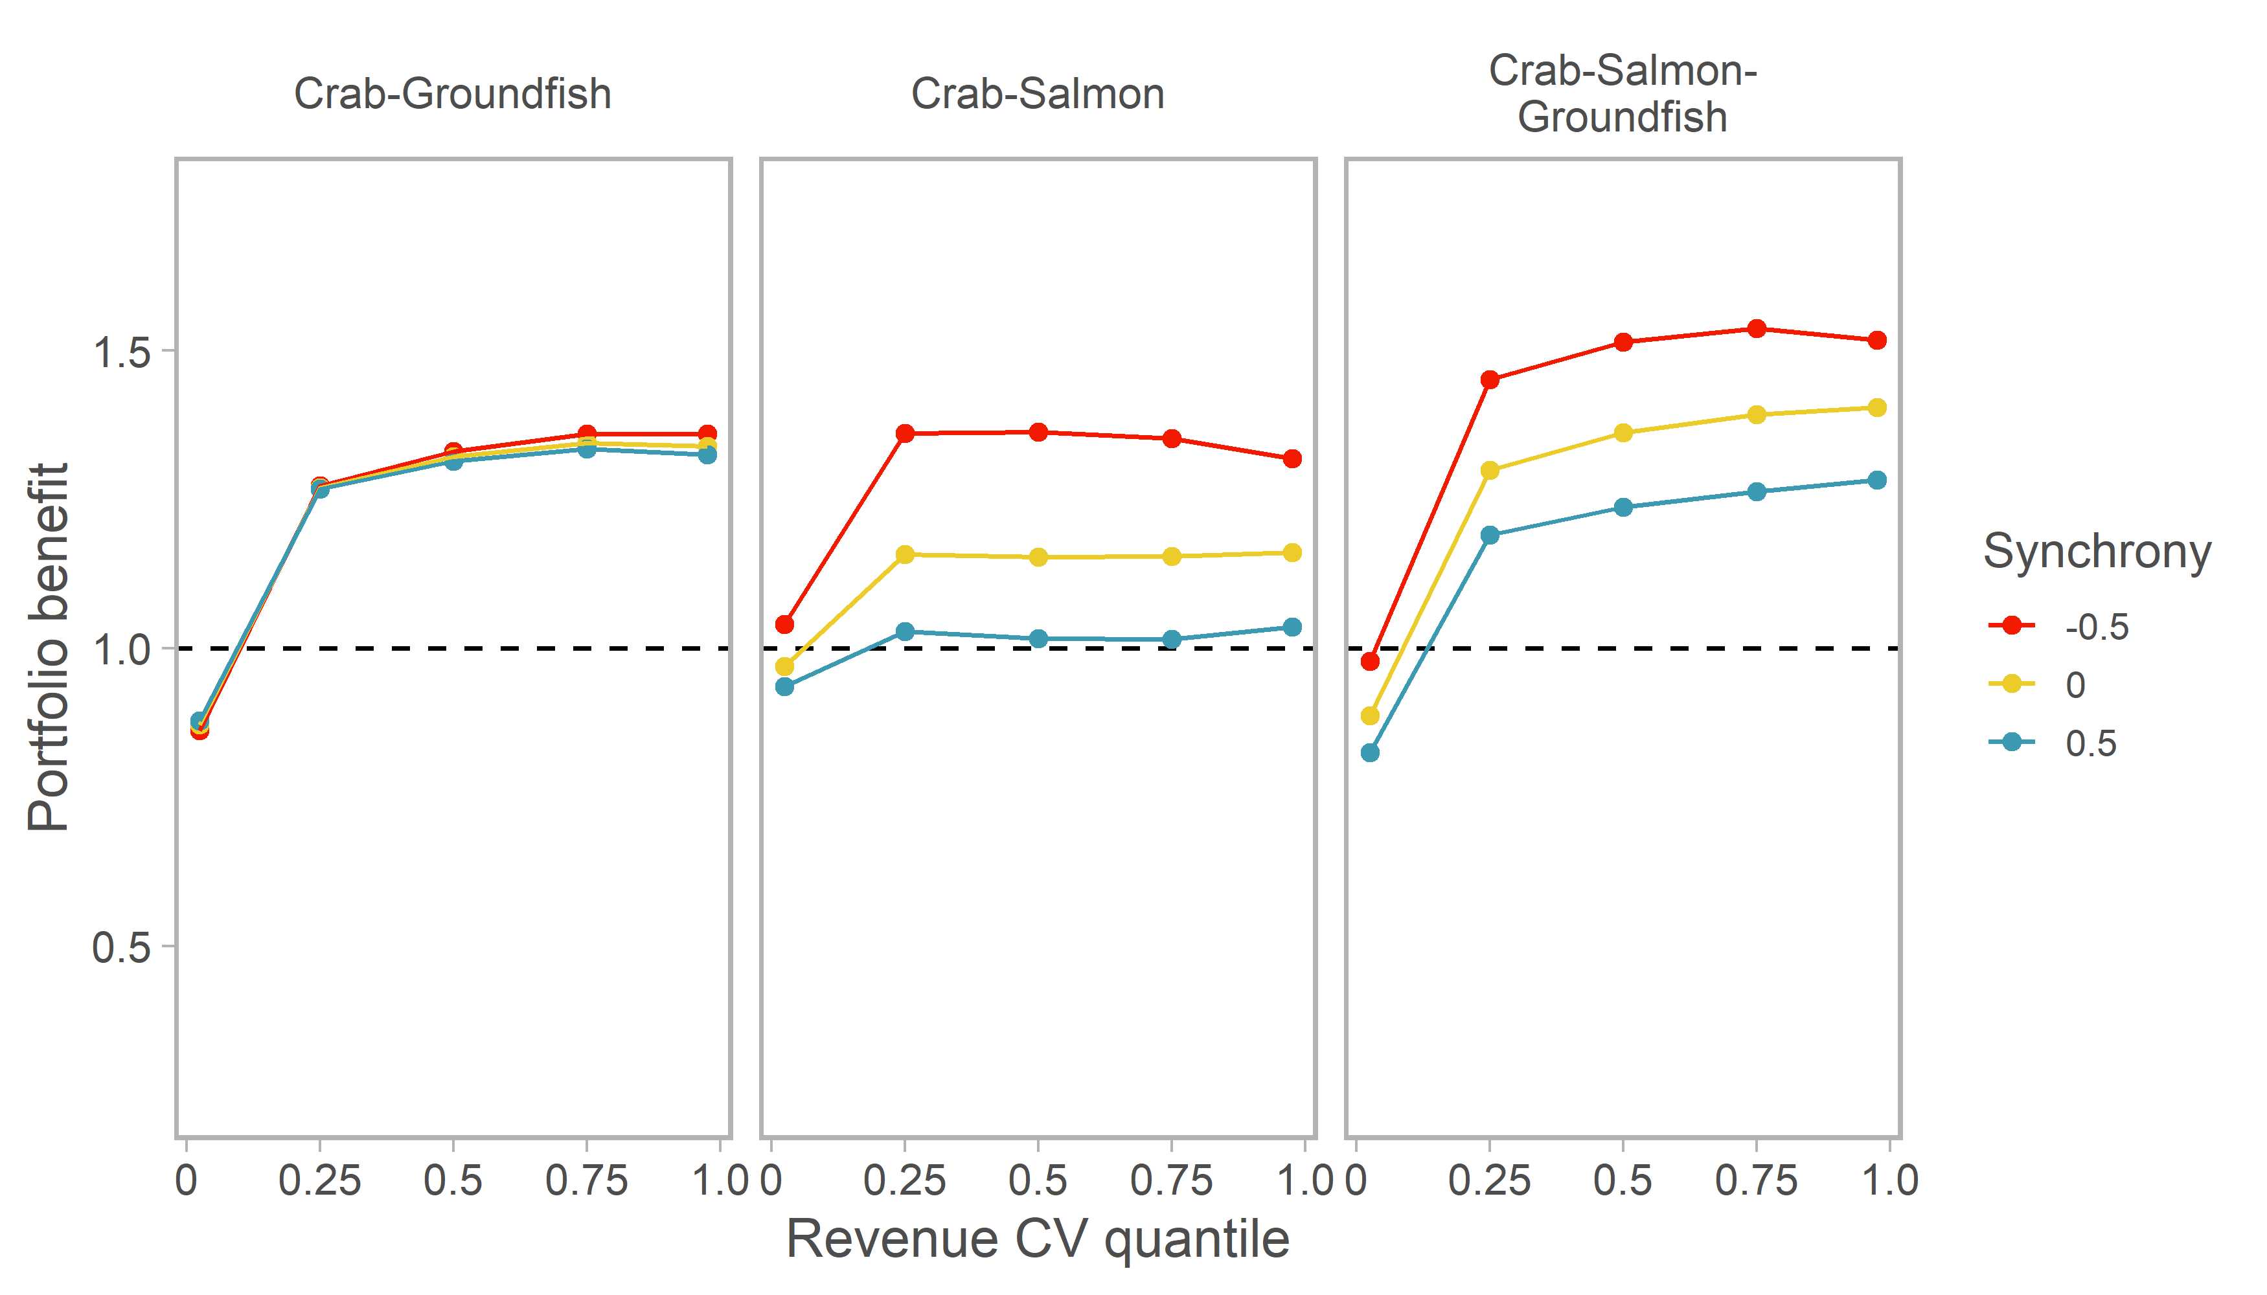

Fig. 4 Benefit to revenue stability of a diversified fishing portfolio over being a crab specialist under different synchrony scenarios. Portfolio benefit is the revenue CV of the crab specialists at a given quantile divided by the revenue CV of the diversified portfolio at the same quantile. Quantiles are calculated across all vessels in all simulations. Points are at the 2.5th, 25th, 50th, 75th, and 97.5th percentiles. Portfolio benefit remains constant across synchrony scenarios for crab-groundfish permit holders, but portfolio benefit is greater when populations are asynchronous for the two portfolios that include salmon.

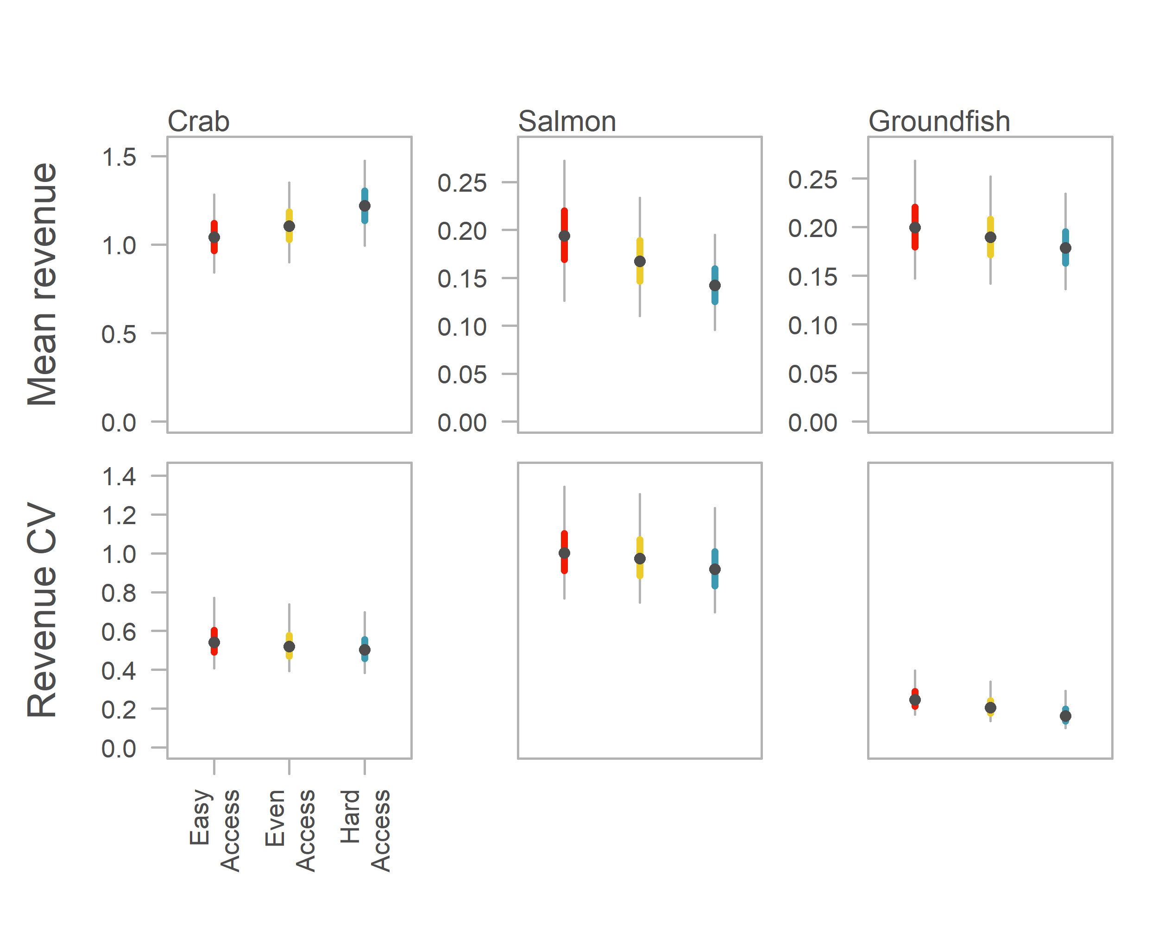

Fig. 5 Distribution of mean and coefficient of variation of revenue for each species under different access scenarios. Center point is median, thick colored line is middle 50% of simulations, thin line is middle 95%. Note mean revenue has different y-axis ranges but revenue CV is consistent. Crab revenue rises with decreasing access, but salmon and groundfish revenue falls. Revenue variability declines in all three populations with decreasing access.

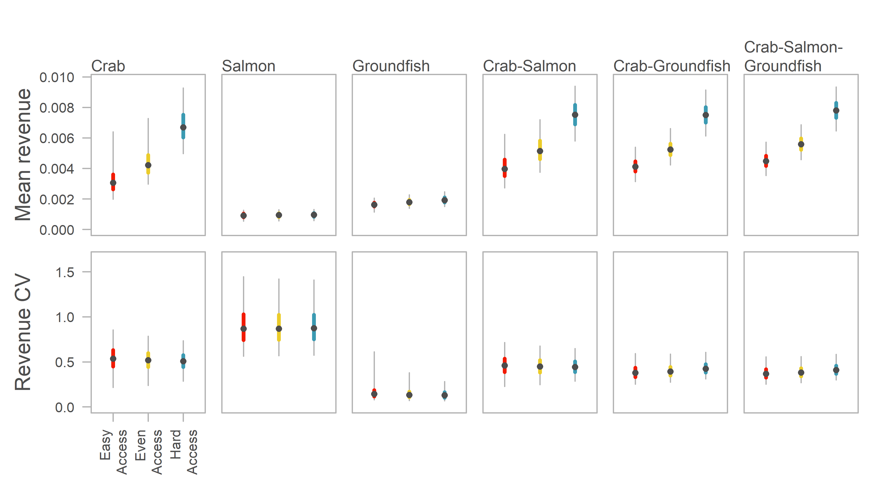

Fig. 6 Distribution of mean and coefficient of variation for individual vessels holding six possible permit portfolios under different access scenarios. Distributions include all vessels in all simulations. Center point is median, thick colored line is middle 50% of simulations, thin line is middle 95%. Mean revenue for all permit portfolios increases with decreasing access. Central tendency of the revenue CV across vessels and simulations remains constant across access scenarios.

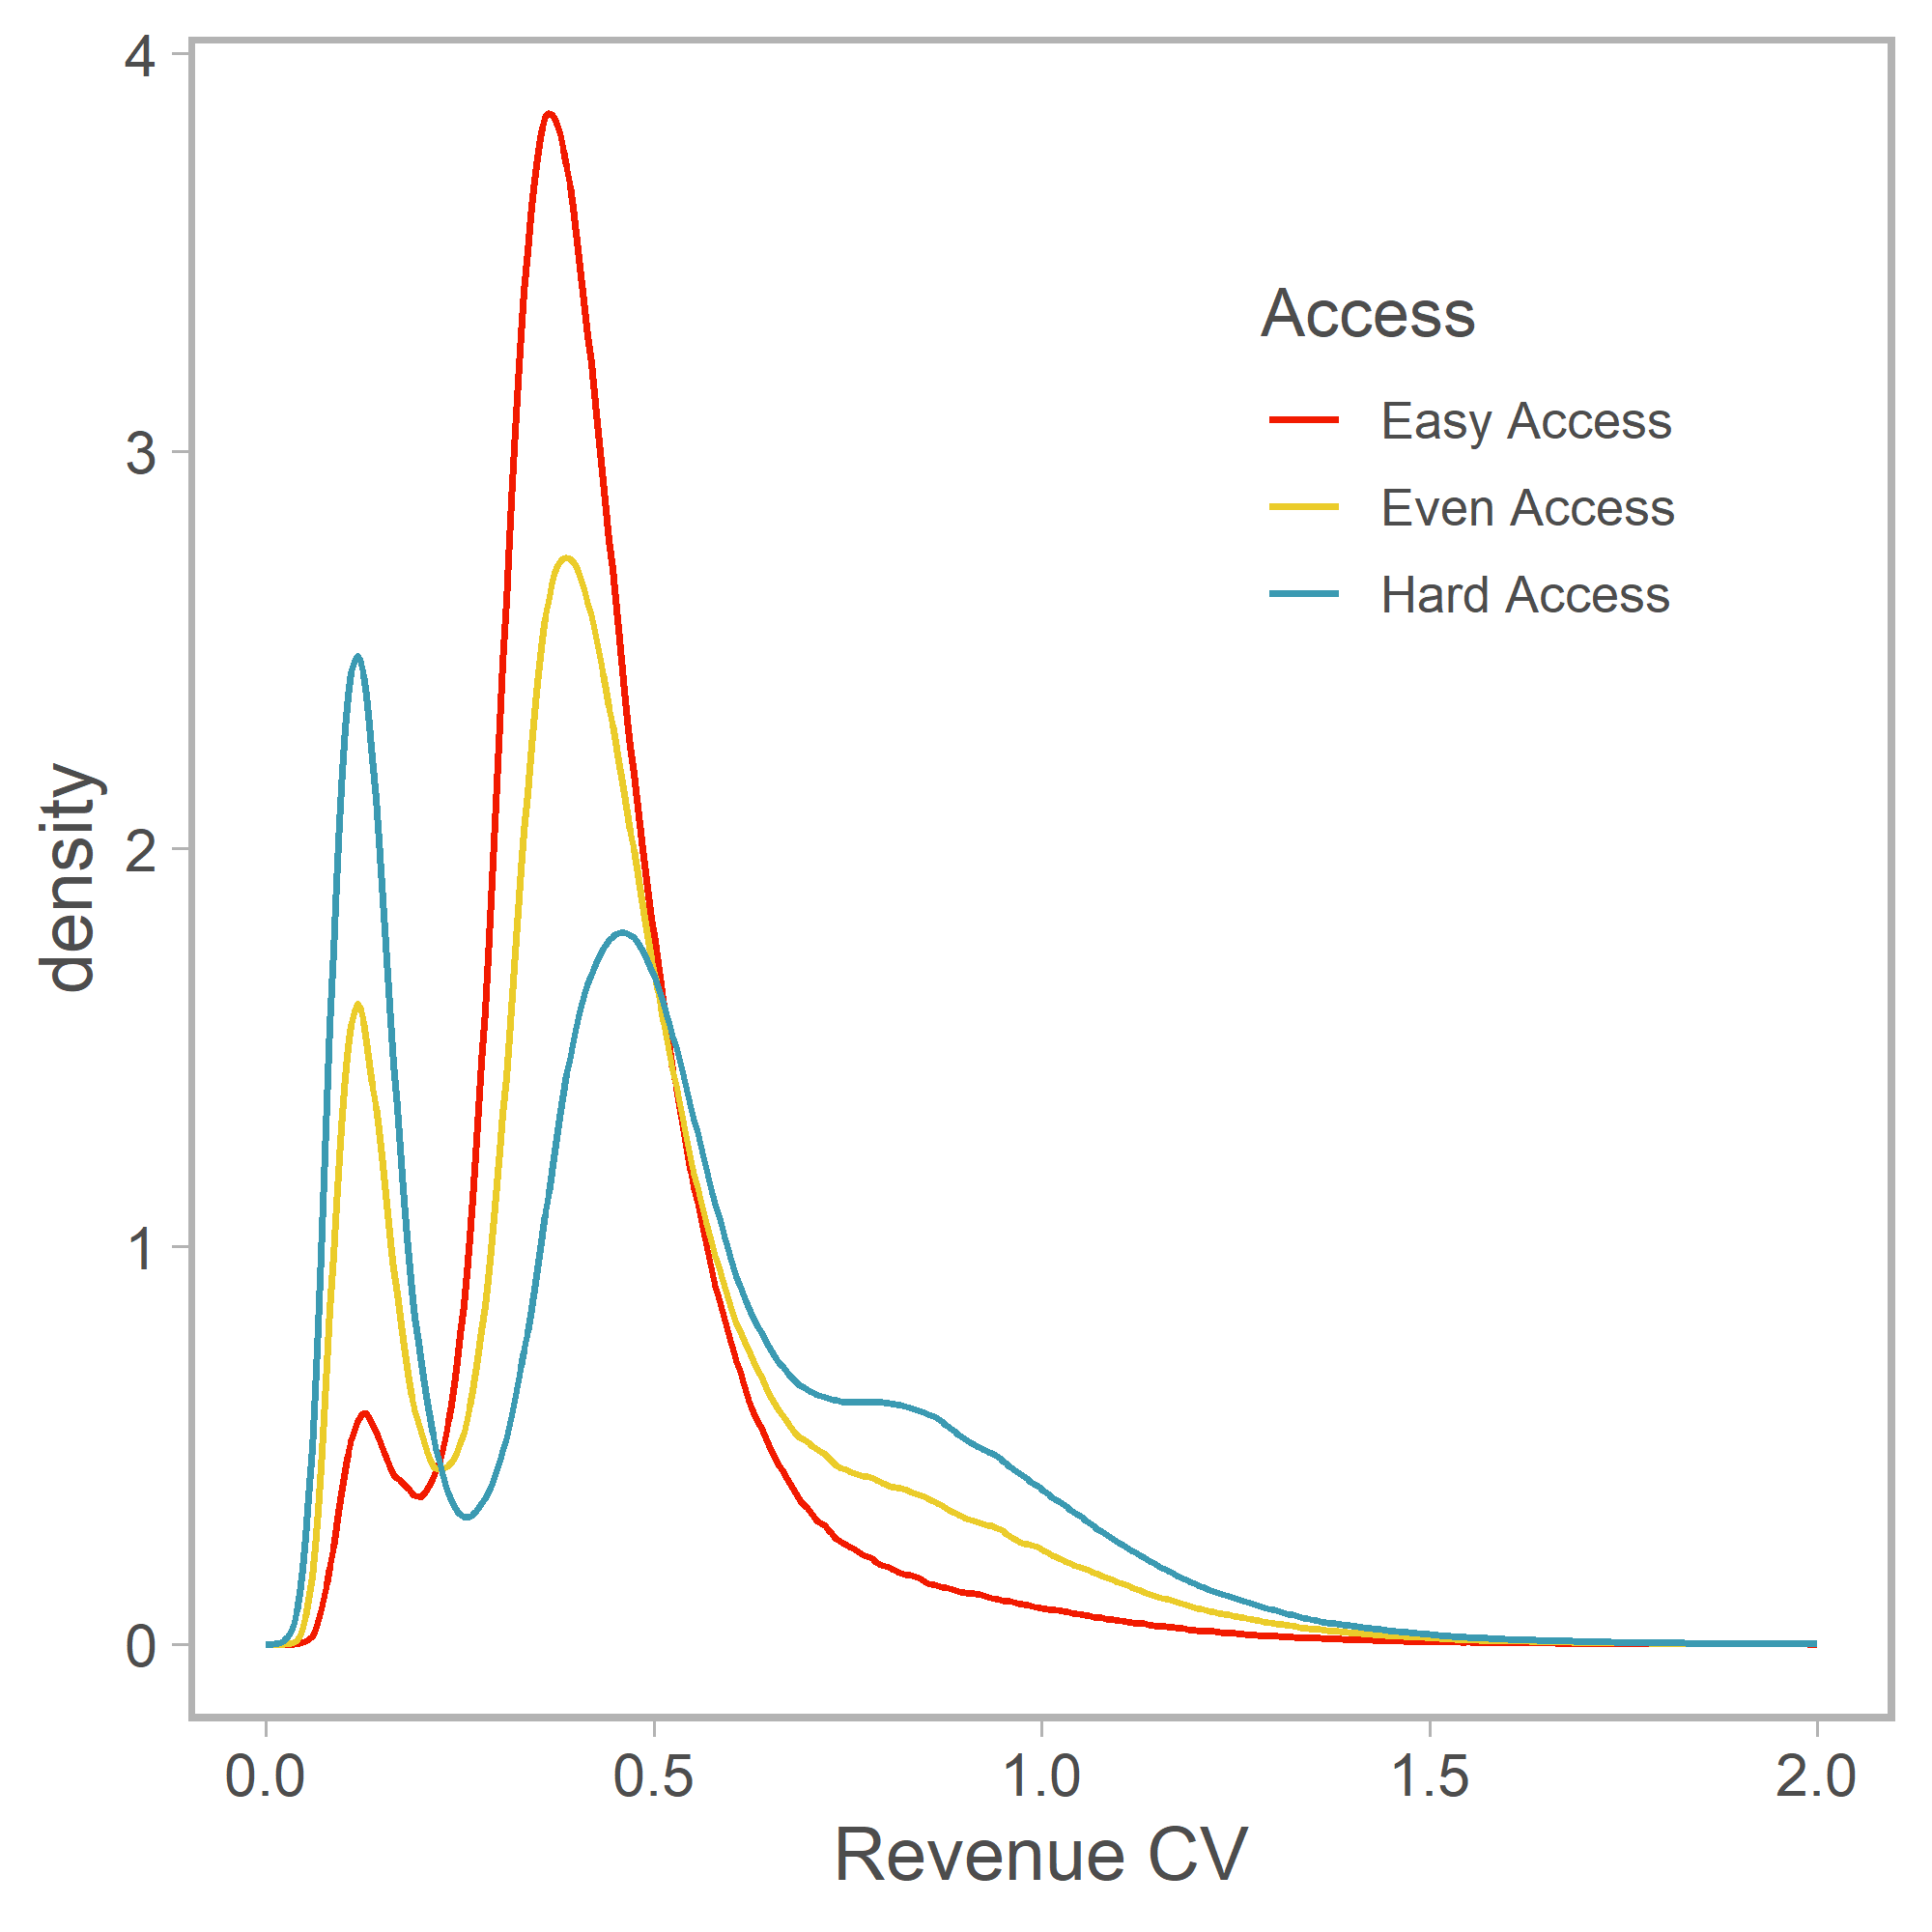

Fig. 7 Revenue CV of all vessels in all simulations across access scenarios. Revenue variability generally declines with increasing access, except for the very low variability peak of groundfish specialists which diminishes as permit access increases.