Table 1 Simulated variables.

|  |  |
| --- | --- |
| **Symbol** | **Description** |
| *y* | Year index |
| *w* | Week index |
| *s* | Species (population) index |
| *v* | Vessel index |
| *Ry,s* | Recruitment |
| *εy,s* | Log of recruitment deviation |
| *rs,y,w* | Revenue |
| *Bs,y,w* | Biomass |
| *Cs,y,w* | Catch |
| *cs,v* | Variable cost to fish for one week |
| *Sy* | Total survival (groundfish only) |
| *Ny* | Abundance (groundfish only) |
| *Hy* | Harvest rate (groundfish only) |

Table 2 Parameters

|  |  |  |
| --- | --- | --- |
| **Symbol** | **Description** | **Value** |
| *y* | Year index |  |
| *w* | Week index |  |
| *s* | Species (population) index |  |
| $${\tilde{c}}_{s}$$ | Annual fixed costs | Crab: 0.0025, salmon: 0.0001, groundfish: tuned internally |
| *cs* | Average variable cost to fish for one week | Crab: tuned internally, salmon: tuned internally, groundfish: 0.00002 |
| *σc* | Standard deviation of log(*c*) | 0.149, CV = 0.15 |
| *ρc* | Correlation of variable costs for a vessel | 0.7 |
| *qs* | Catchability | Crab: 0.0005, salmon: 0.00005, groundfish: tuned internally |
| *Ps,y,w* | Price per unit biomass | Salmon: 1, groundfish: 1, crab: see text |
| *σR,s* | Standard deviation of log(*R*) | 0.555 (all 3 species), CV = 0.6 |
| *ρR,i,j* | Correlation of *εy,i* and *εy,j* (log-recruitment deviations) | -0.5, 0, 0.5 (baseline = 0) |
| *ϕs* | Recruitment autocorrelation parameter | 0.3 (all 3 species) |
| *k* | Age at recruitment (groundfish only) | 4 |
| *ωk,s* | Weight at age *k* (i.e., recruitment) | 1 (all 3 species) |
| $${\overline{R}}_{s}$$ | Average recruitment (crab and salmon) | 1 (both species) |
| *R0­* | Unfished recruitment (groundfish only) | 0.5 |
| *B0* | Unfished biomass (groundfish only) | Calculated internally |
| *h* | Stock-recruit steepness (“resilience”) (groundfish only) | 0.6 * |
| *M* | Natural mortality rate (groundfish only) | 0.07 yr-1 * |
| *α, β* | Intercept, slope, respectively, of Ford-Walford plot (i.e., weight at agevs. age – 1) (groundfish only) | 0.459, 0.736 * |

*Johnson et *al.* 2015

Table 3 Access scenarios

|  |  |  |  |
| --- | --- | --- | --- |
| **Permit portfolio** | **Easy access vessel count** | **Medium access vessel count (baseline)** | **Hard access vessel count** |
| Crab only | 25 | 67 | 109 |
| Salmon only | 25 | 67 | 109 |
| Groundfish only | 25 | 67 | 109 |
| Crab-salmon | 109 | 67 | 25 |
| Crab-groundfish | 109 | 67 | 25 |
| Crab-salmon-groundfish | 109 | 67 | 25 |
| Total number of vessels | 402 | 402 | 402 |

Table 4 Summary of fishery-wide revenue patterns. First two columns are mean and coefficient of variation over time of revenue summed across all vessels, averaged across simulations. Gini index is also averaged across simulations.

|  |  |  |  |
| --- | --- | --- | --- |
|  | Mean revenue | Revenue CV | Gini index |
| Access |  |  |  |
| Easy Access | 1.56 | 0.38 | 0.15 |
| Even Access | 1.59 | 0.37 | 0.27 |
| Hard Access | 1.66 | 0.38 | 0.39 |
| Synchrony | |  |  |
| Asynchronous | 1.59 | 0.33 | 0.27 |
| Independent | 1.59 | 0.37 | 0.27 |
| Synchronous | 1.59 | 0.42 | 0.27 |
| Synchrony & Access | |  |  |
| Asynchronous easy access | 1.56 | 0.33 | 0.15 |
| Synchronous easy access | 1.56 | 0.43 | 0.15 |
| Asynchronous hard access | 1.66 | 0.34 | 0.39 |
| Synchronous hard access | 1.66 | 0.41 | 0.39 |

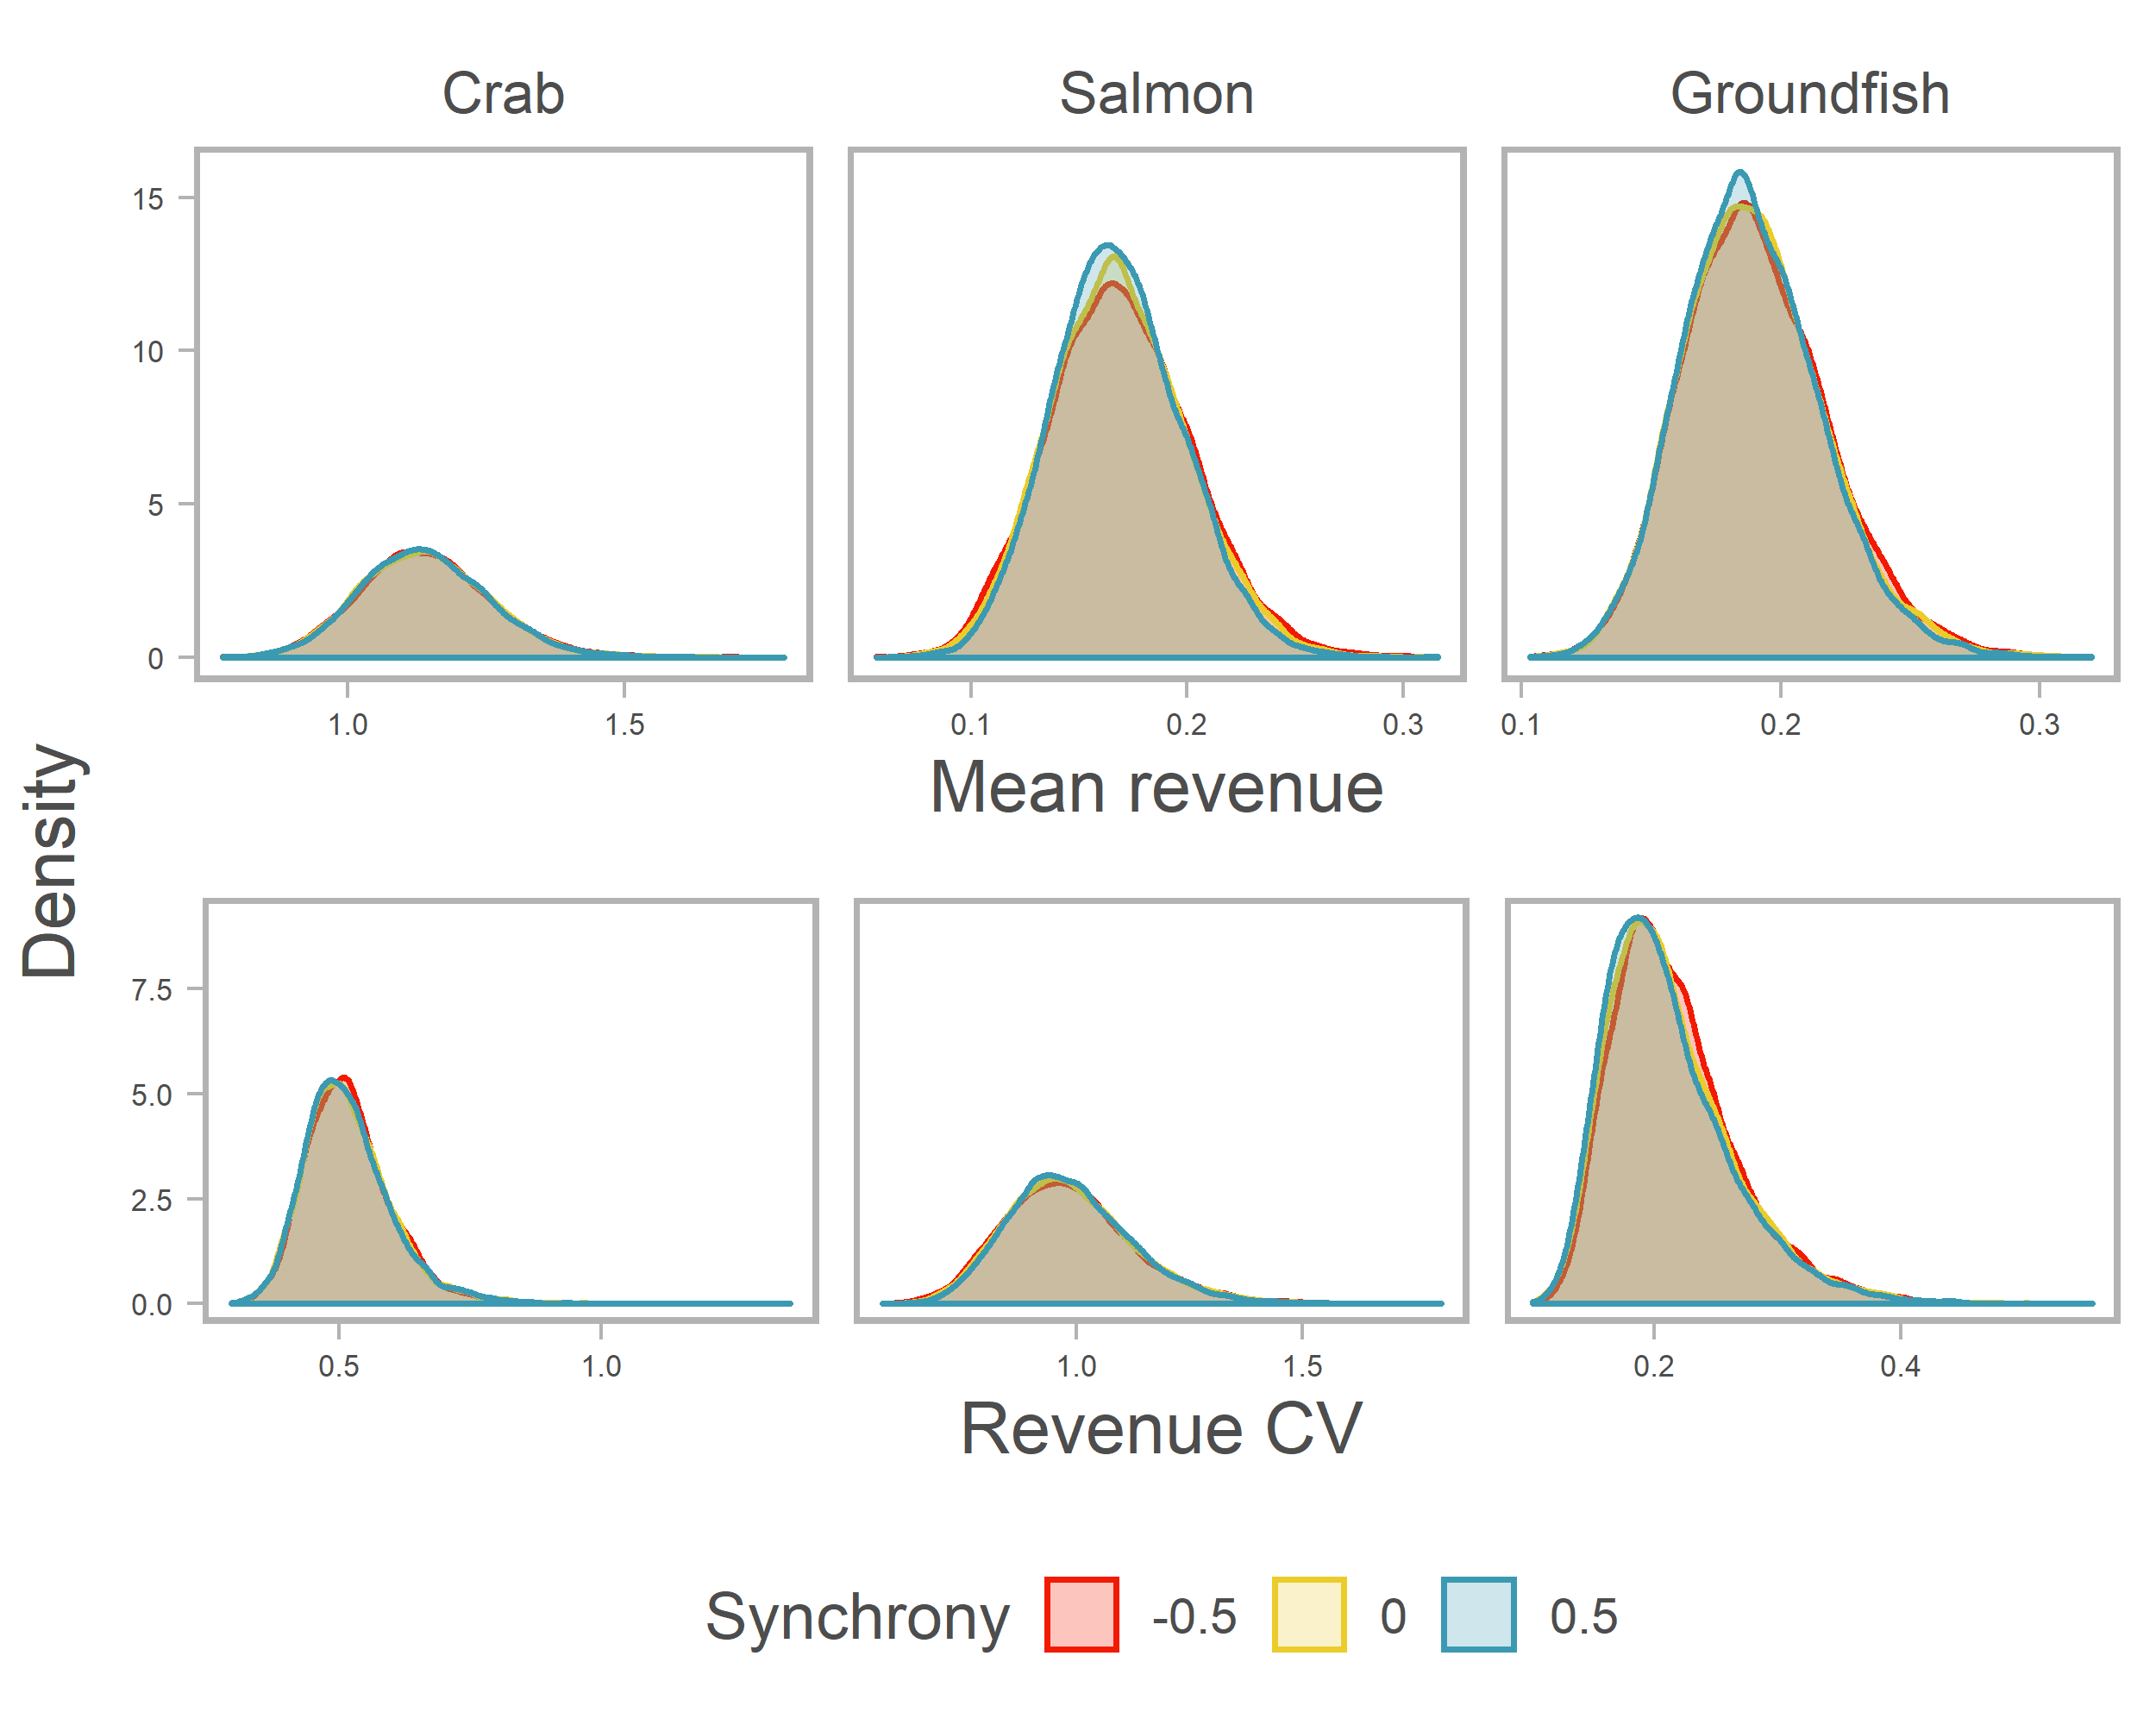

Fig. 1 Distribution of mean (averaged over time) and coefficient of variation of revenue for each species for the synchrony scenarios.

Fig. 2 Distribution of mean and coefficient of variation for individual vessels holding six possible permit portfolios for synchrony scenarios. Mean and CV are calculated over time for each vessel in each simulation, and then averaged across vessels within a simulation. Distributions show variability across simulations.

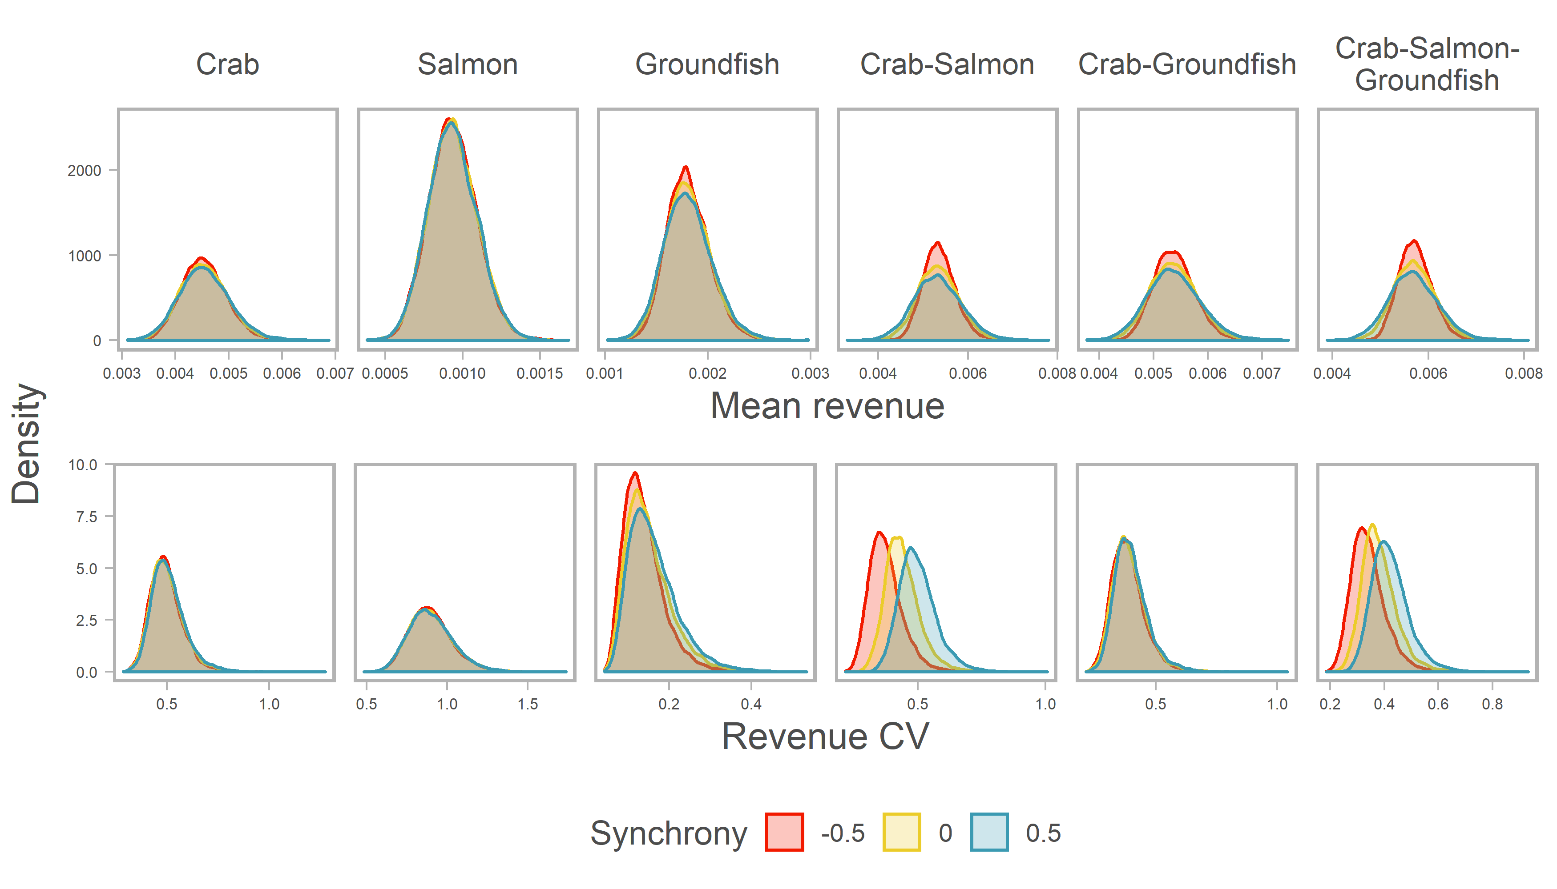

Fig. 3 Benefit to revenue stability of a diversified fishing portfolio over being a crab specialist by synchrony scenario. Portfolio benefit is the revenue CV of the crab specialists at a given quantile divided by the revenue CV of the diversified portfolio at the same quantile. Quantiles are calculated across all vessels in all simulations. Points are at the 2.5th, 25th, 50th, 75th, and 97.5th percentiles.

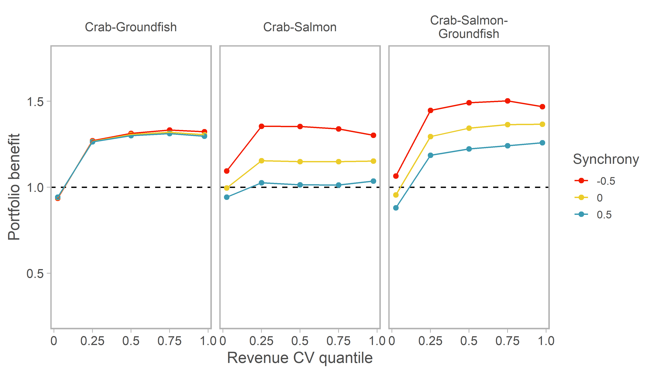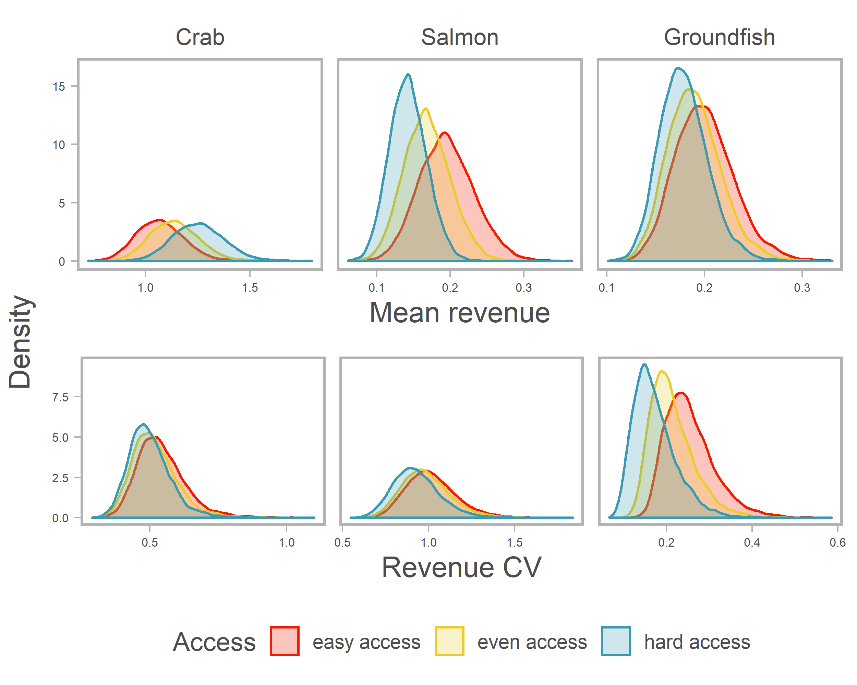

Fig. 4 Distribution of mean (averaged over time) and coefficient of variation of revenue for each species for the access scenarios. Fig. 5 Distribution of mean and coefficient of variation for individual vessels holding six possible permit portfolios for access scenarios. Mean and CV are calculated over time for each vessel in each simulation, and then averaged across vessels within a simulation. Distributions show variability across simulations.

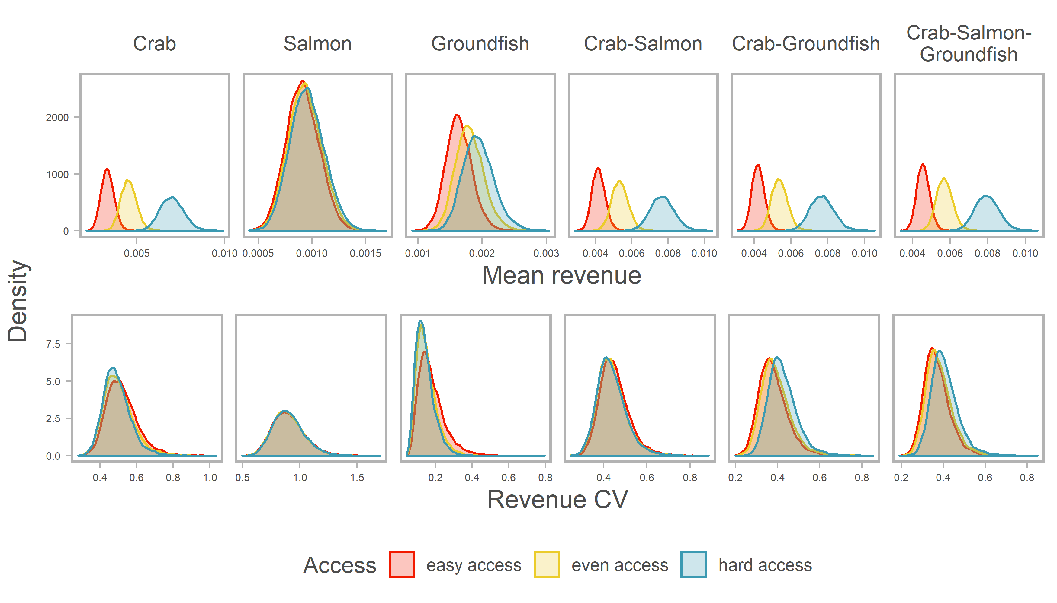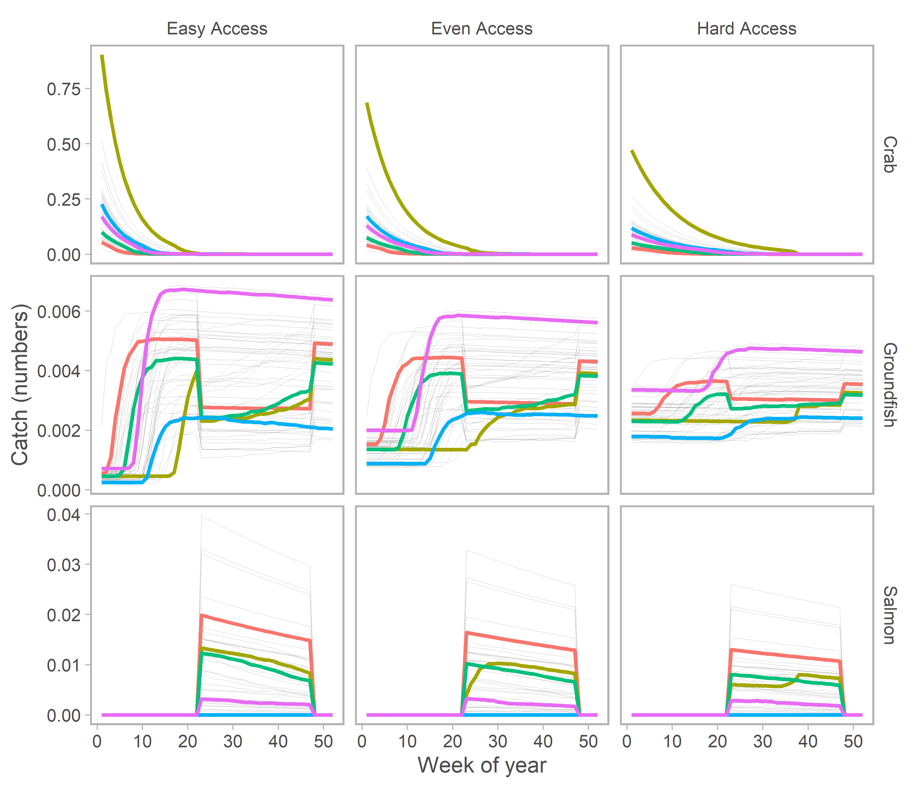

Fig. 6 One simulation’s catch dynamics through the year of the three species under the three different access scenarios. Recruitment is the same across access scenarios. Colored lines are five years representing a range of crab recruitment strength.

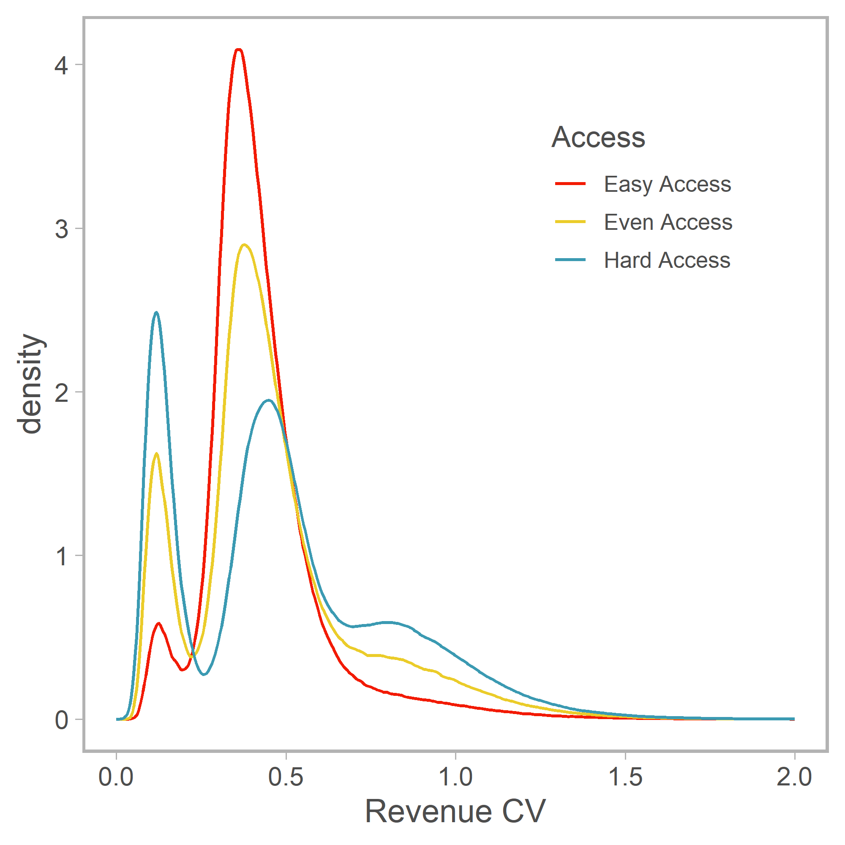

Fig. 7 Distribution of revenue CV of all vessels in all simulations across access scenarios. Smaller low variability mode is due to groundfish specialists.