Table 1 Indices and simulated variables

|  |  |  |
| --- | --- | --- |
| **Symbol** | **Description** | **Equation Numbers** |
| *Indexes* |  |  |
| *y* | Year index |  |
| *w* | Week index |  |
| *s* | Species index |  |
| *v* | Vessel index |  |
| *Variables* |  |  |
| *Rs,y* | Recruitment | 1, 9 |
| *εs,y* | Log of recruitment deviation | 2, 16 |
| *Ns,y,w* | Abundance | 1, 6 |
| *Bs,y,w* | Biomass | 4, 5, 8 |
| *Sy* | Total survival (groundfish only) | 7 |
| *Cs,y,w* | Catch | 3 |
| *cs,v* | Variable cost to fish for one week | 14 |
| *rs,y,w* | Expected weekly revenue if fishing | 12 |
| *Iv,s,y,w* | Indicator variable for whether vessel *v* fishes for species *s* | 15 |
| $${\dot{r}}_{v,s,y}$$ | Annual revenue earned | 18 |
| *πv,s,y* | Annual profit | 19 |

Table 2 Parameters.

|  |  |  |
| --- | --- | --- |
| **Symbol** | **Description** | **Value** |
| $${\tilde{c}}_{s}$$ | Annual fixed costs | Crab: 0.0025, salmon: 0.0001, groundfish: tuned internally (see supplement) |
| *cs* | Average variable cost to fish for one week | Crab: tuned internally, salmon: tuned internally, groundfish: 0.00002 (see supplement) |
| *σc* | Standard deviation of log(*c*) | 0.149, CV = 0.15 |
| *ρc* | Correlation of variable costs for a vessel | 0.7 |
| *qs* | Catchability | Crab: 0.0005, salmon: 0.00005, groundfish: tuned internally (see supplement) |
| *Ps,y,w* | Price per unit biomass | Salmon: 1, groundfish: 1, crab: see text |
| *σR,s* | Standard deviation of log(*R*) | 0.555 (all 3 species), CV = 0.6 |
| *ρR,i,j* | Correlation of *εy,i* and *εy,j* (log-recruitment deviations) | -0.5, 0, 0.5 (baseline = 0) |
| Σ | Variance covariance matrix of log-recruitment deviations | Equations 2, 17 |
| *ϕs* | Recruitment autocorrelation parameter | 0.3 (all 3 species) |
| *k* | Age at recruitment (groundfish only) | 4 |
| *ωk,s* | Weight at recruitment (*k* subscript for weight at age *k*, applies to groundfish only) | 1 (all 3 species) |
| $${\overline{R}}_{s}$$ | Average recruitment (crab and salmon) | 1 (both species) |
| *R0­* | Unfished recruitment (groundfish only) | 0.5 |
| *B0* | Unfished biomass (groundfish only) | Equation 7 |
| *h* | Stock-recruit steepness (“resilience”) (groundfish only) | 0.6 * |
| *M* | Natural mortality rate (groundfish only) | 0.07 yr-1 * |
| *α, β* | Intercept, slope, respectively, of Ford-Walford plot (i.e., weight at agevs. age – 1) (groundfish only) | 0.459, 0.736 * |
| *κ* | Growth-survival constant | Equation 8 |

*Johnson et *al.* (2015)

Table 3 Access scenarios

|  |  |  |  |
| --- | --- | --- | --- |
| **Permit portfolio** | **Easy access**  **vessel count** | **Medium access**  **vessel count**  **(baseline)** | **Hard access**  **vessel count** |
| Crab only | 25 | 67 | 109 |
| Salmon only | 25 | 67 | 109 |
| Groundfish only | 25 | 67 | 109 |
| Crab-salmon | 109 | 67 | 25 |
| Crab-groundfish | 109 | 67 | 25 |
| Crab-salmon-groundfish | 109 | 67 | 25 |
| Total number of vessels | 402 | 402 | 402 |

Table 4 Summary of fishery-wide revenue patterns. First two columns are mean and coefficient of variation over time of revenue summed across all vessels and species, yielding one value per simulation. Entries in the column itself are averages across simulations. The Gini index entries are also averaged across simulations.

|  |  |  |  |
| --- | --- | --- | --- |
|  | Mean revenue | Revenue CV | Gini index |
| Access |  |  |  |
| Easy Access | 1.56 | 0.38 | 0.15 |
| Medium Access | 1.59 | 0.37 | 0.27 |
| Hard Access | 1.66 | 0.38 | 0.39 |
| Synchrony | |  |  |
| Asynchronous | 1.59 | 0.33 | 0.27 |
| Independent | 1.59 | 0.37 | 0.27 |
| Synchronous | 1.59 | 0.42 | 0.27 |
| Synchrony & Access | |  |  |
| Asynchronous Easy Access | 1.56 | 0.33 | 0.15 |
| Synchronous Easy Access | 1.56 | 0.43 | 0.15 |
| Asynchronous Hard Access | 1.66 | 0.34 | 0.39 |
| Synchronous Hard Access | 1.66 | 0.41 | 0.39 |

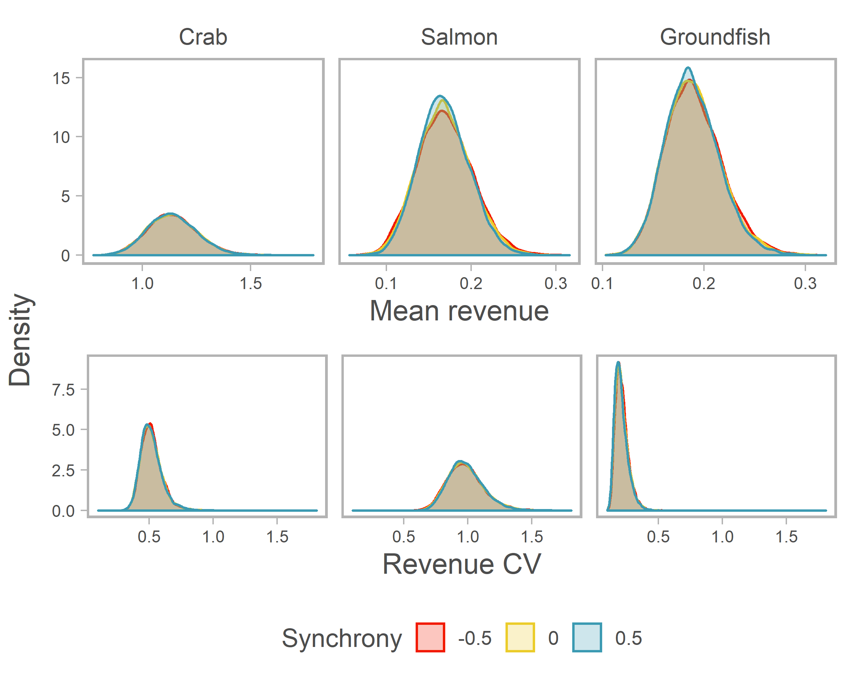

Fig. 1 Distribution of mean and coefficient of variation (both calculated over time) of revenue for each species for the synchrony scenarios. Note common x-axis scales for CV but variable scales for mean.

Fig. 2 Distribution of mean and coefficient of variation for individual vessels holding six possible permit portfolios for synchrony scenarios. Mean and CV are calculated over time for each vessel in each simulation, and then averaged across vessels within a simulation. Distributions show variability across simulations. Note common x-axis scales for CV but variable scales for mean.

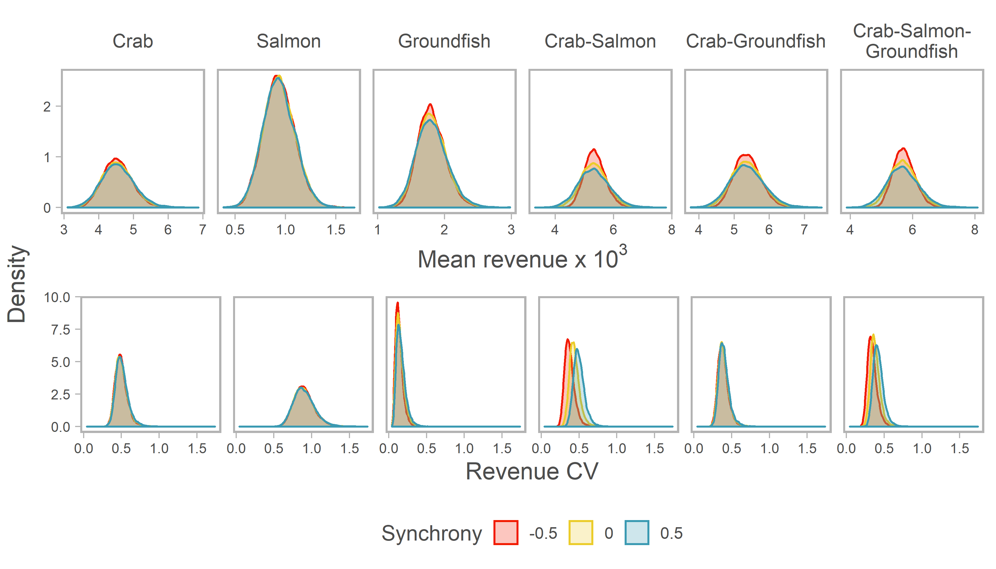

Fig. 3 Benefit to revenue stability of a diversified fishing portfolio over being a crab specialist by synchrony scenario. Portfolio benefit is the revenue CV of the crab specialists at a given quantile divided by the revenue CV of the diversified portfolio at the same quantile. Quantiles are calculated across all vessels in all simulations. Points are at the 2.5th, 25th, 50th, 75th, and 97.5th percentiles.

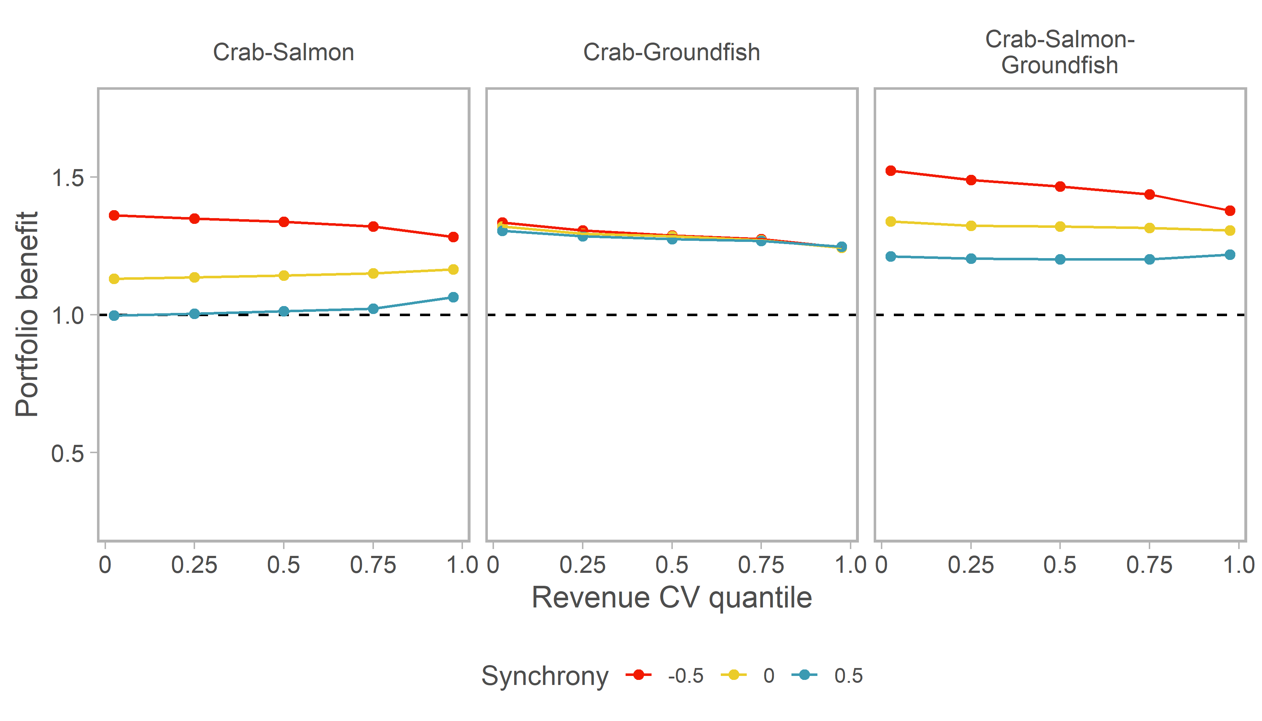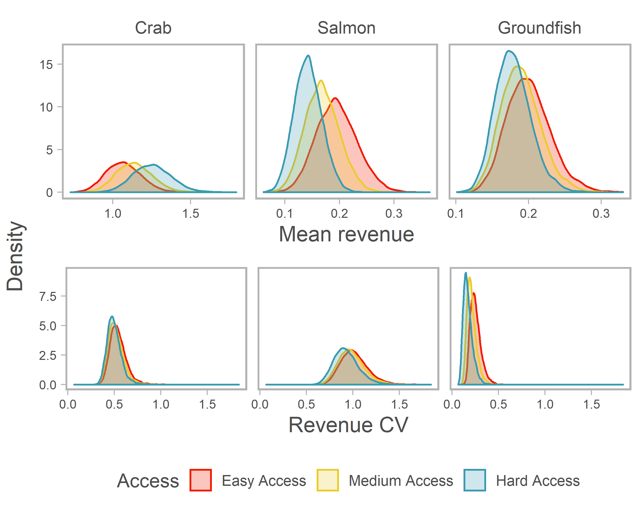

Fig. 4 Distribution of mean (averaged over time) and coefficient of variation of revenue for each species for the access scenarios. Note common x-axis scales for CV but variable scales for mean.

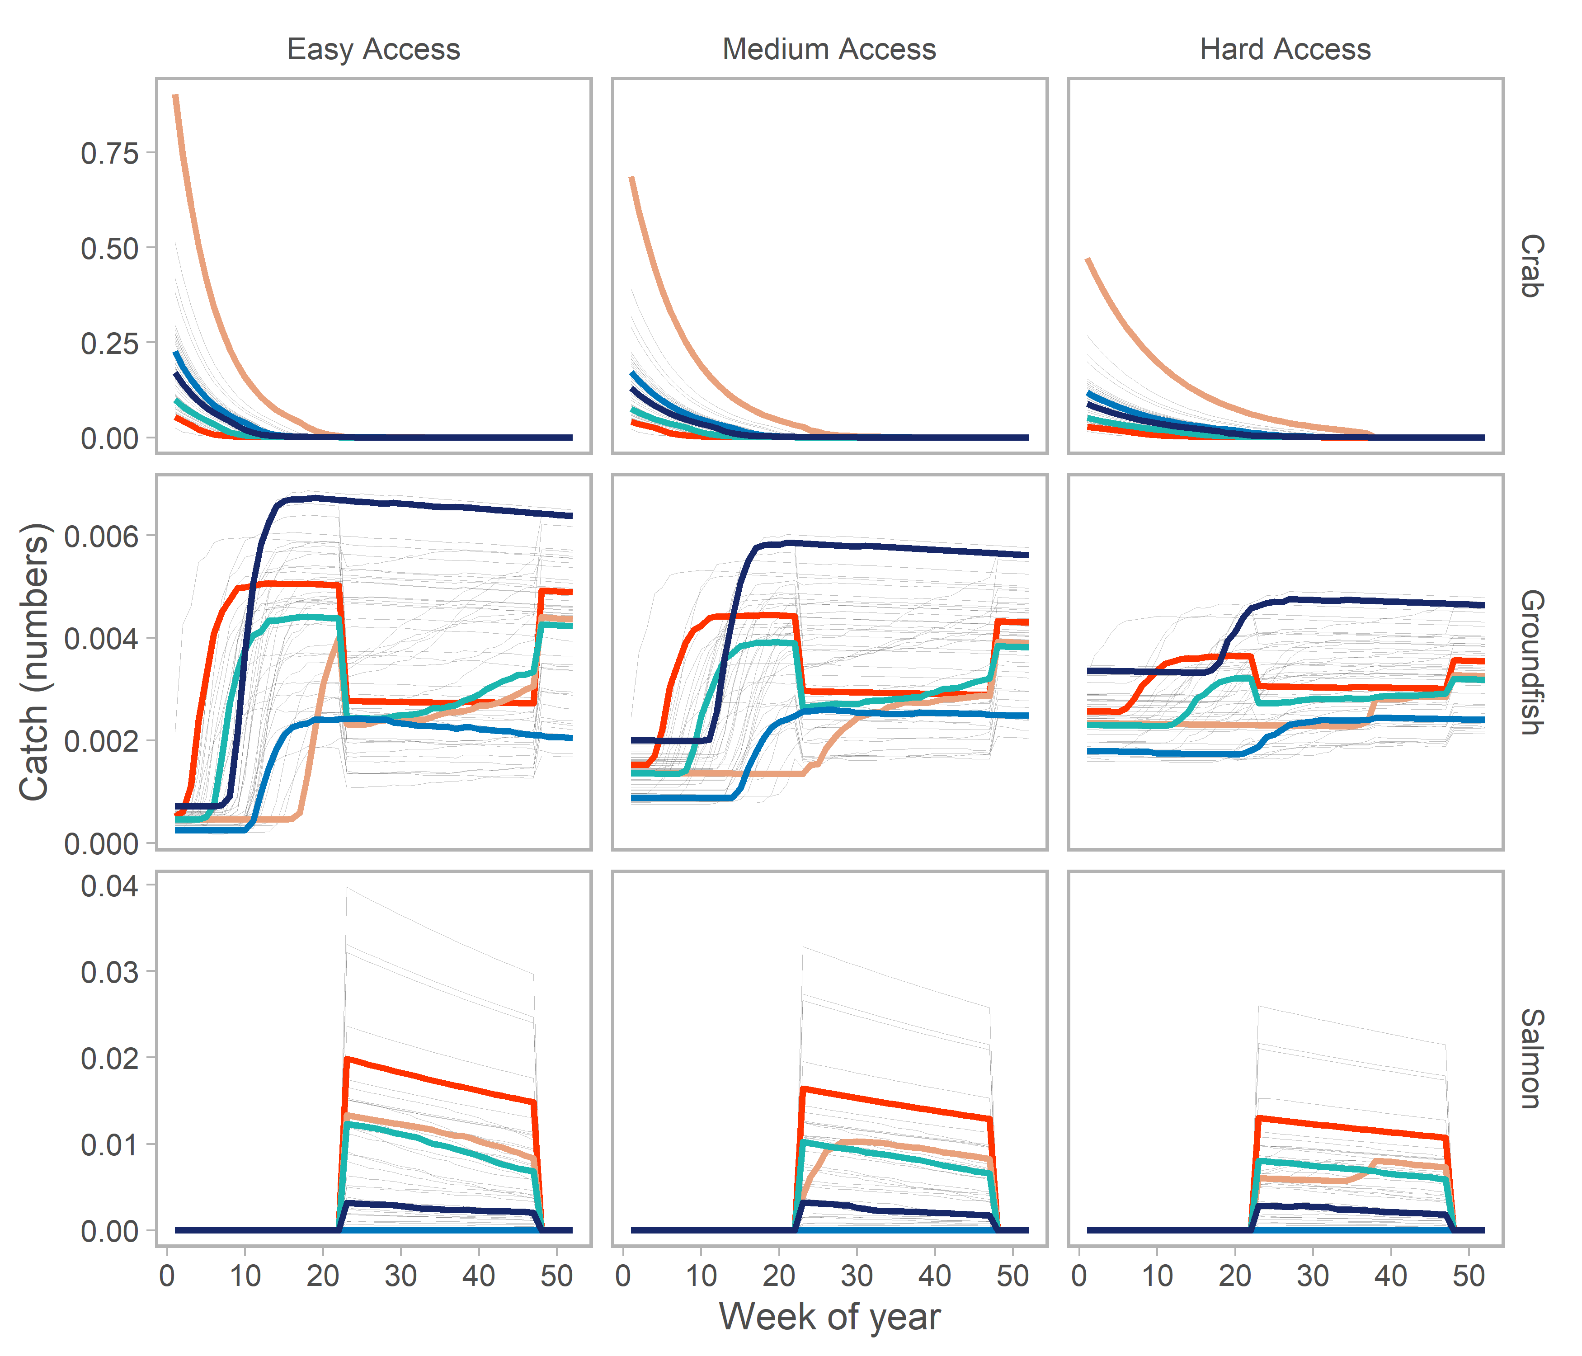

Fig. 5 Catch dynamics through the year of the three species under the three different access scenarios in one simulation. Each line represents a different year of a single 50-year simulation. Recruitment is the same across access scenarios. Colored lined emphasize dynamics for five different representative years from the simulation.

Fig. 6 Distribution of mean and coefficient of variation for individual vessels holding six possible permit portfolios for access scenarios. Mean and CV are calculated over time for each vessel in each simulation, and then averaged across vessels within a simulation. Distributions show variability across simulations. Note common x-axis scales for CV but variable scales for mean.

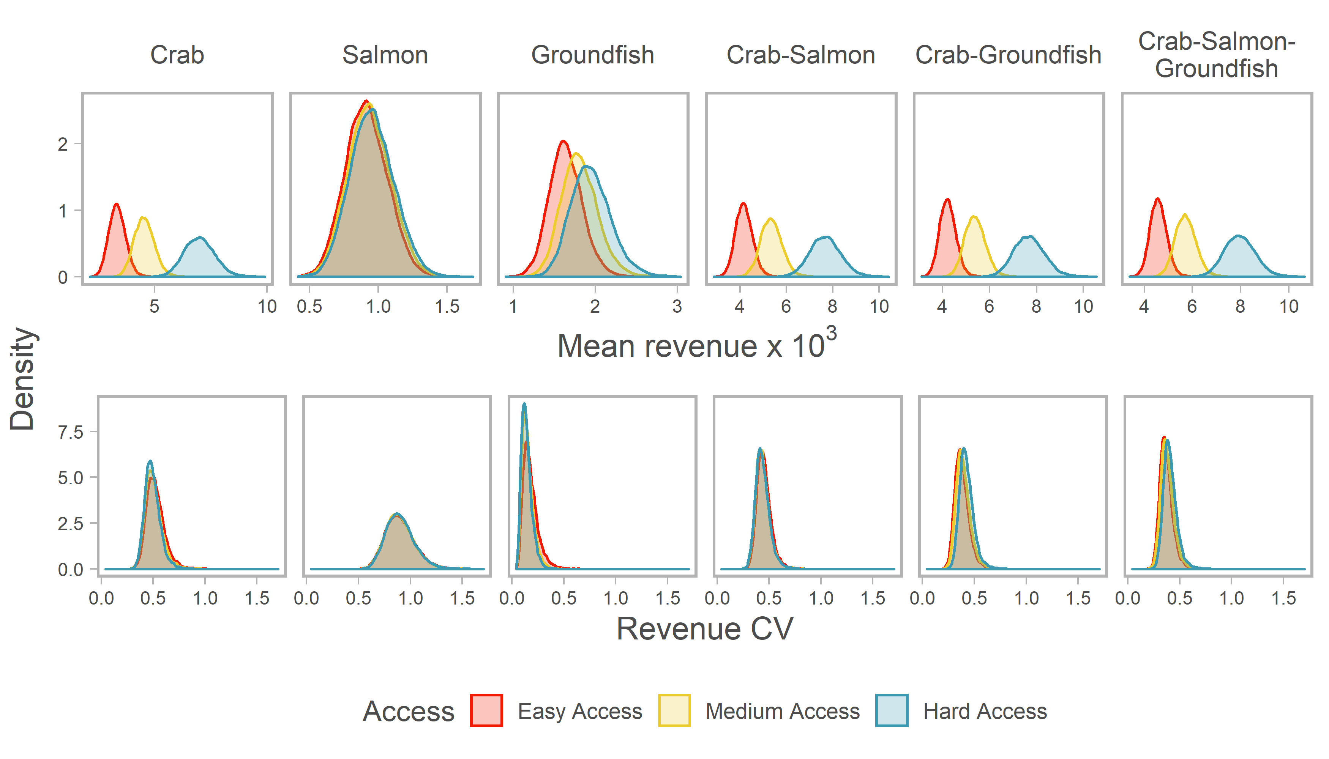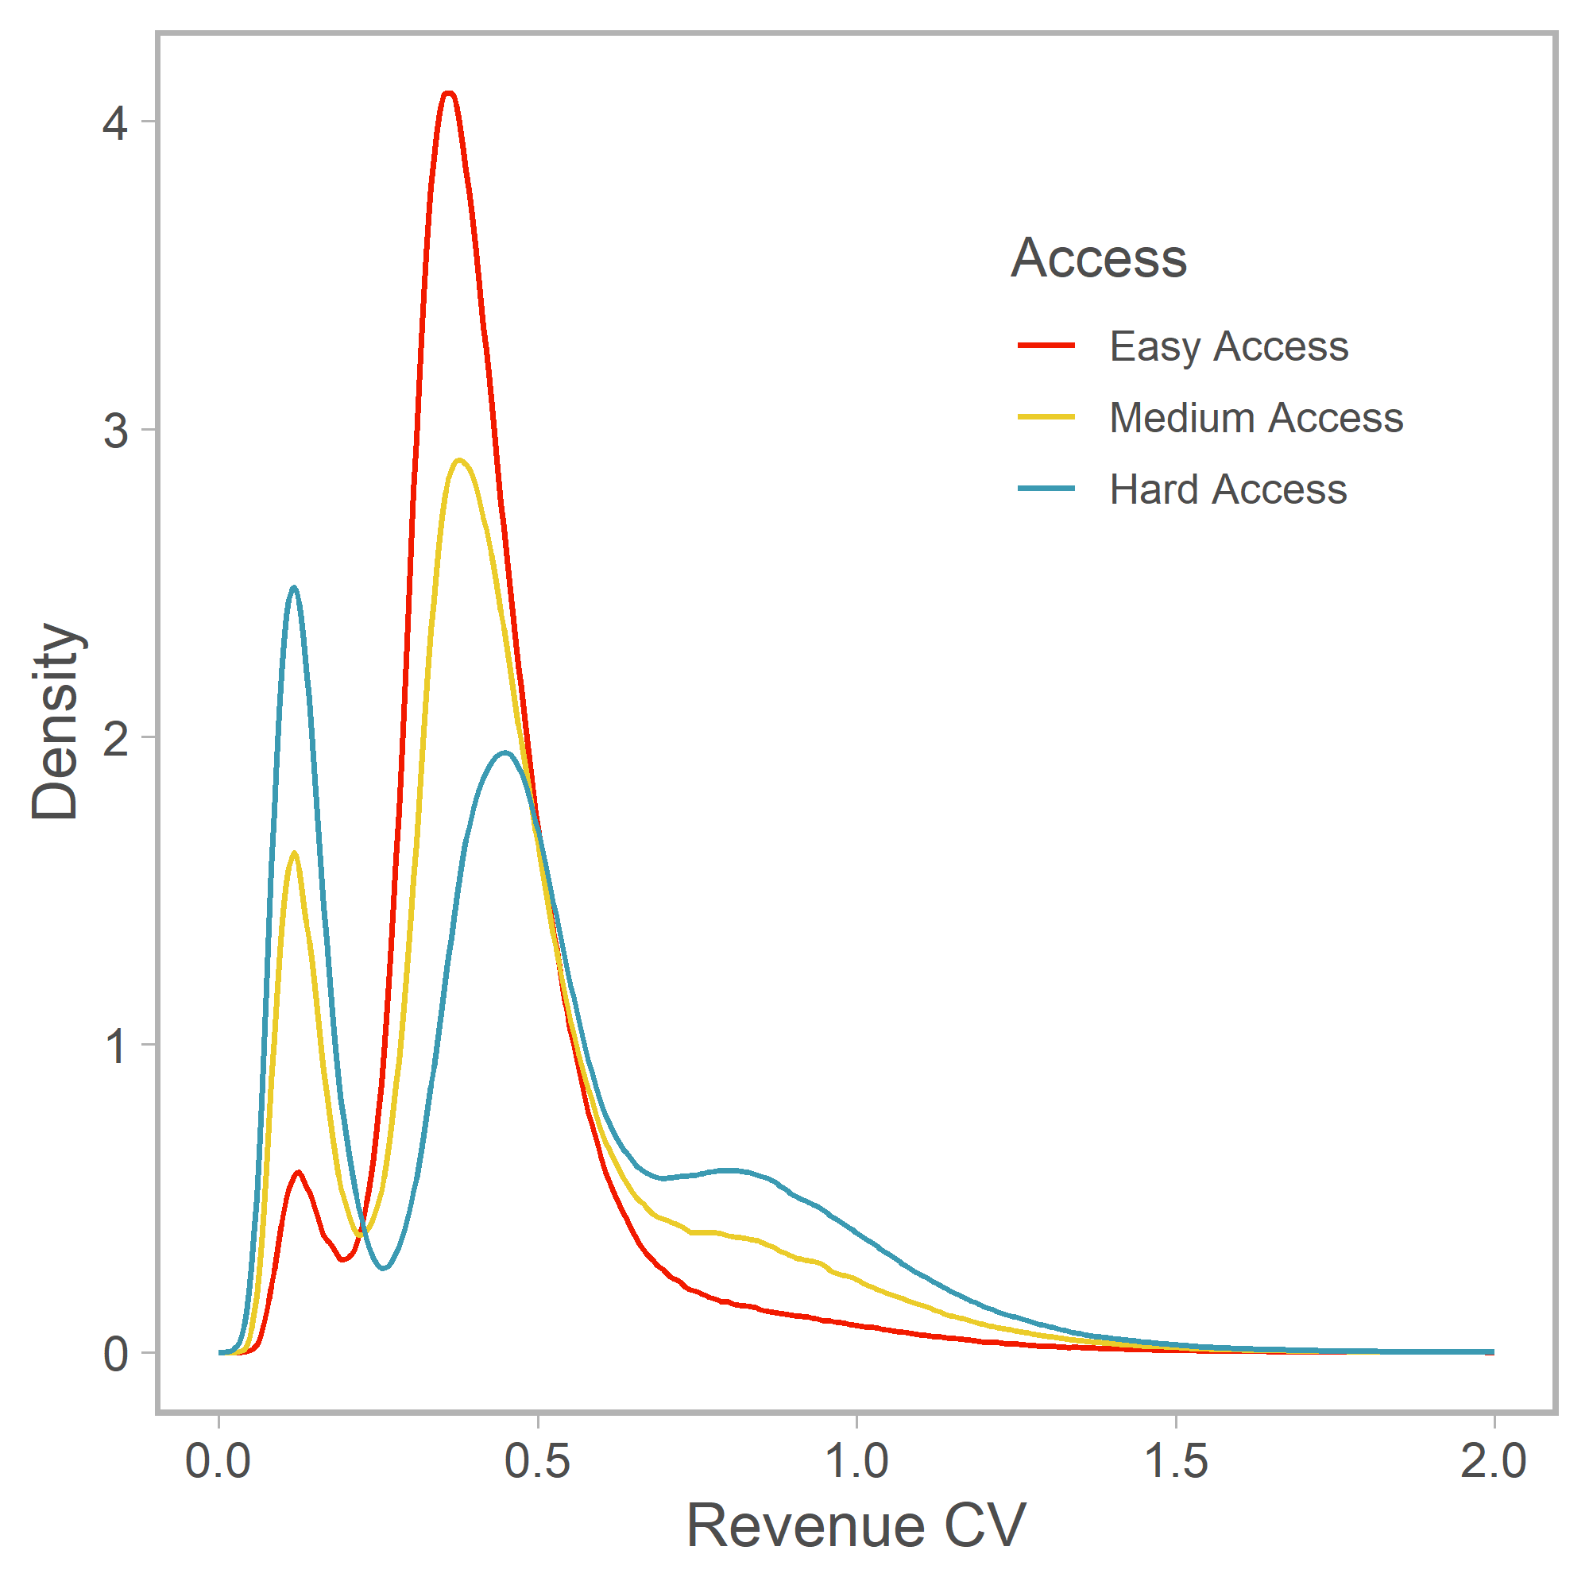

Fig. 7 Distribution of revenue CV of all vessels in all simulations across access scenarios.