Tuning fishery parameters

We parameterized fixed costs, variable costs, and catchability to ensure total costs in a year with average recruitment would be equal to total revenue for a marginal fisher who might be considering entry into the fishery. We based the calculations on a fleet consisting of the same number of vessels as held permits for the fishery in the baseline “medium access” scenario (Table 3, described in “Scenarios” section). We considered an inefficient marginal vessel to have a weekly variable cost at the upper 95th percentile of the variable cost distribution. For the tuning only, we assigned vessel-specific variable costs based on quantiles of the lognormal distribution to avoid Monte Carlo error. That is, rather than randomly simulating the variable costs for each vessel, vessel 1 had a cost at the 1/(number of vessels+1)quantile of the distribution, vessel 2 at the 2/(number of vessels+1) quantile, etc. This profitability constraint for species *s* can be expressed mathematically as:

$$-{\tilde{c}}_{s}+\sum_{w}{{(r}_{s,y*w}-c_{s,v*})}I_{v*,s,y*,w}=0$$

Where *εs,y\** equals zero (average recruitment), and *v\** is the marginal vessel described above.

For crab and salmon, we manually adjusted *qs* and ${\tilde{c}}_{s}$ to achieve an acceptable annual ratio of variable costs to fixed costs for an average fisher (40% of total costs are variable for crab, 89% for salmon) and acceptable patterns of depletion over the year (Fig. 6, center column). While the parameterization of catchability and fixed costs was somewhat arbitrary, our primary goal was to model a diversity of fisheries that range in capital intensity and depletion patterns, as we observe in the CCLME.

Tuning the fishery parameters for groundfish was more complex than for crab and salmon because the groundfish population dynamics respond to the fishery dynamics. First, we solved for catchability so that total yield is equal to the yield that leads the population to equilibrate at 40% of the unfished biomass (the actual management target for most U.S. west coast groundfish species). To calculate this catchability, we projected the fishery for 40 weeks assuming 100% participation each week and solved for the catchability that led to the target yield. We used 40 weeks since vessels do not actually fish every week of the year in reality, nor in our model since some vessels spend part of the year in other fisheries. Next, we manually adjusted the mean variable cost (*cg*) and solved for the fixed cost (${\tilde{c}}_{g}$) such that the marginal vessel described above had no net profit at the target equilibrium conditions. That is, we calculated

$${\tilde{c}}_{g}=\frac{B_{40\%}H_{40\%}P_{g}}{\text{\# vessels}}-F^{-1}\left(0.95 | \log{(}c_{g}\right)-{{σ_{c}}^{2}}/2,σ_{c})*40$$

In the above equation, the first term is the revenue earned per vessel under equilibrium conditions at 40% of unfished biomass and *F*-1 is the inverse lognormal cumulative density function (“qlnorm” in R). The mean variable cost was tuned to achieve an acceptable annual ratio of variable to fixed costs for an average vessel in an average year with a population equilibrated at 40% of the unfished biomass (66% of total costs are variable assuming 40 weeks of fishing).

We conducted two post hoc checks for groundfish to ensure the complicated process described above led to reasonable dynamics despite the assumptions made. First, we checked that all vessels would actually fish for 40 weeks under the cost structure, as no constraint actively prevented vessels from leaving the fishery earlier during the year. We calculated per vessel revenue during the 40th week of the year and ensured it was greater than the variable cost for the least cost-efficient vessel (costs calculated deterministically based on quantiles, note this is different than the “marginal” vessel). Second, we visually checked that the fishery was roughly in equilibrium and that the groundfish population did not consistently tend to grow or decline considerably during simulations that included all three fisheries (Fig. S1).

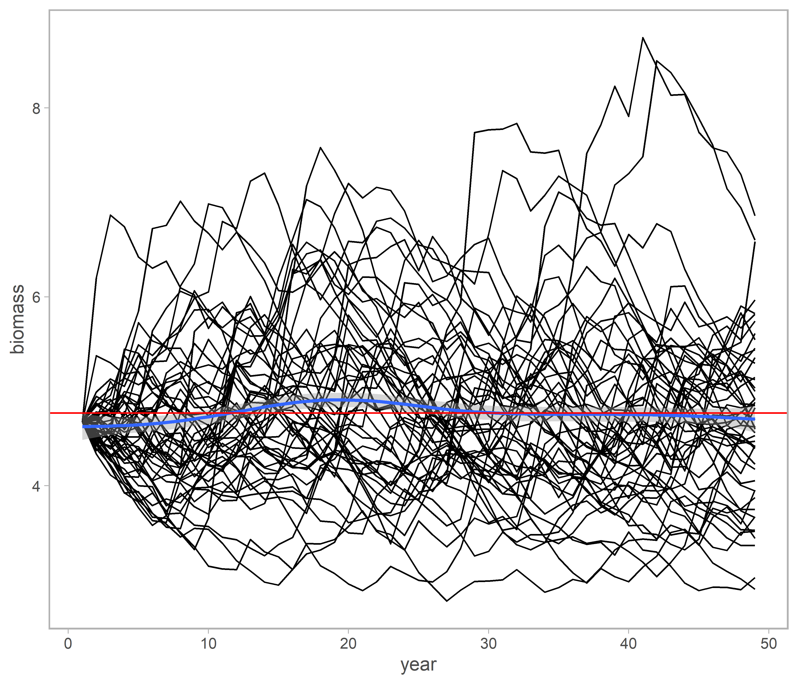

Fig. S1 Time series of week one biomass over 50 years for 50 simulations in baseline conditions. Red horizontal line is average biomass across all years in all simulations, blue line is GAM smoother showing biomass remains roughly stable on average.

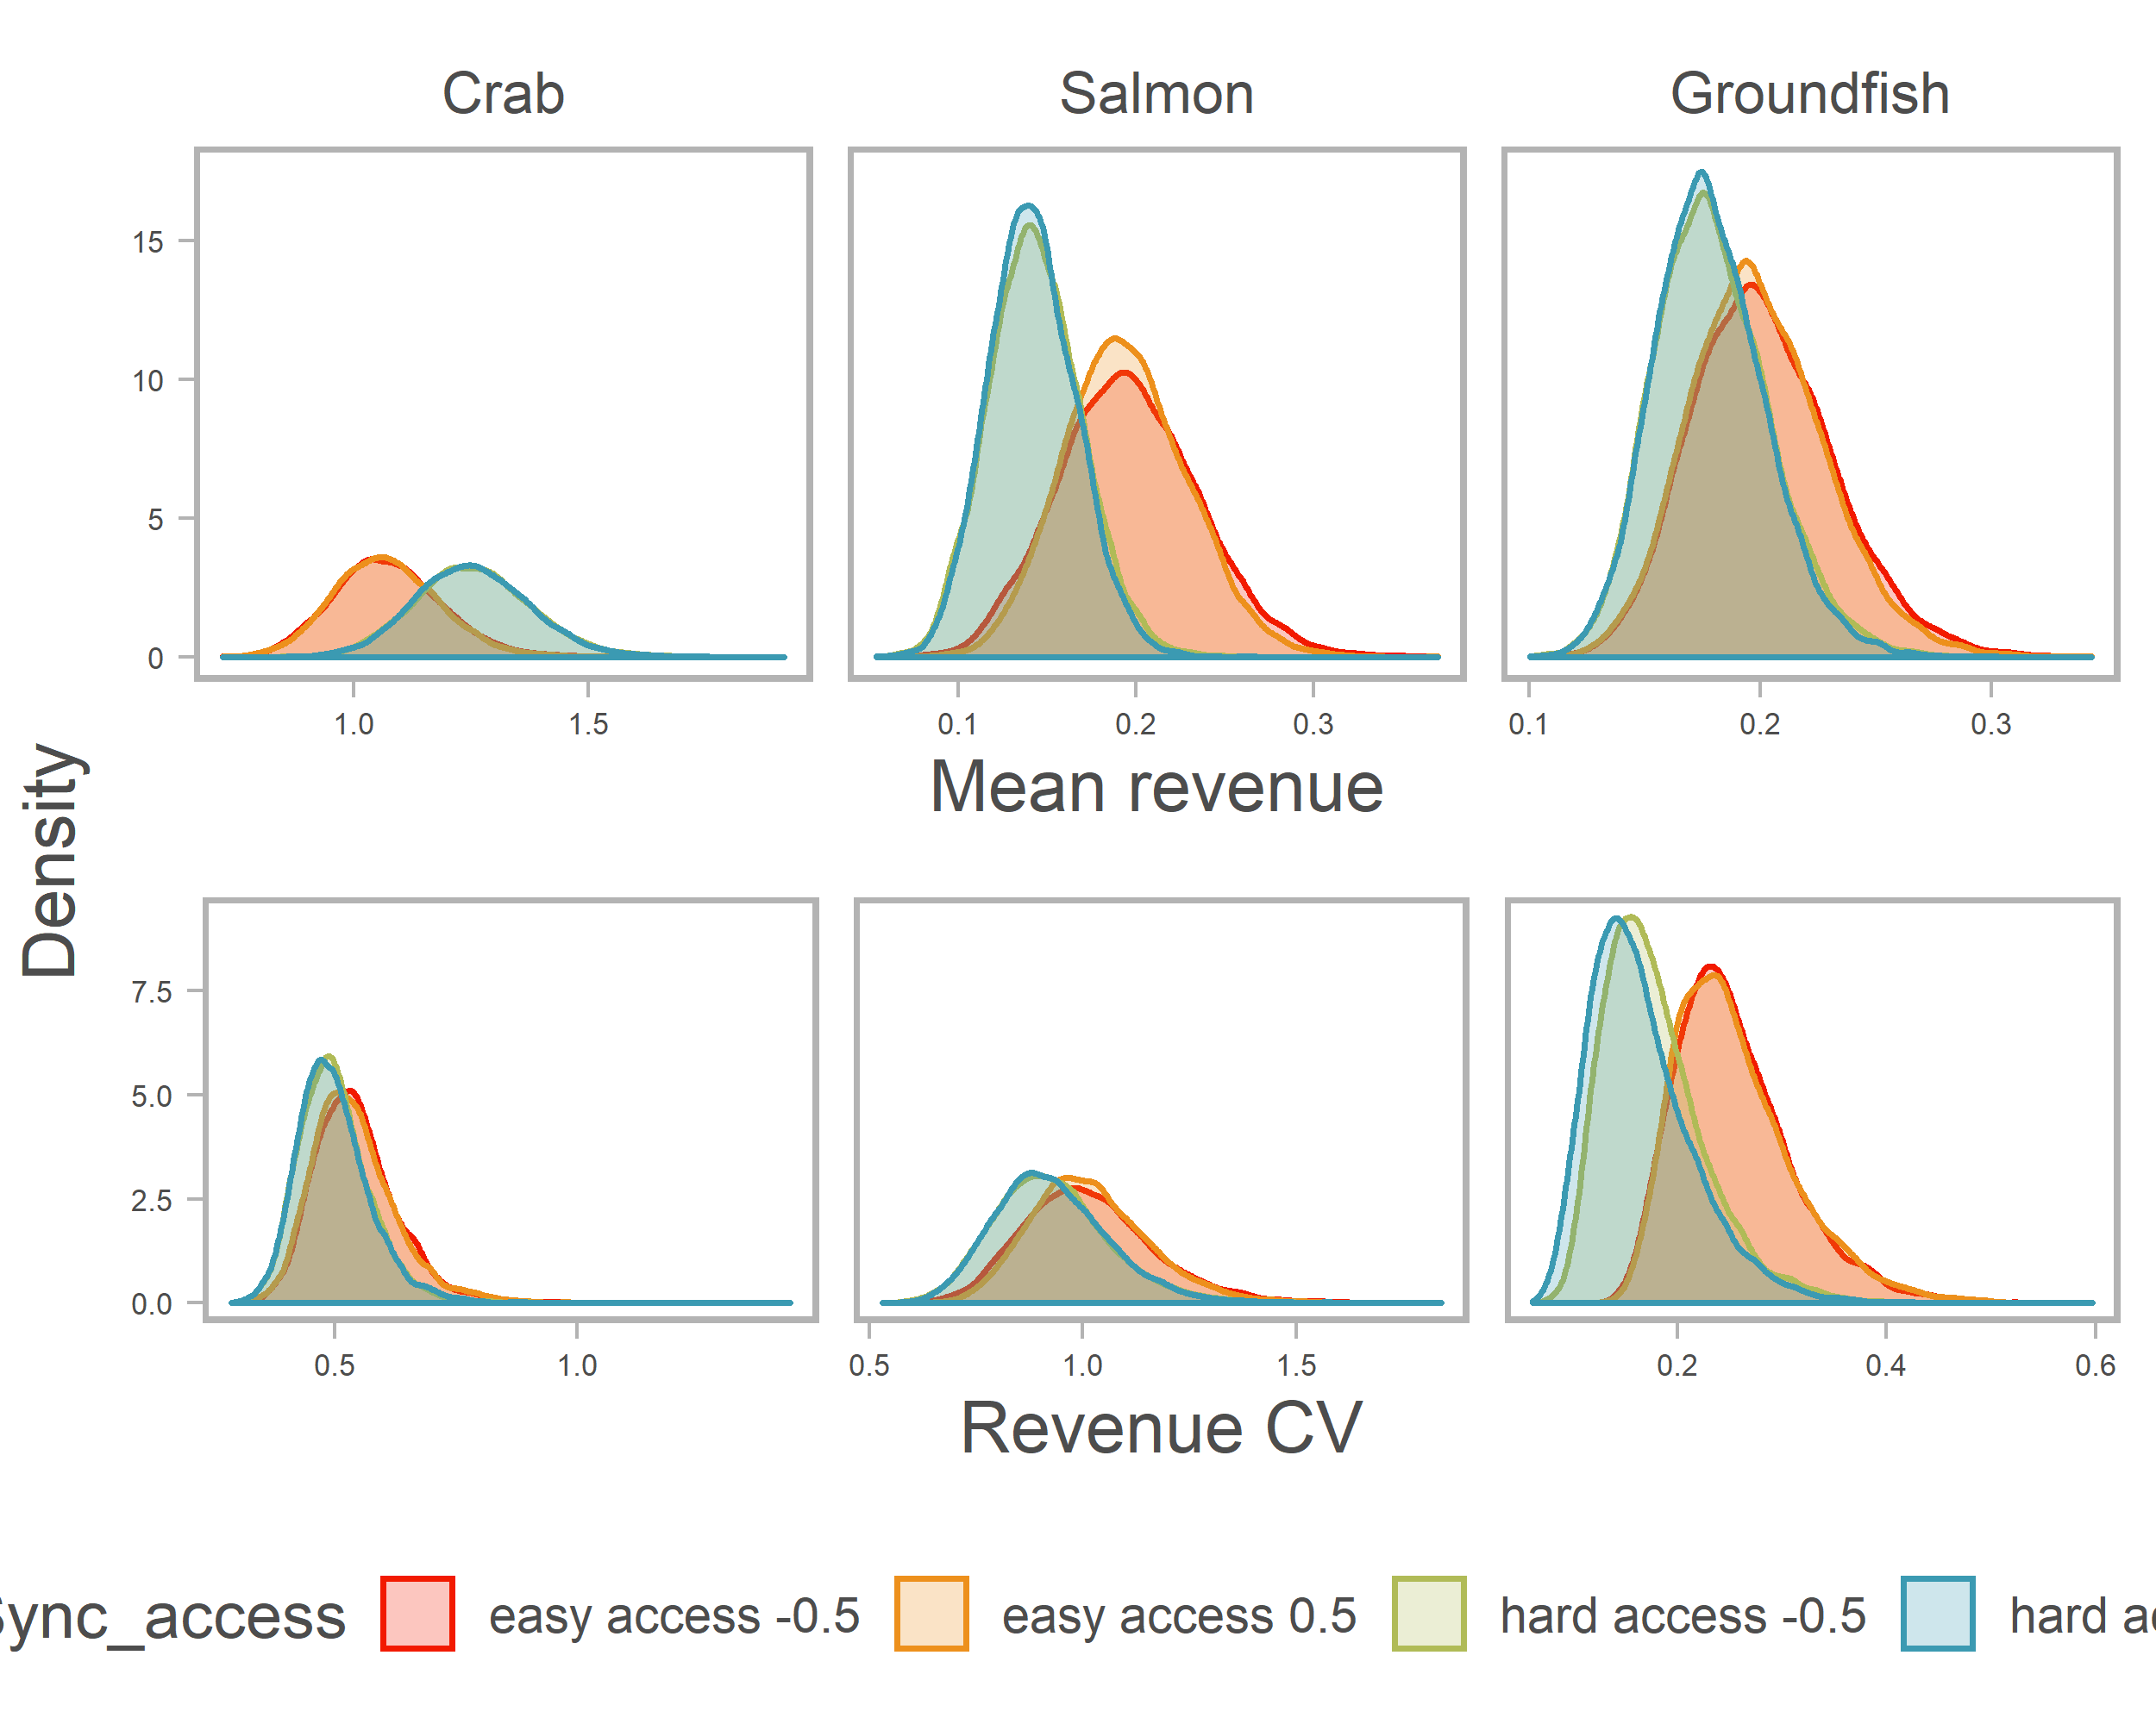

Fig. S2 Distribution of mean and coefficient of variation of revenue for each species under different synchrony and access scenarios.

Fig. S3 Distribution of mean and coefficient of variation for individual vessels holding six possible permit portfolios under different synchrony scenarios. Mean and CV are calculated over time for each vessel in each simulation, and then averaged across vessels within a simulation. Distributions show variability across simulations.

