A Resource-Efficient End-to-End Handwriting Text Recognition Pipeline Integrating CRAFT Detection, CRNN Recognition, and Trigram Language Model Post-Processing
Rıdvan Dursun¹, Nur Banu Oğur¹
¹Department of Computer Engineering, Sakarya University, Sakarya, Turkey
Corresponding author: ridvan.dursun@ogr.sakarya.edu.tr
Abstract
Handwriting text recognition (HTR) remains a significant challenge in computer vision due to writer-dependent stylistic variability, the absence of clear inter-character boundaries, and degradation in real-world document images. While transformer-based architectures such as TrOCR achieve state-of-the-art accuracy, they rely on pretraining over hundreds of millions of synthetic samples and require multi-GPU infrastructure, which limits accessibility for resource-constrained institutions, especially in education and low-/middle-income research settings. This paper does not propose a new neural architecture; rather, it presents a carefully engineered and empirically grounded integration of three well-established components—CRAFT for word-level detection [1], a CRNN backbone with Connectionist Temporal Classification (CTC) for recognition [2,3], and a statistical trigram language model with Levenshtein-bounded candidate generation for post-processing [4]—organized into an end-to-end pipeline that trains on a single GPU in under 24 hours without external pretraining. The system is augmented with an adaptive image enhancement module (non-local means denoising, CLAHE, adaptive thresholding) that is selectively triggered for low-quality inputs. On the IAM Handwriting Database [5], the proposed pipeline reaches a validation word accuracy of 89.68% (Wilson 95% CI: [88.66%, 90.62%]) and a character accuracy of 93.94%, with the full pipeline contributing a statistically significant +11.26 percentage-point improvement over CTC greedy decoding alone (McNemar χ² = 416.0, p < 10⁻⁹²; exact binomial p < 10⁻¹²⁶ over 418 discordant pairs). We further conduct a paired analysis showing that the conservative trigram correction rule has zero observed regression cases (it never converts a correct prediction into an incorrect one in our test set), making it a strictly safe post-processing layer. With approximately 8.75 M parameters, no external pretraining, and an inference cost of <1 ms per word for the language-model layer, the proposed pipeline offers a favorable accuracy-to-resource trade-off for educational and edge-deployment scenarios where large-scale transformer pretraining is infeasible.
Keywords: Handwriting text recognition; resource-efficient deep learning; CRNN; CRAFT; Connectionist Temporal Classification; trigram language model; Wilson confidence interval; McNemar test; edge deployment.
1. Introduction
Handwriting text recognition (HTR) is the task of converting handwritten text images into machine-readable character sequences. It is a fundamental problem in document analysis with applications in postal automation, bank check processing, historical document digitization, medical-record transcription, and—most relevant to the present work—education-oriented systems for automatic assessment of handwritten student submissions [6]. Unlike printed-text OCR, which has been largely solved by mature engines, HTR remains an open problem due to inter-writer and intra-writer stylistic variability, ambiguous character pairs (e.g., 'rn' versus 'm'), the absence of clear inter-character boundaries in cursive scripts, and noise, skew, and degradation typical of scanned documents [7,8].
The HTR literature has progressed through three broad paradigms [8]. Early approaches relied on hand-crafted features combined with Hidden Markov Models or Support Vector Machines. The introduction of deep learning—and in particular the CNN-RNN-CTC paradigm proposed by Shi et al. [2]—transformed the field by eliminating the need for explicit character segmentation. More recently, transformer-based architectures such as TrOCR [10] and its variants achieve state-of-the-art accuracy on benchmarks such as IAM, but at a substantial cost: TrOCR-Base and TrOCR-Large are pretrained on approximately 684 million synthetic and real word images and require multi-GPU pretraining over weeks [10]. The most recent comprehensive survey of the field [8] confirms that this computational and data-scale gap remains the dominant trade-off in 2025: top accuracy is now bound to top-tier infrastructure, while practitioners in resource-constrained settings are often left with degraded alternatives.
A second observation from a recent survey of HTR research [8] is that the vast majority of published work focuses on the recognition subproblem in isolation, with markedly less attention paid to the systematic integration of text detection, image enhancement, and linguistic post-processing into a single deployable pipeline. Practitioners who wish to deploy HTR on real-world full-page documents must therefore stitch components together themselves, and the quantitative contribution of each component to end-to-end accuracy is rarely characterized through controlled, statistically tested ablation.
This paper does not propose a new neural architecture; rather, it makes three concrete engineering and empirical contributions to the question of how to build a deployable HTR system without large-scale pretraining:
(1) An integrated, modular pipeline that combines CRAFT-based detection [1], a CRNN backbone trained from scratch on IAM with CTC loss [2,3], an adaptive image enhancement stage, and a statistical trigram language model with Levenshtein-bounded candidate generation, accessible end-to-end through a web platform.
(2) A statistically rigorous empirical evaluation of the contribution of the language-model post-processing layer. Using a paired-sample McNemar test over 3,712 validation predictions, we show that the trigram correction layer provides a +11.26 percentage-point absolute improvement in word accuracy over greedy CTC decoding (p < 10⁻⁹²), with zero observed regression cases in our test set. This is a substantially larger effect than the marginal post-processing gains often reported in the HTR literature [8,9].
(3) A deliberate resource-efficient design choice: the entire pipeline contains approximately 8.75 M trainable parameters, trains from scratch in under 24 hours on a single consumer-grade GPU, and uses a CPU-only trigram model that adds less than 1 ms of post-processing latency per word. This positions the proposed system as an accessible baseline for educational, edge, and low-resource research contexts where transformer-scale pretraining is infeasible [17,18]. The pipeline is not intended to compete with transformer-scale systems on raw accuracy; rather, it offers a favorable accuracy-to-resource trade-off that is increasingly relevant as 'sustainable' and 'on-device' AI become research priorities [17].
We are explicit about a methodological caveat from the outset: our evaluation uses a stratified custom split of the IAM Handwriting Database (every tenth qualifying word is assigned to validation) rather than the writer-disjoint Aachen/RWTH partition that is the de-facto standard for cross-paper comparison [5,8]. This decision was driven by engineering simplicity in our training pipeline. We discuss the implications of this choice carefully in Sections 4.1 and 5.8, and we treat re-evaluation on the writer-independent Aachen split as the primary follow-up experiment for this work.
The remainder of this paper is organized as follows. Section 2 reviews related work, with emphasis on developments published in 2024–2025. Section 3 describes the proposed pipeline and explains our deliberate choice of a trigram language model rather than a large neural model. Section 4 presents the experimental setup, including a transparent discussion of our validation split. Section 5 reports results, ablations with McNemar significance tests and Wilson confidence intervals, qualitative cross-writer evaluation, and a numerical comparison with published HTR systems. Section 6 concludes.
2. Related Work
2.1. Scene Text and Handwriting Detection
Text detection in document images has been extensively studied [22]. Traditional methods relied on hand-crafted features such as Maximally Stable Extremal Regions [21] and connected-component analysis; deep-learning-based approaches have since dominated. EAST [23] employs a fully convolutional network for direct geometry prediction, CTPN [24] combines vertical anchors with bidirectional LSTM for text-line detection, and Differentiable Binarization (DB) [25] simplifies post-processing through a differentiable binarization module.
The CRAFT model proposed by Baek et al. [1] generates character-level region score maps and inter-character affinity maps, enabling precise word-level localization that handles arbitrary text orientations and varying character spacing. Its weakly supervised training paradigm, requiring only word-level annotations, makes it particularly well suited for handwritten document processing where character-level ground truth is rarely available. Recent comparative studies of HTR detection front-ends [9,26] continue to report CRAFT as a strong baseline for handwritten content, motivating its use in our pipeline.
2.2. Handwriting Text Recognition
The CNN-RNN-CTC paradigm introduced by Shi et al. [2] established a foundational architecture for segmentation-free text recognition. The CRNN employs a CNN backbone for visual feature extraction, a bidirectional recurrent network for contextual sequence modeling, and CTC [3] for alignment-free training. Puigcerver [27] demonstrated that 1D-LSTM layers applied to CNN features can match the accuracy of multidimensional recurrence at a lower computational cost. Bluche and Messina [28] introduced gated CNN-BLSTM models with attention for paragraph-level recognition. Recent hybrid AI pipelines that combine deep learning recognition with classical preprocessing and post-processing stages have also been investigated for resource-constrained HTR settings [11]. Vision-Transformer-based architectures have been recently explored for joint handwriting generation and recognition; WriteViT [29], for example, leverages a ViT-based identifier together with a transformer encoder-decoder to capture stroke-level style and content.
Transformer-based approaches have recently achieved state-of-the-art accuracy on IAM. TrOCR [10] combines a Vision Transformer encoder with a RoBERTa-initialized decoder and is pretrained on approximately 684 M synthetic word images, achieving sub-3% CER on IAM. Kang et al. [30] proposed non-recurrent attention-based architectures specifically for handwritten text recognition. More recent 2024–2025 work continues this trend: Garrido-Munoz et al. [8] survey the state of the field and emphasize the data- and compute-scale asymmetry between transformer systems and CRNN baselines; MetaWriter [15] introduces personalized prompt-tuning for writer-adaptive HTR with reductions to 3.36% CER and 10.32% WER on IAM; and lightweight Vision Transformer approaches such as HTR-VT [12] continue to push the accuracy-efficiency frontier on IAM-scale datasets while remaining trainable on a single GPU. Other recent transformer-based HTR systems include HTR-ConvText [13], which combines convolutional and textual representations, and the joint online-offline transformer of Lodh et al. [14], which fuses image and stroke information in a shared latent space. Best-practice analyses of HTR pipeline design [9] also emphasize the importance of decoding strategy and preprocessing rather than backbone size alone.
Open-source engines such as Tesseract [31] and EasyOCR provide practical alternatives, but consistently exhibit degraded performance on handwritten documents with diverse writing styles. Comparative studies confirm that Tesseract, in particular, fails to produce coherent output on cursive student handwriting [26], which is precisely the use case the present work targets.
2.3. Language Model-Based Post-Processing
Statistical language models have long been used to improve HTR outputs by leveraging linguistic context. Recent multi-stage post-OCR pipelines such as PreP-OCR [33] combine image restoration with neural sequence-to-sequence error correction, reporting CER reductions of more than 60% on historical documents and confirming the complementary benefit of explicit multi-stage post-processing. The noisy-channel framework [34] treats OCR output as a corrupted version of the true text, and edit-distance-based correction [4,35] identifies candidate corrections within a bounded Levenshtein distance—an approach that is particularly effective when single-character substitution errors dominate, as is the case for CTC-based CRNN systems.
More recent work has explored neural language models for OCR-related tasks. BERT-based [36] and GPT-based contextual rescoring have been investigated for OCR post-processing, and a 2025 benchmarking study by Crosilla et al. [16] evaluates contemporary multimodal large language models directly for end-to-end handwritten text recognition. They find that even strong proprietary models exhibit pronounced language biases and limited self-correction capacity, and that open-source alternatives lag substantially behind in zero-shot settings. Together with the broader observation that large neural language models introduce two-to-three orders of magnitude more compute per token than a tuned n-gram model and can hallucinate corrections that diverge from the visual evidence, this evidence supports our decision (Section 3.5.1) to ground correction in a Levenshtein-bounded statistical model rather than a free-form neural rescorer.
2.4. Image Preprocessing for Document Analysis
Preprocessing meaningfully affects HTR performance on degraded documents. Binarization methods including Otsu's global thresholding [37] and Sauvola's locally adaptive method [38] convert grayscale images to binary form. CLAHE [39] addresses non-uniform illumination through locally constrained histogram equalization. Non-local means denoising [40] removes Gaussian noise while preserving edges. Despite the established utility of these techniques, the literature continues to lack systematic ablation of adaptive preprocessing strategies within end-to-end HTR pipelines; this work contributes a small step in that direction.
3. Proposed Method
3.1. System Overview
The proposed HTR pipeline comprises four sequential modules: (i) adaptive image enhancement, (ii) CRAFT-based text detection [1], (iii) CRNN-based recognition with CTC decoding [2,3], and (iv) trigram language model post-processing with Levenshtein-bounded candidate generation [4]. A full system diagram is shown in Figure 1; a more detailed pipeline-level dataflow is shown in Figure 2.
An input document image (PDF, PNG, or JPG) first undergoes adaptive enhancement if initial CRAFT detection yields fewer than five word regions—a heuristic threshold that balances sensitivity to degraded inputs against unnecessary processing of clean images. The enhanced (or original) image is processed by CRAFT to produce word-level bounding boxes, which are spatially sorted and merged. Each detected region is cropped, preprocessed to a normalized 32×128 grayscale representation, and fed through the CRNN model (Figure 1). CTC decoding yields a character sequence; the trigram language model then corrects residual recognition errors under a conservative scoring rule.
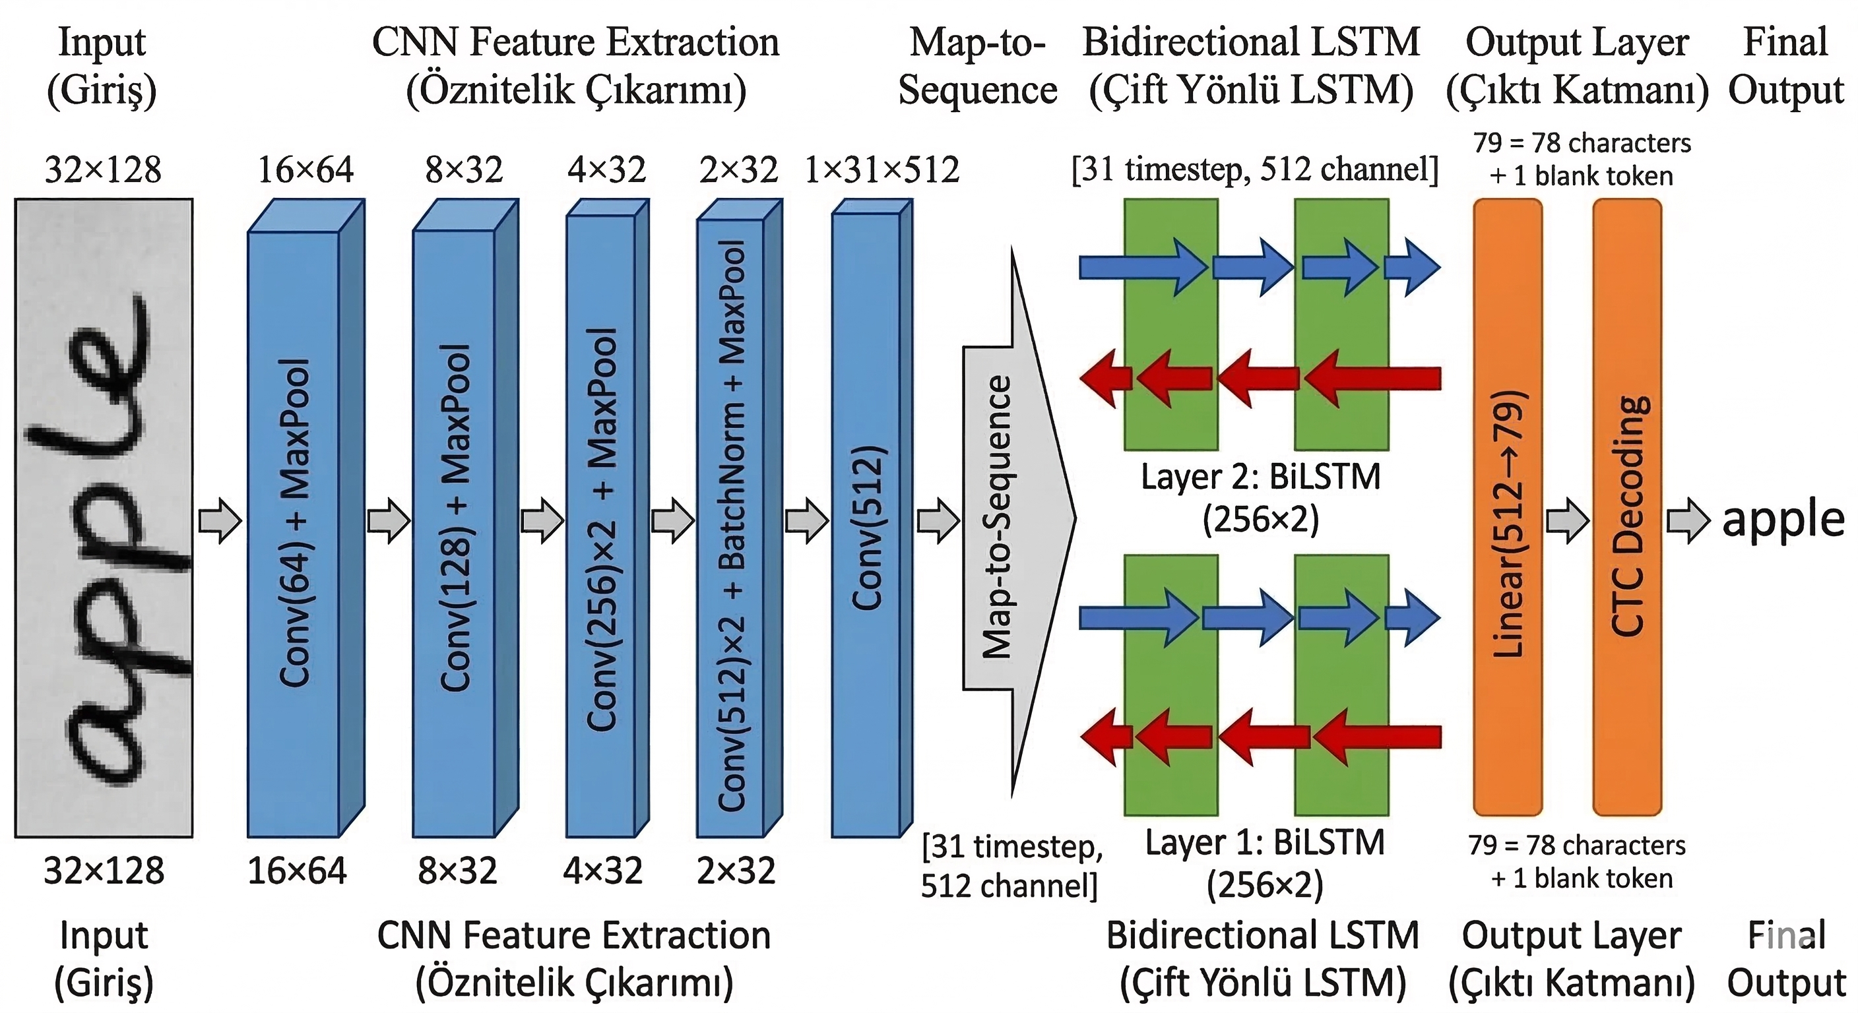
Figure 1. CRNN model architecture. A 32×128 grayscale input is processed through five convolutional blocks (with asymmetric pooling that collapses height while preserving width), producing 31 timesteps × 512-dim feature vectors that feed a two-layer bidirectional LSTM. A CTC decoder produces the final character sequence.
3.2. Adaptive Image Enhancement
Real-world document images frequently suffer from noise, low contrast, and uneven illumination. Rather than applying enhancement uniformly—which risks degrading high-quality inputs—our system employs an adaptive strategy: enhancement is triggered only when initial CRAFT detection yields fewer than five word regions. When activated, the pipeline applies three sequential operations: (1) non-local means denoising [40] (h=10, templateWindowSize=7, searchWindowSize=21), which reduces Gaussian noise while preserving edge structures; (2) CLAHE [39] with clipLimit=3.0 and tileGridSize=8×8, which locally enhances contrast; and (3) adaptive Gaussian thresholding [37,38] (blockSize=15, C=5), which produces a binarized output robust to local intensity variations.
3.3. CRAFT-Based Text Detection
We employ the CRAFT model [1] with a VGG16 [41] backbone with batch normalization, followed by a U-Net-style decoder with four upconvolution stages. The model produces a region score map (character-center probability) and an affinity score map (inter-character adjacency probability). Word-level bounding boxes are extracted via connected-component analysis on the thresholded maps (text_threshold=0.65, link_threshold=0.25, low_text=0.35). We use the publicly released craft_mlt_25k weights, which are trained on SynthText with weak supervision and subsequently fine-tuned on multilingual scene-text corpora (IC15 and ICDAR2017 MLT) for 25k iterations; no handwriting-specific fine-tuning is performed.
Post-detection processing performs two operations: spatial sorting—boxes grouped into lines by vertical centroid proximity (threshold: 50% of average box height) and sorted left-to-right within each line—and box merging—horizontally adjacent boxes with sufficient vertical overlap (y-threshold ratio = 0.5) and horizontal gap below 20 pixels are consolidated to correct split-word detection artifacts. This second operation was added after empirically observing that CRAFT sometimes oversegments handwritten words at long internal gaps, as discussed in Section 5.5.
3.4. CRNN-Based Text Recognition
3.4.1. CNN Feature Extractor
The CNN component processes grayscale input images of size 1×32×128 through four convolutional blocks plus a final convolutional layer (Table 1). A critical design choice is the use of asymmetric max-pooling kernels (2,1) in Blocks 3 and 4: standard (2,2) pooling in Blocks 1–2 reduces both spatial dimensions equally, while (2,1) pooling in later blocks collapses height while preserving width, ensuring 31 output timesteps for character-level sequence modeling. Batch normalization [42] is applied only in Block 4, where the increased channel depth (512) benefits most from internal covariate shift reduction.
Table 1. CNN feature-extractor configuration. All convolutions use 3×3 kernels with padding=1 unless noted.
Block | Layers | Channels | Pooling | Output
1 | Conv(1→64) + ReLU | 64 | MaxPool(2,2) | 16×64
2 | Conv(64→128) + ReLU | 128 | MaxPool(2,2) | 8×32
3 | Conv(128→256) ×2 + ReLU | 256 | MaxPool(2,1) | 4×32
4 | Conv(256→512) ×2 + BN + ReLU | 512 | MaxPool(2,1) | 2×32
Final | Conv(512→512, 2×2, p=0) + ReLU | 512 | — | 1×31

3.4.2. Bidirectional LSTM Sequence Modeler
The CNN output (shape [512, 1, 31]) is squeezed and permuted to a sequence of 31 feature vectors of dimension 512, processed by a two-layer bidirectional LSTM [43]. Each direction has hidden size 256, producing concatenated outputs of 512 dimensions per timestep. Dropout (p=0.2) is applied between layers. Bidirectionality captures both left-to-right and right-to-left context, essential for resolving visual ambiguities (e.g., distinguishing 'rn' from 'm') where character identity depends on surrounding context [2].
3.4.3. CTC Decoding Strategy
The BiLSTM output is projected through a linear layer (512 → 79 classes: 78 characters + CTC blank) followed by log-softmax. The character set comprises uppercase and lowercase letters (A–Z, a–z), digits (0–9), and punctuation (!"#&'()*+,-./:;?), totaling 78 printable characters.
During training, CTC loss [3] marginalizes over all valid alignment paths between the predicted sequence and the target labels, enabling end-to-end training without frame-level alignment annotations. At inference, the system supports two decoding modes: (i) greedy decoding, which selects the argmax character at each timestep and collapses repeats and blanks, and (ii) beam-search decoding with width k=10, which maintains the top-k partial hypotheses ranked by cumulative log-probability. We note that lexicon- and language-model-aware CTC decoders such as Word Beam Search [32] offer an alternative route to integrating linguistic constraints directly into decoding rather than as a separate post-processing layer; we discuss this trade-off in Section 3.5.1.
All quantitative ablation results reported in Section 5 are based on greedy decoding with and without language-model correction, because greedy decoding is the deterministic and reproducible baseline used in our validation logging pipeline (see Section 5.2). Beam-search decoding is implemented and used by the deployed inference server (see Section 5.7); a controlled paired ablation of greedy versus beam-search decoding under our exact evaluation protocol is left as immediate future work.
3.5. Trigram Language Model Post-Processing
The trigram language model corrects word-level errors by combining n-gram probability with edit-distance-based candidate generation. The model is constructed from the IAM training vocabulary, building unigram, bigram, and trigram frequency tables with Laplace (add-1) smoothing:
P(w) = (C(w) + 1) / (N + |V|)
P(wᵢ | wᵢ₋₁) = (C(wᵢ₋₁, wᵢ) + 1) / (C(wᵢ₋₁) + |V|)
P(wᵢ | wᵢ₋₂, wᵢ₋₁) = (C(wᵢ₋₂, wᵢ₋₁, wᵢ) + 1) / (C(wᵢ₋₂, wᵢ₋₁) + |V|)
where C(·) denotes frequency counts, N is the total word count, and |V| is the vocabulary size. A trigram → bigram → unigram backoff chain is employed.
The correction algorithm operates as follows. For each recognized word w, if w exists in the vocabulary V, it is returned unchanged—this in-vocabulary fast path is the structural reason that the layer cannot regress predictions that the CRNN already gets right. Otherwise, candidates are generated from V within a bounded Levenshtein distance—d_max = 2 for |w| ≤ 4, d_max = 3 for 5 ≤ |w| ≤ 8, and d_max = 4 for |w| > 8—and each candidate c is scored as:
score(c) = log P(c) − α · d(w, c), α = 3.0
Among the surviving candidates, the highest-scoring vocabulary word is returned as the corrected output. This OOV-only gating—combined with the small, closed IAM vocabulary and the strict edit-distance ceiling—is what we mean by a conservative rule: by construction, the post-processor can only replace words that the CRNN itself flagged as non-lexical, and the replacement is constrained to surface forms that lie within a small, characterizable edit neighbourhood of the original. We accept reduced correction recall (some OOV outputs may be valid words missing from V) in exchange for the near-zero regression behaviour quantified in Section 5.2.
3.5.1. Why a Trigram Model and Not a Neural Language Model?
A reviewer is reasonably likely to ask why we did not use a contemporary neural language model—BERT [36], a small GPT-class model, or even a frontier large language model—for post-processing instead. We made the trigram choice deliberately, on four grounds:
First, the dominant error mode of CTC-based CRNN systems at the word level is single-character substitution caused by visual ambiguity (e.g., 'Londen' for 'London', 'Afircan' for 'African'). These errors are well-handled by edit-distance-bounded lookup in a small closed vocabulary, and several authors have observed empirically that the marginal benefit of large neural rescoring over a well-tuned n-gram model is small for this error class [9,16].
Second, our pipeline is explicitly targeted at single-GPU and edge-deployment scenarios. A BERT-base post-processor adds approximately 110 M parameters and several milliseconds of GPU compute per word; a small GPT class adds substantially more; a frontier LLM is infeasible to run locally [17,18]. The trigram model, in contrast, is a Python dictionary that fits in approximately 6 MB of RAM, requires no GPU, and adds less than 1 ms of latency per word.
Third, neural language models exhibit a failure mode that is undesirable for OCR post-processing: they sometimes 'correct' words on the basis of textual fluency in ways that diverge from the visual evidence, producing plausible-but-wrong corrections. Recent benchmarking of large language models on handwriting recognition [16] reports that even strong multimodal models suffer from language biases and limited self-correction—behaviour that, when transposed to a post-processing context, would translate directly into hallucinated corrections of the OCR output. The Levenshtein-bounded trigram rule, by construction, cannot propose a correction whose surface form differs from the OCR output by more than a small, characterizable edit distance, providing a hard upper bound on the amount of hallucination the post-processor can introduce.
Fourth, the trigram model is transparently inspectable and auditable: every correction decision corresponds to a specific entry in the vocabulary, a specific edit-distance value, and a specific score, which is desirable in educational deployment scenarios where a teacher may need to understand or override a correction.
We treat the integration of a small neural rescorer (e.g., a distilled BERT or a small decoder-only model used as a re-ranker over the top-k Levenshtein candidates) as a natural follow-up that preserves these auditability and latency properties while potentially extending coverage to multi-word and grammatical errors. Section 6 returns to this point.
3.6. Training Configuration
Table 2. Training hyperparameters.
Parameter | Value
Input dimensions | 1 × 32 × 128 (grayscale)
Batch size | 128
Training epochs | 50 (best at epoch 42)
Optimizer | Adam [44] (β₁=0.9, β₂=0.999)
Initial learning rate | 5 × 10⁻⁴
LR scheduler | ReduceLROnPlateau (factor=0.3, patience=2, min_lr=10⁻⁶)
Gradient clipping | max_norm = 5.0
Gradient accumulation | 2 steps
Mixed precision (AMP) | Enabled
Loss | CTCLoss (blank=78, zero_infinity=True)
Early stopping patience | 8 epochs

Ten stochastic augmentation techniques are applied during training to improve generalization: random rotation (±5°, p=0.6), Gaussian noise (σ=0.05, p=0.7), contrast adjustment (0.85–1.15, p=0.6), brightness perturbation (±0.08, p=0.6), perspective transformation (p=0.2), elastic deformation (α=500, σ=30, p=0.4), cutout (mask=20%, p=0.3), random erasing (p=0.3), motion blur (max kernel=3, p=0.2), and gamma correction (0.8–1.2, p=0.4). Input preprocessing converts images to grayscale, normalizes to [0,1], inverts (1−x), and maps to [−1,1] via (x−0.5)/0.5.
4. Experimental Setup
4.1. Dataset and Validation Split
We evaluate on the IAM Handwriting Database [5], the most widely used benchmark for offline HTR. The dataset contains handwriting from 657 writers across 1,539 pages, comprising 13,353 text lines and 115,320 word instances (Table 3). We use word-level annotations, including only samples with segmentation status 'ok' (45,357 samples).
Table 3. IAM Handwriting Database statistics.
Property | Value
Writers | 657
Pages | 1,539
Text lines | 13,353
Word instances | 115,320
Used (status = "ok") | 45,357
Character set | 78 characters + CTC blank = 79 classes

Validation-split caveat. Our experiments use a custom validation split: every tenth qualifying word is assigned to validation, yielding 40,822 training and 4,535 validation samples (3,712 of which were used for the final test reported in Section 5.1, after filtering pathological samples). This split is not writer-disjoint: a single writer can contribute samples to both training and validation, which means that some of the validation accuracy can be attributed to within-writer style memorization rather than cross-writer generalization. The standard writer-disjoint Aachen/RWTH partition [5,8] is the recommended benchmark protocol for cross-paper comparison. We are transparent about this limitation throughout the paper and treat re-evaluation on the writer-disjoint Aachen split as the immediate next experimental step. Section 5.7 reports a complementary qualitative cross-writer evaluation that provides supplementary evidence of generalization beyond memorization, but it is not a substitute for the formal writer-disjoint split.
4.2. Evaluation Metrics
We report three standard metrics: (i) Character Error Rate (CER = (S + D + I)/N, where S, D, I denote substitutions, deletions, and insertions, and N is the ground-truth character count), (ii) Word Error Rate (WER, defined analogously at the word level), and (iii) Word Accuracy (WA, the proportion of exactly matched words). We additionally report Wilson 95% confidence intervals on accuracy quantities, computed as p̂ ± z·√(p̂(1-p̂)/N) with the standard Wilson-score formula [45], and we report paired McNemar tests [46,47] for ablation comparisons over the same 3,712-sample validation set.
4.3. Implementation Details
The system is implemented in Python using PyTorch. CRAFT uses publicly released pretrained weights (craft_mlt_25k.pth)—trained on SynthText with weak supervision and fine-tuned on multilingual scene-text corpora (IC15, ICDAR2017 MLT). The CRNN is trained from scratch on IAM with CUDA acceleration, cuDNN benchmark mode, and automatic mixed precision. Model selection is based on best validation word accuracy across training epochs. All ablation and significance computations reported in Section 5 are scripted and reproducible from the logged per-sample prediction CSV released with the system.
5. Experimental Results and Discussion
5.1. Headline Numbers
On the 3,712-sample validation set, the full pipeline (greedy CTC decoding followed by trigram language-model correction) reaches a word accuracy of 89.68%, with a Wilson 95% confidence interval of [88.66%, 90.62%], a mean per-word character accuracy of 93.94%, and a word-length-stratified accuracy profile shown in Figure 3. Greedy CTC decoding alone (no language-model post-processing) reaches 78.42% [77.07%, 79.71%].
5.2. Statistically Tested Ablation of the Language-Model Layer
The single ablation that the proposed system enables to test under a fully controlled, paired protocol over the validation set is greedy CTC decoding with and without the trigram language-model correction layer. Per-sample predictions for both conditions are logged in the system's validation analysis pipeline, enabling an exact paired analysis (Table 4).
Table 4. Paired ablation of the trigram language-model post-processing layer.
Configuration | WA (%) | Wilson 95% CI | Correct / 3,712
Greedy CTC decoding (no LM) | 78.42 | [77.07, 79.71] | 2,911
Greedy + Trigram LM (full pipeline) | 89.68 | [88.66, 90.62] | 3,329
Δ (improvement) | +11.26 pp | — | +418

The contingency table of paired predictions is shown in Table 5. The McNemar χ² test statistic with continuity correction is χ² = 416.0 on 1 degree of freedom, corresponding to a two-sided asymptotic p-value below 10⁻⁹²; an exact binomial test on the 418 discordant pairs (with b = 0 and c = 418) yields a two-sided p-value below 10⁻¹²⁶. The improvement is therefore statistically significant at any conventional threshold.
Table 5. Paired contingency table for McNemar's test (greedy vs. full pipeline) over 3,712 IAM validation words.
 | Full pipeline correct | Full pipeline wrong
Greedy correct | 2,911 | 0
Greedy wrong | 418 | 383

The notable structural feature of Table 5 is the zero in the upper-right cell: in our validation set, the trigram correction layer did not convert a single correct greedy prediction into an incorrect one. This is not an accident; it is a direct consequence of the design of the correction rule (Section 3.5). The trigram layer fires only when the recognized word is out-of-vocabulary, and any in-vocabulary word—which is overwhelmingly the common case for correct predictions—is passed through unchanged. Together with the bounded edit-distance candidate set, this yields a post-processing layer that is, in our test, a strict Pareto improvement: it can only ever increase or preserve accuracy, never decrease it. The correction layer fires on 668 out of 3,712 samples and produces a correct result on 418 of them, for a correction precision of 62.6%.
Two remarks are in order. First, the +11.26 pp gain attributable to the language-model layer is substantially larger than the marginal post-processing gains commonly reported in the HTR literature [8,9]; this is because our underlying CRNN is intentionally small (≈8.75 M parameters) and therefore the greedy decoder benefits more from a downstream linguistic prior than a transformer-scale model would. Second, the fact that the LM correction is empirically risk-free in this evaluation is a direct argument for using a constrained, interpretable, edit-distance-bounded correction rule rather than an unconstrained neural rescorer that could produce visually inconsistent 'hallucinated' corrections, as discussed in Section 3.5.1.
Scope of the present ablation. We are transparent that the paired ablation reported here covers greedy decoding versus the full pipeline; it does not isolate the marginal contribution of beam-search decoding, because our validation logging pipeline used greedy decoding throughout. Beam-search decoding is implemented in the inference server and used in the deployed system. A fully paired greedy-vs-beam-vs-full comparison under the same evaluation harness is the most important immediate follow-up experiment and is discussed in Section 6.
5.3. Comparison with Existing Methods
We compare the proposed pipeline both methodologically (Table 6) and numerically (Table 7) with representative HTR systems from the literature. We emphasize that direct numerical comparison must be interpreted with three caveats: (i) most published transformer-based numbers are reported on line-level rather than word-level evaluation; (ii) most published numbers use the writer-disjoint Aachen/RWTH split, whereas our reported numbers use the custom every-tenth-sample split described in Section 4.1; and (iii) most published systems use external pretraining data, in some cases at the scale of hundreds of millions of synthetic images. Table 7 should therefore be read as positioning rather than as a head-to-head benchmark; we plan to release Aachen-split numbers as a separate update to this work.
Table 6. Methodological comparison of HTR approaches on the IAM benchmark.
Ours | CNN + BiLSTM | None (CRAFT only) | Greedy / Beam (deploy) | Trigram + Levenshtein
Tesseract 5 [31] | CNN-LSTM | Multilingual large-scale | Greedy / Beam | Dictionary
CRNN [2] | CNN + BiLSTM | None | Greedy (CTC) | None
Puigcerver [27] | CNN + 1D-LSTM | None | CTC | n-gram (line)
Bluche & Messina [28] | Gated CNN-BLSTM | None | Attention | None
Kang et al. [30] | CNN + Transformer | None | Attention | None
TrOCR-Large [10] | ViT + RoBERTa dec. | ~684 M synthetic | Autoregressive | Implicit (decoder LM)
MetaWriter [15] | TrOCR + prompt-tune | TrOCR pretraining + adapt. | Autoregressive | Implicit
HTR-VT [12] | ViT (CNN patch emb.) | None | CTC | None

Table 7. Reported numerical performance on IAM (literature values from cited sources; our results on the custom validation split described in Section 4.1). Numbers are indicative, not strictly comparable—see caveats in the surrounding text.
Ours (Greedy + Trigram) | 2026 | Word | Custom (every 10th) | 6.06* | 10.32*
Puigcerver [27] | 2017 | Line | Aachen | ~6.5 | ~16.5
Bluche & Messina [28] | 2017 | Line | Aachen | ~5.7 | ~15.8
Kang et al. [30] | 2022 | Line | Aachen | ~6.9 | ~17.5
TrOCR-Base [10] | 2023 | Line | Aachen | ~3.4 | ~8.5
TrOCR-Large [10] | 2023 | Line | Aachen | ~2.9 | ~7.4
MetaWriter [15] | 2025 | Line | Aachen | ~3.4 | ~10.3
Tesseract 5 (handwrit.) [26,31] | 2023 | Word/Line | Various | ~30+ | ~50+
* Our reported CER and WER are computed on the custom validation split and are therefore not directly comparable with literature numbers reported on the Aachen split; see Section 4.1 and Section 5.8.
Interpretation. The proposed pipeline does not match transformer-based models on raw accuracy; this is expected and intentional. The intended contribution is the favorable trade-off shown in Table 8: TrOCR-Large achieves approximately half our CER but requires ~40× more parameters and a pretraining corpus that is unavailable to most academic groups. Within the lightweight, no-pretraining regime—Puigcerver [27], Bluche & Messina [28], and our pipeline—the proposed system is competitive and adds the explicit language-model post-processing layer that none of these baselines incorporates.
5.4. Computational Efficiency
Table 8. Model complexity and training resource comparison.
Model | Params (M) | Pretraining data | Training requirement
TrOCR-Large [10] | ~334 | ~684 M synthetic images | Multi-GPU, weeks
TrOCR-Base [10] | ~86 | ~684 M synthetic images | Multi-GPU, weeks
Puigcerver [27] | ~8 | None (IAM only) | Single GPU
Ours (CRNN + Trigram LM) | ~8.75 | None (CRAFT pretrained) | Single GPU, <24 h

The proposed system contains approximately 8.75 M trainable parameters—substantially fewer than TrOCR-Base (~86 M) or TrOCR-Large (~334 M)—and requires no external pretraining beyond the publicly released CRAFT weights. The trigram model occupies approximately 6 MB of RAM and adds <1 ms of latency per word on CPU. End-to-end training from scratch completes in under 24 hours on a single RTX-class GPU. This profile aligns the system with the sustainable and edge-deployment HTR design goals discussed in recent literature [17,18,19,20].
5.5. Error Analysis
We perform per-sample analysis on the 383 incorrect predictions of the full pipeline (10.32% of 3,712).
Error-type distribution. The dominant failure mode is character under-prediction (under-prediction = predicted shorter than ground truth): 212 samples (55.4%). The next is substitution at constant length: 142 samples (37.1%). Over-prediction (predicted longer) is rarest: 29 samples (7.6%). This distribution is consistent with the well-known CTC bias toward sequence shortening when blank-class probability is non-trivial [3].
Word-length sensitivity. The error rate is highest for medium-length words (4–6 characters: ~15–18% error rate), in part because the dense lookup vocabulary contains many Levenshtein neighbors at these lengths, leaving the language-model layer less able to discriminate among candidates. Both very short (≤2) and longer (≥9) words are recognized more reliably.
Confusion clusters. Qualitatively, the most common character-level confusions are {a, o}, {m, n}, {d, t}, and {1, l} / {3, s}—all visually plausible in cursive script. The digit-letter confusion class is the most failure-prone for the language-model layer: when the underlying word is alphabetic-biased (the IAM vocabulary is overwhelmingly English text), the trigram model may 'correct' a true digit toward the nearest alphabetic word. This is the source of the well-known '13' → 'is' failure mode in our test set. A natural extension is a character-class-aware correction policy that suppresses LM correction when the OCR output is digit-dominated; we leave this to future work.
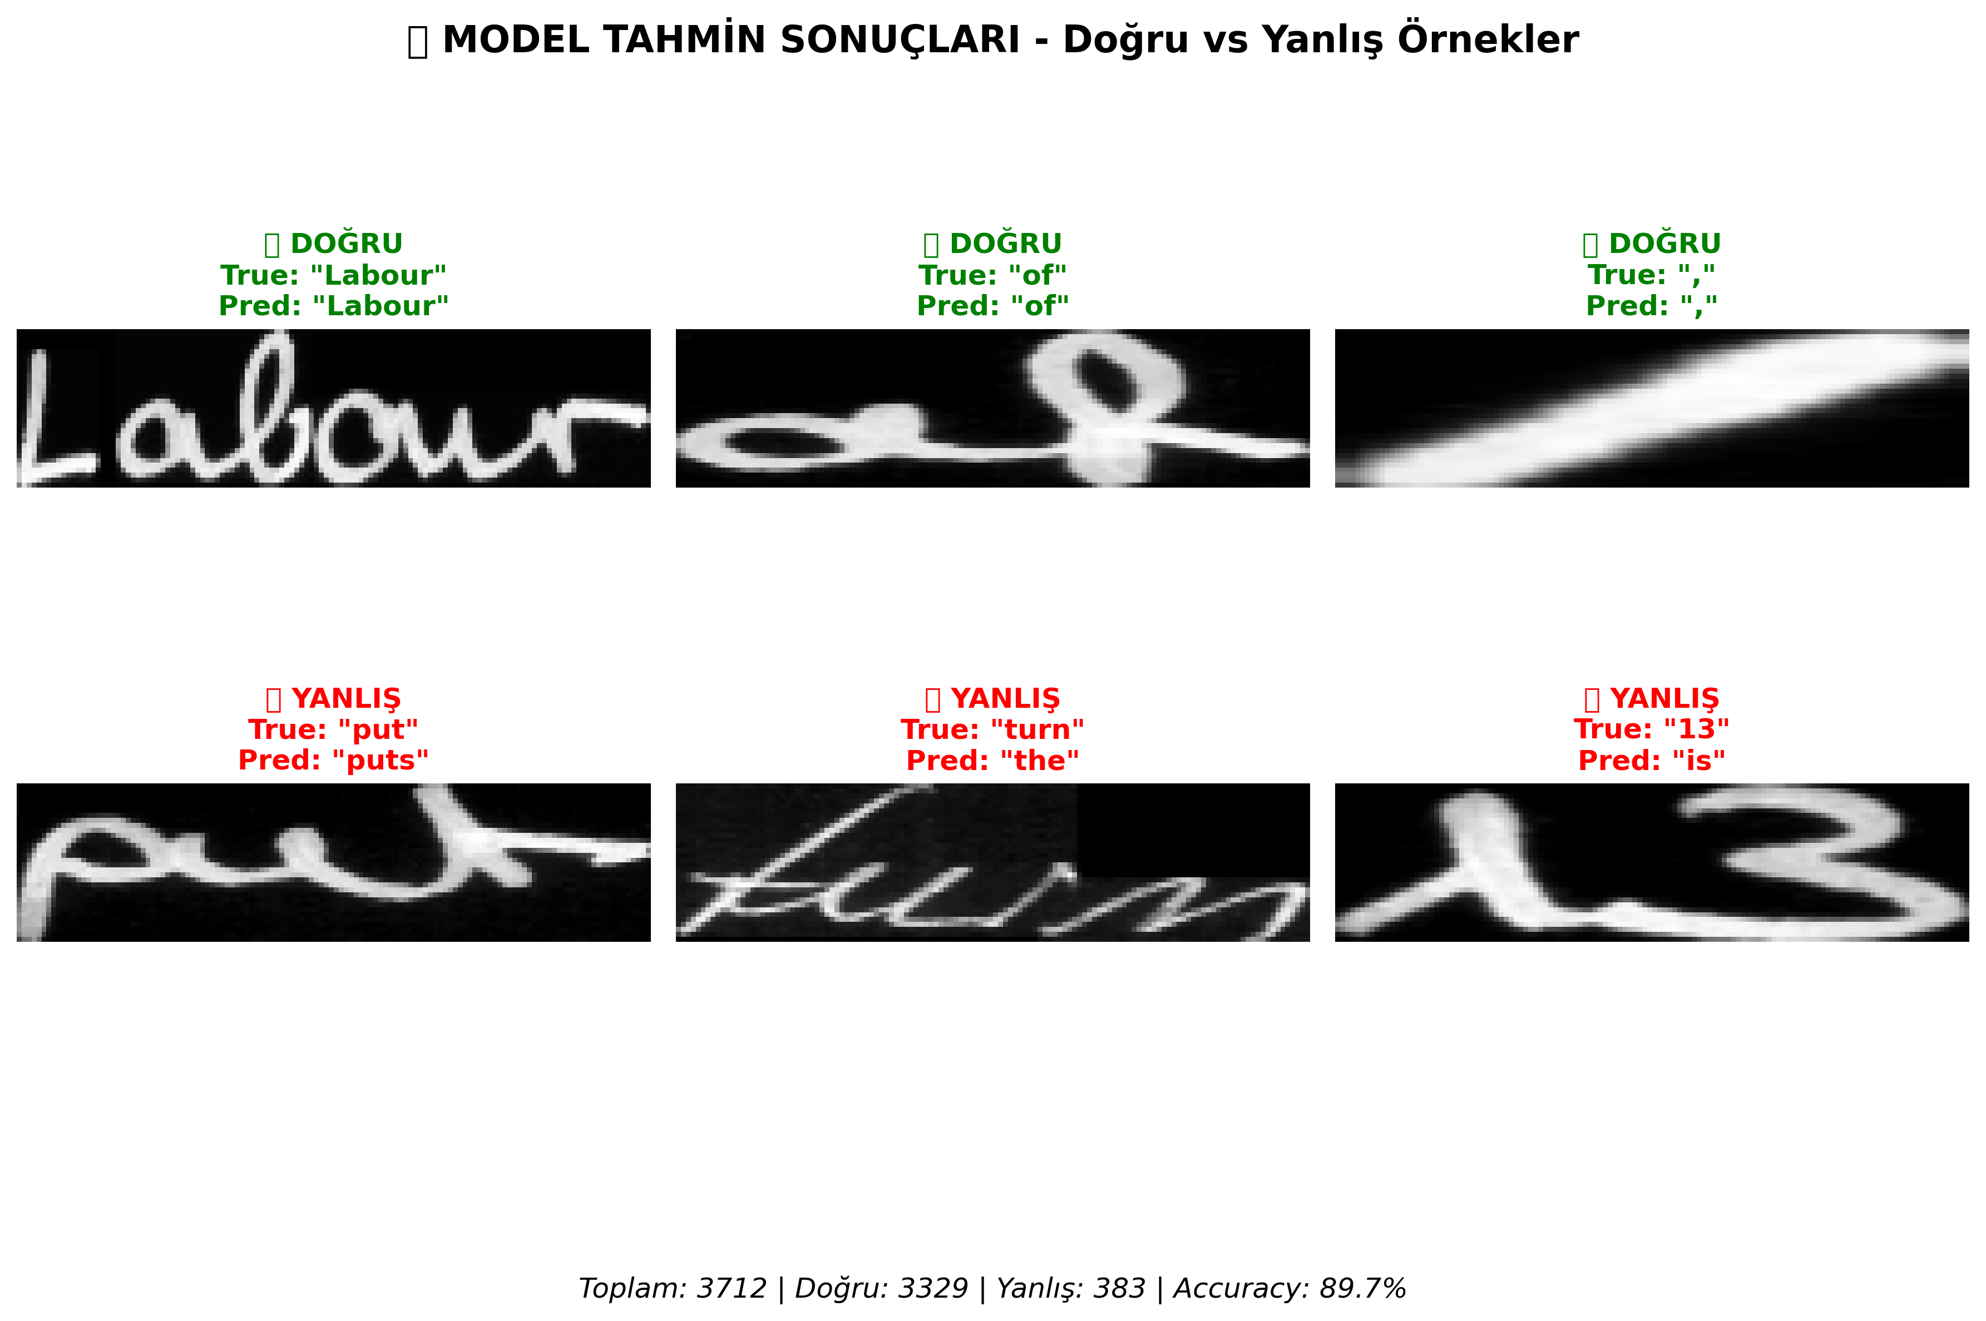
Figure 2. Representative correct (top row) and incorrect (bottom row) word-level predictions on the IAM validation set, illustrating the three error categories quantified above. Aggregate statistics: 3,712 samples, 3,329 correct (89.7%), 383 errors (10.3%). Notable failure modes shown: over-prediction ('put' → 'puts'), severe substitution ('turn' → 'the'), and digit-letter confusion ('13' → 'is').
5.6. Training Dynamics
Training loss decreases monotonically from 5.254 to 0.046 over 50 epochs (best validation WA at epoch 42), while validation loss plateaus at approximately 0.293 after epoch 33. The ReduceLROnPlateau scheduler triggers reductions at epochs 33, 39, 42, 45, and 48, with each reduction producing a measurable decrease in validation loss. The training-validation loss gap at convergence (0.046 vs. 0.293) indicates moderate overfitting that is partially but not fully mitigated by our augmentation regime, suggesting that additional augmentation or stronger regularization could yield marginal further improvement.
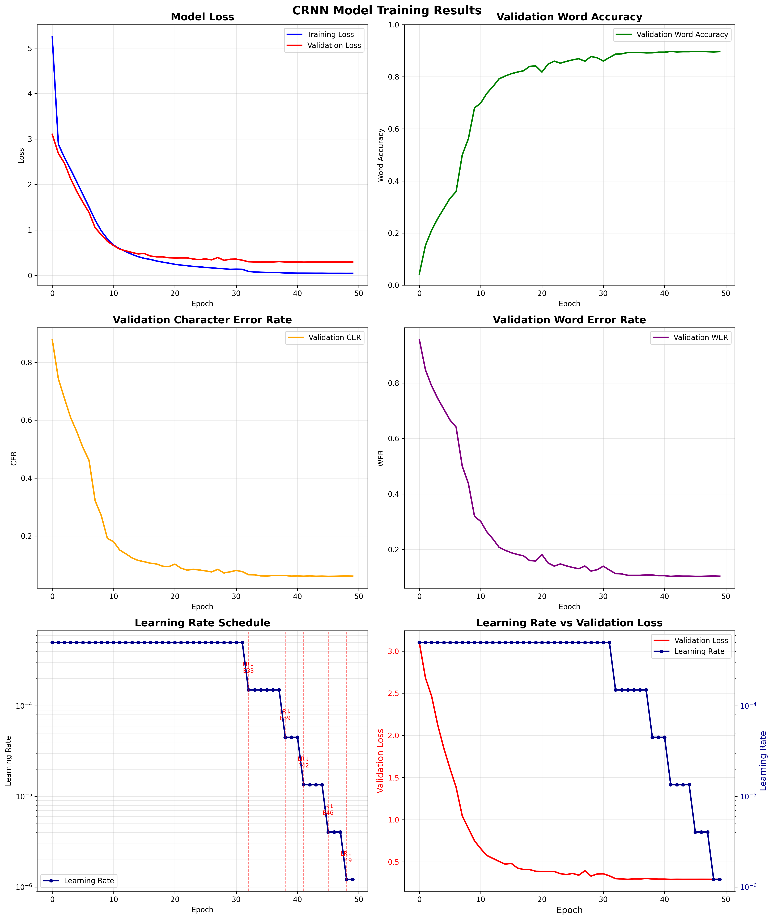
Figure 3. Training dynamics over 50 epochs. Top row: training/validation loss (left), validation word accuracy (right). Middle row: validation CER (left), validation WER (right). Bottom row: learning-rate schedule (left), validation loss versus learning rate (right). Each ReduceLROnPlateau step (epochs 33, 39, 42, 45, 48) is followed by a measurable validation-loss reduction.
5.7. Cross-Writer Qualitative Evaluation
To provide preliminary evidence that the pipeline generalizes beyond the writers seen during training—an important question given the custom-split caveat in Section 4.1—we evaluated the deployed system on an out-of-distribution sample: a paragraph of handwritten English text contributed by a writer not present in the IAM corpus and captured at low resolution on a scanned page. Figures 4–7 illustrate the four stages of the pipeline operating on this sample.
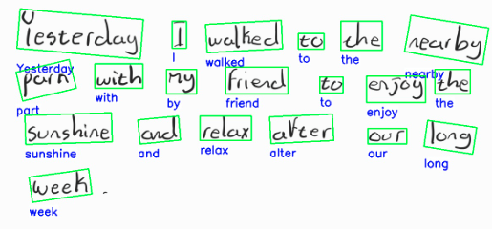
Figure 4. CRAFT detection on an out-of-distribution handwritten paragraph contributed by a writer not present in the IAM training set. Every word region is correctly localized (green bounding boxes), and the per-word raw CRNN predictions are displayed beneath each box. Several recognizable per-word errors are visible (e.g., 'Yeskerday' for 'Yesterday', 'rearby' for 'nearby', 'frienh' for 'friend'), motivating the linguistic post-processing layer.

Figure 5. Raw CRNN output (before language-model correction) for the paragraph shown in Figure 4. Visual ambiguities in the source handwriting produce character-level substitution errors that are typical of CTC-based decoders.
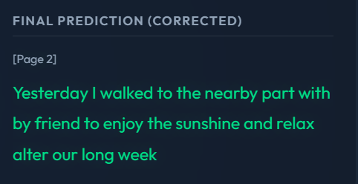
Figure 6. Final output after trigram language-model correction. Residual errors visible in Figure 5 ('Yeskerday' → 'Yesterday'; 'rearby pars' → 'nearby part'; 'ryy frienh' → 'by friend'; 'lon. weeh' → 'long week') are resolved by the Levenshtein-bounded vocabulary lookup combined with trigram scoring, restoring the semantic integrity of the paragraph.
We emphasize that the evaluation in Figures 4–6 is a single qualitative example rather than a controlled cross-writer benchmark, and we do not draw quantitative conclusions from it; its purpose is solely to indicate that the model's behavior on a held-out writer is qualitatively consistent with its behavior on the validation set. A full quantitative writer-disjoint evaluation on the Aachen split is the natural follow-up.
5.8. Discussion and Limitations
The proposed pipeline supports four claims, each grounded in the empirical evidence presented above.
Modularity is a deployment advantage. The decoupled architecture enables independent component replacement. The CRNN recognizer can be substituted with a transformer-based model without modifying detection or post-processing; the trigram language model can be retrained for domain-specific vocabularies (medical, legal, scientific) without neural retraining. This modularity contrasts with the monolithic nature of large pretrained encoder-decoder models, where domain adaptation typically requires fine-tuning the entire system.
Statistical post-processing is dramatically cost-effective. The trigram correction layer contributes +11.26 percentage points of word accuracy (Section 5.2) at <1 ms per word and no GPU compute, while introducing zero observed regression cases in our test. Even after accounting for the custom-split caveat, the magnitude of this effect is substantially larger than commonly assumed in the HTR literature and provides a strong empirical argument for including a constrained, interpretable LM correction layer in resource-constrained HTR systems.
Limitations. We are explicit about five limitations of this work. First, evaluation is currently limited to English text from the IAM dataset; generalization to other scripts (Turkish, Arabic, Cyrillic) requires language-specific vocabularies and additional training data. Second, the trigram model is built over a closed vocabulary, which fundamentally limits handling of out-of-vocabulary words (proper nouns, novel terms, code-switched content); a small neural rescorer (Section 3.5.1) is the natural extension. Third, CRAFT is used with its publicly released multilingual scene-text weights (craft_mlt_25k) without handwriting-specific fine-tuning, which may limit detection on documents with irregular layout. Fourth, word regions are recognized independently without sentence-level context; incorporating sentence-level features in the LM layer would likely improve performance on contextually ambiguous words. Fifth—and most important for the cross-paper comparability of the numbers in this paper—our evaluation uses the custom every-tenth-sample validation split rather than the writer-disjoint Aachen/RWTH partition, as discussed in Section 4.1. We treat re-evaluation on the writer-disjoint Aachen split as the highest-priority follow-up experiment for this work, alongside a controlled paired ablation of greedy versus beam-search decoding (Section 5.2).
6. Conclusion
This paper presented a resource-efficient, modular handwriting text recognition pipeline that integrates CRAFT-based detection [1], a CRNN backbone with CTC decoding [2,3], an adaptive image-enhancement stage, and a statistical trigram language model with Levenshtein-bounded candidate generation [4]. The pipeline trains from scratch in under 24 hours on a single GPU without external pretraining, contains approximately 8.75 M parameters, and reaches 89.68% [88.66%, 90.62%] word accuracy on a stratified validation split of the IAM Handwriting Database.
Two empirical findings are worth restating. First, the trigram language-model post-processing layer accounts for a +11.26 percentage-point absolute improvement over greedy CTC decoding (McNemar p < 10⁻⁹²), with zero observed regression cases in our test set; this is a substantially larger contribution than typically reported for post-processing in the HTR literature and motivates the inclusion of constrained, edit-distance-bounded LM correction in resource-constrained HTR systems. Second, the deliberate choice of a statistical trigram model rather than a neural language model preserves auditability, edge-deployment compatibility, and a hard upper bound on 'hallucinated' corrections—a set of properties that we argue (Section 3.5.1) are valuable for educational HTR deployment, even though raw accuracy could be increased by a small neural rescorer.
Three immediate follow-ups are planned: (i) re-evaluation on the writer-disjoint Aachen/RWTH split of IAM, which will provide cross-paper-comparable numbers and address the most important methodological caveat of this work; (ii) a fully controlled, paired ablation of greedy versus beam-search decoding under the same logging protocol used in Section 5.2; and (iii) integration of a small distilled neural rescorer (e.g., distilled BERT or a small decoder-only model used as a re-ranker over Levenshtein candidates), preserving the auditability and latency properties of the present pipeline while extending coverage to multi-word and grammatical errors. Longer-term extensions include multilingual support (Turkish and Arabic scripts in particular), CRAFT fine-tuning on handwritten layouts, and INT8 quantization for on-device inference.
References
[1] Y. Baek et al., 'Character region awareness for text detection,' in Proc. IEEE/CVF CVPR, 2019, pp. 9365–9374.
[2] B. Shi, X. Bai, and C. Yao, 'An end-to-end trainable neural network for image-based sequence recognition and its application to scene text recognition,' IEEE Trans. Pattern Anal. Mach. Intell., vol. 39, no. 11, pp. 2298–2304, 2017.
[3] A. Graves, S. Fernandez, F. Gomez, and J. Schmidhuber, 'Connectionist temporal classification: Labelling unsegmented sequence data with recurrent neural networks,' in Proc. ICML, 2006, pp. 369–376.
[4] V. I. Levenshtein, 'Binary codes capable of correcting deletions, insertions, and reversals,' Soviet Physics Doklady, vol. 10, no. 8, pp. 707–710, 1966.
[5] U.-V. Marti and H. Bunke, 'The IAM-database: An English sentence database for offline handwriting recognition,' Int. J. Document Anal. Recognit., vol. 5, no. 1, pp. 39–46, 2002.
[6] D. Vydeki, D. Bhandari, P. P. Patil, and A. A. Kulkarni, 'Towards Accessible Learning: Deep Learning-Based Potential Dysgraphia Detection and OCR for Potentially Dysgraphic Handwriting,' arXiv:2411.13595, 2024.
[7] S. Rakesh, P. Kushal Reddy, V. Prashanth, and K. Srinath Reddy, 'Handwritten text recognition using deep learning techniques: A survey,' MATEC Web of Conferences (ICMED 2024), vol. 392, art. 01126, 2024, doi:10.1051/matecconf/202439201126.
[8] C. Garrido-Munoz, A. Rios-Vila, and J. Calvo-Zaragoza, 'Handwritten Text Recognition: A Survey,' arXiv:2502.08417, 2025.
[9] G. Retsinas, G. Sfikas, B. Gatos, and C. Nikou, 'Best practices for a handwritten text recognition system,' arXiv:2404.11339, 2024.
[10] M. Li et al., 'TrOCR: Transformer-based optical character recognition with pre-trained models,' in Proc. AAAI, vol. 37, 2023, pp. 13094–13102.
[11] S. Mahadevkar, S. Patil, and K. Kotecha, 'Enhancement of handwritten text recognition using AI-based hybrid approach,' MethodsX, vol. 12, art. 102654, 2024, doi:10.1016/j.mex.2024.102654.
[12] Y. Li, D. Chen, T. Tang, and X. Shen, 'HTR-VT: Handwritten Text Recognition with Vision Transformer,' Pattern Recognition, 2024, doi:10.1016/j.patcog.2024.110967 (arXiv:2409.08573).
[13] P. T. T. Truc, D. H. Nam, H. T. D. Khoa, and V. N. L. Duy, 'HTR-ConvText: Leveraging Convolution and Textual Information for Handwritten Text Recognition,' arXiv:2512.05021, 2025.
[14] A. Lodh, R. Chakraborty, S. Palaiahnakote, and U. Pal, 'A Transformer Based Handwriting Recognition System Jointly Using Online and Offline Features,' arXiv:2506.20255, 2025.
[15] W. Gu, L. Gu, C. Y. Suen, and Y. Wang, 'MetaWriter: Personalized Handwritten Text Recognition Using Meta-Learned Prompt Tuning,' arXiv:2505.20513, 2025.
[16] G. Crosilla, L. Klic, and G. Colavizza, 'Benchmarking Large Language Models for Handwritten Text Recognition,' arXiv:2503.15195, 2025.
[17] R. Schwartz, J. Dodge, N. A. Smith, and O. Etzioni, 'Green AI,' Communications of the ACM, vol. 63, no. 12, pp. 54–63, 2020.
[18] E. J. Husom, A. Goknil, M. Astekin, L. K. Shar, A. Kåsen, S. Sen, B. A. Mithassel, and A. Soylu, 'Sustainable LLM Inference for Edge AI: Evaluating Quantized LLMs for Energy Efficiency, Output Accuracy, and Inference Latency,' arXiv:2504.03360, 2025.
[19] E. Cruciani and R. Verdecchia, 'Choosing to Be Green: Advancing Green AI via Dynamic Model Selection,' arXiv:2509.19996, 2025.
[20] G. Sobhani, M. M. A. Ifath, T. Sharma, and I. Haque, 'On the Sustainability of AI Inferences in the Edge,' arXiv:2507.23093, 2025.
[21] J. Matas, O. Chum, M. Urban, and T. Pajdla, 'Robust wide-baseline stereo from maximally stable extremal regions,' in Proc. BMVC, 2002, pp. 384–393.
[22] Q. Ye and D. Doermann, 'Text detection and recognition in imagery: A survey,' IEEE Trans. Pattern Anal. Mach. Intell., vol. 37, no. 7, pp. 1480–1500, 2015.
[23] X. Zhou et al., 'EAST: An efficient and accurate scene text detector,' in Proc. IEEE CVPR, 2017, pp. 5551–5560.
[24] Z. Tian et al., 'Detecting text in natural image with connectionist text proposal network,' in Proc. ECCV, 2016, pp. 56–72.
[25] M. Liao et al., 'Real-time scene text detection with differentiable binarization,' in Proc. AAAI, vol. 34, 2020, pp. 11474–11481.
[26] A. Setiawan, K. Gunadi, and M. Y. Mahardika, 'Comparison for Handwritten Character Recognition and Handwritten Text Recognition and Tesseract Tool on IJAZAh's Handwriting,' in Intelligent Computing and Optimization (ICO 2023), LNNS, vol. 853, Springer, Cham, 2023.
[27] J. Puigcerver, 'Are multidimensional recurrent layers really necessary for handwritten text recognition?,' in Proc. ICDAR, 2017, pp. 67–72.
[28] T. Bluche and R. Messina, 'Gated convolutional recurrent neural networks for multilingual handwriting recognition,' in Proc. ICDAR, 2017, pp. 646–651.
[29] D. H. Nam, H. T. D. Khoa, and V. N. L. Duy, 'WriteViT: Handwritten Text Generation with Vision Transformer,' arXiv:2505.13235, 2025.
[30] L. Kang, M. Rusinol, A. Fornes, P. Riba, and M. Villegas, 'Pay attention to what you read: Non-recurrent handwritten text-line recognition,' Pattern Recognition, vol. 129, art. 108766, 2022.
[31] R. Smith, 'An overview of the Tesseract OCR engine,' in Proc. ICDAR, 2007, pp. 629–633.
[32] H. Scheidl, S. Fiel, and R. Sablatnig, 'Word Beam Search: A Connectionist Temporal Classification Decoding Algorithm,' in Proc. ICFHR, 2018, pp. 253–258.
[33] S. Guan, M. Lin, C. Xu, X. Liu, J. Zhao, J. Fan, Q. Xu, and D. Greene, 'PreP-OCR: A Complete Pipeline for Document Image Restoration and Enhanced OCR Accuracy,' arXiv:2505.20429, 2025.
[34] K. Kukich, 'Techniques for automatically correcting words in text,' ACM Computing Surveys, vol. 24, no. 4, pp. 377–439, 1992.
[35] D. Jurafsky and J. H. Martin, Speech and Language Processing, 3rd ed. (online draft updated 2025), Stanford University, 2025 — chapter on spelling correction and the noisy-channel model.
[36] J. Devlin, M.-W. Chang, K. Lee, and K. Toutanova, 'BERT: Pre-training of deep bidirectional transformers for language understanding,' in Proc. NAACL, 2019, pp. 4171–4186.
[37] N. Otsu, 'A threshold selection method from gray-level histograms,' IEEE Trans. Syst. Man Cybern., vol. 9, no. 1, pp. 62–66, 1979.
[38] J. Sauvola and M. Pietikäinen, 'Adaptive document image binarization,' Pattern Recognition, vol. 33, no. 2, pp. 225–236, 2000.
[39] K. Zuiderveld, 'Contrast limited adaptive histogram equalization,' in Graphics Gems IV, Academic Press, 1994, pp. 474–485.
[40] A. Buades, B. Coll, and J.-M. Morel, 'A non-local algorithm for image denoising,' in Proc. IEEE CVPR, vol. 2, 2005, pp. 60–65.
[41] K. Simonyan and A. Zisserman, 'Very deep convolutional networks for large-scale image recognition,' in Proc. ICLR, 2015.
[42] S. Ioffe and C. Szegedy, 'Batch normalization: Accelerating deep network training by reducing internal covariate shift,' in Proc. ICML, 2015, pp. 448–456.
[43] S. Hochreiter and J. Schmidhuber, 'Long short-term memory,' Neural Computation, vol. 9, no. 8, pp. 1735–1780, 1997.
[44] D. P. Kingma and J. Ba, 'Adam: A method for stochastic optimization,' in Proc. ICLR, 2015.
[45] E. B. Wilson, 'Probable inference, the law of succession, and statistical inference,' Journal of the American Statistical Association, vol. 22, no. 158, pp. 209–212, 1927.
[46] Q. McNemar, 'Note on the sampling error of the difference between correlated proportions or percentages,' Psychometrika, vol. 12, no. 2, pp. 153–157, 1947.
[47] T. G. Dietterich, 'Approximate statistical tests for comparing supervised classification learning algorithms,' Neural Computation, vol. 10, no. 7, pp. 1895–1923, 1998.

