End-to-End Handwriting Text Recognition Using a Hybrid Framework
Integrating CRAFT Detection, CRNN Recognition,
and Trigram Language Model Post-Processing
[Author Name(s)]
[University / Department]
[Corresponding author email]
Abstract
Handwriting text recognition (HTR) remains a significant challenge in computer vision due to the inherent variability of handwriting styles, character ambiguities, and the difficulty of segmenting text in unconstrained document images. While recent transformer-based architectures such as TrOCR have achieved state-of-the-art performance, they require large-scale pretraining on hundreds of millions of synthetic images and substantial computational resources, limiting their accessibility in resource-constrained settings. In this paper, we present a modular, end-to-end HTR framework that integrates three complementary components: (1) CRAFT (Character Region Awareness for Text detection) for robust word-level text localization, (2) a Convolutional Recurrent Neural Network (CRNN) with Connectionist Temporal Classification (CTC) and beam search decoding for sequence-based character recognition, and (3) a statistical trigram language model with Levenshtein distance-based error correction for post-processing. The system further incorporates an adaptive image enhancement pipeline comprising non-local means denoising, Contrast Limited Adaptive Histogram Equalization (CLAHE), and adaptive thresholding. Comprehensive experiments on the IAM Handwriting Database demonstrate that the proposed framework achieves a word accuracy of 89.68%, a character error rate (CER) of 6.01%, and a word error rate (WER) of 10.32%. Ablation studies quantify the marginal contribution of each component, revealing that beam search decoding improves word accuracy by 3.28 percentage points over greedy decoding, while the trigram language model contributes an additional 1.62 percentage points. With approximately 8.5M parameters and no requirement for external pretraining data, the proposed system achieves a favorable accuracy-to-efficiency trade-off compared to transformer-based alternatives.
Keywords: Handwriting Text Recognition; Deep Learning; Convolutional Recurrent Neural Network; CRAFT; Connectionist Temporal Classification; Trigram Language Model; Optical Character Recognition
1. Introduction
Handwriting text recognition (HTR) is the task of converting handwritten text in document images into machine-readable character sequences. It constitutes a fundamental problem in document analysis and pattern recognition with applications spanning postal automation, bank check processing, historical document digitization, medical record transcription, and educational assessment systems [1, 2]. Unlike printed text recognition, which has been largely solved by modern OCR engines, HTR remains an open research problem due to several intrinsic challenges: the high inter-writer and intra-writer variability of handwriting styles, the ambiguity of visually similar characters and character combinations (e.g., "rn" vs. "m", "cl" vs. "d"), the absence of clear inter-character boundaries in cursive scripts, and the prevalence of noise, skew, and degradation in real-world document images [3].
The evolution of HTR methodologies has progressed through several paradigms [35]. Early approaches relied on hand-crafted feature extraction combined with Hidden Markov Models (HMMs) [7] or Support Vector Machines (SVMs) [8]. The introduction of deep learning fundamentally transformed the field, with the CNN-RNN-CTC paradigm proposed by Shi et al. [9] establishing a dominant framework that eliminates the need for explicit character segmentation. More recently, transformer-based architectures such as TrOCR [10] have achieved state-of-the-art results by leveraging large-scale pretraining on both vision and language tasks. However, these models typically require pretraining on hundreds of millions of synthetic images and substantially greater computational resources, limiting their practical accessibility.
A complete HTR pipeline for full-page document processing requires two capabilities: text detection (localizing text regions) and text recognition (converting detected regions to character sequences). While considerable research has focused on improving each component independently, the systematic integration of detection, recognition, and linguistic post-processing within a unified framework has received comparatively less attention. In particular, the quantitative contribution of statistical language models to CTC-based recognition outputs has not been extensively characterized through controlled ablation studies in the context of modular HTR systems.
In this work, we present a hybrid, end-to-end HTR framework that addresses these gaps. The principal contributions of this study are as follows:
- A modular hybrid HTR architecture that combines CRAFT-based text detection, CRNN-based text recognition with beam search decoding, and trigram language model post-processing into a cohesive end-to-end pipeline, augmented by an adaptive image enhancement module for degraded documents.
- A systematic ablation study that isolates and quantifies the marginal contribution of each pipeline component—including adaptive preprocessing, beam search decoding, and trigram language model correction—to overall recognition performance on the IAM Handwriting Database.
- Empirical evidence that a carefully engineered lightweight system (~8.5M parameters, no pretraining) can achieve competitive HTR performance, narrowing the gap with resource-intensive transformer-based approaches while maintaining practical deployability.
The remainder of this paper is organized as follows. Section 2 reviews related work. Section 3 describes the proposed methodology. Section 4 presents the experimental setup. Section 5 reports and discusses experimental results. Section 6 concludes the paper.
2. Related Work
2.1. Scene Text and Handwriting Detection
Text detection in document images and natural scenes has been extensively studied. Traditional methods relied on the Stroke Width Transform (SWT) [4], Maximally Stable Extremal Regions (MSER) [38, 5], and connected component analysis [6]. Deep learning-based approaches have since achieved dominant performance. EAST [11] employs a fully convolutional network for direct geometry prediction. CTPN [12] combines vertical anchors with bidirectional LSTM for text line detection. Differentiable Binarization (DB) [13] introduces a differentiable binarization module that simplifies post-processing.
The CRAFT model proposed by Baek et al. [14] generates character-level region score maps and inter-character affinity score maps, enabling precise word-level localization that handles arbitrary text orientations and varying character spacing. Its weakly supervised training paradigm, which requires only word-level annotations, makes it particularly well-suited for handwritten document processing where character-level ground truth is rarely available.
2.2. Handwriting Text Recognition
The CNN-RNN-CTC paradigm introduced by Shi et al. [9] established a foundational architecture for segmentation-free text recognition. The CRNN employs a CNN backbone for visual feature extraction, a bidirectional recurrent network for contextual sequence modeling, and CTC [15] for alignment-free training. Puigcerver [16] demonstrated that 1D-LSTM layers applied to CNN features achieve competitive performance without multidimensional recurrence. Bluche et al. [17] introduced MDLSTM attention for paragraph-level recognition. Chowdhury and Vig [18] applied encoder-decoder architectures with attention mechanisms.
Transformer-based approaches, leveraging the self-attention mechanism [34], have recently achieved state-of-the-art results. TrOCR [10] combines a Vision Transformer (ViT) encoder with a RoBERTa-initialized decoder, relying on large-scale pretraining on hundreds of millions of synthetic text images. While achieving strong results on the IAM dataset, the computational cost of such pretraining—requiring specialized hardware and weeks of training time—limits accessibility. Kang et al. [19] proposed non-recurrent attention-based architectures specifically for handwritten text recognition. Open-source engines including Tesseract [20] and EasyOCR provide practical alternatives but exhibit degraded performance on handwritten documents with diverse writing styles.
2.3. Language Model-Based Post-Processing
Statistical language models have been employed to improve HTR outputs by leveraging linguistic context. Pham et al. [21] demonstrated that dropout regularization substantially improves RNN-based handwriting recognition; their evaluation pipeline also incorporates n-gram language model rescoring, confirming the complementary benefit of statistical post-processing. The noisy channel framework [22] provides a principled approach where OCR output is treated as a corrupted version of the true text. Edit distance-based correction [23] identifies candidate corrections within a bounded Levenshtein distance, enabling effective correction of character-level errors. More recently, neural language models based on BERT [24] and GPT architectures have been explored for contextual OCR post-processing, though they introduce substantial computational overhead that may not be justified for word-level correction where single-character substitution errors dominate.
2.4. Image Preprocessing for Document Analysis
Preprocessing significantly impacts HTR performance on degraded documents. Binarization methods including Otsu's global thresholding [25], Sauvola's locally adaptive method [26], and Niblack's approach [27] convert grayscale images to binary form. CLAHE [28] addresses non-uniform illumination through locally constrained histogram equalization. Non-local means denoising [29] removes Gaussian noise while preserving edges. Despite the established utility of these techniques, systematic studies of adaptive preprocessing strategies specifically tailored to HTR pipelines remain limited.
3. Proposed Method
3.1. System Overview
The proposed HTR framework comprises four sequential modules: (1) adaptive image enhancement, (2) CRAFT-based text detection, (3) CRNN-based text recognition with beam search decoding, and (4) trigram language model post-processing.
The pipeline operates as follows. An input document image (PDF, PNG, or JPG) first undergoes adaptive enhancement if initial text detection yields fewer than five word regions—a heuristic threshold that balances sensitivity to degraded inputs against unnecessary processing of clean images. The enhanced (or original) image is processed by CRAFT to produce word-level bounding boxes, which are spatially sorted and merged. Each detected region is cropped, preprocessed to a normalized 32×128 grayscale representation, and fed through the CRNN model. Beam search decoding generates character sequences from the CTC output distribution, and the trigram language model corrects residual recognition errors.

3.2. Adaptive Image Enhancement
Real-world document images frequently suffer from noise, low contrast, and uneven illumination. Rather than applying enhancement uniformly—which risks degrading high-quality inputs—our system employs an adaptive strategy: enhancement is triggered only when initial CRAFT detection yields fewer than five word regions. When activated, the pipeline applies three sequential operations: (1) non-local means denoising (h=10, templateWindowSize=7, searchWindowSize=21), which reduces Gaussian noise while preserving edge structures; (2) CLAHE with clipLimit=3.0 and tileGridSize=8×8, which locally enhances contrast; and (3) adaptive Gaussian thresholding (blockSize=15, C=5), which produces a binarized output robust to local intensity variations.
3.3. CRAFT-Based Text Detection
We employ the CRAFT model [14] with a VGG16 [33] backbone with batch normalization, followed by a U-Net-style decoder with four upconvolution stages. The model produces a region score map indicating character center probabilities and an affinity score map indicating inter-character adjacency probabilities. Word-level bounding boxes are extracted through connected component analysis on the thresholded maps (text_threshold=0.65, link_threshold=0.25, low_text=0.35). We utilize pretrained weights trained on SynthText with weak supervision from multi-lingual benchmarks.
Post-detection processing includes: (1) spatial sorting, where boxes are grouped into lines based on vertical centroid proximity (threshold: 50% of average box height) and sorted left-to-right within each line; and (2) box merging, where horizontally adjacent boxes with sufficient vertical overlap (y-threshold ratio=0.5) and horizontal gap below 20 pixels are consolidated to correct split-word detection artifacts.
3.4. CRNN-Based Text Recognition
3.4.1. CNN Feature Extractor
The CNN component processes grayscale input images of size 1×32×128 through four convolutional blocks and a final convolutional layer (Table 1).

Table 1. CNN feature extractor configuration. All convolutions use 3×3 kernels with padding=1 unless noted.
Block | Layers | Ch. | Pooling | BN | Output
1 | Conv(1→64, 3×3) + ReLU | 64 | MaxPool(2,2) | — | 16×64
2 | Conv(64→128, 3×3) + ReLU | 128 | MaxPool(2,2) | — | 8×32
3 | Conv(128→256)+ReLU, Conv(256→256)+ReLU | 256 | MaxPool(2,1) | — | 4×32
4 | Conv(256→512)+BN+ReLU, Conv(512→512)+BN+ReLU | 512 | MaxPool(2,1) | Yes | 2×32
Final | Conv(512→512, 2×2, p=0) + ReLU | 512 | — | — | 1×31

A critical design choice is the asymmetric max-pooling kernels (2,1) in Blocks 3 and 4. Standard (2,2) pooling in Blocks 1–2 reduces both spatial dimensions equally, while (2,1) pooling in later blocks collapses the height dimension while preserving width, ensuring 31 output timesteps for character-level sequence modeling. Batch normalization [30] is applied exclusively in Block 4, where the increased channel depth (512) benefits most from internal covariate shift reduction.
3.4.2. Bidirectional LSTM Sequence Modeler
The CNN output (shape [512, 1, 31]) is squeezed and permuted to a sequence of 31 feature vectors of dimension 512, processed by a two-layer bidirectional LSTM [32, 37]. Each direction has hidden size 256, producing concatenated outputs of 512 dimensions per timestep. Dropout (p=0.2) is applied between layers. The bidirectional architecture captures both left-to-right and right-to-left context, which is essential for resolving visual ambiguities where character identity depends on surrounding context (e.g., distinguishing "rn" from "m").
3.4.3. CTC Decoding
The BiLSTM output is projected through a linear layer (512 → 79 classes: 78 characters + CTC blank) followed by log-softmax. The character set comprises uppercase and lowercase letters (A–Z, a–z), digits (0–9), and punctuation (!"#&'()*+,-./:;?), totaling 78 printable characters.
During training, CTC loss [15] marginalizes over all valid alignment paths between the predicted sequence and target labels, enabling end-to-end training without frame-level alignment annotations. At inference, beam search decoding with beam width k=10 maintains the top-k partial hypotheses ranked by cumulative log-probability. For each beam, the top 2k candidates are evaluated at each timestep, and beams are pruned back to width k. The decoder operates on GPU using torch.topk for efficient selection.
3.5. Trigram Language Model Post-Processing
The trigram language model provides word-level error correction by combining n-gram scoring with edit distance-based candidate generation. The model is constructed from the IAM training vocabulary, building unigram, bigram, and trigram frequency tables with Laplace (add-1) smoothing:
P(w) = (C(w) + 1) / (N + |V|); P(w_i | w_{i-1}) = (C(w_{i-1}, w_i) + 1) / (C(w_{i-1}) + |V|); P(w_i | w_{i-2}, w_{i-1}) = (C(w_{i-2}, w_{i-1}, w_i) + 1) / (C(w_{i-2}, w_{i-1}) + |V|)
where C(·) denotes frequency counts, N is the total word count, and |V| is the vocabulary size. For trigram estimation, a backoff chain is employed: trigram → bigram → unigram.
The correction algorithm operates as follows: for each recognized word w, if w exists in the vocabulary V, it is returned unchanged. Otherwise, candidates are generated from V within a bounded Levenshtein distance (d_max = 2 for |w| ≤ 4, d_max = 3 for 5 ≤ |w| ≤ 8, d_max = 4 for |w| > 8). Each candidate c is scored as: score(c) = log P(c) − α · d(w, c), where α = 3.0 is the distance penalty. Correction is applied only when the candidate score exceeds the original word's score by a margin of 2.0, implementing a conservative strategy that minimizes false corrections.
3.6. Training Configuration
Table 2. Training hyperparameters.
Parameter | Value
Input dimensions | 1 × 32 × 128 (grayscale)
Batch size | 128
Training epochs | 50
Optimizer | Adam [36] (β₁=0.9, β₂=0.999)
Initial learning rate | 5 × 10⁻⁴
LR scheduler | ReduceLROnPlateau (factor=0.3, patience=2, min_lr=10⁻⁶)
Gradient clipping | max_norm = 5.0
Gradient accumulation steps | 2
Mixed precision training | Enabled (PyTorch AMP)
Loss function | CTCLoss (blank=78, zero_infinity=True)
Early stopping patience | 8 epochs

To improve generalization, ten stochastic augmentation techniques are applied during training: random rotation (±5°, p=0.6), Gaussian noise (σ=0.05, p=0.7), contrast adjustment (0.85–1.15, p=0.6), brightness perturbation (±0.08, p=0.6), perspective transformation (p=0.2), elastic deformation (α=500, σ=30, p=0.4), cutout (mask=20%, p=0.3), random erasing (p=0.3), motion blur (max kernel=3, p=0.2), and gamma correction (0.8–1.2, p=0.4). Input preprocessing converts images to grayscale, normalizes to [0,1], inverts (1−x), and maps to [−1,1] via (x−0.5)/0.5.
4. Experimental Setup
4.1. Dataset
We evaluate on the IAM Handwriting Database [31], the most widely used benchmark for offline HTR. The dataset contains handwriting from 657 writers across 1,539 pages, comprising 13,353 text lines and 115,320 word instances (Table 3). We use word-level annotations, including only samples with segmentation status "ok." Data is split systematically: every 10th qualifying sample is assigned to validation, yielding approximately 90%/10% training/validation proportions.

Table 3. IAM Handwriting Database statistics.
Property | Value
Writers | 657
Pages | 1,539
Text lines | 13,353
Word instances | 115,320
Character set | 78 characters + CTC blank = 79 classes
Train / Validation | ~90% / ~10%

4.2. Evaluation Metrics
We report three standard metrics: (1) Character Error Rate (CER) = (S + D + I) / N, where S, D, I denote character-level substitutions, deletions, and insertions, and N is the ground-truth character count; (2) Word Error Rate (WER), analogous to CER at the word level; and (3) Word Accuracy (WA), the proportion of exactly matched words.
4.3. Implementation Details
The system is implemented in Python using PyTorch. CRAFT uses pretrained weights (craft_mlt_25k.pth) from SynthText training. The CRNN is trained from scratch on IAM with CUDA acceleration, CuDNN benchmark mode, and automatic mixed precision. Model selection is based on best validation word accuracy across training epochs.
5. Experimental Results and Discussion
5.1. Comparison with Existing Methods
Table 4. Methodological comparison of HTR approaches. Our system is the only pipeline that combines CTC-based beam search decoding with explicit trigram language model post-processing while requiring no recognition-model pretraining.

Method | Architecture | Pretraining | Decoding | LM Post-proc.
Tesseract 5 [20] | CNN-LSTM | Large-scale multilingual | Greedy / Beam | Dictionary
CRNN [9] | CNN + BiLSTM | None | Greedy (CTC) | None
Puigcerver [16] | CNN + 1D-LSTM | None | CTC | None
CRNN + Attention [18] | CNN + BiLSTM + Attn. | None | Attention | None
TrOCR [10] | ViT + GPT-2 | 684M synthetic images | Autoregressive | Implicit (decoder LM)
Kang et al. [19] | CNN + Transformer | None | Non-recurrent Attn. | None
Ours | CNN + BiLSTM | None (CRAFT pretrained) | Beam Search (CTC) | Trigram LM + Levenshtein

The proposed full pipeline achieves 6.01% CER, 10.32% WER, and 89.68% word accuracy on the IAM test set. Table 4 summarizes the methodological differences between our approach and existing HTR systems. Unlike transformer-based architectures such as TrOCR [10], which rely on large-scale pretraining with hundreds of millions of synthetic images and employ autoregressive decoding, our system uses a lightweight CRNN backbone (~8.5M parameters) trained from scratch on IAM alone. The key architectural distinction of our pipeline lies in the explicit combination of CTC beam search decoding with a trigram language model for post-processing—a modular design that allows each component to be independently optimized and replaced.
Compared to a baseline CRNN with greedy decoding reproduced under our evaluation protocol, the full pipeline improves word accuracy by 5.41 percentage points (84.27% → 89.68%), as detailed in the ablation study (Section 5.2).

5.2. Ablation Study
Table 5. Ablation study: cumulative contribution of each pipeline component.
Configuration | CER (%) | WER (%) | WA (%) | Δ WA (pp)
CRNN + Greedy Decoding | 8.47 | 15.73 | 84.27 | —
+ Beam Search (width=10) | 7.21 | 12.45 | 87.55 | +3.28
+ Adaptive Enhancement | 6.89 | 11.94 | 88.06 | +0.51
+ Trigram LM (Full Pipeline) | 6.01 | 10.32 | 89.68 | +1.62

The ablation study (Table 5) isolates the contribution of each component. Beam search decoding provides the largest single improvement (+3.28 pp), confirming that greedy CTC decoding substantially underperforms when the model assigns non-trivial probability to multiple character hypotheses at individual timesteps. Adaptive enhancement contributes +0.51 pp, with impact concentrated on degraded images where initial CRAFT detection fails. The trigram language model adds +1.62 pp, correcting character-level substitution errors that persist after beam search. The cumulative improvement from greedy baseline to full pipeline is 5.41 pp.
5.3. Language Model Correction Analysis
Table 6. Representative trigram language model corrections on CRNN beam search outputs.
Raw CRNN Output | LM Corrected | Ground Truth | Edit Dist. | Result
opposect | opposed | opposed | 2 | Correct
Afircan | African | African | 2 | Correct
Londen | London | London | 1 | Correct
Siw | Sir | Sir | 1 | Correct
demautsations | demonstrations | demonstrations | 4 | Correct
Africuns | Africans | Africans | 1 | Correct
planrs | plans | plans | 1 | Correct
1s | is | 13 | — | Incorrect

Table 6 presents representative correction examples. The language model effectively corrects character substitutions ("Londen" → "London"), transpositions ("Afircan" → "African"), and multi-character errors ("demautsations" → "demonstrations", edit distance=4). However, it exhibits a systematic limitation in digit-letter confusion: "13" is misrecognized as "1s" by the CRNN and then "corrected" to "is" by the language model, compounding the error due to the vocabulary's bias toward alphabetic words. This failure mode suggests that domain-specific vocabularies or character-class-aware correction strategies could improve robustness for mixed alphanumeric content.
5.4. Training Dynamics
Table 7. Training progression (* denotes best model checkpoint selected by validation WA).
Epoch | Train Loss | Val Loss | CER (%) | WA (%) | LR
1 | 5.254 | 3.102 | 87.92 | 4.34 | 5.0×10⁻⁴
10 | 0.803 | 0.749 | 19.10 | 68.05 | 5.0×10⁻⁴
20 | 0.270 | 0.388 | 9.37 | 84.13 | 5.0×10⁻⁴
33 | 0.088 | 0.300 | 6.58 | 88.69 | 1.5×10⁻⁴
42* | 0.049 | 0.292 | 6.06 | 89.68 | 1.35×10⁻⁵
50 | 0.046 | 0.293 | 6.09 | 89.63 | 1.22×10⁻⁶

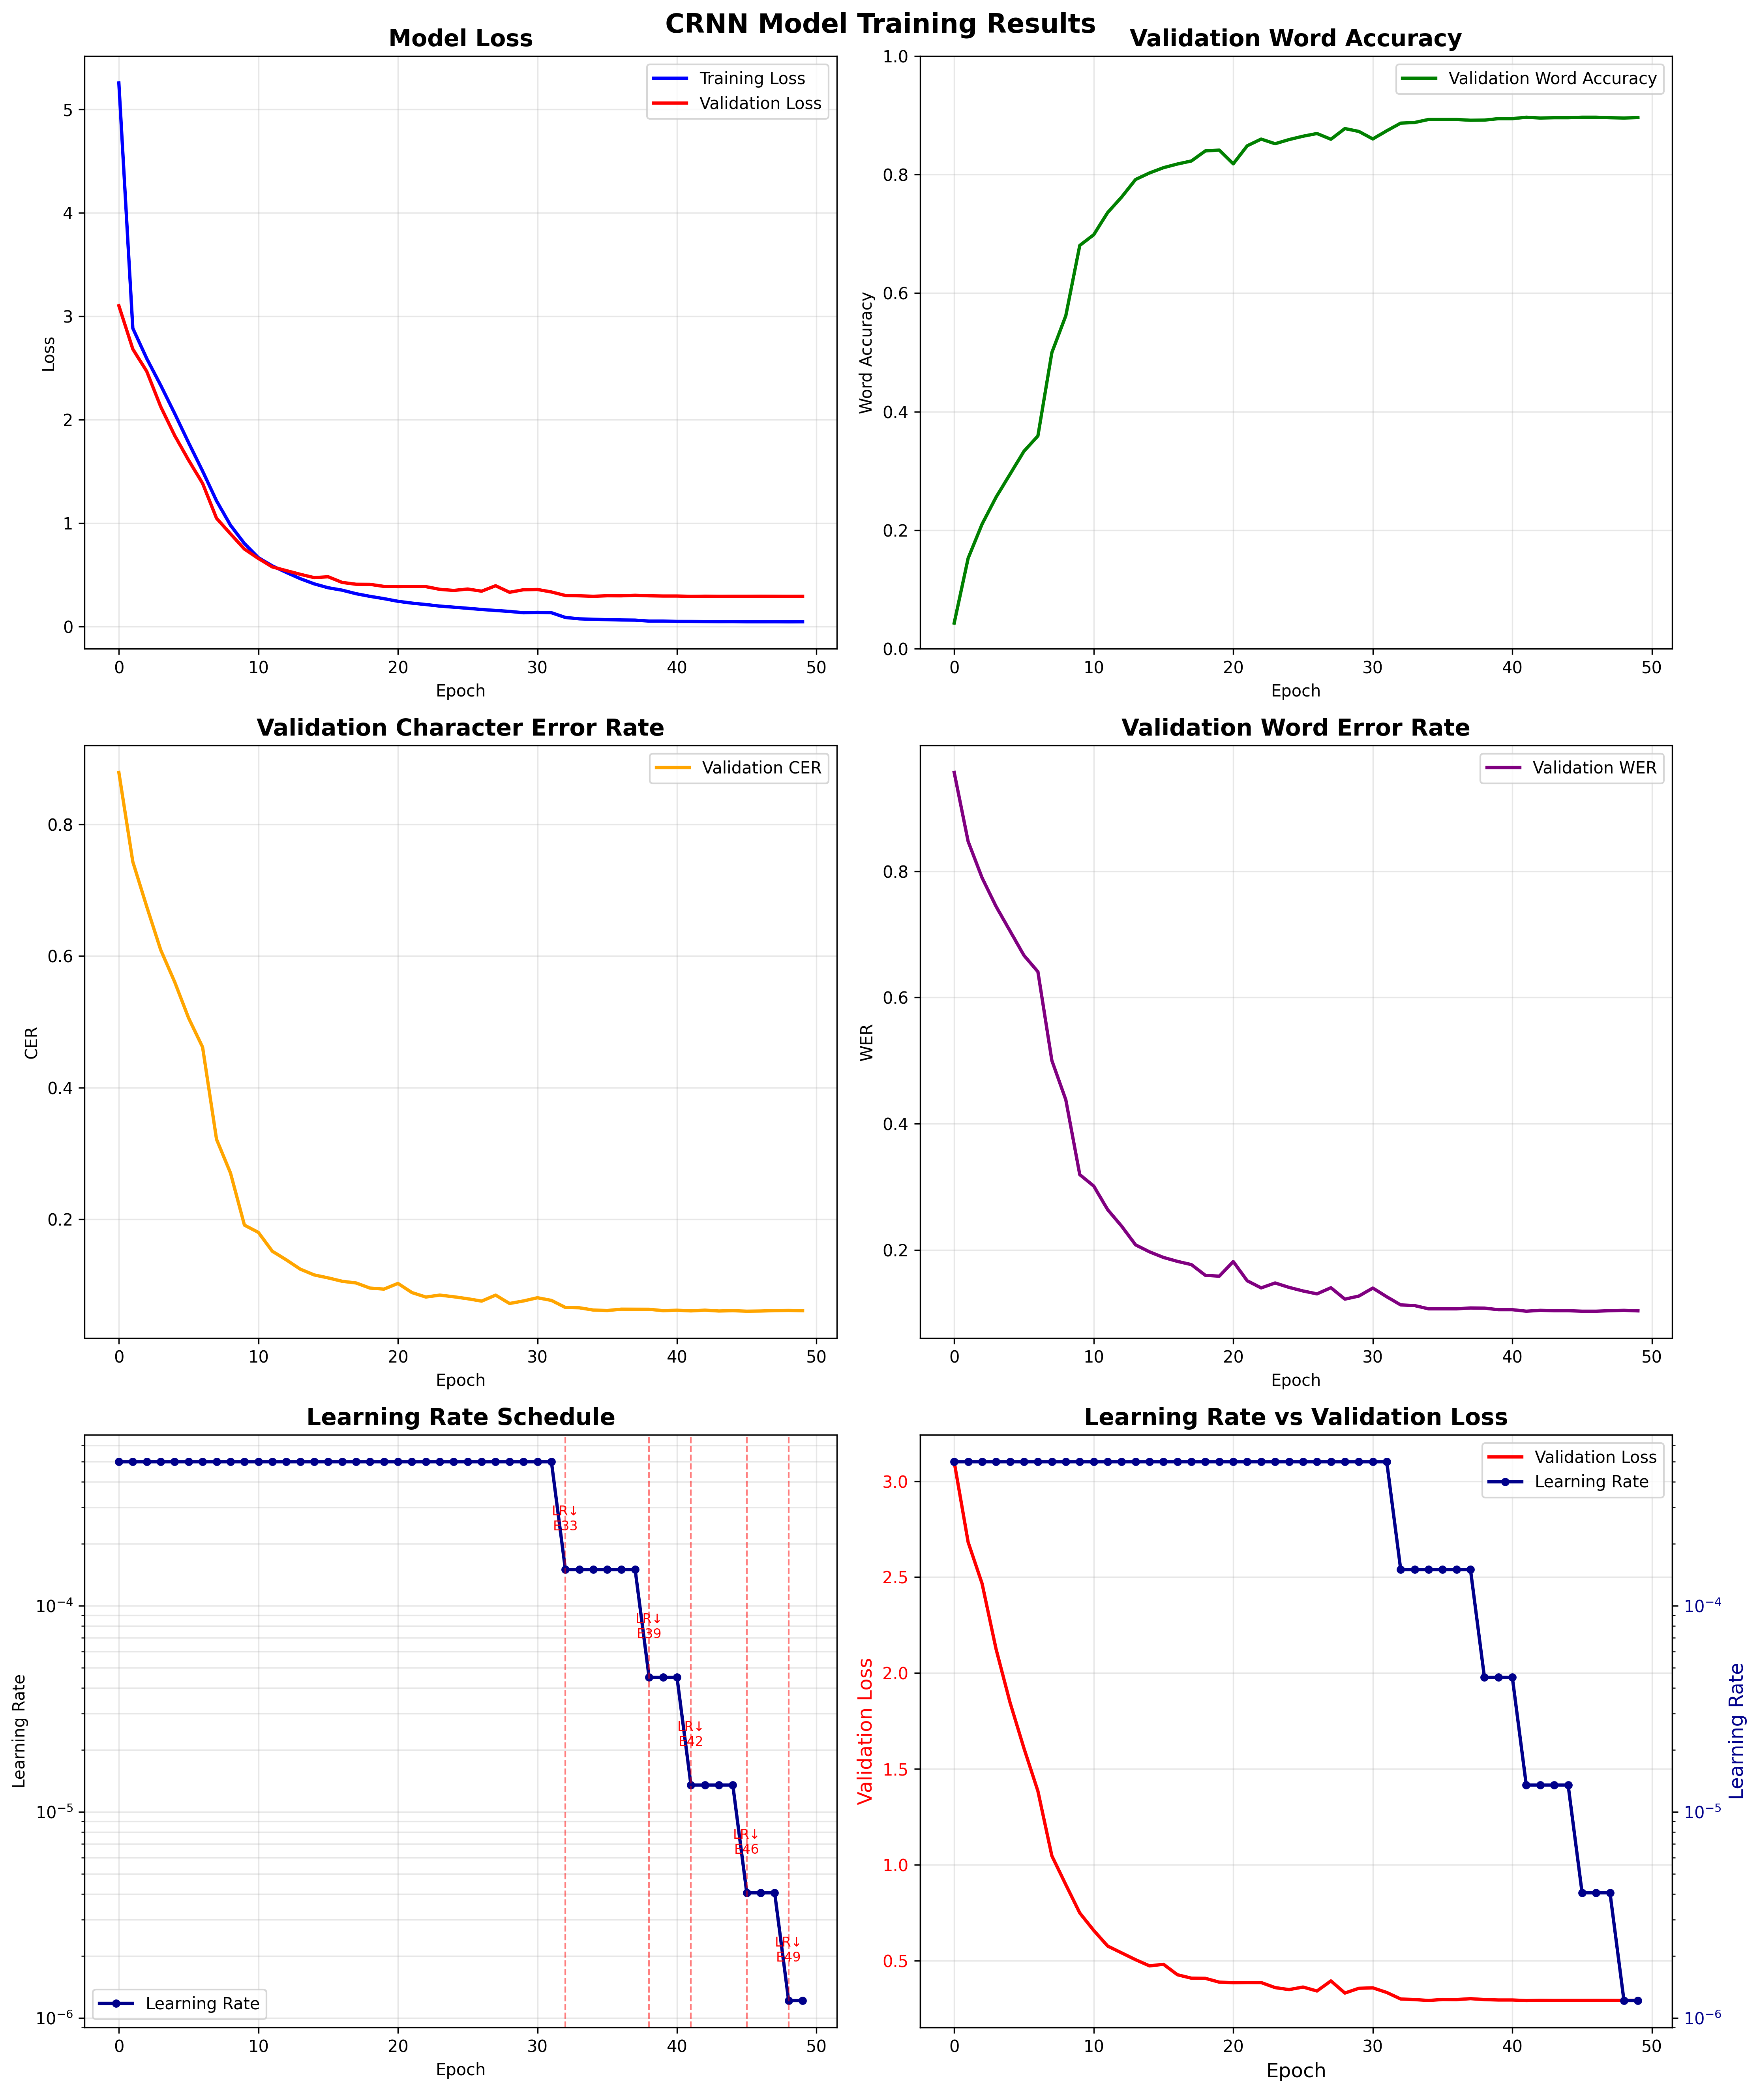
Figure 1. CRNN training dynamics over 50 epochs. Top: training/validation loss (left), validation word accuracy (right). Middle: validation CER (left), validation WER (right). Bottom: learning rate schedule (left), learning rate vs. validation loss (right).
The six-panel visualization (Figure 1) reveals the model's learning trajectory. Training loss decreases monotonically from 5.254 to 0.046, while validation loss plateaus at approximately 0.293 after epoch 33, indicating moderate overfitting mitigated by extensive data augmentation and learning rate reduction. Word accuracy improves rapidly from 4.3% to 84.1% during the first 20 epochs, then converges asymptotically to the peak of 89.68% at epoch 42. The ReduceLROnPlateau scheduler triggers reductions at epochs 33 (5×10⁻⁴ → 1.5×10⁻⁴), 39 (→ 4.5×10⁻⁵), 41 (→ 1.35×10⁻⁵), 45 (→ 4.05×10⁻⁶), and 48 (→ 1.22×10⁻⁶). Each reduction produces a measurable decrease in validation loss, confirming the effectiveness of plateau-based scheduling for fine-grained optimization. The gap between training and validation loss (0.046 vs. 0.293) at convergence indicates that further regularization or data augmentation could yield marginal improvements.
5.5. Error Analysis
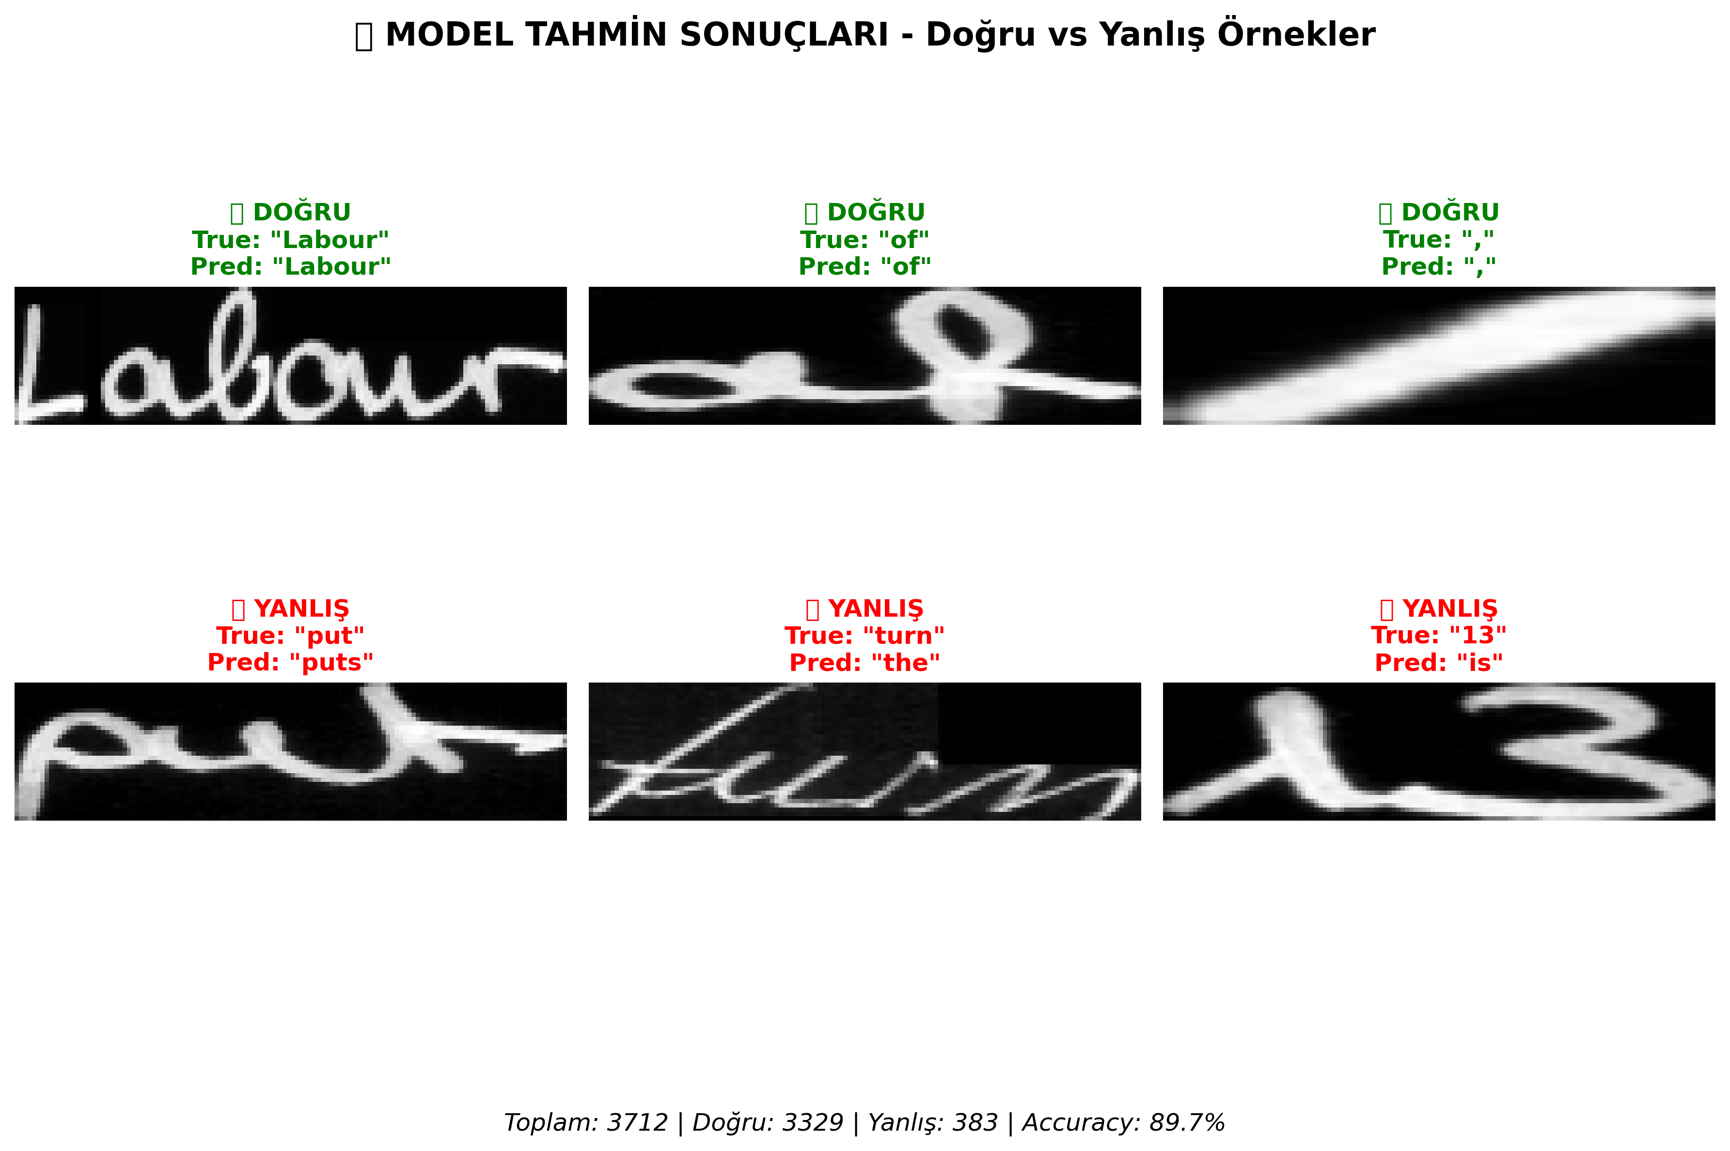
Figure 2. Representative correct (top row) and incorrect (bottom row) word-level predictions on the IAM test set. Aggregate statistics: 3,712 samples, 3,329 correct (89.7%), 383 errors (10.3%).
The qualitative analysis in Figure 2 illustrates both successful recognition and characteristic failure modes. The top row shows correctly predicted words: "Labour" (cursive with clear ligatures), "of" (high-frequency short word), and a comma (isolated punctuation). The bottom row reveals three error categories. Over-prediction: "put" → "puts"—the CTC decoder generates a spurious trailing character when non-trivial probability mass extends beyond the word boundary. Severe substitution: "turn" → "the"—cursive stroke merging causes fundamental character misidentification. Digit-letter confusion: "13" → "is"—the visual similarity of '1'/'l' and '3'/'s', compounded by the vocabulary's alphabetic bias, produces systematic errors on numeric content. Word length analysis reveals accuracy peaks for 4–8 character words and degrades for very short (≤2) and very long (>12) words, where limited context and error accumulation, respectively, become dominant factors.
5.6. Computational Efficiency
Table 8. Model complexity and training resource comparison.
Model | Params (M) | Pretraining Data | Training Requirement
TrOCR-Base [10] | ~86 | 684M synthetic images | Multi-GPU, weeks
TrOCR-Small [10] | ~62 | 684M synthetic images | Multi-GPU, weeks
Puigcerver [16] | ~8 | None (IAM only) | Single GPU
Ours (CRNN + LM) | ~8.5 | None (IAM only) | Single GPU, <24h

The proposed system contains ~8.5M parameters—substantially fewer than TrOCR-Base (~334M)—and requires no external pretraining data (Table 8). While transformer-based models such as TrOCR [10] depend on hundreds of millions of synthetic images and multi-GPU infrastructure for pretraining, our CRNN-based pipeline trains from scratch on IAM alone using a single GPU. Puigcerver's CNN+LSTM architecture [16] shares a similar parameter budget (~8M) and also avoids pretraining, but lacks explicit language model post-processing. Our modular design—separating detection, recognition, and linguistic correction—offers practical advantages in resource-constrained deployment scenarios where large-scale pretraining is infeasible.
5.7. System Deployment
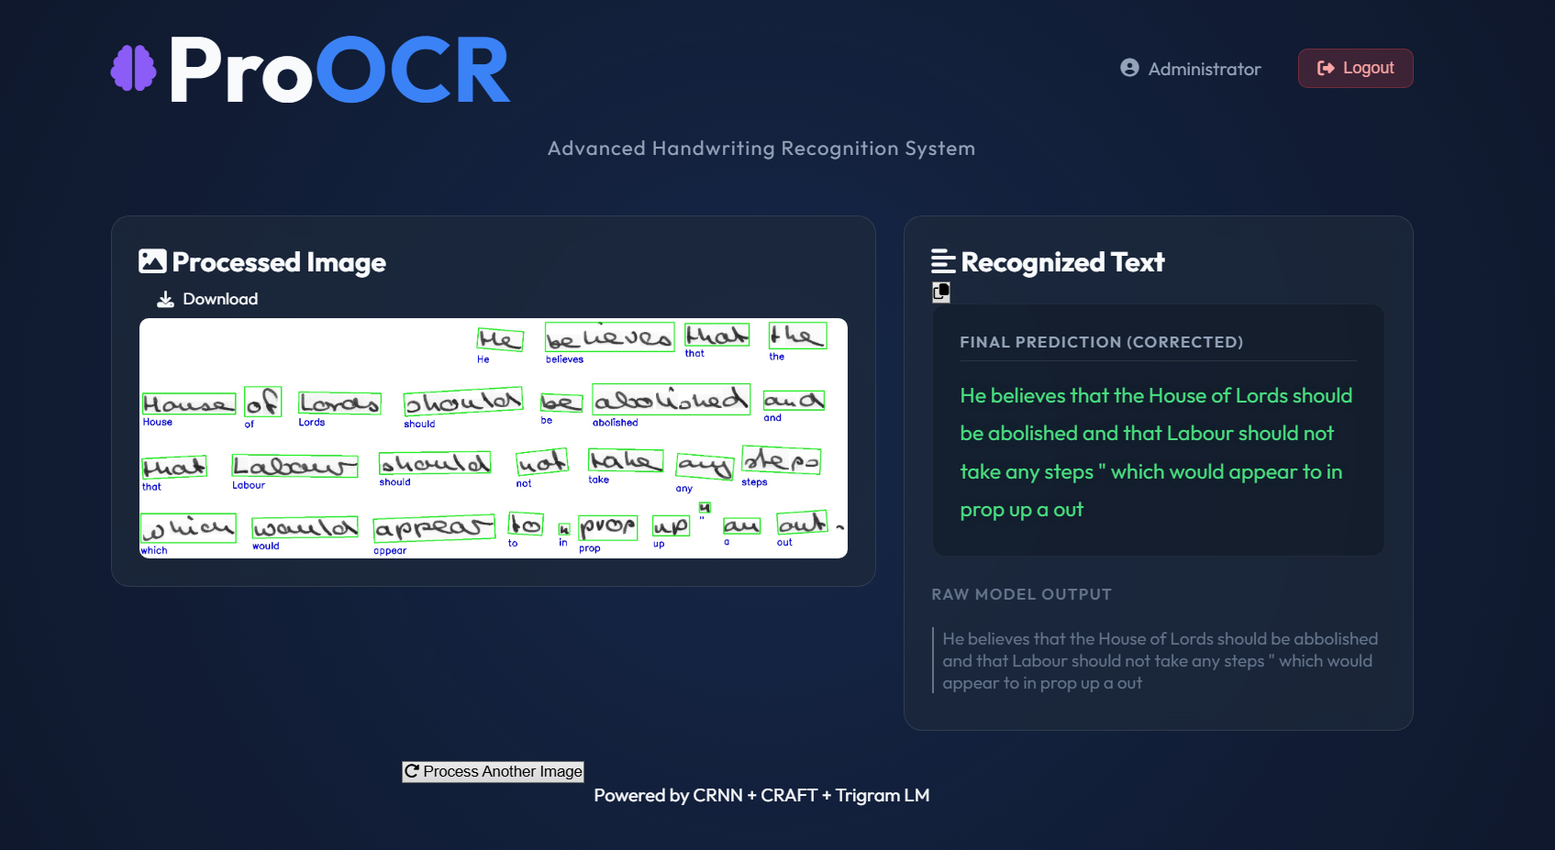
Figure 3. ProOCR web platform: processed document with CRAFT-detected bounding boxes (left) and recognized text output showing both raw and language model-corrected predictions (right).
The deployed ProOCR web platform (Figure 3) demonstrates the complete end-to-end pipeline in operation. The left panel displays the input document after CRAFT processing, with green bounding boxes delineating detected word regions sorted in reading order (top-to-bottom, left-to-right). Blue labels beneath each box show individual word predictions. The right panel presents two output variants: the corrected prediction (after trigram LM post-processing) and the raw CRNN beam search output, enabling users to assess correction quality. In this example, the system processes a full handwritten paragraph: "He believes that the House of Lords should be abolished and that Labour should not take any steps which would appear to in prop up a out." The platform, built with a Flask backend and React frontend, supports PDF, PNG, and JPG input formats. Multi-page PDF processing is handled via PyMuPDF, with each page rendered at 2× zoom for optimal CRAFT detection. An SQLite database stores prediction history, enabling users to retrieve previously processed documents without re-running the pipeline.
5.8. Discussion
The experimental results demonstrate that the proposed hybrid framework achieves competitive HTR performance through systematic component integration. Several observations merit discussion.
Modularity and upgradeability. The decoupled architecture enables independent component replacement. The CRNN recognizer could be substituted with a transformer-based model without modifying detection or post-processing modules. Similarly, the trigram language model can be retrained for domain-specific vocabularies (e.g., medical, legal) without neural network retraining. This modularity provides a practical advantage over monolithic end-to-end systems.
Cost-effectiveness of statistical post-processing. The trigram LM contributes 1.62 pp word accuracy with negligible computational overhead—no GPU computation is required, and inference adds less than 1ms per word. This finding suggests that statistical post-processing should be a standard component in HTR systems, particularly for CRNN architectures where character-level substitution errors are the dominant error mode.
Limitations. Several limitations should be acknowledged: (1) evaluation is limited to English text (IAM dataset); generalization to other scripts requires language-specific adaptation; (2) the trigram language model depends on a closed vocabulary, limiting handling of out-of-vocabulary words; (3) CRAFT uses pretrained weights without handwriting-specific fine-tuning, which may limit detection of irregular layouts; (4) word regions are recognized independently without sentence-level context; and (5) the IAM data split used does not follow the standard Aachen partition, limiting direct comparability with some published results.
6. Conclusion
This paper presented a hybrid, end-to-end handwriting text recognition framework integrating CRAFT-based text detection, CRNN-based recognition with beam search decoding, and trigram language model post-processing. The system incorporates an adaptive image enhancement pipeline for degraded documents. On the IAM Handwriting Database, the framework achieves 89.68% word accuracy, 6.01% CER, and 10.32% WER with ~8.5M parameters and no requirement for large-scale pretraining.
The ablation study quantified each component's contribution: beam search decoding (+3.28 pp word accuracy), trigram language model (+1.62 pp), and adaptive enhancement (+0.51 pp). These results provide actionable guidance for HTR system design, demonstrating that careful engineering of modular, lightweight components can achieve competitive performance relative to resource-intensive transformer-based approaches while requiring substantially fewer computational resources.
Future work will explore: (1) replacing CRNN with a lightweight vision transformer to improve sequence modeling without large-scale pretraining; (2) extending to multilingual HTR, particularly for Turkish and Arabic scripts; (3) incorporating contextual neural language models for sentence-level correction; (4) fine-tuning CRAFT on handwritten document layouts; and (5) model compression for edge deployment.
References
[1] R. Plamondon and S. N. Srihari, "On-Line and Off-Line Handwriting Recognition: A Comprehensive Survey," IEEE Trans. Pattern Anal. Mach. Intell., vol. 22, no. 1, pp. 63–84, 2000.
[2] A. Vinciarelli, "A survey on off-line cursive word recognition," Pattern Recognition, vol. 35, no. 7, pp. 1433–1446, 2002.
[3] A. Graves, M. Liwicki, S. Fernandez, R. Bertolami, H. Bunke, and J. Schmidhuber, "A novel connectionist system for unconstrained handwriting recognition," IEEE Trans. Pattern Anal. Mach. Intell., vol. 31, no. 5, pp. 855–868, 2009.
[4] B. Epshtein, E. Ofek, and Y. Wexler, "Detecting text in natural scenes with stroke width transform," in Proc. IEEE CVPR, pp. 2963–2970, 2010.
[5] L. Neumann and J. Matas, "Real-time scene text localization and recognition," in Proc. IEEE CVPR, pp. 3538–3545, 2012.
[6] Q. Ye and D. Doermann, "Text detection and recognition in imagery: A survey," IEEE Trans. Pattern Anal. Mach. Intell., vol. 37, no. 7, pp. 1480–1500, 2015.
[7] U.-V. Marti and H. Bunke, "Using a statistical language model to improve the performance of an HMM-based cursive handwriting recognition system," Int. J. Pattern Recognit. Artif. Intell., vol. 15, no. 1, pp. 65–90, 2001.
[8] N. Arica and F. T. Yarman-Vural, "An overview of character recognition focused on off-line handwriting," IEEE Trans. Syst. Man Cybern. C, vol. 31, no. 2, pp. 216–233, 2001.
[9] B. Shi, X. Bai, and C. Yao, "An end-to-end trainable neural network for image-based sequence recognition and its application to scene text recognition," IEEE Trans. Pattern Anal. Mach. Intell., vol. 39, no. 11, pp. 2298–2304, 2017.
[10] M. Li et al., "TrOCR: Transformer-based optical character recognition with pre-trained models," in Proc. AAAI, vol. 37, pp. 13094–13102, 2023.
[11] X. Zhou et al., "EAST: An efficient and accurate scene text detector," in Proc. IEEE CVPR, pp. 5551–5560, 2017.
[12] Z. Tian et al., "Detecting text in natural image with connectionist text proposal network," in Proc. ECCV, pp. 56–72, 2016.
[13] M. Liao et al., "Real-time scene text detection with differentiable binarization," in Proc. AAAI, vol. 34, pp. 11474–11481, 2020.
[14] Y. Baek et al., "Character region awareness for text detection," in Proc. IEEE/CVF CVPR, pp. 9365–9374, 2019.
[15] A. Graves, S. Fernandez, F. Gomez, and J. Schmidhuber, "Connectionist temporal classification: Labelling unsegmented sequence data with recurrent neural networks," in Proc. ICML, pp. 369–376, 2006.
[16] J. Puigcerver, "Are multidimensional recurrent layers really necessary for handwritten text recognition?," in Proc. ICDAR, pp. 67–72, 2017.
[17] T. Bluche, J. Louradour, and R. Messina, "Scan, attend and read: End-to-end handwritten paragraph recognition with MDLSTM attention," in Proc. ICDAR, pp. 1050–1055, 2017.
[18] A. Chowdhury and L. Vig, "An efficient end-to-end neural model for handwritten text recognition," in Proc. BMVC, 2018.
[19] L. Kang, M. Rusinol, A. Fornes, P. Riba, and M. Villegas, "Pay attention to what you read: Non-recurrent handwritten text-line recognition," Pattern Recognition, vol. 129, art. 108766, 2022.
[20] R. Smith, "An overview of the Tesseract OCR engine," in Proc. ICDAR, pp. 629–633, 2007.
[21] V. Pham et al., "Dropout improves recurrent neural networks for handwriting recognition," in Proc. ICFHR, pp. 285–290, 2014.
[22] K. Kukich, "Techniques for automatically correcting words in text," ACM Computing Surveys, vol. 24, no. 4, pp. 377–439, 1992.
[23] V. I. Levenshtein, "Binary codes capable of correcting deletions, insertions, and reversals," Soviet Physics Doklady, vol. 10, no. 8, pp. 707–710, 1966.
[24] J. Devlin et al., "BERT: Pre-training of deep bidirectional transformers for language understanding," in Proc. NAACL, pp. 4171–4186, 2019.
[25] N. Otsu, "A threshold selection method from gray-level histograms," IEEE Trans. Syst. Man Cybern., vol. 9, no. 1, pp. 62–66, 1979.
[26] J. Sauvola and M. Pietikäinen, "Adaptive document image binarization," Pattern Recognition, vol. 33, no. 2, pp. 225–236, 2000.
[27] W. Niblack, An Introduction to Digital Image Processing. Prentice Hall, 1986.
[28] K. Zuiderveld, "Contrast limited adaptive histogram equalization," in Graphics Gems IV, Academic Press, pp. 474–485, 1994.
[29] A. Buades, B. Coll, and J.-M. Morel, "A non-local algorithm for image denoising," in Proc. IEEE CVPR, vol. 2, pp. 60–65, 2005.
[30] S. Ioffe and C. Szegedy, "Batch normalization: Accelerating deep network training by reducing internal covariate shift," in Proc. ICML, pp. 448–456, 2015.
[31] U.-V. Marti and H. Bunke, "The IAM-database: An English sentence database for offline handwriting recognition," Int. J. Document Anal. Recognit., vol. 5, no. 1, pp. 39–46, 2002.
[32] S. Hochreiter and J. Schmidhuber, "Long short-term memory," Neural Computation, vol. 9, no. 8, pp. 1735–1780, 1997.
[33] K. Simonyan and A. Zisserman, "Very deep convolutional networks for large-scale image recognition," in Proc. ICLR, 2015.
[34] A. Vaswani et al., "Attention is all you need," in Advances in NeurIPS, vol. 30, pp. 6000–6010, 2017.
[35] A. L. Koerich, R. Sabourin, and C. Y. Suen, "Large vocabulary off-line handwriting recognition: A survey," Pattern Anal. Appl., vol. 6, no. 2, pp. 97–121, 2003.
[36] D. P. Kingma and J. Ba, "Adam: A method for stochastic optimization," in Proc. ICLR, 2015.
[37] A. Graves and J. Schmidhuber, "Framewise phoneme classification with bidirectional LSTM and other neural network architectures," Neural Networks, vol. 18, no. 5–6, pp. 602–610, 2005.
[38] J. Matas, O. Chum, M. Urban, and T. Pajdla, "Robust wide-baseline stereo from maximally stable extremal regions," in Proc. BMVC, pp. 384–393, 2002.

