|  |  |
| --- | --- |
| **Topic** | Oracle SQL Language Fundamentals I |
| **Document Name** | SQL01-EX-01 |
|  |  |

|  |  |  |  |
| --- | --- | --- | --- |
| **Document Difficulty Level** | | | |
| **Beginner** | **Junior** | **Senior** | **Expert** |
| ■ | □ | □ | □ |

# Document History

|  |  |  |  |
| --- | --- | --- | --- |
| Date | Author | Ver | Comments |
| 02.10.2013 | Erman İbrişim | 1.0 | Initial Draft |

# Oracle SQL Language Fundamentals I

## Exercise SQL01-EX-01:

**Definiton :** Write an SQL query that selects employee’s id, employee’s first name and employee’s department name for all employees. (Please use HR.EMPLOYEES and HR.DEPARTMENTS tables.)

**Sample Output :**

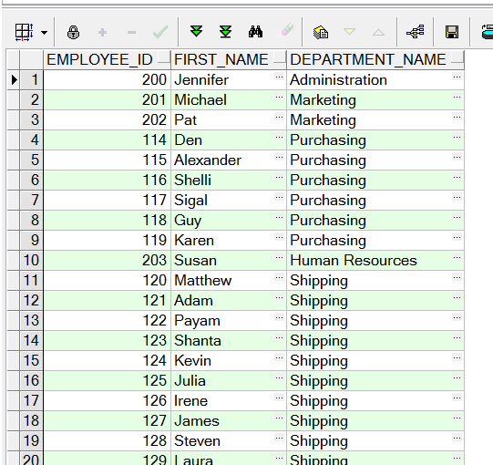

**Objectives** : To learn relations on tables and SQL language keyword JOIN.

**Exercise Keywords:** INNER JOIN, JOIN.

## Solution of SQL01-EX-01:

For solution of example, please send your answer to your supervisor.