|  |  |
| --- | --- |
| **Topic** | Oracle SQL Language Fundamentals I |
| **Document Name** | SQL01-EX-02 |
|  |  |

|  |  |  |  |
| --- | --- | --- | --- |
| **Document Difficulty Level** | | | |
| **Beginner** | **Junior** | **Senior** | **Expert** |
| ■ | □ | □ | □ |

# Document History

|  |  |  |  |
| --- | --- | --- | --- |
| Date | Author | Ver | Comments |
| 03.10.2013 | Erman İbrişim | 1.0 | Initial Draft |

# Oracle SQL Language Fundamentals I

## Exercise SQL01-EX-02:

**Definiton :** Create a report that displays the employee’s id and their manager’s id. (Please use HR.EMPLOYEES table)

**Sample Output :**

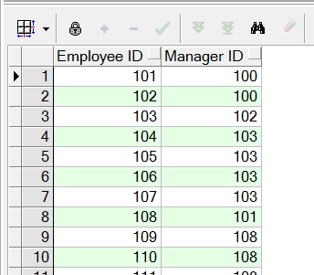

**Objectives** : To learn SQL join logic like SELF JOIN.

## Solution of SQL01-EX-02:

For solution of example, please send your answer to your supervisor.