|  |  |
| --- | --- |
| **Topic** | Oracle SQL Language Fundamentals I |
| **Document Name** | SQL01-EX-03 |
|  |  |

|  |  |  |  |
| --- | --- | --- | --- |
| **Document Difficulty Level** | | | |
| **Beginner** | **Junior** | **Senior** | **Expert** |
| ■ | □ | □ | □ |

# Document History

|  |  |  |  |
| --- | --- | --- | --- |
| Date | Author | Ver | Comments |
| 03.10.2013 | Erman İbrişim | 1.0 | Initial Draft |

# Oracle SQL Language Fundamentals I

## Exercise SQL01-EX-03:

**Definiton :** For example; first three character of PHONE_NUMBER column gives us a operator of employee. Create a report that displays the operators and their total subscriber. But we want two different displays with diffrent queries. (Please use HR.EMPLOYEES table)

**Sample Output :**

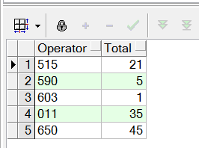

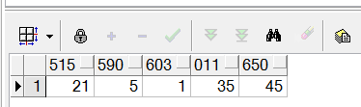

**Objectives** : To learn basic SQL keywords like COUNT, SUM, CASE.

## Solution of SQL01-EX-03:

For solution of example, please send your answer to your supervisor.