|  |  |
| --- | --- |
| **Topic** | Oracle SQL Language Fundamentals I |
| **Document Name** | SQL01-EX-04 |
|  |  |

|  |  |  |  |
| --- | --- | --- | --- |
| **Document Difficulty Level** | | | |
| **Beginner** | **Junior** | **Senior** | **Expert** |
| ■ | □ | □ | □ |

# Document History

|  |  |  |  |
| --- | --- | --- | --- |
| Date | Author | Ver | Comments |
| 03.10.2013 | Erman İbrişim | 1.0 | Initial Draft |

# Oracle SQL Language Fundamentals I

## Exercise SQL01-EX-04:

**Definiton :** Create a table (table name like HR.EMP) from HR.EMPLOYEES table. Insert a new row to HR.EMP table and update this employee’s phone number and salary. Delete your new row and display the HR.EMP table. Finally drop your table HR.EMP.

**Sample Output :**

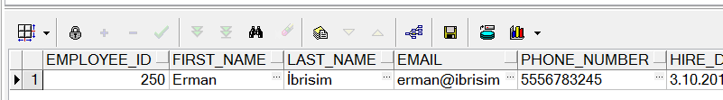

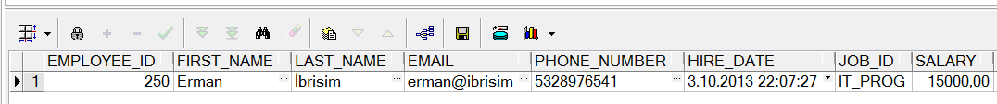

**Objectives** : To learn basic SQL keywords like INSERT, UPDATE, DELETE, DROP and CREATE TABLE from table.

## Solution of SQL01-EX-04:

For solution of example, please send your answer to your supervisor.