DETERMINANTS AND DYNAMICS OF NIGERIA'S EXTERNAL RESERVES, 2005–2024
A Cointegration and Vector Error Correction (VECM) Analysis of Exchange Rate, Interest Rate, Remittance, and FDI Linkages
Ridwan Okeshola
Financial/ Economic Analyst

September 2026
Analysis prepared as an applied econometrics exercise. Data: World Bank World Development Indicators (WDI).

Abstract
This study examines the macro-financial determinants of Nigeria's external reserves between 2005 and 2024, using annual data on total reserves, the official exchange rate, the bank lending rate, personal remittances, and net foreign direct investment (FDI) inflows sourced from the World Bank's World Development Indicators. Because unit root tests indicate that all five series are integrated of order one, the analysis proceeds through Johansen's trace test for cointegration, which identifies three cointegrating relationships among the variables; it estimates a Vector Error Correction Model (VECM) to characterise both the long-run equilibrium and the short-run dynamics linking reserves to the exchange rate, interest rate, remittances, and FDI. A dummy variable marking Nigeria's June 2023 exchange rate unification is introduced as an exogenous regressor to test whether the float constitutes a structural break in the system. The results show that reserves adjust rapidly toward their long-run equilibria, that a weaker exchange rate in the prior year is systematically associated with reserve drawdowns, and that the 2023 float produced statistically significant shifts in four of the five system equations. Impulse response and forecast error variance decomposition analysis further reveal that exchange rate shocks account for the overwhelming majority, in most cases upward of 95 per cent, of the forecast error variance in reserves and other system variables over a five-year horizon, with FDI the notable exception. The paper concludes by discussing the policy implications of this concentrated shock exposure and the limitations of estimating a five-variable system from twenty annual observations.
Keywords: Nigeria; external reserves; cointegration; Vector Error Correction Model; structural break; exchange rate; FDI; remittances

Table of Contents
Abstract 2
Table of Contents 3
1. Introduction 4
2. Data and Variables 4
3. Methodology 5
3.1 Data Sourcing and Cleaning 5
3.2 Exploratory Data Analysis 5
3.3 Unit Root Testing 5
3.4 Johansen Cointegration Test 6
3.5 Vector Error Correction Model (VECM) 6
3.6 Structural Break: The 2023 FX Float 6
3.7 Impulse Response Functions and Forecast Error Variance Decomposition 6
4. Results 6
4.1 Exploratory Data Analysis 6
4.2 Unit Root Testing 8
4.3 Johansen Cointegration Test 9
4.4 The VECM: Long-Run Adjustment in the Reserves Equation 10
4.5 The VECM: Short-Run Drivers of Reserves 10
4.6 Structural Break: The 2023 FX Float 11
4.7 Impulse Response Functions 12
4.8 Forecast Error Variance Decomposition 13
5. Discussion and Policy Implications 15
5.1 Reserves Adjust Quickly, But to a Narrow Set of Signals 15
5.2 The 2023 Float Is a Genuine Regime Change 15
5.3 Reserve Resilience Is Concentrated in a Single Channel 15
5.4 FDI Warrants Separate Attention 16
6. Limitations 16
7. Conclusion 17
References 17

1. Introduction
External reserves play a central role in managing a commodity-dependent, import-reliant economy such as Nigeria's. According to the IMF (1993), external reserves serve simultaneously as a buffer against balance-of-payments shocks, an instrument for defending the domestic currency during periods of speculative or fundamental-driven pressure, and a signal to international creditors and investors of the country's capacity to meet its external obligations. Over the two decades spanned by this study, Nigeria's reserve position has been buffeted by a series of large, largely exogenous shocks: the 2005–06 Paris Club debt relief agreement, the 2008 Global Financial Crisis, the 2014–16 collapse in international crude oil prices and the accompanying recession, the 2020 COVID-19 pandemic and — most consequentially for the period covered here — the June 2023 unification and floatation of the naira alongside the removal of the petrol subsidy (Businessfront, 2025).
This study asks a deliberately narrow and tractable question: how do movements in the exchange rate, the bank lending rate, personal remittances, and net FDI inflows relate to the level and short-run evolution of Nigeria's external reserves, and did the 2023 policy shift alter those relationships in a statistically detectable way? The analysis asked this empirical question. It does not attempt a comprehensive review of Nigeria's exchange rate history, nor does it test a specific theoretical model of reserve demand; rather, it applies a standard cointegration and Vector Error Correction Model (VECM) framework — well suited to a small system of non-stationary, plausibly co-moving macro-financial series — to twenty years of annual World Bank data, and reports what the data show.
The remainder of the report proceeds as follows. Section 2 describes the data and variables. Section 3 sets out the seven-stage econometric methodology. Section 4 reports the results at each stage: descriptive statistics, unit root tests, the Johansen cointegration test, the VECM estimates, the structural break analysis, and the impulse response and variance decomposition results. Section 5 discusses the findings and their policy implications. Section 6 sets out the limitations of the analysis, and Section 7 concludes.

2. Data and Variables
All data are annual observations for Nigeria spanning 2005 to 2024 (twenty observations per series), drawn from the World Bank's World Development Indicators (WDI) database via the pandas_datareader interface. Table 1 lists the five variables used in the analysis, their definitions, units, and WDI indicator codes. Monetary variables are rescaled from current US dollars to billions of US dollars for readability. Where the raw WDI series contained missing values, I closed gaps using linear interpolation, filled any remaining missing values at the start or end of the sample using forward- and backwards-fill, respectively.
Table 1. Variable Definitions and Sources
Variable | Role in the System | Definition | Unit | WDI Indicator Code
reserves | Focal / dependent | Total reserves, including gold | US$ billions | FI.RES.TOTL.CD
exchange_rate | System variable | Official exchange rate (period average) | ₦ per US$ | PA.NUS.FCRF
lending_rate | System variable | Bank lending interest rate | % per annum | FR.INR.LEND
remittances | System variable | Personal remittances received | US$ billions | BX.TRF.PWKR.CD.DT
fdi | System variable | Net inflows of foreign direct investment | US$ billions | BX.KLT.DINV.CD.WD
Reserves are treated as the focal series throughout the results discussion, consistent with the analysis's stated objective of examining the impacts of the remaining four variables on reserves; however, the estimation is a full system VECM in which all five variables are jointly determined.

3. Methodology
The analysis follows a seven-stage econometric pipeline, chosen to guard against the principal hazard of time-series regression on macroeconomic level data, spurious regression arising from unmodelled non-stationarity, while still allowing the long-run equilibrium relationships among the variables to be estimated explicitly.

3.1 Data Sourcing and Cleaning
The WDI panel for the five indicators is downloaded for Nigeria over 2005–2024, reshaped into a year-indexed table, and cleaned as described in Section 2.

3.2 Exploratory Data Analysis
Time trend plots (annotated with major macroeconomic events) and distributional diagnostics (histograms, skewness, and kurtosis) are produced for each variable, alongside a standard descriptive statistics table, to characterise the data before formal modelling.

3.3 Unit Root Testing
Each series is tested for a unit root using the Augmented Dickey-Fuller (ADF) test and the KPSS test under three trend specifications — no deterministic terms, a constant only, and a constant plus linear trend —both at levels and after first differencing. The ADF test's null hypothesis is that the series has a unit root; the KPSS test's null hypothesis is that the series is stationary, so that the two tests provide complementary, non-nested evidence. Agreement between the two — ADF failing to reject a unit root while KPSS rejects stationarity — is treated as strong evidence of non-stationarity; disagreement is flagged as a mixed result.

3.4 Johansen Cointegration Test
Having established that the series are plausibly integrated of order one, I(1), the Johansen trace test is applied to the five-variable system (with one lagged difference and a constant included in the cointegrating relation) to determine the cointegrating rank r — the number of linearly independent stationary combinations of the five I(1) series.

3.5 Vector Error Correction Model (VECM)
Given a cointegrating rank of r, a VECM with one lag of the differenced variables and r cointegrating relations is estimated. The VECM decomposes the change in each variable into (i) an error-correction component, which pulls the variable back toward each of the r long-run equilibria at an estimated speed (the loading, or alpha, coefficients), and (ii) short-run dynamics driven by the lagged differences of all variables in the system. Residual diagnostics, including a system Jarque–Bera normality test, assess model adequacy.

3.6 Structural Break: The 2023 FX Float
To test whether Nigeria's June 2023 exchange rate unification altered the estimated relationships, I added an exogenous dummy variable (0 for 2005–2022, 1 for 2023–2024) to the VECM. A statistically significant coefficient on this dummy in each equation indicates a level shift attributable to the policy change, the ordinary short-run and error-correction dynamics. This is complemented by a simple comparison of pre-float (≤2022) and post-float (≥2023) sample means for each variable.

3.7 Impulse Response Functions and Forecast Error Variance Decomposition
Orthogonalised impulse response functions (IRFs) over a five-year horizon are computed from the fitted VECM to trace how a one-time shock to each variable propagates through the system. Forecast error variance decomposition (FEVD) is computed from a companion VAR (1) fitted to the stationary, first-differenced data, quantifying the share of each variable's five-year-ahead forecast error variance attributable to shocks in each of the five variables.

4. Results

4.1 Exploratory Data Analysis
Figure 1 plots the five series from 2005 to 2024 with vertical markers at major macroeconomic events. Reserves climb from roughly $28 billion in 2005 to a sample peak near $54 billion around 2008 (reflecting the Paris Club debt relief and buoyant oil receipts), decline sharply through the 2014–16 oil price collapse and recession to a trough near $28 billion, recover moderately through 2017–2019, and drift down again into the 2020s. The exchange rate is comparatively flat for most of the samples moving gradually from roughly ₦150 to ₦460 per dollar between 2005 and 2022 — before rising sharply to approximately ₦1,480 per dollar by 2024 following the 2023 float. The lending rate oscillates in an 11–19 per cent band with no strong trend, easing markedly after 2020. Remittances trend upward over the sample but fall sharply in 2020, consistent with a pandemic-related disruption to diaspora income flows. FDI trends downward across most of the sample and turns briefly negative, a rare net outflow, around 2022.
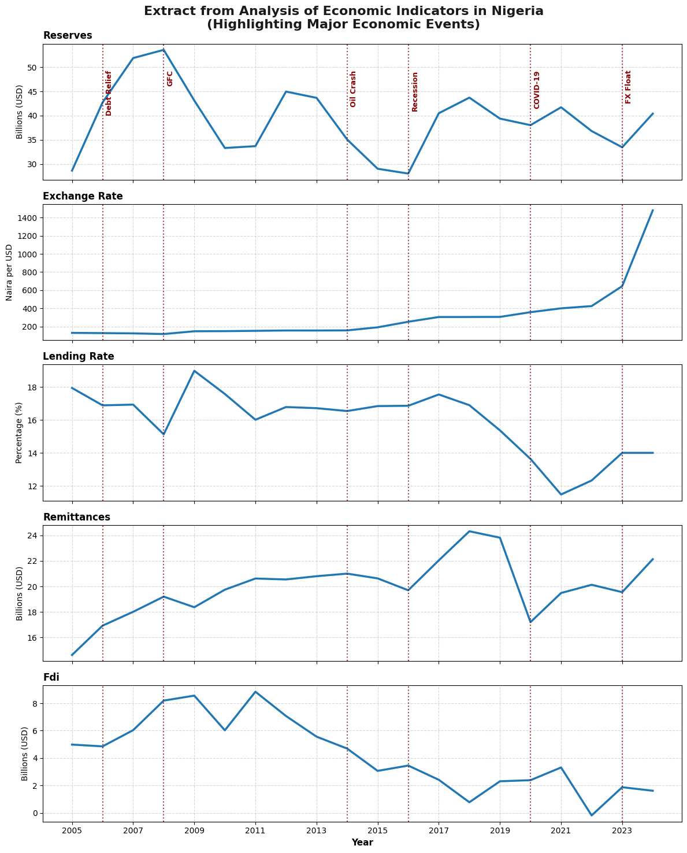
Figure 1. Nigeria's external reserves, exchange rate, lending rate, remittances, and FDI, 2005–2024, with major macroeconomic events marked.
Table 2 reports descriptive statistics for the five series over the full sample.
Table 2. Descriptive Statistics, 2005–2024 (N = 20)
Variable | Mean | Std. Dev. | Min | Median | Max | Skewness | Kurtosis
Reserves ($bn) | 39.09 | 7.04 | 28.02 | 39.89 | 53.60 | 0.26 | -0.18
Exchange Rate (₦/$) | 305.28 | 307.82 | 118.57 | 175.50 | 1,478.97 | 3.24 | 11.90
Lending Rate (%) | 15.93 | 1.94 | 11.48 | 16.76 | 18.99 | -0.88 | 0.23
Remittances ($bn) | 19.94 | 2.27 | 14.64 | 19.94 | 24.31 | -0.22 | 0.73
FDI ($bn) | 4.29 | 2.62 | -0.19 | 4.07 | 8.84 | 0.24 | -0.83
The exchange rate's skewness (3.24) and excess kurtosis (11.90) are far outside the range expected of a normally distributed series. They are attributable to the single, discrete post-2023 jump in the series rather than any gradual trend — a pattern fully consistent with Figure 1. FDI's minimum value of –$0.19 billion, occurring around 2022, marks the sample's only year of net FDI outflow. Reserves and remittances are comparatively well-behaved and close to symmetric.

4.2 Unit Root Testing
Table 3 summarises the ADF and KPSS unit root test results at levels, across the three trend specifications described in Section 3.3.
Table 3. Unit Root Test Results at Levels
Variable | Trend | ADF Statistic | ADF p-value | KPSS Statistic | KPSS p-value | Assessment
Reserves | None | -0.302 | 0.575 | — | — | Unit root
 | Constant | -5.075 | 0.000 | 0.279 | 0.156 | Stationary
 | Const.+Trend | -5.179 | 0.000 | 0.244 | 0.006 | Mixed
Exchange Rate | None | -0.561 | 0.471 | — | — | Unit root
 | Constant | 1.757 | 0.998 | 0.379 | 0.083 | Mixed
 | Const.+Trend | 3.200 | 1.000 | 0.178 | 0.025 | Unit root (strong)
Lending Rate | None | -0.763 | 0.386 | — | — | Unit root
 | Constant | 2.330 | 0.999 | 0.352 | 0.098 | Mixed
 | Const.+Trend | -2.347 | 0.408 | 0.181 | 0.023 | Unit root (strong)
Remittances | None | 0.541 | 0.834 | — | — | Unit root
 | Constant | -3.078 | 0.028 | 0.320 | 0.119 | Stationary
 | Const.+Trend | -1.252 | 0.899 | 0.176 | 0.026 | Unit root (strong)
FDI | None | -0.877 | 0.338 | — | — | Unit root
 | Constant | -0.719 | 0.842 | 0.317 | 0.121 | Mixed
 | Const.+Trend | -3.307 | 0.065 | 0.202 | 0.014 | Unit root (strong)
After first differencing (Table 4), all five series become stationary under the no-trend and constant-only specifications, though a handful of series still show mixed or unit-root signatures under the constant-plus-trend specification — a pattern commonly encountered in short annual samples, where the additional trend parameter absorbs degrees of freedom disproportionately.
Table 4. Unit Root Test Results, First Differences
Variable | Trend | ADF Statistic | ADF p-value | Assessment
Reserves | None / Constant | -5.806 / -5.613 | 0.000 / 0.000 | Stationary
Exchange Rate | None | 1.397 | 0.959 | Unit root persists
Lending Rate | None / Constant | -4.771 / -3.285 | 0.000 / 0.016 | Stationary
Remittances | None / Constant | -14.048 / -4.466 | 0.000 / 0.000 | Stationary
FDI | None / Constant | -5.758 / -5.677 | 0.000 / 0.000 | Stationary
Conclusion: The weight of evidence across both tests and all three trend specifications supports treating all five series as integrated of order one, I (1), non-stationary in levels and stationary after first differencing. This is the necessary precondition for proceeding to a cointegration test rather than risking a spurious regression in levels.

4.3 Johansen Cointegration Test
Table 5 reports the Johansen trace test statistics for the null hypothesis of at most r cointegrating relationships among the five I (1) series, against the alternative of more than r.
Table 5. Johansen Trace Test for Cointegration
Null Hypothesis | Trace Statistic | 5% Critical Value | Decision
r ≤ 0 | 116.230 | 33.878 | Reject
r ≤ 1 | 48.402 | 27.586 | Reject
r ≤ 2 | 21.748 | 21.131 | Reject
r ≤ 3 | 5.434 | 14.264 | Fail to reject
r ≤ 4 | 0.291 | 3.842 | Fail to reject
The trace statistic rejects the null at r ≤ 0, r ≤ 1, and r ≤ 2 (each comfortably exceeding its 5% critical value), and fails to reject at r ≤ 3. This identifies a cointegrating rank of r = 3: three independent, stationary long-run relationships bind reserves, the exchange rate, the lending rate, remittances, and FDI together, even as each series individually wanders as a non-stationary I (1) process. This finding justifies estimating a VECM, which models these long-run relationships explicitly through error-correction terms, rather than an unrestricted VAR in first differences, which would discard this long-run information entirely.

4.4 The VECM: Long-Run Adjustment in the Reserves Equation
Table 6 reports the estimated loading (error-correction) coefficients for the reserves equation of the baseline VECM (one lag, three cointegrating relations, constant included).
Table 6. VECM Error-Correction (Loading) Coefficients — Reserves Equation
Cointegrating Relation | Coefficient (α) | Std. Error | z-statistic | p-value
ec1 | -0.963 | 0.115 | -8.370 | < 0.001
ec2 | 0.062 | 0.010 | 5.955 | < 0.001
ec3 | 2.624 | 0.658 | 3.986 | < 0.001
All three error-correction terms are statistically significant at conventional levels. The coefficient on ec1 (–0.963) implies that reserves close roughly 96 per cent of any deviation from that long-run equilibrium within a single year — a very rapid adjustment speed, consistent with active management of the reserve position rather than a slow, passive drift toward equilibrium. The remaining two error-correction terms are also significant, indicating that reserves respond to all three identified long-run relationships, not merely one.
A system-wide Jarque–Bera normality test on the VECM residuals returns a test statistic of 3.931 with a system p-value of 0.950, providing no evidence against normally distributed residuals and supporting the adequacy of the model specification.

4.5 The VECM: Short-Run Drivers of Reserves
Table 7 reports on the short-run (lagged first-difference) coefficients in the reserves equation.
Table 7. VECM Short-Run Coefficients — Reserves Equation
Lagged Regressor (t-1) | Coefficient | Std. Error | p-value | Interpretation
Constant | 10.394 | 8.845 | 0.240 | Not significant
Δ Reserves | 0.651 | 0.097 | < 0.001 | Strong own persistence
Δ Exchange Rate | -0.093 | 0.023 | < 0.001 | Weaker Naira > reserve drawdown
Δ Lending Rate | -1.028 | 0.541 | 0.057 | Borderline negative
Δ Remittances | -0.154 | 0.308 | 0.617 | Not significant
Δ FDI | 1.282 | 0.401 | 0.001 | Higher FDI → reserve accumulation
The reserves equation's own lag is the strongest short-run predictor, indicating strong year-to-year persistence. The exchange rate's lagged coefficient is negative and highly significant: a naira depreciation in the prior year is systematically followed by a reserve drawdown, a pattern consistent with the Central Bank of Nigeria's historical practice of drawing on reserves to intervene in the foreign exchange market and moderate currency depreciation. FDI's lagged coefficient is positive and significant, indicating that stronger FDI inflows in one year are associated with reserve accumulation in the next. The lending rate's coefficient is negative but only borderline significant (p = 0.057), and remittances show no significant short-run association with reserves once the error-correction terms already account for the long-run relationship.

4.6 Structural Break: The 2023 FX Float
Table 8 reports the coefficient on the exogenous 2023 FX-float dummy variable in each of the five VECM equations.
Table 8. Structural Break Coefficients (2023 FX Float Dummy) by Equation
Equation | Coefficient | Std. Error | p-value | Significant?
Reserves | +12.804 | 1.670 | < 0.001 | Yes
Exchange Rate | +357.985 | 52.785 | < 0.001 | Yes
Lending Rate | +2.443 | 1.181 | 0.039 | Yes
Remittances | -0.540 | 2.106 | 0.798 | No
FDI | +6.431 | 0.933 | < 0.001 | Yes
Four of the five equations show a statistically significant shift associated with the 2023 float, indicating that the policy change represents a genuine structural break in the system's dynamics rather than a continuation of pre-existing trends. The exchange rate equation's coefficient (+357.99) is, as expected, the largest in absolute terms, mechanically reflecting the discrete jump in the official rate following unification. The reserves equation's positive and significant coefficient (+12.80) indicates an upward level shift in the short-run dynamic relationship once the float is controlled for; the lending rate's smaller positive shift (+2.44) is consistent with the monetary tightening the Central Bank of Nigeria pursued alongside the float.
Table 9 supplements this with a simple comparison of unconditional (unconditional on the VECM's lagged dynamics) sample means before and after the float.
Table 9. Pre- vs Post-Float Mean Comparison
Variable | Pre-Float Mean (≤2022) | Post-Float Mean (≥2023) | Change
Reserves ($bn) | 39.33 | 36.93 | -2.40
Exchange Rate (₦/$) | 221.19 | 1,062.08 | +840.89
Lending Rate (%) | 16.14 | 14.01 | -2.13
Remittances ($bn) | 19.84 | 20.84 | +1.00
FDI ($bn) | 4.57 | 1.74 | -2.83
A point of interpretive care arises with FDI: the unconditional post-float mean is markedly lower than the pre-float mean (a fall of $2.83 billion). In the VECM, the dummy coefficient in the FDI equation is positive and significant. These two facts are not contradictory, but they are easy to conflate. The sample mean is an unconditional average across all pre- and post-float years; the VECM coefficient is a conditional shift, estimated holding constant the lagged values of reserves, the exchange rate, the lending rate, and remittances. The conditional, dynamics-adjusted shift is positive, while the raw average level is lower if the years immediately following the float also inherited unfavourable lagged conditions from 2022 that the model attributes to other channels. Both figures are reported here precisely so the reader can weigh the evidence rather than rely on either one in isolation; a longer post-float sample, once available, would allow this ambiguity to be resolved with more confidence.

4.7 Impulse Response Functions
Figure 2 (an excerpt from the full 5×5 system) shows the orthogonalised impulse response of reserves to a one-time, one-standard-deviation shock in each of the five system variables, over a five-year horizon, with 95% confidence bands.
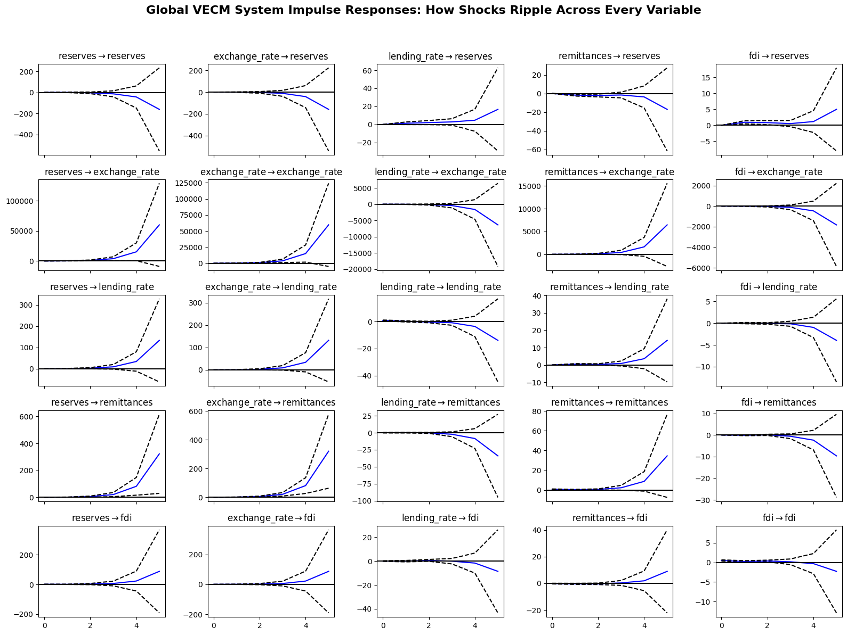
Figure 2. Full system impulse responses: response of each variable (rows) to a shock in each variable (columns), five-year horizon.
A recurring feature of the IRF grid is that response magnitudes grow, rather than decay, over the five-year horizon — a normal characteristic of impulse responses computed from a levels-VECM built on cointegrated I(1) series, since shocks to non-stationary variables have permanent, cumulative effects that only the error-correction mechanism gradually offsets. The exchange rate's shock to reserves is comparable in magnitude to reserves' response to its own shock, underscoring the exchange rate's outsized role in the system — a result corroborated more formally by the variance decomposition in Section 4.8. Confidence bands widen rapidly with the horizon, reflecting the small sample; the qualitative direction and relative ranking of effects are more reliable than the precise numerical magnitudes.

4.8 Forecast Error Variance Decomposition
Figure 3 reports the forecast error variance decomposition (FEVD) from the companion VAR(1) fitted to the stationary, differenced data, for all five system variables over a five-year horizon.
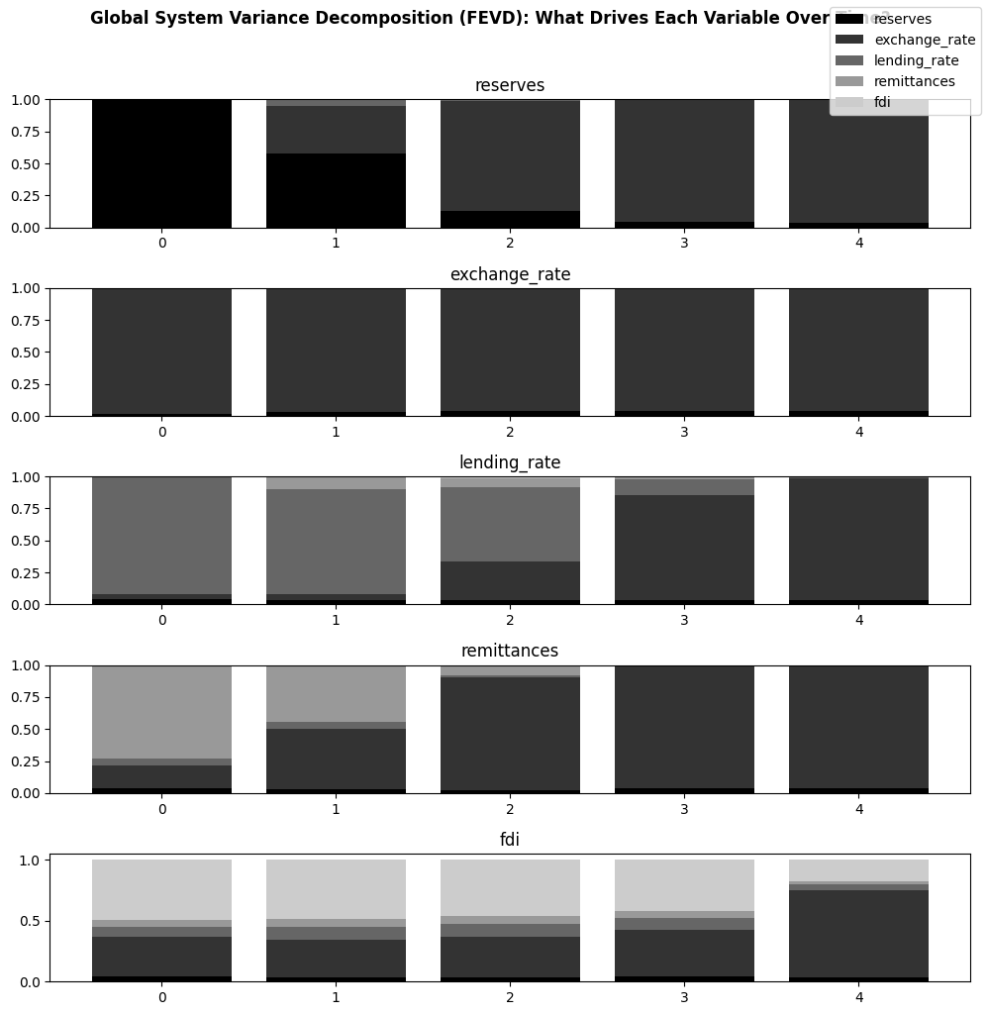
Figure 3. Forecast error variance decomposition (FEVD) for all five system variables; has a five-year horizon.
Table 10 reports the numerical breakdown of the five-year-ahead forecast error variance for reserves, the focal variable of this study.
Table 10. Five-Year-Ahead Forecast Error Variance Decomposition — Reserves
Source of Shock | Contribution to Reserves' Forecast Error Variance (Year 5)
Exchange Rate | 95.74%
Reserves (own shocks) | 3.73%
Remittances | 0.50%
Lending Rate | 0.02%
FDI | 0.01%
The exchange rate alone accounts for 95.74 per cent of the five-year-ahead forecast error variance in reserves, dwarfing reserves' own shocks (3.73%) and all other sources combined (0.53%). This pattern of exchange-rate dominance is not unique to reserves: it recurs, in materially similar proportions (typically 94–96%), in the lending rate and remittances equations as well. FDI is the clear exception in the system: exchange rate shocks account for a comparatively modest 71.5 per cent of its forecast error variance. In comparison, FDI's own shocks retain a substantially larger 17.8 per cent share, alongside smaller contributions from the lending rate (4.2%) and remittances (2.7%). This exceptionally concentrated pattern — one variable dominating the variance decomposition of nearly an entire system — is a striking empirical result, and one that should be read in light of the sample-size caveats discussed in Section 6: a 20-observation annual sample estimating a 5-variable VAR/VECM system leaves comparatively few degrees of freedom, and results of this magnitude of concentration warrant confirmation as longer time series become available.

5. Discussion and Policy Implications
Three findings stand out from the results reported in Section 4; each has a distinct implication for how Nigeria's external reserve position might be understood and managed going forward.

5.1 Reserves Adjust Quickly, But to a Narrow Set of Signals
The speed of error correction in the VECM — reserves closing roughly 96 per cent of a long-run disequilibrium within a year — indicates that Nigeria's reserve stock is not a passive residual but is actively managed relative to its equilibrium relationships with the exchange rate, lending rate, remittances, and FDI. At the same time, the short-run dynamics (Section 4.5) and the variance decomposition (Section 4.8) both point to the exchange rate as the dominant short-run and forecast-relevant driver, with the lending rate and remittances playing comparatively minor roles. This is consistent with a reserve-management regime historically oriented around currency defence rather than, say, a rules-based accumulation target tied to import cover or external debt service.

5.2 The 2023 Float Is a Genuine Regime Change
The statistical significance of the FX-float dummy in four of five VECM equations (Section 4.6) strongly signals that June 2023 divides the sample into two distinct dynamic regimes. Practically, this means that any forecasting, stress-testing, or further econometric modelling of Nigeria's external sector that pools pre- and post-2023 data without an explicit structural adjustment — whether a dummy variable, a regime-switching specification, or simply re-estimating on the post-2023 sample once it is long enough — risks materially misstating both the average levels and the short-run dynamics of the system. As the post-float sample lengthens in the coming years, re-estimating this model on 2023-onward data alone, or with an interacted structural-break specification, would be a natural and valuable extension.

5.3 Reserve Resilience Is Concentrated in a Single Channel
Perhaps the report's most policy-relevant finding is the degree to which shocks to a single variable — the exchange rate — dominate the forecast error variance of reserves and most of the rest of the system. From a risk-management perspective, this concentration is a source of fragility: if the primary channel through which reserves are buffeted also happens to be the channel most exposed to sentiment-driven, speculative, or oil-price-linked volatility, then reserve resilience is only as robust as exchange rate stability itself. Diversifying the sources of variation that influence reserves — for instance, by strengthening formal (as opposed to informal) remittance channels, or by improving the investment climate for non-oil FDI, both of which the results in Section 4.8 show move comparatively independently of the exchange rate — could reduce this concentration and make reserves more resilient to a wider range of shocks, not solely those transmitted via the naira.

5.4 FDI Warrants Separate Attention
FDI is the one system variable that does not conform to the broader pattern: its forecast error variance is driven substantially by its own shocks rather than by the exchange rate, and its post-float trajectory — whether read from the unconditional mean decline or considered alongside the VECM's conditional coefficient — is more ambiguous than that of the other variables. Given FDI's statistically significant positive short-run contribution to reserve accumulation (Section 4.5), this ambiguity is worth monitoring as more post-float data becomes available, rather than resolving prematurely in either direction.

6. Limitations
- Sample size: twenty annual observations is a small sample for a five-variable VECM/VAR system. Coefficient estimates, cointegration test statistics, and — especially — the variance decomposition results carry considerable estimation uncertainty, as shown in the wide confidence bands of the impulse response functions (Figure 2). Read the results as indicative of direction and relative importance rather than as precise point estimates.
- Mixed unit root evidence: while the overall weight of evidence supports treating all five series as I(1), several series (notably the exchange rate, lending rate, and remittances) show mixed ADF/KPSS signals under the constant-plus-trend specification. Classifying every series as strictly I(1) is therefore a reasonable working assumption rather than an unambiguous, uniformly supported conclusion.
- Interpolated data: several years within the WDI series required linear interpolation to fill missing values. While standard and defensible practice, interpolation can understate genuine short-run volatility in the years it affects.
- Untransformed levels: the variables analysed throughout are levels in their original units (US$ billions, ₦ per US$, percentage points) rather than natural-log transformations. Coefficients in the VECM should accordingly be read as level effects rather than elasticities; a log-linear respecification is a natural extension for future work, particularly given the exchange rate's extreme post-float level shift, which log-transformation would help stabilise statistically.
- Valuation and reporting effects around the float: because reserves, remittances, and FDI are all measured in current US dollars, the 2023–24 currency unification could introduce valuation or reporting discontinuities into these series that are mechanically, rather than economically, related to the float — a possibility the structural break specification cannot fully disentangle from genuine behavioural change.
- Associational, not causal: the VECM is a reduced-form statistical model. Its coefficients describe estimated statistical relationships among the five variables, conditional on the model's specification; they should not be interpreted as identified causal effects of policy interventions without further identification assumptions that this analysis does not impose.

7. Conclusion
This analysis shows how the exchange rate, the bank lending rate, personal remittances, and net FDI inflows relate to the level and short-run dynamics of Nigeria's external reserves between 2005 and 2024, and whether the 2023 exchange rate float altered those relationships. Using a Johansen cointegration test and a Vector Error Correction Model, the analysis finds that reserves are bound to the other four variables through three distinct long-run equilibrium relationships, and that reserves adjust to deviations from these equilibria within roughly a year.
The 2023 float is a genuine structural break, producing statistically significant shifts in four of the five system equations. Perhaps most notably, the exchange rate is found to be the dominant channel through which shocks reach reserves, the rest of the system, explaining upward of 95 per cent of the five-year-ahead forecast error variance in reserves — a degree of concentration that carries a clear policy implication: strengthening reserve resilience is likely to depend less on exchange rate management in isolation, and more on diversifying the inflow channels, particularly remittances and FDI, that currently move largely in the exchange rate's shadow.
The results reported here should be read alongside the limitations set out in Section 6, foremost among them the modest size of the annual sample available for a system of this dimensionality. As Nigeria's post-float experience lengthens, revisiting this analysis with a longer and more balanced pre-/post-float sample would allow several of the report's more provisional findings — particularly the FDI structural-break result discussed in Section 5.4 — to be assessed with greater confidence.

References
Businessfront. (2025). Nigeria at 65: Six decades of booms, busts, and reforms. https://businessfront.com/finance/insights/nigeria-65-booms-busts-and-reform/
Dickey, D. A., & Fuller, W. A. (1979). Distribution of the estimators for autoregressive time series with a unit root. Journal of the American Statistical Association, 74(366a), 427–431.
Engle, R. F., & Granger, C. W. J. (1987). Co-integration and error correction: Representation, estimation, and testing. Econometrica, 55(2), 251–276.
International Monetary Fund. (1993). Balance of payments manual (5th ed.). International Monetary Fund.
Johansen, S. (1991). Estimation and hypothesis testing of cointegration vectors in Gaussian vector autoregressive models. Econometrica, 59(6), 1551–1580.
Kwiatkowski, D., Phillips, P. C. B., Schmidt, P., & Shin, Y. (1992). Testing the null hypothesis of stationarity against the alternative of a unit root. Journal of Econometrics, 54(1–3), 159–178.
Sims, C. A. (1980). Macroeconomics and reality. Econometrica, 48(1), 1–48.
World Bank. World Development Indicators. Washington, DC: World Bank Group. Retrieved via the pandas_datareader Python interface.

