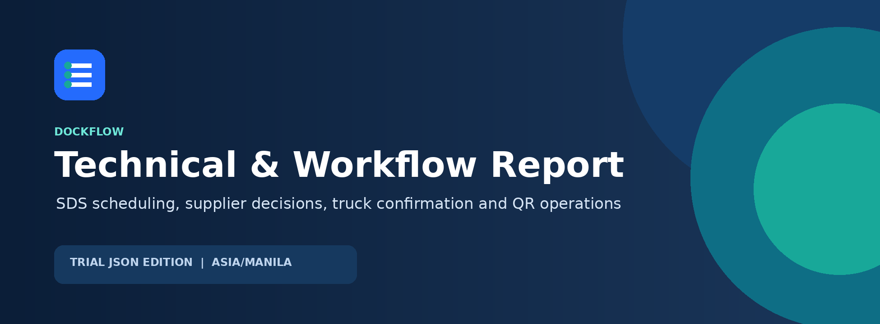
SENIOR DEVELOPER HANDOFF
A designed reference for architecture, business flow, roles, security, deployment and production readiness.
CURRENT RELEASE
Trial JSON edition - application version 0.1.0 - timezone Asia/Manila - report date 31 August 2026

01 / ORIENTATION

Executive brief
DockFlow coordinates delivery proposals from SDS spreadsheets through supplier confirmation, company schedule decisions, truck assignment, QR handoffs, ETA tracking, history and performance reporting.
CORE CONTROL
An SDS upload creates a proposal, not an immediate booking. The booking becomes operational only after the supplier assigns every material code to confirmed truck details.

What this build provides
- Role-scoped workspaces for Administrator, Planner, Production, Supplier, Driver, Security and Warehouse.
- Supplier-specific SDS proposals with conflict comparison and protected material-code exposure.
- A formal alternative-schedule decision step owned by Administrator, Planner or Production.
- Email and in-app notifications for schedule changes and company decisions.
- One QR process from Trip through Gate out, with Manila-time timestamps and duration tracking.
- Styled Excel reports, compact booking PDFs, monitoring, history and ETA without live traffic.

Current operating model
Layer | Current choice | Purpose
Primary business data | data/trial-data.json | Portable single-instance trial
Web | Next.js 16 / React 19 | Role-specific interface and /api proxy
API | Express 5 / Node.js 22 | Workflow, security, validation and exports
Email | Gmail SMTP | Verified operational notifications
ETA | Nominatim + OSRM | Road distance and duration without traffic
Optional database | PostgreSQL Dockflow schema | Refresh tokens, summarized API activity and trial records

02 / PRIMARY FLOW

Operational workflow roadmap
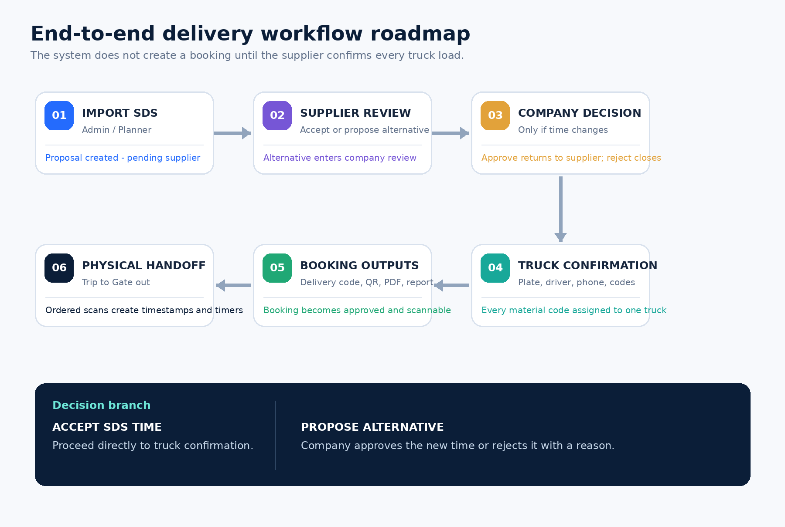

Flow ownership by stage
Stage | Owner | System result
1. Import SDS | Administrator / Planner | New or updated supplier proposal
2. Supplier review | Supplier | Accept time or provide reason and alternative
3. Company decision | Admin / Planner / Production | Approve new time or reject with reason
4. Truck confirmation | Supplier | Plate, driver, phone and material-code allocation
5. Booking outputs | System | Delivery code, protected QR, PDF, Monitoring and report eligibility
6. Physical handoff | Supplier / Security / Warehouse | Ordered scans and timestamps through Gate out

03 / BOOKING GOVERNANCE

Supplier and company decision flow

Path A - supplier accepts the SDS time
1. Supplier opens Schedule or My entries and selects Review & confirm delivery.
2. Supplier enters truck plate, driver name, country code, numeric phone and material codes.
3. If another truck is needed, the supplier confirms the remaining material codes in another pass.
4. When every code has exactly one truck, the booking becomes APPROVED / BOOKED.

Path B - supplier proposes a different time
1. Supplier provides a reason, alternative date, start time and later end time.
2. The proposal moves to PENDING_COMPANY and notifies Planner and Production.
3. Company reviewer sees the original schedule, proposal and supplier reason.
4. Approval applies the new time and returns the item to PENDING_SUPPLIER for truck details.
5. Rejection requires a company reason, ends the proposal and notifies the supplier.
NOTIFICATION BEHAVIOR
The company decision always creates an in-app supplier notification. Verified supplier emails are also notified. The interface checks for new state every 30 seconds.

Booking-state reference
Booking status | Meaning | Next action
PENDING_SUPPLIER | Supplier action is required | Accept or propose alternative; add truck data when accepted
PENDING_COMPANY | Supplier proposed another time | Admin, Planner or Production decides
APPROVED | All material codes have confirmed trucks | QR operational flow may begin
REJECTED | Company rejected the alternative or booking ended | Record remains in History

04 / PHYSICAL OPERATIONS

QR movement and timing roadmap
SEQUENCE RULE
A scan cannot skip an earlier stage. Wrong-role, wrong-supplier and unapproved scans are rejected by the API.

Step | State | Authorized role | Recorded result
Booking | BOOKED | Supplier confirmation | QR becomes available
Trip | IN_TRANSIT | Supplier / Admin | Starts travel timer and ETA
Gate in | GATE_IN | Security / Admin | Records site arrival
Unloading | UNLOADING | Warehouse / Admin | Starts unloading activity
Received | RECEIVED | Warehouse / Admin | Records receiving completion
Gate out | GATE_OUT | Security / Admin | Ends site turnaround timer

Tracked durations
- Trip to Gate in - supplier transit against the stored no-traffic route estimate.
- Gate in to Unloading - site waiting time before unloading begins.
- Unloading to Received - receiving work duration.
- Received to Gate out - post-receipt exit time.
- Gate in to Gate out - total vehicle time inside the site.

05 / ACCESS MODEL

Roles, visibility and responsibilities
Role | Data scope | Main responsibility
Administrator | All suppliers | Import, company decision, accounts, catalogs, routes, all scans
Planner | All suppliers | Import, conflict resolution, company decision, reports
Production | All suppliers | Company decision, monitoring, schedule, history, reports
Supplier | Linked company only | Respond, confirm trucks, scan Trip, verify own email
Driver | Linked company only | Read-only schedule, monitoring, QR entries, history and reports
Security | Active deliveries | Gate in and Gate out scans
Warehouse | Active deliveries | Unloading and Received scans

DEFENSE IN DEPTH
The interface hides unauthorized controls, but every sensitive API route repeats role and supplier-ownership checks. UI visibility alone is never treated as authorization.

Supplier data protection
- Supplier and Driver bootstrap responses contain only their linked supplier's shipments.
- Supplier-facing items expose material code, quantity, UOM, site and week - not material descriptions, PO details or source-sheet metadata.
- A Supplier cannot scan or open another supplier's delivery by changing an ID or QR value.

06 / WHAT THE SYSTEM DOES

Functional capability map
Capability | Implemented behavior
Accounts | Create role accounts, link suppliers/drivers, verify email, delete with admin password while retaining records.
SDS import | Read common spreadsheet formats, accept incomplete useful rows, check supplier accounts, compare fingerprints and review conflicts.
Supplier response | Accept schedule or propose one alternative with a mandatory reason and complete time window.
Company review | Approve or reject supplier alternatives with a full-page comparison and notification trail.
Truck allocation | Confirm one truck at a time, validate international phone, prevent duplicate plates and one-code-to-two-truck assignment.
Schedule | Day/week views, compact 24-hour calendar, pending and approved visual separation; SDS remains source of truth.
Monitoring | Approved active trucks ordered by process progress, date-range filtering and ETA after Trip.
QR stations | Camera, USB scanner or manual entry with role-specific ordered state changes.
History and reports | Retained outcomes, detailed record view, supplier filters and styled Excel export.

07 / TECHNICAL DESIGN

Architecture and data boundaries
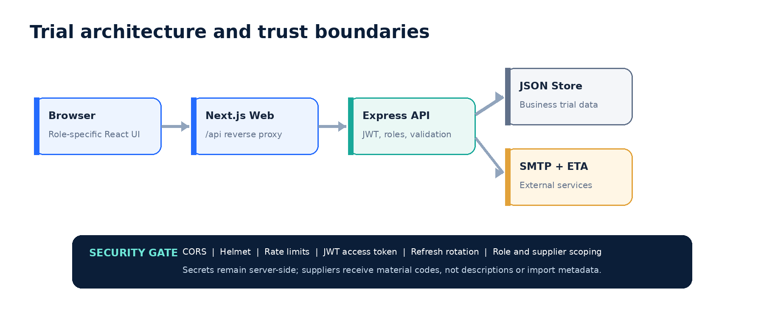

Primary data collections
Collection | Purpose | Sensitive contents
users | Identity, role and supplier link | bcrypt password hash, email verification state
suppliers | Company, material catalog and route | Origin address and coordinates
shipments | Proposal, booking, truck and scan lifecycle | Driver name and phone
notifications | Per-user app alerts | Decision messages and read timestamp
importBatches | Import totals and delivery result | Filename and notification summary
audit | Business-action trail | Actor, action, shipment and detail
settings | Site, schedule and sequence | Receiving address and coordinates

STORAGE REALITY
PostgreSQL is optional in this trial and is not the business-data store. Deliveries, accounts, suppliers and notifications still live in JSON.

08 / PROTECTION MODEL

Security controls
Control | Implementation | Operational meaning
Passwords | bcrypt cost 10 | Plain passwords are not stored
Access tokens | JWT, default 15 minutes | Short-lived API authorization
Refresh tokens | HttpOnly SameSite=Strict cookie, default 7 days | Browser JavaScript cannot read the refresh token
Rotation | Old refresh token revoked on use | Captured older token cannot be reused indefinitely
CORS | Explicit origins plus optional private-LAN allowance | Unknown public browser origins receive 403
Rate limits | API 300/min; failed login 10/15 min; refresh 30/15 min | Excess calls receive 429 until window reset
Headers | Helmet | Browser receives common hardening headers
Validation | Server-side fields, file limits and transition checks | Handcrafted requests cannot bypass workflow
Request trace | X-Request-ID and optional session summaries | Client errors can be matched to server activity

Secret handling
- SMTP_USER and SMTP_APP_PASSWORD belong only in the private server .env file.
- Use a Google App Password, not the mailbox's normal password.
- JWT, access-token and refresh-token secrets must be different long random values.
- Production must use HTTPS, COOKIE_SECURE=true and explicit public origins.

09 / QUALITY ATTRIBUTES

Non-functional requirements
Quality | Current measure | Assessment
Security | Role checks, supplier scope, token rotation, CORS, rate limits, secret separation | Implemented for trial
Privacy | Supplier-safe responses and no material descriptions/source metadata | Implemented
Reliability | Queued JSON updates, atomic rename and idempotent import comparison | Single API process
Performance | Static Next build, compact bootstrap and 30-second notification polling | Small-site trial target
Usability | Responsive layouts, role navigation, full-page decisions, light/dark themes | Implemented; continue UAT
Maintainability | Typed React models and isolated parser, mailer, store and DB modules | Automated integration coverage
Observability | Request IDs and optional summarized PostgreSQL activity | No central alerting yet
Portability | npm and Docker workflows with environment configuration | Local, LAN and proxy-ready
Accessibility | Labels, semantic controls and keyboard-close modals | Formal WCAG audit pending

10 / INTEGRATION SURFACE

API reference
Endpoint | Access | Purpose
POST /api/auth/login | Public | Issue access and refresh session
POST /api/auth/refresh | Cookie | Rotate refresh token
GET /api/bootstrap | Authenticated | Return role-scoped application state
PATCH /api/notifications/:id/read | Owner | Mark app alert read
POST /api/imports/excel/preview | Admin / Planner | Parse, validate and compare SDS
POST /api/imports/excel/commit | Admin / Planner | Apply reviewed import and email suppliers
PATCH /api/shipments/:id/supplier-response | Supplier | Accept load or propose alternative
PATCH /api/shipments/:id/company-decision | Admin / Planner / Production | Approve or reject alternative
POST /api/shipments/scan-stage | Station role | Record QR movement
GET /api/shipments/:id/qr.svg | Authorized viewer | Protected QR image
GET /api/shipments/:id/booking.pdf | Authorized viewer | Protected booking PDF
PATCH /api/settings/site-address | Admin | Save and geocode destination
PATCH /api/suppliers/:id/route | Admin | Calculate no-traffic supplier route
POST /api/users | Admin | Create account
DELETE /api/users/:id | Admin + password | Delete login, retain records
GET /api/reports/export.xlsx | Report roles | Download scoped Excel report

COMPATIBILITY NOTE
Legacy availability and manual schedule endpoints remain in the API, but the current Schedule UI is read-only and SDS-driven.

11 / OPERATING GUIDE

Deployment and verification

Docker deployment
COMMANDS
Copy-Item .env.example .env
Edit the private .env values
docker compose up --build -d
docker compose ps
docker compose logs -f api web

Open http://localhost:5059. For another device on the LAN, use the host PC's LAN IP and allow port 5059 through the firewall. The API container remains internal to the Compose network.

Automated verification
COMMAND
npm.cmd test

- Spreadsheet formats, missing values, exact times, duplicate-safe comparison and conflict decisions.
- CORS allowed/blocked origins, authentication, refresh rotation and supplier data scoping.
- Supplier acceptance, multi-truck allocation, company approval/rejection and app notifications.
- Protected QR, one-page PDF, ETA at Trip, ordered station scans and Excel export.
- Production build and TypeScript compilation.

Manual UAT scenario
1. Import one SDS proposal for a verified supplier.
2. Supplier proposes another time with a reason.
3. Production approves it and supplier confirms the truck.
4. Verify email, in-app alert, QR, PDF, Monitoring and report entry.
5. Scan Trip, Gate in, Unloading, Received and Gate out; inspect timers and History.
6. Repeat with company rejection and verify the supplier receives the company reason.

12 / NEXT MILESTONES

Production roadmap
Roadmap phase | When | Deliverable | Decision
Phase 1 - Trial | Now | JSON workflow, role UIs, SDS comparison, decisions, QR, ETA, email and reports | Complete / UAT
Phase 2 - Data hardening | Next | Move users, suppliers, shipments, notifications and audit to PostgreSQL; add migrations and backups | Highest priority
Phase 3 - Service reliability | Next | Durable email outbox/retry, private object storage, malware scanning, shared Redis rate limits | Required for scale
Phase 4 - Secure deployment | Before internet | HTTPS reverse proxy, secure cookies, explicit CORS, secret manager, password reset and MFA | Release gate
Phase 5 - Live operations | After pilot | WebSocket/SSE alerts, traffic-aware ETA, dashboards, SLA alerts and analytics | Optimization

Known limitations
- JSON supports one API instance only and is not safe for horizontal scaling.
- With PostgreSQL disabled, refresh sessions reset whenever the API restarts.
- App alerts poll every 30 seconds rather than using real-time push.
- Email is best effort; business state saves even when SMTP fails.
- Public ETA requires internet and has no live traffic.
- MFA, password reset, formal penetration testing, malware scanning and WCAG audit are still pending.
SENIOR-REVIEW CONCLUSION
The trial proves the end-to-end business flow and enforces it in the API. Production readiness depends mainly on shared durable storage, reliable background jobs, HTTPS/security operations and formal testing.

APPENDIX / CONFIGURATION

Environment checklist

Production-critical settings
Variable | Expected value | Classification
ACCESS_TOKEN_SECRET | Long random access-token key | Secret
REFRESH_TOKEN_SECRET | Different long random refresh-token key | Secret
APP_ORIGIN / CORS_ORIGINS | Exact HTTPS DockFlow origin | Configuration
ALLOW_PRIVATE_NETWORK_ORIGINS | false for public deployment | Security
COOKIE_SECURE | true behind HTTPS | Security
SMTP_USER | Dedicated sender mailbox | Secret-adjacent
SMTP_APP_PASSWORD | Google App Password | Secret
TZ | Asia/Manila | Operations

Final handoff checklist
- Change every seeded trial credential.
- Back up the data directory and uploaded-document volume.
- Test supplier email verification, SDS change mail and company decision mail.
- Test ETA from a saved destination and supplier origin.
- Run npm.cmd test and confirm a successful Docker healthcheck.
- Complete UAT for every role before enabling external access.

