2110531 Data Science and Data Engineering Tools (2026/1)
Take-Home Midterm Exam Report
Bangkok CCTV Vehicle Detection

Name: Chinnakrit Ongsritrakul
Student ID: 6870061721
Kaggle username: 6870061721_Chinnakrit (team name)

Source code / data / weights: <GitHub / Google Drive link>
Model weights (Google Drive): <Google Drive link>

Chapter 1: Introduction
The task is multi-class object detection of vehicles in Bangkok traffic-camera (CCTV) images. The images were scraped automatically every 30 minutes from the Bangkok Metropolitan Administration (BMA) traffic platform (cpudapp.bangkok.go.th/bmatraffic) between 25/08/2026 06:00 and 31/08/2026 21:00. After a quality screening, 20 cameras were kept. Every vehicle has to be localised with a bounding box and assigned to one of eight classes: Car, Motorcycle, Bus, Truck, Tuktuk, Van, Pickup and Songthaew.
Submissions are scored on Kaggle with mAP@50: the COCO-style average precision at IoU 0.50, computed with pycocotools for each class and averaged over the eight classes. Because every class has the same weight, rare classes such as Songthaew or Tuktuk affect the score as much as Car does.
Objectives of this work:
- explore and clean the data, and build a validation scheme that reflects the hidden test set;
- fine-tune a modern pretrained detector (YOLO26 from the Ultralytics framework) and evaluate it with the same metric as Kaggle;
- analyse the errors and describe how the model could be improved.
The code is in two Jupyter notebooks: vehicle_detection.ipynb (EDA, cleaning, split, YOLO26s experiments, evaluation, visualisation, submission; local GPU) and cv_kfold_kaggle.ipynb (final YOLO26m camera 5-fold cross-validation and ensemble; Kaggle GPU). No generative-AI / VLM API was used, so there is no API cost. The final submission reaches 0.605 mAP@50 on the public leaderboard.

Chapter 2: Data Preparation
The analysis follows the data-preparation steps taught in the course (Week 2 slides and Lab1-Lab4): (1) examine the data set, (2) understand / narrow down the features and check for leakage, (3) handle outliers and skewness, and (4) build the train / validation split with a fixed random seed.

2.1 Examining the data set
Table 1: Dataset summary
Item | Value
Train images | 2,991 (15 cameras)
Test images | 1,013 (5 cameras); 997 are listed in sample_submission.csv
Image size | 352 x 288 pixels (all images)
Annotated boxes (train) | 27,396 in 2,889 images; 102 images have no vehicle
Boxes per image | mean 9.2, max 48
Box size (w x h) | median 13 x 20 px, 25% of boxes are smaller than 8 x 12 px
Submission format | id, image_id, class_id, confidence, x1, y1, x2, y2 (one row per box)

Table 2: Data dictionary of train.csv (27,396 rows x 7 columns)
Column | Type | Description | Missing
id | int | row id - identifier only, not a feature | 0
image_id | str | <camera>_<YYYYMMDD>_<HHMMSS>.jpg; camera, date, hour and day/night are derived from it | 0
class_id | int (nominal) | target class 0-7 | 0
x1, y1 | int | top-left corner of the box [px] | 0
x2, y2 | int | bottom-right corner of the box [px] | 0

Out-of-range values and miscodes. No missing values; all class ids are in 0-7; no inverted boxes and no box outside the image; every image_id exists on disk and all images are 352 x 288. Found: 25 exact duplicate boxes, 15 boxes with a side < 2 px, and 102 training images without any vehicle (kept as negative examples).

Target distribution
Table 3: Class distribution in the training set
ID | Class | Boxes | Share | Images containing class | Imbalance vs Car
0 | Car | 17,762 | 64.83% | 2,712 | 1.0x
1 | Motorcycle | 6,563 | 23.96% | 2,160 | 2.7x
2 | Bus | 482 | 1.76% | 410 | 36.9x
3 | Truck | 1,356 | 4.95% | 962 | 13.1x
4 | Tuktuk | 265 | 0.97% | 226 | 67.0x
5 | Van | 354 | 1.29% | 294 | 50.2x
6 | Pickup | 497 | 1.81% | 408 | 35.7x
7 | Songthaew | 117 | 0.43% | 59 | 151.8x

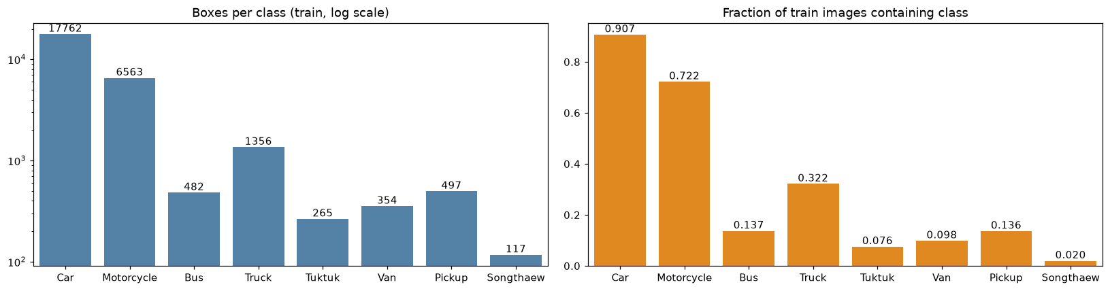
Figure 1: Boxes per class (log scale) and fraction of training images that contain each class
The target is heavily imbalanced: Car is 64.8% of all boxes while Songthaew is 0.43% (152 times fewer). Because mAP@50 averages the AP of the eight classes equally, the rare classes matter as much as Car.

2.2 Feature understanding, association with the target and leakage
Camera. Train uses cameras 1066, 12, 1407, 1426, 1427, 1437, 172, 180, 182, 214, 222, 229, 231, 232, 244; test uses 1068, 1072, 1192, 1439, 227. The two sets are disjoint, so the model must generalise to unseen viewpoints.
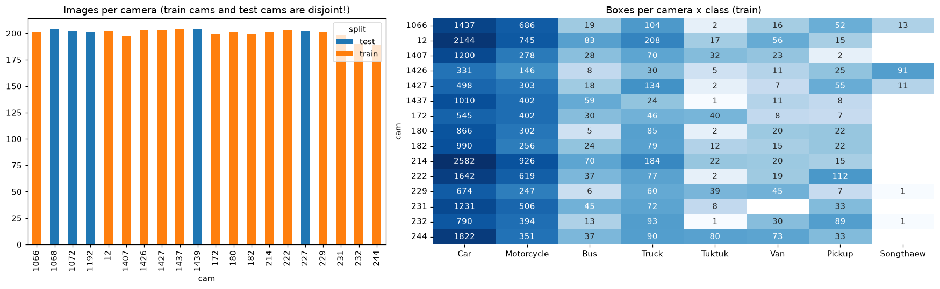
Figure 2: Images per camera (train vs test) and boxes per camera x class
Chi-square test of camera x class (slide appendix): chi2 = 4,823, dof = 98, p < 1e-300, Cramer's V = 0.159. H0 (same class distribution for every camera) is rejected: the vehicle mix depends strongly on the camera. The standardised residuals show, for example, that 91 of the 117 Songthaews come from camera 1426 (residual +53), Pickups are over-represented at cameras 232 and 222 and Tuktuks at 244, 229 and 172.
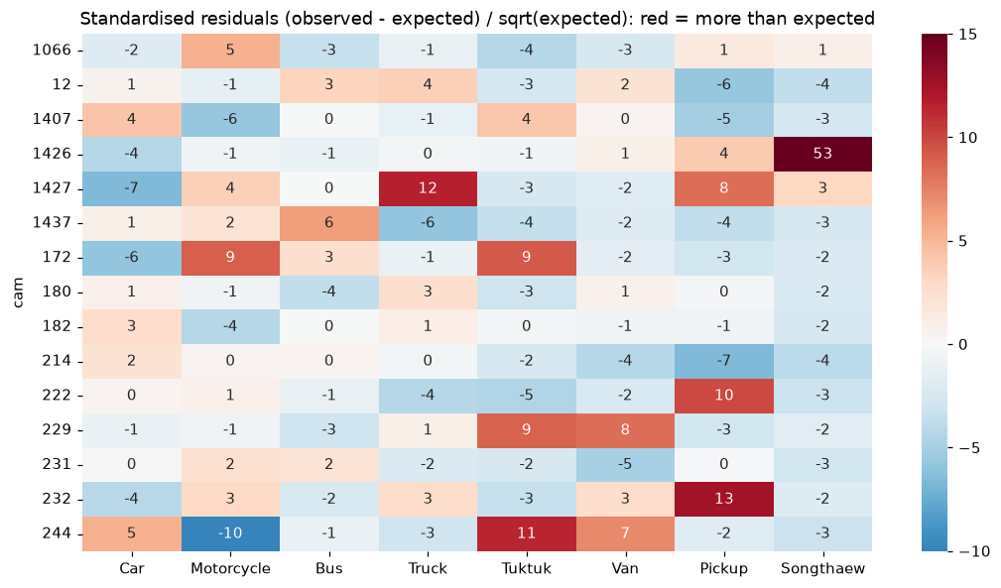
Figure 3: Standardised chi-square residuals, camera x class (red = more boxes than expected)
Time of day. Frames cover 06:00-21:00 every 30 minutes. Street lights keep night frames bright, so night was defined by clock time (after 18:30, about 17% of frames). The class mix also changes at night (chi-square p = 6.1e-33, Cramer's V = 0.078); e.g. Songthaew rises from 0.27% of boxes by day to 1.53% at night and Tuktuk from 0.84% to 1.86%.
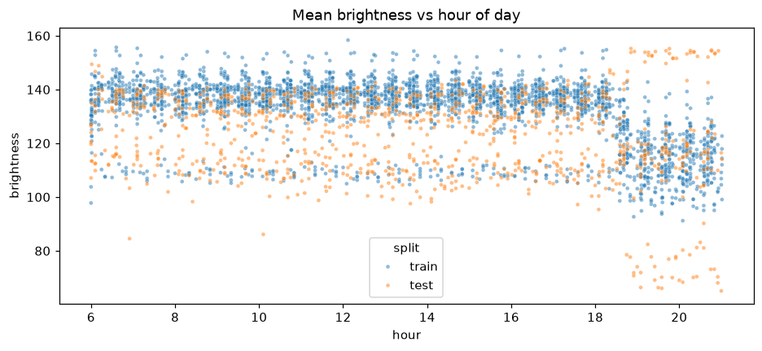
Figure 4: Mean brightness vs hour of day
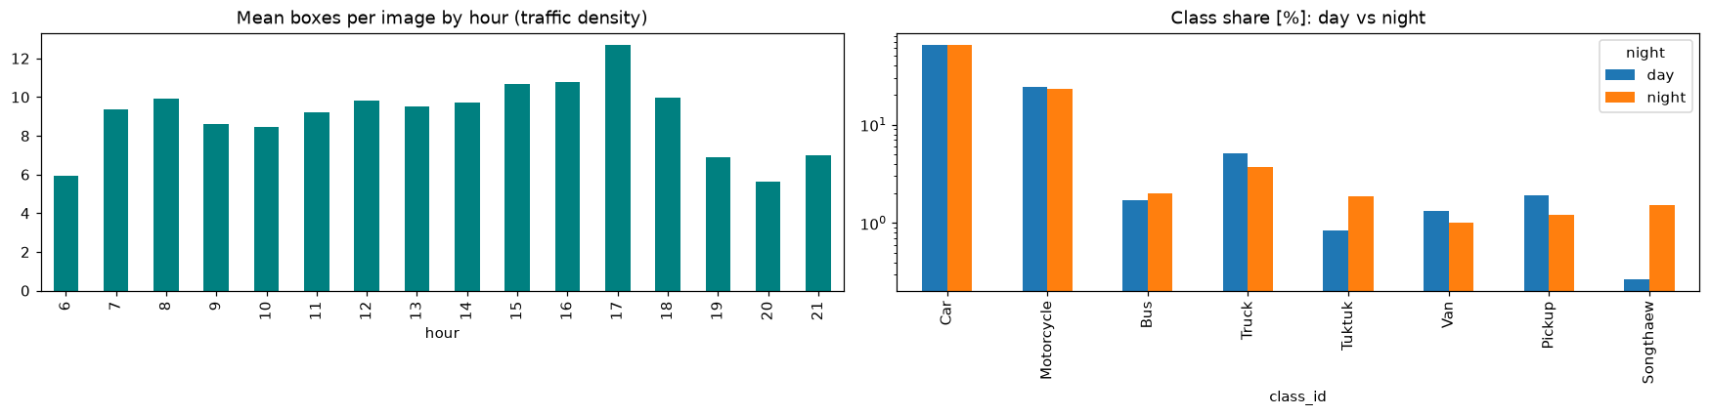
Figure 5: Traffic density by hour and class share by day / night
Leakage check. In Lab1, columns that leak information were removed. Here the leak is at the image level: consecutive frames of the same camera differ by a median of 14.5 grey levels, versus 53.6 for frames of different cameras (3.7x more similar). A random train / validation split would put almost identical scenes on both sides and measure memorisation instead of generalisation. Therefore whole cameras are held out for validation (Section 2.6).
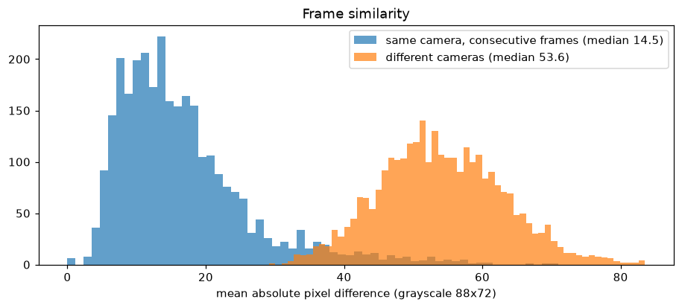
Figure 6: Frame similarity: same camera (consecutive frames) vs different cameras
Train vs test distribution. The test cameras have a similar share of night frames (17.6% vs 17.1%) and a slightly darker mean brightness (123 vs 132).
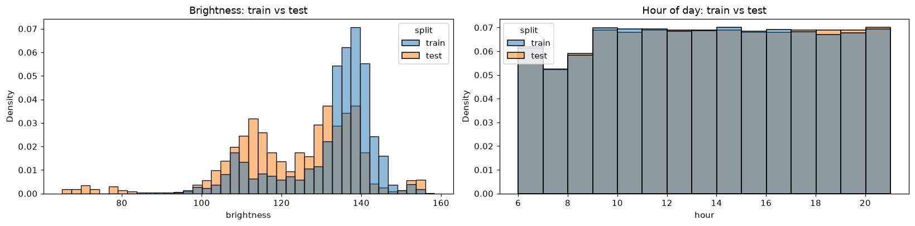
Figure 7: Brightness and hour-of-day distributions of train and test images

2.3 Outliers and skewness
Box sizes are tiny and strongly right-skewed: the box area has skew 7.05 and kurtosis 96.0; after a log transform the skew is 0.19 (Lab4 approach). This motivates upscaling the images (imgsz 640 -> 960) and a multi-scale detector.
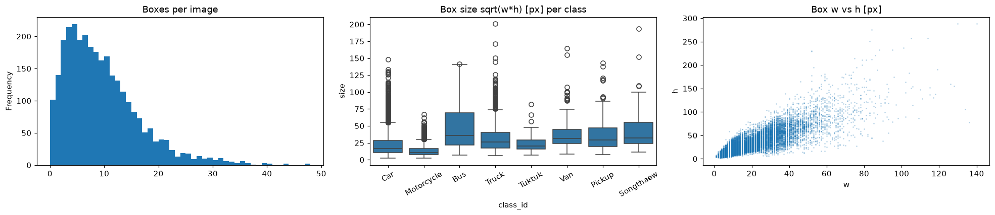
Figure 8: Boxes per image, box size per class and box width vs height
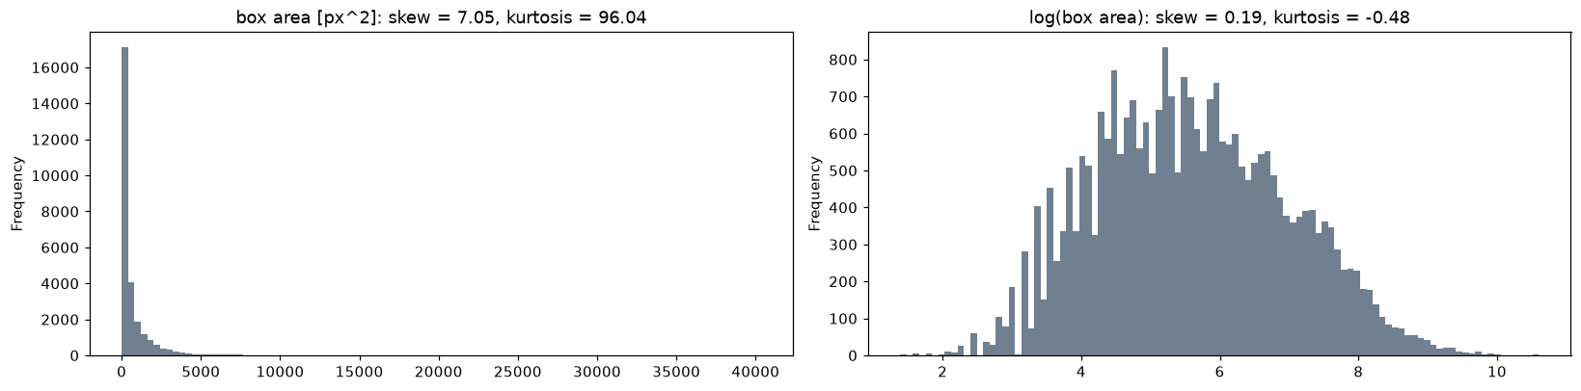
Figure 9: Box area before and after log transform
Table 4: Outliers per class (1.5 x IQR rule)
Class | Boxes | Median area | log-area IQR outliers | Median h/w | h/w IQR outliers
Car | 17762 | 276 | 5 | 1.33 | 452
Motorcycle | 6563 | 119 | 14 | 2.56 | 58
Bus | 482 | 1272 | 0 | 1.8 | 6
Truck | 1356 | 670 | 4 | 1.78 | 13
Tuktuk | 265 | 420 | 1 | 1.93 | 0
Van | 354 | 990 | 4 | 1.6 | 2
Pickup | 497 | 840 | 0 | 1.42 | 1
Songthaew | 117 | 1054 | 0 | 1.54 | 14

The extremes were inspected visually before deciding what to do. The largest boxes are real vehicles very close to camera 1426 (6 boxes are almost full height) and are kept. The extreme aspect ratios are annotation errors: slivers such as 1 x 8 or 2 x 16 px with no vehicle inside (195 boxes have a side <= 2 px). Boxes with a side < 2 px are removed; truncating coordinates, as done for numeric features in Lab4, is not meaningful for boxes.
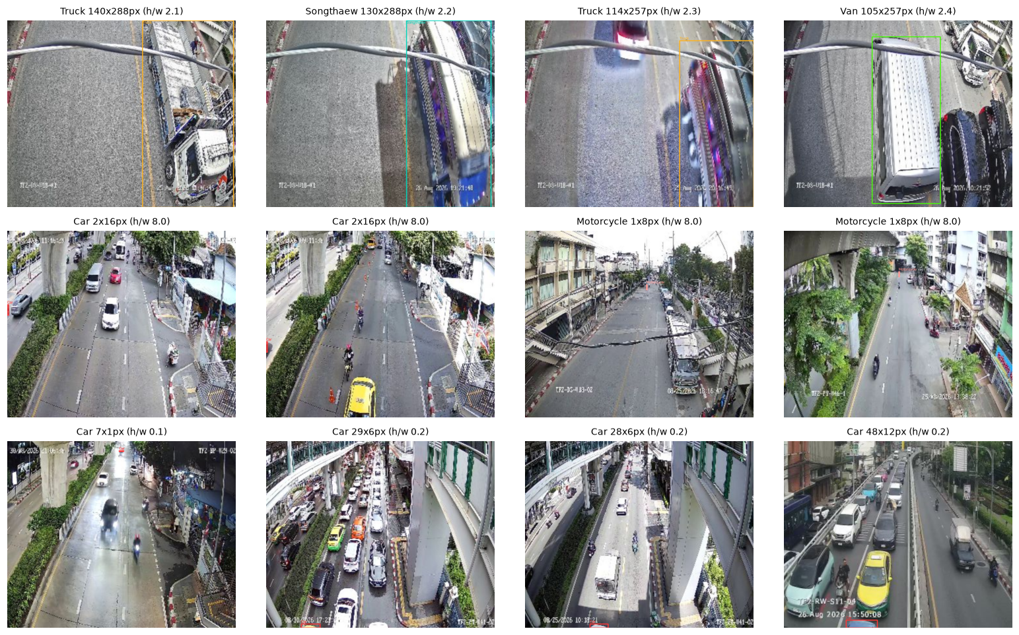
Figure 10: Most extreme boxes: largest area (top), tallest (middle), widest (bottom)

2.4 Visual inspection
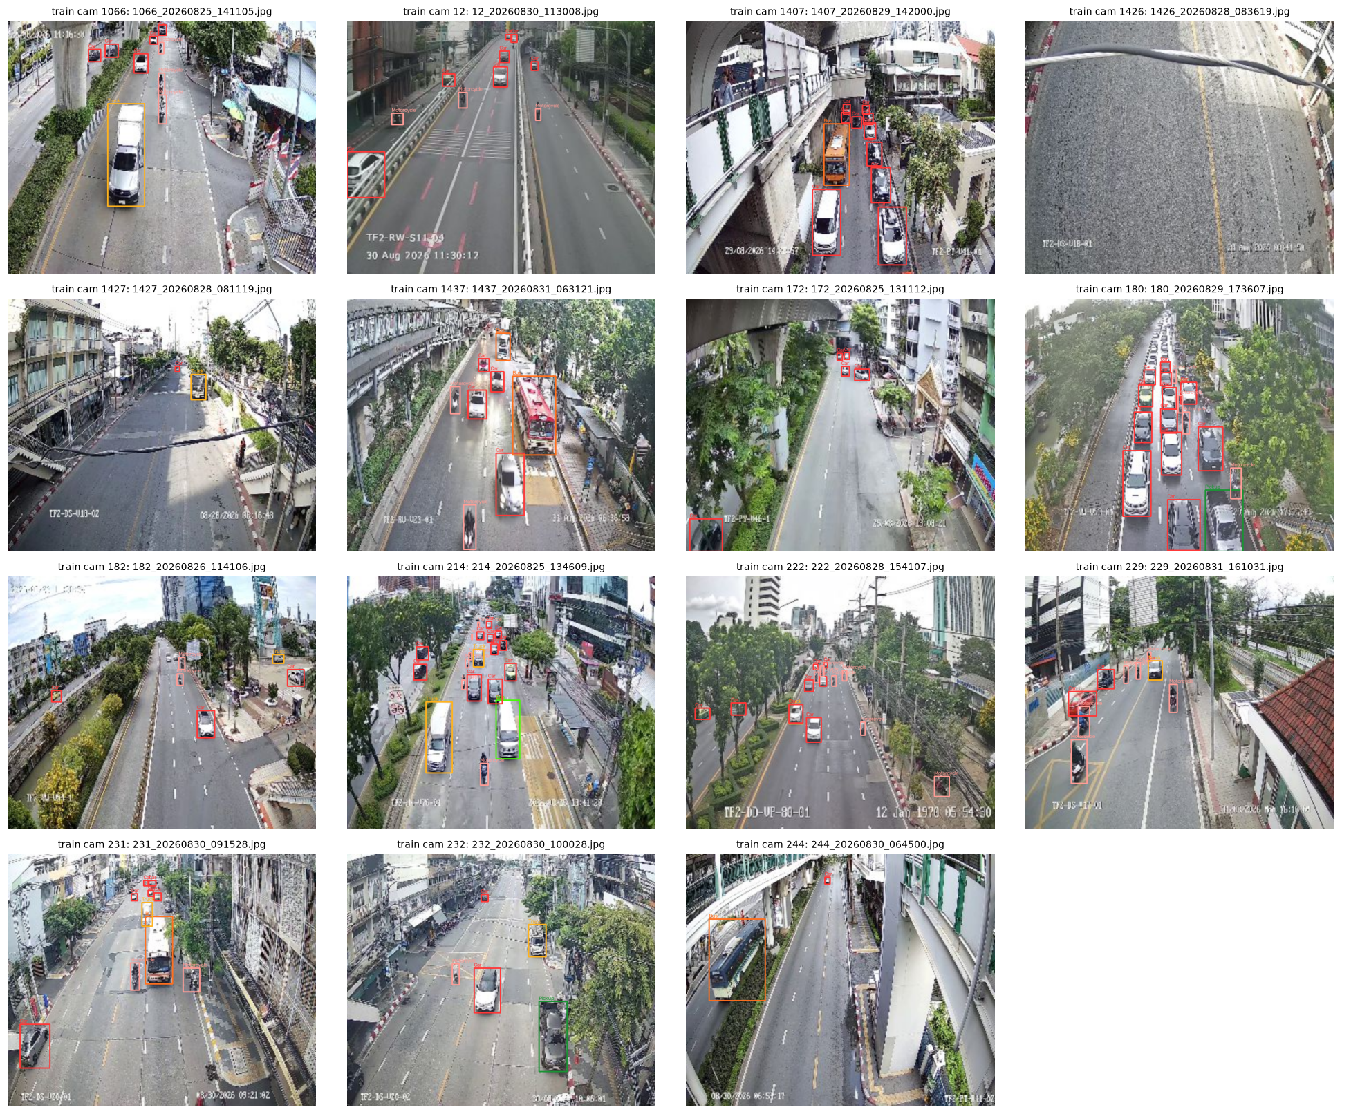
Figure 11: Preview: one daytime frame per training camera with ground-truth boxes
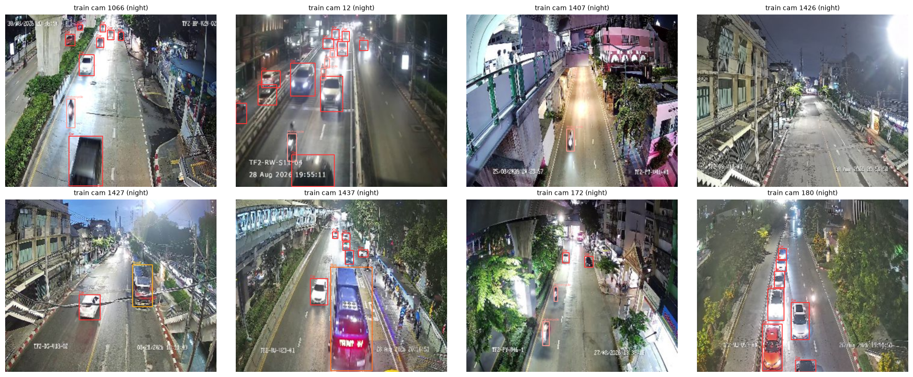
Figure 12: Preview: night frames of training cameras. Training uses all frames (day and night); only this preview is split by time
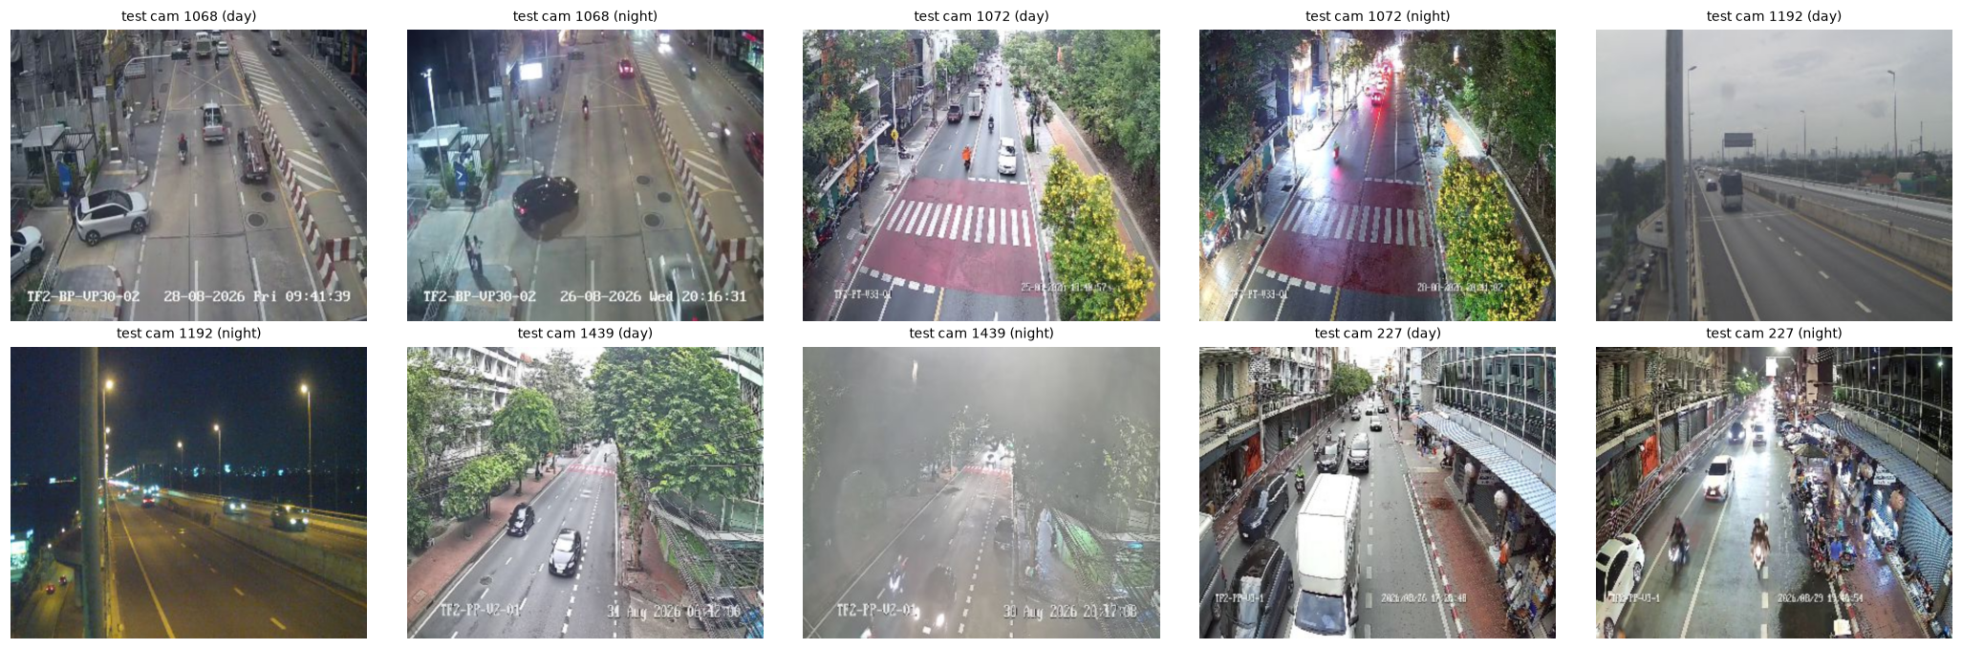
Figure 13: Test cameras (day and night); these viewpoints never appear in training
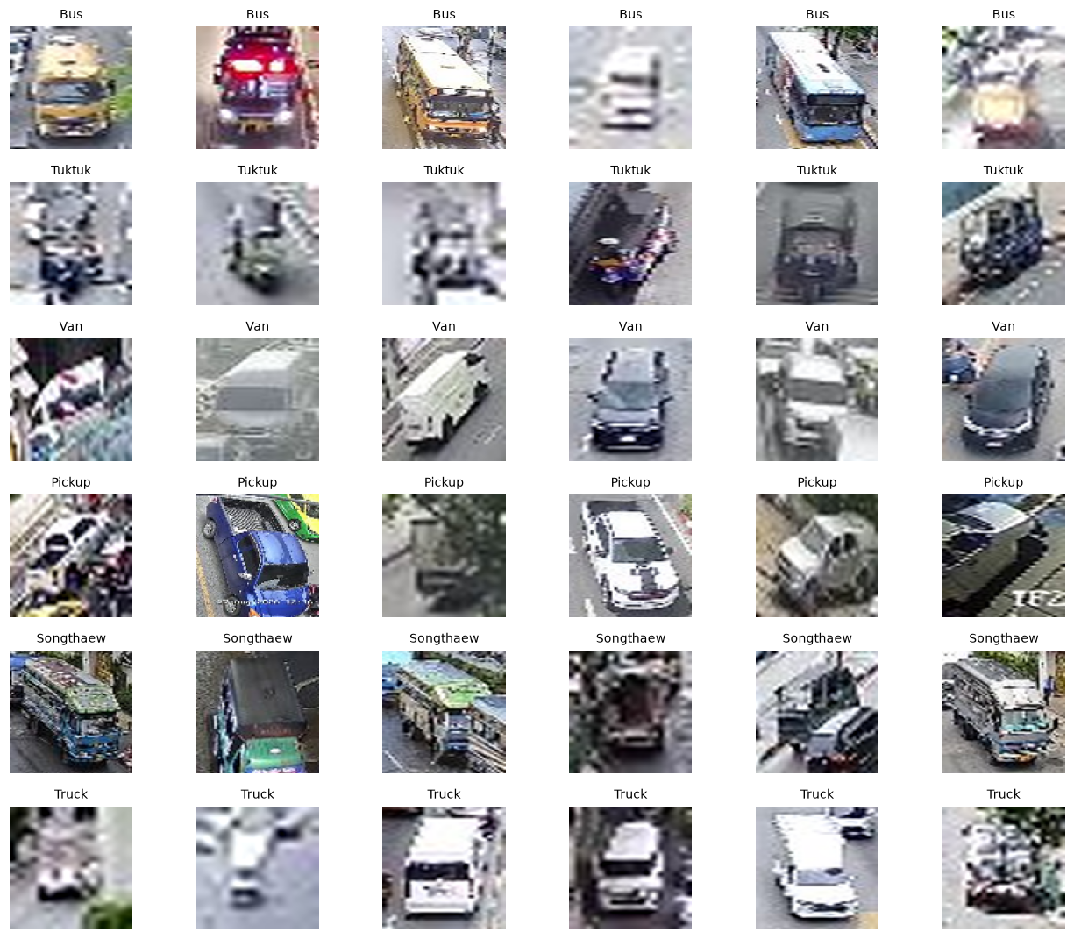
Figure 14: Examples of rare classes (crops). Van / Pickup / Truck are hard to separate even for a human
sample_submission.csv uses different ids from the test file names. It lists 997 long ids (dataset_<cam>_annotated_coco1.0_<cam>_<Thai location name>_<date>_<time>.jpg), while the 1,013 test images are named <cam>_<date>_<time>.jpg. The Kaggle solution uses the file names (Section 4.3), so predictions are written for all 1,013 test images with the file name as image_id.

2.5 Data cleaning
Cleaning is applied to the training labels only. Validation is always scored against the raw labels, the same way Kaggle scores the raw test labels.
Table 5: Data-cleaning log
Step | Count
raw boxes | 27396
boxes on missing images | 0
boxes outside image (clipped) | 0
exact duplicates removed | 25
tiny boxes (< 2 px) removed | 15
near-duplicates removed (same class, IoU > 0.9) | 9
class conflicts kept (different class, IoU > 0.9) | 280
clean boxes | 27347
background images (no boxes) | 102

280 pairs of boxes overlap with IoU > 0.9 but have different classes (mostly Car vs Truck and Bus vs Truck): the same vehicle was labelled twice. They were kept because the test labels probably contain the same pattern, and a model that outputs both classes at lower confidence can still match both.

2.6 Train / validation split and dataset construction
To mimic the unseen-camera test set and avoid the leakage shown in 2.2, 4 whole cameras (1066, 1427, 1437, 244) were held out for validation. As a stratification over cameras, the notebook tries all 1,365 combinations of 4 cameras out of 15 and keeps the one where every class has at least 10 validation boxes and the validation share of each class is closest to 4/15. The random seed is fixed (42) everywhere.
Table 6: Camera-held-out split after cleaning: 2,194 train / 797 val images (class proportions compared as in Lab3)
Class | Train boxes | Val boxes | Val share | Train % | Val %
Car | 12969 | 4765 | 26.9% | 64.87% | 64.79%
Motorcycle | 4808 | 1741 | 26.6% | 24.05% | 23.67%
Bus | 346 | 133 | 27.8% | 1.73% | 1.81%
Truck | 1002 | 352 | 26.0% | 5.01% | 4.79%
Tuktuk | 180 | 85 | 32.1% | 0.90% | 1.16%
Van | 247 | 107 | 30.2% | 1.24% | 1.45%
Pickup | 347 | 148 | 29.9% | 1.74% | 2.01%
Songthaew | 93 | 24 | 20.5% | 0.47% | 0.33%

Repeat-factor sampling (RFS). mAP weights all classes equally, so images that contain rare classes are repeated during training (LVIS-style): for class c with image frequency f_c, r_c = max(1, sqrt(t / f_c)) with t = 0.15, and each image is repeated r = max_c r_c times with stochastic rounding. Songthaew images are repeated about 2.8x, Tuktuk 1.4x and Van 1.2x. Repeats are only added to the training list, never to validation.
Labels were converted to the YOLO format (class x_center y_center width height, normalised) and the image lists were written as train.txt / val.txt / full.txt, which Ultralytics reads directly.

2.7 Summary: findings and decisions
Table 7: EDA findings and the resulting decisions
Finding | Decision
Test cameras never appear in training; same-camera frames are near-duplicates | Hold out whole cameras for validation
Class mix depends on camera and time (chi-square p ~ 0) | Every class must be present in val; RFS for rare classes
Car : Songthaew = 152 : 1 | Repeat-factor sampling; per-class AP analysis
Tiny, right-skewed box sizes | Upscale to imgsz 960; multi-scale detector
Sliver boxes are label noise; duplicates | Remove side < 2 px and exact / near duplicates
17% night frames in both train and test | Report day / night mAP; HSV augmentation

Chapter 3: Model

3.1 Choice of model
The course slides (Week 5, Object Detection) describe the change from two-stage CNNs (Faster R-CNN) to one-stage YOLO detectors, transformer detectors (DETR / RT-DETR) and, most recently, end-to-end NMS-free YOLO26. The course example notebook fine-tunes YOLOv8 with Ultralytics. This work uses the newest model in that family, YOLO26, fine-tuned from COCO-pretrained weights. Two sizes were used: YOLO26s for the experiments on the local 4 GB GPU, and YOLO26m for the final model, trained on Kaggle GPUs with camera 5-fold cross-validation and a 5-model ensemble.
Table 8: YOLO26 models used
Property | YOLO26s (experiments) | YOLO26m (final)
Framework | Ultralytics 8.4.163, PyTorch 2.8.0 | Ultralytics 8.4.163, PyTorch (Kaggle image)
Parameters | 9.95 M | 21.8 M
FLOPs | 22.8 G at 640 | 75.0 G at 640 / 169.5 G at 960
Pretraining | COCO 2017 detection (80 classes, ~118k images) | same
Backbone | CSP-style CNN with C3k2 blocks, SPPF and C2PSA (attention) block | same design, wider / deeper
Neck | PAN/FPN feature pyramid, strides 8 / 16 / 32 (small vehicles) | same
Head | Anchor-free, end-to-end (one-to-one) head: no NMS, no DFL | same
Transfer | head rows of car, motorcycle, bus, truck initialised from the COCO classes | same

YOLO is a one-stage detector: a single CNN pass predicts, for every location of three feature maps, a box and class scores. YOLO26 trains with a one-to-one assignment so each object gets a single prediction, which removes the non-maximum-suppression step, and it drops the Distribution Focal Loss. According to the Ultralytics documentation it also uses progressive loss balancing (ProgLoss) and small-target-aware label assignment (STAL), which suits this dataset because most vehicles are tiny.
No generative-AI / VLM API was used, so there is no API cost. Compute: the YOLO26s runs used a local laptop GPU; the YOLO26m cross-validation used the free Kaggle GPU quota (2 x NVIDIA T4, 8.0 GPU-session hours for the 5 folds, including prediction).

3.2 Training setup
Table 9: Training configuration
Hyper-parameter | YOLO26s (experiments) | YOLO26m 5-fold (final)
Input size | 640 and 960 (upscaled from 352 x 288, letterbox) | 960
Epochs / early stopping | 100 (640) / 40 (960), patience 30, best-val checkpoint | 30 per fold, patience 10, best-val checkpoint of each fold
Batch size | 8 (640) / 4 (960), 4 GB VRAM | 16 (8 per GPU, 2 GPUs, DDP)
Validation | 4 held-out cameras (1066, 1427, 1437, 244) | StratifiedGroupKFold by camera: 5 folds x 3 cameras
Optimizer | Ultralytics "auto" -> AdamW (lr 0.000833, momentum 0.9, wd 0.0005), cosine LR, warm-up 3 epochs | same
Augmentation | Mosaic (off for the last 10 epochs), scale 0.5, translate 0.1, flip 0.5, HSV (0.015, 0.7, 0.4), random erasing 0.4 | same
Class balance | Repeat-factor sampling (Section 2.6) | same
Seed | 42, deterministic=True | same
Hardware | RTX 3050 Ti Laptop GPU (4 GB), 32 GB RAM | Kaggle Notebook, 2 x NVIDIA T4 (16 GB each)

Camera K-fold cross-validation. The single 4-camera split of Section 2.6 wastes 4 cameras for training and gives a noisy score. For the final model the 15 training cameras were split with scikit-learn StratifiedGroupKFold (group = camera, stratified on the rarest class of each image) into 5 folds of 3 cameras. Each fold model is trained on 12 cameras and early-stopped on its own 3 unseen cameras, so every camera is used for validation exactly once (out-of-fold score) and for training in 4 of the 5 models. The folds are fixed in the notebook because a different scikit-learn version produces a different assignment.

3.3 Inference, ensemble and post-processing
- Confidence threshold 0.001: low-confidence boxes only extend the precision-recall curve and never reduce AP, so a very low threshold gives the highest mAP.
- Test-time augmentation (flips + scales) for every model.
- Weighted Boxes Fusion (WBF) of the 5 fold models: boxes of the same class from different models that overlap with IoU > 0.55 are merged into one box whose coordinates are the confidence-weighted average; the score is averaged over the 5 models, so a box found by only one model gets a low score. Up to 300 boxes per image are kept (pycocotools uses at most 100 per image and class).
- Boxes are written in absolute pixel coordinates (x1, y1, x2, y2); image_id is the test file name; images without detections get no row and no dummy boxes are added (Data-page rule).

3.4 Evaluation
Both notebooks re-implement the Kaggle metric with pycocotools (COCOeval, IoU = 0.50, area = all, maxDets = 100) on held-out cameras, using the raw labels. Ultralytics' own mAP50 is a bit higher because it uses the cleaned labels.

Chapter 4: Results

4.1 Experiments with YOLO26s (validation = 4 held-out cameras)
Table 10: YOLO26s experiments
Run | Description | Val mAP@50 | Kaggle public
yolo26s_640 | YOLO26s, imgsz 640, batch 8, RFS; 100 ep max, early-stopped at 60 (best ep 30) | 0.4666 | -
yolo26s_640_tta | same weights + test-time augmentation (flips + multi-scale) | 0.4919 | -
yolo26s_960 | YOLO26s, imgsz 960, batch 4, RFS; 40 ep (best ep 22) | 0.4958 | -
yolo26s_960_tta | yolo26s_960 weights + TTA | 0.5247 | 0.5165
yolo26s_960_full_tta | final: same settings trained on all 15 cameras (25 ep, last epoch) + TTA; val cams are inside training, so no unbiased val score | - | 0.5481

Higher resolution (640 -> 960) and TTA each add about +0.03. The YOLO26s results below are for the best single-split model (960 + TTA).
Table 11: Per-class AP@50, YOLO26s 960 + TTA, 4 validation cameras
Class | Car | Motorcycle | Bus | Truck | Tuktuk | Van | Pickup | Songthaew
AP@50 | 0.901 | 0.800 | 0.699 | 0.588 | 0.448 | 0.337 | 0.315 | 0.109

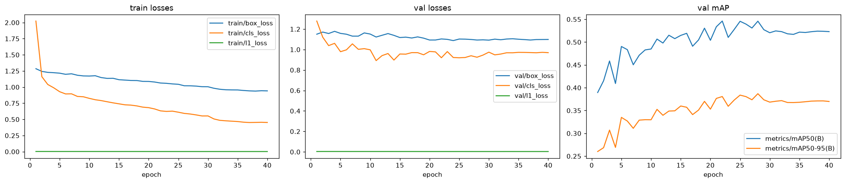
Figure 15: YOLO26s 960: training curves (losses and validation mAP)
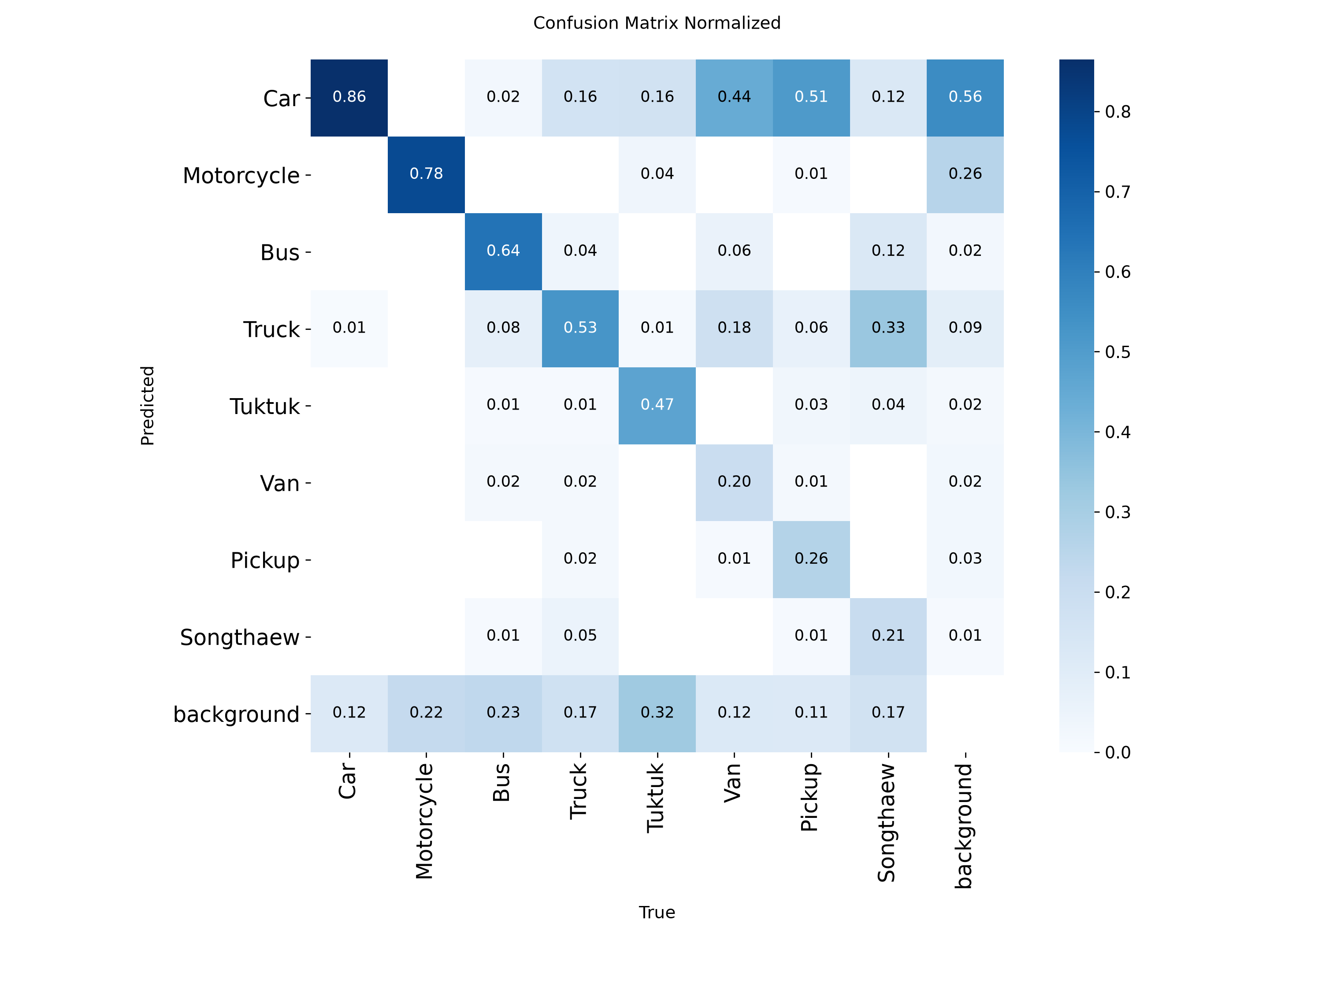
Figure 16: YOLO26s 960: normalised confusion matrix on the validation cameras
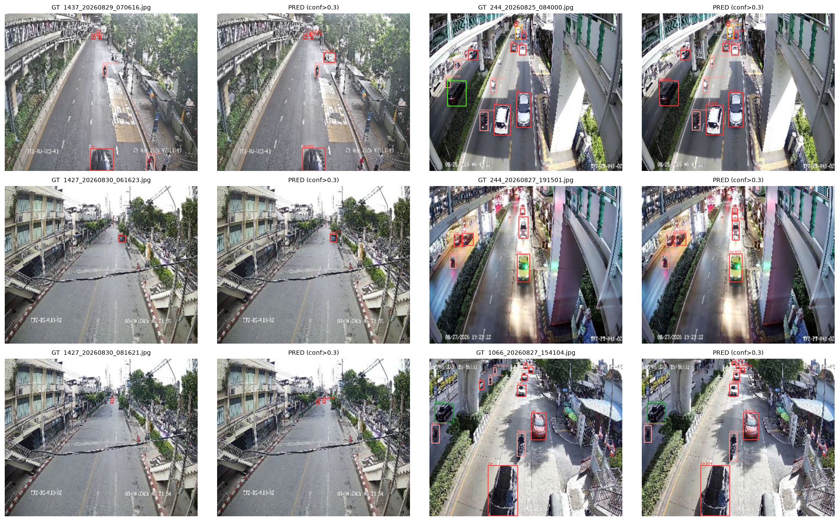
Figure 17: YOLO26s 960: ground truth (left) vs prediction with confidence > 0.3 (right)

4.2 Final model: YOLO26m, camera 5-fold cross-validation
Table 12: YOLO26m 960 + TTA: per-fold and out-of-fold (OOF) validation mAP@50
Fold | Validation cameras | Val mAP@50 | Epochs run | Best epoch | Hours
0 | 1426, 1427, 172 | 0.4297 | 28 | 18 | 0.95
1 | 1066, 182, 222 | 0.5198 | 30 | 17 | 1.84
2 | 229, 232, 244 | 0.5025 | 25 | 15 | 1.56
3 | 1407, 1437, 180 | 0.7089 | 30 | 24 | 1.85
4 | 12, 214, 231 | 0.5449 | 29 | 19 | 1.78
OOF | all 15 cameras (2,991 images) | 0.4756 |  |  | 8.0

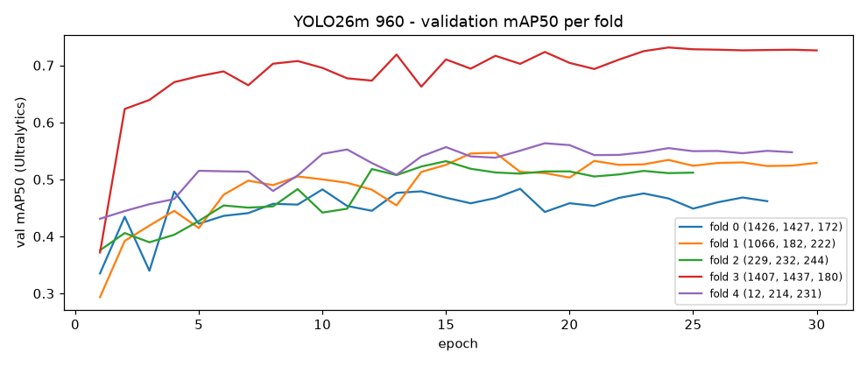
Figure 18: YOLO26m: validation mAP50 per epoch for each fold
Table 13: Per-class AP@50 on cameras that were not used for training
Class | YOLO26s (4 cams) | YOLO26m CV (same 4 cams) | YOLO26m CV (15 cams)
Car | 0.901 | 0.921 | 0.866
Motorcycle | 0.800 | 0.827 | 0.694
Bus | 0.699 | 0.672 | 0.675
Truck | 0.588 | 0.602 | 0.496
Tuktuk | 0.448 | 0.480 | 0.483
Van | 0.337 | 0.400 | 0.300
Pickup | 0.315 | 0.346 | 0.290
Songthaew | 0.109 | 0.005 | 0.001
mAP@50 | 0.525 | 0.532 | 0.476

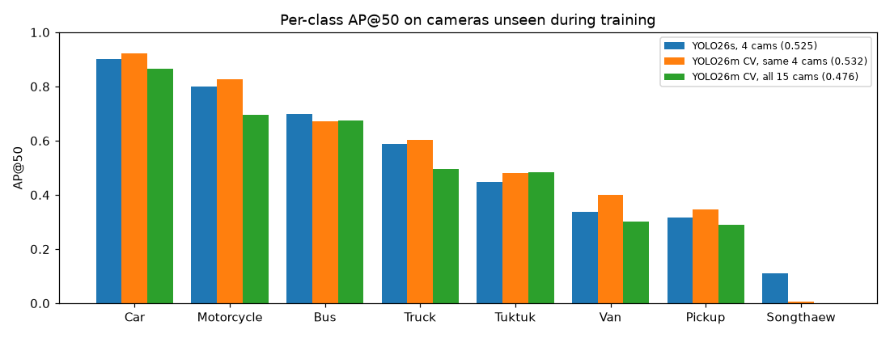
Figure 19: Per-class AP@50: YOLO26s vs YOLO26m on unseen cameras
On the same four cameras YOLO26m is better for 6 of 8 classes (e.g. Van 0.34 -> 0.40, Car 0.90 -> 0.92). The OOF score over all 15 cameras (0.476) is lower mainly because of Songthaew (AP 0.001): 91 of its 117 boxes come from camera 1426, so the fold that validates on 1426 has almost no Songthaew to learn from (see Chapter 5). In the test ensemble, 4 of the 5 models have seen camera 1426.
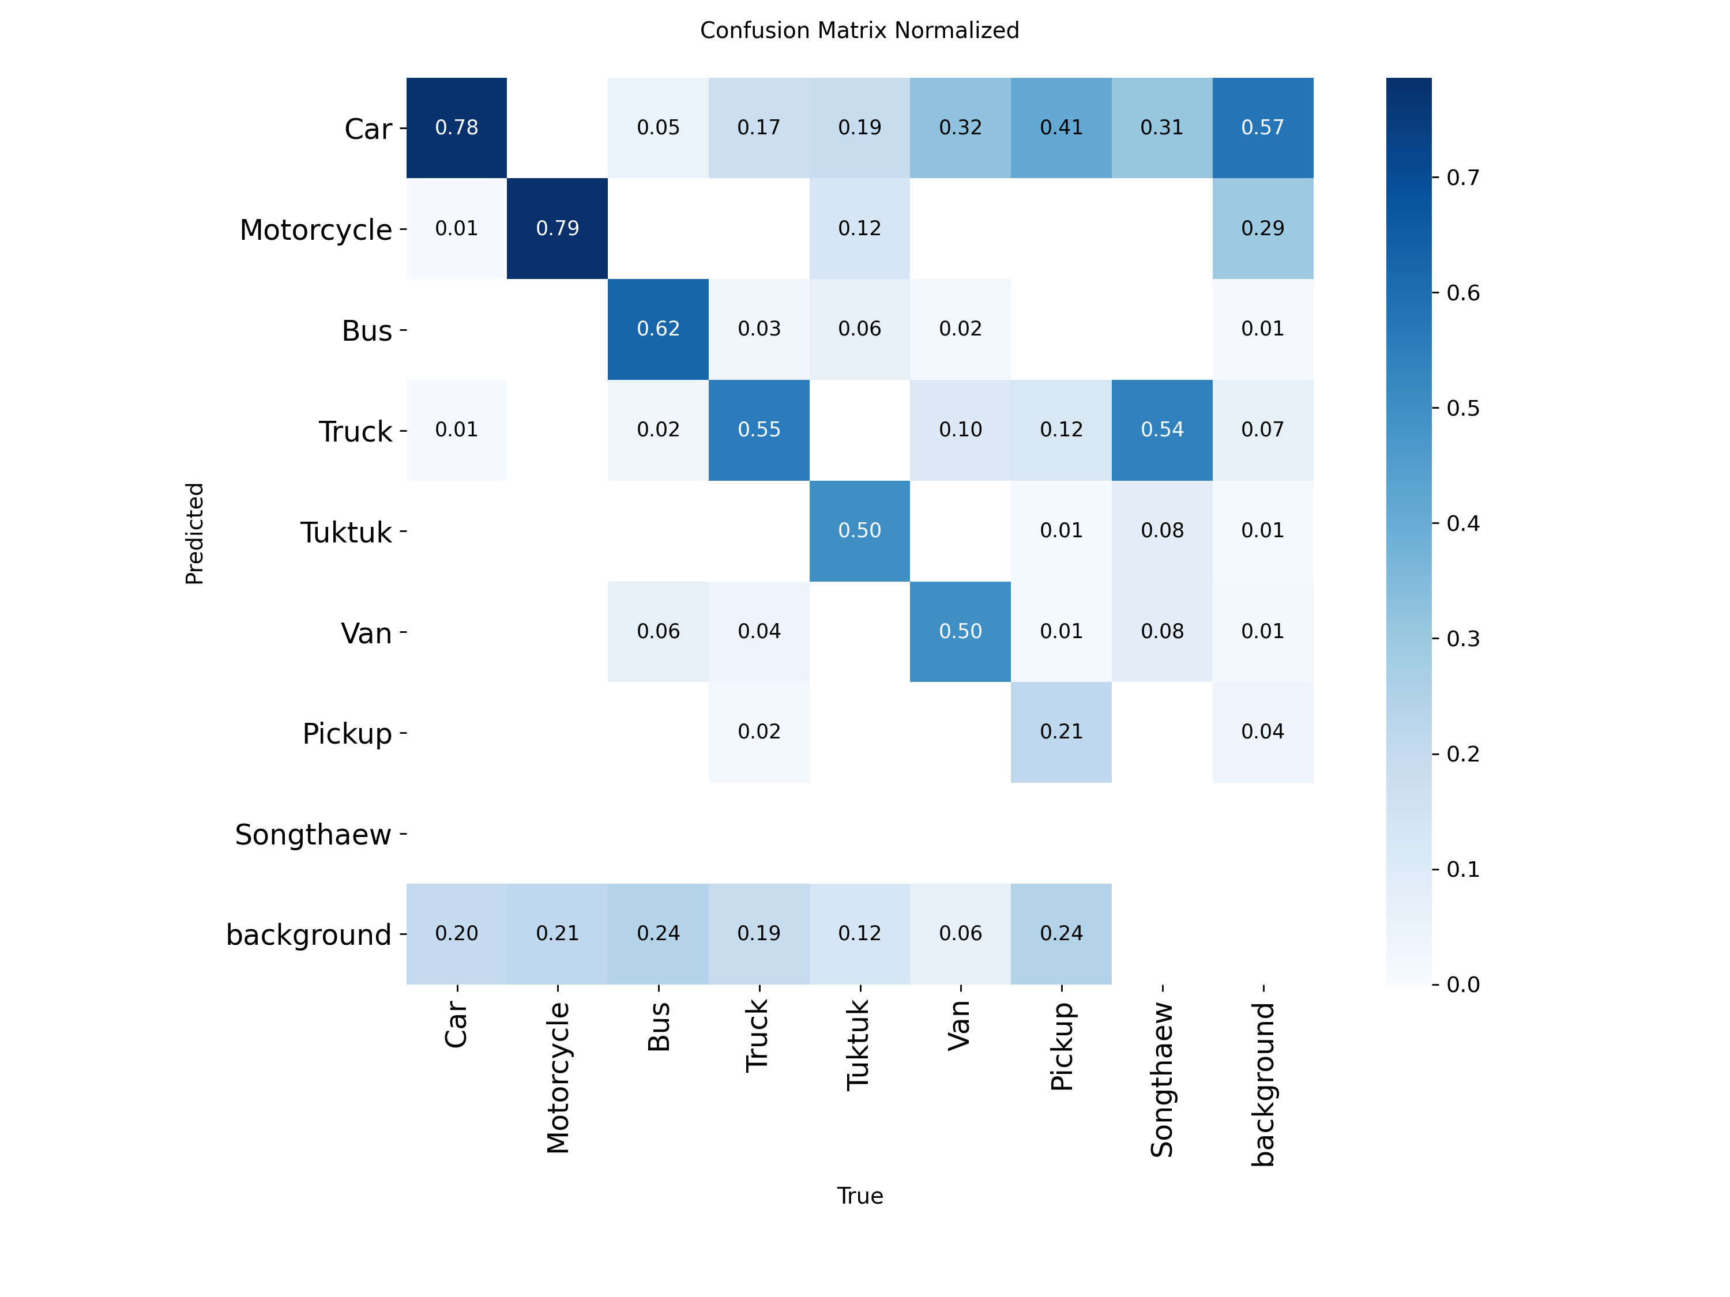
Figure 20: YOLO26m fold 1: normalised confusion matrix on its validation cameras (1066, 182, 222)
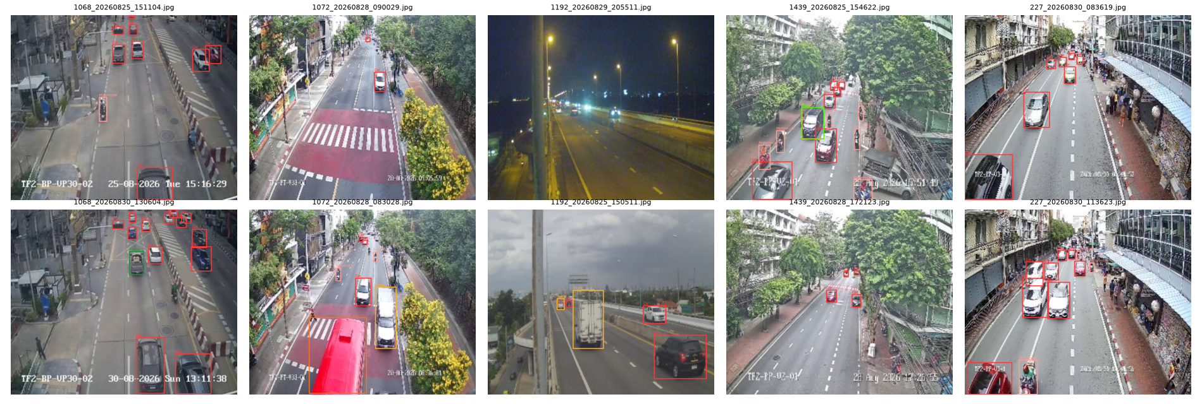
Figure 21: WBF ensemble predictions (confidence > 0.3) on the unseen test cameras

4.3 Kaggle submissions
Table 14: Kaggle submission history
Submitted file | Model / image_id format | Public mAP@50
yolo26s_960_full_tta.csv | YOLO26s 15 cams; long ids from sample_submission | 0.00000
yolo26s_960_tta.csv | YOLO26s 11 cams; long ids from sample_submission | 0.00000
yolo26s_960_tta.csv (re-submitted) | YOLO26s 11 cams; test file names | 0.51648
yolo26s_960_full_tta.csv | YOLO26s 15 cams; test file names, 1,013 images | 0.54814
yolo26m_960_cv5fold_wbf.csv (final) | YOLO26m 5-fold CV + TTA + WBF ensemble | 0.60457

The first two submissions scored 0.000 although the model was the same: they used the long ids copied from sample_submission.csv, which do not exist in the solution file. Re-submitting the same predictions with the test file names gave 0.516, close to the validation score of the same model (0.525), which confirms that camera-held-out validation is a reliable estimate of the leaderboard. Training YOLO26s on all 15 cameras gave 0.548, and the YOLO26m 5-fold WBF ensemble gave 0.605.
Final submission file: submissions/yolo26m_960_cv5fold_wbf.csv. Public leaderboard mAP@50: 0.6046.
Reproducibility check. Re-running cv_kfold_kaggle.ipynb locally (RTX 3050 Ti) with the submitted fold weights reproduced every fold score within 0.0002 of the Kaggle run (e.g. fold 1: 0.5198 on Kaggle vs 0.5200 locally) and the ensemble file differs only by floating-point noise (6,948 vs 6,949 boxes with confidence > 0.3).
Model weights: weights/yolo26m_960_cv_fold0.pt ... fold4.pt (final ensemble); weights/yolo26s_960_full.pt and yolo26s_960.pt (YOLO26s experiments).
[Insert screenshot of the Kaggle submission page / leaderboard here]

Chapter 5: Discussion

5.1 Error analysis by class (YOLO26s, 4 validation cameras)
- Car (0.90) and Motorcycle (0.80) are detected well: they are frequent and look distinctive.
- Van (0.34), Pickup (0.32) and Songthaew (0.11) are the main weakness. The confusion matrix shows that 44% of Vans and 51% of Pickups are predicted as Car, and 33% of Songthaews as Truck. At 15-25 px these vehicles differ only by a few pixels (roof shape, open cargo bed, rear bench).
- Label noise makes this harder: the crops in Chapter 2 contain SUVs labelled as Van and vans labelled as Truck, and 280 vehicles carry two boxes with different classes (mostly Car + Truck). One of the two boxes can never be matched by a single prediction, which caps the achievable AP.
- Songthaew generalises poorly because 91 of its 117 training boxes come from one camera (1426), so the model learns that camera's appearance rather than the vehicle.
- Tuktuk is often missed completely (32% predicted as background): tuktuks are small, partially covered by motorcycles and look like a motorcycle with a roof.

5.2 Error analysis by condition and camera
- Day vs night (960 + TTA): 0.537 vs 0.494. Headlight glare and motion blur reduce the visible shape.
- Per validation camera: 0.52 (cam 244, 1427) to 0.69 (cam 1437). Accuracy depends strongly on the viewpoint, so the unseen test cameras are the biggest source of uncertainty.
- Overfitting to the training cameras: validation mAP peaks early (epoch 30 at 640, epoch 22 at 960) and then slowly decreases while the training loss keeps going down. Early stopping on held-out cameras was therefore essential.
- Validation vs leaderboard: the same model scored 0.525 on the held-out cameras and 0.516 on the public test set, so the camera-held-out split predicts the leaderboard well; a random split would have been over-optimistic.

5.3 What helped
- Camera-held-out validation: an honest estimate for unseen cameras (validation 0.525 vs public 0.516 for the same model).
- Higher input resolution (640 -> 960): +0.029 mAP on validation, mainly Truck and Tuktuk.
- Test-time augmentation: +0.025 at 640 and +0.029 at 960; helps the rare classes most.
- Training on all cameras: YOLO26s public 0.516 (11 cams) -> 0.548 (15 cams).
- Larger model + camera 5-fold CV + WBF ensemble (YOLO26m): public 0.548 -> 0.605 (+0.057). On the same four unseen cameras YOLO26m alone improves 0.525 -> 0.532; the rest of the gain comes from averaging five models, each trained on a different 12-camera subset and early-stopped on its own unseen cameras.
- Very low confidence threshold (0.001) so the precision-recall curve is complete; keeping 300 instead of 100 boxes per image changed the score by only +0.001.

5.4 How to improve
- Even larger models (YOLO26l/x, RT-DETR) and imgsz 1280, and more ensemble members (several seeds per fold); YOLO26m at 960 already filled the free Kaggle session budget.
- Songthaew: copy-paste augmentation of Songthaew crops from camera 1426 into other cameras, so that the model does not tie the class to one viewpoint.
- A second-stage classifier (or a VLM) that re-classifies crops of the confusable classes Car / Van / Pickup / Truck / Songthaew at higher resolution, emitting the alternative classes with lower scores.
- Ensembling several models / resolutions with Weighted Boxes Fusion.
- Semi-supervised domain adaptation: pseudo-label the unlabelled test cameras with high-confidence predictions and fine-tune.
- Copy-paste augmentation of rare vehicles into other cameras, and relabelling the noisy Van / Truck / duplicate boxes.
- Cross-validation over several camera folds to choose hyper-parameters more reliably than a single 4-camera split.

5.5 Lessons from cross-validation
- Songthaew generalises across cameras only if camera 1426 is in the training set: in the fold that validates on 1426 the model has only 26 Songthaew boxes, and the OOF AP of Songthaew is 0.001. The OOF mAP over 15 cameras (0.476) is therefore a pessimistic estimate; for the test set, 4 of the 5 ensemble models have seen camera 1426.
- Validation mAP varies strongly between folds (0.43 to 0.71): the difficulty depends on the viewpoint, which confirms that a single 4-camera split is noisy and that K-fold CV gives a more reliable model selection.
- Early stopping per fold chose epochs 15-24, so a fixed number of epochs would be sub-optimal for some camera subsets.
- Reproducibility: StratifiedGroupKFold returned a different camera assignment on the Kaggle image than locally (different scikit-learn version); the folds of the submitted run are therefore fixed in the notebook.

Chapter 6: Conclusion
A YOLO26 detector pretrained on COCO was fine-tuned to detect eight vehicle classes in low-resolution Bangkok CCTV images. The EDA showed that the test cameras never appear in training, that frames of one camera are near-duplicates, that the objects are tiny and that the classes are strongly imbalanced. The pipeline was designed around these facts: camera-held-out validation, repeat-factor sampling for rare classes, upscaled training (imgsz 960) and test-time augmentation.
With YOLO26s on the local GPU the best single model reached 0.525 on four held-out cameras and 0.548 on the public leaderboard. The final solution trains YOLO26m with camera 5-fold cross-validation on Kaggle GPUs and fuses the five fold models with Weighted Boxes Fusion; it scores 0.605 mAP@50 on the public leaderboard. The remaining errors are mostly fine-grained confusion between Car, Van, Pickup, Truck and Songthaew, and viewpoint changes between cameras.
Everything is reproducible from the two notebooks with fixed seeds, fixed folds, pinned package versions and the submitted weights.

Appendix: How to reproduce
- conda create -n dsde python=3.12; pip install torch==2.8.0 torchvision==0.23.0 --index-url https://download.pytorch.org/whl/cu126; pip install -r requirements.txt
- kaggle competitions download -c 2110531-dsde-2026-1 -p data/raw, then unzip into data/raw
- Open vehicle_detection.ipynb from the midterm/ folder and run all cells. The settings are in the Config cell (or set environment variables, e.g. MODEL, IMGSZ, EPOCHS, FULL_TRAIN=1).
- YOLO26s submission without training: SKIP_TRAIN=1 WEIGHTS=<submitted .pt> (and the same IMGSZ / TTA as in the submission .json file).
- Final YOLO26m ensemble: run cv_kfold_kaggle.ipynb on a Kaggle Notebook (GPU T4 x2, attach the competition data) or locally. To reproduce without training, copy weights/yolo26m_960_cv_fold{k}.pt to cv_out/fold{k}/best.pt; the notebook then only predicts and writes cv_out/yolo26m_960_cv5fold_wbf.csv (PRED_BATCH=8 on a 4 GB GPU).

