**Validation and evaluation of TAMSAT-ALERT soil moisture: Lesotho**

**Contact:** Vicky Boult, Dept of Meteorology, University of Reading ([v.l.boult@reading.ac.uk](mailto:v.l.boult@reading.ac.uk))

# **Introduction**

In order to support drought risk management, operational drought monitoring and forecasting tools must: 1) estimate a metric which is relevant to the impacts of drought, 2) provide skilful estimates of drought within a timeframe which allows for actions to take place, and 3) include skill information on drought monitoring and forecasting to build users’ confidence and encourage an long-term perspective.

Here, we assess the suitability of the TAMSAT-ALERT decision-support tool, which aims to provide early warnings of drought by exploiting the expected persistence of root-zone soil moisture anomalies (Brown *et al.*, 2017). TAMSAT-ALERT (T-A) provides daily estimates of soil moisture for all of Africa at a 0.25˚ resolution. The historic datasets begin in 1983, when the TAMSAT rainfall archive began (Maidment *et al.*, 2017). Alongside the historic dataset, T-A importantly includes a forecasting system to predict soil moisture for a region and period of interest (Asfaw *et al.*, 2018).

We examine the historic relationship between T-A soil moisture estimates and measures of vegetation productivity. In addition, we assess the skill of T-A forecasts in anticipating drought impacts at a range of lead-times throughout the growing season.

# **Study region: Lesotho**

This report details the evaluation and validation of T-A soil moisture for drought risk management in Lesotho.

The rainy season in Lesotho begins in October and continues through April the following calendar year (Figure 1). Mean total annual rainfall is widely below 800mm with the exception of the Maloti mountain region.

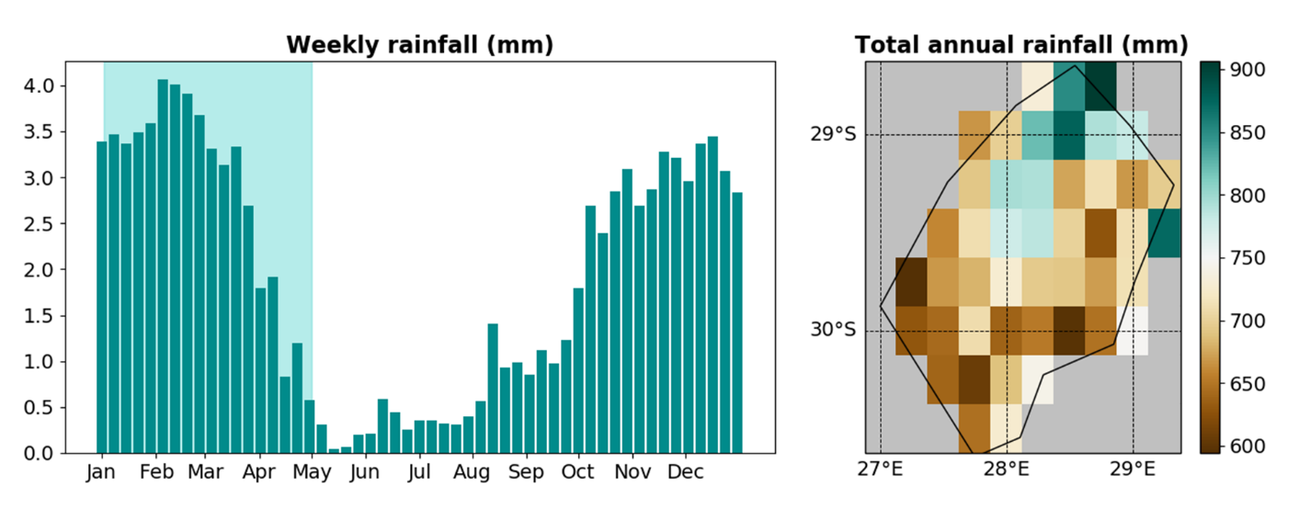

**Figure 1.** The distribution of rainfall in space and time. In Lesotho, rainfall is largely restricted to the rainy season, beginning in October and ending in April. Rainfall data from TAMSAT version 3.0 (Maidment et al., 2017). On the map, grey shaded areas mask surrounding countries.

In Lesotho, maize provides a staple source of food for much of the population. In addition, Lesotho has a substantial pastoral community, which depends on available pasture to support grazing livestock. Agricultural systems are predominantly rainfed, so crop and pasture production are limited to the rainy season (Figure 2). We therefore assessed the relationship between T-A soil moisture and vegetation production for the key growing season spanning January to April.

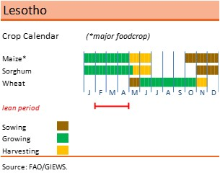

**Figure 2.** FAO crop calendar outlining the key sowing, growing and harvesting period for food crops in Lesotho. Source: FAO, 2020 ([available online](http://www.fao.org/giews/countrybrief/country.jsp?code=LSO)).

# **TAMSAT-ALERT**

The TAMSAT-ALERT (Tropical Applications of Meteorology using SATellite data – AgriculturaL Early waRning sysTem) considers the (1) historical weather conditions, (2) current state of the land surface, (3) evolution of the growing season and (4) meteorological forecast to assess the risk of meteorological hazards (e.g. drought).

Historical meteorological variables are used to drive a land-surface model, to produce a historical time series of land-surface variables (including soil moisture). The historical timeseries of land-surface metrics provides a climatology of land-surface metrics for the period of interest. Historical meteorological variables are used to construct the climatological ensemble of meteorological variables. The initial conditions of the land-surface model are estimated from the historical run. Using each of the climatological ensembles of meteorological variables, the land-surface model is driven forward in time to produce an ensemble time series of future land-surface conditions. Combining the historical time series and ensemble of future land-surface variables, an ensemble of the land-surface metric of interest can be derived for the whole period (incorporating the historic or observed period and the forecast period). The ensemble can be weighted based on a related meteorological forecast. Considering both the historical and ensemble time series, the likelihood of an adverse event (e.g. drought) can be estimated.

Full details of the T-A system are documented in Boult et al. (in review).

# **Validation data**

## *Vegetation productivity*

Historic measures of vegetation productivity were obtained from the Global Inventory Monitoring and Modelling System (GIMMS) project’s Normalised Difference Vegetation Index (NDVI). NDVI correlates closely with ground-based measures of vegetation dynamics including biomass, net primary productivity and leaf area index (Tucker *et al.*, 1985; Reed *et al.*, 1994; Pettorelli *et al.*, 2005). Here, we therefore use NDVI as a proxy for the growth of green vegetation, including pasture and crops.

Mean seasonal NDVI was subsequently used to calculate the Vegetation Condition Index (VCI) using the methods presented in (Yang et al., 2011). The VCI compares NDVI recorded in a given year to that observed over the same period in other years. It is expressed as a percentage, with 0% and 100% representing the lowest and highest observations of NDVI, respectively. Here, VCI was calculated for the season of interest with a 15-day lag in season start and end in order to account for the known lag between soil moisture and vegetation growth. The VCI has been shown to be a good indicator of drought (Liu & Kogan, 1996).

# **Analysis**

## *Historic validation of TAMSAT-ALERT soil moisture*

Mean growing season (January-April) soil moisture estimates were compared with mean seasonal VCI using Pearson’s correlation coefficient (r; p < 0.05 deemed significant). The correlation was assessed for Lesotho as a whole and on a gridded basis to understand how this relationship varies spatially.

## *Assessing the skill of soil moisture forecasts*

The T-A forecasting system was used to generate hindcasts of seasonal mean soil moisture for each year in the climatological period. We chose to use a relatively short 15-year climatological period (2003-2017) because of the interdecadal variability in the region.

Hindcasts were generated every week from the beginning (1st January) to the end (30th April) of the season to assess the influence of lead time on forecast skill. Here, we use lead time to refer to the number of days before the end of the season rainy season (30th April). The resulting soil moisture ensemble forecasts were compared to historic observations of mean seasonal soil moisture and VCI using Pearson’s correlation coefficient (r).

Ensemble forecasts were also used to calculate the probability of seasonal mean soil moisture being below the 20th percentile. Years in which soil moisture falls below the 20th percentile represent extreme drought years or a one-in-five-year drought event. Observations of soil moisture and VCI were also classified as below their respective 20th percentile or not. Comparison of the forecast probability with observed classifications was used to calculate rates of hits, misses, false-alarms and correct rejections (Coughlan De Perez *et al.*, 2015). These were subsequently used to generate Receiver Operating Characteristic (ROC) Area Under the Curve (AUC) scores (Mason and Graham, 2002). ROC-AUC scores are used to determine how well a probabilistic forecast can delineate a particular event, in this case for example, soil moisture below the 20th percentile and soil moisture above. ROC-AUC scores range from 0 to 1, with values representing the following.

* ROC-AUC scores less than 0.5: the forecast can delineate events, but events are mislabelled.
* ROC-AUC scores of 0.5: the forecast has no delineation skill, or a random chance of correctly delineating events.
* ROC-AUC scores from 0.5 to 1: the forecast has a better than random chance of correctly delineating events.
* ROC-AUC scores of 1: the forecast can perfectly delineate events.

Here, we deemed any ROC-AUC score over 0.8 as representing a skilful forecast. This threshold in determining a sufficiently skilful forecast is demonstrative in this case but can be altered to account for the varying implications of incorrectly delineating an event. For instance, actions which have a higher cost of acting in vain should only be triggered by highly skilful forecasts (high ROC-AUC scores), whilst low-regret actions may be based on forecasts with lower ROC-AUC scores.

# **Results and Discussion**

## *Historic validation of TAMSAT-ALERT soil moisture*

Soil moisture correlates strongly with VCI at the national and seasonal scale (Figure 3). Also important to anticipatory drought management applications, is that soil moisture correctly identifies anomalously low seasonal VCI given that VCI is a proxy for vegetation productivity. Indeed, in most cases, the lowest VCI values were met with low soil moisture values. This is with the exception of 1987, which whilst experiencing one of the five lowest VCI values across all years was not accompanied by an equally low soil moisture value, suggesting the T-A soil moisture ‘missed’ low VCI conditions.

On the other hand, there are several instances in the time series in which T-A soil moisture gave a ‘false-alarm’, where the soil moisture anomaly was not accompanied by low VCI. This occurs in 2012 and 2014.

It is possible that, with insight into the situation on the ground in Lesotho, some misses and false-alarms may be explained. For instance, these mismatches between the soil moisture data and VCI could be the result of disease, pests, or changes in agricultural practice.

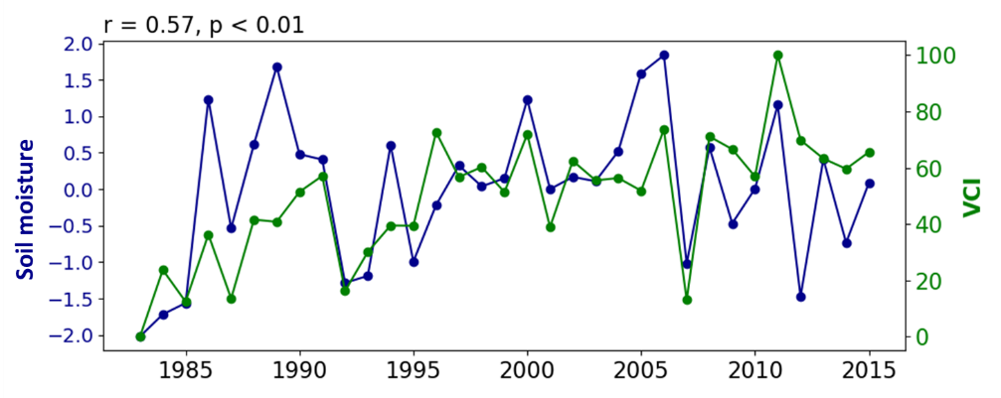

**Figure 3.** Interannual variation in seasonal (Jan-Apr) soil moisture estimates compared to VCI. Both metrics represent mean seasonal values. Soil moisture anomalies have been standardised. Pearson’s correlation coefficients (r) are presented above each plot.

Spatially, soil moisture and VCI climatologies follow largely similar patterns (Figure 4). Soil moisture is generally higher along the borders of the northeast and east, along the Drakensberg mountain range, and lower in the south and west. VCI too is higher along northeast and east borders and is lower in the south and west, however, VCI is also high along the Maloti mountain range running from the northern point of the country southwest.

The correlation between seasonal mean soil moisture and VCI is generally high with some variation in the correlation coefficient. This correlation is significant (p < 0.05) for most of the country with only small regions in the east showing no significant relationship between soil moisture and VCI.

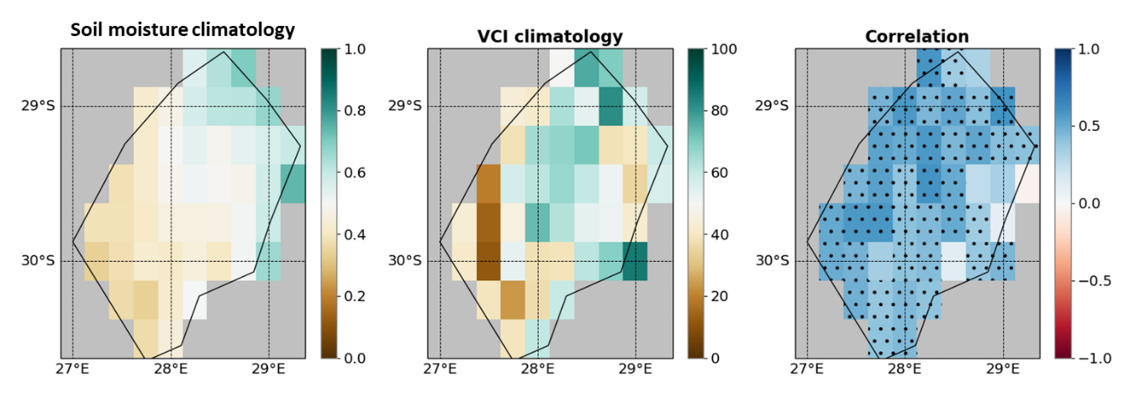

**Figure 4.** A comparison of soil moisture and VCI climatology across Lesotho for each wet season. Pearson’s correlation coefficient (r) is presented in the third column and indicates the relationship between interannual variation in seasonal mean soil moisture and VCI. Darker blue colours show a strong positive correlation and red shows a negative correlation. Grey areas are masked to exclude surrounding countries. Stippling indicates statistical significance (p < 0.05).

It's also worth noting that the relationship between soil moisture and VCI is stronger than that between rainfall and VCI (r = 0.4, p < 0.05), and applies across more of the country (rainfall-VCI correlation only significant in along Lesotho’s western border).

## *Forecast skill*

The analysis of hindcasts to identify the lead-time at which T-A soil moisture forecasts can reliably and skilfully predict observed values revealed that soil moisture can be forecast with good accuracy well ahead of the end-of-season.

The soil moisture ensemble forecast mean correlates strongly (r > 0.8) with observed seasonal values by the end of January (up to 98 days before the end-of-season on April 30th; Figure 5) and is able to skilfully (ROC-AUC > 0.8) identify 1-in-5-years drought events (< 20th percentile) by early January (up to 112 days before the end-of-season). Both the r-values and ROC-AUC increases as the season progresses.

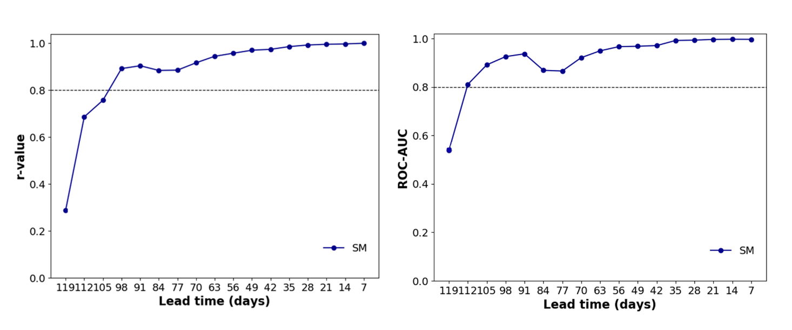

**Figure 5.** Skill of T-A soil moisture forecasts as the season progresses. The left plot shows the correlation (r) between mean seasonal soil moisture against the forecast soil moisture ensemble mean. The right plot shows the ROC-AUC scores of the ensemble mean for identifying <20th percentile seasonal soil moisture at a range of lead times. The dashed horizontal lines indicate r = 0.8 and ROC-AUC = 0.8, here used to represent ‘high’ correlations and skill.

In addition to considering variation in forecast skill at a range of lead times, we also considered how forecast skill varies spatially. Figures 6 show ROC-AUC scores calculated at a range of lead times for each 0.25˚ grid cell. Again, ROC-AUC scores measure the ability of the soil moisture forecast to identify years in which seasonal soil moisture is below their respective 20th percentiles.

ROC-AUC scores calculated for soil moisture indicate that the skill of soil moisture forecasts generally increases across Lesotho (Figure 6). However, ROC-AUC scores do vary spatially. Early in the season, ROC-AUC is generally highest in the south and west. However, as the season progresses, skill expands to the east and eventually encompasses the whole country.

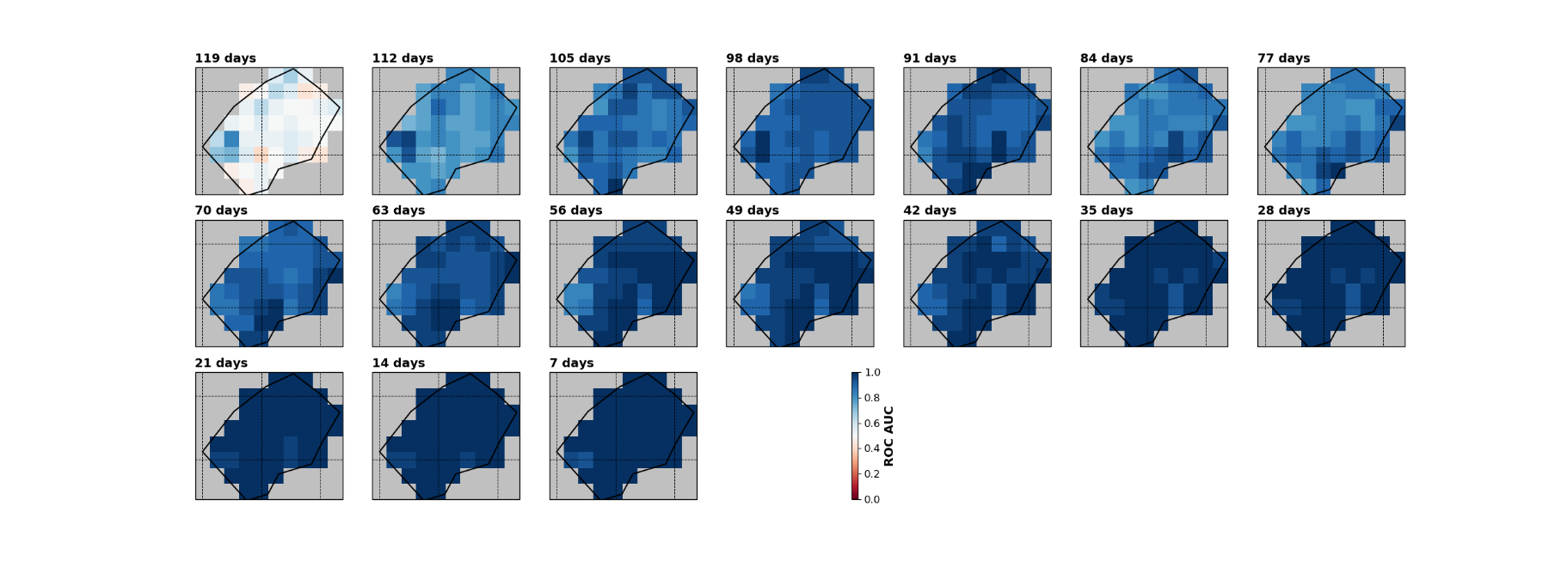

**Figure 6.** ROC-AUC scores for identifying <20th percentile soil moisture using T-A soil moisture ensemble forecast at a range of lead times. Grey areas are masked to exclude surrounding countries.

# **Conclusion**

TAMSAT-ALERT soil moisture estimates relate strongly to the impacts of drought, namely reduced vegetation productivity (here indicated by VCI) across Lesotho. In addition, T-A forecasts are able to reliably and skilfully anticipate seasonal soil moisture from early in the season, allowing several months to take action ahead of the end-of-season.

The relationship between soil moisture and VCI may be further improved and made more relevant to agricultural decision making by incorporating spatial information on the distribution of agriculture across Lesotho.

Whilst this general validation of T-A soil moisture estimates and forecasts presents promise in terms of anticipatory drought risk management, further work should now begin to refine the analysis, define trigger windows and thresholds for early-action.

# **References**

Asfaw D., Black E., Brown M., Jane Nicklin K., Otu-Larbi F., Pinnington E., Challinor A., Maidment R., Quaife T. 2018. TAMSAT-ALERT v1: A new framework for agricultural decision support. *Geosci. Model Dev.* **11**:2353–2371.

Brown M., Black E., Asfaw D., Otu-Larbi F. 2017. Monitoring drought in Ghana using TAMSAT-ALERT: a new decision support system. *Weather* **72**:201–205.

Coughlan De Perez E., Van Den Hurk B., Van Aalst MK., Jongman B., Klose T., Suarez P. 2015. Forecast-based financing: An approach for catalyzing humanitarian action based on extreme weather and climate forecasts. *Nat. Hazards Earth Syst. Sci.* **15**:895–904.

Liu WT., Kogan FN. 1996. Monitoring regional drought using the vegetation condition index. *Int. J. Remote Sens.* **17**:2761–2782.

Maidment RI., Grimes D., Black E., Tarnavsky E., Young M., Greatrex H., Allan RP., Stein T., Nkonde E., Senkunda S., Alcántara EMU. 2017. A new, long-term daily satellite-based rainfall dataset for operational monitoring in Africa. *Sci. Data* **4**.

Pettorelli N., Vik JO., Mysterud A., Gaillard JM., Tucker CJ., Stenseth NC. 2005. Using the satellite-derived NDVI to assess ecological responses to environmental change. *Trends Ecol. Evol.* **20**:503–510.

Reed BC., Brown JF., VanderZee D., Loveland TR., Merchant JW., Ohlen DO. 1994. Measuring phenological variability from satellite imagery. *J. Veg. Sci.* **5**:703–714.

Tucker CJ., Townshend JRG., Goff TE. 1985. African Land-Cover Classification Using Satellite Data. *Science (80-. ).* **227**:369–375.