

# 

**Faculty of Industrial Engineering**

**Computational Intelligence 1BM120**

**Assignment 2**

Healt.e-Nag

**Authors:**

**David Berenstein - 0861433**

**Alex ten Harkel - 0858269**

**Dennis Kok - 0865033**

**Jesse Mulder - 080573**

**Teachers:**

**Uzay Kaymak**

**Kalliopi Zervanou**

**Paulo De Oliveira Da Costa**

**Eindhoven, May 20, 2019**

**Table of Content**

Question 1 – descriptive statistics 1

Descriptive statistics 1

Trends by correlation 1

Histograms 1

Question 3 – FOTS classification 1

Question 6 – optimized NN classification 1

Question 7 – model comparison 1

References 1

Descriptive statistics 1

Trends by correlation 2

# Question 1

## i

For the ‘points’ we know that the dataset contain the following values [0.125, 0.059, 0.082, 0.111, 0.116, 0.012, 0.013,0.673, 0.122]. For the activities we know that the dataset contain the following values [0.084, 0.019, 0.103, 0.258, 0.09, 0.006, 0.006, 0.823, 0.061].

Based on the quartile function in Excel, we were able to compute the first and third quartiles for ‘points’ and ‘activities’. Quartiles ‘points’ = [0.059,0.122] and quartiles ‘activities’ = [0.019, 0.103].

By definition of the assignment we know that every value for ‘points’ and ‘activities’ is only High if it exceeds the 3rd quartile, only Low if it precedes the 1st quartile, and is partly the Low and partly High in between the 1st and 3rd quartile. We know this because ‘A trapezoidal membership function should define each fuzzy set without bounds on the left (Low) and right (High) sides.’.

To determine the values in between we derive two line equations for both value sets. Each line equation represent either High or Low. We know the line equation of the Low fuzzy set is defined by two point (1st quartile, 1) and (3rd quartile, 0), while the line equation of the High fuzzy set is defined by the two point (1st quartile, 0) and (3rd quartile, 1).

|  |  |  |  |  |
| --- | --- | --- | --- | --- |
| Column | High points | High line | Low points | Low line |
| ‘points’ | (0.059, 0), (0.122, 1) | y = 15.873*x - 0.936508 | (0.059, 1), (0.122, 0) | y = 1.93651 - 15.873*x |
| ‘activities’ | (0.019, 0), (0.103, 1) | y = 11.9048*x - 0.22619 | (0.019, 1), (0.103, 0) | y = 1.22619 - 11.9048*x |

We can now use these line equations to compute the till what extend each ‘uid’ belongs to each fuzzy set.

|  |  |  |  |  |  |  |
| --- | --- | --- | --- | --- | --- | --- |
| uid | Points value | Points Low | Points High | Activities value | Activities Low | Activities High |
| 1 | 0.125 | 0 | 1 | 0.084 | 0.774 | 0.226 |
| 2 | 0.059 | 1 | 0 | 0.019 | 1 | 0 |
| 3 | 0.082 | 0.636 | 0.365 | 0.103 | 0 | 1 |
| 4 | 0.111 | 0.175 | 0.825 | 0.258 | 0 | 1 |
| 5 | 0.116 | 0.095 | 0.905 | 0.09 | 0.845 | 0.155 |
| 6 | 0.012 | 1 | 0 | 0.006 | 1 | 0 |
| 7 | 0.013 | 1 | 0 | 0.006 | 1 | 0 |
| 8 | 0.673 | 0 | 1 | 0.823 | 0 | 1 |
| 9 | 0.122 | 0 | 1 | 0.061 | 0.500 | 0.500 |

Points_ Low = {(‘2’, 1), (‘3’, 0.635), (‘4’, 0.175), (‘5’, 0.095), (‘6’, 1), (‘7’, 1)}

Points_ High = {(‘1’, 1), (‘3’, 0.365), (‘4’, 0.825), (‘5’, 0.905), (‘8’, 1), (‘9’, 1)}

Activities_ Low = {(‘1’, 0.774), (‘2’, 1), (‘5’, 0.845), (‘6’, 1), (‘7’, 1), (‘9’, 0.5)}

Activities_ High = {(‘1’, 0.226), (‘3’, 1), (‘4’, 1), (‘5’, 0.155), (‘8’, 1), (‘9’, 0.5)}

## ii

We will plot the function membership functions separately for points and activities. Note that we cut-off the x-axis at 0.2, to focus of the relevant information. The y-value of the lines remain the same after reaching the 3rd quartile point of each plot.

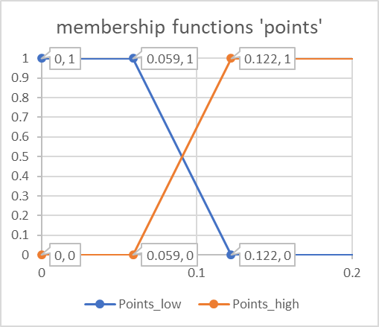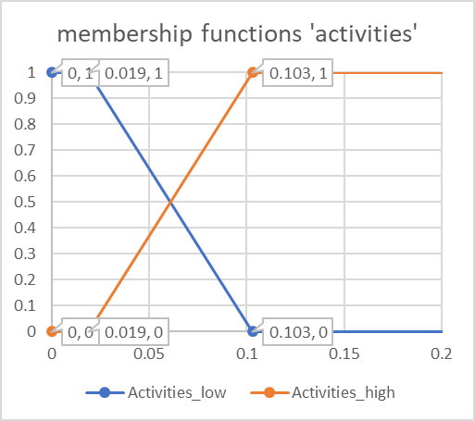

## iii

We know that the following holds:

$C=A \bigcup{B }⟺ μ_{c}\left(x\right)=\min\left(μ_{A}\left(x\right), μ_{B}\left(x\right)\right)= μ_{A}\left(x\right) ⋀ μ_{B}\left(x\right)$

|  |  |  |  |  |  |  |
| --- | --- | --- | --- | --- | --- | --- |
| uid | Points Low | Points High | Points  AND | Activities Low | Activities High | Points  AND |
| 1 | 0 | 1 | 0 | 0.774 | 0.226 | 0.226 |
| 2 | 1 | 0 | 0 | 1 | 0 | 0 |
| 3 | 0.636 | 0.365 | 0.365 | 0 | 1 | 0 |
| 4 | 0.175 | 0.825 | 0.175 | 0 | 1 | 0 |
| 5 | 0.095 | 0.905 | 0.095 | 0.845 | 0.155 | 0.155 |
| 6 | 1 | 0 | 0 | 1 | 0 | 0 |
| 7 | 1 | 0 | 0 | 1 | 0 | 0 |
| 8 | 0 | 1 | 0 | 0 | 1 | 0 |
| 9 | 0 | 1 | 0 | 0.500 | 0.500 | 0.5 |

Points_AND = {(‘3’, 0.365), (‘4’, 0.175), (‘5’, 0.095)}

Activities_AND = {(‘1’, 0.226), (‘5’, 0.155), (‘9’, 0.5)}

MOET NOG AFGEMAAKT WORDEN, definieer alle regels!!!

# References