Game Design Document

Fill up the following document

1. Write the title of your project.

The times of our lives.

1. What is the goal of the game?

The player must overcome difficulties faced by him in every level.

1. Write a brief story of your game.

The main player is under peer pressure and needs to drink healing potions to come back to normal state

1. Which are the playing characters of this game?

* Playing characters are the ones who respond to the user based on the input from the user.
* Cars, monkeys, dinos, wizards, etc., are the playing characters in the game.

|  |  |  |
| --- | --- | --- |
| Number | Character Name | What can this character do? |
| 1 | Marellyen | The female gender playing the game |
| 2 | Oliver | The male gender playing the game |
| 3 |  |  |
| 4 |  |  |
| 5 |  |  |
| 6 |  |  |
| 7 |  |  |
| 8 |  |  |

1. Which are the Non-Playing Characters of this game?

* Non-Playing characters are the ones that don't have an action or behavior when the user interacts with the game.
* Hurdles, stones, bananas, coins, etc., are non-playing characters in the game.

|  |  |  |
| --- | --- | --- |
| Number | Character Name | What can this character do? |
| 1 | Healing potions | They heal the PC’s |
| 2 | Social media | They put the PC’s under depression |
| 3 | Professor Liamheart | Assigns a lot of hw to the PC’s |
| 4 | The Bully gang | They bully the PC’s |
| 5 |  |  |
| 6 |  |  |
| 7 |  |  |
| 8 |  |  |

Draw your imagination of this game. What does this game look like?

* Draw the game either on your computer or on paper.
* Add images of the game scenes to show each of the playing and non-playing characters at least once.

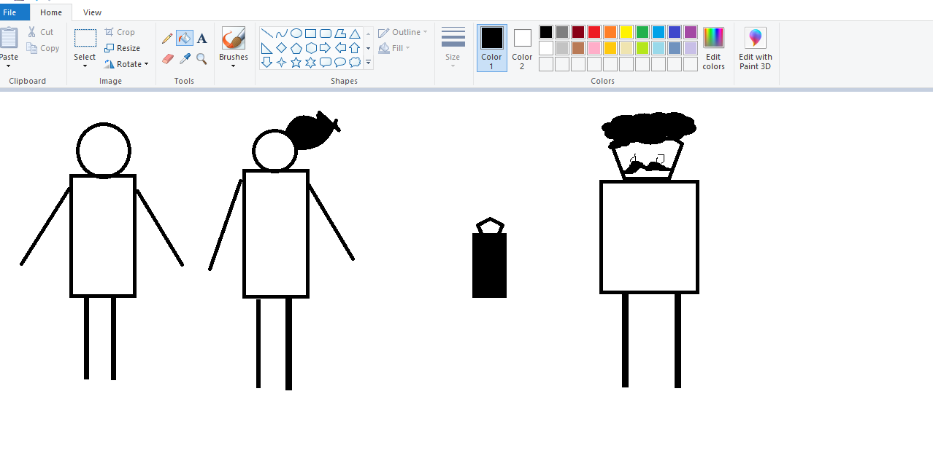

How do you plan to make your game engaging?

The difficulties will be increasing as the player reaches the next level