TABLE OF CONTENTS

CHAPTER NO. | TITLE | PAGE NO.
1. INTRODUCTION 1
1.1 OVERVIEW OF THE PROJECT 2
1.2 LITERATURE SURVEY 2
1.3 PROPOSED SYSTEM OBJECTIVES AND SCOPES 4
2. REQUIREMENTS SPECIFICATIONS 7
2.1 OVERALL DESCRIPTION 8
2.1.1 Functional Requirements 9
2.2 PRODUCT PERSPECTIVE 10
2.3 PRODUCT FUNCTIONS 11
2.3.1 User Registration and Authentication 11
2.3.2 Disaster Reporting Management 12
2.3.3 Emergency Support Request Management 12
2.3.4 Volunteer Coordination Management 12
2.3.5 NGO and Resource Management 12
2.3.6 Shelter Management 13
2.3.7 Notification and Alert System 13
2.3.8 Machine Learning-Based Disaster Severity Prediction 13
2.3.9 Analytics and Monitoring Dashboard 14
2.3.10 Administrative Management 14
2.4 USER CHARACTERISTICS 14
2.4.1 Admin 14
2.4.2 NGO / Authority 15
2.4.3 Volunteer 15
2.4.4 Regular User (Victim) 16
2.5 OPERATING ENVIRONMENT CONSTRAINTS 16
2.5.1 Software Specifications 17
2.6 SPECIFIC REQUIREMENTS 18
2.6.1. User Requirements: 19
2.6.2. Admin Requirements: 20
2.6.3. Functional Requirements: 21
2.6.4. Non-functional Requirements: 21
2.6.5. Security Requirements: 22
2.7 EXTERNAL INTERFACE REQUIREMENTS 22
2.7.1. User Interface Requirements: 23
2.7.2. Hardware Interface Requirements: 23
2.7.3. Software Interface Requirements: 24
2.7.4. Communication Interface Requirements: 24
2.8 SYSTEM FEATURES 25
3. SYSTEM DESIGN AND TEST PLAN 28
3.1 DATA FLOW DIAGRAM (DFD) 29
3.1.1 Level 0 DFD 30
3.1.2 Level 1 DFD 32
3.2 USE CASE DIAGRAM 34
3.3 TABLE DESIGNS 38
3.3.1 User Table 38
3.3.2 Disaster Report Table 39
3.3.3 Emergency Request Table 39
3.3.4 Resource Table 40
3.3.5 Shelter Table 41
3.3.6 Volunteer Assignment Table 42
Table 3.7: notifications table 42
3.3.8 Prediction Table 43
3.4 PERFORMANCE REQUIREMENTS 44
3.5 SOFTWARE QUALITY ATTRIBUTES 45
3.6 DETAILED DESIGN 47
3.6.1 System Architecture: 47
3.6.2 User Registration and Authentication: 48
3.6.3 Disaster Reporting and Emergency Request Management: 48
3.6.4 NGO, Resource, and Shelter Management: 48
3.6.5 Volunteer Coordination and Assignment Management: 49
3.6.6 Machine Learning Prediction and Analytics: 49
3.6.7 Notification and Communication Management: 49
3.6.8 Security Measures: 50
3.6.9 Performance Optimization: 50
3.6.10 Testing and Deployment: 50
3.7 TEST CASES 51
3.7.1 Test Case for Admin 51
3.7.2 Test Case for NGO / Authority 53
3.7.3 Test Case for Volunteer 55
3.7.4 Test Case for Regular User (Victim) 56
4. IMPLEMENTATION AND RESULTS 58
4.1 IMPLEMENTATION 58
4.1.1 Backend Development 60
4.1.2 Frontend Development 60
4.1.3 Integration and Testing 61
4.2 IMPLEMENTATION RESULTS 62
5. CONCLUSION AND FUTURE WORKS 64
5.1 CONCLUSION 64
5.2 FUTURE WORKS 65
5.2.1 Future Implementation Plan: 65
6. REFERENCES 67
7. APPENDIXES 68

ABSTRACT

AI-Driven Disaster Relief Coordination And Resource Management System is an intelligent, data-driven platform designed to assist authorities, volunteers, an affected individuals in managing disasters efficiently and making informed decisions during emergencies. The system integrates multiple Artificial Intelligence and Machine Learning modules, including disaster prediction, emergency response coordination, shelter management, damage assessment, and alert notification systems.
The Disaster Prediction Module utilizes supervised machine learning algorithms such as Random Forest and Decision Trees to analyze environmental conditions including rainfall, temperature, humidity, seismic activity, and historical disaster data, thereby predicting the possibility and severity of disasters. The Weather and Risk Analysis Module leverages real-time weather APIs and geographical datasets to provide current conditions and future forecasts, enabling authorities to plan evacuation and emergency operations more effectively.
The Emergency Response Coordination Module determines optimal rescue and resource allocation strategies by analyzing affected locations, shelter capacities, available volunteers, and predicted disaster impact, thereby minimizing delays and ensuring efficient crisis management. The Disaster Detection Module employs deep learning techniques, specifically Convolutional Neural Networks (CNNs), to analyze disaster-related images and identify damages such as floods, fires, landslides, and collapsed infrastructure at an early stage, along with recommended emergency measures.
The Resource and Shelter Management Module analyzes historical and real-time disaster data to identify shortages and resource requirements, allowing authorities to make informed decisions regarding food distribution, medical support, and temporary shelter allocation. Additionally, the Severity Assessment Module applies regression-based models to estimate expected damage levels and affected populations based on environmental and historical datasets, helping organizations plan rescue operations and rehabilitation activities.
Unlike traditional disaster management systems that rely heavily on IoT sensors and dedicated hardware infrastructure, the proposed system is entirely software-based and utilizes publicly available datasets along with API-driven inputs, making it cost-effective, scalable, and accessible for wider adoption. The system is designed with a modular architecture and role-based access, supporting three primary user roles: administrators, volunteers, and affected users. Administrators monitor disaster activities and manage system configurations, volunteers coordinate rescue operations, and affected users access alerts, emergency requests, and shelter information.
Furthermore, the system incorporates data visualization dashboards, enabling users to interpret predictions through graphs, heat maps, and trends, thereby improving usability and decision-making.

LIST OF TABLES

TABLE NO. | TITLE | PAGE NO.
Table 3.1 | Users Table | 40-41
Table 3.2 | Disaster Reports Table | 41-42
Table 3.3 | Emergency Requests Table | 42-43
Table 3.4 | Resources Table | 43
Table 3.5 | Shelters Table | 43-44
Table 3.6 | Tasks Table | 44
Table 3.7 | Hospitals Table | 45
Table 3.8 | Messages Table | 45-46
Table 3.9 | Notifications Table | 46

LIST OF FIGURES

FIGURE NO. | TITLE | PAGE NO.
3.1 | DFD Level 0 | 33
3.2 | DFD Level 1 | 34
3.3 | Admin Use Case Diagram | 37
3.4 | NGO / Authority Use Case Diagram | 38
3.5 | Volunteer Use Case Diagram | 39
3.6 | User (Victim) Use Case Diagram | 40
A.1 | Home Page | 72
A.2 | Login Page | 72
A.3 | User Dashboard | 73
A.4 | Admin Dashboard | 73

LIST OF ABBREVIATIONS

LIST | ABBREVIATIONS | MEANING
1 | AI | Artificial Intelligence
2 | API | Application Programming Interface
3 | CSS | Cascading Style Sheets
4 | DFD | Data Flow Diagram
5 | DL | Deep Learning
6 | HTML | Hypertext Markup Language
7 | HTTP | Hypertext Transfer Protocol
8 | ML | Machine Learning

CHAPTER 1

INTRODUCTION

The increasing frequency and severity of natural and man-made disasters have highlighted the importance of efficient emergency response systems and disaster management solutions. Traditional disaster management approaches often rely on manual coordination, delayed communication, paper-based reporting, and fragmented information sharing between authorities, volunteers, NGOs, and affected individuals. These limitations frequently result in inefficient rescue operations, delayed resource allocation, and difficulties in maintaining proper coordination during emergency situations.
To overcome these challenges, the AI-Driven Disaster Relief Coordination And Resource Management System is proposed as a centralized web-based platform designed to streamline disaster reporting, emergency response coordination, volunteer management, shelter monitoring, and resource allocation within a unified digital environment. The system is developed using the MERN stack, consisting of React.js for frontend development, Node.js and Express.js for backend services, and MongoDB for database management, ensuring scalability, maintainability, and efficient data handling.
The platform integrates machine learning technologies through Flask-based services to provide disaster severity prediction and analytical insights that assist authorities in making informed emergency response decisions. The system supports multiple user roles such as Admin, NGO/Authority, Volunteer, and Regular User (Victim), enabling secure communication and coordinated disaster response operations.

OVERVIEW OF THE PROJECT

The AI-Driven Disaster Relief Coordination And Resource Management System is an intelligent and interactive web-based platform designed to improve disaster response coordination and emergency management operations through modern web technologies and machine learning integration. The system enables victims to report disasters, request emergency assistance, and receive real-time updates regarding rescue operations and shelter availability. The platform allows NGOs and authorities to manage emergency inventories, coordinate volunteers, allocate resources, and monitor rescue requests efficiently. Volunteers can receive assignments, track incident locations, and provide field-level updates during emergency situations. Administrators are provided with monitoring dashboards and analytical tools to supervise the overall functioning of the system and ensure operational coordination.
By integrating predictive analytics and centralized communication, the platform improves response efficiency, enhances public safety, and reduces delays in disaster management operations.

LITERATURE SURVEY

1.2.1 Web-Based Disaster Management and Emergency Response Systems
Several studies have highlighted the importance of web-based disaster management systems in improving emergency response, communication, and coordination during natural and man-made disasters. Traditional disaster response methods often depend on manual reporting, phone-based communication, and disconnected departmental operations, which can delay rescue activities and resource distribution. Web-based disaster management platforms provide a centralized environment where disaster reports, rescue requests, shelter details, and emergency resources can be managed efficiently.
These systems allow affected individuals to report incidents in real time and enable authorities to monitor disaster situations through dashboards and analytical views. By digitizing emergency data, web-based platforms improve the speed and accuracy of disaster response operations. The study emphasizes that centralized disaster management solutions reduce communication gaps, improve decision-making, and support better coordination among government agencies, NGOs, volunteers, and victims.

1.2.2 Role-Based Disaster Relief Coordination Platforms
Research on role-based disaster relief systems focuses on assigning specific responsibilities to different users involved in disaster response operations. In such systems, administrators manage overall monitoring and verification, NGOs handle logistics and relief supplies, volunteers support field-level rescue activities, and victims report emergencies or request assistance. This role-based approach improves security, accountability, and operational efficiency.
The study explains that clearly defined user roles help prevent unauthorized access to sensitive disaster information and ensure that each participant performs only the activities assigned to them. Role-based access control also supports better coordination between authorities and field responders. In the context of disaster relief, this approach is highly effective because emergency operations require fast, organized, and secure information exchange among multiple stakeholders.
1.2.3 Machine Learning-Based Disaster Severity Prediction
Machine learning techniques have been increasingly applied in disaster management systems to predict disaster severity, assess risk levels, and support emergency decision-making. These models analyze disaster-related data such as disaster type, location, affected population, resource needs, and severity indicators to classify incidents according to priority levels. The prediction results help authorities identify high-risk zones and allocate rescue teams and resources more effectively.
The study highlights that machine learning-based disaster prediction can reduce delays in emergency response by providing early analytical insights. Instead of depending only on manual assessment, automated prediction models assist authorities in identifying critical cases quickly. Such systems improve preparedness, resource planning, and prioritization during large-scale disaster situations.

1.2.4 Volunteer and Resource Management in Disaster Relief Systems
Studies related to volunteer and resource management emphasize the importance of organized coordination during disaster response operations. In many disaster situations, volunteers and NGOs play a major role in rescue support, food distribution, medical assistance, and shelter management. However, without a proper digital system, volunteer assignments and resource allocation may become inefficient and difficult to track.
A AI-Driven Disaster Relief Coordination And Resource Management System with volunteer and resource management features allows NGOs and authorities to assign tasks, monitor progress, manage inventories, and allocate resources to affected regions. The study shows that digital coordination reduces duplication of work, improves transparency, and ensures that essential supplies such as food, water, medicine, and rescue equipment reach the required locations on time.
1.2.5 Real-Time Disaster Reporting and Notification Systems
Real-time disaster reporting and notification systems are designed to improve communication between affected individuals and emergency authorities. These systems allow victims or local users to report incidents immediately by providing details such as disaster type, location, description, and required support. Emergency notifications and alerts can then be sent to users, volunteers, NGOs, and authorities to improve awareness and response speed.
The study identifies that real-time reporting reduces the dependency on delayed manual communication and helps authorities receive accurate field-level information. Notification systems also play a major role in warning users about dangerous situations, shelter availability, rescue updates, and emergency instructions. Such features enhance public safety and improve the effectiveness of disaster response operations.

PROPOSED SYSTEM OBJECTIVES AND SCOPES
1.3.1 Objectives of the Proposed System
The primary objective of the AI-Driven Disaster Relief Coordination And Resource Management System is to provide an efficient, centralized, and technology-driven platform for disaster response coordination and emergency management operations. The proposed system aims to improve communication between victims, volunteers, NGOs, rescue authorities, and administrators during disaster situations through real-time reporting and organized information management.
The system is designed to simplify disaster reporting by enabling affected individuals to submit disaster incidents, emergency requests, and safety updates through a web-based interface. By digitizing emergency communication, the platform helps reduce delays associated with traditional manual disaster management methods.
Another important objective of the system is to improve resource allocation and volunteer coordination during emergency situations. The platform enables NGOs and authorities to manage inventories, assign volunteers to rescue requests, monitor relief activities, and track the availability of emergency resources such as food, water, medicines, shelters, and rescue equipment.
The proposed system also focuses on improving decision-making through machine learning-based disaster severity prediction. The integrated machine learning module analyzes disaster-related information and generates severity insights that help authorities identify high-risk situations and prioritize rescue operations more effectively.
The system aims to provide secure role-based access control for different users including Admins, NGOs, Volunteers, and Victims. Each user role is assigned specific permissions to ensure proper operational coordination, secure information handling, and efficient disaster response management.
In addition, the proposed platform seeks to improve public safety and disaster preparedness by providing real-time emergency notifications, rescue updates, shelter information, and analytical monitoring dashboards for authorities and emergency response teams.
1.3.2 Scope of the Proposed System
The scope of the AI-Driven Disaster Relief Coordination And Resource Management System includes disaster reporting, emergency communication, volunteer coordination, shelter management, resource allocation, analytics monitoring, and machine learning-based disaster severity prediction within a centralized digital platform.
The system allows victims and regular users to report disasters, request emergency assistance, update safety information, and receive real-time notifications regarding rescue operations and shelter availability. Volunteers can access rescue assignments, monitor incident locations, and coordinate with NGOs and authorities during field operations.
NGOs and authorities can manage emergency inventories, monitor disaster reports, allocate resources to affected regions, supervise volunteer activities, and track rescue progress through dedicated dashboards. Administrators can oversee overall system operations, verify sensitive user roles, monitor disaster analytics, and manage emergency coordination activities.
The system supports secure authentication, role-based access control, real-time communication, and centralized database management to ensure reliable disaster management operations. The integration of machine learning prediction services further extends the scope of the platform by enabling disaster severity analysis and emergency response prioritization.
The proposed system is primarily designed as a web-based platform that can be accessed through internet-enabled devices. Future enhancements may extend the system to mobile platforms, IoT-based disaster monitoring systems, GPS tracking services, and cloud-based distributed deployment environments.

CHAPTER 2

REQUIREMENTS SPECIFICATIONS
Requirements specification is the process of identifying, analyzing, and documenting the functional and non-functional requirements necessary for developing the AI-Driven Disaster Relief Coordination And Resource Management System. It provides a detailed description of system functionalities, operational constraints, user interactions, and performance expectations required for effective disaster management and emergency response coordination.
The AI-Driven Disaster Relief Coordination And Resource Management System is designed to provide a centralized platform for managing disaster reporting, emergency communication, volunteer coordination, shelter monitoring, resource allocation, and disaster severity prediction. The system integrates multiple user roles including Admins, NGOs/Authorities, Volunteers, and Regular Users (Victims), each performing specific functionalities within the platform according to assigned permissions.
The requirement specification phase helps define the system architecture, database structure, user interfaces, communication workflows, and security mechanisms required for implementing the proposed application. It also ensures that the developed system fulfills operational objectives such as real-time disaster reporting, efficient rescue coordination, resource management, and emergency notification delivery.
The proposed system incorporates role-based access control, secure authentication mechanisms, responsive web interfaces, centralized database management, and machine learning integration to improve disaster response efficiency and operational reliability. The machine learning module is designed to analyze disaster-related information and generate disaster severity predictions that support emergency authorities in decision-making and rescue prioritization.
This chapter defines both functional and non-functional requirements of the AI-Driven Disaster Relief Coordination And Resource Management System and provides a clear understanding of system operations, user interactions, hardware requirements, software requirements, and performance expectations necessary for successful implementation.

2.1 OVERALL DESCRIPTION

The AI-Driven Disaster Relief Coordination And Resource Management System is a web-based emergency response and disaster coordination platform developed to improve disaster reporting, rescue management, resource allocation, volunteer coordination, and communication between authorities and affected individuals. The system provides a centralized environment where disaster-related information can be collected, monitored, analyzed, and managed efficiently during emergency situations.
The platform integrates multiple modules such as user management, disaster reporting, volunteer coordination, NGO management, shelter monitoring, resource allocation, analytics dashboards, and machine learning-based disaster severity prediction. These modules work together to support organized disaster response operations and improve emergency management efficiency.
The proposed system supports multiple user roles including Admin, NGO/Authority, Volunteer, and Regular User (Victim). Each role performs specific operations within the platform according to assigned permissions and responsibilities. Victims can report disasters and request emergency assistance, volunteers can participate in rescue operations and receive assignments, NGOs can manage emergency inventories and resource allocation, while administrators supervise overall system activities and disaster monitoring operations.
The application is developed using MERN stack technologies consisting of React.js for frontend development, Node.js and Express.js for backend services, and MongoDB for database management. Flask-based machine learning services are integrated with the system to provide disaster severity prediction and analytical insights for emergency authorities.
The platform provides responsive user interfaces, secure authentication mechanisms, centralized database management, and real-time communication features to ensure efficient disaster response coordination. The system also supports emergency notifications, rescue updates, shelter information management, and analytical monitoring dashboards to improve communication between users and authorities during disaster situations.
The AI-Driven Disaster Relief Coordination And Resource Management System is designed to reduce communication delays, improve resource management, support faster rescue coordination, and enhance public safety through intelligent and technology-driven disaster management operations.

2.1.1 Functional Requirements

Functional requirements define the core operations and services provided by the AI-Driven Disaster Relief Coordination And Resource Management System. These requirements describe how the system behaves under different conditions and specify the functionalities available to different user roles within the platform.mo
The system must provide secure user registration and login functionalities for Admins, NGOs/Authorities, Volunteers, and Regular Users (Victims). Each user should be authenticated through secure login mechanisms and granted access according to assigned roles and permissions.
The platform must allow victims and regular users to report disasters by submitting information such as disaster type, location, description, severity details, and emergency support requirements. The system should store disaster reports within the centralized database and forward them to emergency authorities for monitoring and response coordination.
The system should provide emergency support request functionalities that enable affected individuals to request rescue assistance, shelter support, food supplies, medical services, and emergency transportation during disaster situations.
The NGO/Authority module must support inventory management, resource allocation, shelter monitoring, volunteer coordination, and rescue operation supervision. NGOs and authorities should be able to track emergency resources and allocate supplies to affected regions according to disaster severity levels.
The Volunteer module should allow volunteers to register, receive rescue assignments, monitor incident locations, update task progress, and communicate with NGOs and administrators during emergency response activities.
The Admin module must support user management, role verification, disaster monitoring, analytics visualization, report verification, and overall system supervision. Administrators should be able to monitor disaster reports and manage emergency operations through centralized dashboards.
The platform should provide real-time notifications and emergency alerts to users regarding disaster warnings, rescue updates, shelter availability, and emergency instructions.
The machine learning module must analyze disaster-related information and generate disaster severity prediction outputs that assist emergency authorities in identifying high-risk situations and prioritizing rescue operations effectively.
The system should also support analytics dashboards that display statistical information regarding disaster incidents, volunteer activities, shelter occupancy, resource utilization, and rescue coordination activities.

2.2 PRODUCT PERSPECTIVE

The AI-Driven Disaster Relief Coordination And Resource Management System is designed as a standalone web-based application that provides centralized disaster management and emergency response coordination functionalities. The system acts as an integrated platform connecting victims, volunteers, NGOs, rescue authorities, and administrators within a unified digital environment.
The application is developed using the MERN stack architecture consisting of React.js for frontend development, Node.js and Express.js for backend services, and MongoDB for database management. Flask-based machine learning services are integrated with the platform to provide disaster severity prediction and analytical support functionalities.
The proposed system replaces traditional manual disaster management approaches that rely on paper-based reporting, disconnected communication systems, and delayed emergency coordination. By digitizing disaster operations and integrating real-time communication features, the platform improves operational efficiency, response speed, and emergency resource management.
The product supports role-based access control to ensure secure and organized disaster management operations. Different user roles are provided with dedicated dashboards and functionalities according to their operational responsibilities within the platform.
The system interacts with mapping services, database servers, machine learning modules, and notification systems to support disaster monitoring and emergency communication. The platform is designed with modular architecture principles, enabling future scalability, maintainability, and integration with advanced technologies such as IoT-based monitoring systems, GPS tracking, cloud deployment, and mobile applications.
The AI-Driven Disaster Relief Coordination And Resource Management System is primarily intended for use by disaster management authorities, NGOs, volunteers, rescue teams, and affected individuals requiring emergency support and disaster-related communication services.

2.3 PRODUCT FUNCTIONS

2.3.1 User Registration and Authentication

The AI-Driven Disaster Relief Coordination And Resource Management System provides secure user registration and authentication functionalities for different user roles including Admins, NGOs/Authorities, Volunteers, and Regular Users (Victims). Users can create accounts using required personal information and securely access the system through login credentials. Authentication mechanisms ensure that only authorized users can access protected functionalities within the platform.
The system also supports role-based access control, allowing each user to access functionalities according to assigned permissions and operational responsibilities.

2.3.2 Disaster Reporting Management

The platform allows victims and users to report disaster incidents through a structured reporting interface. Users can submit disaster details such as disaster type, location, severity description, affected area information, and emergency support requirements.
Submitted reports are stored in the centralized database and forwarded to NGOs, rescue teams, and administrators for monitoring and emergency response coordination. This functionality improves real-time disaster communication and helps authorities identify affected regions quickly.

2.3.3 Emergency Support Request Management

The system provides emergency support request functionalities for affected individuals during disaster situations. Users can request assistance related to food supplies, medical services, shelter support, rescue operations, transportation facilities, and emergency resources. Authorities and NGOs can monitor support requests and coordinate emergency response activities according to disaster severity and user requirements.

2.3.4 Volunteer Coordination Management

The Volunteer Coordination module manages volunteer registration, assignment allocation, task monitoring, and field-level communication during disaster response operations. Volunteers can receive rescue assignments, access incident locations, update operational progress, and coordinate with NGOs and administrators.
The module helps improve organized rescue coordination and ensures efficient utilization of volunteer support during emergency situations.

2.3.5 NGO and Resource Management

The NGO/Authority module supports inventory management, emergency resource allocation, shelter monitoring, and rescue coordination functionalities. NGOs can manage food supplies, medicines, rescue equipment, water resources, and emergency transportation facilities through dedicated dashboards.
The system also helps authorities allocate resources to high-risk regions and monitor ongoing relief operations efficiently.

2.3.6 Shelter Management

The Shelter Management functionality maintains information regarding available shelters, occupancy capacity, medical support availability, sanitation facilities, food resources, and accommodation status.
Affected users can access nearby shelter information during emergency situations, while authorities and NGOs can update shelter details dynamically according to operational requirements.

2.3.7 Notification and Alert System

The platform provides real-time emergency notifications and disaster alerts to users regarding rescue operations, disaster warnings, shelter availability, emergency instructions, and operational updates.
This functionality improves communication between authorities and affected individuals and helps users receive timely emergency information during disaster situations.

2.3.8 Machine Learning-Based Disaster Severity Prediction

The system integrates machine learning services to analyze disaster-related information and generate disaster severity prediction outputs. The prediction module evaluates disaster data and identifies high-risk situations that require immediate emergency response.
These predictive insights help authorities prioritize rescue operations, allocate resources effectively, and improve disaster management decision-making.

2.3.9 Analytics and Monitoring Dashboard

The Analytics and Monitoring module provides graphical dashboards and statistical reports related to disaster incidents, volunteer participation, shelter occupancy, resource allocation, and rescue activities.
Administrators and authorities can monitor operational activities in real time and analyze disaster trends using charts, analytical views, and monitoring dashboards.

2.3.10 Administrative Management

The Admin module provides centralized management and supervision functionalities for the entire AI-Driven Disaster Relief Coordination And Resource Management System. Administrators can verify user roles, manage accounts, monitor disaster reports, supervise emergency operations, and analyze system-wide activities. The module ensures secure system management and coordinated disaster response operations across all user roles and functionalities.

2.4 USER CHARACTERISTICS

2.4.1 Admin

The Admin is the central authority responsible for monitoring and managing the overall activities of the AI-Driven Disaster Relief Coordination And Resource Management System. The Admin has complete access privileges to supervise disaster reports, verify sensitive user roles, monitor emergency operations, and manage system-wide functionalities.
The Admin verifies NGO/Authority and Volunteer registrations before granting operational access to the platform. Administrators monitor disaster incidents reported by users, supervise emergency response coordination, manage shelters, oversee resource allocation activities, and analyze system performance through dashboards and graphical reports.
The Admin is also responsible for maintaining system security, monitoring analytics, managing notifications, and ensuring smooth communication between different user roles within the platform. Since the Admin handles critical operational data and emergency coordination activities, proper authentication and secure access mechanisms are required.
The Admin should possess basic computer knowledge, internet usage skills, and an understanding of disaster management operations for efficient system administration.

2.4.2 NGO / Authority

The NGO / Authority user is responsible for managing logistical support and coordinating disaster relief operations within the AI-Driven Disaster Relief Coordination And Resource Management System. NGOs and authorities monitor disaster incidents, manage emergency inventories, allocate resources to affected areas, and supervise rescue activities during emergency situations.
This user role allows NGOs and authorities to manage food supplies, medicines, rescue equipment, shelter facilities, transportation resources, and volunteer coordination activities through dedicated dashboards. Authorities can monitor rescue requests submitted by victims and assign volunteers according to operational requirements and disaster severity levels.
The NGO / Authority user can also track relief operations, update emergency resource availability, monitor shelter occupancy, and communicate with volunteers and administrators for coordinated disaster response management.
Users assigned to this role should possess basic computer knowledge, internet handling skills, and an understanding of disaster management and emergency response operations. Since the role involves handling sensitive operational information and resource management activities, secure authentication and authorized system access are essential.

2.4.3 Volunteer

The Volunteer user acts as a field responder within the AI-Driven Disaster Relief Coordination And Resource Management System and supports rescue operations during disaster situations. Volunteers can register with the platform, receive rescue assignments, access disaster locations, and coordinate with NGOs and authorities during emergency response activities.
The Volunteer module allows users to update rescue task progress, report local disaster incidents, and provide field-level operational updates to authorities. Volunteers can also assist in emergency resource distribution, evacuation support, and communication between affected individuals and disaster response agencies.
Volunteers are expected to possess basic mobile or computer usage skills and the ability to interact with mapping and reporting functionalities within the platform. Proper verification and approval by the Admin are required before volunteers receive operational access to the system.

2.4.4 Regular User (Victim)

The Regular User (Victim) is the primary source of disaster-related information within the AI-Driven Disaster Relief Coordination And Resource Management System. Victims and affected individuals can access the platform to report disasters, request emergency assistance, update personal safety information, and receive real-time notifications regarding rescue operations and shelter availability.
Users can submit disaster details such as incident type, affected location, emergency requirements, and support requests through structured reporting interfaces. Victims can also monitor emergency updates, locate nearby shelters, and communicate with authorities during disaster situations.
The system is designed to provide simple and user-friendly interfaces so that users with minimal technical knowledge can easily access disaster management services during emergency conditions. Internet access and basic smartphone or computer usage knowledge are sufficient for operating the user functionalities within the platform.

2.5 OPERATING ENVIRONMENT CONSTRAINTS

The operating environment constraints define the limitations and conditions under which the AI-Driven Disaster Relief Coordination And Resource Management System functions effectively. These constraints include hardware requirements, software compatibility, network availability, browser support, security considerations, and operational dependencies necessary for maintaining reliable disaster management and emergency response operations.
The system is developed as a web-based application and requires a stable internet connection for accessing real-time functionalities such as disaster reporting, emergency notifications, volunteer coordination, shelter monitoring, and resource allocation. Limited or unstable network connectivity during disaster situations may affect system accessibility and communication between users and authorities.
The platform is designed to operate on standard computing devices including desktop systems, laptops, and internet-enabled mobile devices. The application supports modern web browsers such as Google Chrome, Mozilla Firefox, Microsoft Edge, and other standards-compliant browsers. Older browsers with limited JavaScript support may not provide complete functionality or proper interface rendering.
The AI-Driven Disaster Relief Coordination And Resource Management System requires a compatible operating environment capable of supporting MERN stack technologies, MongoDB database services, and Flask-based machine learning modules. The server environment must support Node.js runtime, MongoDB database connectivity, and Python Flask services for proper system execution. The machine learning prediction module depends on the availability of trained datasets and proper server-side processing capabilities. System performance may vary depending on server resources, concurrent users, network conditions, and database operations during large-scale disaster situations.
The application also requires secure authentication mechanisms and protected server environments to maintain data confidentiality and prevent unauthorized access to sensitive disaster-related information. Role-based access control and secure API communication are necessary for ensuring operational security within the platform.
Although the system is designed for scalability and modularity, future enhancements such as IoT integration, GPS tracking, cloud deployment, and mobile application support may require additional infrastructure and operational configurations.

2.5.1 Software Specifications

Software requirements are technical specifications for software products. The goal of software requirements definition is to completely and consistently specify the technical requirements for the software product concisely and unambiguously.
Operating System : Windows 10/11, Ubuntu 20.04+, or macOS
Web Browser : Any Standard web browser
Frontend : React.js, HTML, CSS, JavaScript
Backend : Node.js, Express.js
Database : MongoDB
Machine Learning : Python Flask
2.5.2 Hardware Specifications
The hardware requirement is the minimum required specification for the system to work.
Processor : Intel i5 / AMD Ryzen 5 or higher
RAM : 8GB Minimum
Storage : 500MB+
Internet : Stable Broadband Connection
Input Devices : Keyboard and Mouse

2.6 SPECIFIC REQUIREMENTS

The AI-Driven Disaster Relief Coordination And Resource Management System is designed to provide efficient disaster response coordination, emergency communication, resource management, and volunteer support through a centralized web-based platform. The system must support secure user authentication and role-based access control for Admins, NGOs/Authorities, Volunteers, and Regular Users (Victims).
The application should allow victims to report disasters, request emergency assistance, and receive real-time notifications regarding rescue operations and shelter availability. NGOs and authorities should be able to manage emergency inventories, allocate resources, monitor disaster reports, and coordinate rescue activities efficiently.
The Volunteer module should support volunteer registration, assignment management, incident location tracking, and field-level reporting functionalities. The Admin module should provide monitoring dashboards, analytical reports, role verification mechanisms, and overall system supervision functionalities.
The system must provide centralized database management for storing disaster reports, user information, shelter details, volunteer records, resource allocation data, and machine learning prediction outputs. Real-time communication and notification delivery should be supported to improve emergency coordination during disaster situations.
The application should integrate machine learning functionalities for disaster severity prediction and analytical monitoring. The prediction module should analyze disaster-related data and assist authorities in identifying high-risk situations and prioritizing emergency response operations.
The system should provide responsive user interfaces, secure API communication, scalability, maintainability, and reliable performance during emergency conditions. Proper security mechanisms must be implemented to prevent unauthorized access to sensitive disaster-related information.

2.6.1. User Requirements:

The system must allow users to register and authenticate securely using valid credentials such as email and password. Users should be able to login into the platform according to their assigned roles including Admin, NGO/Authority, Volunteer, and Regular User (Victim). The system should provide secure authentication mechanisms and maintain proper access control for all users. A password recovery mechanism should also be available for users who forget their login credentials.
Regular Users (Victims) should be able to report disasters by providing details such as disaster type, location, affected area information, and emergency support requirements. Users must be able to request rescue assistance, shelter support, medical aid, food supplies, and emergency transportation services during disaster situations. The system should also allow users to receive notifications regarding rescue operations, shelter availability, and emergency alerts.
NGO/Authority users should be able to manage emergency inventories, allocate resources to affected regions, monitor disaster reports, supervise rescue activities, and coordinate volunteers during emergency response operations. The system should provide dashboards for monitoring resource availability, shelter management, volunteer activities, and rescue coordination.
Volunteer users must be able to receive rescue assignments, access disaster locations, submit field-level updates, and coordinate with NGOs and authorities during rescue operations. Volunteers should also be able to report newly identified disaster incidents and update task progress through the platform.
Admin users should have complete access to monitor system activities, verify sensitive user roles, supervise disaster response operations, manage users, monitor analytics dashboards, and maintain overall system coordination. The system should provide centralized monitoring functionalities to ensure efficient disaster management operations.

2.6.2. Admin Requirements:

Admins must have complete control over the AI-Driven Disaster Relief Coordination And Resource Management System and should be responsible for supervising overall disaster management operations. The system should allow Admins to verify NGO/Authority and Volunteer registrations before granting operational access to the platform.
Admins should be able to monitor disaster reports submitted by users, supervise emergency response coordination activities, manage shelters, allocate resources, and monitor volunteer participation through centralized dashboards. The platform should provide analytical reports and graphical monitoring interfaces to assist Admins in analyzing disaster situations and operational performance.
The system must allow Admins to manage user accounts, including activating, deactivating, verifying, or removing users when necessary. Admins should also be able to monitor machine learning prediction outputs, supervise notification systems, and ensure proper coordination between different user roles within the platform.
Additionally, the Admin should have access to system-wide monitoring functionalities such as disaster analytics, resource utilization reports, shelter occupancy details, volunteer coordination activities, and operational statistics related to emergency response management.

2.6.3. Functional Requirements:

The system must provide secure user authentication and role-based access control to ensure that only authorized users can access specific functionalities within the platform. The application should support disaster reporting, emergency support requests, volunteer coordination, shelter management, resource allocation, notification delivery, and analytical monitoring functionalities.
The platform should allow users to submit disaster reports dynamically by providing disaster details, location information, and emergency requirements. NGOs and authorities must be able to allocate emergency resources, manage inventories, supervise rescue operations, and coordinate volunteer activities efficiently.
The Volunteer module should support assignment management, incident location access, field-level reporting, and rescue coordination functionalities. The Admin module should support user verification, disaster monitoring, analytics visualization, operational supervision, and centralized system management functionalities.
The system should integrate machine learning modules for disaster severity prediction and analytical processing. The prediction module must analyze disaster-related information and generate severity insights to support emergency decision-making and rescue prioritization activities.
Additionally, the application should provide notification and alert functionalities to deliver real-time emergency updates, disaster warnings, shelter information, and rescue instructions to users and authorities.

2.6.4. Non-functional Requirements:

The system must be capable of supporting multiple concurrent users during disaster situations without affecting operational performance or system stability. The application should provide responsive and user-friendly interfaces that function efficiently across desktops, laptops, tablets, and mobile devices.
The platform should maintain reliable communication between frontend interfaces, backend services, databases, and machine learning modules during emergency operations. The system must support scalability and modularity to accommodate future enhancements and increasing operational demands.
High availability and reliability should be ensured through proper database management, secure API communication, and error-handling mechanisms. The application should maintain acceptable response times for disaster reporting, notification delivery, machine learning predictions, and emergency coordination functionalities.
The system should also provide maintainability and flexibility for future integration with advanced technologies such as IoT-based monitoring systems, GPS tracking services, cloud deployment platforms, and mobile applications.

2.6.5. Security Requirements:

The system must ensure that all sensitive user information and disaster-related data are securely transmitted using protected communication protocols and secure API handling mechanisms. User credentials and confidential information stored within the database should be protected against unauthorized access.
Strong authentication and authorization mechanisms should be implemented to maintain secure access control for Admins, NGOs/Authorities, Volunteers, and Regular Users. The system should enforce role-based access control to ensure that users can only access functionalities assigned to their specific roles.
Sensitive operations such as user verification, disaster monitoring, resource allocation, and administrative management should require proper authentication and authorized access permissions. The application should also maintain secure database communication and protected server-side operations to ensure data confidentiality and operational security.
The platform should implement proper validation, error handling, and secure session management mechanisms to reduce security vulnerabilities and maintain reliable disaster management operations.

2.7 EXTERNAL INTERFACE REQUIREMENTS

The external interface requirements for the AI-Driven Disaster Relief Coordination And Resource Management System define how the system interacts with users, hardware components, and external services to ensure smooth communication and efficient disaster management operations. These interfaces are designed to support real-time data exchange, user interaction, emergency coordination, and integration with external technologies required for disaster response activities. The requirements are categorized into user interface, hardware interface, software interface, and communication interface components to provide a well-structured and organized system environment.

2.7.1. User Interface Requirements:

The system must provide a simple, intuitive, and user-friendly web interface that allows users to access different functionalities such as registration, login, disaster reporting, emergency support requests, shelter management, volunteer coordination, and analytics monitoring. The dashboard should display important features and operational details according to the user role including Admin, NGO/Authority, Volunteer, and Regular User (Victim).
The interface should allow victims to report disasters and request emergency assistance easily during critical situations. NGOs and authorities should be able to manage resources, monitor disaster incidents, supervise volunteers, and track rescue operations through dedicated dashboards. Volunteers should be able to access assignments, update rescue progress, and communicate with authorities efficiently.
The platform should display notifications, alerts, shelter details, rescue updates, and analytical reports in a clear and organized manner. The interface must be responsive and compatible with different devices including desktops, laptops, tablets, and smartphones to ensure accessibility during emergency conditions.

2.7.2. Hardware Interface Requirements:

The system requires standard hardware components for supporting disaster management and emergency response functionalities. Users should have access to internet-enabled devices such as desktop systems, laptops, tablets, or smartphones for interacting with the web application.
The platform should support standard input and output devices including keyboards, monitors, speakers, and mobile touch interfaces. The system must efficiently handle user interactions, report submissions, notification delivery, and communication functionalities with minimal operational delays.
The server environment should support proper processing capabilities for database management, API handling, machine learning operations, and real-time communication between users and authorities during disaster situations.

2.7.3. Software Interface Requirements:

The system must integrate with multiple software components and services to support disaster management operations effectively. The frontend application developed using React.js should communicate efficiently with backend services implemented using Node.js and Express.js through REST APIs.
The backend system must interact with MongoDB database services for storing and retrieving disaster reports, user information, shelter details, volunteer records, resource allocation data, and analytical information. The system should also integrate with Flask-based machine learning services for disaster severity prediction and analytical processing.
The platform should support integration with mapping services, notification systems, authentication modules, and machine learning libraries to ensure smooth disaster response coordination and operational monitoring.

2.7.4. Communication Interface Requirements:

The system must support secure communication over the internet using standard communication protocols such as HTTP and HTTPS. All data exchanges between users, backend services, machine learning modules, and database systems should be protected using secure communication mechanisms to maintain data confidentiality and operational security.
The platform should support real-time data transmission for disaster reporting, notification delivery, rescue coordination, shelter updates, and emergency communication activities with minimal delays. Efficient communication handling is necessary to maintain reliable coordination between victims, volunteers, NGOs, rescue authorities, and administrators during disaster situations.
The system should also provide notification mechanisms to inform users about emergency alerts, rescue updates, shelter availability, resource allocation activities, and operational announcements to ensure continuous communication and disaster awareness.

2.8 SYSTEM FEATURES

The AI-Driven Disaster Relief Coordination And Resource Management System includes a comprehensive set of features designed to improve disaster response coordination, emergency communication, resource management, volunteer support, and analytical monitoring during disaster situations. These features are focused on automation, centralized coordination, real-time communication, and intelligent disaster management operations to support authorities, volunteers, NGOs, and affected individuals effectively.
Disaster Reporting and Emergency Request System:
The platform allows victims and regular users to report disaster incidents by providing information such as disaster type, affected location, severity details, and emergency support requirements. Users can also request assistance related to rescue operations, medical aid, shelter support, food supplies, transportation, and emergency resources. The system ensures that submitted disaster reports are stored securely and forwarded to authorities and NGOs for emergency response coordination.
Role-Based User Management:
The system supports role-based access control for Admins, NGOs/Authorities, Volunteers, and Regular Users (Victims). Each user role is provided with dedicated functionalities and dashboards according to operational responsibilities. Secure authentication and authorization mechanisms ensure that users can access only the features assigned to their specific roles.

NGO and Resource Management:
The platform provides NGOs and authorities with functionalities for managing emergency inventories, shelter facilities, food supplies, medicines, rescue equipment, transportation resources, and operational logistics. NGOs can allocate resources to affected areas, monitor rescue activities, and supervise volunteer participation during disaster response operations.
Volunteer Coordination and Assignment Management:
The Volunteer module allows volunteers to register with the system, receive rescue assignments, access disaster locations, and submit field-level updates during emergency situations. Volunteers can coordinate with NGOs and authorities to support rescue operations, resource distribution, evacuation activities, and emergency communication processes.
Shelter Management System:
The system maintains information regarding available shelters, occupancy capacity, food availability, medical support, sanitation facilities, and accommodation status. Authorities and NGOs can update shelter details dynamically, while affected users can locate nearby shelters during emergency situations.
Real-Time Notification and Alert System:
The platform includes an integrated notification mechanism that informs users about disaster warnings, rescue updates, shelter availability, emergency instructions, and operational announcements. Real-time notifications improve communication between authorities, volunteers, NGOs, and affected individuals during disaster situations.
Machine Learning-Based Disaster Severity Prediction:
The system integrates machine learning services for disaster severity prediction and analytical monitoring. The prediction module analyzes disaster-related information and identifies high-risk situations that require immediate emergency response. These predictive insights assist authorities in prioritizing rescue operations and allocating resources effectively.
Analytics and Monitoring Dashboard:
The platform provides graphical dashboards and analytical reports for monitoring disaster incidents, volunteer participation, shelter occupancy, resource allocation, and rescue activities. Administrators and authorities can analyze operational performance and disaster trends through charts, statistical summaries, and monitoring interfaces.
User Profile and Activity Management:
The system allows users to create and manage personal accounts securely. Users can update profile information, monitor disaster report history, track emergency requests, and access notifications and rescue updates through personalized dashboards.
Security and Authentication Features:
The platform implements secure authentication mechanisms, role-based access control, secure database communication, and protected API handling to maintain data confidentiality and operational security. Sensitive disaster-related information and user data are protected against unauthorized access through proper security measures.

CHAPTER 3
SYSTEM DESIGN AND TEST PLAN
System design refers to the process of defining and developing the architecture, components, modules, interfaces, and data flow of a system based on the requirements gathered during the analysis phase. It acts as the foundation for transforming conceptual ideas into a fully functional software solution. In the AI-Driven Disaster Relief Coordination And Resource Management System project, system design focuses on creating an intelligent, secure, scalable, and centralized platform capable of supporting disaster reporting, emergency response coordination, resource allocation, volunteer management, shelter monitoring, and machine learning-based disaster severity prediction through the integration of modern web technologies and analytical services.
The system design process builds upon the functional and non-functional requirements identified during system analysis. It involves planning the structure of the platform, designing the interaction between different modules, and defining how information flows across the system. The design ensures that the proposed system fulfills its primary objectives of improving disaster communication, coordinating emergency response activities, managing rescue operations, and supporting authorities in disaster monitoring and decision-making processes. System analysts and developers must possess a clear understanding of these objectives to create an efficient and reliable architecture that supports smooth communication between users, authorities, volunteers, NGOs, databases, and machine learning services.
The AI-Driven Disaster Relief Coordination And Resource Management System is designed as a web-based application using MERN stack technologies including React.js for frontend development, Node.js and Express.js for backend services, and MongoDB for database management. Flask-based machine learning services are integrated with the platform to provide disaster severity prediction and analytical monitoring functionalities. The system architecture consists of multiple interconnected modules including user authentication, disaster reporting, emergency support request management, shelter management, volunteer coordination, NGO and resource management, notification delivery, analytics monitoring, machine learning prediction, and admin management functionalities. Each module is designed to perform specific operations while maintaining seamless interaction with other components within the system.
System design also involves defining the database structure for storing user profiles, disaster reports, emergency requests, volunteer assignments, shelter details, resource allocation records, prediction outputs, notifications, and administrative information. Proper database design ensures efficient data retrieval, secure storage, scalability, and reliable disaster management operations during emergency situations. The backend logic manages communication between frontend interfaces, database services, and machine learning modules, while the frontend provides responsive and user-friendly interfaces for all categories of users.
Additionally, the system design incorporates security mechanisms such as secure authentication, encrypted communication, role-based access control, protected API handling, and secure database operations to maintain data confidentiality and operational security. Real-time communication capabilities are integrated to support disaster reporting, notification delivery, rescue coordination, analytical monitoring, and emergency response management with minimal delays.
System design forms the core of the software development life cycle of the AI-Driven Disaster Relief Coordination And Resource Management System. It acts as the bridge between requirement analysis and implementation by transforming conceptual requirements into technical specifications, workflows, interfaces, and processing mechanisms. The design phase plays a critical role in ensuring that the system remains efficient, scalable, maintainable, reliable, and capable of delivering intelligent and organized disaster management operations.

3.1 DATA FLOW DIAGRAM (DFD)

A data flow diagram (DFD) is a graphical representation of the flow of data within a system. It illustrates how data is input, processed, stored, and transferred between different components of a system. DFDs are widely used in software development, system analysis, and business process modeling to understand and communicate the movement of information between users, processes, and databases within an application.
A Level 0 DFD, also called a context diagram or fundamental system model, represents the entire system as a single process with incoming and outgoing data flows represented through arrows. It provides a high-level overview of system functionality without describing internal processing details.
Additional process and information flow components are represented in the next level, namely Level 1 DFD. Each process represented in Level 1 acts as a sub-function of the overall system shown in the context diagram. Complex processes in Level 1 can be further divided into additional sub-functions in higher-level DFDs if necessary.
Data flow diagrams illustrate how information is processed by the system in terms of inputs, processing activities, storage mechanisms, and outputs. Major processes are generally represented using circles or rounded shapes, external entities are represented using rectangular boxes, and databases or data stores are represented using parallel lines or open-ended rectangles. Data flows between different components are represented using directional arrows.
A data flow diagram consists of several important components including processes, data stores, external entities, and data flows. These components collectively represent how information moves across the AI-Driven Disaster Relief Coordination And Resource Management System and how different modules interact with each other during disaster management operations.

3.1.1 Level 0 DFD

The Level 0 DFD of the AI-Driven Disaster Relief Coordination And Resource Management System provides a high-level representation of how data flows between the primary entities and the central disaster management platform. It illustrates the interaction between the major external entities including Admin, NGO/Authority, Volunteer, and Regular User (Victim) with the AI-Driven Disaster Relief Coordination And Resource Management System. The Level 0 DFD focuses on the overall functionality of the platform without describing detailed internal processes, thereby providing a simplified overview of system operations and information exchange.
In the proposed system, the Regular User (Victim) acts as one of the primary external entities interacting directly with the platform. The user begins by registering and logging into the system using valid credentials. After successful authentication, the user can report disasters, request emergency assistance, update personal safety information, and access shelter and rescue-related details. These requests and disaster reports are transferred to the central AI-Driven Disaster Relief Coordination And Resource Management System for further processing and emergency coordination.
The NGO/Authority acts as another important external entity responsible for managing emergency resources, shelters, rescue coordination activities, and volunteer assignments. NGOs and authorities interact with the system to monitor disaster incidents, allocate resources to affected areas, supervise rescue operations, and manage emergency support services. Information related to resource availability, shelter occupancy, and volunteer coordination is continuously updated within the system.
The Volunteer acts as a field-level responder within the system and interacts with the platform for receiving rescue assignments, accessing disaster locations, updating operational progress, and communicating with NGOs and authorities during emergency situations. Volunteers can also report newly identified incidents and provide field-level updates regarding ongoing rescue activities.
The Admin acts as the central controlling authority of the system and interacts with the platform through administrative management functionalities. The Admin monitors user activities, verifies NGO and Volunteer registrations, supervises disaster reports, manages notifications, monitors analytics dashboards, and oversees overall system operations. Administrative reports and disaster analytics are retrieved from the central database and displayed through monitoring dashboards.
The AI-Driven Disaster Relief Coordination And Resource Management System also integrates machine learning-based prediction services that analyze disaster-related information and generate disaster severity predictions. These predictions help authorities identify high-risk situations and prioritize emergency response operations more effectively.
The centralized database plays a critical role within the Level 0 DFD by storing and managing all essential system information including user profiles, disaster reports, emergency requests, volunteer records, shelter details, resource allocation data, notifications, prediction outputs, and administrative information. All major processes interact with the database to retrieve and update information efficiently during disaster management operations.
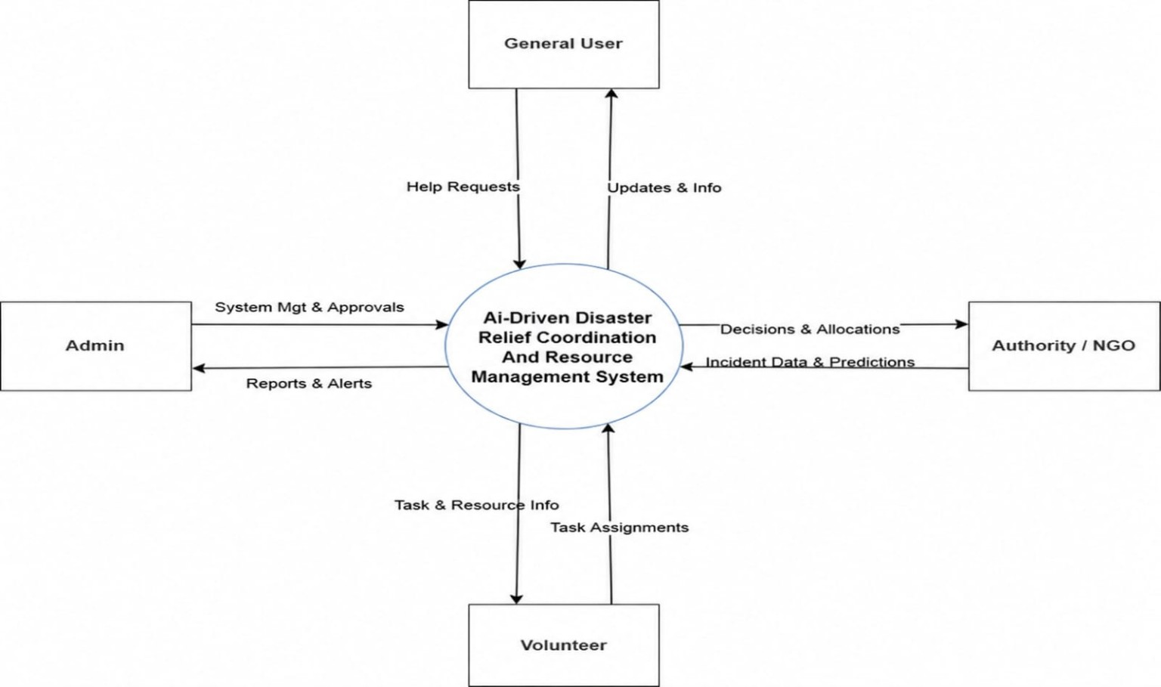
Figure 3.1: Level 0 DFD

3.1.2 Level 1 DFD

The Level 1 DFD of the AI-Driven Disaster Relief Coordination And Resource Management System illustrates the detailed flow of data between the users and the major internal functional processes of the platform. This diagram expands the high-level operations represented in the Level 0 DFD into multiple sub-processes, showing how information is processed, stored, retrieved, and transferred across different modules within the system. The Level 1 DFD provides a more detailed understanding of system functionality and operational workflow.
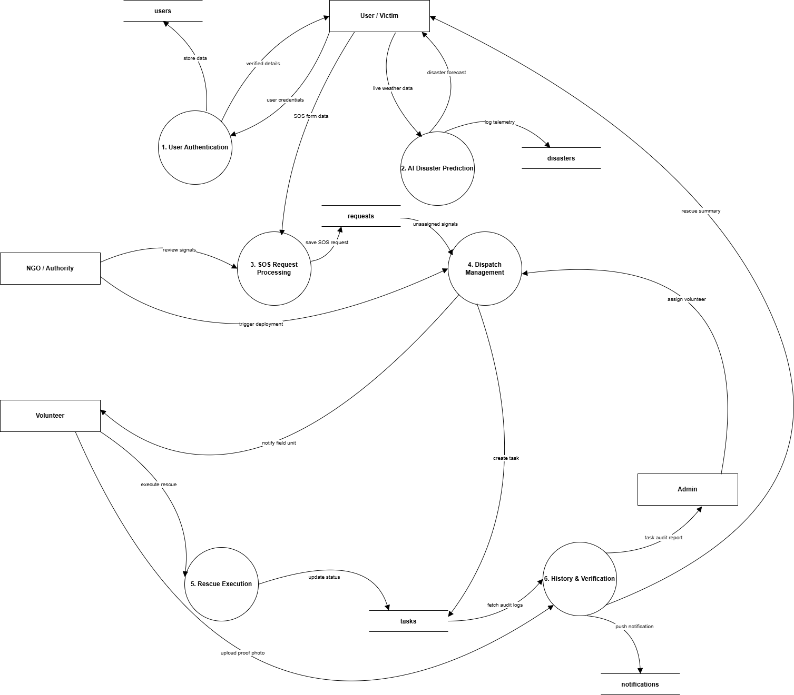
Figure 3.2: Level 1 DFD
The process begins with the Register/Login functionality, where users enter valid credentials such as email and password to access the platform securely. The authentication process verifies the login details using the User database and grants access to the system dashboard upon successful verification. This process ensures secure access control and protects sensitive disaster-related information from unauthorized access.
After successful authentication, users can access the Disaster Reporting process. Through this module, users can submit disaster details such as disaster type, affected location, severity information, and emergency support requirements. The submitted disaster reports are processed by the system and stored in the Disaster Report database for monitoring and emergency response coordination.
The system also includes an Emergency Support Request process that allows users to request rescue assistance, shelter support, food supplies, medical services, transportation facilities, and emergency resources during disaster situations. These requests are forwarded to the appropriate authorities, NGOs, and volunteers for operational coordination and emergency response management.
Another important process within the Level 1 DFD is the Resource and Shelter Management module. This process manages information related to emergency inventories, shelter facilities, volunteer assignments, rescue coordination activities, and resource allocation operations. The system retrieves and updates operational information through the Shelter database, Resource database, and Volunteer database to ensure efficient disaster management activities.
The Notification and Alert process is responsible for delivering real-time emergency notifications, disaster warnings, rescue updates, and operational announcements to users. Notification details are retrieved from the Notification database and displayed through the user interface to improve communication and emergency awareness during disaster situations.
The system also integrates a Machine Learning Prediction process that analyzes disaster-related information and generates disaster severity predictions. The prediction module processes analytical data and stores prediction outputs within the Prediction database. These predictions assist authorities in identifying high-risk situations and prioritizing emergency response operations effectively.
The data stores associated with the Level 1 DFD include the User database, Disaster Report database, Shelter database, Resource database, Volunteer database, Notification database, Emergency Request database, and Prediction database. These databases act as centralized repositories for storing and retrieving operational information required for disaster management activities and emergency coordination processes.
The Level 1 DFD provides a detailed representation of how the AI-Driven Disaster Relief Coordination And Resource Management System processes information, coordinates emergency operations, manages resources, and supports communication between different modules within the platform.

3.2 USE CASE DIAGRAM
The Use Case Diagram of the AI-Driven Disaster Relief Coordination And Resource Management System illustrates the interaction between the primary actors of the system and the major functionalities provided by the platform. The diagram mainly consists of four actors: Admin, NGO/Authority, Volunteer, and Regular User (Victim). It represents how each actor interacts with different modules of the system to perform specific operations related to disaster reporting, emergency coordination, volunteer management, shelter monitoring, resource allocation, and system administration. The use case diagram provides a high-level functional overview of the system and helps in understanding the responsibilities and interactions of each user role within the platform.
Use Case Diagram for Admin
The Admin actor is responsible for managing and monitoring the overall activities of the AI-Driven Disaster Relief Coordination And Resource Management System. One of the primary use cases associated with the Admin is Manage Users, where the Admin can verify, monitor, update, or remove user accounts to maintain proper system control and operational security. Another important functionality is Monitor Disaster Reports, which allows the Admin to supervise reported incidents, monitor emergency response activities, and analyze disaster-related information.
The Admin also interacts with the Manage Resources and Shelters use case, enabling supervision of emergency inventories, shelter facilities, volunteer coordination activities, and rescue operations. Through the Analytics and Monitoring use case, the Admin can analyze disaster statistics, monitor system activities, and review machine learning-based disaster severity predictions. Additionally, the Notification Management use case allows the Admin to manage emergency alerts, rescue updates, and operational announcements for users within the system.
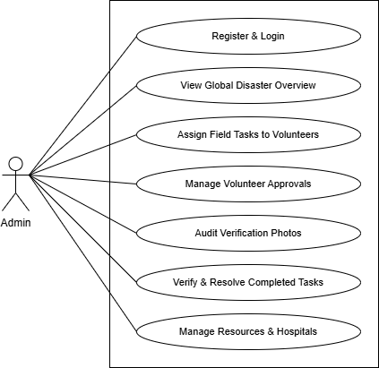
Figure 3.3: Use Case Diagram for Admin
Use Case Diagram for NGO
The NGO/Authority actor is responsible for managing logistical support and disaster response coordination activities. NGOs and authorities can access the Manage Resources use case to allocate food supplies, medicines, rescue equipment, shelter facilities, and transportation resources to affected regions. They can also interact with the Coordinate Volunteers use case to assign volunteers for rescue operations and monitor operational activities during emergency situations.

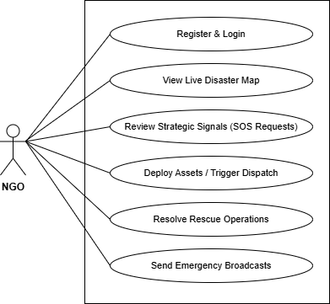
Figure 3.4: Use Case Diagram for NGO

Use Case Diagram for Volunteer
The Volunteer actor represents field-level responders who support disaster management activities. Volunteers interact with the Receive Assignments use case to access rescue tasks and operational responsibilities assigned by NGOs or authorities. They can also access the Update Rescue Status use case to submit field-level updates, report newly identified incidents, and communicate operational progress during rescue activities.

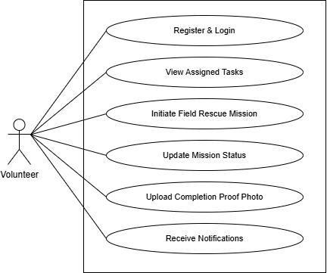
Figure 3.5: Use Case Diagram for Volunteer

Use Case Diagram for User (Victim)
The Regular User (Victim) actor represents affected individuals who utilize the system for disaster reporting and emergency assistance. The first interaction of the user with the system occurs through the Register/Login use case, where users create accounts and securely access the platform using valid credentials. After authentication, users can interact with the Report Disaster use case to submit disaster details and emergency information
The user can also access the Request Emergency Support use case to request rescue operations, shelter assistance, food supplies, medical services, and transportation support during disaster situations. Through the View Shelter Information use case, users can locate nearby shelters and access accommodation details. Additionally, the Receive Notifications use case enables users to receive emergency alerts, rescue updates, and disaster-related announcements from authorities and administrators.
The Use Case Diagram provides a clear representation of how different actors interact with the AI-Driven Disaster Relief Coordination And Resource Management System and illustrates the major functionalities involved in disaster response coordination and emergency management operations.
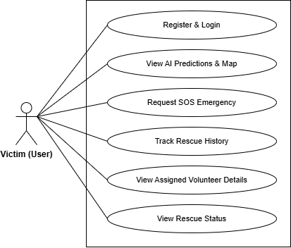
Figure 3.6: Use Case Diagram for User(Victim)

3.3 TABLE DESIGNS

3.3.1 User Table
Stores core user identity, credentials, role information, and account status.
Table 3.1: users table
Column | Type | Constraints | Description
_id | ObjectId | Primary Key, Auto-Generated | Unique database record identifier
name | String | None | Full name of the user
email | String | Required, Unique | Unique email address used for login
password | String | Required | Encrypted authentication password
role | String | Enum: ['Admin', 'User', 'Volunteer', 'NGO'], Default: 'User' | System access tier of the profile
contact | String | None | Voice / Emergency callback number
location | String | None | General address or area of residence
coordinates.lat | Number | None | GPS latitude coordinates
coordinates.lng | Number | None | GPS longitude coordinates

3.3.2 Disaster Report Table
Stores disaster incident details reported by users or volunteers.
Table 3.2: disasters table
Column | Type | Constraints | Description
_id | ObjectId | Primary Key, Auto-Generated | Unique disaster incident identifier
type | String | Required | Calamity class (e.g. Flood, Wildfire)
description | String | None | Severity notes of active situation
severity | String | Enum: ['Low', 'Medium', 'High', 'Critical'], Default: 'Medium' | Intensity threat metric of the disaster
location.type | String | Default: 'Point' | Spatial mapping identifier
location.coordinates | Array [Number] | Indexed: 2dsphere (Format: [Lng, Lat]) | Latitude and longitude coordinates
address | String | None | Visual physical address of the disaster zone
status | String | Enum: ['Reported', 'Ongoing', 'Resolved', 'Rescued'], Default: 'Reported' | Active monitoring status of the zone
telemetry.rainfall | Number | Default: 0 | Rain meter telemetry

3.3.3 Emergency Request Table
Stores emergency support requests submitted by affected users.
Table 3.3: requests table
Column | Type | Constraints | Description
_id | ObjectId | Primary Key, Auto-Generated | Unique distress request identifier
victimId | ObjectId | Required, References: users | Primary key relationship to the reporting victim
disasterId | ObjectId | References: disasters | Relates the SOS signal to a mapped active disaster
helpType | String | Required | Category of dispatch targeted (e.g. food, rescue)
description | String | None | Incident details typed by the victim
location.address | String | None | Written location address of the incident
location.lat | Number | None | Pinpointed extraction Latitude
location.lng | Number | None | Pinpointed extraction Longitude
urgency | String | Enum: ['Low', 'Medium', 'High', 'Critical'], Default: 'Medium' | Speed priority rating of incoming request
status | String | Enum: ['Pending', 'In Progress', 'Completed'], Default: 'Pending' | Current status of targeted rescue operation

3.3.4 Resource Table
Stores emergency resource and inventory details managed by NGOs or authorities.
Table 3.4: resources table
Column | Type | Constraints | Description
_id | ObjectId | Primary Key, Auto-Generated | Unique resource inventory identifier
type | String | Required | Category classification (Food, Water, Medicine, Tents)
quantity | Number | Required | Available quantity count
ngoId | ObjectId | References: users | References the NGO owning this resource
location | String | None | Storage facility / warehouse details
expiryDate | Date | None | Shelf-life expiration date
status | String | Enum: ['In Stock', 'Allocated', 'Collected', 'Used', 'Expired'], Default: 'In Stock' | Availability state of resource
createdAt | Date | Auto-Generated on creation | Resource creation timestamp
updatedAt | Date | Auto-Updated on edit | Resource update timestamp

3.3.5 Shelter Table
Stores shelter information and accommodation availability details.
Table 3.5: shelters table
Column | Type | Constraints | Description
_id | ObjectId | Primary Key, Auto-Generated | Unique shelter facility identifier
name | String | Required | Commercial name of shelter hub
address | String | Required | Street location instructions
location.lat | Number | Required | Shelter GPS Latitude
location.lng | Number | Required | Shelter GPS Longitude
capacity | Number | None | Evacuee headcount capacity limit
occupied | Number | Default: 0 | Count of evacuees currently routed inside
contact | String | None | Shelter desk emergency contact line
amenities | Array [String] | None | evacuee services (e.g. Beds, Rations, Electric)

3.3.6 Volunteer Assignment Table
Stores volunteer task assignment and rescue operation details.
Table 3.6: tasks table
Column | Type | Constraints | Description
_id | ObjectId | Primary Key, Auto-Generated | Unique task tracking identifier
title | String | Required | Display title of field rescue operation
description | String | None | Operational instructions from the dispatcher
volunteerId | ObjectId | References: users | Target volunteer assigned to execute task
isNGOAlert | Boolean | Default: false | Flags if task originated as an urgent NGO alert
status | String | Enum: ['Pending', 'In Progress', 'Pending Verification', 'Completed', 'Rejected', 'Resolved'], Default: 'Pending' | Active lifecycle stage of the task
priority | String | Enum: ['Low', 'Medium', 'High', 'Critical'], Default: 'Medium' | Mission priority assignment
incidentId | ObjectId | References: disasters | Link to the global active disaster mapping

3.3.7 Emergency Hospital Center Table
Stores hospital availability records, emergency services, coordinates, and real-time medical beds.

Table 3.7: hospitals table
Column | Type | Constraints | Description
_id | ObjectId | Primary Key, Auto-Generated | Unique medical facility identifier
name | String | Required | Medical center name
address | String | Required | Physical hospital address
location.lat | Number | Required | Hospital destination Latitude
location.lng | Number | Required | Hospital destination Longitude
contact | String | None | Emergency phone directory line
specialization | Array [String] | None | Specialized departments (e.g. trauma care)
emergencyServices | Boolean | Default: true | Emergency services functional flag
availableBeds | Number | Default: 0 | Available empty bed count
createdAt | Date | Auto-Generated on creation | Hospital registration timestamp
updatedAt | Date | Auto-Updated on edit | Hospital update timestamp

3.3.8 Tactical System Messages Table
Stores direct or global channel communications dispatched between coordinators and field rescue teams.
Table 3.8: messages table
Column | Type | Constraints | Description
_id | ObjectId | Primary Key, Auto-Generated | Unique message transaction identifier
sender | ObjectId | Required, References: users | References the sending user
recipient | ObjectId | References: users, Optional | Target user address (Null targets global system mesh)
senderName | String | Required | Visual name of sender profile
senderRole | String | Required | Security role of sending user
content | String | Required | String message body
createdAt | Date | Auto-Generated on creation | Message sent timestamp
updatedAt | Date | Auto-Updated on edit | Message updated timestamp

3.3.9 System Alerts & Notifications Table

Stores real-time system warnings, task updates, and alerts targeted to individual users.

Table 3.9: notifications table
Column | Type | Constraints | Description
_id | ObjectId | Primary Key, Auto-Generated | Unique notification record identifier
userId | ObjectId | Required, References: users | Reference to recipient of the notification
title | String | Required | Notification title text
message | String | Required | Detailed notification details
type | String | Enum: ['Alert', 'Task', 'Help', 'System'], Default: 'System' | Classification type of dispatch event
isRead | Boolean | Default: false | True if notification has been read
createdAt | Date | Auto-Generated on creation | Notification timestamp
updatedAt | Date | Auto-Updated on edit | Notification update timestamp

3.4 PERFORMANCE REQUIREMENTS
The performance requirements of the AI-Driven Disaster Relief Coordination And Resource Management System define the operational expectations necessary for maintaining efficient, reliable, and scalable disaster management activities. The system is designed to support real-time disaster reporting, emergency communication, resource allocation, volunteer coordination, and analytical monitoring with minimal delays during disaster situations.
The platform should provide fast response times for user authentication, disaster report submission, emergency request processing, notification delivery, and shelter information retrieval. Users should be able to access system functionalities smoothly without significant waiting time even during high operational load conditions.
The system must support multiple concurrent users including Admins, NGOs/Authorities, Volunteers, and Regular Users (Victims) without affecting overall system performance or operational stability. The application should efficiently handle simultaneous disaster reports, emergency requests, volunteer assignments, and resource management activities during large-scale disaster situations.
The database management system should provide efficient data storage, retrieval, updating, and processing capabilities for handling disaster-related information and operational records. Proper indexing and optimized query processing mechanisms should be implemented to improve database performance and reduce response delays.
The machine learning prediction module should generate disaster severity prediction results efficiently to support emergency decision-making and rescue prioritization activities. Prediction outputs and analytical reports should be processed within acceptable response time limits to ensure timely disaster response coordination.
The notification and communication modules should support real-time information exchange between users, authorities, NGOs, and volunteers with minimal transmission delays. Emergency alerts, rescue updates, and operational announcements should be delivered reliably to ensure continuous disaster communication and public awareness.
The application should also provide responsive user interfaces that function efficiently across different devices including desktops, laptops, tablets, and smartphones. The system should maintain stable performance under varying network conditions and support scalable architecture for future expansion and operational growth.
Proper error handling, backup mechanisms, and secure communication processes should be implemented to maintain reliability, availability, and operational continuity of the AI-Driven Disaster Relief Coordination And Resource Management System during emergency situations.

3.5 SOFTWARE QUALITY ATTRIBUTES

Software quality attributes define the characteristics and standards required to ensure that the AI-Driven Disaster Relief Coordination And Resource Management System operates efficiently, reliably, securely, and effectively during disaster management operations. These attributes help improve system performance, usability, maintainability, scalability, and operational reliability while supporting emergency response coordination activities.
Reliability
The AI-Driven Disaster Relief Coordination And Resource Management System should provide reliable performance during disaster situations and emergency operations. The platform must ensure continuous availability of disaster reporting, notification delivery, resource management, and rescue coordination functionalities without operational failures or significant interruptions.
Scalability
The system should support scalability to accommodate increasing numbers of users, disaster reports, emergency requests, and operational activities. The modular architecture and centralized database design should allow future expansion and integration of additional functionalities without major system modifications.
Security
The application should provide secure authentication, authorization, encrypted communication, and protected database operations to maintain confidentiality and integrity of disaster-related information. Role-based access control should ensure that users can access only authorized functionalities within the system.
Maintainability
The AI-Driven Disaster Relief Coordination And Resource Management System should be designed using modular architecture principles to simplify maintenance, debugging, testing, and future enhancements. Proper code organization and structured database management should support efficient system updates and operational improvements.
Availability
The system should maintain high availability during emergency situations and support continuous access to disaster management services. Proper backup mechanisms, error handling processes, and reliable server configurations should be implemented to reduce operational downtime.
Usability
The application should provide a simple, user-friendly, and responsive interface that can be easily accessed by Admins, NGOs/Authorities, Volunteers, and Regular Users (Victims). The system should support smooth navigation and easy interaction with disaster management functionalities across multiple devices.
Efficiency
The platform should process disaster reports, emergency requests, notifications, volunteer assignments, and machine learning predictions efficiently within acceptable response time limits. Optimized database operations and proper resource management techniques should be implemented to improve operational performance.

Portability
The system should support operation across different operating systems, browsers, and internet-enabled devices. The web-based architecture should ensure compatibility with desktops, laptops, tablets, and smartphones without requiring significant platform-specific modifications.
Flexibility
The AI-Driven Disaster Relief Coordination And Resource Management System should support future integration with advanced technologies such as IoT-based disaster monitoring systems, GPS tracking services, cloud deployment platforms, and mobile applications. The flexible system design should allow easy modification and extension of functionalities according to future operational requirements.

3.6 DETAILED DESIGN

The detailed design of the AI-Driven Disaster Relief Coordination And Resource Management System involves a comprehensive approach to system architecture, module interaction, database management, emergency communication, machine learning integration, and operational coordination to fulfill both functional and non-functional requirements effectively.

3.6.1 System Architecture:

The AI-Driven Disaster Relief Coordination And Resource Management System is developed using the MERN stack architecture with React.js for frontend development, Node.js and Express.js for backend services, and MongoDB for database management. The system follows a modular and scalable architecture to ensure maintainability, flexibility, security, and efficient disaster management operations.
The frontend provides responsive and interactive user interfaces that allow Admins, NGOs/Authorities, Volunteers, and Regular Users (Victims) to access the platform through desktops, laptops, tablets, and smartphones. The interface enables users to report disasters, request emergency assistance, monitor shelters, manage resources, coordinate rescue activities, and receive notifications efficiently.
The backend manages the core business logic and coordinates communication between frontend interfaces, databases, machine learning modules, and notification services. Flask-based machine learning services are integrated with the platform to support disaster severity prediction and analytical processing functionalities. The modular architecture ensures smooth interaction between disaster management modules while supporting future scalability and feature enhancements.

3.6.2 User Registration and Authentication:

Users can register on the platform using valid personal details such as name, email address, phone number, and password. Passwords are securely encrypted before storage to maintain account security and protect sensitive user information. The authentication process is managed through secure login mechanisms that verify user credentials before granting access to the platform.
Role-based access control mechanisms are implemented to ensure that Admins, NGOs/Authorities, Volunteers, and Regular Users can access only the functionalities assigned to their respective roles. Password recovery functionalities are also provided through secure verification mechanisms to help users reset forgotten passwords safely.

3.6.3 Disaster Reporting and Emergency Request Management:

The disaster reporting module allows victims and users to report disaster incidents by providing details such as disaster type, affected location, severity level, description, and emergency support requirements. Submitted disaster reports are processed and stored within the centralized database for monitoring and emergency response coordination.
The emergency request management module enables users to request rescue assistance, shelter support, medical aid, food supplies, transportation services, and emergency resources during disaster situations. The system forwards these requests to NGOs, Volunteers, and Authorities for rescue coordination and operational management.

3.6.4 NGO, Resource, and Shelter Management:

The NGO and resource management module allows NGOs and authorities to manage emergency inventories, allocate resources, supervise rescue operations, and monitor volunteer activities during disaster situations. Resource details such as food supplies, medicines, water resources, rescue equipment, and transportation facilities are maintained within the database for efficient allocation and monitoring.
The shelter management module maintains information regarding available shelters, accommodation capacity, food availability, sanitation facilities, and medical support. Authorities and NGOs can dynamically update shelter information while users can access nearby shelter details during emergencies.

3.6.5 Volunteer Coordination and Assignment Management:

The volunteer coordination module manages volunteer registration, assignment allocation, rescue coordination, and field-level operational updates. Volunteers can receive assignments, access disaster locations, report operational progress, and coordinate with NGOs and authorities during emergency response activities.
The system also maintains volunteer availability status, assignment history, and rescue operation details within the database to support efficient volunteer management and operational supervision.

3.6.6 Machine Learning Prediction and Analytics:

The system integrates machine learning services to analyze disaster-related information and generate disaster severity predictions. The prediction module processes disaster data and identifies high-risk situations that require immediate emergency response and resource allocation.
The analytics module generates statistical reports, graphical dashboards, operational summaries, and monitoring interfaces related to disaster incidents, shelter occupancy, volunteer participation, resource utilization, and rescue coordination activities. These analytical insights assist administrators and authorities in decision-making and operational planning.

3.6.7 Notification and Communication Management:

The notification management module provides real-time communication between users, NGOs, Volunteers, Authorities, and Administrators during disaster situations. Emergency alerts, disaster warnings, rescue updates, shelter notifications, and operational announcements are delivered through the platform to improve communication and disaster awareness.
The communication module ensures efficient data transmission and coordination between different system modules with minimal delays during emergency operations.

3.6.8 Security Measures:

To ensure platform security and operational reliability, sensitive user information and disaster-related data are securely protected during storage and communication processes. Secure authentication mechanisms, encrypted communication protocols, role-based access control, and protected API handling are implemented to prevent unauthorized access and maintain data confidentiality.
The system also incorporates secure session management, input validation, database protection, and operational monitoring mechanisms to identify and reduce potential security vulnerabilities.

3.6.9 Performance Optimization:

The system is optimized to provide fast response times and reliable real-time processing during disaster situations. Efficient database queries, optimized API communication, and proper indexing mechanisms improve data retrieval performance for disaster reports, emergency requests, shelter information, volunteer coordination, and analytical monitoring activities.
The modular architecture supports scalability, allowing the system to manage increasing numbers of concurrent users and disaster operations without significant performance degradation.

3.6.10 Testing and Deployment:

Comprehensive testing methodologies are followed to ensure system reliability, functionality, and operational accuracy. Unit testing, integration testing, system testing, and user acceptance testing are performed to validate all disaster management modules and communication processes.
The application can be deployed on cloud-based or local server environments using modern deployment technologies to support scalability, maintainability, and operational continuity. Proper deployment and monitoring practices ensure stable system performance and efficient disaster management operations.

3.7 TEST CASES

Test cases are used to verify whether the functionalities of the AI-Driven Disaster Relief Coordination And Resource Management System work according to the specified requirements. Testing ensures that each module performs correctly, user interactions are processed properly, and the system produces expected outputs under different input conditions. The test cases are categorized based on major user roles and system functionalities.

3.7.1 Test Case for Admin

Category | Test Case | Description | Expected Result | Status
User Management | View All Users | Ensure the Admin can view all registered users. | A list of all users is displayed with name, email, role, and account status. | Pass
User Management | Verify NGO/Volunteer | Ensure the Admin can verify NGO and Volunteer accounts. | Selected NGO/Volunteer account is verified successfully. | Pass
User Management | Delete User Account | Ensure the Admin can remove invalid or inactive users. | User account is deleted from the system database. | Pass
Disaster Monitoring | View Disaster Reports | Ensure the Admin can view submitted disaster reports. | Disaster reports are displayed with location, type, severity, and status. | Pass
Disaster Monitoring | Update Report Status | Ensure the Admin can update disaster report status. | Report status is updated successfully. | Pass
Resource Monitoring | View Resource Details | Ensure the Admin can monitor available emergency resources. | Resource details are displayed correctly. | Pass
Shelter Monitoring | View Shelter Details | Ensure the Admin can monitor shelter information. | Shelter capacity, location, and availability details are displayed. | Pass
Volunteer Monitoring | View Volunteer Activities | Ensure the Admin can monitor volunteer assignments. | Volunteer task status and assignment details are displayed. | Pass
Prediction Monitoring | View Severity Prediction | Ensure the Admin can view ML-based disaster severity output. | Predicted severity level and risk score are displayed correctly. | Pass
Notification Management | Send Emergency Alert | Ensure the Admin can send emergency alerts to users. | Notification is delivered successfully. | Pass
Analytics | View Dashboard Analytics | Ensure the dashboard displays charts and statistics. | Disaster statistics, resource usage, and user activity charts are displayed. | Pass
Security & Access | Secure Admin Login | Ensure only authorized Admin can access the dashboard. | Valid Admin login succeeds and invalid access is blocked. | Pass
Security & Access | Logout Functionality | Ensure Admin can logout securely. | Admin is logged out and redirected to login page. | Pass
Error Handling | Invalid Operation Handling | Ensure the system handles invalid admin actions properly. | Appropriate error message is displayed without system crash. | Pass

3.7.2 Test Case for NGO / Authority

Category | Test Case | Description | Expected Result | Status
Authentication | NGO Login | Ensure verified NGO/Authority can login successfully. | NGO dashboard is displayed after successful login. | Pass
Resource Management | Add Resource | Ensure NGO can add emergency resource details. | Resource is added and stored successfully. | Pass
Resource Management | Update Resource Quantity | Ensure NGO can update available resource quantity. | Updated resource quantity is saved correctly. | Pass
Resource Allocation | Allocate Resource | Ensure NGO can allocate resources to affected locations. | Resource allocation details are updated successfully. | Pass
Disaster Monitoring | View Assigned Disaster Reports | Ensure NGO can view disaster reports assigned for response. | Assigned disaster reports are displayed correctly. | Pass
Shelter Management | Add Shelter Details | Ensure NGO can add shelter information. | Shelter details are saved successfully. | Pass
Shelter Management | Update Shelter Availability | Ensure NGO can update shelter occupancy and availability. | Shelter availability is updated correctly. | Pass
Volunteer Coordination | Assign Volunteer | Ensure NGO can assign volunteers to rescue requests. | Volunteer assignment is completed successfully. | Pass
Rescue Monitoring | Track Rescue Progress | Ensure NGO can monitor rescue activity status. | Rescue progress details are displayed properly. | Pass
Notification | Send Rescue Update | Ensure NGO can send rescue updates to users. | Rescue update notification is delivered successfully. | Pass
Security & Access | Unauthorized Access Check | Ensure NGO cannot access Admin-only functionalities. | Unauthorized access is blocked. | Pass

3.7.3 Test Case for Volunteer

Category | Test Case | Description | Expected Result | Status
Authentication | Volunteer Login | Ensure verified Volunteer can login successfully. | Volunteer dashboard is displayed after login. | Pass
Assignment Management | View Assigned Tasks | Ensure Volunteer can view assigned rescue tasks. | Assigned tasks are displayed with location and details. | Pass
Location Access | View Disaster Location | Ensure Volunteer can access disaster location details. | Incident location is displayed correctly. | Pass
Rescue Operation | Update Task Status | Ensure Volunteer can update rescue task progress. | Task status is updated successfully. | Pass
Disaster Reporting | Report Local Disaster | Ensure Volunteer can report newly identified disaster incidents. | Disaster report is submitted successfully. | Pass
Communication | Receive Instructions | Ensure Volunteer receives instructions from NGO/Authority. | Instructions are displayed in the dashboard. | Pass
Resource Distribution | Update Distribution Status | Ensure Volunteer can update relief distribution activity. | Distribution status is saved successfully. | Pass
Security & Access | Volunteer Logout | Ensure Volunteer can logout securely. | Volunteer is logged out successfully. | Pass
Error Handling | Invalid Update Handling | Ensure invalid task updates are handled properly. | Validation message is displayed. | Pass

3.7.4 Test Case for Regular User (Victim)

User Authentication | User Registration | Ensure victim can register using valid details. | User account is created successfully. | Pass
User Authentication | User Login | Ensure victim can login using valid credentials. | User is redirected to user dashboard. | Pass
User Authentication | Invalid Login | Ensure system prevents login with invalid credentials. | Error message is displayed. | Pass
Profile Management | Update Safety Profile | Ensure user can update personal and safety information. | Updated profile details are saved successfully. | Pass
Disaster Reporting | Submit Disaster Report | Ensure user can report disaster incidents. | Disaster report is stored successfully. | Pass
Emergency Request | Request Rescue Support | Ensure user can request rescue assistance. | Rescue request is submitted successfully. | Pass
Emergency Request | Request Medical Support | Ensure user can request medical assistance. | Medical support request is submitted successfully. | Pass
Emergency Request | Request Shelter Support | Ensure user can request shelter assistance. | Shelter request is stored successfully. | Pass
Shelter Information | View Shelter Details | Ensure user can view available shelters. | Shelter location and availability details are displayed. | Pass
Notification System | Receive Emergency Alert | Ensure user receives disaster alerts and rescue updates. | Emergency notification is displayed. | Pass
Report Tracking | Track Request Status | Ensure user can track emergency request status. | Request status is displayed correctly. | Pass
Security & Access | Secure User Logout | Ensure user can logout securely. | User is logged out and redirected to login page. | Pass
Error Handling | Empty Report Validation | Ensure empty disaster reports are not accepted. | Validation message is displayed. | Pass

CHAPTER 4
IMPLEMENTATION AND RESULTS

IMPLEMENTATION

Implementation is the process of converting the system design into a fully functional software application by developing and integrating all modules, interfaces, databases, and operational functionalities. The implementation phase of the AI-Driven Disaster Relief Coordination And Resource Management System focuses on building a secure, scalable, and efficient platform capable of supporting disaster reporting, emergency communication, resource management, volunteer coordination, shelter monitoring, and machine learning-based disaster severity prediction.
The AI-Driven Disaster Relief Coordination And Resource Management System is implemented using the MERN stack architecture consisting of React.js for frontend development, Node.js and Express.js for backend services, and MongoDB for database management. Flask-based machine learning services are integrated with the platform to support disaster severity prediction and analytical monitoring functionalities.
The frontend implementation provides responsive and interactive user interfaces for Admins, NGOs/Authorities, Volunteers, and Regular Users (Victims). The user interface includes functionalities such as registration, login, disaster reporting, emergency support requests, shelter monitoring, volunteer coordination, analytics dashboards, notification management, and profile management. Responsive design techniques are implemented to ensure compatibility across desktops, laptops, tablets, and smartphones.
The backend implementation handles business logic, API communication, authentication processes, disaster data management, emergency request processing, volunteer coordination, resource allocation, and notification services. REST APIs are developed using Express.js to facilitate smooth communication between frontend interfaces, databases, and machine learning modules.
MongoDB is used as the centralized database management system for storing user details, disaster reports, emergency requests, volunteer records, shelter information, resource allocation data, notifications, and prediction outputs. Mongoose is used for database modeling and schema management to maintain data integrity and efficient data handling operations.
The machine learning prediction module is implemented using Python Flask services integrated with the backend through API communication. The prediction module processes disaster-related information and generates disaster severity outputs to support emergency decision-making and rescue prioritization activities.
Secure authentication and authorization mechanisms are implemented using JWT-based authentication and role-based access control. Password encryption, protected API communication, and secure session management techniques are integrated to maintain data confidentiality and operational security.
Version control and project management are maintained using Git and GitHub for source code tracking, collaborative development, and backup management. The application is tested across different environments to ensure functionality, performance, compatibility, and operational reliability during disaster management activities.
The implementation phase ensures that all modules of the AI-Driven Disaster Relief Coordination And Resource Management System work together efficiently to provide organized disaster response coordination, emergency communication, analytical monitoring, and intelligent disaster management operations.
The AI-Driven Disaster Relief Coordination And Resource Management System was implemented using React.js for frontend development, Node.js and Express.js for backend services, MongoDB for database management, and Flask-based machine learning modules for disaster severity prediction.The frontend provides responsive interfaces for disaster reporting, volunteer coordination, shelter management, analytics dashboards, and
administrative monitoring. Backend APIs handle user authentication, disaster data processing, resource allocation, and communication between modules.

4.1.1 Backend Development

The backend of the AI-Driven Disaster Relief Coordination And Resource Management System was developed using Node.js and Express.js. The backend manages all core functionalities of the platform, including user authentication, disaster reporting, emergency request handling, volunteer coordination, shelter management, resource allocation, notification management, and machine learning-based disaster severity prediction. MongoDB was integrated as the database management system for efficient storage and retrieval of disaster-related information.
Secure authentication and authorization mechanisms were implemented using JWT authentication and role-based access control. Separate access privileges were provided for Admins, NGOs/Authorities, Volunteers, and Regular Users (Victims). The backend also handled communication with machine learning services for generating disaster severity predictions and analytical outputs using Flask-based APIs.
The backend coordinated communication between frontend interfaces, databases, machine learning modules, and notification services. Disaster reports, emergency requests, shelter details, volunteer assignments, and resource allocation records were processed and stored securely within the database for efficient disaster management operations and emergency coordination activities.

4.1.2 Frontend Development

The frontend of the AI-Driven Disaster Relief Coordination And Resource Management System was designed to provide an interactive, responsive, and user-friendly experience for all categories of users. The user interface enables users to register, login, report disasters, request emergency support, monitor shelters, manage resources, coordinate volunteers, and view analytical dashboards efficiently. The frontend was developed with a focus on simplicity, accessibility, responsiveness, and operational usability across desktops, laptops, tablets, and smartphones.
Users can report disaster incidents, request rescue assistance, access shelter information, and receive emergency notifications through responsive interfaces. NGOs and authorities can manage emergency inventories, monitor disaster reports, coordinate volunteers, and supervise rescue operations through dedicated dashboards.
The Admin interface was also implemented as part of the frontend, enabling administrators to verify user accounts, monitor disaster activities, analyze reports, manage notifications, and supervise overall disaster management operations through centralized dashboards.

4.1.3 Integration and Testing

After completing the frontend and backend development, both components were integrated to ensure smooth communication and efficient system operation. Extensive testing procedures were conducted to validate the functionality, reliability, security, and performance of the AI-Driven Disaster Relief Coordination And Resource Management System. The development process included unit testing, integration testing, white-box testing, and black-box testing to identify and resolve potential issues within the platform.
White-box testing focused on verifying the internal logic, backend functionalities, database communication, authentication mechanisms, API operations, disaster reporting processes, resource allocation modules, and machine learning integration services. Critical components such as disaster report handling, emergency request processing, volunteer coordination, notification delivery, and prediction generation were thoroughly tested to ensure operational stability and reliability.
Black-box testing was conducted from the perspective of end users to validate system behavior and functionalities without analyzing internal code structures. Functional testing ensured that major features such as user registration, login authentication, disaster reporting, emergency support requests, shelter management, volunteer coordination, notification delivery, and analytics monitoring operated correctly under different conditions.Usability testing was also performed to evaluate interface responsiveness, ease of navigation, operational accessibility, and user interaction during disaster management operations. Minor improvements were implemented to improve usability, responsiveness, and interaction flow based on testing observations.
The combined results from white-box testing and black-box testing confirmed that the AI-Driven Disaster Relief Coordination And Resource Management System was reliable, secure, scalable, and capable of supporting efficient disaster response coordination and emergency management activities effectively. The successful integration and comprehensive testing process ensured that the platform was ready for deployment and operational usage during disaster situations.

4.2 IMPLEMENTATION RESULTS

The implementation of the AI-Driven Disaster Relief Coordination And Resource Management System resulted in an intelligent, centralized, and efficient platform that supports disaster reporting, emergency communication, volunteer coordination, shelter management, resource allocation, and disaster severity prediction. By utilizing MERN stack technologies, MongoDB database services, REST APIs, and machine learning integration, the project successfully established seamless communication between frontend interfaces, backend services, databases, and analytical processing modules. The integration of secure authentication mechanisms and role-based access control ensured protected user sessions and reliable system access for Admins, NGOs/Authorities, Volunteers, and Regular Users (Victims).
The platform successfully enabled users to report disaster incidents, request emergency assistance, access shelter information, and receive real-time notifications regarding rescue operations and emergency alerts. The disaster reporting system efficiently processed and stored disaster-related information, improving communication between affected individuals and emergency authorities during disaster situations.
The implementation of NGO and resource management functionalities enabled authorities to manage emergency inventories, allocate resources, supervise rescue operations, and coordinate volunteer activities effectively. The shelter management module successfully maintained information regarding available shelters, accommodation capacity, medical support, and food availability, allowing users to access shelter details during emergencies.
The volunteer coordination module effectively managed volunteer registration, assignment allocation, operational updates, and rescue coordination activities. Volunteers were able to receive assignments, monitor disaster locations, and provide field-level updates through the platform, improving rescue coordination and operational communication.
The machine learning prediction module successfully analyzed disaster-related information and generated disaster severity prediction outputs to support emergency decision-making and rescue prioritization. The integration of analytical dashboards and monitoring interfaces helped administrators and authorities analyze disaster trends, monitor operational activities, and manage emergency response coordination efficiently.
The Admin module effectively facilitated user monitoring, disaster supervision, notification management, resource tracking, volunteer coordination, and analytics monitoring through centralized dashboards and reporting tools. Real-time notifications and operational updates improved communication between users, volunteers, NGOs, and authorities during disaster management activities.
Comprehensive testing and optimization ensured that the platform delivered reliable performance, secure data handling, responsive interfaces, and stable operation across multiple devices and concurrent users. The modular architecture also positioned the system for future scalability and integration of advanced technologies such as IoT-based disaster monitoring systems, GPS tracking services, cloud deployment, and mobile application support. Overall, the AI-Driven Disaster Relief Coordination And Resource Management System successfully achieved its objectives of providing a secure, scalable, intelligent, and user-friendly disaster management environment. The platform effectively combines modern web technologies, machine learning integration, real-time communication, and centralized coordination functionalities to improve emergency response operations, disaster communication, and public safety management.
CHAPTER 5
CONCLUSION AND FUTURE WORKS

5.1 CONCLUSION

The AI-Driven Disaster Relief Coordination And Resource Management System was successfully developed and implemented as a centralized web-based platform for improving disaster management and emergency response coordination. The project effectively integrated modern web technologies, database management systems, real-time communication mechanisms, and machine learning-based prediction services to support disaster reporting, volunteer coordination, shelter monitoring, resource allocation, and emergency communication activities.
The system successfully enabled victims and users to report disaster incidents, request emergency assistance, access shelter information, and receive real-time notifications regarding rescue operations and disaster alerts. NGOs and authorities were able to manage emergency inventories, allocate resources, supervise rescue operations, and coordinate volunteer activities efficiently through dedicated operational dashboards.
The implementation of machine learning-based disaster severity prediction improved analytical capabilities and supported emergency authorities in identifying high-risk situations and prioritizing rescue operations effectively. The integration of centralized monitoring dashboards and analytical reports further enhanced operational visibility, decision-making processes, and disaster management efficiency.
Secure authentication mechanisms and role-based access control ensured protected access to system functionalities for Admins, NGOs/Authorities, Volunteers, and Regular Users. The system also demonstrated reliable performance, responsive operation, and efficient data management during disaster management activities and emergency communication processes.
Comprehensive testing procedures confirmed that the platform was stable, scalable, secure, and capable of supporting efficient disaster response coordination across multiple user roles and operational modules. The modular system architecture also supports future scalability and integration of advanced technologies such as IoT-based disaster monitoring systems, GPS tracking services, cloud deployment, and mobile applications.
Overall, the AI-Driven Disaster Relief Coordination And Resource Management System successfully achieved its objectives of providing an intelligent, secure, scalable, and user-friendly disaster management environment. The platform effectively combines modern web technologies, centralized coordination, analytical monitoring, and machine learning integration to improve disaster response operations, public safety management, and emergency communication efficiency.

5.2 FUTURE WORKS

Looking ahead, there are several opportunities for enhancing the functionality, intelligence, scalability, and operational efficiency of the AI-Driven Disaster Relief Coordination And Resource Management System. Future developments can focus on improving disaster prediction accuracy, expanding emergency coordination capabilities, integrating advanced technologies, and strengthening communication systems to provide a more intelligent and responsive disaster management environment. By incorporating modern analytical techniques and real-time monitoring technologies, the platform can further improve disaster preparedness, emergency response coordination, and public safety management.

5.2.1 Future Implementation Plan:

❖ Implement multilingual support to improve accessibility and communication for users from different regions and language backgrounds during disaster situations.
❖ Integrate cloud-based deployment and distributed system architecture to improve scalability, availability, reliability, and operational performance during large-scale disaster events.
❖ Develop mobile application support for Android and iOS platforms to provide users with more flexible and accessible disaster management services.
❖ Implement drone-assisted disaster monitoring and rescue coordination features to support emergency response operations in high-risk or inaccessible regions.
❖ Enhance the system with offline emergency communication capabilities to support disaster response activities in areas with limited or disrupted internet connectivity.

REFERENCES

Conference Proceedings:
Sharma, R., Kumar, A., Singh, P., & Verma, S. (2024, March). Intelligent AI-Driven Disaster Relief Coordination And Resource Management System Using Machine Learning and Web Technologies. In 2024 International Conference on Smart Computing and Communication Systems (ICSCCS) (pp. 1-6). IEEE.
Reddy, K. V., Nair, S. R., Joseph, A., & Thomas, P. (2025, July). AI-Based Emergency Response and Disaster Coordination Platform. In 2025 International Conference on Emerging Technologies in Disaster Management and Smart Systems (ICETDMS) (pp. 112-118). Springer.
Khan, M. A., Patel, R., Mehta, S., & Das, A. (2024, November). Real-Time Disaster Monitoring and Resource Allocation System Using MERN Stack Technologies. In International Conference on Advanced Computing and Intelligent Systems (ICACIS 2024) (pp. 256-263). Atlantis Press.
Journal Articles:
Gupta, R., Sharma, N., & Bhatia, P. (2025). Machine Learning-Based Disaster Severity Prediction and Emergency Response Coordination System. International Journal of Disaster Management and Intelligent Systems, 6(2), 45-58.
Li, X., Wang, H., Chen, Y., & Zhao, J. (2024). Intelligent Web-Based Disaster Management Platforms for Emergency Communication and Resource Coordination. Journal of Information Systems and Emergency Technologies, 18(4), 211-225.
Ahmed, S., Roy, T., & Mukherjee, D. (2025). Role-Based Disaster Relief Coordination Systems Using Real-Time Communication and Predictive Analytics. International Journal of Smart Computing and Humanitarian Technologies, 9(1), 77-91.
Patel, V., Kumar, R., & George, A. (2024). Volunteer and Shelter Management in Intelligent Disaster Response Systems. Journal of Emergency Response and Technology Management, 12(3), 133-147.
Chowdhury, M., Rahman, F., & Islam, S. (2025). AI-Integrated Disaster Relief Platforms for Resource Allocation and Emergency Monitoring. International Journal of Artificial Intelligence and Disaster Analytics, 5(2), 89-103.

APPENDIXES

+ Appendix A- Screenshots

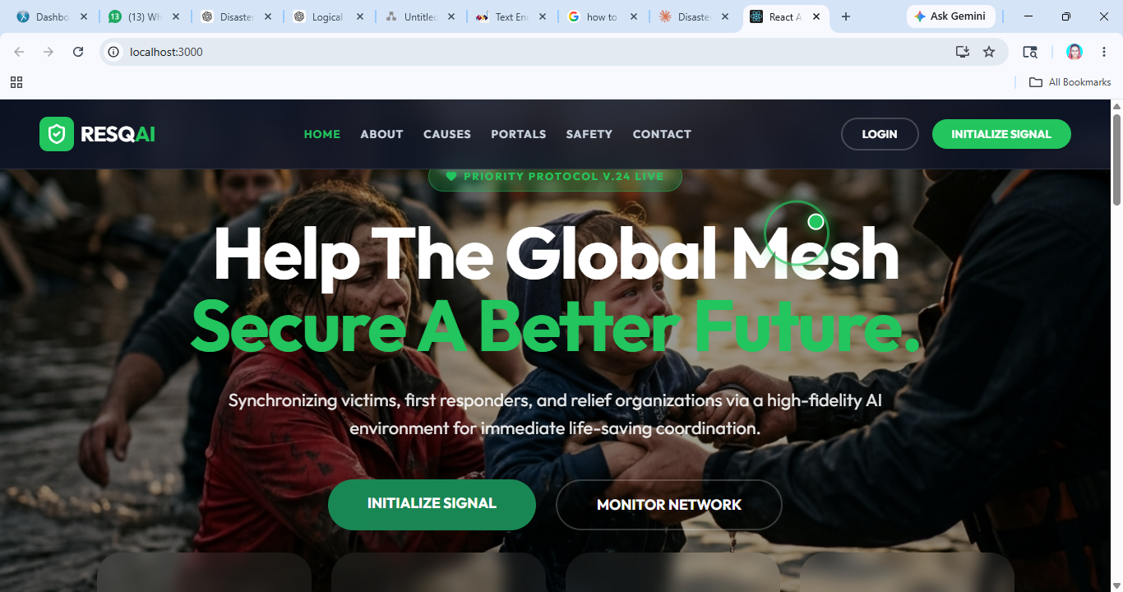
Figure A.1 Home Page

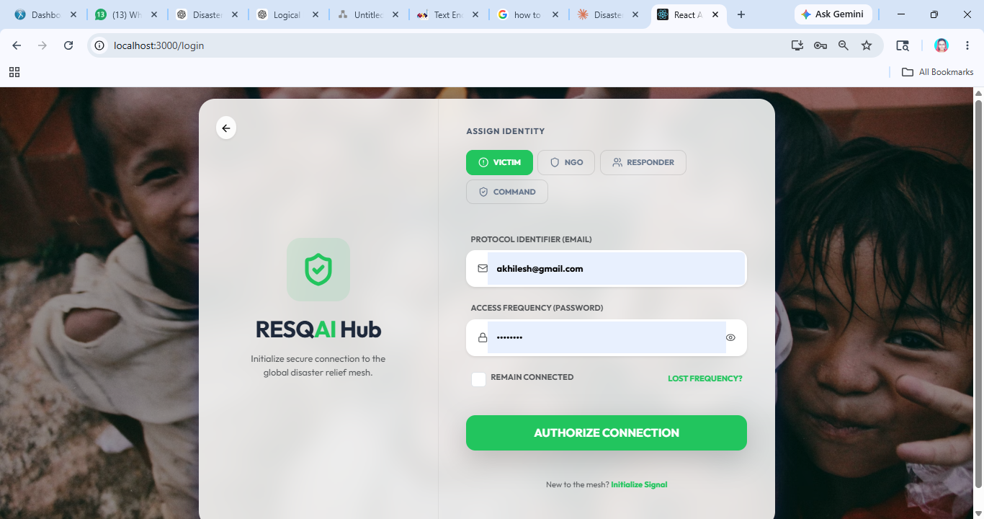
Figure A.2 Login Page

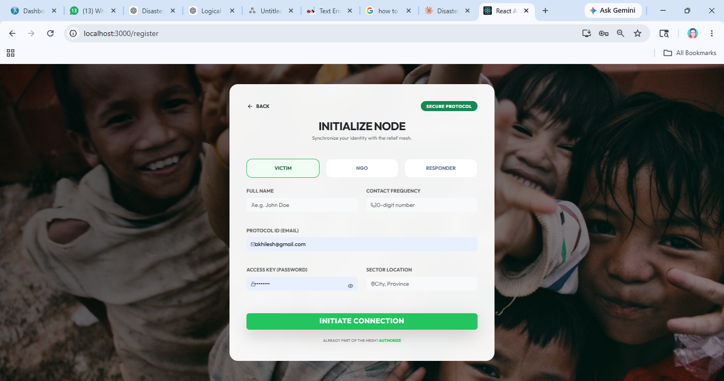
Figure A.3 Register Page

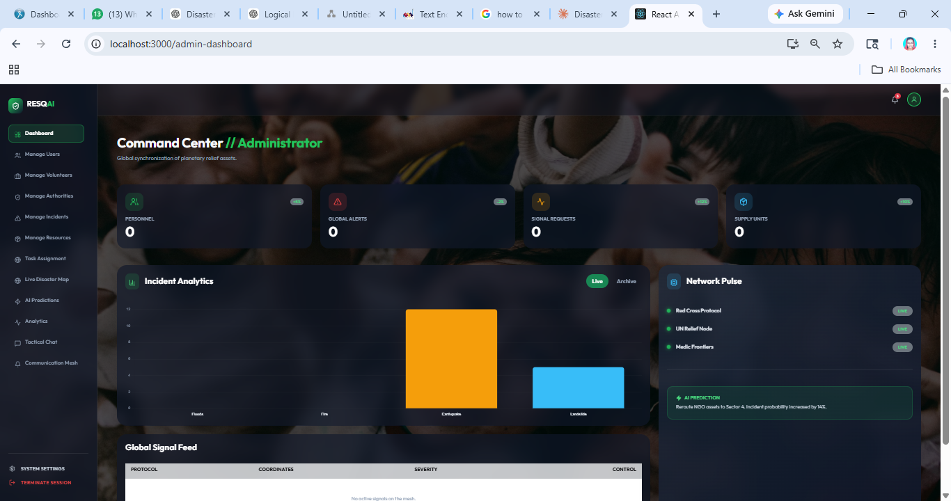
Figure A.4 Admin Page

Appendix B- Sample Code
App.py
from flask import Flask, request, jsonify
from flask_cors import CORS
import joblib
import numpy as np
import os

app = Flask(__name__)
CORS(app) # Enable CORS for MERN integration

# Load the trained model
MODEL_PATH = os.path.join(os.path.dirname(__file__), 'severity_model.pkl')
model = joblib.load(MODEL_PATH)

# Feature names (must match the training script)
FEATURES = [
'rainfall', 'temperature', 'humidity', 'wind_speed',
'seismic_activity', 'water_level', 'soil_moisture', 'vegetation_index'
]

@app.route('/predict', methods=['POST'])
def predict():
try:
data = request.get_json()
# Extract features in the correct order
input_data = [data.get(f, 0) for f in FEATURES]
# Reshape for prediction
input_array = np.array([input_data])
# Make prediction
prediction = model.predict(input_array)[0]
# Calculate risk level (simplified logic for demo)
risk_level = "Low"
if prediction != "None":
# Just a simple heuristic for risk level
if data.get('seismic_activity', 0) > 7 or data.get('wind_speed', 0) > 130:
risk_level = "Extreme"
elif data.get('rainfall', 0) > 200:
risk_level = "High"
else:
risk_level = "Medium"

# Resources Mapping (As per user request)
resources = [
"1. Immediate Emergency Response 🚨 (Rescue, First Aid)",
"2. Provide Basic Needs 🍞💧 (Food, Water, Blankets)",
"3. Shelter & Temporary Housing 🏠",
"4. Medical Support 🏥 (Mobile Clinics, Medicine)",
"5. Rescue & Volunteer Coordination 👥",
"6. Information & Communication 📢",
"7. Resource Management 📦 (Tracking & Distribution)",
"8. Rehabilitation & Recovery 🔄"
]

return jsonify({
"status": "success",
"prediction": {
"disaster_type": prediction,
"risk_level": risk_level,
"reasoning": f"Based on environmental telemetry showing {prediction} indicators.",
"resources_needed": resources
}
})

except Exception as e:
return jsonify({"status": "error", "message": str(e)}), 400

@app.route('/health', methods=['GET'])
def health():
return jsonify({"status": "healthy", "model_loaded": model is not None})

if __name__ == '__main__':
# Use port 8000 for the flask server
app.run(host='0.0.0.0', port=8000, debug=True)

app.js
require('dotenv').config();
const express=require("express");
const cors=require("cors");
const bodyParser=require("body-parser");
const database=require("./config/database");

const authRouter = require("./routes/authrouter");
const disasterRouter = require("./routes/disasterrouter");
const resourceRouter = require("./routes/resourcerouter");
const requestRouter = require("./routes/requestrouter");
const taskRouter = require("./routes/taskrouter");
const aiRouter = require("./routes/airouter");
const shelterRouter = require("./routes/shelterrouter");
const hospitalRouter = require("./routes/hospitalrouter");
const notificationRouter = require("./routes/notificationrouter");
const analyticsRouter = require("./routes/analyticsrouter");
const configRouter = require("./routes/configrouter");
const messageRouter = require("./routes/messagerouter");
const app=express();
app.use(cors());
app.use(bodyParser.urlencoded({ extended: true }));
app.use(bodyParser.json());
database();
app.use('/auth', authRouter);
app.use('/disaster', disasterRouter);
app.use('/resource', resourceRouter);
app.use('/request', requestRouter);
app.use('/task', taskRouter);
app.use('/ai', aiRouter);
app.use('/shelter', shelterRouter);
app.use('/hospital', hospitalRouter);
app.use('/notification', notificationRouter);
app.use('/analytics', analyticsRouter);
app.use('/api/config', configRouter);
app.use('/message', messageRouter);
app.listen(5000,()=>{
console.log("Server started on port 5000");
});

